**VIT BHOPAL UNIVERSITY**

**SCHOOL OF COMPUTING SCIENCE AND ENGINEERING**

DSN-2099 PROJECT EXHIBITION –II

WEEKLY REPORT

Title:Handwriting Analysis for Detection of Personality Traits Using Deep Learning

Team Members:

1.Shubham Singh (21BCE10456)

2.Harshita Nimje(21BCE10524)

3.Stuti Yadav(21BCE10543)

4.Pritha Dey(21BCE10707)

**II YEAR BTECH (CSE), IVth SEMESTER**

**Batch: 2021-2025**

**ABSTRACT**

Personality traits are of paramount importance in identifying human behavior.

They represent a useful information source for forensic control, recruitment profiling medical symptoms, and other applications.

Personality traits are identified through various physical aspects, including sense, honesty and other emotions as well. These aspects can be revealed through handwritten features.

Since handwriting is unique to everyone, it is viewed as a combined psycho-mechanic process achieved by the writer according to his brain commands.

This effect is endorsed by two natural factors that contribute to the script individuality; first the genetic factor, which is responsible for muscular strength and brain system properties, while the second, concept acquired through the basic education and cultural environment influence.

In another way, individual writing is subject to several improvements during the lifetime.

**WEEKLY REPORT**

**From:** November 2022 **To:** February 2023

**Topic Discussion/Work Done:**

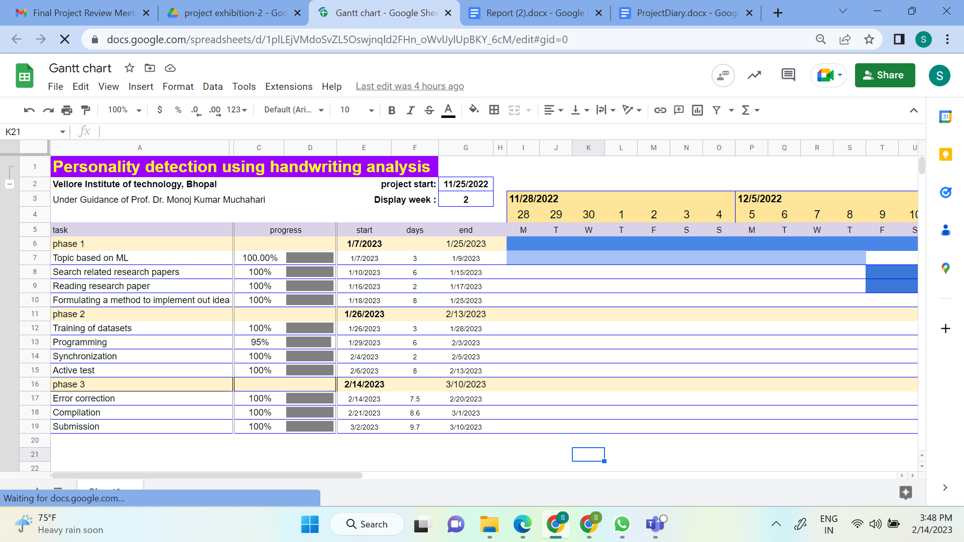

**Work Proposed:**

**Remark:**

**Guide Signature**

**REVIEW COMMENTS**

**Guide:**

**Co Guide:**

**Guide Signature Co Guide Signature**