A
PROJECT REPORT
ON
LIBRARY MANAGEMENT SYSTEM
For
HNU Library
Submitted
By
The Sooners
Vera(Liu Jiawei) R8J9400107
Vicky(Liu Liping) R8J9400121
Sihon(Zhao Sihao) R8J9400116
York(Yi Yu) R8J9400119
Date
2019/05/16 -2019/05/24
Internal Guide External
Mr. Ashok Mr. Ashok
Head of IT Department Head of Computer Science
HUN NIIT





Indian Instituteof Technology Delhi
PROJECT INDEX

S no. | Particulars | Page no.
1 | About the library management system and team introduction | 01-02
2 | Helpful people | 03
4 | SDLC and requirement analysis | 04-05
5 | System Design | 05-07
6 | Database Design | 08-09
7 | Testing  Cost Estimation  Division and Cooperation | 09-10
8 | Snapshots  Login module  User module  Administrator module  Registration module | 11-19
9 | Source code of  Mysql  AdminManageBooks_112.java  AdminMangeMenu_110.java  AdminManageSystem_114.java  AdminManageUser_111.java  AdminReport_113.java  ChangeAddress_122.java  ChangePassword_121.java  ChangeUserName_123.java  DBClass.java  LoginMenu_100.java  Main.java  RegistrationPage_130.java  UserFounctionMenu_120.java  Welcome_131.java | 19-116

TEAM DESCRIPTION & OVERVIEW
Our team was founded on April 18, 2019, named Sooners, with four members, Sihon, York, Vicky, Vera. With the common dream and pursuit, as well as the love of learning, we have formed this united team. Our team slogan is: "where there is a will, there is a way. Our team has a strong spirit of exploration and desire for the unknown. Under the leadership of group leader Sihon, we have a clear division of labor, and we help each other and make progress together in the process. We met with many difficulties in doing this project. But our slogan guides us and makes us believe that we will succeed.

CERTIFICATE
This is certify that this report , titled Library Management System, embodies the original work done by Sihon, York, Vicky and Vara in partial fulfillment of their course requirement at NIIT.

Coordinator: Mr. Ashok 刘德才导师

AKNOWLEDGEMENT

写上对此项目有帮助的人

CSDN
A Blog which once helped us
Ashok
A teacher who once helped us
刘德才(Delucia)
A Chinese teacher who once helped us
闫冰洁
A classmate who once helped us
岳琮涵
A classmate who once helped us
段熙宇
A classmate who once helped us
查皓晗
A classmate who once helped us
段熙宇
A classmate who once helped us
林云龙
A classmate who once helped us
PROJECT REPORT

LIBRARY MANAGEMENT
SYSTEM
Library with hundreds of thousands of people in and out every day, or borrow books, or return books, not in the library management system, requires the librarian to processing, in order to reduce the burden of the librarian, reduce the disadvantages of manual processing error prone, we design a set of books management system management system in HaiNan University library. It can not only reduce the burden of the library staff, but also serve the readers more conveniently.
图书馆每天都有着成百上千的人进进出出，或借走图书，或归还图书，这些在没有图书馆管理系统前，都需要图书管理员一一处理，为了减轻图书管理员的负担，减少人工处理容易出错的弊端，我们为海南大学图书馆设计了一套图书管理系统。它不仅可以减轻图书工作人员的负担，还可以更方便地为读者服务。
System Requirements
- Java Jdk11
- Netbeans10.0

This is a management system for library, it can realize the automation of operation flow by electronic method, which replaces the traditional manual operation, thus reducing the workload of librarians. The library management system not only realizes the self-help loan and return of books, but also effectively reduces the friction between the administrator and the user. It effectively shortens the distance between books and users, reduces the dependence on librarians, and believes that our system will bring convenience to users and administrators.
这是一个为图书馆服务的管理系统，它可以通过电子方法实现操作流程的自动化，这替代了传统的人工操作，从而减少了图书管理员的工作量。该图书管理系统不仅实现了用户自助借还书，还可以有效减少管理员与用户之间的摩擦。它有效地缩短了书本与用户的距离，减轻了对图书管理员的依赖，相信我们的系统会给用户和管理员带来方便。

SDLC of the Project系统开发生命周期
This project is a system and going to be developed using some technology like GUI and JDBC similar to other systems, this system too has its own unique function. The SDLC of this system will be discussed under the following heads.
本项目是一个系统，将使用GUI和JDBC等类似于其他系统的技术进行开发，该系统也有其独特的功能。系统的开发生命周期将在下面详细讨论。

Requirement Analysis 需求分析
With the popularization of computer and the development of information technology, people's life has changed with each passing day. All kinds of computer software have gradually penetrated into every corner of the society, greatly improving people's quality of life and improving people's work efficiency. In colleges and universities, book lending is a very important way for students to acquire knowledge. It is very important to make it convenient for students to borrow books and reduce the work burden of library management personnel.Thus,the library management system came into being.
随着计算机的普及和信息技术的发展，人们的生活发生了日新月异的变化，各类计算机软件逐渐渗透到了社会的每个角落，大大地改善了人们的生活质量，提高了人们的工作效率。在高校中，图书借阅是学生获取知识的一个很重要的途径，如何既能方便学生借书，又能减轻图书馆管理人员的工作负担，高效地完成图书借阅管理工作，是一件非常重要的事情。于是，图书管理系统应运而生。

- Entering, storing and searching of employing information manually are time consuming and error prone process: Libraries lend and recover a lot of books every day. Before there is a library management system, administrators need to manually repeat input, storage, changes, and searches to keep library books in order. However, the process is often long and error-prone.
- 手动输入、存储和搜索使用信息是耗时且容易出错的过程：图书馆每天都要借出和收回许许多多的书籍，在没有图书馆管理系统之前，管理员们需要手动的重复的输入，存储，更改，搜索来维持图书馆书籍的井井有条。然而这个过程往往十分漫长而且容易出错。
- The second task which is very important is user self-management books: In order to lighten the burden of librarians, our library management system has launched the function of user self-management of books, users can register to obtain an account, which contains the user's personal information and book information. After registration, users can log on to their account to query their book information. In the account, users can not only search books independently, but also borrow and return books by one click. I believe this will bring a lot of convenience to librarians and users.
- 第二个非常重要的任务是用户自我管理书：为了减轻图书管理员的负担，我们的图书管理系统推出了用户自主管理书籍的功能，用户可以通过注册获得一个账号，里面有用户的个人信息和书籍信息。用户在注册之后就可以登录账号查询自己的书籍信息了，在账户中，用户不仅可以实现自主搜索图书，还可以一键借书和还书，相信这会为图书管理员和用户带来不少方便。
- Administrator work reset: manage books: administrators can add, delete and change books; manage users: administrators can change the user's password, log off the account number, and query the user's information.
- 管理员工作的重新设定：管理书籍：管理员可以对书籍进行增删改查；管理用户：管理员可以更改用户的密码，注销账号，查询用户的信息。

System Design系统设计
System design is a solution- “how to manage the library efficiently”. This important phase is composed of several steps. It provides the understanding and procedural details necessary for implementing the system recommended in the feasibility study.
系统设计是一种解决方案-“如何有效地管理图书馆”。这一重要阶段由几个步骤组成。它为实施可行性研究中建议的制度提供了必要的理解和程序细节。
In system design, there are three distinct types of activities:
- External design
- Architectural design
- Detailed design

External Design外部设计
In order to provide administrators with the function of adding, modifying, deleting books and managing student information, this project provides students with the function of viewing books they borrow and borrowing book information.
This project is mainly tree structure, facing two objects, respectively administrator and user.
Administrator interface is divided into book information management, user information management, system management and monthly reports. First of all, in the book management system, it includes adding, deleting, looking for books and borrowing books, and returning books. Secondly, the user management system includes adding, deleting and modifying user information. Finally, the system management system contains Add book parameters, thaw users and modify passwords. The user interface contains modification information, book queries, loan status and password changes. These can be displayed in the same interface, just click on the options on the left.
本项目为了实现给管理员提供增加、修改、删除图书和管理学生信息的功能，给学生提供可以查看自己借阅的书籍和借阅书籍信息的功能。
此项目主要是树状结构，面对两个对象，分别是管理员和用户。
管理员界面分为书籍信息管理、用户信息管理、系统管理和月报表。首先，在书籍管理系统中又包含添加、删除、查找书籍和借阅书籍、归还书籍的查询。其次，用户管理系统中包含添加、删除用户和修改用户信息。最后，系统管理系统中包含添加书籍参数、解冻用户和修改密码。
用户界面中包含着修改信息、书籍查询、借阅状态和更改密码。这些都可以在同一个界面中显示，只需要点击左侧的选项即可。

Internal Design内部设计
In order to satisfy the independent operation of users and administrators, our library management system has designed many convenient functions in the interface, such as one-click borrowing and returning books in user operation, and querying personal information (including the status of borrowing and returning books). Edit books, edit user information, and so on.
我们的图书管理系统为了满足用户与管理员的自主操作，我们在界面中设计了许多方便的功能，比如用户操作中的一键借书还书，查询个人信息（包括借还书状态），管理员操作中的编辑图书，编辑用户信息等等。
Architectural design 架构设计
Architecture design involves the connection of system modules, the verification of login registration and editing, the functional design of each button, the link and jump between windows, the optimization of interface and performance, and the check and flow of database.
架构设计涉及系统模块的衔接，登录注册与编辑时的验证，各个按钮的功能设计，窗口之间的链接与跳转，优化界面与性能，以及数据库的增删查改与流动。

The system will be designed according to the various modules required to full fill all the requirements uncovered in our requirements analysis. The whole system can be divided into a number of modules. The following modules can be recognized in our project:
该系统将根据需要的各个模块进行设计，以充分满足我们在需求分析中发现的所有需求。整个系统可分为若干个模块。在我们的项目中可以分为以下模块：
- Login and Register module
- Administrator management module
- User usage module
- Book management module
Login module
This module can be implemented for both users and administrators. When logging in, after the user or administrator enters his or her account number and password and clicks to confirm, the system will automatically match the account information in the database. Only successful users or administrators can log in successfully. At the time of registration, the registrant will be required to choose "user registration" or "administrator registration". Both registrations will need to fill in personal information, which will be added to the database at the same time as registration for the next login.
这个模块对用户与管理员都可以实现，登录时，在用户或管理员输入自己的账号与密码并点击确认后，系统将会自动的与数据库中的账号信息匹配，只有验证成功的用户或管理员才能登录成功。在注册时，系统会要求注册者选择“用户注册”或“管理员注册”，两种注册都会需要填写个人的信息，这些信息在注册的同时会在数据库中添加，以便下一次的登录。
Administrator management module
This module will work after the administrator logs in successfully. Administrators can implement many functions in this module, edit book information, edit user information. Editing book information includes adding books, deleting (reducing) books, modifying book information such as author and book title, editing user information including canceling users, modifying user information such as password accounts, etc.这个模块会在管理员登录成功后发挥作用。管理员可以在这个模块中实现许多的功能，编辑书本信息，编辑用户信息。编辑书本信息包括了增添图书，删除（减少）图书，修改图书信息如作者，书名；编辑用户信息包括了冻结用户，修改用户信息如密码账号等。

User usage module
This is a module specially designed for users, its function is relatively simple, so it is suitable for users to operate independently. Its functions include borrowing books, returning books, querying book information, querying their own information, changing account passwords and so on.
这是为用户特地设计的一个模块，它的功能比较简单，因此适合用户的自主操作。它的功包括了借书，还书，查询书籍信息，查询自身信息，更改账号密码等。

Database Design
The whole project is in fact an information management system, which interacts with the database having a number of tables. The tables with their column names and data type are as follows.
整个项目实际上是一个信息管理系统，它与具有多个表的数据库进行交互。表及其列名和数据类型如下。

userdata
Field Name | Data Type | Size | Primary Key | Null
id | Int | 5 | Y | N
name | Varchar | 20 |  | N
phonenumber | Varchar | 15
state | Varchar | 10 |  | N
address | Varchar | 50
password | Varchar | 16 |  | N

admindata
Field Name | Data Type | Size | Primary Key | Null
id | int | 5 | Y | N
name | Varchar | 20 |  | N
phonenumber | Varchar | 15
address | Varchar | 50
password | Varchar | 18 |  | N

bookdata
Field Name | Data Type | Size | Primary Key | Null
ID | int | 5 | Y | N
title | Varchar | 50 |  | N
author | Varchar | 30
type | Varchar | 50 |  | N

bookreport
Field Name | Data Type | Size | Primary Key | Null
BookID | Int | 5
BookName | Varchar | 30
UserAction | Varchar | 15
UserID | Varchar | 5
ActionTime | timestamp

Database Connection

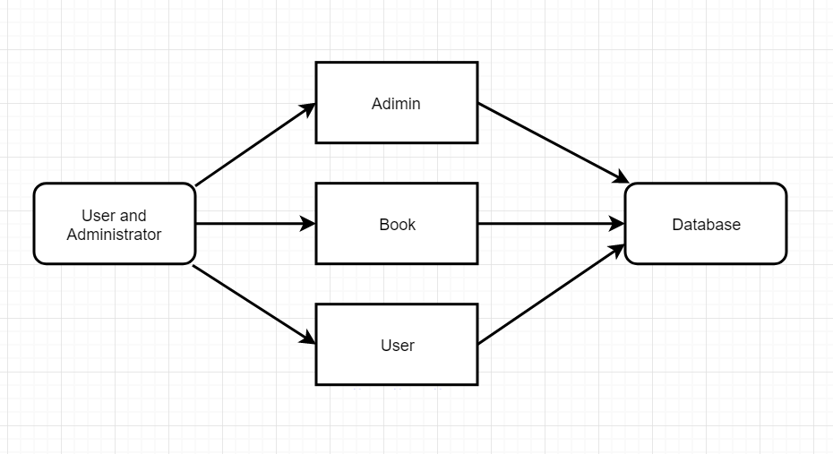

Data Flow Diagram:

DFD of Login module

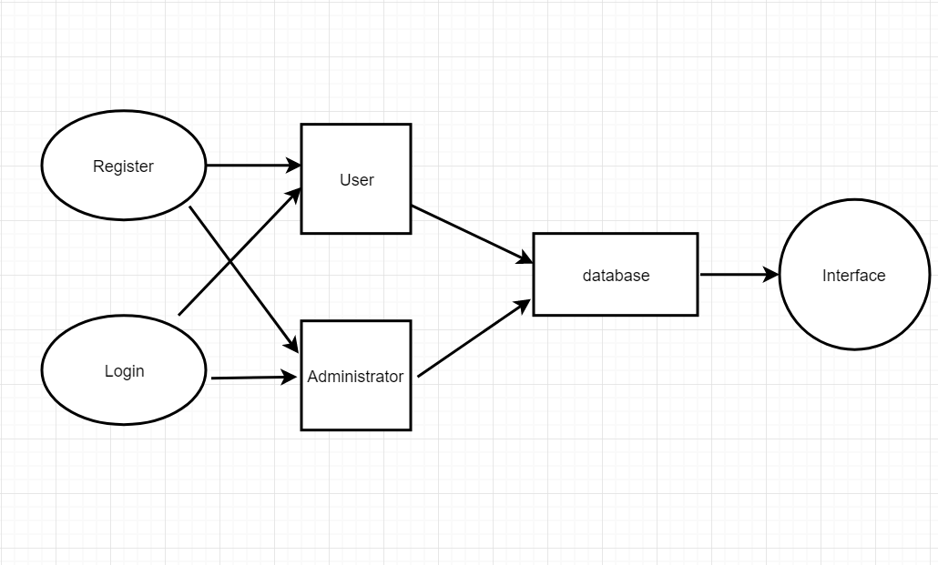

Testing
Before the implementation, functioning of the whole projects need to be tested for insuring proper navigation and valid data entry into the forms and corresponding actions accordingly. This is only after a throughout testing process, when the project is ready to be implemented and to be used by the client in the real environment.
After designing and developing, the application is tested for all logical paths and proper working of all operations. The project is also tested for all navigation links provided in all user interfaces. Finally, the project is tested whether all the requirements listed during requirement analysis are being fulfilled or not.
The steps of testing is illustrated in Figure

Over testing | Function Testing | Connectation Testing

Over testing
At this stage, we modify all error reporting frames and rule out all warnings
在这一阶段，我们修改所有的报错窗体，排除所有的警告
Function Testing
At this stage, we debug all the buttons to make sure that clicking on them produces the same effect as we expected.
在这个阶段，我们调试所有的按钮的功能，确保点击它们产生的效果与我们预期的一样。

Connection Testing
In the final phase, we check the connections between all windows; the links between the database and the form to make sure that our data flows according to our plan.
在最后阶段，我们检查所有窗口之间的连接；数据库与窗体之间的链接，确保我们的数据都是按照我们规划的流动的。
COST ESTIMATION估价
The book management system we designed is a free system, and if we can update our system in the future, we will consider charging part of the fee.
我们设计的图书管理系统是一个免费的系统，如果将来我们能更新我们的系统，我们将会考虑收取部分费用。

Given Table shows starting and ending date of each work task and total working days. Table also shows concurrency between two or more work tasks. Code generation, Report Working, and Integration & Testing work tasks have been completed in concurrent manner.

Work Done By | Work task | Starting Date | Ending Date | Duration(day)
Sihon+Vera | Code generation | 6May | 16May | 10
Vera+Vicky | Interface Design | 6May | 16May | 10
Sihon | Integration | 6May | 16May | 10
Vicky +York | Report Writing | 16May | 22May | 6
Sihon+Vera+Vicky+York | Testing | 12May | 16May | 4
 |  |  |  | Total Day = 16
This system has been developed in 16 days. I work on this project 5 hours a day averagely.
The total hours = 16*6 = 96

Login module

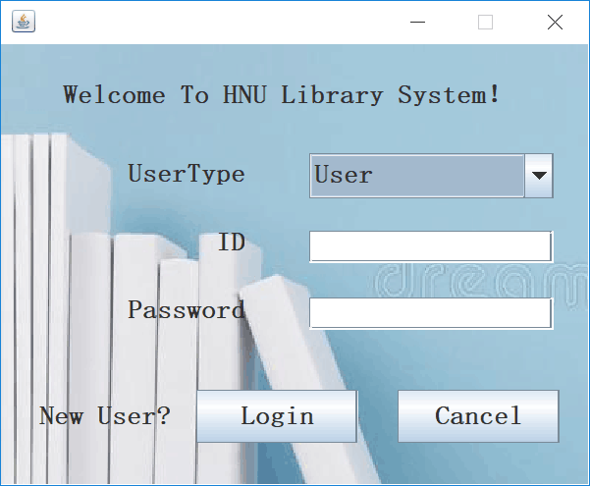

User module

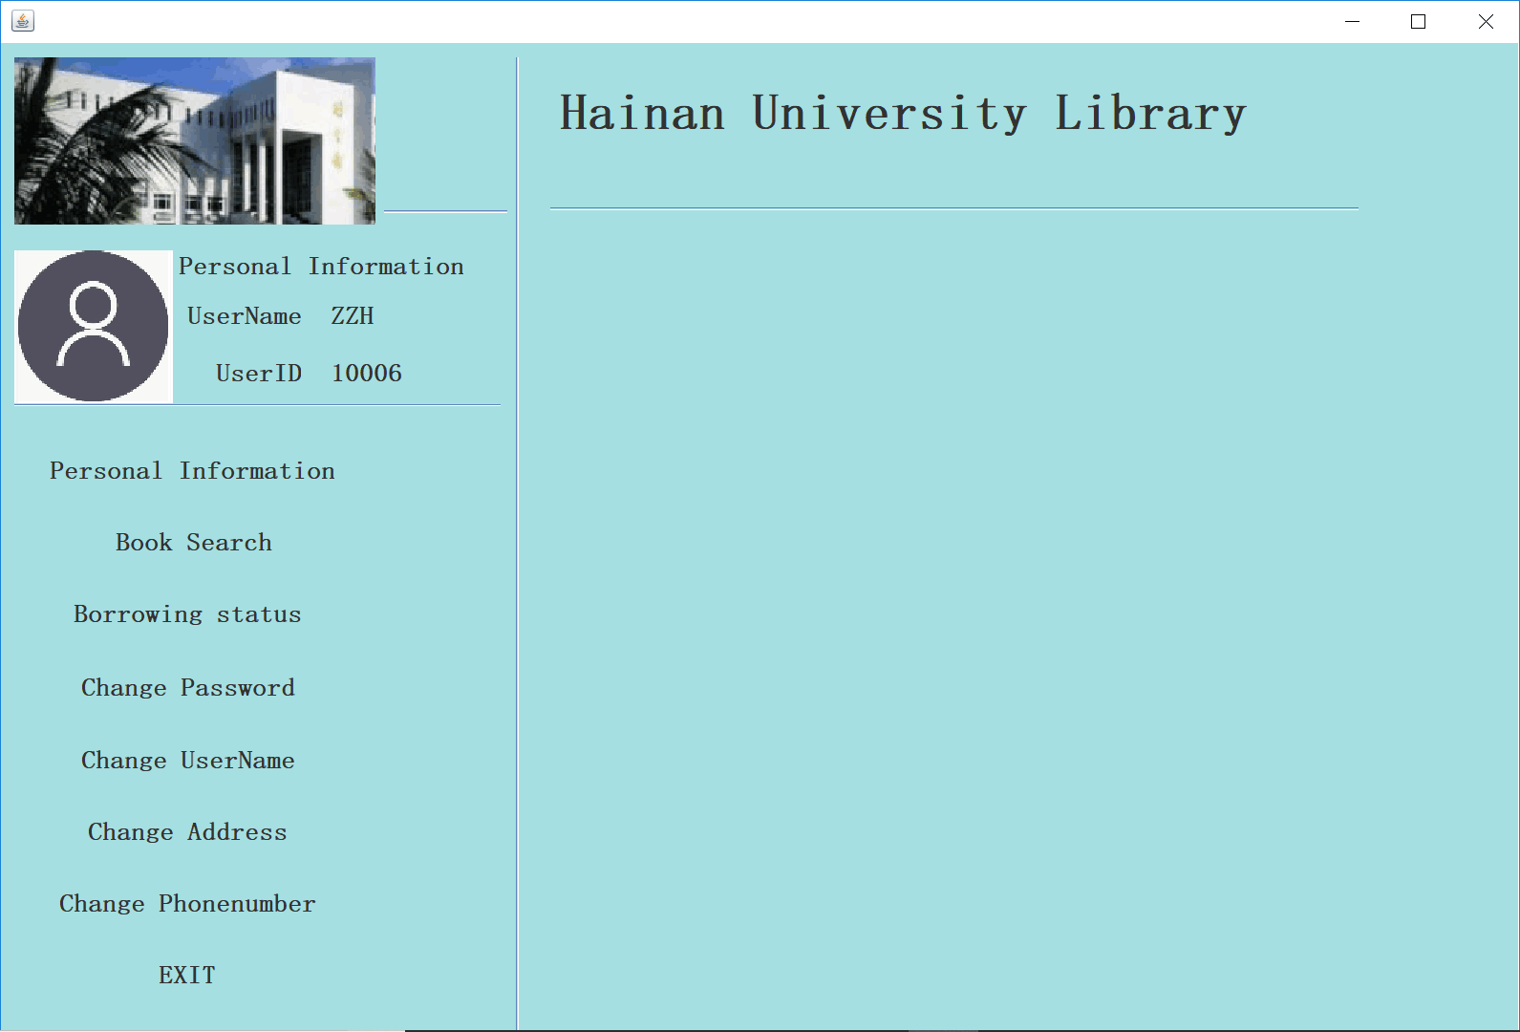

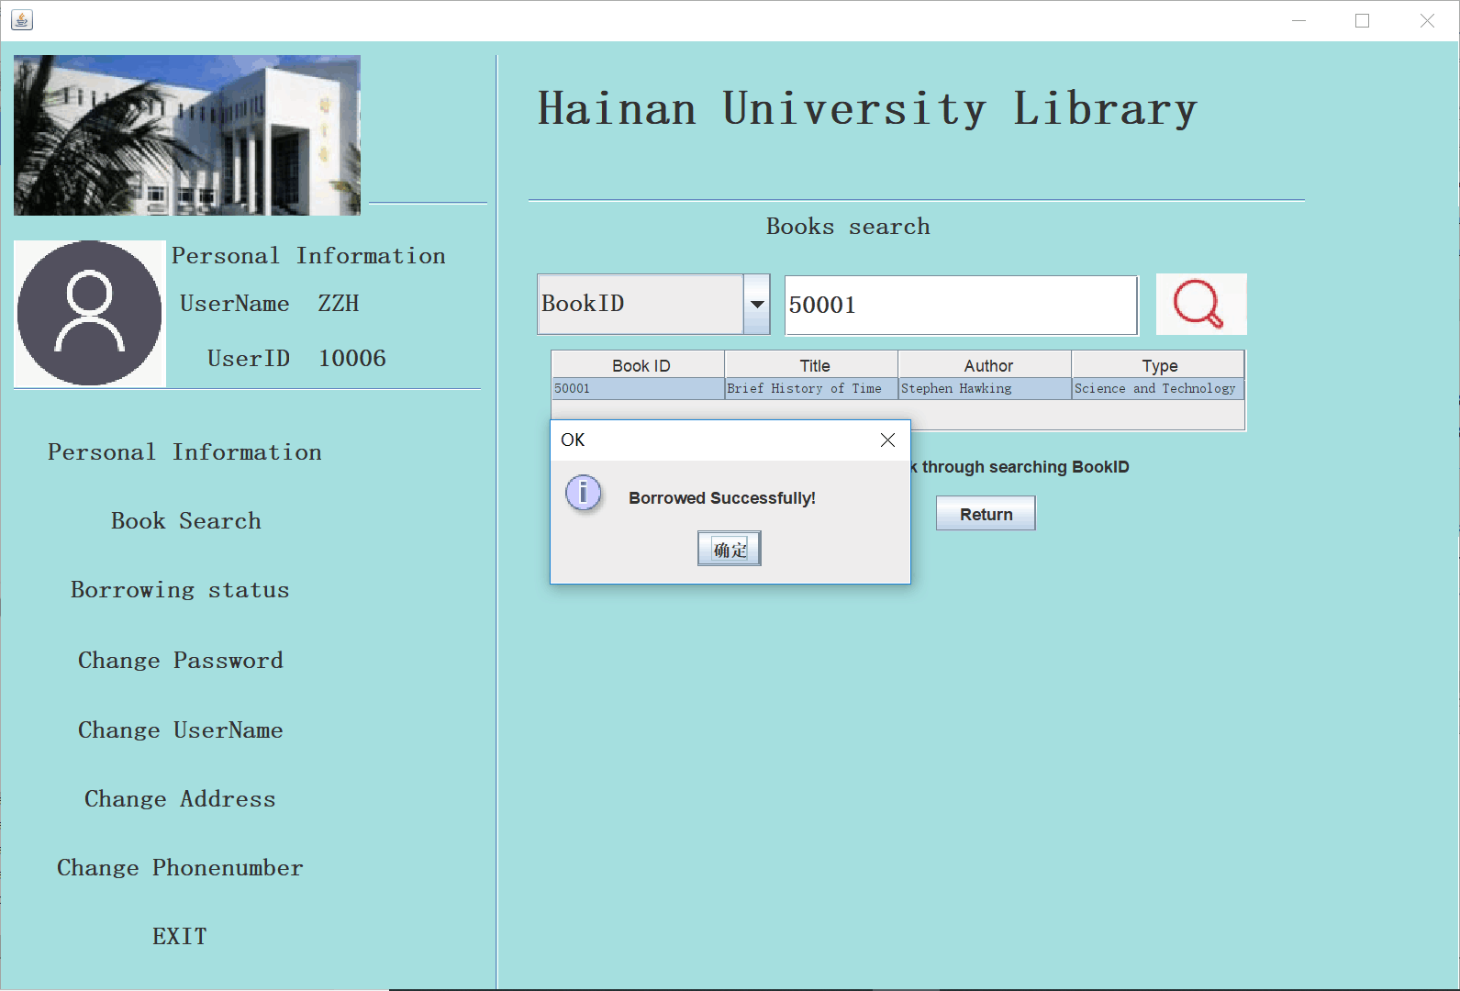

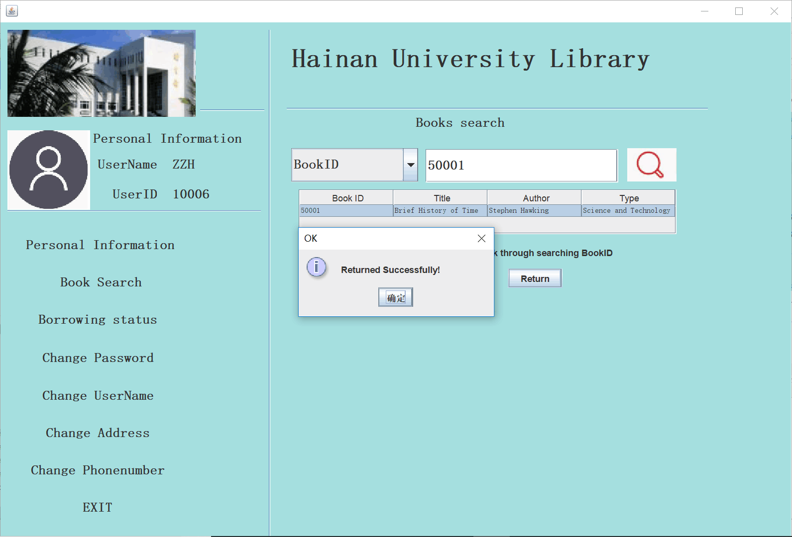

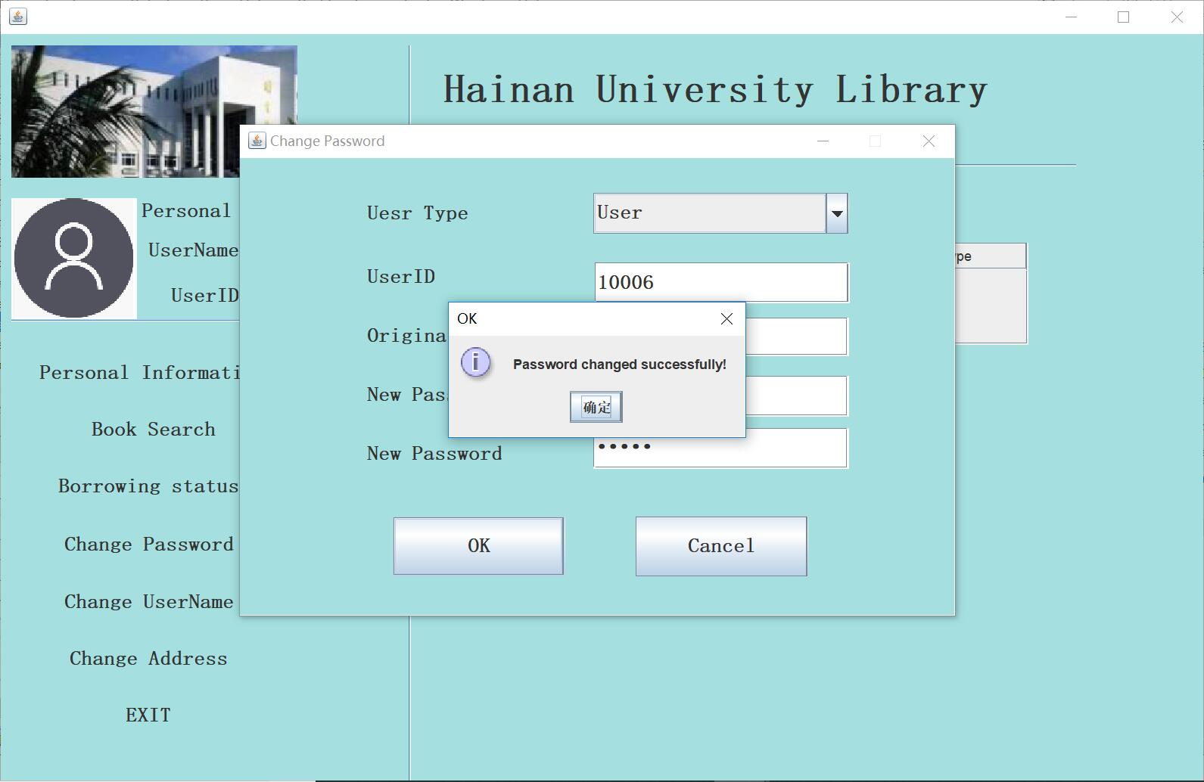

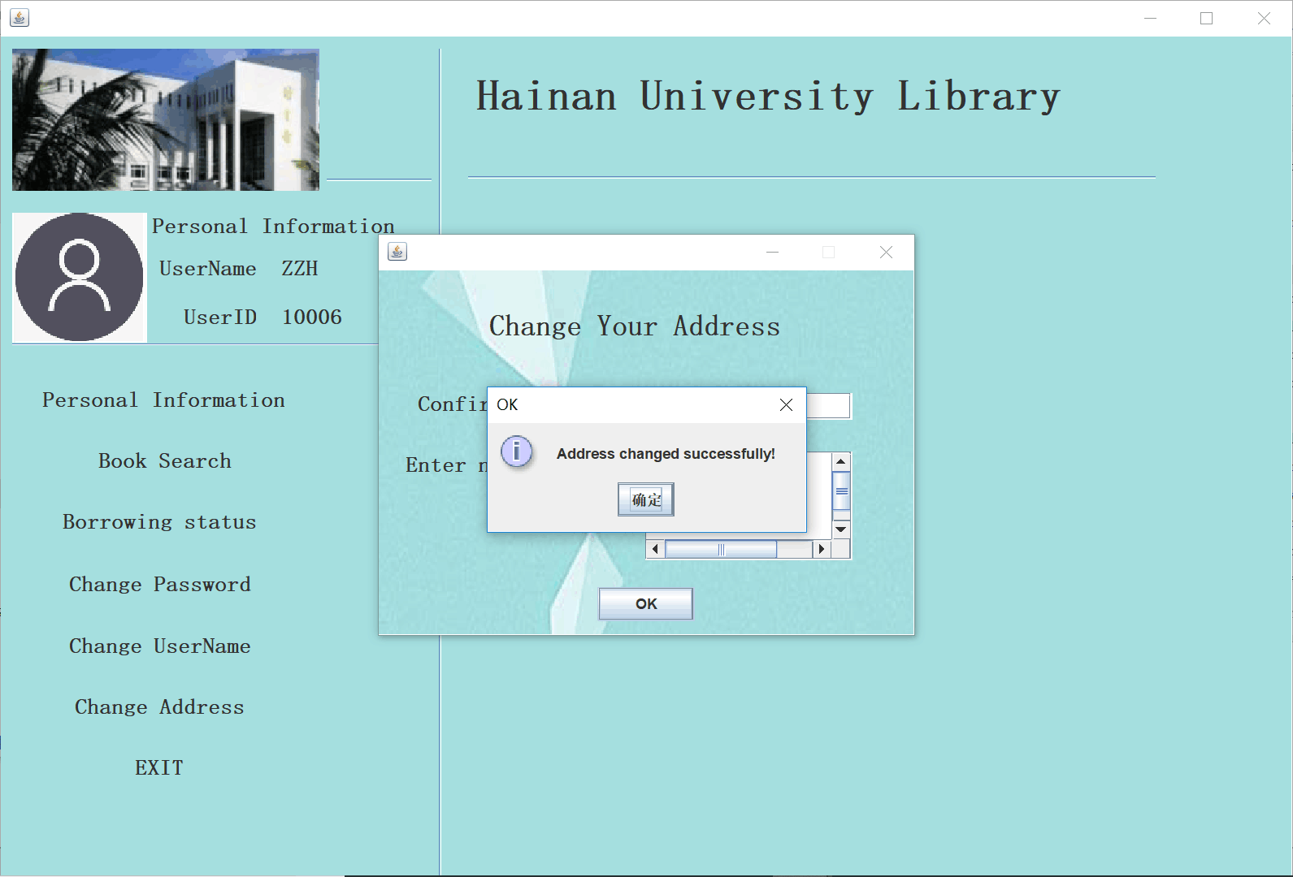

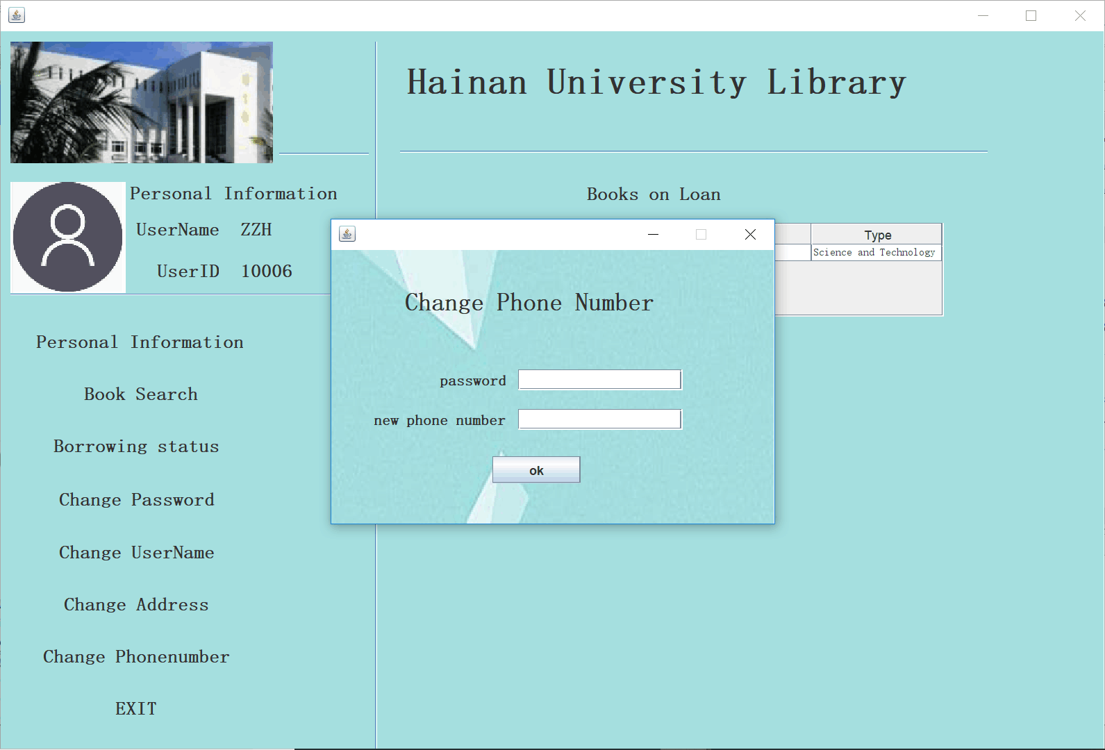

Administrator module

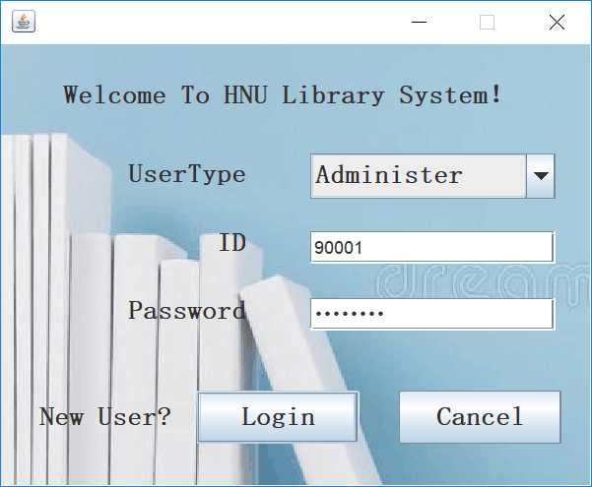

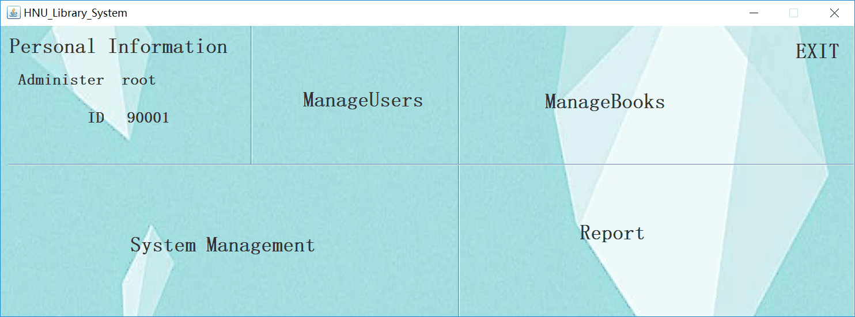

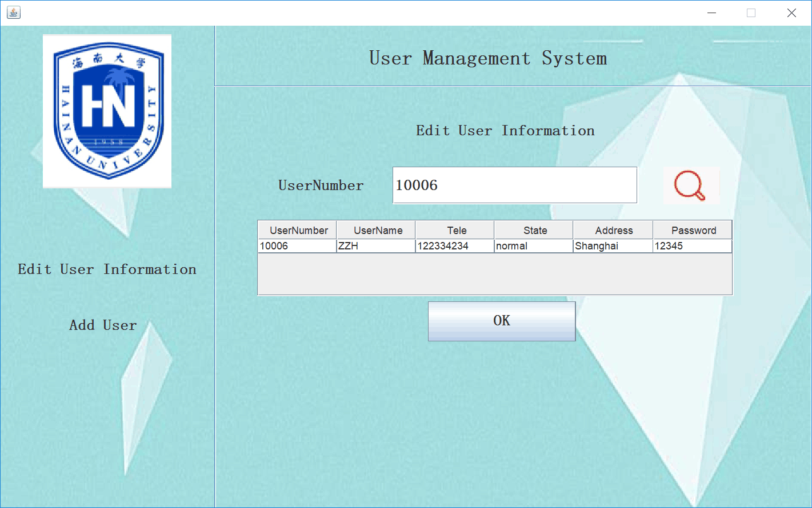

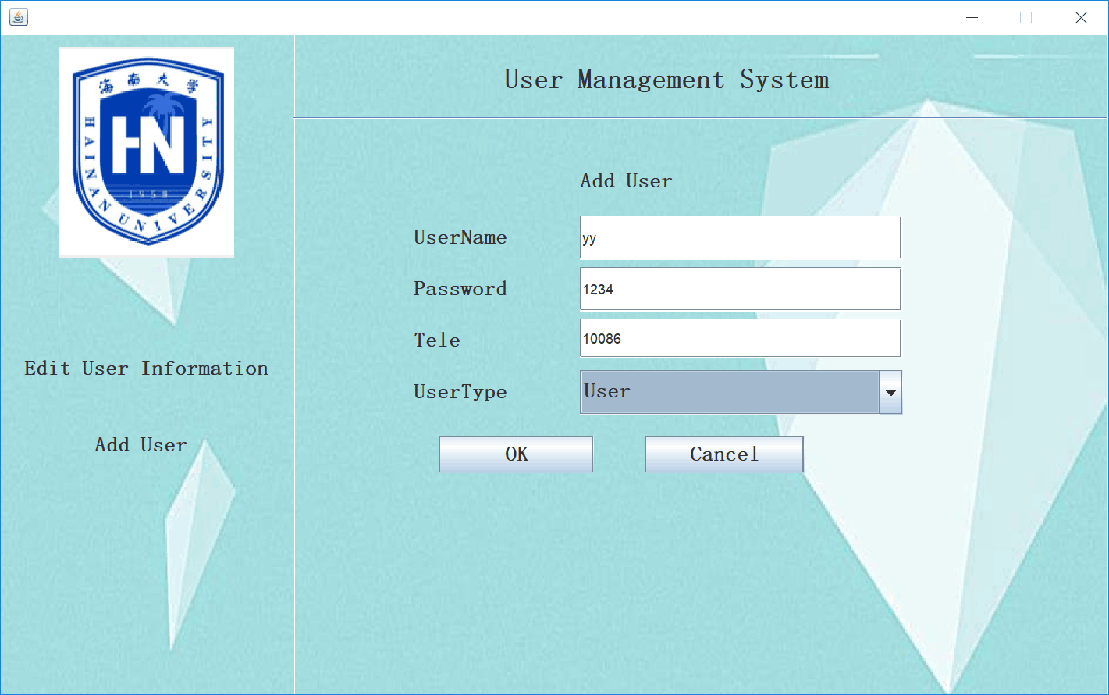

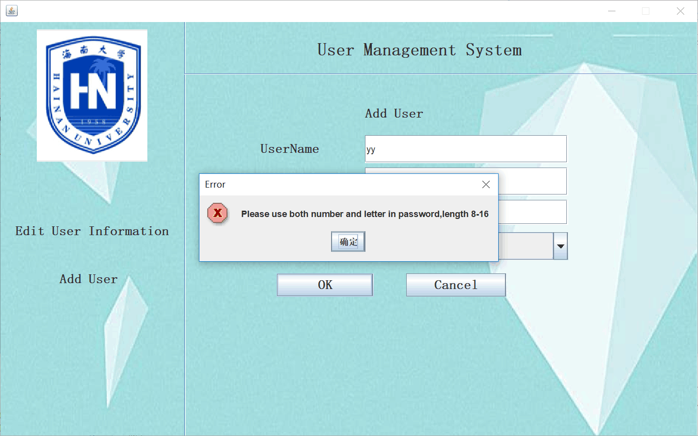

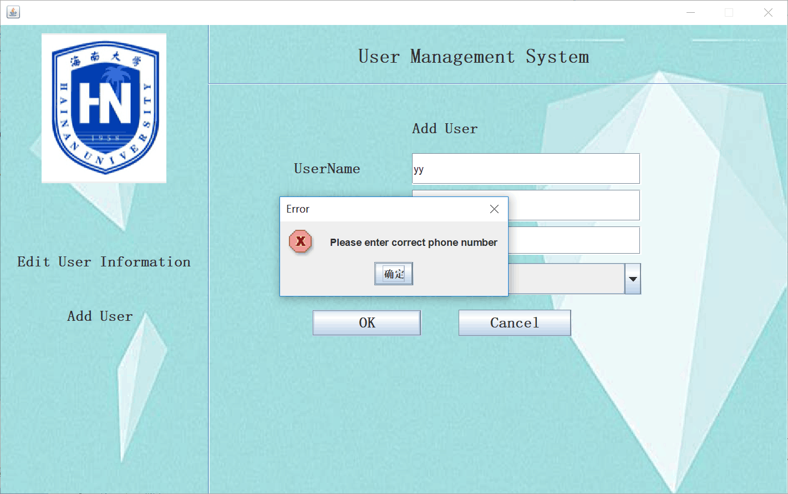

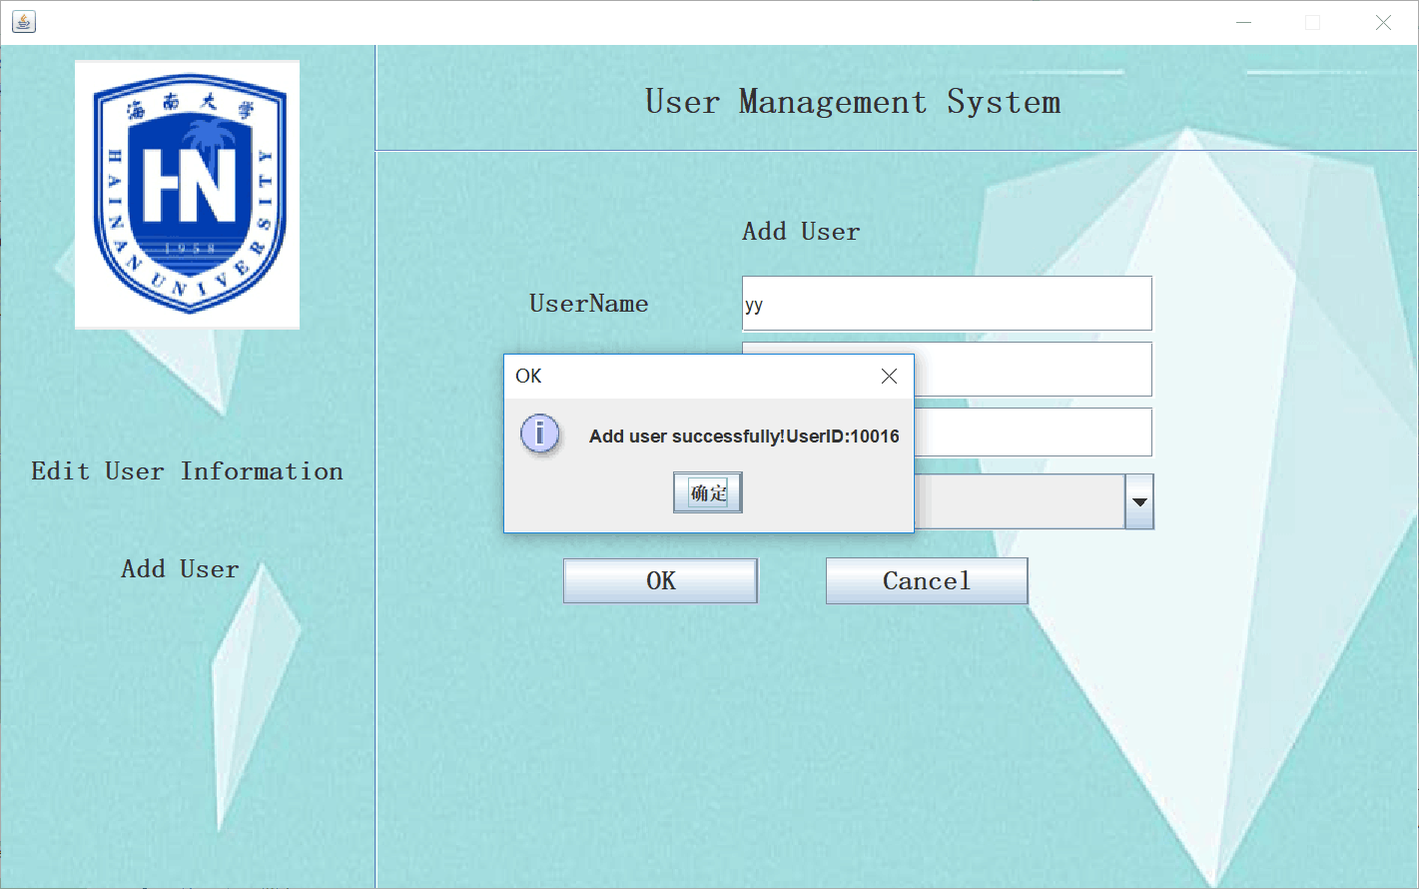
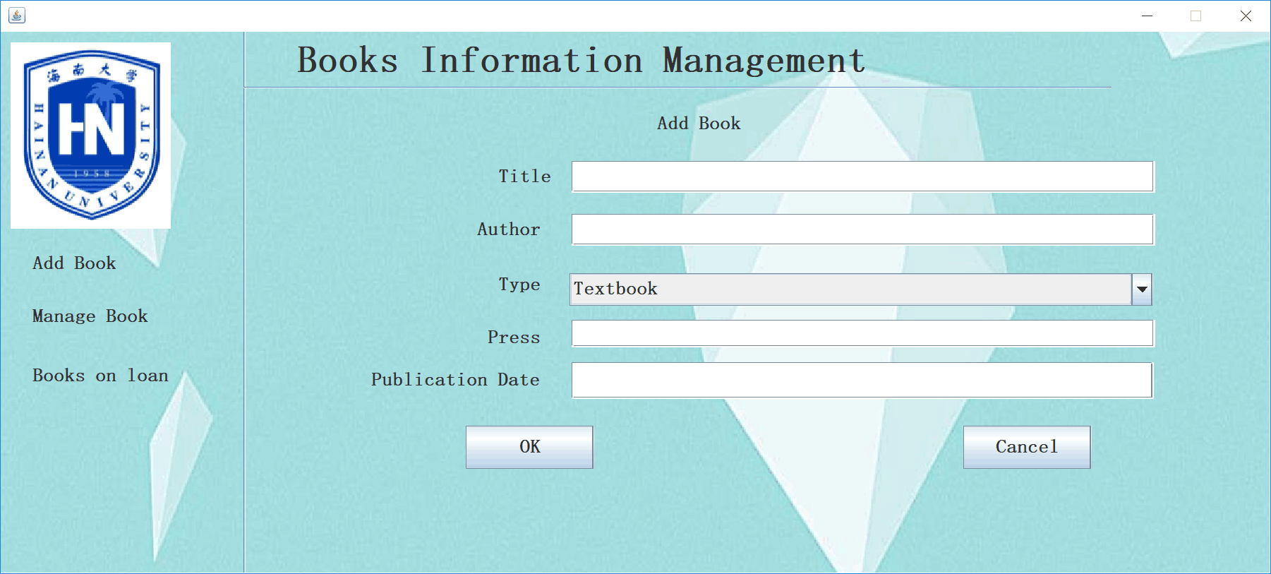

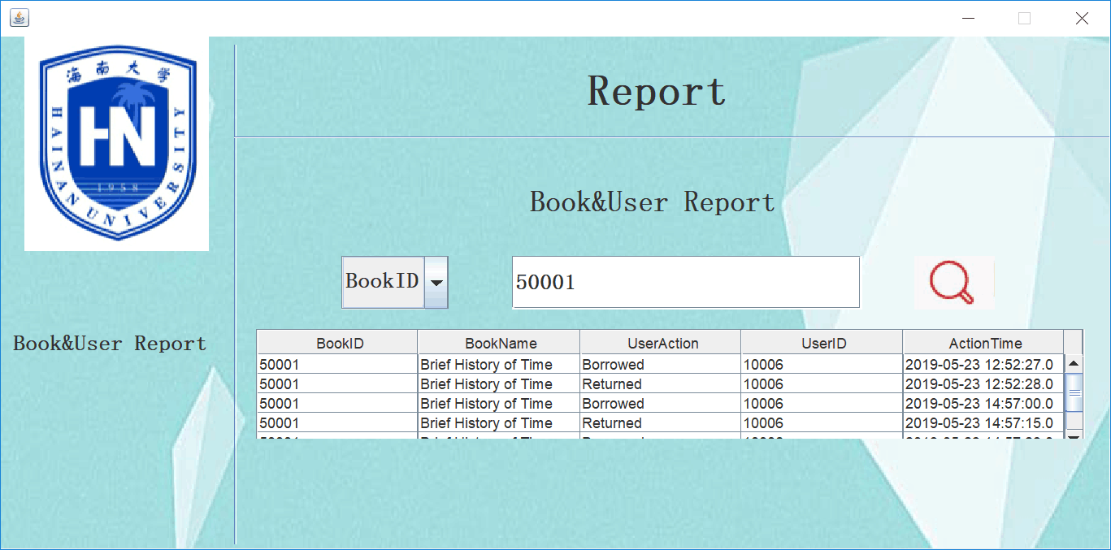

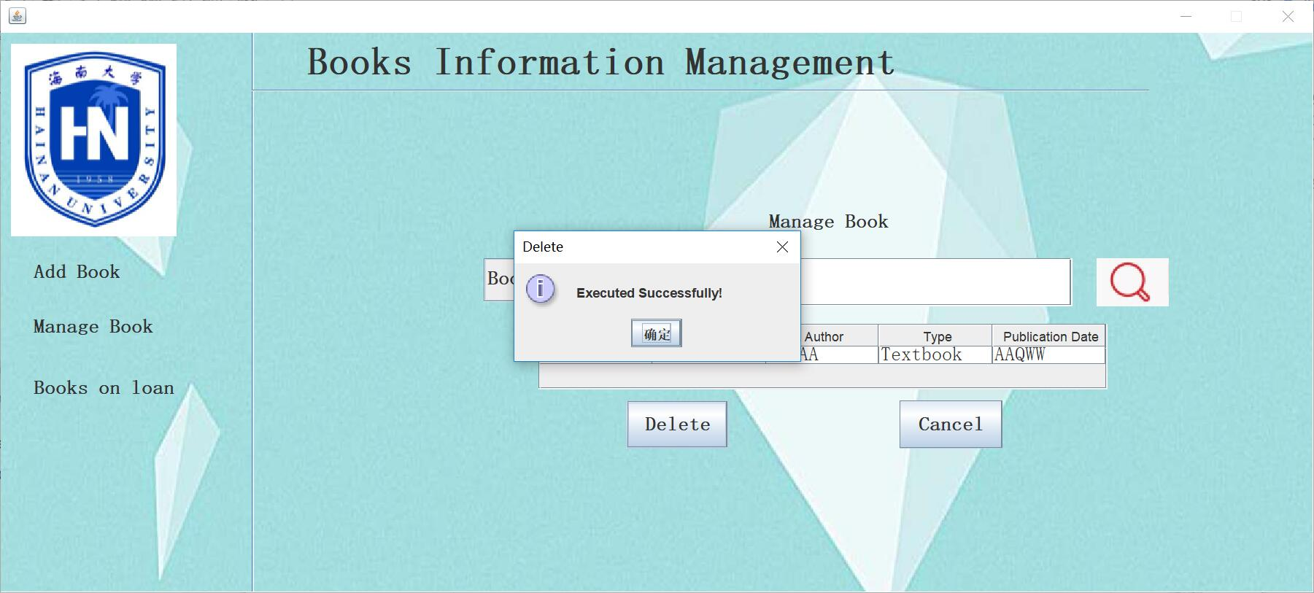

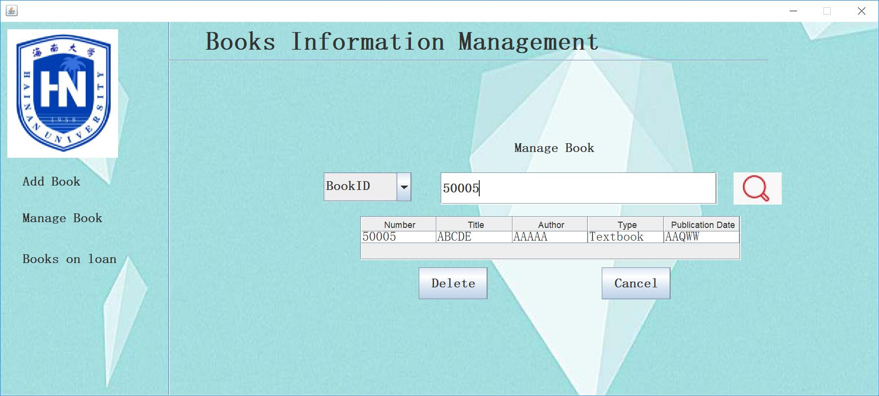

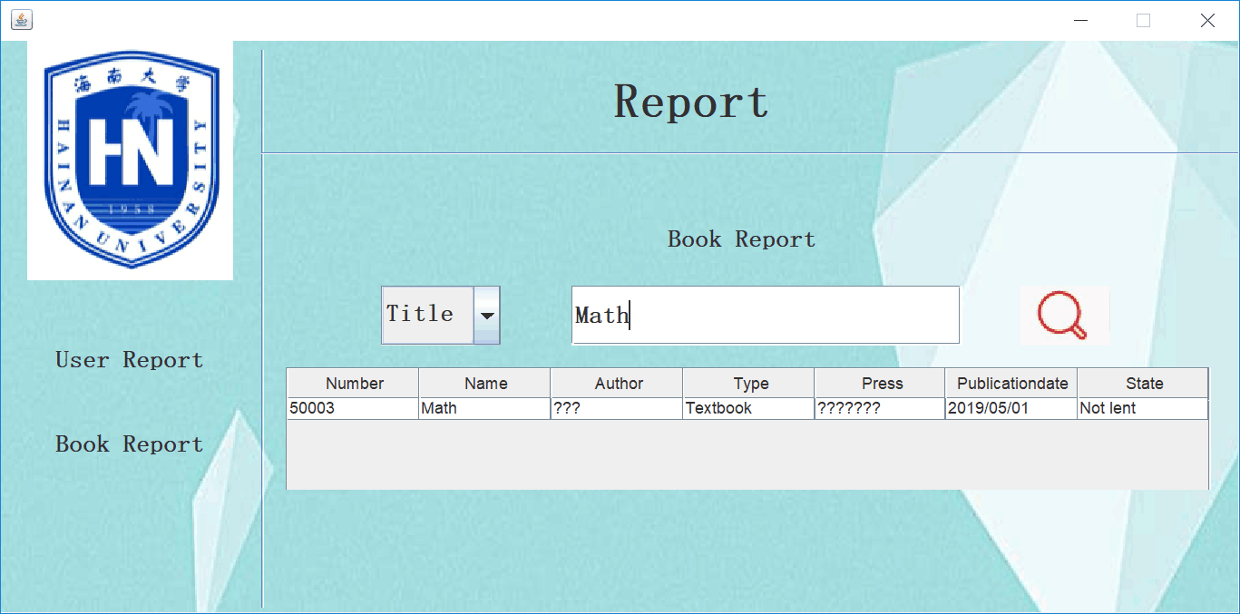

System Management

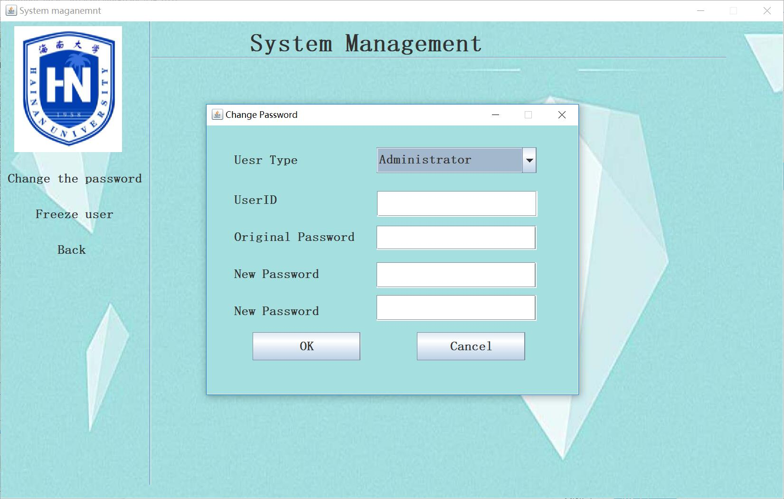

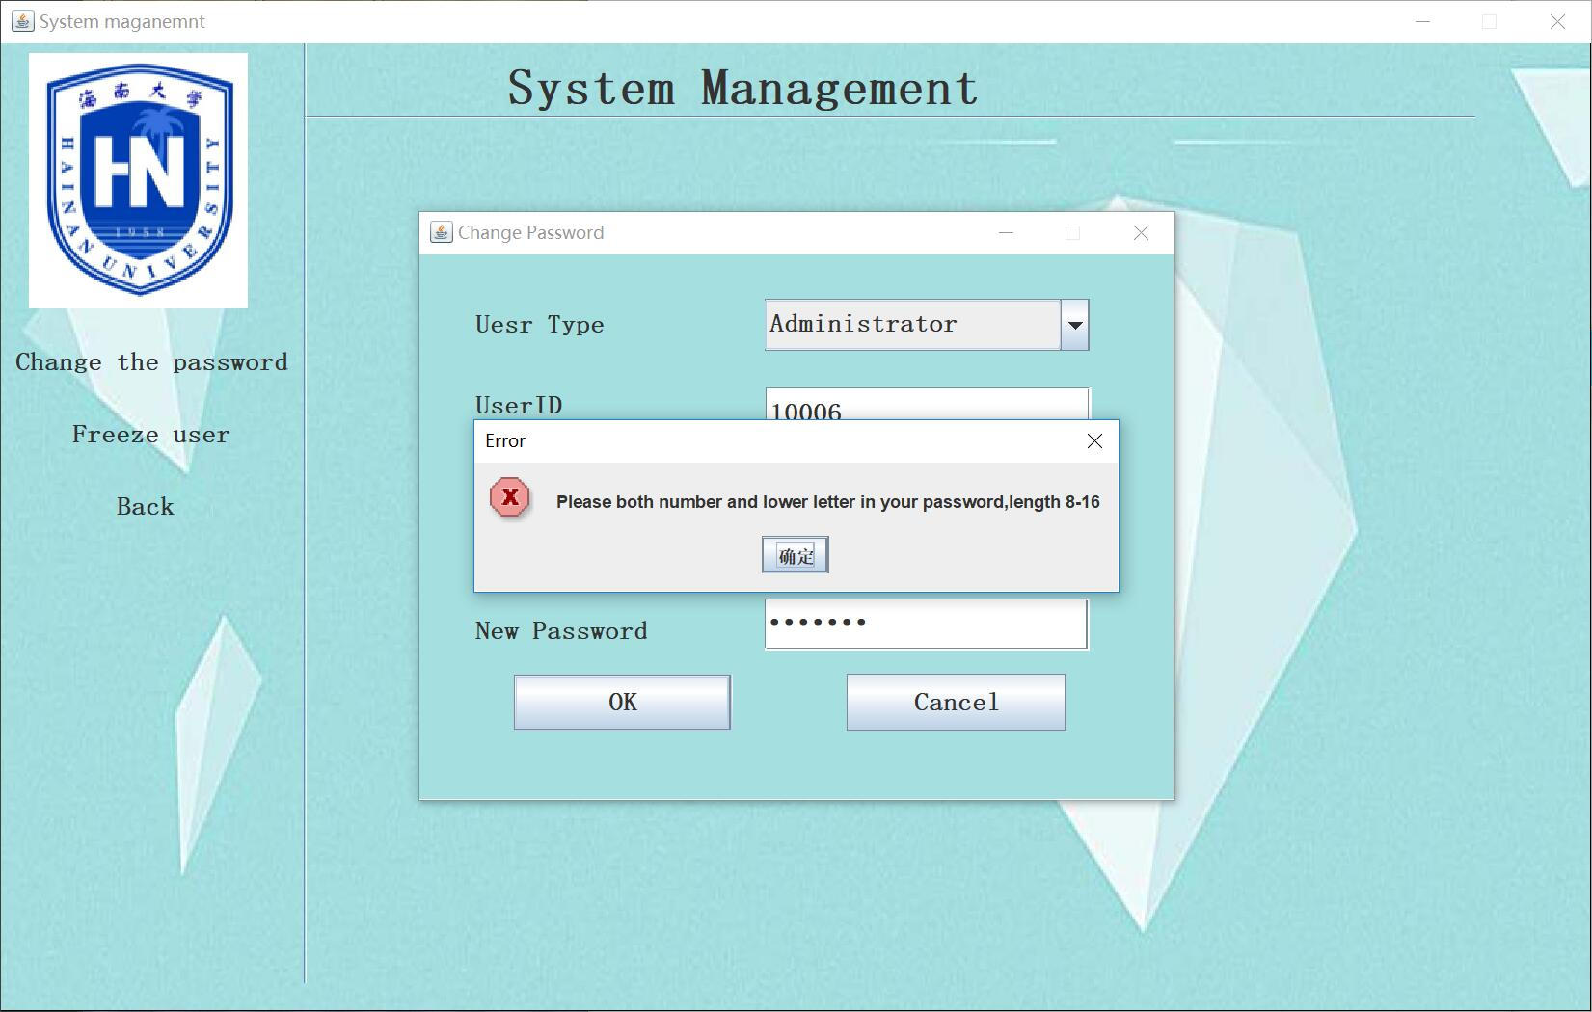

Registration module

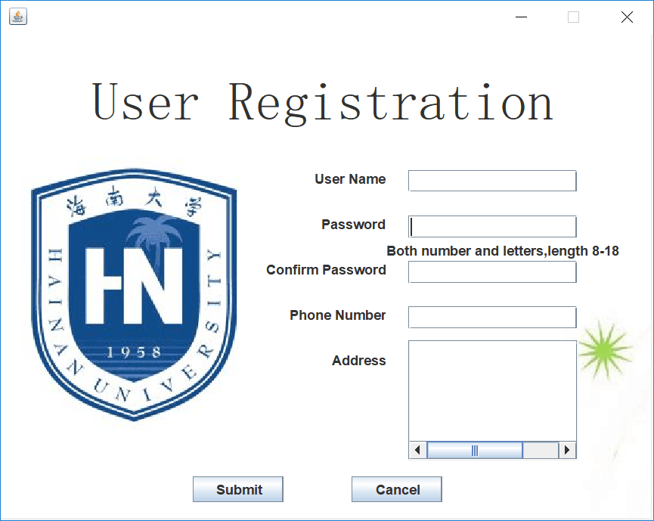

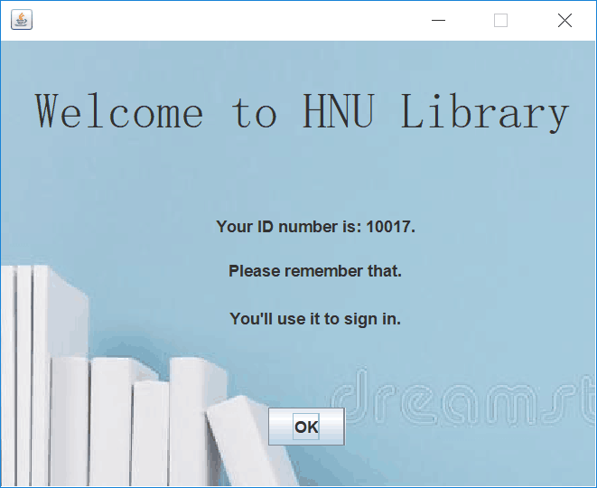
Code of Mysql

create database if not exists library;
use library;
create table if not exists admindata(
id int(5) not null primary key auto_increment,
name varchar(20) not null,
phonenumber varchar(15),
state varchar(10) default 'normal',
address varchar(50),
password varchar(18) not null
)charset utf8 engine myisam;
alter table admindata auto_increment=90001;
create table if not exists userdata(
id int(5) not null primary key auto_increment,
name varchar(20) not null,
phonenumber varchar(15),
state varchar(10) default 'normal',
address varchar(50),
password varchar(18) not null
)charset utf8 engine myisam;
alter table userdata auto_increment=10001;
create table if not exists bookdata(
id int(5) not null primary key auto_increment,
title varchar(30) not null,
author varchar(30) not null,
type varchar(50) not null,
publishing_house varchar(50) not null,
publicationdate varchar(15),
book_borrowing_state varchar(20) default 'Not lent',
borrower_id int(5),
BorrowDate date
)charset utf8 engine myisam;
alter table bookdata auto_increment=50001;
create table if not exists bookreport(
BookID int(5),
BookName varchar(30),
UserAction varchar(15),
UserID int(5),
ActionTime timestamp #primary key
)charset utf8 engine myisam;
insert into userdata(name,password,phonenumber,address) values
('user','niit1234','15234526352','Renmin Road 58th');
insert into admindata(name,password,phonenumber,address) values
('root','niit1234','13732134321','hbrd');
insert into bookdata(title,author,publishing_house,book_borrowing_state,borrower_id,type)
values ('Brief History of Time','Stephen Hawking','OnePublishingHouse',
'lent','10001','Science and Technology');

Code of AdminManageBooks_112.java
/*
* To change this template, choose Tools | Templates
* and open the template in the editor.
*/
package Librarymanagement;

import java.sql.*;
import java.util.logging.Level;
import java.util.logging.Logger;
import javax.swing.JOptionPane;
import javax.swing.table.DefaultTableModel;

/**
*
* @author 26625
*/
public class AdminManageBooks_112 extends javax.swing.JFrame {

/**
* Creates new form AdminManageBooks_112
*/
String [] a;
Statement stmt;
Connection con=DBClass.getConnection();//连接数据库
ResultSet rs;
DefaultTableModel tm;
PreparedStatement preparedStatement;
public AdminManageBooks_112() {
initComponents();
editbookpanel.setVisible(false);
addbookpanel.setVisible(false);
Books_on_loan.setVisible(false);
this.setDefaultCloseOperation(0x1);
}

/**
* This method is called from within the constructor to initialize the form.
* WARNING: Do NOT modify this code. The content of this method is always
* regenerated by the Form Editor.
*/
@SuppressWarnings("unchecked")
// <editor-fold defaultstate="collapsed" desc="Generated Code">
private void initComponents() {

jPanel1 = new javax.swing.JPanel();
editbook = new javax.swing.JLabel();
Books__on__loan = new javax.swing.JLabel();
addbook = new javax.swing.JLabel();
jLabel3 = new javax.swing.JLabel();
jLabel11 = new javax.swing.JLabel();
jSeparator1 = new javax.swing.JSeparator();
jSeparator2 = new javax.swing.JSeparator();
jPanel2 = new javax.swing.JPanel();
addbookpanel = new javax.swing.JPanel();
jLabel2 = new javax.swing.JLabel();
jLabel4 = new javax.swing.JLabel();
jLabel5 = new javax.swing.JLabel();
jLabel6 = new javax.swing.JLabel();
jLabel7 = new javax.swing.JLabel();
jLabel8 = new javax.swing.JLabel();
titletxt = new javax.swing.JTextField();
authortxt = new javax.swing.JTextField();
publicationdate = new javax.swing.JTextField();
numbertxt = new javax.swing.JTextField();
typebox = new javax.swing.JComboBox();
addok = new javax.swing.JButton();
addcancel = new javax.swing.JButton();
jLabel12 = new javax.swing.JLabel();
press = new javax.swing.JTextField();
Books_on_loan = new javax.swing.JPanel();
jLabel10 = new javax.swing.JLabel();
booktable1 = new javax.swing.JScrollPane();
booktable2 = new javax.swing.JTable();
cancel3 = new javax.swing.JButton();
editbookpanel = new javax.swing.JPanel();
jLabel9 = new javax.swing.JLabel();
searchbooktxt = new javax.swing.JTextField();
searchbutton = new javax.swing.JLabel();
booktable = new javax.swing.JScrollPane();
editbooktable = new javax.swing.JTable();
editcancel = new javax.swing.JButton();
jComboBox1 = new javax.swing.JComboBox();
jLabel1 = new javax.swing.JLabel();

setDefaultCloseOperation(javax.swing.WindowConstants.EXIT_ON_CLOSE);
setResizable(false);

jPanel1.setBackground(new java.awt.Color(204, 204, 204));
jPanel1.setLayout(null);

editbook.setBackground(new java.awt.Color(255, 255, 255));
editbook.setFont(new java.awt.Font("宋体", 1, 18)); // NOI18N
editbook.setText("Search Book");
editbook.addMouseListener(new java.awt.event.MouseAdapter() {
public void mouseClicked(java.awt.event.MouseEvent evt) {
editbookMouseClicked(evt);
}
});
jPanel1.add(editbook);
editbook.setBounds(30, 250, 110, 38);

Books__on__loan.setBackground(new java.awt.Color(255, 255, 255));
Books__on__loan.setFont(new java.awt.Font("宋体", 1, 18)); // NOI18N
Books__on__loan.setText("Books on loan");
Books__on__loan.addMouseListener(new java.awt.event.MouseAdapter() {
public void mouseClicked(java.awt.event.MouseEvent evt) {
Books__on__loanMouseClicked(evt);
}
});
jPanel1.add(Books__on__loan);
Books__on__loan.setBounds(30, 300, 160, 50);

addbook.setBackground(new java.awt.Color(255, 255, 255));
addbook.setFont(new java.awt.Font("宋体", 1, 18)); // NOI18N
addbook.setText("Add Book");
addbook.addMouseListener(new java.awt.event.MouseAdapter() {
public void mouseClicked(java.awt.event.MouseEvent evt) {
addbookMouseClicked(evt);
}
});
jPanel1.add(addbook);
addbook.setBounds(30, 200, 79, 38);

jLabel3.setFont(new java.awt.Font("宋体", 1, 36)); // NOI18N
jLabel3.setText("Books Information Management");
jPanel1.add(jLabel3);
jLabel3.setBounds(280, 0, 610, 56);

jLabel11.setIcon(new javax.swing.ImageIcon(getClass().getResource("/Picture/HUNI.png"))); // NOI18N
jPanel1.add(jLabel11);
jLabel11.setBounds(10, 10, 151, 176);
jPanel1.add(jSeparator1);
jSeparator1.setBounds(230, 52, 820, 10);

jSeparator2.setOrientation(javax.swing.SwingConstants.VERTICAL);
jPanel1.add(jSeparator2);
jSeparator2.setBounds(230, 0, 30, 580);

jPanel2.setOpaque(false);

addbookpanel.setBackground(new java.awt.Color(255, 255, 255));
addbookpanel.setOpaque(false);
addbookpanel.setLayout(new org.netbeans.lib.awtextra.AbsoluteLayout());

jLabel2.setFont(new java.awt.Font("宋体", 1, 18)); // NOI18N
jLabel2.setText("Add Book");
addbookpanel.add(jLabel2, new org.netbeans.lib.awtextra.AbsoluteConstraints(310, 0, 100, 30));

jLabel4.setFont(new java.awt.Font("宋体", 1, 18)); // NOI18N
jLabel4.setText("Title");
addbookpanel.add(jLabel4, new org.netbeans.lib.awtextra.AbsoluteConstraints(51, 40, 100, 30));

jLabel5.setFont(new java.awt.Font("宋体", 1, 18)); // NOI18N
jLabel5.setText("Number");
addbookpanel.add(jLabel5, new org.netbeans.lib.awtextra.AbsoluteConstraints(51, 111, -1, 35));

jLabel6.setFont(new java.awt.Font("宋体", 1, 18)); // NOI18N
jLabel6.setText("Author");
addbookpanel.add(jLabel6, new org.netbeans.lib.awtextra.AbsoluteConstraints(51, 74, 100, 30));

jLabel7.setFont(new java.awt.Font("宋体", 1, 18)); // NOI18N
jLabel7.setText("Publication Date");
addbookpanel.add(jLabel7, new org.netbeans.lib.awtextra.AbsoluteConstraints(50, 240, -1, 35));

jLabel8.setFont(new java.awt.Font("宋体", 1, 18)); // NOI18N
jLabel8.setText("Type");
addbookpanel.add(jLabel8, new org.netbeans.lib.awtextra.AbsoluteConstraints(51, 152, -1, 35));

titletxt.setFont(new java.awt.Font("宋体", 1, 18)); // NOI18N
addbookpanel.add(titletxt, new org.netbeans.lib.awtextra.AbsoluteConstraints(228, 41, 551, 30));

authortxt.setFont(new java.awt.Font("宋体", 1, 18)); // NOI18N
addbookpanel.add(authortxt, new org.netbeans.lib.awtextra.AbsoluteConstraints(228, 75, 551, 30));

publicationdate.setFont(new java.awt.Font("宋体", 1, 18)); // NOI18N
addbookpanel.add(publicationdate, new org.netbeans.lib.awtextra.AbsoluteConstraints(230, 240, 550, 35));

numbertxt.setFont(new java.awt.Font("宋体", 1, 18)); // NOI18N
addbookpanel.add(numbertxt, new org.netbeans.lib.awtextra.AbsoluteConstraints(228, 115, 551, -1));

typebox.setFont(new java.awt.Font("宋体", 1, 18)); // NOI18N
typebox.setModel(new javax.swing.DefaultComboBoxModel(new String[] { "Textbook", "Science and Technology", "Literature books", "Military science books", "Agriculturte science books" }));
addbookpanel.add(typebox, new org.netbeans.lib.awtextra.AbsoluteConstraints(228, 156, 551, -1));

addok.setFont(new java.awt.Font("宋体", 1, 18)); // NOI18N
addok.setText("OK");
addok.addMouseListener(new java.awt.event.MouseAdapter() {
public void mouseClicked(java.awt.event.MouseEvent evt) {
addokMouseClicked(evt);
}
});
addbookpanel.add(addok, new org.netbeans.lib.awtextra.AbsoluteConstraints(130, 300, 121, 41));

addcancel.setFont(new java.awt.Font("宋体", 1, 18)); // NOI18N
addcancel.setText("Cancel");
addcancel.addActionListener(new java.awt.event.ActionListener() {
public void actionPerformed(java.awt.event.ActionEvent evt) {
addcancelActionPerformed(evt);
}
});
addbookpanel.add(addcancel, new org.netbeans.lib.awtextra.AbsoluteConstraints(600, 300, 121, 41));

jLabel12.setFont(new java.awt.Font("宋体", 1, 18)); // NOI18N
jLabel12.setText("Press");
addbookpanel.add(jLabel12, new org.netbeans.lib.awtextra.AbsoluteConstraints(50, 200, -1, 35));

press.setFont(new java.awt.Font("宋体", 1, 18)); // NOI18N
addbookpanel.add(press, new org.netbeans.lib.awtextra.AbsoluteConstraints(230, 200, 551, -1));

Books_on_loan.setBackground(new java.awt.Color(255, 255, 255));
Books_on_loan.setOpaque(false);
Books_on_loan.setLayout(new org.netbeans.lib.awtextra.AbsoluteLayout());

jLabel10.setFont(new java.awt.Font("宋体", 1, 18)); // NOI18N
jLabel10.setText("Books on loan");
Books_on_loan.add(jLabel10, new org.netbeans.lib.awtextra.AbsoluteConstraints(350, 0, 150, 46));

booktable2.setFont(new java.awt.Font("宋体", 0, 18)); // NOI18N
booktable2.setModel(new javax.swing.table.DefaultTableModel(
new Object [][] {
{null, null, null, null, null, null, null, null},
{null, null, null, null, null, null, null, null},
{null, null, null, null, null, null, null, null},
{null, null, null, null, null, null, null, null},
{null, null, null, null, null, null, null, null},
{null, null, null, null, null, null, null, null},
{null, null, null, null, null, null, null, null},
{null, null, null, null, null, null, null, null},
{null, null, null, null, null, null, null, null},
{null, null, null, null, null, null, null, null},
{null, null, null, null, null, null, null, null},
{null, null, null, null, null, null, null, null},
{null, null, null, null, null, null, null, null},
{null, null, null, null, null, null, null, null},
{null, null, null, null, null, null, null, null},
{null, null, null, null, null, null, null, null},
{null, null, null, null, null, null, null, null},
{null, null, null, null, null, null, null, null},
{null, null, null, null, null, null, null, null},
{null, null, null, null, null, null, null, null}
},
new String [] {
"Number", "Title", "Author", "Type", "publicationdate", "Press", "Borrowing_state", "Borrower_Number"
}
));
booktable1.setViewportView(booktable2);

Books_on_loan.add(booktable1, new org.netbeans.lib.awtextra.AbsoluteConstraints(0, 40, 900, 290));

cancel3.setFont(new java.awt.Font("宋体", 1, 18)); // NOI18N
cancel3.setText("Return");
cancel3.addMouseListener(new java.awt.event.MouseAdapter() {
public void mouseClicked(java.awt.event.MouseEvent evt) {
cancel3MouseClicked(evt);
}
});
Books_on_loan.add(cancel3, new org.netbeans.lib.awtextra.AbsoluteConstraints(350, 340, -1, 46));

editbookpanel.setBackground(new java.awt.Color(255, 255, 255));
editbookpanel.setForeground(new java.awt.Color(255, 255, 255));
editbookpanel.setOpaque(false);
editbookpanel.setLayout(new org.netbeans.lib.awtextra.AbsoluteLayout());

jLabel9.setFont(new java.awt.Font("宋体", 1, 18)); // NOI18N
jLabel9.setText("Search Book");
editbookpanel.add(jLabel9, new org.netbeans.lib.awtextra.AbsoluteConstraints(319, 10, 140, 34));

searchbooktxt.setFont(new java.awt.Font("宋体", 1, 18)); // NOI18N
editbookpanel.add(searchbooktxt, new org.netbeans.lib.awtextra.AbsoluteConstraints(230, 60, 378, 44));

searchbutton.setIcon(new javax.swing.ImageIcon(getClass().getResource("/Picture/search2.png"))); // NOI18N
searchbutton.addMouseListener(new java.awt.event.MouseAdapter() {
public void mouseClicked(java.awt.event.MouseEvent evt) {
searchbuttonMouseClicked(evt);
}
});
editbookpanel.add(searchbutton, new org.netbeans.lib.awtextra.AbsoluteConstraints(630, 60, -1, -1));

editbooktable.setFont(new java.awt.Font("宋体", 0, 18)); // NOI18N
editbooktable.setModel(new javax.swing.table.DefaultTableModel(
new Object [][] {
{null, null, null, null, null}
},
new String [] {
"Number", "Title", "Author", "Type", "Publication Date"
}
));
booktable.setViewportView(editbooktable);

editbookpanel.add(booktable, new org.netbeans.lib.awtextra.AbsoluteConstraints(150, 120, 520, 60));

editcancel.setFont(new java.awt.Font("宋体", 1, 18)); // NOI18N
editcancel.setText("Cancel");
editcancel.addActionListener(new java.awt.event.ActionListener() {
public void actionPerformed(java.awt.event.ActionEvent evt) {
editcancelActionPerformed(evt);
}
});
editbookpanel.add(editcancel, new org.netbeans.lib.awtextra.AbsoluteConstraints(350, 220, -1, 44));

jComboBox1.setFont(new java.awt.Font("宋体", 1, 18)); // NOI18N
jComboBox1.setModel(new javax.swing.DefaultComboBoxModel(new String[] { "Titie", "BookID", "Author", " " }));
editbookpanel.add(jComboBox1, new org.netbeans.lib.awtextra.AbsoluteConstraints(70, 60, 120, 40));

javax.swing.GroupLayout jPanel2Layout = new javax.swing.GroupLayout(jPanel2);
jPanel2.setLayout(jPanel2Layout);
jPanel2Layout.setHorizontalGroup(
jPanel2Layout.createParallelGroup(javax.swing.GroupLayout.Alignment.LEADING)
.addGroup(jPanel2Layout.createSequentialGroup()
.addGap(70, 70, 70)
.addComponent(addbookpanel, javax.swing.GroupLayout.PREFERRED_SIZE, javax.swing.GroupLayout.DEFAULT_SIZE, javax.swing.GroupLayout.PREFERRED_SIZE)
.addContainerGap(109, Short.MAX_VALUE))
.addGroup(jPanel2Layout.createParallelGroup(javax.swing.GroupLayout.Alignment.LEADING)
.addGroup(jPanel2Layout.createSequentialGroup()
.addComponent(Books_on_loan, javax.swing.GroupLayout.PREFERRED_SIZE, 910, javax.swing.GroupLayout.PREFERRED_SIZE)
.addGap(0, 50, Short.MAX_VALUE)))
.addGroup(jPanel2Layout.createParallelGroup(javax.swing.GroupLayout.Alignment.LEADING)
.addGroup(jPanel2Layout.createSequentialGroup()
.addGap(0, 0, Short.MAX_VALUE)
.addComponent(editbookpanel, javax.swing.GroupLayout.PREFERRED_SIZE, javax.swing.GroupLayout.DEFAULT_SIZE, javax.swing.GroupLayout.PREFERRED_SIZE)
.addGap(0, 0, Short.MAX_VALUE)))
);
jPanel2Layout.setVerticalGroup(
jPanel2Layout.createParallelGroup(javax.swing.GroupLayout.Alignment.LEADING)
.addGroup(jPanel2Layout.createSequentialGroup()
.addContainerGap()
.addComponent(addbookpanel, javax.swing.GroupLayout.PREFERRED_SIZE, javax.swing.GroupLayout.DEFAULT_SIZE, javax.swing.GroupLayout.PREFERRED_SIZE)
.addContainerGap(55, Short.MAX_VALUE))
.addGroup(jPanel2Layout.createParallelGroup(javax.swing.GroupLayout.Alignment.LEADING)
.addGroup(jPanel2Layout.createSequentialGroup()
.addComponent(Books_on_loan, javax.swing.GroupLayout.PREFERRED_SIZE, 396, javax.swing.GroupLayout.PREFERRED_SIZE)
.addGap(0, 10, Short.MAX_VALUE)))
.addGroup(jPanel2Layout.createParallelGroup(javax.swing.GroupLayout.Alignment.LEADING)
.addGroup(jPanel2Layout.createSequentialGroup()
.addGap(0, 0, Short.MAX_VALUE)
.addComponent(editbookpanel, javax.swing.GroupLayout.PREFERRED_SIZE, javax.swing.GroupLayout.DEFAULT_SIZE, javax.swing.GroupLayout.PREFERRED_SIZE)
.addGap(0, 0, Short.MAX_VALUE)))
);

jPanel1.add(jPanel2);
jPanel2.setBounds(240, 60, 960, 406);

jLabel1.setIcon(new javax.swing.ImageIcon(getClass().getResource("/Picture/背景（几何）1.jpg"))); // NOI18N
jPanel1.add(jLabel1);
jLabel1.setBounds(0, 0, 1200, 520);

javax.swing.GroupLayout layout = new javax.swing.GroupLayout(getContentPane());
getContentPane().setLayout(layout);
layout.setHorizontalGroup(
layout.createParallelGroup(javax.swing.GroupLayout.Alignment.LEADING)
.addGroup(layout.createSequentialGroup()
.addComponent(jPanel1, javax.swing.GroupLayout.PREFERRED_SIZE, 1200, javax.swing.GroupLayout.PREFERRED_SIZE)
.addGap(0, 0, Short.MAX_VALUE))
);
layout.setVerticalGroup(
layout.createParallelGroup(javax.swing.GroupLayout.Alignment.LEADING)
.addComponent(jPanel1, javax.swing.GroupLayout.DEFAULT_SIZE, 512, Short.MAX_VALUE)
);

pack();
}// </editor-fold>

private void editcancelActionPerformed(java.awt.event.ActionEvent evt) {
// TODO add your handling code here:
this.dispose();
}

private void searchbuttonMouseClicked(java.awt.event.MouseEvent evt) {
// TODO add your handling code here:
try{
String sql;
PreparedStatement pst;
String str = this.searchbooktxt.getText();
switch (jComboBox1.getSelectedIndex()) {
case 0:
sql = "select * from bookdata where title=?";
break;
case 1:
sql = "select * from bookdata where ID=?";
break;
default:
sql = "select * from bookdata where author=?";
break;
}
pst = con.prepareStatement(sql);
pst.setString(1,str);
rs = pst.executeQuery();
ResultSetMetaData rsmd = rs.getMetaData();//获取原数据，数据的数据，比如行数列数，列名
int ColumnCount = rsmd.getColumnCount();//获取表格列数
tm = (DefaultTableModel) editbooktable.getModel();//建立表格模型，editbooktable表格变量名
tm.setRowCount(0);//更新行数据，使表格清空
while (rs.next())//结果不为空，执行，以行进行循环，一次提取一条结果
{
for (int i = 1; i <= ColumnCount; i++)//小于列数循环
{ // tm.addColumn(rsmd.getColumnName(i));//添加列头
a=new String[ColumnCount];//获取列头名字
for (int s =0; s < ColumnCount; s++)//小于行循环
{
a[s]=rs.getString(s+1);//获取列数据
}
}
tm.addRow(a);//将行和列的数据整合，进行输出
}
//当文本字段为空时弹出Warming窗口
if(searchbooktxt.getText().length()==0)
{
JOptionPane.showMessageDialog(this, "Empty!","Warning",JOptionPane.WARNING_MESSAGE);
}
tm.fireTableDataChanged();
}
catch (SQLException e) {
JOptionPane.showMessageDialog(this, e, e.getMessage(), WIDTH, null);
}//数据库报错
catch (Exception ex) {
JOptionPane.showMessageDialog(this, ex, ex.getMessage(), WIDTH, null);
}//整体报错
}

private void cancel3MouseClicked(java.awt.event.MouseEvent evt) {
// TODO add your handling code here:
editbookpanel.setVisible(false);
addbookpanel.setVisible(false);
Books_on_loan.setVisible(false);
}

private void addcancelActionPerformed(java.awt.event.ActionEvent evt) {
// TODO add your handling code here:
this.dispose();
}

//add book-ADDButton
private void addokMouseClicked(java.awt.event.MouseEvent evt) {
// TODO add your handling code here:

String sql = null;
if(titletxt.getText().length()==0)
{
JOptionPane.showMessageDialog(this, "Empty Title！", "Warning", JOptionPane.WARNING_MESSAGE);
}
else if(authortxt.getText().length()==0)
{
JOptionPane.showMessageDialog(this, "Empty Author!", "Warning", JOptionPane.WARNING_MESSAGE);
}
else if(numbertxt.getText().length()==0)
{
JOptionPane.showMessageDialog(this, "Empty Number!", "Warning", JOptionPane.WARNING_MESSAGE);
}
else if(publicationdate.getText().length()==0)
{
JOptionPane.showMessageDialog(this, "Empty Publication Date!", "Warning", JOptionPane.WARNING_MESSAGE);
}
else if(press.getText().length()==0)
{
JOptionPane.showMessageDialog(this, "Empty Press!", "Warning", JOptionPane.WARNING_MESSAGE);
}
else
{
try {
if(typebox.getSelectedIndex()==0)
{
sql = "insert into bookdata(title,author,type,publishing_house,publicationdate) values ('"+titletxt.getText()+"','"+authortxt.getText()+"','Textbook','"+press.getText()+"','"+publicationdate.getText()+"');";
stmt = con.createStatement();//执行语句
stmt.executeUpdate(sql);//执行语句
}
else if(typebox.getSelectedIndex()==1)
{
sql = "insert into bookdata(title,author,type,publishing_house,publicationdate) values ('"+titletxt.getText()+"','"+authortxt.getText()+"','Science&Technology','"+press.getText()+"','"+publicationdate.getText()+"');";
stmt = con.createStatement();//执行语句
stmt.executeUpdate(sql);//执行语句
}
else if(typebox.getSelectedIndex()==2)
{
sql = "insert into bookdata(title,author,type,publishing_house,publicationdate) values ('"+titletxt.getText()+"','"+authortxt.getText()+"','Science&Technology','"+press.getText()+"','"+publicationdate.getText()+"');";
stmt = con.createStatement();//执行语句
stmt.executeUpdate(sql);//执行语句
}
else if(typebox.getSelectedIndex()==3)
{
sql = "insert into bookdata(title,author,type,publishing_house,publicationdate) values ('"+titletxt.getText()+"','"+authortxt.getText()+"','Military science books','"+press.getText()+"','"+publicationdate.getText()+"');";
stmt = con.createStatement();//执行语句
stmt.executeUpdate(sql);//执行语句
}
else{
sql = "insert into bookdata(title,author,type,publishing_house,publicationdate) values ('"+titletxt.getText()+"','"+authortxt.getText()+"','Agriculturte science books','"+press.getText()+"','"+publicationdate.getText()+"');";
stmt = con.createStatement();//执行语句
stmt.executeUpdate(sql);//执行语句
}
} catch (SQLException ex) {
Logger.getLogger(AdminManageBooks_112.class.getName()).log(Level.SEVERE, null, ex);
}
JOptionPane.showMessageDialog(this, "Add book successfully!", "OK", JOptionPane.INFORMATION_MESSAGE);
this.dispose();
}
}

private void addbookMouseClicked(java.awt.event.MouseEvent evt) {
Books_on_loan.setVisible(false);
editbookpanel.setVisible(false);
addbookpanel.setVisible(true);
// TODO add your handling code here:
}

private void Books__on__loanMouseClicked(java.awt.event.MouseEvent evt) {
// TODO add your handling code here:
editbookpanel.setVisible(false);
addbookpanel.setVisible(false);
Books_on_loan.setVisible(true);
try{
String sql;
//通过组合框进行选择
sql = "select * from bookdata where book_borrowing_state ='Lent'";
stmt = con.createStatement();//查询
rs = stmt.executeQuery(sql);//执行语句
ResultSetMetaData rsmd = rs.getMetaData();//获取原数据，数据的数据，比如行数列数，列名
int ColumnCount = rsmd.getColumnCount();//获取表格列数
tm = (DefaultTableModel) booktable2.getModel();//建立表格模型，editbooktable表格变量名
tm.setRowCount(0);//更新行数据，使表格清空
while (rs.next())//结果不为空，执行，以行进行循环，一次提取一条结果
{
for (int i = 1; i <= ColumnCount; i++)//小于列数循环
{ // tm.addColumn(rsmd.getColumnName(i));//添加列头
a=new String[ColumnCount];//获取列头名字
for (int s =0; s < ColumnCount; s++)//小于行循环
{
a[s]=rs.getString(s+1);//获取列数据
}
}
tm.addRow(a);//将行和列的数据整合，进行输出
}
tm.fireTableDataChanged();
}
catch (SQLException e) {
JOptionPane.showMessageDialog(this, e, e.getMessage(), WIDTH, null);
}//数据库报错
catch (Exception ex) {
JOptionPane.showMessageDialog(this, ex, ex.getMessage(), WIDTH, null);
}//整体报错
}

private void editbookMouseClicked(java.awt.event.MouseEvent evt) {
addbookpanel.setVisible(false);
Books_on_loan.setVisible(false);
editbookpanel.setVisible(true);
}

/**
* @param args the command line arguments
*/

// Variables declaration - do not modify
private javax.swing.JLabel Books__on__loan;
private javax.swing.JPanel Books_on_loan;
private javax.swing.JLabel addbook;
private javax.swing.JPanel addbookpanel;
private javax.swing.JButton addcancel;
private javax.swing.JButton addok;
private javax.swing.JTextField authortxt;
private javax.swing.JScrollPane booktable;
private javax.swing.JScrollPane booktable1;
private javax.swing.JTable booktable2;
private javax.swing.JButton cancel3;
private javax.swing.JLabel editbook;
private javax.swing.JPanel editbookpanel;
private javax.swing.JTable editbooktable;
private javax.swing.JButton editcancel;
private javax.swing.JComboBox jComboBox1;
private javax.swing.JLabel jLabel1;
private javax.swing.JLabel jLabel10;
private javax.swing.JLabel jLabel11;
private javax.swing.JLabel jLabel12;
private javax.swing.JLabel jLabel2;
private javax.swing.JLabel jLabel3;
private javax.swing.JLabel jLabel4;
private javax.swing.JLabel jLabel5;
private javax.swing.JLabel jLabel6;
private javax.swing.JLabel jLabel7;
private javax.swing.JLabel jLabel8;
private javax.swing.JLabel jLabel9;
private javax.swing.JPanel jPanel1;
private javax.swing.JPanel jPanel2;
private javax.swing.JSeparator jSeparator1;
private javax.swing.JSeparator jSeparator2;
private javax.swing.JTextField numbertxt;
private javax.swing.JTextField press;
private javax.swing.JTextField publicationdate;
private javax.swing.JTextField searchbooktxt;
private javax.swing.JLabel searchbutton;
private javax.swing.JTextField titletxt;
private javax.swing.JComboBox typebox;
// End of variables declaration
}

Code of AdminManageMenu_110.java
/*
* To change this template, choose Tools | Templates
* and open the template in the editor.
*/
package Librarymanagement;

import java.sql.Connection;
import java.sql.PreparedStatement;
import java.sql.ResultSet;
import java.sql.SQLException;
import java.util.logging.Level;
import java.util.logging.Logger;
import javax.swing.JFrame;

/**
*
* @author 26625
*/
public class AdminManageMenu_110 extends javax.swing.JFrame {

/**
* Creates new form AdminManageMenu_110
*/
String str,adminnm;
PreparedStatement pst;
Connection con;
ResultSet rs1;
public AdminManageMenu_110() {
try {
con = DBClass.getConnection();
str = "select * from admindata where id = ?";
pst = con.prepareStatement(str);
pst.setString(1,LoginMenu_100.idinput.getText());
rs1 = pst.executeQuery();
rs1.next();
adminnm = rs1.getString(2);
initComponents();
} catch (SQLException ex) {
Logger.getLogger(AdminManageMenu_110.class.getName()).log(Level.SEVERE, null, ex);
}

}

/**
* This method is called from within the constructor to initialize the form.
* WARNING: Do NOT modify this code. The content of this method is always
* regenerated by the Form Editor.
*/
@SuppressWarnings("unchecked")
// <editor-fold defaultstate="collapsed" desc="Generated Code">
private void initComponents() {

jLayeredPane1 = new javax.swing.JLayeredPane();
jLabel6 = new javax.swing.JLabel();
jLabel5 = new javax.swing.JLabel();
jSeparator1 = new javax.swing.JSeparator();
jSeparator4 = new javax.swing.JSeparator();
jSeparator2 = new javax.swing.JSeparator();
jPanel2 = new javax.swing.JPanel();
jLabel1 = new javax.swing.JLabel();
jLabel3 = new javax.swing.JLabel();
Admininame = new javax.swing.JLabel();
number = new javax.swing.JLabel();
jLabel4 = new javax.swing.JLabel();
managebooks = new javax.swing.JLabel();
systemmanagement = new javax.swing.JLabel();
manageusers = new javax.swing.JLabel();
jLabel2 = new javax.swing.JLabel();

setDefaultCloseOperation(javax.swing.WindowConstants.EXIT_ON_CLOSE);
setTitle("HNU_Library_System");
setResizable(false);

jLabel6.setFont(new java.awt.Font("宋体", 1, 24)); // NOI18N
jLabel6.setText("EXIT");
jLabel6.addMouseListener(new java.awt.event.MouseAdapter() {
public void mouseClicked(java.awt.event.MouseEvent evt) {
jLabel6MouseClicked(evt);
}
});
jLayeredPane1.add(jLabel6);
jLabel6.setBounds(920, 10, 60, 40);

jLabel5.setFont(new java.awt.Font("宋体", 1, 24)); // NOI18N
jLabel5.setText("Report");
jLabel5.addMouseListener(new java.awt.event.MouseAdapter() {
public void mouseClicked(java.awt.event.MouseEvent evt) {
jLabel5MouseClicked(evt);
}
});
jLayeredPane1.add(jLabel5);
jLabel5.setBounds(670, 210, 90, 60);
jLayeredPane1.add(jSeparator1);
jSeparator1.setBounds(10, 160, 990, 20);

jSeparator4.setOrientation(javax.swing.SwingConstants.VERTICAL);
jLayeredPane1.add(jSeparator4);
jSeparator4.setBounds(290, 0, 10, 160);

jSeparator2.setOrientation(javax.swing.SwingConstants.VERTICAL);
jLayeredPane1.add(jSeparator2);
jSeparator2.setBounds(530, 0, 50, 440);

jPanel2.setBackground(new java.awt.Color(255, 204, 255));
jPanel2.setOpaque(false);
jPanel2.setLayout(new org.netbeans.lib.awtextra.AbsoluteLayout());

jLabel1.setFont(new java.awt.Font("宋体", 1, 18)); // NOI18N
jLabel1.setText("Administer");
jPanel2.add(jLabel1, new org.netbeans.lib.awtextra.AbsoluteConstraints(20, 50, -1, 26));

jLabel3.setFont(new java.awt.Font("宋体", 1, 18)); // NOI18N
jLabel3.setHorizontalAlignment(javax.swing.SwingConstants.RIGHT);
jLabel3.setText("ID");
jPanel2.add(jLabel3, new org.netbeans.lib.awtextra.AbsoluteConstraints(30, 90, 90, 34));

Admininame.setFont(new java.awt.Font("宋体", 1, 18)); // NOI18N
Admininame.setText(adminnm);
jPanel2.add(Admininame, new org.netbeans.lib.awtextra.AbsoluteConstraints(140, 50, 140, 26));

number.setFont(new java.awt.Font("宋体", 1, 18)); // NOI18N
number.setText(LoginMenu_100.idinput.getText());
jPanel2.add(number, new org.netbeans.lib.awtextra.AbsoluteConstraints(146, 90, 130, 34));

jLabel4.setFont(new java.awt.Font("宋体", 1, 24)); // NOI18N
jLabel4.setText("Personal Information");
jPanel2.add(jLabel4, new org.netbeans.lib.awtextra.AbsoluteConstraints(10, 10, 276, -1));

jLayeredPane1.add(jPanel2);
jPanel2.setBounds(0, 0, 290, 160);

managebooks.setFont(new java.awt.Font("宋体", 1, 24)); // NOI18N
managebooks.setText("ManageBooks");
managebooks.addMouseListener(new java.awt.event.MouseAdapter() {
public void mouseClicked(java.awt.event.MouseEvent evt) {
managebooksMouseClicked(evt);
}
});
jLayeredPane1.add(managebooks);
managebooks.setBounds(630, 60, 139, 57);

systemmanagement.setFont(new java.awt.Font("宋体", 1, 24)); // NOI18N
systemmanagement.setText("System Management");
systemmanagement.addMouseListener(new java.awt.event.MouseAdapter() {
public void mouseClicked(java.awt.event.MouseEvent evt) {
systemmanagementMouseClicked(evt);
}
});
jLayeredPane1.add(systemmanagement);
systemmanagement.setBounds(150, 240, 215, 28);

manageusers.setFont(new java.awt.Font("宋体", 1, 24)); // NOI18N
manageusers.setText("ManageUsers");
manageusers.addMouseListener(new java.awt.event.MouseAdapter() {
public void mouseClicked(java.awt.event.MouseEvent evt) {
manageusersMouseClicked(evt);
}
});
jLayeredPane1.add(manageusers);
manageusers.setBounds(350, 50, 139, 73);

jLabel2.setIcon(new javax.swing.ImageIcon(getClass().getResource("/Picture/背景（几何）1.jpg"))); // NOI18N
jLabel2.setText("jLabel2");
jLayeredPane1.add(jLabel2);
jLabel2.setBounds(0, 0, 990, 340);

javax.swing.GroupLayout layout = new javax.swing.GroupLayout(getContentPane());
getContentPane().setLayout(layout);
layout.setHorizontalGroup(
layout.createParallelGroup(javax.swing.GroupLayout.Alignment.LEADING)
.addComponent(jLayeredPane1, javax.swing.GroupLayout.DEFAULT_SIZE, 989, Short.MAX_VALUE)
);
layout.setVerticalGroup(
layout.createParallelGroup(javax.swing.GroupLayout.Alignment.LEADING)
.addComponent(jLayeredPane1, javax.swing.GroupLayout.PREFERRED_SIZE, 337, javax.swing.GroupLayout.PREFERRED_SIZE)
);

pack();
}// </editor-fold>

private void manageusersMouseClicked(java.awt.event.MouseEvent evt) {

// TODO add your handling code here:
AdminManageUser_111 AMU = new AdminManageUser_111();
AMU.setLocationRelativeTo(null);
AMU.setVisible(true);

}

private void systemmanagementMouseClicked(java.awt.event.MouseEvent evt) {
AdminManageSystem_114 AMS = new AdminManageSystem_114();
AMS.setLocationRelativeTo(null);
AMS.setVisible(true);
// TODO add your handling code here:
}

private void managebooksMouseClicked(java.awt.event.MouseEvent evt) {

// TODO add your handling code here:
AdminManageBooks_112 AMB = new AdminManageBooks_112();
AMB.setLocationRelativeTo(null);
AMB.setVisible(true);
}

private void jLabel5MouseClicked(java.awt.event.MouseEvent evt) {
// TODO add your handling code here:
AdminReport_113 AR =new AdminReport_113();
AR.setLocationRelativeTo(null);
AR.setVisible(true);
}

private void jLabel6MouseClicked(java.awt.event.MouseEvent evt) {
// TODO add your handling code here:
System.exit(0);
}

/**
* @param args the command line arguments
*/

// Variables declaration - do not modify
private javax.swing.JLabel Admininame;
private javax.swing.JLabel jLabel1;
private javax.swing.JLabel jLabel2;
private javax.swing.JLabel jLabel3;
private javax.swing.JLabel jLabel4;
private javax.swing.JLabel jLabel5;
private javax.swing.JLabel jLabel6;
private javax.swing.JLayeredPane jLayeredPane1;
private javax.swing.JPanel jPanel2;
private javax.swing.JSeparator jSeparator1;
private javax.swing.JSeparator jSeparator2;
private javax.swing.JSeparator jSeparator4;
private javax.swing.JLabel managebooks;
private javax.swing.JLabel manageusers;
private javax.swing.JLabel number;
private javax.swing.JLabel systemmanagement;
// End of variables declaration
}
Code of AdminManageSystem_114.java
/*
* To change this template, choose Tools | Templates
* and open the template in the editor.
*/
package Librarymanagement;

import java.awt.HeadlessException;
import java.sql.*;
import java.util.logging.Level;
import java.util.logging.Logger;
import javax.swing.JOptionPane;
import javax.swing.table.DefaultTableModel;

/**
*
* @author asus
*/
public class AdminManageSystem_114 extends javax.swing.JFrame {

/**
* Creates new form AdminManageUser_111
*/
String [] a;
String str;
Statement stmt;
Connection con=DBClass.getConnection();//连接数据库
ResultSet rs;
DefaultTableModel tm;
PreparedStatement preparedStatement;
PreparedStatement pst1,pst2,pst3,pst4;
ChangePassword_121 cp =new ChangePassword_121();
public AdminManageSystem_114() {
initComponents();
thaw.setVisible(false);
this.setDefaultCloseOperation(0x1);

}

/**
* This method is called from within the constructor to initialize the form.
* WARNING: Do NOT modify this code. The content of this method is always
* regenerated by the Form Editor.
*/
@SuppressWarnings("unchecked")
// <editor-fold defaultstate="collapsed" desc="Generated Code">
private void initComponents() {

jLabel6 = new javax.swing.JLabel();
jPanel1 = new javax.swing.JPanel();
freeze_users = new javax.swing.JLabel();
change = new javax.swing.JLabel();
jLabel2 = new javax.swing.JLabel();
jSeparator2 = new javax.swing.JSeparator();
jLabel1 = new javax.swing.JLabel();
jLabel8 = new javax.swing.JLabel();
thaw = new javax.swing.JPanel();
jLabel17 = new javax.swing.JLabel();
jLabel18 = new javax.swing.JLabel();
searchusertxt = new javax.swing.JTextField();
searchuser = new javax.swing.JLabel();
jScrollPane2 = new javax.swing.JScrollPane();
usertable = new javax.swing.JTable();
thawChange = new javax.swing.JButton();
thawReset = new javax.swing.JButton();
thawExit = new javax.swing.JButton();
jSeparator3 = new javax.swing.JSeparator();
exit = new javax.swing.JLabel();
jLabel5 = new javax.swing.JLabel();

jLabel6.setText("jLabel6");

setDefaultCloseOperation(javax.swing.WindowConstants.EXIT_ON_CLOSE);
setTitle("System maganemnt");
setCursor(new java.awt.Cursor(java.awt.Cursor.DEFAULT_CURSOR));
setResizable(false);
getContentPane().setLayout(new org.netbeans.lib.awtextra.AbsoluteLayout());

jPanel1.setLayout(null);
getContentPane().add(jPanel1, new org.netbeans.lib.awtextra.AbsoluteConstraints(0, 192, -1, -1));

freeze_users.setFont(new java.awt.Font("宋体", 1, 18)); // NOI18N
freeze_users.setText(" Freeze user");
freeze_users.addMouseListener(new java.awt.event.MouseAdapter() {
public void mouseClicked(java.awt.event.MouseEvent evt) {
freeze_usersMouseClicked(evt);
}
});
getContentPane().add(freeze_users, new org.netbeans.lib.awtextra.AbsoluteConstraints(40, 260, -1, -1));

change.setFont(new java.awt.Font("宋体", 1, 18)); // NOI18N
change.setText("Change the password");
change.addMouseListener(new java.awt.event.MouseAdapter() {
public void mouseClicked(java.awt.event.MouseEvent evt) {
changeMouseClicked(evt);
}
});
getContentPane().add(change, new org.netbeans.lib.awtextra.AbsoluteConstraints(10, 210, -1, -1));

jLabel2.setFont(new java.awt.Font("宋体", 1, 36)); // NOI18N
jLabel2.setText("System Management");
getContentPane().add(jLabel2, new org.netbeans.lib.awtextra.AbsoluteConstraints(350, -10, 390, 84));

jSeparator2.setOrientation(javax.swing.SwingConstants.VERTICAL);
getContentPane().add(jSeparator2, new org.netbeans.lib.awtextra.AbsoluteConstraints(210, 0, 20, 650));

jLabel1.setIcon(new javax.swing.ImageIcon(getClass().getResource("/Picture/HUNI.png"))); // NOI18N
getContentPane().add(jLabel1, new org.netbeans.lib.awtextra.AbsoluteConstraints(20, 0, 170, 190));
getContentPane().add(jLabel8, new org.netbeans.lib.awtextra.AbsoluteConstraints(0, 0, -1, -1));

thaw.setOpaque(false);
thaw.setLayout(null);

jLabel17.setFont(new java.awt.Font("宋体", 1, 24)); // NOI18N
jLabel17.setText("Thaw the users");
thaw.add(jLabel17);
jLabel17.setBounds(230, 20, 176, 28);

jLabel18.setFont(new java.awt.Font("宋体", 1, 18)); // NOI18N
jLabel18.setText("User ID ");
thaw.add(jLabel18);
jLabel18.setBounds(100, 60, 80, 20);

searchusertxt.setFont(new java.awt.Font("宋体", 1, 18)); // NOI18N
searchusertxt.addActionListener(new java.awt.event.ActionListener() {
public void actionPerformed(java.awt.event.ActionEvent evt) {
searchusertxtActionPerformed(evt);
}
});
thaw.add(searchusertxt);
searchusertxt.setBounds(190, 53, 310, 41);

searchuser.setIcon(new javax.swing.ImageIcon(getClass().getResource("/Picture/search2.png"))); // NOI18N
searchuser.addMouseListener(new java.awt.event.MouseAdapter() {
public void mouseClicked(java.awt.event.MouseEvent evt) {
searchuserMouseClicked(evt);
}
});
thaw.add(searchuser);
searchuser.setBounds(510, 50, 66, 40);

usertable.setModel(new javax.swing.table.DefaultTableModel(
new Object [][] {
{null, null, null, null}
},
new String [] {
"User Number", "User Name", "Tele", "Status"
}
) {
Class[] types = new Class [] {
java.lang.Integer.class, java.lang.String.class, java.lang.String.class, java.lang.Object.class
};

public Class getColumnClass(int columnIndex) {
return types [columnIndex];
}
});
jScrollPane2.setViewportView(usertable);

thaw.add(jScrollPane2);
jScrollPane2.setBounds(170, 137, 386, 60);

thawChange.setFont(new java.awt.Font("宋体", 1, 18)); // NOI18N
thawChange.setText("Freeze");
thawChange.addMouseListener(new java.awt.event.MouseAdapter() {
public void mouseClicked(java.awt.event.MouseEvent evt) {
thawChangeMouseClicked(evt);
}
});
thawChange.addActionListener(new java.awt.event.ActionListener() {
public void actionPerformed(java.awt.event.ActionEvent evt) {
thawChangeActionPerformed(evt);
}
});
thaw.add(thawChange);
thawChange.setBounds(130, 230, 100, 31);

thawReset.setFont(new java.awt.Font("宋体", 1, 18)); // NOI18N
thawReset.setText("Reset");
thawReset.addMouseListener(new java.awt.event.MouseAdapter() {
public void mouseClicked(java.awt.event.MouseEvent evt) {
thawResetMouseClicked(evt);
}
});
thawReset.addActionListener(new java.awt.event.ActionListener() {
public void actionPerformed(java.awt.event.ActionEvent evt) {
thawResetActionPerformed(evt);
}
});
thaw.add(thawReset);
thawReset.setBounds(300, 230, 100, 31);

thawExit.setFont(new java.awt.Font("宋体", 1, 18)); // NOI18N
thawExit.setText("Exit");
thawExit.addMouseListener(new java.awt.event.MouseAdapter() {
public void mouseClicked(java.awt.event.MouseEvent evt) {
thawExitMouseClicked(evt);
}
});
thaw.add(thawExit);
thawExit.setBounds(490, 230, 90, 31);

getContentPane().add(thaw, new org.netbeans.lib.awtextra.AbsoluteConstraints(210, 60, 650, 270));
getContentPane().add(jSeparator3, new org.netbeans.lib.awtextra.AbsoluteConstraints(210, 50, 810, 30));

exit.setFont(new java.awt.Font("宋体", 1, 18)); // NOI18N
exit.setHorizontalAlignment(javax.swing.SwingConstants.CENTER);
exit.setText("Back");
exit.addMouseListener(new java.awt.event.MouseAdapter() {
public void mouseClicked(java.awt.event.MouseEvent evt) {
exitMouseClicked(evt);
}
});
getContentPane().add(exit, new org.netbeans.lib.awtextra.AbsoluteConstraints(60, 310, 80, -1));

jLabel5.setIcon(new javax.swing.ImageIcon(getClass().getResource("/Picture/背景（几何）1.jpg"))); // NOI18N
getContentPane().add(jLabel5, new org.netbeans.lib.awtextra.AbsoluteConstraints(-20, 0, 1120, 670));

pack();
}// </editor-fold>

private void searchusertxtActionPerformed(java.awt.event.ActionEvent evt) {
// TODO add your handling code here:
}

private void searchuserMouseClicked(java.awt.event.MouseEvent evt) {
// TODO add your handling code here:
try{
String sql;
sql = "select * from userdata where id=?";
pst1 = con.prepareStatement(sql);
pst1.setString(1, this.searchusertxt.getText());
rs = pst1.executeQuery();//执行语句
ResultSetMetaData rsmd = rs.getMetaData();//获取原数据，数据的数据，比如行数列数，列名
int ColumnCount = rsmd.getColumnCount();//获取表格列数
tm = (DefaultTableModel)usertable.getModel();//建立表格模型，editbooktable表格变量名
tm.setRowCount(0);//更新行数据，使表格清空
while (rs.next())//结果不为空，执行，以行进行循环，一次提取一条结果
{
for (int i = 1; i <= ColumnCount; i++)//小于列数循环
{ // tm.addColumn(rsmd.getColumnName(i));//添加列头
a=new String[ColumnCount];//获取列头名字
for (int s =0; s < ColumnCount; s++)//小于行循环
{
a[s]=rs.getString(s+1);//获取列数据
}
}
tm.addRow(a);//将行和列的数据整合，进行输出
}
//当文本字段为空时弹出Warning窗口
if(searchusertxt.getText().length()==0)
{
JOptionPane.showMessageDialog(this, "Empty!","Warning",JOptionPane.WARNING_MESSAGE);
}
tm.fireTableDataChanged();
}
catch (SQLException e) {
JOptionPane.showMessageDialog(this, e, e.getMessage(), WIDTH, null);
}//数据库报错
catch (HeadlessException ex) {
JOptionPane.showMessageDialog(this, ex, ex.getMessage(), WIDTH, null);
}//整体报错
}

private void changeMouseClicked(java.awt.event.MouseEvent evt) {
cp.setLocationRelativeTo(null);
cp.setVisible(true);
}

private void freeze_usersMouseClicked(java.awt.event.MouseEvent evt) {
thaw.setVisible(true);
}

private void thawChangeMouseClicked(java.awt.event.MouseEvent evt) {

}

private void thawExitMouseClicked(java.awt.event.MouseEvent evt) {
// TODO add your handling code here:
thaw.setVisible(false);
}

private void thawResetMouseClicked(java.awt.event.MouseEvent evt) {
// TODO add your handling code here:
}

private void thawResetActionPerformed(java.awt.event.ActionEvent evt) {
// TODO add your handling code here:
try {
String sql = "update userdata set state='Normal' where id=?";
pst2= con.prepareStatement(sql);
pst2.setString(1,searchusertxt.getText());
pst2.executeUpdate();//执行语句
JOptionPane.showMessageDialog(this, "Execute Successfully!","Reset",JOptionPane.INFORMATION_MESSAGE);
} catch (SQLException ex) {
Logger.getLogger(AdminManageSystem_114.class.getName()).log(Level.SEVERE, null, ex);
}
}

private void thawChangeActionPerformed(java.awt.event.ActionEvent evt) {
// TODO add your handling code here:
try {
if(searchusertxt.getText().length()==0)
{
JOptionPane.showMessageDialog(this, "Empty!","Warning",JOptionPane.WARNING_MESSAGE);
}
else{
String sql;
sql = "update userdata set state='Abnormal' where id= ?";//冻结用户
pst3= con.prepareStatement(sql);
pst3.setString(1,searchusertxt.getText());
pst3.executeUpdate();//执行语句
JOptionPane.showMessageDialog(this, "Execute Successfully!","Freeze",JOptionPane.INFORMATION_MESSAGE);
}
} catch (SQLException ex) {
Logger.getLogger(AdminManageSystem_114.class.getName()).log(Level.SEVERE, null, ex);
}
}

private void exitMouseClicked(java.awt.event.MouseEvent evt) {
// TODO add your handling code here:
this.dispose();
cp.dispose();
}

/**
* @param args the command line arguments
*/

// Variables declaration - do not modify
private javax.swing.JLabel change;
private javax.swing.JLabel exit;
private javax.swing.JLabel freeze_users;
private javax.swing.JLabel jLabel1;
private javax.swing.JLabel jLabel17;
private javax.swing.JLabel jLabel18;
private javax.swing.JLabel jLabel2;
private javax.swing.JLabel jLabel5;
private javax.swing.JLabel jLabel6;
private javax.swing.JLabel jLabel8;
private javax.swing.JPanel jPanel1;
private javax.swing.JScrollPane jScrollPane2;
private javax.swing.JSeparator jSeparator2;
private javax.swing.JSeparator jSeparator3;
private javax.swing.JLabel searchuser;
private javax.swing.JTextField searchusertxt;
private javax.swing.JPanel thaw;
private javax.swing.JButton thawChange;
private javax.swing.JButton thawExit;
private javax.swing.JButton thawReset;
private javax.swing.JTable usertable;
// End of variables declaration
}

Code of AdminManageUser_111.java
/*
* To change this template, choose Tools | Templates
* and open the template in the editor.
*/
package Librarymanagement;

import java.sql.*;
import java.util.logging.Level;
import java.util.logging.Logger;
import java.util.regex.Matcher;
import java.util.regex.Pattern;
import javax.swing.JOptionPane;
import javax.swing.table.DefaultTableModel;

/**
*
* @author 26625
*/
public class AdminManageUser_111 extends javax.swing.JFrame {

/**
* Creates new form AdminManageUser_111
*/
String [] a;
Statement stmt;
Connection con=DBClass.getConnection();//连接数据库
ResultSet rs;
DefaultTableModel tm;
PreparedStatement preparedStatement;
public AdminManageUser_111() {
initComponents();
adduserpanel.setVisible(false);
edituserpanel.setVisible(false);
this.setDefaultCloseOperation(0x1);
}

/**
* This method is called from within the constructor to initialize the form.
* WARNING: Do NOT modify this code. The content of this method is always
* regenerated by the Form Editor.
*/
@SuppressWarnings("unchecked")
// <editor-fold defaultstate="collapsed" desc="Generated Code">
private void initComponents() {

jPanel1 = new javax.swing.JPanel();
adduser = new javax.swing.JLabel();
jLabel4 = new javax.swing.JLabel();
top = new javax.swing.JLabel();
adduserpanel = new javax.swing.JPanel();
jLabel5 = new javax.swing.JLabel();
jLabel6 = new javax.swing.JLabel();
jLabel8 = new javax.swing.JLabel();
jLabel9 = new javax.swing.JLabel();
jLabel10 = new javax.swing.JLabel();
ok1 = new javax.swing.JButton();
cancel1 = new javax.swing.JButton();
tele = new javax.swing.JTextField();
password = new javax.swing.JTextField();
username = new javax.swing.JTextField();
types = new javax.swing.JComboBox();
edituserpanel = new javax.swing.JPanel();
jLabel12 = new javax.swing.JLabel();
searchusertxt = new javax.swing.JTextField();
searchbutton = new javax.swing.JLabel();
jScrollPane1 = new javax.swing.JScrollPane();
usertable = new javax.swing.JTable();
cancel2 = new javax.swing.JButton();
jLabel3 = new javax.swing.JLabel();
edituser = new javax.swing.JLabel();
jSeparator1 = new javax.swing.JSeparator();
jSeparator2 = new javax.swing.JSeparator();
jLabel2 = new javax.swing.JLabel();

setDefaultCloseOperation(javax.swing.WindowConstants.EXIT_ON_CLOSE);
setResizable(false);

jPanel1.setOpaque(false);
jPanel1.setLayout(null);

adduser.setFont(new java.awt.Font("宋体", 1, 18)); // NOI18N
adduser.setText("Add User");
adduser.addMouseListener(new java.awt.event.MouseAdapter() {
public void mouseClicked(java.awt.event.MouseEvent evt) {
adduserMouseClicked(evt);
}
});
jPanel1.add(adduser);
adduser.setBounds(80, 320, 100, 60);

jLabel4.setIcon(new javax.swing.ImageIcon(getClass().getResource("/Picture/HUNI.png"))); // NOI18N
jLabel4.setOpaque(true);
jPanel1.add(jLabel4);
jLabel4.setBounds(50, 10, 150, 180);

top.setFont(new java.awt.Font("宋体", 1, 24)); // NOI18N
top.setText("User Management System");
jPanel1.add(top);
top.setBounds(430, 10, 312, 57);

adduserpanel.setOpaque(false);

jLabel5.setFont(new java.awt.Font("宋体", 1, 18)); // NOI18N
jLabel5.setText("Add User");

jLabel6.setFont(new java.awt.Font("宋体", 1, 18)); // NOI18N
jLabel6.setText("UserType");

jLabel8.setFont(new java.awt.Font("宋体", 1, 18)); // NOI18N
jLabel8.setText("Tele");

jLabel9.setFont(new java.awt.Font("宋体", 1, 18)); // NOI18N
jLabel9.setText("UserName");

jLabel10.setFont(new java.awt.Font("宋体", 1, 18)); // NOI18N
jLabel10.setText("Password");

ok1.setFont(new java.awt.Font("宋体", 1, 18)); // NOI18N
ok1.setText("OK");
ok1.addMouseListener(new java.awt.event.MouseAdapter() {
public void mouseClicked(java.awt.event.MouseEvent evt) {
ok1MouseClicked(evt);
}
});
ok1.addActionListener(new java.awt.event.ActionListener() {
public void actionPerformed(java.awt.event.ActionEvent evt) {
ok1ActionPerformed(evt);
}
});

cancel1.setFont(new java.awt.Font("宋体", 1, 18)); // NOI18N
cancel1.setText("Cancel");
cancel1.addActionListener(new java.awt.event.ActionListener() {
public void actionPerformed(java.awt.event.ActionEvent evt) {
cancel1ActionPerformed(evt);
}
});

types.setFont(new java.awt.Font("宋体", 1, 18)); // NOI18N
types.setModel(new javax.swing.DefaultComboBoxModel(new String[] { "User", "Administrator" }));

javax.swing.GroupLayout adduserpanelLayout = new javax.swing.GroupLayout(adduserpanel);
adduserpanel.setLayout(adduserpanelLayout);
adduserpanelLayout.setHorizontalGroup(
adduserpanelLayout.createParallelGroup(javax.swing.GroupLayout.Alignment.LEADING)
.addGroup(adduserpanelLayout.createSequentialGroup()
.addGroup(adduserpanelLayout.createParallelGroup(javax.swing.GroupLayout.Alignment.LEADING)
.addGroup(adduserpanelLayout.createSequentialGroup()
.addGap(73, 73, 73)
.addGroup(adduserpanelLayout.createParallelGroup(javax.swing.GroupLayout.Alignment.TRAILING)
.addComponent(jLabel9, javax.swing.GroupLayout.PREFERRED_SIZE, 109, javax.swing.GroupLayout.PREFERRED_SIZE)
.addComponent(jLabel10, javax.swing.GroupLayout.PREFERRED_SIZE, 109, javax.swing.GroupLayout.PREFERRED_SIZE)
.addComponent(jLabel8, javax.swing.GroupLayout.PREFERRED_SIZE, 109, javax.swing.GroupLayout.PREFERRED_SIZE)
.addComponent(jLabel6, javax.swing.GroupLayout.PREFERRED_SIZE, 109, javax.swing.GroupLayout.PREFERRED_SIZE)))
.addGroup(adduserpanelLayout.createSequentialGroup()
.addGap(215, 215, 215)
.addGroup(adduserpanelLayout.createParallelGroup(javax.swing.GroupLayout.Alignment.LEADING)
.addComponent(jLabel5, javax.swing.GroupLayout.PREFERRED_SIZE, 109, javax.swing.GroupLayout.PREFERRED_SIZE)
.addComponent(username, javax.swing.GroupLayout.PREFERRED_SIZE, 276, javax.swing.GroupLayout.PREFERRED_SIZE)
.addComponent(password, javax.swing.GroupLayout.PREFERRED_SIZE, 276, javax.swing.GroupLayout.PREFERRED_SIZE)
.addComponent(tele, javax.swing.GroupLayout.PREFERRED_SIZE, 276, javax.swing.GroupLayout.PREFERRED_SIZE)
.addComponent(types, javax.swing.GroupLayout.PREFERRED_SIZE, 276, javax.swing.GroupLayout.PREFERRED_SIZE)))
.addGroup(adduserpanelLayout.createSequentialGroup()
.addGap(95, 95, 95)
.addComponent(ok1, javax.swing.GroupLayout.PREFERRED_SIZE, 132, javax.swing.GroupLayout.PREFERRED_SIZE)
.addGap(44, 44, 44)
.addComponent(cancel1, javax.swing.GroupLayout.PREFERRED_SIZE, 136, javax.swing.GroupLayout.PREFERRED_SIZE)))
.addContainerGap(19, Short.MAX_VALUE))
);
adduserpanelLayout.setVerticalGroup(
adduserpanelLayout.createParallelGroup(javax.swing.GroupLayout.Alignment.LEADING)
.addGroup(adduserpanelLayout.createSequentialGroup()
.addContainerGap()
.addComponent(jLabel5, javax.swing.GroupLayout.PREFERRED_SIZE, 46, javax.swing.GroupLayout.PREFERRED_SIZE)
.addPreferredGap(javax.swing.LayoutStyle.ComponentPlacement.RELATED)
.addGroup(adduserpanelLayout.createParallelGroup(javax.swing.GroupLayout.Alignment.LEADING)
.addComponent(jLabel9, javax.swing.GroupLayout.PREFERRED_SIZE, 38, javax.swing.GroupLayout.PREFERRED_SIZE)
.addComponent(username))
.addPreferredGap(javax.swing.LayoutStyle.ComponentPlacement.RELATED)
.addGroup(adduserpanelLayout.createParallelGroup(javax.swing.GroupLayout.Alignment.LEADING)
.addComponent(jLabel10, javax.swing.GroupLayout.PREFERRED_SIZE, 38, javax.swing.GroupLayout.PREFERRED_SIZE)
.addComponent(password))
.addPreferredGap(javax.swing.LayoutStyle.ComponentPlacement.RELATED)
.addGroup(adduserpanelLayout.createParallelGroup(javax.swing.GroupLayout.Alignment.LEADING)
.addComponent(jLabel8, javax.swing.GroupLayout.PREFERRED_SIZE, 38, javax.swing.GroupLayout.PREFERRED_SIZE)
.addComponent(tele, javax.swing.GroupLayout.PREFERRED_SIZE, 34, javax.swing.GroupLayout.PREFERRED_SIZE))
.addPreferredGap(javax.swing.LayoutStyle.ComponentPlacement.RELATED)
.addGroup(adduserpanelLayout.createParallelGroup(javax.swing.GroupLayout.Alignment.LEADING, false)
.addComponent(jLabel6, javax.swing.GroupLayout.DEFAULT_SIZE, javax.swing.GroupLayout.DEFAULT_SIZE, Short.MAX_VALUE)
.addComponent(types, javax.swing.GroupLayout.PREFERRED_SIZE, 38, javax.swing.GroupLayout.PREFERRED_SIZE))
.addGap(18, 18, 18)
.addGroup(adduserpanelLayout.createParallelGroup(javax.swing.GroupLayout.Alignment.LEADING)
.addComponent(ok1, javax.swing.GroupLayout.DEFAULT_SIZE, javax.swing.GroupLayout.DEFAULT_SIZE, Short.MAX_VALUE)
.addComponent(cancel1, javax.swing.GroupLayout.DEFAULT_SIZE, javax.swing.GroupLayout.DEFAULT_SIZE, Short.MAX_VALUE))
.addContainerGap())
);

jPanel1.add(adduserpanel);
adduserpanel.setBounds(280, 90, 510, 291);

edituserpanel.setOpaque(false);

jLabel12.setFont(new java.awt.Font("宋体", 1, 18)); // NOI18N
jLabel12.setText("UserNumber");

searchusertxt.setFont(new java.awt.Font("宋体", 1, 18)); // NOI18N

searchbutton.setIcon(new javax.swing.ImageIcon(getClass().getResource("/Picture/search2.png"))); // NOI18N
searchbutton.addMouseListener(new java.awt.event.MouseAdapter() {
public void mouseClicked(java.awt.event.MouseEvent evt) {
searchbuttonMouseClicked(evt);
}
});

usertable.setModel(new javax.swing.table.DefaultTableModel(
new Object [][] {
{null, null, null, null, null, null}
},
new String [] {
"UserNumber", "UserName", "Tele", "State", "Address", "Password"
}
));
jScrollPane1.setViewportView(usertable);

cancel2.setFont(new java.awt.Font("宋体", 1, 18)); // NOI18N
cancel2.setText("OK");
cancel2.addMouseListener(new java.awt.event.MouseAdapter() {
public void mouseClicked(java.awt.event.MouseEvent evt) {
cancel2MouseClicked(evt);
}
});
cancel2.addActionListener(new java.awt.event.ActionListener() {
public void actionPerformed(java.awt.event.ActionEvent evt) {
cancel2ActionPerformed(evt);
}
});

jLabel3.setFont(new java.awt.Font("宋体", 1, 18)); // NOI18N
jLabel3.setText("Edit User Information");

javax.swing.GroupLayout edituserpanelLayout = new javax.swing.GroupLayout(edituserpanel);
edituserpanel.setLayout(edituserpanelLayout);
edituserpanelLayout.setHorizontalGroup(
edituserpanelLayout.createParallelGroup(javax.swing.GroupLayout.Alignment.LEADING)
.addGroup(edituserpanelLayout.createSequentialGroup()
.addGroup(edituserpanelLayout.createParallelGroup(javax.swing.GroupLayout.Alignment.LEADING)
.addComponent(jScrollPane1)
.addGroup(edituserpanelLayout.createSequentialGroup()
.addGroup(edituserpanelLayout.createParallelGroup(javax.swing.GroupLayout.Alignment.LEADING)
.addGroup(edituserpanelLayout.createSequentialGroup()
.addGap(24, 24, 24)
.addComponent(jLabel12, javax.swing.GroupLayout.PREFERRED_SIZE, 106, javax.swing.GroupLayout.PREFERRED_SIZE)
.addPreferredGap(javax.swing.LayoutStyle.ComponentPlacement.RELATED, 29, Short.MAX_VALUE)
.addComponent(searchusertxt, javax.swing.GroupLayout.PREFERRED_SIZE, 287, javax.swing.GroupLayout.PREFERRED_SIZE))
.addGroup(javax.swing.GroupLayout.Alignment.TRAILING, edituserpanelLayout.createSequentialGroup()
.addContainerGap(javax.swing.GroupLayout.DEFAULT_SIZE, Short.MAX_VALUE)
.addComponent(jLabel3)
.addGap(51, 51, 51)))
.addPreferredGap(javax.swing.LayoutStyle.ComponentPlacement.RELATED, 30, Short.MAX_VALUE)
.addComponent(searchbutton)
.addGap(16, 16, 16)))
.addContainerGap())
.addGroup(edituserpanelLayout.createSequentialGroup()
.addGap(199, 199, 199)
.addComponent(cancel2, javax.swing.GroupLayout.PREFERRED_SIZE, 173, javax.swing.GroupLayout.PREFERRED_SIZE)
.addContainerGap(javax.swing.GroupLayout.DEFAULT_SIZE, Short.MAX_VALUE))
);
edituserpanelLayout.setVerticalGroup(
edituserpanelLayout.createParallelGroup(javax.swing.GroupLayout.Alignment.LEADING)
.addGroup(edituserpanelLayout.createSequentialGroup()
.addContainerGap()
.addComponent(jLabel3)
.addGap(31, 31, 31)
.addGroup(edituserpanelLayout.createParallelGroup(javax.swing.GroupLayout.Alignment.TRAILING)
.addGroup(edituserpanelLayout.createParallelGroup(javax.swing.GroupLayout.Alignment.BASELINE)
.addComponent(searchusertxt, javax.swing.GroupLayout.PREFERRED_SIZE, 44, javax.swing.GroupLayout.PREFERRED_SIZE)
.addComponent(jLabel12, javax.swing.GroupLayout.PREFERRED_SIZE, 44, javax.swing.GroupLayout.PREFERRED_SIZE))
.addComponent(searchbutton))
.addGap(18, 18, 18)
.addComponent(jScrollPane1, javax.swing.GroupLayout.PREFERRED_SIZE, 89, javax.swing.GroupLayout.PREFERRED_SIZE)
.addPreferredGap(javax.swing.LayoutStyle.ComponentPlacement.RELATED, javax.swing.GroupLayout.DEFAULT_SIZE, Short.MAX_VALUE)
.addComponent(cancel2, javax.swing.GroupLayout.PREFERRED_SIZE, 47, javax.swing.GroupLayout.PREFERRED_SIZE)
.addContainerGap())
);

jPanel1.add(edituserpanel);
edituserpanel.setBounds(300, 100, 568, 277);

edituser.setFont(new java.awt.Font("宋体", 1, 18)); // NOI18N
edituser.setText("Check User Information");
edituser.addMouseListener(new java.awt.event.MouseAdapter() {
public void mouseClicked(java.awt.event.MouseEvent evt) {
edituserMouseClicked(evt);
}
});
jPanel1.add(edituser);
edituser.setBounds(20, 260, 220, 50);
jPanel1.add(jSeparator1);
jSeparator1.setBounds(250, 70, 710, 10);

jSeparator2.setOrientation(javax.swing.SwingConstants.VERTICAL);
jPanel1.add(jSeparator2);
jSeparator2.setBounds(250, 0, 40, 590);

jLabel2.setIcon(new javax.swing.ImageIcon(getClass().getResource("/Picture/背景（几何）1.jpg"))); // NOI18N
jLabel2.setPreferredSize(new java.awt.Dimension(900, 600));
jPanel1.add(jLabel2);
jLabel2.setBounds(0, 0, 960, 570);

javax.swing.GroupLayout layout = new javax.swing.GroupLayout(getContentPane());
getContentPane().setLayout(layout);
layout.setHorizontalGroup(
layout.createParallelGroup(javax.swing.GroupLayout.Alignment.LEADING)
.addComponent(jPanel1, javax.swing.GroupLayout.DEFAULT_SIZE, 947, Short.MAX_VALUE)
);
layout.setVerticalGroup(
layout.createParallelGroup(javax.swing.GroupLayout.Alignment.LEADING)
.addComponent(jPanel1, javax.swing.GroupLayout.PREFERRED_SIZE, 563, javax.swing.GroupLayout.PREFERRED_SIZE)
);

pack();
}// </editor-fold>

private void adduserMouseClicked(java.awt.event.MouseEvent evt) {

edituserpanel.setVisible(false);
adduserpanel.setVisible(true);
// TODO add your handling code here:
}

private void edituserMouseClicked(java.awt.event.MouseEvent evt) {
adduserpanel.setVisible(false);
edituserpanel.setVisible(true);
}

private void searchbuttonMouseClicked(java.awt.event.MouseEvent evt) {
// TODO add your handling code here:
try{
String sql;
sql = "select * from userdata where id= '"+this.searchusertxt.getText()+"'";
stmt = con.createStatement();//查询
rs = stmt.executeQuery(sql);//执行语句
ResultSetMetaData rsmd = rs.getMetaData();//获取原数据，数据的数据，比如行数列数，列名
int ColumnCount = rsmd.getColumnCount();//获取表格列数
tm = (DefaultTableModel)usertable.getModel();//建立表格模型，editbooktable表格变量名
tm.setRowCount(0);//更新行数据，使表格清空
while (rs.next())//结果不为空，执行，以行进行循环，一次提取一条结果
{
for (int i = 1; i <= ColumnCount; i++)//小于列数循环
{
a=new String[ColumnCount];//获取列头名字
for (int s =0; s < ColumnCount; s++)//小于行循环
{
a[s]=rs.getString(s+1);//获取列数据
}
}
tm.addRow(a);//将行和列的数据整合，进行输出
}
//当文本字段为空时弹出Warming窗口
if(searchusertxt.getText().length()==0)
{
JOptionPane.showMessageDialog(this, "Empty!","Warming",JOptionPane.WARNING_MESSAGE);
}
tm.fireTableDataChanged();
}
catch (SQLException e) {
JOptionPane.showMessageDialog(this, e, e.getMessage(), WIDTH, null);
}//数据库报错
catch (Exception ex) {
JOptionPane.showMessageDialog(this, ex, ex.getMessage(), WIDTH, null);
}//整体报错
}

private void cancel2MouseClicked(java.awt.event.MouseEvent evt) {
// TODO add your handling code here:
adduserpanel.setVisible(false);
edituserpanel.setVisible(false);
}

private void ok1MouseClicked(java.awt.event.MouseEvent evt) {
// TODO add your handling code here:
Pattern p = Pattern.compile("^(?=.*[0-9])(?=.*[a-zA-Z])(.{8,16})$");
Matcher m1 = p.matcher(password.getText());

Pattern p1 = Pattern.compile("^((13[0-9])|(15[^4])|(18[0-9])|(17[0-9])|(147))\\d{8}$");
Matcher m2 = p1.matcher(tele.getText());
String sql = null;
if(username.getText().length()==0)
{
JOptionPane.showMessageDialog(this, "Empty user name!", "Warning", JOptionPane.WARNING_MESSAGE);
}
else if(password.getText().length()==0)
{
JOptionPane.showMessageDialog(this, "Empty password!", "Warning", JOptionPane.WARNING_MESSAGE);
}
else if(tele.getText().length()==0)
{
JOptionPane.showMessageDialog(this, "Empty Tele!", "Warning", JOptionPane.WARNING_MESSAGE);
}else if(m1.matches()==false){
JOptionPane.showMessageDialog(this, "Please use both number and letter in password,length 8-16 ", "Error", JOptionPane.ERROR_MESSAGE);
}else if(m2.matches()==false){
JOptionPane.showMessageDialog(this, " Please enter correct number ", "Error", JOptionPane.ERROR_MESSAGE);
}
else
{
try {
String strr;
if(types.getSelectedIndex()==0)//user
{
sql = "insert into userdata(name,phonenumber,password) values ('"+username.getText()+"','"+tele.getText()+"','"+password.getText()+"');";
strr = "select id from userdata where name = ? and phonenumber = ? and password = ?";
}
else
{
sql = "insert into admindata(name,phonenumber,password) values ('"+username.getText()+"','"+tele.getText()+"','"+password.getText()+"');";
strr = "select id from admindata where name = ? and phonenumber = ? and password = ?";
}
stmt = con.createStatement();//执行语句
stmt.executeUpdate(sql);//执行语句

con = DBClass.getConnection();
PreparedStatement pst = con.prepareStatement(strr);
pst.setString(1,username.getText());
pst.setString(2,tele.getText());
pst.setString(3,password.getText());
rs = pst.executeQuery();
rs.next();

} catch (SQLException ex) {
Logger.getLogger(AdminManageBooks_112.class.getName()).log(Level.SEVERE, null, ex);
}
try {
JOptionPane.showMessageDialog(this, "Add user successfully!UserID:"+rs.getString(1), "OK", JOptionPane.INFORMATION_MESSAGE);
} catch (SQLException ex) {
Logger.getLogger(AdminManageUser_111.class.getName()).log(Level.SEVERE, null, ex);
}
this.dispose();
}

}

private void cancel1ActionPerformed(java.awt.event.ActionEvent evt) {
// TODO add your handling code here:
this.dispose();
}

private void cancel2ActionPerformed(java.awt.event.ActionEvent evt) {
// TODO add your handling code here:
this.dispose();
}

private void ok1ActionPerformed(java.awt.event.ActionEvent evt) {
// TODO add your handling code here:

}

/**
* @param args the command line arguments
*/

// Variables declaration - do not modify
private javax.swing.JLabel adduser;
private javax.swing.JPanel adduserpanel;
private javax.swing.JButton cancel1;
private javax.swing.JButton cancel2;
private javax.swing.JLabel edituser;
private javax.swing.JPanel edituserpanel;
private javax.swing.JLabel jLabel10;
private javax.swing.JLabel jLabel12;
private javax.swing.JLabel jLabel2;
private javax.swing.JLabel jLabel3;
private javax.swing.JLabel jLabel4;
private javax.swing.JLabel jLabel5;
private javax.swing.JLabel jLabel6;
private javax.swing.JLabel jLabel8;
private javax.swing.JLabel jLabel9;
private javax.swing.JPanel jPanel1;
private javax.swing.JScrollPane jScrollPane1;
private javax.swing.JSeparator jSeparator1;
private javax.swing.JSeparator jSeparator2;
private javax.swing.JButton ok1;
private javax.swing.JTextField password;
private javax.swing.JLabel searchbutton;
private javax.swing.JTextField searchusertxt;
private javax.swing.JTextField tele;
private javax.swing.JLabel top;
private javax.swing.JComboBox types;
private javax.swing.JTextField username;
private javax.swing.JTable usertable;
// End of variables declaration
}

Code of AdminReport_113.java
/*
* To change this template, choose Tools | Templates
* and open the template in the editor.
*/
package Librarymanagement;

import java.awt.HeadlessException;
import java.sql.*;
import javax.swing.JOptionPane;
import javax.swing.table.DefaultTableModel;

/**
*
* @author 26625
*/
public class AdminReport_113 extends javax.swing.JFrame {

/**
* Creates new form AdminReport_113
*/
String [] a;
String str11;
Statement stmt;
PreparedStatement pst;
Connection con=DBClass.getConnection();//连接数据库
ResultSet rs;
DefaultTableModel tm;
PreparedStatement preparedStatement;
public AdminReport_113() {
initComponents();
userreportpanel.setVisible(false);
bookreportpanel.setVisible(false);
this.setDefaultCloseOperation(0x1);

}

/**
* This method is called from within the constructor to initialize the form.
* WARNING: Do NOT modify this code. The content of this method is always
* regenerated by the Form Editor.
*/
@SuppressWarnings("unchecked")
// <editor-fold defaultstate="collapsed" desc="Generated Code">
private void initComponents() {

jPanel1 = new javax.swing.JPanel();
userreportpanel = new javax.swing.JPanel();
searchusertxt = new javax.swing.JTextField();
searchbutton1 = new javax.swing.JLabel();
jScrollPane1 = new javax.swing.JScrollPane();
usertable = new javax.swing.JTable();
jLabel2 = new javax.swing.JLabel();
usertype = new javax.swing.JComboBox();
top = new javax.swing.JLabel();
userbutton = new javax.swing.JLabel();
bookbutton = new javax.swing.JLabel();
bookreportpanel = new javax.swing.JPanel();
searchbooktxt = new javax.swing.JTextField();
searchbutton2 = new javax.swing.JLabel();
jScrollPane2 = new javax.swing.JScrollPane();
booktable = new javax.swing.JTable();
jLabel3 = new javax.swing.JLabel();
booktype = new javax.swing.JComboBox();
jLabel4 = new javax.swing.JLabel();
jSeparator1 = new javax.swing.JSeparator();
jSeparator2 = new javax.swing.JSeparator();
jLabel1 = new javax.swing.JLabel();

setDefaultCloseOperation(javax.swing.WindowConstants.EXIT_ON_CLOSE);
setResizable(false);

jPanel1.setLayout(new org.netbeans.lib.awtextra.AbsoluteLayout());

userreportpanel.setOpaque(false);

searchusertxt.setFont(new java.awt.Font("宋体", 1, 18)); // NOI18N

searchbutton1.setIcon(new javax.swing.ImageIcon(getClass().getResource("/Picture/search2.png"))); // NOI18N
searchbutton1.addMouseListener(new java.awt.event.MouseAdapter() {
public void mouseClicked(java.awt.event.MouseEvent evt) {
searchbutton1MouseClicked(evt);
}
});

usertable.setModel(new javax.swing.table.DefaultTableModel(
new Object [][] {
{null, null, null, null, null, null}
},
new String [] {
"Number", "Name", "Tele", "State", "Address", "Password"
}
));
jScrollPane1.setViewportView(usertable);

jLabel2.setFont(new java.awt.Font("宋体", 1, 18)); // NOI18N
jLabel2.setText("User Report");

usertype.setFont(new java.awt.Font("宋体", 1, 18)); // NOI18N
usertype.setModel(new javax.swing.DefaultComboBoxModel(new String[] { "UserID", "Name" }));

javax.swing.GroupLayout userreportpanelLayout = new javax.swing.GroupLayout(userreportpanel);
userreportpanel.setLayout(userreportpanelLayout);
userreportpanelLayout.setHorizontalGroup(
userreportpanelLayout.createParallelGroup(javax.swing.GroupLayout.Alignment.LEADING)
.addGroup(userreportpanelLayout.createSequentialGroup()
.addGroup(userreportpanelLayout.createParallelGroup(javax.swing.GroupLayout.Alignment.LEADING)
.addGroup(userreportpanelLayout.createSequentialGroup()
.addGap(18, 18, 18)
.addComponent(jScrollPane1, javax.swing.GroupLayout.DEFAULT_SIZE, 527, Short.MAX_VALUE))
.addGroup(userreportpanelLayout.createSequentialGroup()
.addGap(16, 16, 16)
.addComponent(usertype, javax.swing.GroupLayout.PREFERRED_SIZE, 102, javax.swing.GroupLayout.PREFERRED_SIZE)
.addPreferredGap(javax.swing.LayoutStyle.ComponentPlacement.RELATED, javax.swing.GroupLayout.DEFAULT_SIZE, Short.MAX_VALUE)
.addComponent(searchusertxt, javax.swing.GroupLayout.PREFERRED_SIZE, 287, javax.swing.GroupLayout.PREFERRED_SIZE)
.addGap(32, 32, 32)
.addComponent(searchbutton1)))
.addContainerGap(25, javax.swing.GroupLayout.PREFERRED_SIZE))
.addGroup(userreportpanelLayout.createSequentialGroup()
.addGap(218, 218, 218)
.addComponent(jLabel2, javax.swing.GroupLayout.PREFERRED_SIZE, 119, javax.swing.GroupLayout.PREFERRED_SIZE)
.addContainerGap(javax.swing.GroupLayout.DEFAULT_SIZE, Short.MAX_VALUE))
);
userreportpanelLayout.setVerticalGroup(
userreportpanelLayout.createParallelGroup(javax.swing.GroupLayout.Alignment.LEADING)
.addGroup(userreportpanelLayout.createSequentialGroup()
.addGap(16, 16, 16)
.addComponent(jLabel2, javax.swing.GroupLayout.PREFERRED_SIZE, 35, javax.swing.GroupLayout.PREFERRED_SIZE)
.addGap(18, 18, 18)
.addGroup(userreportpanelLayout.createParallelGroup(javax.swing.GroupLayout.Alignment.LEADING)
.addComponent(usertype)
.addComponent(searchbutton1, javax.swing.GroupLayout.DEFAULT_SIZE, javax.swing.GroupLayout.DEFAULT_SIZE, Short.MAX_VALUE)
.addGroup(javax.swing.GroupLayout.Alignment.TRAILING, userreportpanelLayout.createSequentialGroup()
.addGap(0, 0, Short.MAX_VALUE)
.addComponent(searchusertxt, javax.swing.GroupLayout.PREFERRED_SIZE, 44, javax.swing.GroupLayout.PREFERRED_SIZE)))
.addGap(18, 18, 18)
.addComponent(jScrollPane1, javax.swing.GroupLayout.PREFERRED_SIZE, 57, javax.swing.GroupLayout.PREFERRED_SIZE)
.addGap(42, 42, 42))
);

jPanel1.add(userreportpanel, new org.netbeans.lib.awtextra.AbsoluteConstraints(250, 110, 570, 230));

top.setFont(new java.awt.Font("宋体", 1, 36)); // NOI18N
top.setText("Report");
jPanel1.add(top, new org.netbeans.lib.awtextra.AbsoluteConstraints(450, 20, 149, 52));

userbutton.setFont(new java.awt.Font("宋体", 1, 18)); // NOI18N
userbutton.setText("User Report");
userbutton.addMouseListener(new java.awt.event.MouseAdapter() {
public void mouseClicked(java.awt.event.MouseEvent evt) {
userbuttonMouseClicked(evt);
}
});
jPanel1.add(userbutton, new org.netbeans.lib.awtextra.AbsoluteConstraints(40, 213, 130, 44));

bookbutton.setFont(new java.awt.Font("宋体", 1, 18)); // NOI18N
bookbutton.setText("Book Report");
bookbutton.addMouseListener(new java.awt.event.MouseAdapter() {
public void mouseClicked(java.awt.event.MouseEvent evt) {
bookbuttonMouseClicked(evt);
}
});
jPanel1.add(bookbutton, new org.netbeans.lib.awtextra.AbsoluteConstraints(40, 275, 130, 44));

bookreportpanel.setOpaque(false);
bookreportpanel.setLayout(new org.netbeans.lib.awtextra.AbsoluteLayout());

searchbooktxt.setFont(new java.awt.Font("宋体", 1, 18)); // NOI18N
bookreportpanel.add(searchbooktxt, new org.netbeans.lib.awtextra.AbsoluteConstraints(220, 60, 287, 44));

searchbutton2.setIcon(new javax.swing.ImageIcon(getClass().getResource("/Picture/search2.png"))); // NOI18N
searchbutton2.addMouseListener(new java.awt.event.MouseAdapter() {
public void mouseClicked(java.awt.event.MouseEvent evt) {
searchbutton2MouseClicked(evt);
}
});
bookreportpanel.add(searchbutton2, new org.netbeans.lib.awtextra.AbsoluteConstraints(550, 60, -1, -1));

booktable.setModel(new javax.swing.table.DefaultTableModel(
new Object [][] {
{null, null, null, null, null, null, null},
{null, null, null, null, null, null, null},
{null, null, null, null, null, null, null},
{null, null, null, null, null, null, null}
},
new String [] {
"Number", "Name", "Author", "Type", "Press", "Publicationdate", "State"
}
));
booktable.setOpaque(false);
jScrollPane2.setViewportView(booktable);

bookreportpanel.add(jScrollPane2, new org.netbeans.lib.awtextra.AbsoluteConstraints(10, 120, 680, 100));

jLabel3.setFont(new java.awt.Font("宋体", 1, 18)); // NOI18N
jLabel3.setText("Book Report");
bookreportpanel.add(jLabel3, new org.netbeans.lib.awtextra.AbsoluteConstraints(290, 10, 119, 33));

booktype.setFont(new java.awt.Font("宋体", 1, 18)); // NOI18N
booktype.setModel(new javax.swing.DefaultComboBoxModel(new String[] { "BookID", "Title", "Author", "Type" }));
booktype.addActionListener(new java.awt.event.ActionListener() {
public void actionPerformed(java.awt.event.ActionEvent evt) {
booktypeActionPerformed(evt);
}
});
bookreportpanel.add(booktype, new org.netbeans.lib.awtextra.AbsoluteConstraints(80, 60, -1, 44));

jPanel1.add(bookreportpanel, new org.netbeans.lib.awtextra.AbsoluteConstraints(200, 120, 730, 210));

jLabel4.setIcon(new javax.swing.ImageIcon(getClass().getResource("/Picture/HUNI.png"))); // NOI18N
jPanel1.add(jLabel4, new org.netbeans.lib.awtextra.AbsoluteConstraints(20, 0, -1, -1));
jPanel1.add(jSeparator1, new org.netbeans.lib.awtextra.AbsoluteConstraints(192, 82, 759, 13));

jSeparator2.setOrientation(javax.swing.SwingConstants.VERTICAL);
jPanel1.add(jSeparator2, new org.netbeans.lib.awtextra.AbsoluteConstraints(192, 7, 21, 410));

jLabel1.setIcon(new javax.swing.ImageIcon(getClass().getResource("/Picture/背景（几何）1.jpg"))); // NOI18N
jLabel1.setText("jLabel1");
jPanel1.add(jLabel1, new org.netbeans.lib.awtextra.AbsoluteConstraints(0, 0, 910, 420));

javax.swing.GroupLayout layout = new javax.swing.GroupLayout(getContentPane());
getContentPane().setLayout(layout);
layout.setHorizontalGroup(
layout.createParallelGroup(javax.swing.GroupLayout.Alignment.LEADING)
.addComponent(jPanel1, javax.swing.GroupLayout.PREFERRED_SIZE, 911, javax.swing.GroupLayout.PREFERRED_SIZE)
);
layout.setVerticalGroup(
layout.createParallelGroup(javax.swing.GroupLayout.Alignment.LEADING)
.addComponent(jPanel1, javax.swing.GroupLayout.PREFERRED_SIZE, 421, javax.swing.GroupLayout.PREFERRED_SIZE)
);

pack();
}// </editor-fold>

private void userbuttonMouseClicked(java.awt.event.MouseEvent evt) {

bookreportpanel.setVisible(false);
userreportpanel.setVisible(true);
// TODO add your handling code here:
}

private void bookbuttonMouseClicked(java.awt.event.MouseEvent evt) {
userreportpanel.setVisible(false);
bookreportpanel.setVisible(true);
// TODO add your handling code here:
}

private void searchbutton1MouseClicked(java.awt.event.MouseEvent evt) {
// TODO add your handling code here:

try{
String sql = null;
String str12 = this.searchusertxt.getText();
if(usertype.getSelectedIndex()==0)
{
sql = "select * from userdata where id= ?";
}
else{
sql = "select * from userdata where name= ?";
}
//当文本字段为空时弹出Warning窗口
if(searchusertxt.getText().length()==0)
{
JOptionPane.showMessageDialog(this, "Please enter UserID","Warning",JOptionPane.WARNING_MESSAGE);
}
con = DBClass.getConnection();
pst = con.prepareStatement(sql);//查询
pst.setString(1, str12);
rs = pst.executeQuery();//执行语句
ResultSetMetaData rsmd = rs.getMetaData();//获取原数据，数据的数据，比如行数列数，列名
int ColumnCount = rsmd.getColumnCount();//获取表格列数
tm = (DefaultTableModel)usertable.getModel();//建立表格模型，editbooktable表格变量名
tm.setRowCount(0);//更新行数据，使表格清空
while (rs.next())//结果不为空，执行，以行进行循环，一次提取一条结果
{
for (int i = 1; i <= ColumnCount; i++)//小于列数循环
{ // tm.addColumn(rsmd.getColumnName(i));//添加列头
a=new String[ColumnCount];//获取列头名字
for (int s =0; s < ColumnCount; s++)//小于行循环
{
a[s]=rs.getString(s+1);//获取列数据
}
}
tm.addRow(a);//将行和列的数据整合，进行输出
}
tm.fireTableDataChanged();
}
catch (SQLException e) {
JOptionPane.showMessageDialog(this, e, e.getMessage(), WIDTH, null);
}//数据库报错
catch (HeadlessException ex) {
JOptionPane.showMessageDialog(this, ex, ex.getMessage(), WIDTH, null);
}//整体报错
}

private void searchbutton2MouseClicked(java.awt.event.MouseEvent evt) {
// TODO add your handling code here:
try{
String sql;
str11 = this.searchbooktxt.getText();
//通过组合框进行选择
if(booktype.getSelectedIndex()==0){
sql = "select * from bookdata where ID= ?";
}
else if(booktype.getSelectedIndex()==1){
sql = "select * from bookdata where title= ?";
}
else if(booktype.getSelectedIndex()==2)
{
sql = "select * from bookdata where author= ?";
}
else{
sql = "select * from bookdata where type= ?";
}
con = DBClass.getConnection();
pst = con.prepareStatement(sql);//查询
pst.setString(1, str11);
rs = pst.executeQuery();//执行语句
ResultSetMetaData rsmd = rs.getMetaData();//获取原数据，数据的数据，比如行数列数，列名
int ColumnCount = rsmd.getColumnCount();//获取表格列数
tm = (DefaultTableModel) booktable.getModel();//建立表格模型，editbooktable表格变量名
tm.setRowCount(0);//更新行数据，使表格清空
while (rs.next())//结果不为空，执行，以行进行循环，一次提取一条结果
{
for (int i = 1; i <= ColumnCount; i++)//小于列数循环
{ // tm.addColumn(rsmd.getColumnName(i));//添加列头
a=new String[ColumnCount];//获取列头名字
for (int s =0; s < ColumnCount; s++)//小于行循环
{
a[s]=rs.getString(s+1);//获取列数据
}
}
tm.addRow(a);//将行和列的数据整合，进行输出
}
//当文本字段为空时弹出Warming窗口
if(searchbooktxt.getText().length()==0)
{
JOptionPane.showMessageDialog(this, "Empty!","Warning",JOptionPane.WARNING_MESSAGE);
}
tm.fireTableDataChanged();
}
catch (SQLException e) {
JOptionPane.showMessageDialog(this, e, e.getMessage(), WIDTH, null);
}//数据库报错
catch (Exception ex) {
JOptionPane.showMessageDialog(this, ex, ex.getMessage(), WIDTH, null);
}//整体报错
}

private void booktypeActionPerformed(java.awt.event.ActionEvent evt) {
// TODO add your handling code here:
}

/**
* @param args the command line arguments
*/

// Variables declaration - do not modify
private javax.swing.JLabel bookbutton;
private javax.swing.JPanel bookreportpanel;
private javax.swing.JTable booktable;
private javax.swing.JComboBox booktype;
private javax.swing.JLabel jLabel1;
private javax.swing.JLabel jLabel2;
private javax.swing.JLabel jLabel3;
private javax.swing.JLabel jLabel4;
private javax.swing.JPanel jPanel1;
private javax.swing.JScrollPane jScrollPane1;
private javax.swing.JScrollPane jScrollPane2;
private javax.swing.JSeparator jSeparator1;
private javax.swing.JSeparator jSeparator2;
private javax.swing.JTextField searchbooktxt;
private javax.swing.JLabel searchbutton1;
private javax.swing.JLabel searchbutton2;
private javax.swing.JTextField searchusertxt;
private javax.swing.JLabel top;
private javax.swing.JLabel userbutton;
private javax.swing.JPanel userreportpanel;
private javax.swing.JTable usertable;
private javax.swing.JComboBox usertype;
// End of variables declaration
}

Code of ChangeAddress_122.java
/*
* To change this license header, choose License Headers in Project Properties.
* To change this template file, choose Tools | Templates
* and open the template in the editor.
*/
package Librarymanagement;

import java.sql.Connection;
import java.sql.PreparedStatement;
import java.sql.ResultSet;
import java.sql.SQLException;
import java.util.Arrays;
import java.util.logging.Level;
import java.util.logging.Logger;
import javax.swing.JOptionPane;

/**
*
* @author 123
*/
public class ChangeAddress_122 extends javax.swing.JFrame {

/**
* Creates new form ChangeAddress
*/
public ChangeAddress_122() {
initComponents();
}

/**
* This method is called from within the constructor to initialize the form.
* WARNING: Do NOT modify this code. The content of this method is always
* regenerated by the Form Editor.
*/
@SuppressWarnings("unchecked")
// <editor-fold defaultstate="collapsed" desc="Generated Code">
private void initComponents() {

jPanel1 = new javax.swing.JPanel();
jLabel1 = new javax.swing.JLabel();
ConfirmPassword = new javax.swing.JPasswordField();
jLabel2 = new javax.swing.JLabel();
jScrollPane1 = new javax.swing.JScrollPane();
NewAddress = new javax.swing.JTextArea();
OKButon = new javax.swing.JButton();
jLabel3 = new javax.swing.JLabel();
jLabel4 = new javax.swing.JLabel();

setDefaultCloseOperation(javax.swing.WindowConstants.EXIT_ON_CLOSE);
setResizable(false);

jPanel1.setLayout(new org.netbeans.lib.awtextra.AbsoluteLayout());

jLabel1.setFont(new java.awt.Font("宋体", 1, 18)); // NOI18N
jLabel1.setText("Conform password:");
jPanel1.add(jLabel1, new org.netbeans.lib.awtextra.AbsoluteConstraints(32, 99, -1, -1));
jPanel1.add(ConfirmPassword, new org.netbeans.lib.awtextra.AbsoluteConstraints(219, 101, 170, -1));

jLabel2.setFont(new java.awt.Font("宋体", 1, 18)); // NOI18N
jLabel2.setText("Enter new address:");
jPanel1.add(jLabel2, new org.netbeans.lib.awtextra.AbsoluteConstraints(22, 149, -1, -1));

NewAddress.setColumns(20);
NewAddress.setRows(5);
jScrollPane1.setViewportView(NewAddress);

jPanel1.add(jScrollPane1, new org.netbeans.lib.awtextra.AbsoluteConstraints(219, 149, 170, 89));

OKButon.setText("OK");
OKButon.setOpaque(false);
OKButon.addActionListener(new java.awt.event.ActionListener() {
public void actionPerformed(java.awt.event.ActionEvent evt) {
OKButonActionPerformed(evt);
}
});
jPanel1.add(OKButon, new org.netbeans.lib.awtextra.AbsoluteConstraints(180, 260, 80, -1));

jLabel3.setFont(new java.awt.Font("宋体", 1, 24)); // NOI18N
jLabel3.setHorizontalAlignment(javax.swing.SwingConstants.CENTER);
jLabel3.setText("Change Your Address");
jPanel1.add(jLabel3, new org.netbeans.lib.awtextra.AbsoluteConstraints(57, 32, 306, -1));

jLabel4.setIcon(new javax.swing.ImageIcon(getClass().getResource("/Picture/背景（几何）1.jpg"))); // NOI18N
jLabel4.setText("jLabel4");
jPanel1.add(jLabel4, new org.netbeans.lib.awtextra.AbsoluteConstraints(0, 0, 440, 300));

javax.swing.GroupLayout layout = new javax.swing.GroupLayout(getContentPane());
getContentPane().setLayout(layout);
layout.setHorizontalGroup(
layout.createParallelGroup(javax.swing.GroupLayout.Alignment.LEADING)
.addComponent(jPanel1, javax.swing.GroupLayout.DEFAULT_SIZE, javax.swing.GroupLayout.DEFAULT_SIZE, Short.MAX_VALUE)
);
layout.setVerticalGroup(
layout.createParallelGroup(javax.swing.GroupLayout.Alignment.LEADING)
.addComponent(jPanel1, javax.swing.GroupLayout.DEFAULT_SIZE, javax.swing.GroupLayout.DEFAULT_SIZE, Short.MAX_VALUE)
);

pack();
}// </editor-fold>

private void OKButonActionPerformed(java.awt.event.ActionEvent evt) {
// TODO add your handling code here:
PreparedStatement pst,pst1,pst2;
ResultSet rs;
String sql;
boolean a;
Connection con = DBClass.getConnection();
String sql1 = "select * from userdata where id=? and password=?";
try {
pst = con.prepareStatement(sql1);
pst.setString(1, LoginMenu_100.idinput.getText());
pst.setString(2, ConfirmPassword.getText());
rs = pst.executeQuery();//执行语句
a = rs.next();
if (ConfirmPassword.getPassword().length == 0) {
JOptionPane.showMessageDialog(this, "Empty Password", "Warning", JOptionPane.WARNING_MESSAGE);
} else if(a == false){
JOptionPane.showMessageDialog(this, "Wrong Password", "Warning", JOptionPane.WARNING_MESSAGE);
}
else if (a == true) {
sql = "update userdata set address=? where id=?";
pst1 = con.prepareStatement(sql);
pst1.setString(1, NewAddress.getText());
pst1.setString(2, LoginMenu_100.idinput.getText());
pst1.executeUpdate();//执行语句
JOptionPane.showMessageDialog(this, "Address changed successfully!", "OK", JOptionPane.INFORMATION_MESSAGE);
this.dispose();
}
} catch (SQLException ex) {
Logger.getLogger(ChangePassword_121.class.getName()).log(Level.SEVERE, null, ex);
}
}

/**
* @param args the command line arguments
*/
// Variables declaration - do not modify
private javax.swing.JPasswordField ConfirmPassword;
private javax.swing.JTextArea NewAddress;
private javax.swing.JButton OKButon;
private javax.swing.JLabel jLabel1;
private javax.swing.JLabel jLabel2;
private javax.swing.JLabel jLabel3;
private javax.swing.JLabel jLabel4;
private javax.swing.JPanel jPanel1;
private javax.swing.JScrollPane jScrollPane1;
// End of variables declaration
}

Code of ChangePassword_121.java
/*
* To change this template, choose Tools | Templates
* and open the template in the editor.
*/
package Librarymanagement;

import java.sql.*;
import java.util.Arrays;
import java.util.logging.Level;
import java.util.logging.Logger;
import java.util.regex.Matcher;
import java.util.regex.Pattern;
import javax.swing.*;

/**
*
* @author 26625
*/
public class ChangePassword_121 extends javax.swing.JFrame {

/**
* Creates new form ChangePassword_121
*/
Connection con=DBClass.getConnection();//连接数据库
public ChangePassword_121() {
initComponents();
setDefaultCloseOperation(DISPOSE_ON_CLOSE);
}

/**
* This method is called from within the constructor to initialize the form.
* WARNING: Do NOT modify this code. The content of this method is always
* regenerated by the Form Editor.
*/
@SuppressWarnings("unchecked")
// <editor-fold defaultstate="collapsed" desc="Generated Code">
private void initComponents() {

jPanel1 = new javax.swing.JPanel();
jLabel1 = new javax.swing.JLabel();
userid = new javax.swing.JTextField();
jLabel2 = new javax.swing.JLabel();
jLabel5 = new javax.swing.JLabel();
originalpassword = new javax.swing.JPasswordField();
jLabel3 = new javax.swing.JLabel();
new1 = new javax.swing.JPasswordField();
new2 = new javax.swing.JPasswordField();
uesrtype = new javax.swing.JComboBox();
jLabel4 = new javax.swing.JLabel();
cancel = new javax.swing.JButton();
ok = new javax.swing.JButton();

setDefaultCloseOperation(javax.swing.WindowConstants.EXIT_ON_CLOSE);
setTitle("Change Password");
setResizable(false);
getContentPane().setLayout(new java.awt.GridBagLayout());

jPanel1.setBackground(new java.awt.Color(165, 223, 224));

jLabel1.setFont(new java.awt.Font("宋体", 1, 18)); // NOI18N
jLabel1.setText("Original Password");

userid.setFont(new java.awt.Font("宋体", 1, 18)); // NOI18N

jLabel2.setFont(new java.awt.Font("宋体", 1, 18)); // NOI18N
jLabel2.setText("New Password");

jLabel5.setFont(new java.awt.Font("宋体", 1, 18)); // NOI18N
jLabel5.setText("Uesr Type");

originalpassword.setFont(new java.awt.Font("宋体", 1, 18)); // NOI18N

jLabel3.setFont(new java.awt.Font("宋体", 1, 18)); // NOI18N
jLabel3.setText("New Password");

new1.setFont(new java.awt.Font("宋体", 1, 18)); // NOI18N

new2.setFont(new java.awt.Font("宋体", 1, 18)); // NOI18N

uesrtype.setFont(new java.awt.Font("宋体", 1, 18)); // NOI18N
uesrtype.setModel(new javax.swing.DefaultComboBoxModel(new String[] { "Administrator", "User" }));

jLabel4.setFont(new java.awt.Font("宋体", 1, 18)); // NOI18N
jLabel4.setText("UserID");

cancel.setFont(new java.awt.Font("宋体", 1, 18)); // NOI18N
cancel.setText("Cancel");
cancel.addMouseListener(new java.awt.event.MouseAdapter() {
public void mouseClicked(java.awt.event.MouseEvent evt) {
cancelMouseClicked(evt);
}
});

ok.setFont(new java.awt.Font("宋体", 1, 18)); // NOI18N
ok.setText("OK");
ok.addMouseListener(new java.awt.event.MouseAdapter() {
public void mouseClicked(java.awt.event.MouseEvent evt) {
okMouseClicked(evt);
}
});
ok.addActionListener(new java.awt.event.ActionListener() {
public void actionPerformed(java.awt.event.ActionEvent evt) {
okActionPerformed(evt);
}
});

javax.swing.GroupLayout jPanel1Layout = new javax.swing.GroupLayout(jPanel1);
jPanel1.setLayout(jPanel1Layout);
jPanel1Layout.setHorizontalGroup(
jPanel1Layout.createParallelGroup(javax.swing.GroupLayout.Alignment.LEADING)
.addGroup(jPanel1Layout.createSequentialGroup()
.addContainerGap(javax.swing.GroupLayout.DEFAULT_SIZE, Short.MAX_VALUE)
.addGroup(jPanel1Layout.createParallelGroup(javax.swing.GroupLayout.Alignment.LEADING)
.addGroup(javax.swing.GroupLayout.Alignment.TRAILING, jPanel1Layout.createSequentialGroup()
.addGroup(jPanel1Layout.createParallelGroup(javax.swing.GroupLayout.Alignment.LEADING)
.addGroup(jPanel1Layout.createSequentialGroup()
.addComponent(jLabel5)
.addGap(111, 111, 111)
.addComponent(uesrtype, javax.swing.GroupLayout.PREFERRED_SIZE, 225, javax.swing.GroupLayout.PREFERRED_SIZE))
.addGroup(jPanel1Layout.createSequentialGroup()
.addComponent(jLabel4)
.addGap(141, 141, 141)
.addComponent(userid, javax.swing.GroupLayout.PREFERRED_SIZE, 225, javax.swing.GroupLayout.PREFERRED_SIZE))
.addGroup(jPanel1Layout.createSequentialGroup()
.addComponent(jLabel1)
.addGap(31, 31, 31)
.addComponent(originalpassword, javax.swing.GroupLayout.PREFERRED_SIZE, 225, javax.swing.GroupLayout.PREFERRED_SIZE))
.addGroup(jPanel1Layout.createSequentialGroup()
.addComponent(jLabel3)
.addGap(81, 81, 81)
.addComponent(new1, javax.swing.GroupLayout.PREFERRED_SIZE, 225, javax.swing.GroupLayout.PREFERRED_SIZE))
.addGroup(jPanel1Layout.createSequentialGroup()
.addComponent(jLabel2)
.addGap(81, 81, 81)
.addComponent(new2, javax.swing.GroupLayout.PREFERRED_SIZE, 225, javax.swing.GroupLayout.PREFERRED_SIZE)))
.addGap(93, 93, 93))
.addGroup(javax.swing.GroupLayout.Alignment.TRAILING, jPanel1Layout.createSequentialGroup()
.addComponent(ok, javax.swing.GroupLayout.PREFERRED_SIZE, 152, javax.swing.GroupLayout.PREFERRED_SIZE)
.addGap(62, 62, 62)
.addComponent(cancel, javax.swing.GroupLayout.PREFERRED_SIZE, 152, javax.swing.GroupLayout.PREFERRED_SIZE)
.addGap(130, 130, 130))))
);
jPanel1Layout.setVerticalGroup(
jPanel1Layout.createParallelGroup(javax.swing.GroupLayout.Alignment.LEADING)
.addGroup(jPanel1Layout.createSequentialGroup()
.addGap(26, 26, 26)
.addGroup(jPanel1Layout.createParallelGroup(javax.swing.GroupLayout.Alignment.LEADING)
.addComponent(jLabel5, javax.swing.GroupLayout.PREFERRED_SIZE, 46, javax.swing.GroupLayout.PREFERRED_SIZE)
.addGroup(jPanel1Layout.createSequentialGroup()
.addGap(5, 5, 5)
.addComponent(uesrtype, javax.swing.GroupLayout.PREFERRED_SIZE, 36, javax.swing.GroupLayout.PREFERRED_SIZE)))
.addGap(10, 10, 10)
.addGroup(jPanel1Layout.createParallelGroup(javax.swing.GroupLayout.Alignment.LEADING)
.addComponent(jLabel4, javax.swing.GroupLayout.PREFERRED_SIZE, 46, javax.swing.GroupLayout.PREFERRED_SIZE)
.addGroup(jPanel1Layout.createSequentialGroup()
.addGap(10, 10, 10)
.addComponent(userid, javax.swing.GroupLayout.PREFERRED_SIZE, 36, javax.swing.GroupLayout.PREFERRED_SIZE)))
.addGap(6, 6, 6)
.addGroup(jPanel1Layout.createParallelGroup(javax.swing.GroupLayout.Alignment.LEADING)
.addComponent(jLabel1, javax.swing.GroupLayout.PREFERRED_SIZE, 46, javax.swing.GroupLayout.PREFERRED_SIZE)
.addGroup(jPanel1Layout.createSequentialGroup()
.addGap(7, 7, 7)
.addComponent(originalpassword, javax.swing.GroupLayout.PREFERRED_SIZE, 34, javax.swing.GroupLayout.PREFERRED_SIZE)))
.addGap(6, 6, 6)
.addGroup(jPanel1Layout.createParallelGroup(javax.swing.GroupLayout.Alignment.LEADING)
.addComponent(jLabel3, javax.swing.GroupLayout.PREFERRED_SIZE, 46, javax.swing.GroupLayout.PREFERRED_SIZE)
.addGroup(jPanel1Layout.createSequentialGroup()
.addGap(6, 6, 6)
.addComponent(new1, javax.swing.GroupLayout.PREFERRED_SIZE, 36, javax.swing.GroupLayout.PREFERRED_SIZE)))
.addGap(6, 6, 6)
.addGroup(jPanel1Layout.createParallelGroup(javax.swing.GroupLayout.Alignment.LEADING)
.addComponent(jLabel2, javax.swing.GroupLayout.PREFERRED_SIZE, 46, javax.swing.GroupLayout.PREFERRED_SIZE)
.addComponent(new2, javax.swing.GroupLayout.PREFERRED_SIZE, 36, javax.swing.GroupLayout.PREFERRED_SIZE))
.addPreferredGap(javax.swing.LayoutStyle.ComponentPlacement.RELATED, javax.swing.GroupLayout.DEFAULT_SIZE, Short.MAX_VALUE)
.addGroup(jPanel1Layout.createParallelGroup(javax.swing.GroupLayout.Alignment.LEADING, false)
.addComponent(cancel, javax.swing.GroupLayout.DEFAULT_SIZE, 40, Short.MAX_VALUE)
.addComponent(ok, javax.swing.GroupLayout.DEFAULT_SIZE, javax.swing.GroupLayout.DEFAULT_SIZE, Short.MAX_VALUE))
.addGap(48, 48, 48))
);

getContentPane().add(jPanel1, new java.awt.GridBagConstraints());

pack();
}// </editor-fold>

private void okMouseClicked(java.awt.event.MouseEvent evt) {
// TODO add your handling code here:
}

private void cancelMouseClicked(java.awt.event.MouseEvent evt) {
// TODO add your handling code here:
dispose();
}

private void okActionPerformed(java.awt.event.ActionEvent evt) {
// TODO add your handling code here:
PreparedStatement pst,pst1,pst2;
ResultSet rs;
String sql;
//通过组合框进行选择
if (uesrtype.getSelectedIndex() == 0)//Administrator
{
String sql1 = "select * from admindata where id=? and password=?";
try {
pst = con.prepareStatement(sql1);
pst.setString(1, userid.getText());
pst.setString(2, originalpassword.getText());//originalpassword是password
rs = pst.executeQuery();//执行语句
Pattern p = Pattern.compile("^(?=.*[0-9])(?=.*[a-zA-Z])(.{8,16})$");
Matcher m1 = p.matcher(new1.getText());

if (userid.getText().length() == 0) {
JOptionPane.showMessageDialog(this, "Empty UserID", "Warning", JOptionPane.WARNING_MESSAGE);
} else if (originalpassword.getPassword().length == 0) {
JOptionPane.showMessageDialog(this, "Empty OriginalPassword", "Warning", JOptionPane.WARNING_MESSAGE);
} else if(m1.matches()==false){
JOptionPane.showMessageDialog(this, "Please both number and lower letter in your password,length 8-16 ", "Error", JOptionPane.ERROR_MESSAGE);
}

else if (rs.next()) {
if (new1.getPassword().length == 0) {
JOptionPane.showMessageDialog(this, "Empty newpassword!", "Warning", JOptionPane.WARNING_MESSAGE);
} else if (new2.getPassword().length == 0) {
JOptionPane.showMessageDialog(this, "Please enter your new password again!", "Warning", JOptionPane.WARNING_MESSAGE);
} else if (Arrays.equals(new1.getPassword(), new2.getPassword())) {
sql = "update admindata set password=? where id=?";
pst1 = con.prepareStatement(sql);
pst1.setString(1, new2.getText());
pst1.setString(2, userid.getText());
pst1.executeUpdate();//执行语句
this.dispose();
JOptionPane.showMessageDialog(this, "Password changed successfully!", "OK", JOptionPane.INFORMATION_MESSAGE);
} else {
JOptionPane.showMessageDialog(this, "Please confirm that the passwords entered twice are the same!", "Warning", JOptionPane.WARNING_MESSAGE);
}
} else {
JOptionPane.showMessageDialog(this, "Incorrect UserID or Password", "Error", JOptionPane.ERROR_MESSAGE);
}
} catch (SQLException ex) {
Logger.getLogger(ChangePassword_121.class.getName()).log(Level.SEVERE, null, ex);
}
} else//User
{
String sql2 = "select * from userdata where id=? and password=?";
try {
pst = con.prepareStatement(sql2);
pst.setString(1, userid.getText());
pst.setString(2, originalpassword.getText());//originalpassword是password
rs = pst.executeQuery();//执行语句
if (userid.getText().length() == 0) {
JOptionPane.showMessageDialog(this, "Empty UserID", "Warning", JOptionPane.WARNING_MESSAGE);
} else if (originalpassword.getPassword().length == 0) {
JOptionPane.showMessageDialog(this, "Empty OriginalPassword", "Warning", JOptionPane.WARNING_MESSAGE);
} else if (rs.next()) {
if (new1.getPassword().length == 0) {
JOptionPane.showMessageDialog(this, "Empty newpassword!", "Warning", JOptionPane.WARNING_MESSAGE);
} else if (new2.getPassword().length == 0) {
JOptionPane.showMessageDialog(this, "Please enter your new password again!", "Warning", JOptionPane.WARNING_MESSAGE);
} else if (Arrays.equals(new1.getPassword(), new2.getPassword())) //(new1.getPassword()).equals(new2.getPassword())
{
sql = "update userdata set password=? where id=?";
pst2 = con.prepareStatement(sql);
pst2.setString(1, new2.getText());
pst2.setString(2, userid.getText());
pst2.executeUpdate();//执行语句
JOptionPane.showMessageDialog(this, "Password changed successfully!", "OK", JOptionPane.INFORMATION_MESSAGE);
this.dispose();
} else {
JOptionPane.showMessageDialog(this, "Please confirm that the passwords entered twice are the same!", "Warning", JOptionPane.WARNING_MESSAGE);
}
} else {
JOptionPane.showMessageDialog(this, "Incorrect UserID or Password", "Error", JOptionPane.ERROR_MESSAGE);
}
} catch (SQLException ex) {
Logger.getLogger(ChangePassword_121.class.getName()).log(Level.SEVERE, null, ex);
}
}
}

/**
* @param args the command line arguments
*/
// Variables declaration - do not modify
private javax.swing.JButton cancel;
private javax.swing.JLabel jLabel1;
private javax.swing.JLabel jLabel2;
private javax.swing.JLabel jLabel3;
private javax.swing.JLabel jLabel4;
private javax.swing.JLabel jLabel5;
private javax.swing.JPanel jPanel1;
private javax.swing.JPasswordField new1;
private javax.swing.JPasswordField new2;
private javax.swing.JButton ok;
private javax.swing.JPasswordField originalpassword;
private javax.swing.JComboBox uesrtype;
private javax.swing.JTextField userid;
// End of variables declaration
}
Code of ChangeUserName_123.java
/*
* To change this license header, choose License Headers in Project Properties.
* To change this template file, choose Tools | Templates
* and open the template in the editor.
*/
package Librarymanagement;

import java.sql.Connection;
import java.sql.PreparedStatement;
import java.sql.ResultSet;
import java.sql.SQLException;
import java.util.logging.Level;
import java.util.logging.Logger;
import javax.swing.JOptionPane;

/**
*
* @author 123
*/
public class ChangeUserName_123 extends javax.swing.JFrame {

/**
* Creates new form ChangeUserName
*/
public ChangeUserName_123() {
initComponents();
}

/**
* This method is called from within the constructor to initialize the form.
* WARNING: Do NOT modify this code. The content of this method is always
* regenerated by the Form Editor.
*/
@SuppressWarnings("unchecked")
// <editor-fold defaultstate="collapsed" desc="Generated Code">
private void initComponents() {

jPanel1 = new javax.swing.JPanel();
jPanel2 = new javax.swing.JPanel();
jLabel1 = new javax.swing.JLabel();
jPanel3 = new javax.swing.JPanel();
jLabel2 = new javax.swing.JLabel();
jLabel3 = new javax.swing.JLabel();
passwordconfirm1 = new javax.swing.JPasswordField();
jLabel4 = new javax.swing.JLabel();
newusername = new javax.swing.JTextField();
OKButton = new javax.swing.JButton();
bgp = new javax.swing.JLabel();

setDefaultCloseOperation(javax.swing.WindowConstants.EXIT_ON_CLOSE);
setResizable(false);

jPanel1.setLayout(new org.netbeans.lib.awtextra.AbsoluteLayout());

jPanel2.setOpaque(false);

jLabel1.setFont(new java.awt.Font("宋体", 1, 24)); // NOI18N
jLabel1.setHorizontalAlignment(javax.swing.SwingConstants.CENTER);
jLabel1.setText("Change Your UserName");

javax.swing.GroupLayout jPanel2Layout = new javax.swing.GroupLayout(jPanel2);
jPanel2.setLayout(jPanel2Layout);
jPanel2Layout.setHorizontalGroup(
jPanel2Layout.createParallelGroup(javax.swing.GroupLayout.Alignment.LEADING)
.addGroup(javax.swing.GroupLayout.Alignment.TRAILING, jPanel2Layout.createSequentialGroup()
.addContainerGap()
.addComponent(jLabel1, javax.swing.GroupLayout.DEFAULT_SIZE, 380, Short.MAX_VALUE)
.addContainerGap())
);
jPanel2Layout.setVerticalGroup(
jPanel2Layout.createParallelGroup(javax.swing.GroupLayout.Alignment.LEADING)
.addGroup(javax.swing.GroupLayout.Alignment.TRAILING, jPanel2Layout.createSequentialGroup()
.addContainerGap(45, Short.MAX_VALUE)
.addComponent(jLabel1)
.addGap(40, 40, 40))
);

jPanel1.add(jPanel2, new org.netbeans.lib.awtextra.AbsoluteConstraints(0, 0, 400, -1));

jPanel3.setOpaque(false);

jLabel2.setHorizontalAlignment(javax.swing.SwingConstants.CENTER);
jLabel2.setText("Please verify your identity");

jLabel3.setFont(new java.awt.Font("宋体", 1, 18)); // NOI18N
jLabel3.setHorizontalAlignment(javax.swing.SwingConstants.RIGHT);
jLabel3.setText("Password");

jLabel4.setFont(new java.awt.Font("宋体", 1, 18)); // NOI18N
jLabel4.setText("New UserName");

OKButton.setText("OK");
OKButton.setOpaque(false);
OKButton.addActionListener(new java.awt.event.ActionListener() {
public void actionPerformed(java.awt.event.ActionEvent evt) {
OKButtonActionPerformed(evt);
}
});

javax.swing.GroupLayout jPanel3Layout = new javax.swing.GroupLayout(jPanel3);
jPanel3.setLayout(jPanel3Layout);
jPanel3Layout.setHorizontalGroup(
jPanel3Layout.createParallelGroup(javax.swing.GroupLayout.Alignment.LEADING)
.addGroup(jPanel3Layout.createSequentialGroup()
.addGroup(jPanel3Layout.createParallelGroup(javax.swing.GroupLayout.Alignment.LEADING)
.addGroup(jPanel3Layout.createSequentialGroup()
.addGap(40, 40, 40)
.addGroup(jPanel3Layout.createParallelGroup(javax.swing.GroupLayout.Alignment.TRAILING)
.addComponent(jLabel2, javax.swing.GroupLayout.PREFERRED_SIZE, 300, javax.swing.GroupLayout.PREFERRED_SIZE)
.addGroup(jPanel3Layout.createSequentialGroup()
.addGroup(jPanel3Layout.createParallelGroup(javax.swing.GroupLayout.Alignment.TRAILING)
.addComponent(jLabel4)
.addComponent(jLabel3, javax.swing.GroupLayout.PREFERRED_SIZE, 94, javax.swing.GroupLayout.PREFERRED_SIZE))
.addGap(18, 18, 18)
.addGroup(jPanel3Layout.createParallelGroup(javax.swing.GroupLayout.Alignment.LEADING, false)
.addComponent(passwordconfirm1)
.addComponent(newusername, javax.swing.GroupLayout.DEFAULT_SIZE, 173, Short.MAX_VALUE)))))
.addGroup(jPanel3Layout.createSequentialGroup()
.addGap(158, 158, 158)
.addComponent(OKButton, javax.swing.GroupLayout.PREFERRED_SIZE, 71, javax.swing.GroupLayout.PREFERRED_SIZE)))
.addContainerGap(50, Short.MAX_VALUE))
);
jPanel3Layout.setVerticalGroup(
jPanel3Layout.createParallelGroup(javax.swing.GroupLayout.Alignment.LEADING)
.addGroup(jPanel3Layout.createSequentialGroup()
.addContainerGap()
.addComponent(jLabel2)
.addGap(18, 18, 18)
.addGroup(jPanel3Layout.createParallelGroup(javax.swing.GroupLayout.Alignment.BASELINE)
.addComponent(jLabel3)
.addComponent(passwordconfirm1, javax.swing.GroupLayout.PREFERRED_SIZE, javax.swing.GroupLayout.DEFAULT_SIZE, javax.swing.GroupLayout.PREFERRED_SIZE))
.addGap(26, 26, 26)
.addGroup(jPanel3Layout.createParallelGroup(javax.swing.GroupLayout.Alignment.BASELINE)
.addComponent(jLabel4)
.addComponent(newusername, javax.swing.GroupLayout.PREFERRED_SIZE, javax.swing.GroupLayout.DEFAULT_SIZE, javax.swing.GroupLayout.PREFERRED_SIZE))
.addGap(30, 30, 30)
.addComponent(OKButton)
.addContainerGap(32, Short.MAX_VALUE))
);

jPanel1.add(jPanel3, new org.netbeans.lib.awtextra.AbsoluteConstraints(0, 100, 400, 200));

bgp.setIcon(new javax.swing.ImageIcon(getClass().getResource("/Picture/背景（几何）1.jpg"))); // NOI18N
jPanel1.add(bgp, new org.netbeans.lib.awtextra.AbsoluteConstraints(0, 0, 400, 300));

getContentPane().add(jPanel1, java.awt.BorderLayout.CENTER);

pack();
}// </editor-fold>

private void OKButtonActionPerformed(java.awt.event.ActionEvent evt) {
// TODO add your handling code here:
PreparedStatement pst,pst1,pst2;
ResultSet rs;
String sql;
boolean a;
Connection con = DBClass.getConnection();
//通过组合框进行选择
String sql1 = "select * from userdata where id=? and password=?";
try {
pst = con.prepareStatement(sql1);
pst.setString(1, LoginMenu_100.idinput.getText());
pst.setString(2, passwordconfirm1.getText());
rs = pst.executeQuery();//执行语句
a = rs.next();
if (passwordconfirm1.getPassword().length == 0) {
JOptionPane.showMessageDialog(this, "Empty Password", "Warning", JOptionPane.WARNING_MESSAGE);
} else if (a == true) {
sql = "update userdata set name=? where id=?";
pst1 = con.prepareStatement(sql);
pst1.setString(1, newusername.getText());
pst1.setString(2, LoginMenu_100.idinput.getText());
pst1.executeUpdate();//执行语句
JOptionPane.showMessageDialog(this, "UserName changed successfully!", "OK", JOptionPane.INFORMATION_MESSAGE);
this.dispose();
}else if(a == false){
JOptionPane.showMessageDialog(this, "Wrong Password", "Warning", JOptionPane.WARNING_MESSAGE);
}
} catch (SQLException ex) {
Logger.getLogger(ChangePassword_121.class.getName()).log(Level.SEVERE, null, ex);
}
}

/**
* @param args the command line arguments
*/

// Variables declaration - do not modify
private javax.swing.JButton OKButton;
private javax.swing.JLabel bgp;
private javax.swing.JLabel jLabel1;
private javax.swing.JLabel jLabel2;
private javax.swing.JLabel jLabel3;
private javax.swing.JLabel jLabel4;
private javax.swing.JPanel jPanel1;
private javax.swing.JPanel jPanel2;
private javax.swing.JPanel jPanel3;
private javax.swing.JTextField newusername;
private javax.swing.JPasswordField passwordconfirm1;
// End of variables declaration
}

Code of DBClass.java
package Librarymanagement;
import java.sql.*;
import java.util.logging.Logger;

public class DBClass
{
static private Connection connection;
public static Connection getConnection()
{
try
{
Class.forName("com.mysql.jdbc.Driver"); //连接数据库
connection = DriverManager.getConnection("jdbc:mysql://localhost:3306/library", "root", "password");
}
catch(Exception e)
{
Logger.getLogger(e.getMessage());
}
return connection;
}
}

Code of LoginMenu_100.java
/*
* To change this template, choose Tools | Templates
* and open the template in the editor.
*/
package Librarymanagement;

import java.sql.*;
import java.util.logging.Level;
import java.util.logging.Logger;
import javax.swing.JOptionPane;

/**
*
* @author 26625
*/
public class LoginMenu_100 extends javax.swing.JFrame {

/**
* Creates new form LoginMenu_100
*/
protected PreparedStatement pst;
protected Connection con;
protected String sql1 = null;
String userstate;//定义用户状态变量
protected ResultSet rs = null;
protected static UserFounctionMenu_120 ufm = null;
protected static AdminManageMenu_110 am = null;
protected static RegistrationPage_130 rp = null;
public LoginMenu_100() throws SQLException {
con=DBClass.getConnection();
initComponents();
setDefaultCloseOperation(EXIT_ON_CLOSE);
}

/**
* This method is called from within the constructor to initialize the form.
* WARNING: Do NOT modify this code. The content of this method is always
* regenerated by the Form Editor.
*/
@SuppressWarnings("unchecked")
// <editor-fold defaultstate="collapsed" desc="Generated Code">
private void initComponents() {

newuser = new javax.swing.JLabel();
UserType = new javax.swing.JLabel();
Cancel = new javax.swing.JButton();
Login = new javax.swing.JButton();
jPanel1 = new javax.swing.JPanel();
passwordinput = new javax.swing.JPasswordField();
Password = new javax.swing.JLabel();
idinput = new javax.swing.JTextField();
usertype = new javax.swing.JComboBox();
UserID = new javax.swing.JLabel();
title = new javax.swing.JLabel();
background = new javax.swing.JLabel();

setResizable(false);
getContentPane().setLayout(new org.netbeans.lib.awtextra.AbsoluteLayout());

newuser.setFont(new java.awt.Font("宋体", 1, 18)); // NOI18N
newuser.setText("New User?");
newuser.addMouseListener(new java.awt.event.MouseAdapter() {
public void mouseClicked(java.awt.event.MouseEvent evt) {
newuserMouseClicked(evt);
}
});
getContentPane().add(newuser, new org.netbeans.lib.awtextra.AbsoluteConstraints(26, 242, -1, -1));

UserType.setFont(new java.awt.Font("宋体", 1, 18)); // NOI18N
UserType.setText("UserType");
getContentPane().add(UserType, new org.netbeans.lib.awtextra.AbsoluteConstraints(86, 73, -1, 31));

Cancel.setFont(new java.awt.Font("宋体", 1, 18)); // NOI18N
Cancel.setText("Cancel");
Cancel.addActionListener(new java.awt.event.ActionListener() {
public void actionPerformed(java.awt.event.ActionEvent evt) {
CancelActionPerformed(evt);
}
});
getContentPane().add(Cancel, new org.netbeans.lib.awtextra.AbsoluteConstraints(270, 235, 110, 36));

Login.setFont(new java.awt.Font("宋体", 1, 18)); // NOI18N
Login.setText("Login");
Login.addActionListener(new java.awt.event.ActionListener() {
public void actionPerformed(java.awt.event.ActionEvent evt) {
LoginActionPerformed(evt);
}
});
getContentPane().add(Login, new org.netbeans.lib.awtextra.AbsoluteConstraints(133, 235, 110, 36));

jPanel1.setLayout(new org.netbeans.lib.awtextra.AbsoluteLayout());

passwordinput.addActionListener(new java.awt.event.ActionListener() {
public void actionPerformed(java.awt.event.ActionEvent evt) {
passwordinputActionPerformed(evt);
}
});
jPanel1.add(passwordinput, new org.netbeans.lib.awtextra.AbsoluteConstraints(210, 172, 166, -1));

Password.setFont(new java.awt.Font("宋体", 1, 18)); // NOI18N
Password.setText("Password");
jPanel1.add(Password, new org.netbeans.lib.awtextra.AbsoluteConstraints(86, 166, -1, 30));
jPanel1.add(idinput, new org.netbeans.lib.awtextra.AbsoluteConstraints(210, 127, 166, -1));

usertype.setFont(new java.awt.Font("宋体", 1, 18)); // NOI18N
usertype.setModel(new javax.swing.DefaultComboBoxModel(new String[] { "User", "Administrator" }));
usertype.addActionListener(new java.awt.event.ActionListener() {
public void actionPerformed(java.awt.event.ActionEvent evt) {
usertypeActionPerformed(evt);
}
});
jPanel1.add(usertype, new org.netbeans.lib.awtextra.AbsoluteConstraints(210, 74, 166, -1));

UserID.setFont(new java.awt.Font("宋体", 1, 18)); // NOI18N
UserID.setHorizontalAlignment(javax.swing.SwingConstants.RIGHT);
UserID.setText("ID");
jPanel1.add(UserID, new org.netbeans.lib.awtextra.AbsoluteConstraints(86, 120, 80, 30));

title.setFont(new java.awt.Font("宋体", 1, 18)); // NOI18N
title.setHorizontalAlignment(javax.swing.SwingConstants.CENTER);
title.setText("Welcome To HNU Library System！");
jPanel1.add(title, new org.netbeans.lib.awtextra.AbsoluteConstraints(15, 7, 361, 57));

background.setIcon(new javax.swing.ImageIcon(getClass().getResource("/Picture/创造性的学校图书馆-荡桨在蓝色背景的白色空白的书-回到与拷贝空间的学校背景-121723381.jpg"))); // NOI18N
jPanel1.add(background, new org.netbeans.lib.awtextra.AbsoluteConstraints(0, 0, 400, 300));

getContentPane().add(jPanel1, new org.netbeans.lib.awtextra.AbsoluteConstraints(0, 0, 400, 300));

pack();
}// </editor-fold>

private void usertypeActionPerformed(java.awt.event.ActionEvent evt) {
// TODO add your handling code here:
}

private void CancelActionPerformed(java.awt.event.ActionEvent evt) {
// TODO add your handling code here:
System.exit(0);
}

private void newuserMouseClicked(java.awt.event.MouseEvent evt) {
try {
// TODO add your handling code here:
try {
rp = new RegistrationPage_130();
this.dispose();
} catch (SQLException ex) {
Logger.getLogger(LoginMenu_100.class.getName()).log(Level.SEVERE, null, ex);
}
rp.setLocationRelativeTo(null);
rp.setVisible(true);
rp.setDefaultCloseOperation(EXIT_ON_CLOSE);

} catch (ClassNotFoundException ex) {
Logger.getLogger(LoginMenu_100.class.getName()).log(Level.SEVERE, null, ex);
}
}

private void LoginActionPerformed(java.awt.event.ActionEvent evt) {

if(usertype.getSelectedIndex()==0){//User
try {
String str=null;
str = "select * from userdata where id = ?";
pst= con.prepareStatement(str);
pst.setString(1,idinput.getText());
rs = pst.executeQuery();
rs.next();
userstate = rs.getString(4);
sql1 = "select 1 from userdata where id=? and password=?";
if(userstate.equals("Normal"))
{
try {
pst = con.prepareStatement(sql1);
pst.setString(1, idinput.getText());
pst.setString(2,passwordinput.getText());
rs = pst.executeQuery();
} catch (SQLException ex) {
Logger.getLogger(LoginMenu_100.class.getName()).log(Level.SEVERE, null, ex);
}
try {
boolean a;
a=rs.next();
if(a){
ufm = new UserFounctionMenu_120();
ufm.setLocationRelativeTo(null);
ufm.setVisible(true);
this.dispose();
}
else{
JOptionPane.showMessageDialog(this, "Wrong username or password", "Warning", JOptionPane.WARNING_MESSAGE);
}
} catch (SQLException ex) {
Logger.getLogger(LoginMenu_100.class.getName()).log(Level.SEVERE, null, ex);
}
}
else{
JOptionPane.showMessageDialog(this, "Abnormal ID!", "Warning", JOptionPane.WARNING_MESSAGE);
}
} catch (SQLException ex) {
Logger.getLogger(LoginMenu_100.class.getName()).log(Level.SEVERE, null, ex);
}
}
else{//Administrator
sql1 = "select 1 from admindata where id=? and password=?";
try {
pst = con.prepareStatement(sql1);
pst.setString(1, idinput.getText());
pst.setString(2,passwordinput.getText());
rs = pst.executeQuery();
} catch (SQLException ex) {
Logger.getLogger(LoginMenu_100.class.getName()).log(Level.SEVERE, null, ex);
}
try {
boolean a;
a=rs.next();
if(a){
am = new AdminManageMenu_110();
am.setLocationRelativeTo(null);
am.setVisible(true);
this.dispose();
}
else{
JOptionPane.showMessageDialog(this, "Wrong username or password", "Warning", JOptionPane.WARNING_MESSAGE);
}
} catch (SQLException ex) {
Logger.getLogger(LoginMenu_100.class.getName()).log(Level.SEVERE, null, ex);
}
}
}

private void passwordinputActionPerformed(java.awt.event.ActionEvent evt) {
// TODO add your handling code here:
}

// Variables declaration - do not modify
private javax.swing.JButton Cancel;
private javax.swing.JButton Login;
private javax.swing.JLabel Password;
private javax.swing.JLabel UserID;
private javax.swing.JLabel UserType;
private javax.swing.JLabel background;
protected static javax.swing.JTextField idinput;
private javax.swing.JPanel jPanel1;
private javax.swing.JLabel newuser;
private javax.swing.JPasswordField passwordinput;
private javax.swing.JLabel title;
private javax.swing.JComboBox usertype;
// End of variables declaration
}
Code of Main.java
/*
* To change this template, choose Tools | Templates
* and open the template in the editor.
*/
package Librarymanagement;

import java.sql.SQLException;

/**
*
* @author 26625
*/
public class Main {

protected static LoginMenu_100 lm;

public static void main(String[] args) throws SQLException {
// TODO code application logic here
lm = new LoginMenu_100();
lm.setLocationRelativeTo(null);
lm.setVisible(true);
}
}

Code of RegistrationMenu_130.java
/*
* To change this license header, choose License Headers in Project Properties.
* To change this template file, choose Tools | Templates
* and open the template in the editor.
*/
package Librarymanagement;
import java.sql.Connection;
import java.sql.PreparedStatement;
import java.sql.ResultSet;
import java.sql.SQLException;
import java.sql.Statement;
import java.util.Arrays;
import java.util.logging.Level;
import java.util.logging.Logger;
import java.util.regex.Matcher;
import java.util.regex.Pattern;
import javax.swing.*;

/**
*
* @author 123
*/
public class RegistrationPage_130 extends javax.swing.JFrame {

public RegistrationPage_130() throws ClassNotFoundException, SQLException {

con = DBClass.getConnection();
if(con==null){
System.out.println("Failed to connect;");
}else{
System.out.println("Successfully.");
}
initComponents();
}

/**
* This method is called from within the constructor to initialize the form.
* WARNING: Do NOT modify this code. The content of this method is always
* regenerated by the Form Editor.
*/
@SuppressWarnings("unchecked")
// <editor-fold defaultstate="collapsed" desc="Generated Code">
private void initComponents() {

jPanel3 = new javax.swing.JPanel();
Password1 = new javax.swing.JLabel();
phonespace = new javax.swing.JTextField();
Phone = new javax.swing.JLabel();
UserName = new javax.swing.JLabel();
cancel = new javax.swing.JButton();
submit = new javax.swing.JButton();
passwordspace1 = new javax.swing.JPasswordField();
notice2 = new javax.swing.JLabel();
Password2 = new javax.swing.JLabel();
Address = new javax.swing.JLabel();
passwordspace2 = new javax.swing.JPasswordField();
jScrollPane1 = new javax.swing.JScrollPane();
addressspace = new javax.swing.JTextArea();
usernamespace = new javax.swing.JTextField();
jPanel1 = new javax.swing.JPanel();
jPanel2 = new javax.swing.JPanel();
Picture = new javax.swing.JLabel();
Title = new javax.swing.JLabel();
background = new javax.swing.JLabel();

setDefaultCloseOperation(javax.swing.WindowConstants.EXIT_ON_CLOSE);
setBounds(new java.awt.Rectangle(0, 0, 400, 300));
setCursor(new java.awt.Cursor(java.awt.Cursor.DEFAULT_CURSOR));
setResizable(false);

jPanel3.setLayout(null);

Password1.setHorizontalAlignment(javax.swing.SwingConstants.RIGHT);
Password1.setText("Password");
jPanel3.add(Password1);
Password1.setBounds(250, 160, 90, 15);
jPanel3.add(phonespace);
phonespace.setBounds(360, 240, 150, 21);

Phone.setHorizontalAlignment(javax.swing.SwingConstants.RIGHT);
Phone.setText("Phone Number");
jPanel3.add(Phone);
Phone.setBounds(240, 240, 100, 15);

UserName.setHorizontalAlignment(javax.swing.SwingConstants.RIGHT);
UserName.setText("User Name");
jPanel3.add(UserName);
UserName.setBounds(260, 120, 80, 15);

cancel.setText("Cancel");
cancel.addActionListener(new java.awt.event.ActionListener() {
public void actionPerformed(java.awt.event.ActionEvent evt) {
cancelActionPerformed(evt);
}
});
jPanel3.add(cancel);
cancel.setBounds(310, 390, 80, 23);

submit.setText("Submit");
submit.addActionListener(new java.awt.event.ActionListener() {
public void actionPerformed(java.awt.event.ActionEvent evt) {
submitActionPerformed(evt);
}
});
jPanel3.add(submit);
submit.setBounds(170, 390, 80, 23);

passwordspace1.addMouseListener(new java.awt.event.MouseAdapter() {
public void mouseEntered(java.awt.event.MouseEvent evt) {
passwordspace1MouseEntered(evt);
}
public void mouseExited(java.awt.event.MouseEvent evt) {
passwordspace1MouseExited(evt);
}
});
jPanel3.add(passwordspace1);
passwordspace1.setBounds(360, 160, 150, 21);

notice2.setText("Both number and letters,length 8-18");
jPanel3.add(notice2);
notice2.setBounds(340, 180, 220, 20);

Password2.setHorizontalAlignment(javax.swing.SwingConstants.RIGHT);
Password2.setText("Confirm Password");
jPanel3.add(Password2);
Password2.setBounds(230, 200, 110, 15);

Address.setHorizontalAlignment(javax.swing.SwingConstants.RIGHT);
Address.setText("Address");
jPanel3.add(Address);
Address.setBounds(260, 280, 80, 15);

passwordspace2.setAutoscrolls(false);
jPanel3.add(passwordspace2);
passwordspace2.setBounds(360, 200, 150, 21);

addressspace.setColumns(20);
addressspace.setRows(5);
jScrollPane1.setViewportView(addressspace);

jPanel3.add(jScrollPane1);
jScrollPane1.setBounds(360, 270, 150, 106);

usernamespace.setToolTipText("");
usernamespace.addMouseListener(new java.awt.event.MouseAdapter() {
public void mouseEntered(java.awt.event.MouseEvent evt) {
usernamespaceMouseEntered(evt);
}
public void mouseExited(java.awt.event.MouseEvent evt) {
usernamespaceMouseExited(evt);
}
});
usernamespace.addActionListener(new java.awt.event.ActionListener() {
public void actionPerformed(java.awt.event.ActionEvent evt) {
usernamespaceActionPerformed(evt);
}
});
jPanel3.add(usernamespace);
usernamespace.setBounds(360, 120, 150, 20);
usernamespace.getAccessibleContext().setAccessibleName("");

jPanel1.setOpaque(false);

javax.swing.GroupLayout jPanel1Layout = new javax.swing.GroupLayout(jPanel1);
jPanel1.setLayout(jPanel1Layout);
jPanel1Layout.setHorizontalGroup(
jPanel1Layout.createParallelGroup(javax.swing.GroupLayout.Alignment.LEADING)
.addGap(0, 450, Short.MAX_VALUE)
);
jPanel1Layout.setVerticalGroup(
jPanel1Layout.createParallelGroup(javax.swing.GroupLayout.Alignment.LEADING)
.addGap(0, 45, Short.MAX_VALUE)
);

jPanel3.add(jPanel1);
jPanel1.setBounds(50, 20, 450, 45);

jPanel2.setOpaque(false);

Picture.setFont(new java.awt.Font("宋体", 0, 14)); // NOI18N
Picture.setIcon(new javax.swing.ImageIcon(getClass().getResource("/Picture/hnu130.jpg"))); // NOI18N
Picture.setToolTipText("null");

javax.swing.GroupLayout jPanel2Layout = new javax.swing.GroupLayout(jPanel2);
jPanel2.setLayout(jPanel2Layout);
jPanel2Layout.setHorizontalGroup(
jPanel2Layout.createParallelGroup(javax.swing.GroupLayout.Alignment.LEADING)
.addGroup(jPanel2Layout.createSequentialGroup()
.addComponent(Picture)
.addContainerGap(javax.swing.GroupLayout.DEFAULT_SIZE, Short.MAX_VALUE))
);
jPanel2Layout.setVerticalGroup(
jPanel2Layout.createParallelGroup(javax.swing.GroupLayout.Alignment.LEADING)
.addGroup(javax.swing.GroupLayout.Alignment.TRAILING, jPanel2Layout.createSequentialGroup()
.addGap(0, 38, Short.MAX_VALUE)
.addComponent(Picture, javax.swing.GroupLayout.PREFERRED_SIZE, 252, javax.swing.GroupLayout.PREFERRED_SIZE))
);

jPanel3.add(jPanel2);
jPanel2.setBounds(18, 65, 210, 290);

Title.setFont(new java.awt.Font("宋体", 0, 48)); // NOI18N
Title.setText("User Registration");
jPanel3.add(Title);
Title.setBounds(80, 40, 408, 45);

background.setIcon(new javax.swing.ImageIcon(getClass().getResource("/Picture/pbqe4xb5ptf.jpg"))); // NOI18N
jPanel3.add(background);
background.setBounds(0, -10, 580, 440);

javax.swing.GroupLayout layout = new javax.swing.GroupLayout(getContentPane());
getContentPane().setLayout(layout);
layout.setHorizontalGroup(
layout.createParallelGroup(javax.swing.GroupLayout.Alignment.LEADING)
.addGroup(javax.swing.GroupLayout.Alignment.TRAILING, layout.createSequentialGroup()
.addGap(0, 0, Short.MAX_VALUE)
.addComponent(jPanel3, javax.swing.GroupLayout.PREFERRED_SIZE, 574, javax.swing.GroupLayout.PREFERRED_SIZE)
.addGap(2, 2, 2))
);
layout.setVerticalGroup(
layout.createParallelGroup(javax.swing.GroupLayout.Alignment.LEADING)
.addGroup(javax.swing.GroupLayout.Alignment.TRAILING, layout.createSequentialGroup()
.addGap(0, 0, Short.MAX_VALUE)
.addComponent(jPanel3, javax.swing.GroupLayout.PREFERRED_SIZE, 427, javax.swing.GroupLayout.PREFERRED_SIZE)
.addGap(2, 2, 2))
);

pack();
}// </editor-fold>

private void cancelActionPerformed(java.awt.event.ActionEvent evt) {
// TODO add your handling code here:
this.dispose();
Main.lm.setVisible(true);
}

private void submitActionPerformed(java.awt.event.ActionEvent evt) {
// TODO add your handling code here:
DBClass.getConnection();
try {
sql1=usernamespace.getText();
sql2=passwordspace1.getText();
sql3=phonespace.getText();
sql4=addressspace.getText();
sql = "insert into userdata(name,password,phonenumber,address) values (?,?,?,?)";
Pattern p = Pattern.compile("^(?=.*[0-9])(?=.*[a-zA-Z])(.{8,16})$");
Pattern p1 = Pattern.compile("^((13[0-9])|(15[^4])|(18[0-9])|(17[0-9])|(147))\\d{8}$");
Matcher m1 = p.matcher(passwordspace1.getText());
Matcher m2 = p1.matcher(phonespace.getText());
//用户名为空，报错
if (usernamespace.getText().length() == 0) {
JOptionPane.showMessageDialog(this, "Empty User Name", "Warning", JOptionPane.WARNING_MESSAGE);
}
//密码为空，报错
else if (passwordspace1.getPassword().length == 0) {
JOptionPane.showMessageDialog(this, "Empty Password", "Warning", JOptionPane.WARNING_MESSAGE);
}
//密码为空，报错
else if (passwordspace2.getPassword().length == 0) {
JOptionPane.showMessageDialog(this, "Please Confirm your password", "Warning", JOptionPane.WARNING_MESSAGE);
}else if(m1.matches()==false){
JOptionPane.showMessageDialog(this, "Please use both number and letter in your password,length 8-16 ", "Error", JOptionPane.ERROR_MESSAGE);
}else if(m2.matches()==false){
JOptionPane.showMessageDialog(this, "Please enter the right phone number", "Error", JOptionPane.ERROR_MESSAGE);
}
//两次密码一致，欢迎界面弹出
else if (Arrays.equals(passwordspace1.getPassword(), passwordspace2.getPassword())) {
pst = con.prepareStatement(sql);
pst.setString(1,usernamespace.getText());
pst.setString(2,passwordspace1.getText());
pst.setString(3,phonespace.getText());
pst.setString(4,addressspace.getText());
pst.executeUpdate();
Welcome_131 w = new Welcome_131();
w.setLocationRelativeTo(null);
w.setVisible(true);
this.dispose();
}
else {
JOptionPane.showMessageDialog(this, "Please Enter your password again", "Warning", JOptionPane.WARNING_MESSAGE);
}
} catch (SQLException ex) {
Logger.getLogger(RegistrationPage_130.class.getName()).log(Level.SEVERE, null, ex);
}
}

private void usernamespaceActionPerformed(java.awt.event.ActionEvent evt) {
// TODO add your handling code here:
}

private void usernamespaceMouseEntered(java.awt.event.MouseEvent evt) {
// TODO add your handling code here:
}

private void usernamespaceMouseExited(java.awt.event.MouseEvent evt) {
// TODO add your handling code here:
}

private void passwordspace1MouseEntered(java.awt.event.MouseEvent evt) {
// TODO add your handling code here:
if(evt.getSource()==passwordspace1)
{
notice2.setVisible(true);
}

}

private void passwordspace1MouseExited(java.awt.event.MouseEvent evt) {
// TODO add your handling code here:
if(evt.getSource()==passwordspace1)
{
notice2.setVisible(false);
}
}

// Variables declaration - do not modify
private javax.swing.JLabel Address;
private javax.swing.JLabel Password1;
private javax.swing.JLabel Password2;
private javax.swing.JLabel Phone;
private javax.swing.JLabel Picture;
private javax.swing.JLabel Title;
private javax.swing.JLabel UserName;
protected static javax.swing.JTextArea addressspace;
private javax.swing.JLabel background;
private javax.swing.JButton cancel;
private javax.swing.JPanel jPanel1;
private javax.swing.JPanel jPanel2;
private javax.swing.JPanel jPanel3;
private javax.swing.JScrollPane jScrollPane1;
private javax.swing.JLabel notice2;
protected static javax.swing.JPasswordField passwordspace1;
private javax.swing.JPasswordField passwordspace2;
protected static javax.swing.JTextField phonespace;
private javax.swing.JButton submit;
protected static javax.swing.JTextField usernamespace;
// End of variables declaration

String sql;
String sql1;
String sql2;
String sql3;
String sql4;
String p2 = "^(?![0-9]+$)(?![a-zA-Z]+$)[0-9A-Za-z]{8,20}$";
PreparedStatement pst = null;
Statement stmt = null;
ResultSet rs = null;
Connection con = null;
}

Code of UserFounctionMenu_120.java
/*
* To change this template, choose Tools | Templates
* and open the template in the editor.
*/
package Librarymanagement;

import java.awt.HeadlessException;
import java.sql.*;
import javax.swing.JOptionPane;
import javax.swing.table.DefaultTableModel;

/**
*
* @author 26625
*/
public class UserFounctionMenu_120 extends javax.swing.JFrame {
/**
* Creates new form AdminManageBooks_112
*/
//
// Locale l=new Locale("zh", "CN");
String [] a;
String str,usrnm;
Statement stmt;
Connection con=DBClass.getConnection();//连接数据库
ResultSet rs,rs1;
DefaultTableModel tm;
PreparedStatement preparedStatement;
protected ChangeUserName_123 cun;
protected ChangeAddress_122 cad;

public UserFounctionMenu_120() throws SQLException {

str = "select * from userdata where id = ?";
preparedStatement = con.prepareStatement(str);
preparedStatement.setString(1,LoginMenu_100.idinput.getText());
rs1 = preparedStatement.executeQuery();
rs1.next();
usrnm = rs1.getString(2);
initComponents();

personaldetails.setVisible(false);
bibliographicretrieval.setVisible(false);
borrowingstatus.setVisible(false);
}

/**
* This method is called from within the constructor to initialize the form.
* WARNING: Do NOT modify this code. The content of this method is always
* regenerated by the Form Editor.
*/
@SuppressWarnings("unchecked")
// <editor-fold defaultstate="collapsed" desc="Generated Code">
private void initComponents() {

jPanel1 = new javax.swing.JPanel();
jPanel2 = new javax.swing.JPanel();
jLabel2 = new javax.swing.JLabel();
jLabel1 = new javax.swing.JLabel();
jLabel3 = new javax.swing.JLabel();
jLabel4 = new javax.swing.JLabel();
jLabel5 = new javax.swing.JLabel();
jLabel6 = new javax.swing.JLabel();
changeinformation = new javax.swing.JLabel();
bibliographicretrievallabel = new javax.swing.JLabel();
borrowingstatelabel = new javax.swing.JLabel();
personaldetails = new javax.swing.JPanel();
jLabel8 = new javax.swing.JLabel();
jScrollPane1 = new javax.swing.JScrollPane();
changeinformationtable = new javax.swing.JTable();
jSeparator1 = new javax.swing.JSeparator();
jSeparator2 = new javax.swing.JSeparator();
jSeparator3 = new javax.swing.JSeparator();
jSeparator4 = new javax.swing.JSeparator();
bibliographicretrieval = new javax.swing.JPanel();
jLabel7 = new javax.swing.JLabel();
searchtxt = new javax.swing.JTextField();
searchbook = new javax.swing.JLabel();
searchtype1 = new javax.swing.JComboBox();
booktable2 = new javax.swing.JScrollPane();
searchbooktable = new javax.swing.JTable();
borrowingstatus = new javax.swing.JPanel();
jLabel12 = new javax.swing.JLabel();
booktable1 = new javax.swing.JScrollPane();
loantable = new javax.swing.JTable();
jLabel13 = new javax.swing.JLabel();
jLabel9 = new javax.swing.JLabel();
jLabel11 = new javax.swing.JLabel();
changename = new javax.swing.JLabel();
changeaddress = new javax.swing.JLabel();
jLabel10 = new javax.swing.JLabel();

setDefaultCloseOperation(javax.swing.WindowConstants.EXIT_ON_CLOSE);

jPanel1.setBackground(new java.awt.Color(165, 223, 224));
jPanel1.setCursor(new java.awt.Cursor(java.awt.Cursor.DEFAULT_CURSOR));
jPanel1.setLayout(new org.netbeans.lib.awtextra.AbsoluteLayout());

jLabel2.setIcon(new javax.swing.ImageIcon(getClass().getResource("/Picture/Libraryphoto.png"))); // NOI18N

javax.swing.GroupLayout jPanel2Layout = new javax.swing.GroupLayout(jPanel2);
jPanel2.setLayout(jPanel2Layout);
jPanel2Layout.setHorizontalGroup(
jPanel2Layout.createParallelGroup(javax.swing.GroupLayout.Alignment.LEADING)
.addComponent(jLabel2, javax.swing.GroupLayout.PREFERRED_SIZE, 252, javax.swing.GroupLayout.PREFERRED_SIZE)
);
jPanel2Layout.setVerticalGroup(
jPanel2Layout.createParallelGroup(javax.swing.GroupLayout.Alignment.LEADING)
.addComponent(jLabel2, javax.swing.GroupLayout.PREFERRED_SIZE, 117, javax.swing.GroupLayout.PREFERRED_SIZE)
);

jPanel1.add(jPanel2, new org.netbeans.lib.awtextra.AbsoluteConstraints(10, 10, -1, -1));

jLabel1.setFont(new java.awt.Font("宋体", 1, 36)); // NOI18N
jLabel1.setText("Hainan University Library");
jPanel1.add(jLabel1, new org.netbeans.lib.awtextra.AbsoluteConstraints(390, 20, -1, 60));

jLabel3.setIcon(new javax.swing.ImageIcon(getClass().getResource("/Picture/profilephoto.png"))); // NOI18N
jPanel1.add(jLabel3, new org.netbeans.lib.awtextra.AbsoluteConstraints(10, 145, 112, 107));

jLabel4.setFont(new java.awt.Font("宋体", 1, 18)); // NOI18N
jLabel4.setText("UserName");
jPanel1.add(jLabel4, new org.netbeans.lib.awtextra.AbsoluteConstraints(130, 180, -1, -1));

jLabel5.setFont(new java.awt.Font("宋体", 1, 18)); // NOI18N
jLabel5.setText("UserID");
jPanel1.add(jLabel5, new org.netbeans.lib.awtextra.AbsoluteConstraints(150, 220, -1, -1));

jLabel6.setFont(new java.awt.Font("宋体", 1, 18)); // NOI18N
jLabel6.setText("Personal Information");
jPanel1.add(jLabel6, new org.netbeans.lib.awtextra.AbsoluteConstraints(124, 145, -1, -1));

changeinformation.setFont(new java.awt.Font("宋体", 1, 18)); // NOI18N
changeinformation.setHorizontalAlignment(javax.swing.SwingConstants.CENTER);
changeinformation.setText("Personal Information");
changeinformation.addMouseListener(new java.awt.event.MouseAdapter() {
public void mouseClicked(java.awt.event.MouseEvent evt) {
changeinformationMouseClicked(evt);
}
});
jPanel1.add(changeinformation, new org.netbeans.lib.awtextra.AbsoluteConstraints(34, 288, -1, -1));

bibliographicretrievallabel.setFont(new java.awt.Font("宋体", 1, 18)); // NOI18N
bibliographicretrievallabel.setHorizontalAlignment(javax.swing.SwingConstants.CENTER);
bibliographicretrievallabel.setText("Book Search");
bibliographicretrievallabel.addMouseListener(new java.awt.event.MouseAdapter() {
public void mouseClicked(java.awt.event.MouseEvent evt) {
bibliographicretrievallabelMouseClicked(evt);
}
});
jPanel1.add(bibliographicretrievallabel, new org.netbeans.lib.awtextra.AbsoluteConstraints(34, 330, 200, 39));

borrowingstatelabel.setFont(new java.awt.Font("宋体", 1, 18)); // NOI18N
borrowingstatelabel.setHorizontalAlignment(javax.swing.SwingConstants.CENTER);
borrowingstatelabel.setText("Borrowing status");
borrowingstatelabel.addMouseListener(new java.awt.event.MouseAdapter() {
public void mouseClicked(java.awt.event.MouseEvent evt) {
borrowingstatelabelMouseClicked(evt);
}
});
jPanel1.add(borrowingstatelabel, new org.netbeans.lib.awtextra.AbsoluteConstraints(30, 380, 200, 39));

personaldetails.setBackground(new java.awt.Color(255, 255, 255));
personaldetails.setOpaque(false);
personaldetails.setPreferredSize(new java.awt.Dimension(300, 300));
personaldetails.setLayout(new org.netbeans.lib.awtextra.AbsoluteLayout());

jLabel8.setFont(new java.awt.Font("宋体", 1, 18)); // NOI18N
jLabel8.setText("Change Information");
personaldetails.add(jLabel8, new org.netbeans.lib.awtextra.AbsoluteConstraints(200, 10, -1, -1));

changeinformationtable.setModel(new javax.swing.table.DefaultTableModel(
new Object [][] {
{null, null, null, null, null, null}
},
new String [] {
"UserNumber", "UserName", "Tele", "State", "Address", "Password"
}
));
jScrollPane1.setViewportView(changeinformationtable);

personaldetails.add(jScrollPane1, new org.netbeans.lib.awtextra.AbsoluteConstraints(20, 60, 620, 60));

jPanel1.add(personaldetails, new org.netbeans.lib.awtextra.AbsoluteConstraints(408, 166, 650, 186));
jPanel1.add(jSeparator1, new org.netbeans.lib.awtextra.AbsoluteConstraints(384, 115, 564, 11));

jSeparator2.setOrientation(javax.swing.SwingConstants.VERTICAL);
jPanel1.add(jSeparator2, new org.netbeans.lib.awtextra.AbsoluteConstraints(360, 10, 6, 760));
jPanel1.add(jSeparator3, new org.netbeans.lib.awtextra.AbsoluteConstraints(10, 252, 339, 30));
jPanel1.add(jSeparator4, new org.netbeans.lib.awtextra.AbsoluteConstraints(268, 117, 86, 10));

bibliographicretrieval.setOpaque(false);
bibliographicretrieval.setLayout(new org.netbeans.lib.awtextra.AbsoluteLayout());

jLabel7.setFont(new java.awt.Font("宋体", 1, 18)); // NOI18N
jLabel7.setText("Books search");
bibliographicretrieval.add(jLabel7, new org.netbeans.lib.awtextra.AbsoluteConstraints(166, 0, 129, 43));

searchtxt.setFont(new java.awt.Font("宋体", 1, 18)); // NOI18N
bibliographicretrieval.add(searchtxt, new org.netbeans.lib.awtextra.AbsoluteConstraints(180, 50, 258, 45));

searchbook.setIcon(new javax.swing.ImageIcon(getClass().getResource("/Picture/search2.png"))); // NOI18N
searchbook.addMouseListener(new java.awt.event.MouseAdapter() {
public void mouseClicked(java.awt.event.MouseEvent evt) {
searchbookMouseClicked(evt);
}
});
bibliographicretrieval.add(searchbook, new org.netbeans.lib.awtextra.AbsoluteConstraints(450, 49, -1, 45));

searchtype1.setFont(new java.awt.Font("宋体", 1, 18)); // NOI18N
searchtype1.setModel(new javax.swing.DefaultComboBoxModel(new String[] { "Title", "Number", "Author", "Publishcation Date" }));
bibliographicretrieval.add(searchtype1, new org.netbeans.lib.awtextra.AbsoluteConstraints(0, 49, 170, 45));

searchbooktable.setFont(new java.awt.Font("宋体", 0, 18)); // NOI18N
searchbooktable.setModel(new javax.swing.table.DefaultTableModel(
new Object [][] {
{null, null, null, null},
{null, null, null, null}
},
new String [] {
"IDNumber", "Title", "Author", "Type"
}
));
booktable2.setViewportView(searchbooktable);

bibliographicretrieval.add(booktable2, new org.netbeans.lib.awtextra.AbsoluteConstraints(10, 104, 506, 60));

jPanel1.add(bibliographicretrieval, new org.netbeans.lib.awtextra.AbsoluteConstraints(390, 120, 670, 180));

borrowingstatus.setBackground(new java.awt.Color(255, 255, 255));
borrowingstatus.setOpaque(false);
borrowingstatus.setLayout(new org.netbeans.lib.awtextra.AbsoluteLayout());

jLabel12.setFont(new java.awt.Font("宋体", 1, 18)); // NOI18N
jLabel12.setText("Books on Loan");
borrowingstatus.add(jLabel12, new org.netbeans.lib.awtextra.AbsoluteConstraints(173, 10, 142, 34));

loantable.setFont(new java.awt.Font("宋体", 0, 18)); // NOI18N
loantable.setModel(new javax.swing.table.DefaultTableModel(
new Object [][] {
{null, null, null, null},
{null, null, null, null},
{null, null, null, null}
},
new String [] {
"Number", "Title", "Author", "Type"
}
));
booktable1.setViewportView(loantable);

borrowingstatus.add(booktable1, new org.netbeans.lib.awtextra.AbsoluteConstraints(10, 54, 506, 90));

jPanel1.add(borrowingstatus, new org.netbeans.lib.awtextra.AbsoluteConstraints(390, 130, -1, -1));

jLabel13.setFont(new java.awt.Font("宋体", 1, 18)); // NOI18N
jLabel13.setHorizontalAlignment(javax.swing.SwingConstants.CENTER);
jLabel13.setText("Change Password");
jLabel13.addMouseListener(new java.awt.event.MouseAdapter() {
public void mouseClicked(java.awt.event.MouseEvent evt) {
jLabel13MouseClicked(evt);
}
});
jPanel1.add(jLabel13, new org.netbeans.lib.awtextra.AbsoluteConstraints(30, 430, 200, 40));

jLabel9.setFont(new java.awt.Font("宋体", 1, 18)); // NOI18N
jLabel9.setText(LoginMenu_100.idinput.getText());
jPanel1.add(jLabel9, new org.netbeans.lib.awtextra.AbsoluteConstraints(230, 220, 120, -1));

jLabel11.setFont(new java.awt.Font("宋体", 1, 18)); // NOI18N
jLabel11.setText(usrnm);
jPanel1.add(jLabel11, new org.netbeans.lib.awtextra.AbsoluteConstraints(230, 180, 120, -1));

changename.setFont(new java.awt.Font("宋体", 1, 18)); // NOI18N
changename.setHorizontalAlignment(javax.swing.SwingConstants.CENTER);
changename.setText("Change UserName");
changename.addMouseListener(new java.awt.event.MouseAdapter() {
public void mouseClicked(java.awt.event.MouseEvent evt) {
changenameMouseClicked(evt);
}
});
jPanel1.add(changename, new org.netbeans.lib.awtextra.AbsoluteConstraints(30, 490, 200, -1));

changeaddress.setFont(new java.awt.Font("宋体", 1, 18)); // NOI18N
changeaddress.setHorizontalAlignment(javax.swing.SwingConstants.CENTER);
changeaddress.setText("Change Address");
changeaddress.addMouseListener(new java.awt.event.MouseAdapter() {
public void mouseClicked(java.awt.event.MouseEvent evt) {
changeaddressMouseClicked(evt);
}
});
jPanel1.add(changeaddress, new org.netbeans.lib.awtextra.AbsoluteConstraints(30, 540, 200, -1));

jLabel10.setFont(new java.awt.Font("宋体", 1, 18)); // NOI18N
jLabel10.setHorizontalAlignment(javax.swing.SwingConstants.CENTER);
jLabel10.setText("EXIT");
jLabel10.addMouseListener(new java.awt.event.MouseAdapter() {
public void mouseClicked(java.awt.event.MouseEvent evt) {
jLabel10MouseClicked(evt);
}
});
jPanel1.add(jLabel10, new org.netbeans.lib.awtextra.AbsoluteConstraints(30, 590, 200, -1));

getContentPane().add(jPanel1, java.awt.BorderLayout.CENTER);

pack();
}// </editor-fold>

private void changeinformationMouseClicked(java.awt.event.MouseEvent evt) {
//在弹出的panel里面的表格中直接显示用户信息，并点击ok完成修改
bibliographicretrieval.setVisible(false);
borrowingstatus.setVisible(false);
personaldetails.setVisible(true);
try{
String sql = "select * from userdata where id= '"+LoginMenu_100.idinput.getText()+"'";
stmt = con.createStatement();//查询
rs = stmt.executeQuery(sql);//执行语句
ResultSetMetaData rsmd = rs.getMetaData();//获取原数据，数据的数据，比如行数列数，列名
int ColumnCount = rsmd.getColumnCount();//获取表格列数
tm = (DefaultTableModel) changeinformationtable.getModel();//建立表格模型，editbooktable表格变量名
tm.setRowCount(0);//更新行数据，使表格清空
while (rs.next())//结果不为空，执行，以行进行循环，一次提取一条结果
{
for (int i = 1; i <= ColumnCount; i++)//小于列数循环
{ // tm.addColumn(rsmd.getColumnName(i));//添加列头
a=new String[ColumnCount];//获取列头名字
for (int s =0; s < ColumnCount; s++)//小于行循环
{
a[s]=rs.getString(s+1);//获取列数据
}
}
tm.addRow(a);//将行和列的数据整合，进行输出
}
tm.fireTableDataChanged();
// rs.close();
// stmt.close();
// con.close();//关闭
}
catch (SQLException e) {
JOptionPane.showMessageDialog(this, e, e.getMessage(), WIDTH, null);
}//数据库报错
catch (Exception ex) {
JOptionPane.showMessageDialog(this, ex, ex.getMessage(), WIDTH, null);
}//整体报错
}

private void bibliographicretrievallabelMouseClicked(java.awt.event.MouseEvent evt) {

personaldetails.setVisible(false);
borrowingstatus.setVisible(false);
bibliographicretrieval.setVisible(true);
// TODO add your handling code here:
}

private void borrowingstatelabelMouseClicked(java.awt.event.MouseEvent evt) {
//显示在用户名下借出的书籍
personaldetails.setVisible(false);
bibliographicretrieval.setVisible(false);
borrowingstatus.setVisible(true);
try{
String sql = "select * from bookdata where borrower_id= '"+LoginMenu_100.idinput.getText()+"'";
stmt = con.createStatement();//查询
rs = stmt.executeQuery(sql);//执行语句
ResultSetMetaData rsmd = rs.getMetaData();//获取原数据，数据的数据，比如行数列数，列名
int ColumnCount = rsmd.getColumnCount();//获取表格列数
tm = (DefaultTableModel) loantable.getModel();//建立表格模型，editbooktable表格变量名
tm.setRowCount(0);//更新行数据，使表格清空
while (rs.next())//结果不为空，执行，以行进行循环，一次提取一条结果
{
for (int i = 1; i <= ColumnCount; i++)//小于列数循环
{ // tm.addColumn(rsmd.getColumnName(i));//添加列头
a=new String[ColumnCount];//获取列头名字
for (int s =0; s < ColumnCount; s++)//小于行循环
{
a[s]=rs.getString(s+1);//获取列数据
}
}
tm.addRow(a);//将行和列的数据整合，进行输出
}
tm.fireTableDataChanged();
// rs.close();
// stmt.close();
// con.close();//关闭
}
catch (SQLException e) {
JOptionPane.showMessageDialog(this, e, e.getMessage(), WIDTH, null);
}//数据库报错
catch (Exception ex) {
JOptionPane.showMessageDialog(this, ex, ex.getMessage(), WIDTH, null);
}//整体报错
}

private void jLabel13MouseClicked(java.awt.event.MouseEvent evt) {
// TODO add your handling code here:
ChangePassword_121 cp =new ChangePassword_121();
cp.setLocationRelativeTo(null);
cp.setDefaultCloseOperation(HIDE_ON_CLOSE);
cp.setVisible(true);
}

private void searchbookMouseClicked(java.awt.event.MouseEvent evt) {
// TODO add your handling code here:
try{
String sql;
PreparedStatement pst;
String str=this.searchtxt.getText();
//通过组合框进行选择
if(searchtype1.getSelectedIndex()==0){
sql = "select * from bookdata where title=?";
}
else if(searchtype1.getSelectedIndex()==1){
sql = "select * from bookdata where ID=?";
}
else{
sql = "select * from bookdata where author=?";
}
pst = con.prepareStatement(sql);//查询
pst.setString(1, str);
rs = pst.executeQuery();//执行语句
ResultSetMetaData rsmd = rs.getMetaData();//获取原数据，数据的数据，比如行数列数，列名
int ColumnCount = rsmd.getColumnCount();//获取表格列数
tm = (DefaultTableModel) searchbooktable.getModel();//建立表格模型，editbooktable表格变量名
tm.setRowCount(0);//更新行数据，使表格清空
while (rs.next())//结果不为空，执行，以行进行循环，一次提取一条结果
{
for (int i = 1; i <= ColumnCount; i++)//小于列数循环
{ // tm.addColumn(rsmd.getColumnName(i));//添加列头
a=new String[ColumnCount];//获取列头名字
for (int s =0; s < ColumnCount; s++)//小于行循环
{
a[s]=rs.getString(s+1);//获取列数据
}
}
tm.addRow(a);//将行和列的数据整合，进行输出
}
//当文本字段为空时弹出Warning窗口
if(searchtxt.getText().length()==0)
{
JOptionPane.showMessageDialog(this, "Empty!","Warning",JOptionPane.WARNING_MESSAGE);
}
tm.fireTableDataChanged();
// rs.close();
// stmt.close();
// con.close();//关闭
}
catch (SQLException e) {
JOptionPane.showMessageDialog(this, e, e.getMessage(), WIDTH, null);
}//数据库报错
catch (HeadlessException ex) {
JOptionPane.showMessageDialog(this, ex, ex.getMessage(), WIDTH, null);
}//整体报错
}

private void changenameMouseClicked(java.awt.event.MouseEvent evt) {
// TODO add your handling code here:
cun = new ChangeUserName_123();
cun.setLocationRelativeTo(null);
cun.setDefaultCloseOperation(DISPOSE_ON_CLOSE);
cun.setVisible(true);
}

private void changeaddressMouseClicked(java.awt.event.MouseEvent evt) {
// TODO add your handling code here:
cad = new ChangeAddress_122();
cad.setLocationRelativeTo(null);
cad.setDefaultCloseOperation(DISPOSE_ON_CLOSE);
cad.setVisible(true);
}

private void jLabel10MouseClicked(java.awt.event.MouseEvent evt) {
// TODO add your handling code here:
System.exit(0);
}

/**
* @param args the command line arguments
*/
// Variables declaration - do not modify
private javax.swing.JPanel bibliographicretrieval;
private javax.swing.JLabel bibliographicretrievallabel;
private javax.swing.JScrollPane booktable1;
private javax.swing.JScrollPane booktable2;
private javax.swing.JLabel borrowingstatelabel;
private javax.swing.JPanel borrowingstatus;
private javax.swing.JLabel changeaddress;
private javax.swing.JLabel changeinformation;
private javax.swing.JTable changeinformationtable;
private javax.swing.JLabel changename;
private javax.swing.JLabel jLabel1;
private javax.swing.JLabel jLabel10;
private javax.swing.JLabel jLabel11;
private javax.swing.JLabel jLabel12;
private javax.swing.JLabel jLabel13;
private javax.swing.JLabel jLabel2;
private javax.swing.JLabel jLabel3;
private javax.swing.JLabel jLabel4;
private javax.swing.JLabel jLabel5;
private javax.swing.JLabel jLabel6;
private javax.swing.JLabel jLabel7;
private javax.swing.JLabel jLabel8;
private javax.swing.JLabel jLabel9;
private javax.swing.JPanel jPanel1;
private javax.swing.JPanel jPanel2;
private javax.swing.JScrollPane jScrollPane1;
private javax.swing.JSeparator jSeparator1;
private javax.swing.JSeparator jSeparator2;
private javax.swing.JSeparator jSeparator3;
private javax.swing.JSeparator jSeparator4;
private javax.swing.JTable loantable;
private javax.swing.JPanel personaldetails;
private javax.swing.JLabel searchbook;
private javax.swing.JTable searchbooktable;
private javax.swing.JTextField searchtxt;
private javax.swing.JComboBox searchtype1;
// End of variables declaration
}

Code of Welcome_131.java
/*
* To change this license header, choose License Headers in Project Properties.
* To change this template file, choose Tools | Templates
* and open the template in the editor.
*/
package Librarymanagement;

import java.sql.*;
import java.util.logging.Level;
import java.util.logging.Logger;
/**
*
* @author 123
*/
public class Welcome_131 extends javax.swing.JFrame {
String str,strr,strrr,str1,sql1,sql2,sql3,sql4,sql5;
PreparedStatement pst;
Connection con;
ResultSet rs;

/**
* Creates new form Welcome_131
*/
public Welcome_131() throws SQLException {

sql2 = RegistrationPage_130.usernamespace.getText();
sql3 = RegistrationPage_130.passwordspace1.getText();
sql4 = RegistrationPage_130.phonespace.getText();
sql5 = RegistrationPage_130.addressspace.getText();
con = DBClass.getConnection();
sql1 = "select id from userdata where name=? and password = ? and phonenumber = ? and address = ?";
pst = con.prepareStatement(sql1);
pst.setString(1, sql2);

pst.setString(2, sql3);
pst.setString(3, sql4);
pst.setString(4, sql5);

rs = pst.executeQuery();
rs.next();
str1=rs.getString(1);
str = "Your ID number is: "+str1+".";
strr="Please remember that.";
strrr="You'll use it to sign in.";
initComponents();

}

/**
* This method is called from within the constructor to initialize the form.
* WARNING: Do NOT modify this code. The content of this method is always
* regenerated by the Form Editor.
*/
@SuppressWarnings("unchecked")
// <editor-fold defaultstate="collapsed" desc="Generated Code">
private void initComponents() {

jPanel1 = new javax.swing.JPanel();
jPanel2 = new javax.swing.JPanel();
jLabel1 = new javax.swing.JLabel();
jPanel3 = new javax.swing.JPanel();
statement = new javax.swing.JLabel();
OKButton = new javax.swing.JButton();
statement1 = new javax.swing.JLabel();
statement2 = new javax.swing.JLabel();
jLabel2 = new javax.swing.JLabel();

setDefaultCloseOperation(javax.swing.WindowConstants.EXIT_ON_CLOSE);
setResizable(false);
getContentPane().setLayout(new org.netbeans.lib.awtextra.AbsoluteLayout());

jPanel1.setLayout(null);

jPanel2.setOpaque(false);

jLabel1.setFont(new java.awt.Font("宋体", 0, 36)); // NOI18N
jLabel1.setText("Welcome to HNU Library");

javax.swing.GroupLayout jPanel2Layout = new javax.swing.GroupLayout(jPanel2);
jPanel2.setLayout(jPanel2Layout);
jPanel2Layout.setHorizontalGroup(
jPanel2Layout.createParallelGroup(javax.swing.GroupLayout.Alignment.LEADING)
.addGroup(jPanel2Layout.createSequentialGroup()
.addGap(25, 25, 25)
.addComponent(jLabel1, javax.swing.GroupLayout.DEFAULT_SIZE, 405, Short.MAX_VALUE)
.addContainerGap())
);
jPanel2Layout.setVerticalGroup(
jPanel2Layout.createParallelGroup(javax.swing.GroupLayout.Alignment.LEADING)
.addGroup(javax.swing.GroupLayout.Alignment.TRAILING, jPanel2Layout.createSequentialGroup()
.addContainerGap(33, Short.MAX_VALUE)
.addComponent(jLabel1)
.addGap(22, 22, 22))
);

jPanel1.add(jPanel2);
jPanel2.setBounds(0, 0, 440, 97);

jPanel3.setOpaque(false);

statement.setText(str);
statement.setHorizontalAlignment(javax.swing.SwingConstants.CENTER);

OKButton.setText("OK");
OKButton.setOpaque(false);
OKButton.addActionListener(new java.awt.event.ActionListener() {
public void actionPerformed(java.awt.event.ActionEvent evt) {
OKButtonActionPerformed(evt);
}
});

statement1.setText(strr);
statement1.setHorizontalAlignment(javax.swing.SwingConstants.CENTER);

statement2.setText(strrr);
statement2.setHorizontalAlignment(javax.swing.SwingConstants.CENTER);

javax.swing.GroupLayout jPanel3Layout = new javax.swing.GroupLayout(jPanel3);
jPanel3.setLayout(jPanel3Layout);
jPanel3Layout.setHorizontalGroup(
jPanel3Layout.createParallelGroup(javax.swing.GroupLayout.Alignment.LEADING)
.addGroup(jPanel3Layout.createSequentialGroup()
.addGap(82, 82, 82)
.addGroup(jPanel3Layout.createParallelGroup(javax.swing.GroupLayout.Alignment.LEADING)
.addComponent(statement1, javax.swing.GroupLayout.PREFERRED_SIZE, 300, javax.swing.GroupLayout.PREFERRED_SIZE)
.addComponent(statement, javax.swing.GroupLayout.PREFERRED_SIZE, 300, javax.swing.GroupLayout.PREFERRED_SIZE)
.addComponent(statement2, javax.swing.GroupLayout.PREFERRED_SIZE, 300, javax.swing.GroupLayout.PREFERRED_SIZE))
.addContainerGap(58, Short.MAX_VALUE))
.addGroup(javax.swing.GroupLayout.Alignment.TRAILING, jPanel3Layout.createSequentialGroup()
.addContainerGap(javax.swing.GroupLayout.DEFAULT_SIZE, Short.MAX_VALUE)
.addComponent(OKButton, javax.swing.GroupLayout.PREFERRED_SIZE, 57, javax.swing.GroupLayout.PREFERRED_SIZE)
.addGap(185, 185, 185))
);
jPanel3Layout.setVerticalGroup(
jPanel3Layout.createParallelGroup(javax.swing.GroupLayout.Alignment.LEADING)
.addGroup(jPanel3Layout.createSequentialGroup()
.addGap(27, 27, 27)
.addComponent(statement, javax.swing.GroupLayout.PREFERRED_SIZE, 21, javax.swing.GroupLayout.PREFERRED_SIZE)
.addPreferredGap(javax.swing.LayoutStyle.ComponentPlacement.UNRELATED)
.addComponent(statement1, javax.swing.GroupLayout.PREFERRED_SIZE, 21, javax.swing.GroupLayout.PREFERRED_SIZE)
.addGap(14, 14, 14)
.addComponent(statement2, javax.swing.GroupLayout.PREFERRED_SIZE, 21, javax.swing.GroupLayout.PREFERRED_SIZE)
.addPreferredGap(javax.swing.LayoutStyle.ComponentPlacement.RELATED, 62, Short.MAX_VALUE)
.addComponent(OKButton)
.addGap(31, 31, 31))
);

jPanel1.add(jPanel3);
jPanel3.setBounds(0, 100, 440, 230);

jLabel2.setIcon(new javax.swing.ImageIcon(getClass().getResource("/Picture/创造性的学校图书馆-荡桨在蓝色背景的白色空白的书-回到与拷贝空间的学校背景-121723381.jpg"))); // NOI18N
jPanel1.add(jLabel2);
jLabel2.setBounds(-10, -10, 610, 530);

getContentPane().add(jPanel1, new org.netbeans.lib.awtextra.AbsoluteConstraints(0, 0, 440, 330));

pack();
}// </editor-fold>

private void OKButtonActionPerformed(java.awt.event.ActionEvent evt) {
// TODO add your handling code here:
this.dispose();
LoginMenu_100.rp.dispose();
Main.lm.setVisible(true);
}

/**
* @param args the command line arguments
*/
// Variables declaration - do not modify
private javax.swing.JButton OKButton;
private javax.swing.JLabel jLabel1;
private javax.swing.JLabel jLabel2;
private javax.swing.JPanel jPanel1;
private javax.swing.JPanel jPanel2;
private javax.swing.JPanel jPanel3;
private javax.swing.JLabel statement;
private javax.swing.JLabel statement1;
private javax.swing.JLabel statement2;
// End of variables declaration
}

