PROJECT MATCHPOINT
Architecture Design Document
Version 1.0 — Initial proposed architecture
Layered application • Security boundaries • Deployment options • Architecture decisions

Document status | Draft for product-owner review
Date | 24 October 2026
Product | Project MatchPoint
Initial pilot | Sutton Shuttlers Badminton Club
Cost objective | Use free tiers where practical; no member charges initially
Related artefact | Project MatchPoint Logical Data Model v1.0

1. Executive summary
MatchPoint will be designed as a layered web application. The browser-based frontend will call a server-side backend API over HTTPS. The backend will own application workflows, business rules, validation, authorisation and controlled data access. A managed PostgreSQL database will be the durable relational source of truth.
A managed platform such as Supabase is a candidate for PostgreSQL, authentication and object storage. This is a proposed option, not yet a final provider commitment. The backend remains a distinct logical layer even when managed platform services are used.
- Initial target: a free-to-members pilot for Sutton Shuttlers.
- Architecture should support multiple clubs from the outset, with strict club-scoped permissions and data isolation.
- Use private source repositories and keep all secrets out of source control.
- Prefer standard PostgreSQL, versioned migrations, automated tests and portable application code.
- Free-tier availability and limits must be checked before production use; zero cost and uninterrupted service are not guaranteed.

2. Purpose, scope and status
This document establishes a proposed architecture to guide later implementation. It is not a production deployment plan and does not replace the Logical Data Model.

2.1 In scope
- System context and logical components.
- Frontend, backend and database responsibilities.
- Identity, access control and club isolation principles.
- Deployment, repository, environment and secret-management principles.
- API/workflow boundaries, operations, backup and recovery expectations.
- Architecture decisions and unresolved items.

2.2 Out of scope
- Final physical database schema, SQL DDL and indexes.
- Final endpoint-by-endpoint API specification.
- Detailed UI design and user journeys beyond representative workflows.
- Final provider selection, pricing commitment or production service-level guarantee.
- Full junior/guardian policy, which remains an open product decision.

3. Architectural principles
- Layered design: presentation, application/business logic and data persistence have distinct responsibilities.
- Server-side trust: all consequential validation and permission checks run on a trusted backend; frontend checks are for usability only.
- Least privilege: every user and service receives only the permissions it needs.
- Multi-tenant by design: club-owned data is scoped to a club; cross-club access is explicitly authorised.
- Database integrity: use foreign keys, unique constraints, transactions and appropriate check constraints in addition to backend rules.
- Auditability: preserve important business events and corrections, especially match-result changes, attendance and payment adjustments.
- Privacy by default: sensitive profile, contact, guardian and financial information is not public by default.
- Portable foundations: prefer PostgreSQL standards and documented migrations; avoid unnecessary provider-specific coupling.
- Secure secrets: credentials and privileged keys live only in server-side secret storage/environment configuration.
- Incremental delivery: implement and validate a small MVP before adding competitions, ratings, guest booking and other future capabilities.

4. System context
Primary actors are players, parents/guardians where supported, club administrators and session organisers. The same authenticated person may hold different roles in multiple clubs. Public club discovery pages may expose approved club profile information without exposing private member records.
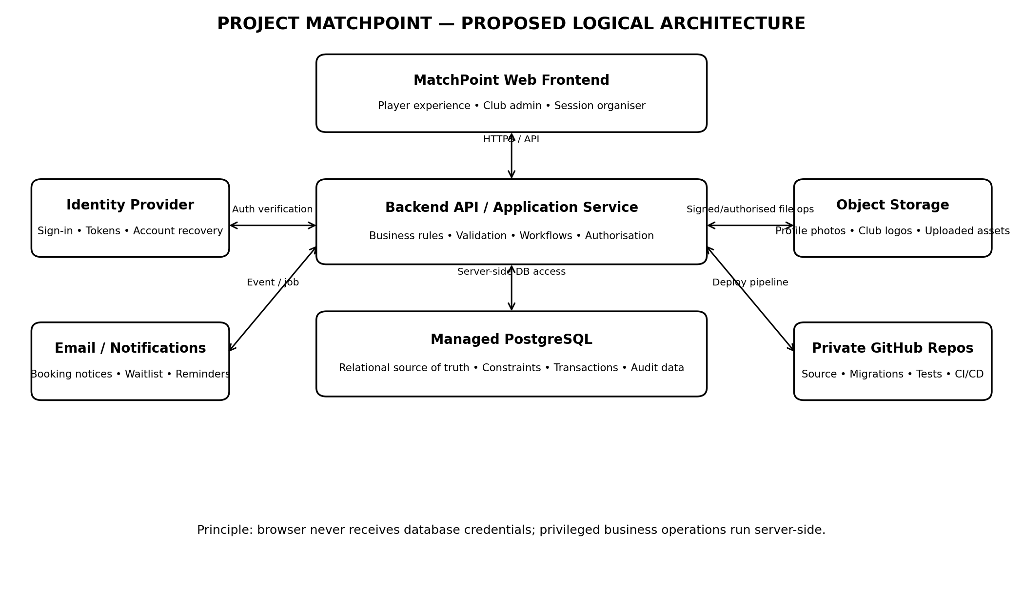
Figure 1. Proposed logical architecture. Provider and hosting choices remain provisional.

5. Logical application architecture

5.1 Presentation layer
- Responsive web interface for desktop and mobile browsers.
- Renders public club pages and authenticated player/admin experiences.
- Collects user input and displays API outcomes.
- May perform client-side validation for usability, but cannot be trusted as the authority for eligibility, capacity, pricing or permissions.
- Contains no database password, service-role key or other privileged server credential.

5.2 Backend / application layer
- Expose versioned HTTPS APIs for frontend operations.
- Authenticate requests or validate identity-provider tokens.
- Resolve the acting user and active club context; enforce role and resource-level permissions.
- Own business workflows: profile setup, booking, waitlist, cancellation, attendance, allocation, match scoring and result correction.
- Apply validation and state transitions consistently, including operations invoked by future integrations.
- Use transactions for concurrent operations such as capacity-limited booking and result updates.
- Access the database through a controlled data-access layer; use parameterised queries or a safe ORM/query builder.
- Record security-relevant and business-relevant audit events.
- Dispatch notifications and run scheduled/background jobs where needed.

5.3 Data layer
- Managed PostgreSQL is the proposed relational database.
- Stores authoritative entities defined by the Logical Data Model: users/account references, player profiles, clubs, memberships, venues, sessions, registrations, matches, results, payment records and audit history.
- Enforce relational integrity and concurrency-safe constraints at the database level.
- Keep file binaries in object storage; store file metadata and references in PostgreSQL.
- Do not make derived rankings or allocation proposals the authoritative source of actual match participation/results.

5.4 Managed platform services
A provider such as Supabase may supply PostgreSQL hosting, authentication and object storage. These services can reduce operational effort, but they do not remove the need for a backend business layer. Use direct frontend-to-provider APIs only for explicitly approved low-risk operations with carefully designed access policies; privileged business workflows should pass through the backend.

6. Representative request flow: session booking
- The player signs in through the identity provider and receives an access token.
- The frontend sends a booking request to the backend over HTTPS.
- The backend validates the token and identifies the user, player profile, club membership and permitted role.
- The backend loads the session policy and validates booking window, eligibility, cancellation status and relevant constraints.
- Within a database transaction, the backend checks capacity and writes either a registration or waitlist outcome. Database constraints and concurrency-safe logic prevent two simultaneous requests from exceeding capacity.
- The backend commits the transaction, records the relevant audit event and returns a clear status to the frontend.
- Notification delivery, if enabled, is handled separately with retries and delivery outcomes recorded.
The backend must not trust a client-supplied club ID, player ID, price, role or booking status without verifying that the user is allowed to act on that resource.

7. Security and privacy

7.1 Identity versus application permissions
Authentication establishes who is signed in. Authorisation determines what that person may do. A MatchPoint account is not the same thing as club membership. Permissions should be scoped to a club and checked on each relevant operation.

7.2 Multi-club isolation
- Every club-owned resource must have an explicit ownership/scope rule.
- Backend queries must enforce the active club and verify membership/role; do not rely solely on UI filtering.
- Use PostgreSQL row-level security as a defence-in-depth control if compatible with the chosen access pattern.
- If a browser-accessible API can query the database directly, its policies must independently prevent unauthorised cross-club access.
- Test negative cases: a member/admin of Club A must not read or mutate private Club B records without an explicitly granted role.

7.3 Secrets and repositories
- Keep the application repositories private during initial development unless there is a deliberate decision to open-source selected components.
- Never commit database passwords, service-role keys, signing secrets, production tokens or personal data.
- Use hosting-platform secret management/environment variables for server-side credentials.
- Use separate development, test and production credentials and data.
- Browser-visible configuration may contain only values explicitly designed to be public, protected by server/database access policies.

7.4 Personal data and junior profiles
Collect the minimum information needed for the feature. Full date of birth, contact details, residential address, guardian links and consent records should be private by default. The simplified parent-created junior profile concept is provisional; age rules, guardian verification, consent and safeguarding workflow remain open decisions and must be reviewed before launch.

7.5 Application security baseline
- HTTPS only for deployed environments.
- Input validation, safe error handling and rate limiting on sensitive endpoints.
- Secure account recovery and email verification where supported.
- Audit important role changes, result corrections and financial adjustments.
- Dependency updates, vulnerability checks and automated tests in CI.
- No secrets or unnecessary personal data in application logs.

8. Data architecture and relationship to the Logical Data Model
The Logical Data Model v1.0 remains the source for business entities and relationships. This architecture document does not independently redefine those entities.
- Next data-design step: map approved logical entities to PostgreSQL tables, keys, constraints, indexes and migration files.
- Keep User/account identity distinct from PlayerProfile and ClubMembership.
- Keep planned allocation separate from actual match participation and results.
- Keep payment obligations, transactions and adjustments distinct rather than storing a single mutable balance only.
- Use a migration history in source control; changes to the schema must be reviewed and reproducible across environments.
- Use synthetic/anonymised test data, not real club-member data, in development and automated tests.

9. API and business logic boundaries
The detailed API contract will be designed after the MVP workflows and open decisions are confirmed. Initial API domains are expected to include:
- Identity and player profile: view/update permitted profile fields; claim/link a player profile through an auditable process.
- Club and membership: public club profile, membership status and club-scoped administration.
- Venue and sessions: session listing, session details and policy configuration.
- Registration: book, cancel, join waitlist, accept/decline a waitlist offer and view booking status.
- Attendance and allocation: record attendance, publish an allocation plan and manage court/round assignments.
- Matches and results: record participants and scores; correct results through a controlled audited workflow.
- Notifications: create notification intent and record delivery attempts.
- Administration: manage club roles, session settings and permitted club configuration.
Each API operation must define the acting identity, required permission, validation rules, transaction boundary, expected status/error responses and audit requirements. Avoid broad generic endpoints that let the client update arbitrary database fields.

10. Deployment and environments

10.1 Proposed environments
- Local development: developers run the frontend/backend locally and use local or isolated development services where practical.
- Development/test cloud environment: non-production credentials and synthetic data for integration tests.
- Pilot/production environment: real club data, restricted access, backup and restore procedures, and controlled deployment.

10.2 Initial hosting pattern
Candidate pattern: static web hosting for the frontend, a low-cost/serverless host for the backend API, managed PostgreSQL, managed identity and object storage. Supabase is a candidate for the latter services; final selection depends on current free-tier terms, integration fit, security needs and the expected pilot workload.

10.3 Cost and free-tier guardrails
- Aim for £0 during development and the initial pilot where practical; do not promise permanent zero cost.
- Check current limits for database size, bandwidth, compute, file storage, email delivery, inactive-project pausing, backups and build minutes before production.
- Understand whether a free tier offers automated backups, point-in-time recovery, support and acceptable availability.
- Set usage alerts/quotas where available and document what happens if a free limit is reached.
- Do not upgrade automatically without owner approval unless a previously agreed emergency policy permits it.

11. Source control and delivery
- Use private GitHub repositories for application code, backend code, schema migrations, tests, architecture documents and deployment configuration.
- Keep secrets out of Git; commit only safe examples such as .env.example with placeholder values.
- Use pull requests or equivalent review for schema and security-sensitive changes.
- Run automated linting, unit tests and migration checks before merging.
- Deploy from a controlled branch/pipeline; keep production secrets in the hosting environment.
- Keep architecture diagrams in Mermaid Markdown so they can be reviewed and versioned with the code.
Repository split (single monorepo versus separate frontend/backend repositories) is not yet decided. For a small initial team, a private monorepo may reduce coordination overhead, but the choice should follow inspection of any existing MatchPoint/Sutton Shuttlers code and deployment setup.

12. Reliability, backup and operations
- Automate database backups/exports at a frequency appropriate to pilot activity and data-loss tolerance.
- Store backup copies separately from the primary database where practical.
- Test restoration before real club data becomes operationally important.
- Document a simple incident process for accidental deletion, account compromise and service outage.
- Record application errors and operational events without leaking credentials or unnecessary personal data.
- Design notification delivery to tolerate provider failures; a failed email should not silently undo a successful booking.
- Define a retention/deletion policy before launch; preserve legally or operationally required records only as justified.

13. Architecture decisions and status
ID |  | Decision |  | Status / statement
ID | Decision |  | Status |  | Decision / rationale
ADR-001 | Layered architecture |  | Proposed |  | Frontend calls backend API; backend owns business rules; PostgreSQL persists authoritative data.
ADR-002 | Relational database |  | Proposed |  | Use PostgreSQL to align with the logical relational model and support portability.
ADR-003 | Managed platform |  | Open |  | Supabase is the leading candidate for managed PostgreSQL/auth/storage; verify current limits and fit.
ADR-004 | Backend runtime/framework |  | Open |  | Select after checking current repositories, team skills, hosting cost and testability.
ADR-005 | Frontend framework/hosting |  | Open |  | Select after inspecting current work and defining browser/mobile requirements.
ADR-006 | Repository strategy |  | Open |  | Private by default; decide monorepo versus multiple repositories after repository inspection.
ADR-007 | Authentication |  | Proposed |  | Use a managed identity provider initially; keep app roles and club membership as application-domain concepts.
ADR-008 | Tenant isolation |  | Mandatory principle |  | Enforce club-scoped access in backend and use database policy/constraints as defence in depth.
ADR-009 | Junior/guardian model |  | Open |  | Keep simple parent-created junior profile as a provisional flow; defer final safeguarding and consent design.
ADR-010 | Production availability and backup |  | Open |  | Define recovery objectives and verify what free-tier services actually provide.
ADR-011 | Payment processing |  | Open |  | No member charges initially; preserve model separation but defer payment gateway selection.
ADR-012 | Public/private club information |  | Proposed |  | Expose a governed public club profile; never expose private member data through public views.

14. Key risks and mitigations
Risk | Mitigation
Cross-club data exposure | Enforce server-side authorisation and test tenant boundaries; use database policies where appropriate.
Free-tier pause/limits | Verify limits, document pilot impact and maintain export/restore process.
Concurrent booking over-capacity | Use transaction-safe workflow, database constraints and concurrency tests.
Scope grows before pilot | Separate MVP from future competition, ratings, guest and substitute capabilities.
Business rules drift between UI and backend | Keep authoritative rules in backend/domain services and cover them with automated tests.
Junior data/privacy gaps | Keep data minimal and private; resolve consent/safeguarding decisions before launch.
Provider lock-in | Use PostgreSQL standards, migrations, export tests and clear boundaries around provider-specific services.

15. Recommended next steps
- Review this architecture and agree the layered design and security principles.
- Inspect the current Sutton Shuttlers/MatchPoint repository and identify any existing frontend, authentication, Google integration, deployment or hosting choices before selecting frameworks.
- Confirm MVP workflows and resolve the LDM open decisions that affect booking, scoring, permissions and junior profiles.
- Select the initial provider combination based on current free-tier terms and the actual repository.
- Produce the physical PostgreSQL model: table definitions, keys, constraints, indexes, row-level security policy and migration strategy.
- Define API contracts and acceptance tests for the highest-priority workflows.
- Build a thin end-to-end vertical slice (sign-in, club membership, session listing and safe booking) before implementing all features.
- Complete security, backup/restore and club-isolation tests before onboarding real members.

Appendix A. Mermaid diagram source
The companion file Project_MatchPoint_Architecture_Diagrams_v1.0.md contains editable Mermaid source for the system context, three-layer architecture, session-booking sequence, deployment topology and security boundaries. Keep that file alongside this document in the private repository.

Appendix B. Assumptions
- The first operational club is Sutton Shuttlers Badminton Club.
- The app is initially free to members; monetisation is not in the MVP scope.
- The system is intended to support multiple clubs eventually, so tenant isolation is a foundational requirement.
- PostgreSQL is the preferred database technology; the final cloud provider is not yet approved.
- A dedicated backend business layer is required; managed services may support but do not replace it.
- The existing repository and Google integration have not yet been inspected in this architecture exercise.

