
Personal Information:
Name: Kevin James Sweeney
Student ID: S3894218
Email: s3894218@student.rmit.edu.au
GitHub Repo: https://github.com/the-sweeney-au/COSC2196
GitHub Pages: https://the-sweeney-au.github.io/COSC2196/

Background:
I am Australian by birth of Irish, Scottish and German descent. I was born and raised in the Kimberley region of Western Australia where I have lived and worked for various periods of my life. I went to school at Holy Rosary Primary School in Derby then completed high school at Catholic Agricultural College Bindoon about an hours north of Perth. I currently reside in Derby where I work as a hardware store manager.
Fun Fact: An image of my brothers and I was once used in a Vegemite advertising poster!

Interest in IT
I have always had an love for technology. Growing up, I would love watching science fiction movies and television shows, even loved reading about science and technology. I gained an interest in IT ever since I first saw a personal computer, but I never got to really to use computers on a regular basis until high school, but the fascination with never abated. The first computer I personally owned I had built with parts I had researched and obtained myself. My knowledge of computing expanded with my time working as a system administrator at Kwinana Senior High School (now Gilmore College), spending time with TCP/IP and IPX/SPX networking as well as NetWare and Windows NT servers. It was this time I was introduced to open source software like Linux, FreeBSD, Apache, Firefox and OpenOffice. Even today, I am still a heavy user of open source software.
I came to studying at RMIT through browsing available online courses on Open Universities Australia (OUA) website. I settled on Bachelor of Information Technology delivered by RMIT and OUA assisted me on my way to this course.
I hope to gain more of a grasp of what is out there in the wide world of IT. What are the current trends and where IT could head in the future. I am hoping this degree would give more of an insight of what career path I can follow in the world of IT.

Ideal Job
The job description
My ideal job would be an Network Engineer as advertised by Freelancer.com. It is a highly technical position dealing with the underlying technologies that drive networks and the internet itself. The position would require deep understanding of core networking fundamentals of which I currently only have basic understanding.
My Current Skill-set
I already have basic understanding of networking technologies and the TCP/IP networking stack, I can setup smaller networks using DHCP and static addressing. I do have some Cisco network switch experience with the Catalyst series switches in getting them up and running. My Linux experience is somewhat lacking but my understanding of FreeBSD more through and I use it on a regular basis. I have used FreeNAS (now TrueNAS Core) and I am familiar in what it can do.

Below is screenshot of The Ideal Job listing from indeed.com
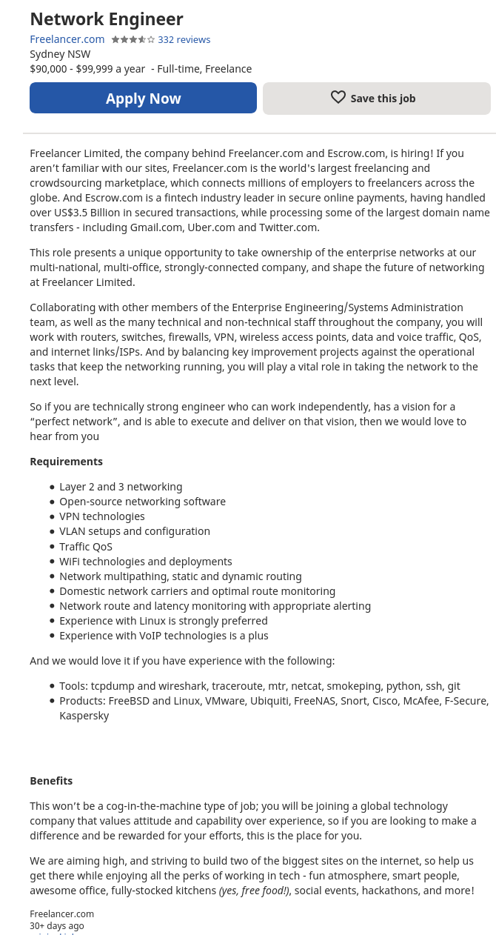

Obtaining Required Skill-set
In order to gain the necessary qualifications I believe obtaining the following certifications would be beneficial in gaining the required qualifications for the position:
- Cisco Certified Network Associate (CCNA)
- Cisco Certified Network Professional (CCNP)
- CompTIA Network+
- Wireshark Certified Network Analyst
The Cisco certifications are widely known and respected across the industry. Obtaining at the CCNA Certification and CCNP Enterprise certifications would provide the essential networking qualifications for the position.
Links: https://www.cisco.com/c/en/us/training-events/training-certifications/certifications/associate/ccna.html
https://www.cisco.com/c/en/us/training-events/training-certifications/certifications/professional/ccnp-enterprise.html
The CompTIA Network+ certification is provided by the Computing Technology Industry Association (CompTIA) and also an industry wide recognised certification. The CompTIA Network+ certification would also be a beneficial qualification to have, like the Cisco qualifications, it is network specific and would demonstrate I have the required skill set for the position.
Link: https://www.comptia.org/certifications/network
To fulfil the Linux requirement, obtaining the CompTIA Linux+ certification would be extremely helpful. Link: https://www.comptia.org/certifications/linux
It would be entirely optional, the BSD Associate could be beneficial in demonstrating my FreeBSD experience.
Link: http://www.bsdcertification.org/certification/certification/bsd-associate.html
Wireshark is an widely used, free and open-sourced packet analyser, that is supported on multiple operating systems. The Wireshark certification would also be beneficial to have, as the qualification would demonstrate that I have the skill set to diagnose, monitor and analyse network traffic using the Wireshark tool set.
Link: https://www.wcnacertification.com/

Personal Profile
16Persionalilies.com
According to 16Persionalilies.com, I am an Turbulent Logician with the code INTP-T. According to this profile, I am a analytical and abstract thinker, imaginative and original, open-minded, enthusiastic, objective as well as honest and straightforward. Ask anyone would knows me personally if the results of this test are accurate, they are more to likely agree. Though personally I do believe the test accurately describe who I believe to be, I still remain rather sceptical.
Link: https://www.16personalities.com/profiles/d2d33df9eea80

Personal Learning Profile
Using the Personal Learning Profile on the Online Student Support Orientation, I am a Dynamo. It suppose to mean that I am good at managing competing priorities and have a good skill set that I can apply to my studies. Time will tell as I progress along with my studies whether or not this profile actually applies to me.

Screenshot of Personal Learning Profile
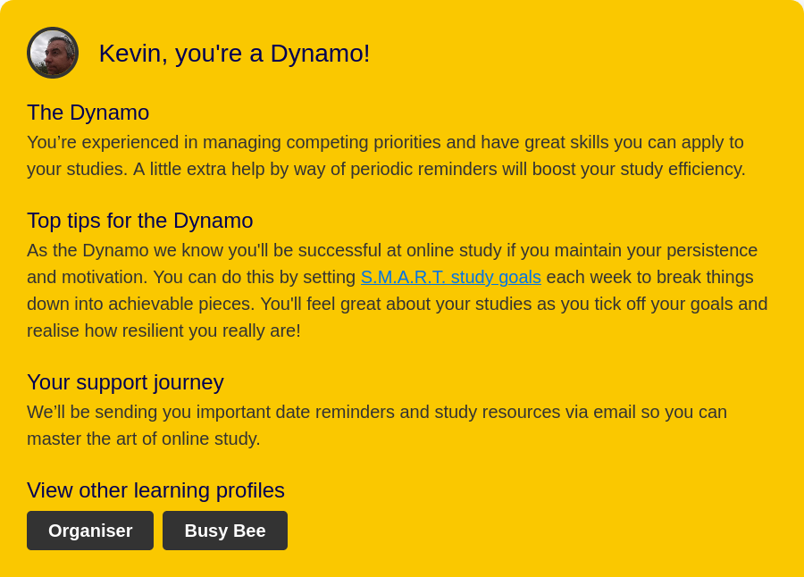
The Big Five
Using the Big Five test, I scored:
Neuroticism: 79 (High) – high tendency to experience negative feelings
Extroversion: 62 (Low) – have an introverted personality
Openness to Experience: 78 (High) – scored high in imagination, artistic and intellectual traits
Agreeableness: 85 (high) – basically means gets I do get along with others
Conscientiousness: 81 (High) – has confidence, drive and self control to accomplish tasks
I do feel that the test results are accurate reflection of who I am.
Link: https://bigfive-test.com/result/6056b052d0b1120008c8c5c0

Theses test do provide a insight into my personality in a measured manor for people who do not know me or who I am. Potential employers can use it to gain an insight into what type an employee I could and how I can fit with my potential co-workers on projects. Though these tests can provide an insight into potential members of an team, they should not be over relied on. Performance of the team is still largely dependant of leadership and management of the team.

Project Idea
1. Real Time Strategy game – Stars of Fortune
Overview
My open source Real Time Strategy game would be based in the futuristic world of Stars of Fortune created by my brother. It would use traditional game elements and ideas from various existing RTS games.
Motivation
Real time strategy game is my favourite genre of computer games. I grew up playing RTS games like Dune2, WarCraft, WarCraft 2, StartCraft, Command & Conquer and Age of Empires. My favourite modern RTS is Dawn Of War and StarCraft 2. The only open source RTS games I have found have been either been clones of Dune2 and Command & Conquer which require the original game assets or the Age of Empires inspired 0AD, which itself very interesting take of historical type RTS game.
Description
The economy of Stars of Fortune for most missions, would be a traditional resource gathering type economy. Similar to StarCraft and Command & Conquer in where minerals are to be gathered or mined order to construct buildings or units. Energy would be another resource that would have to be gathered. Energy would be generated by power generators built by the player, in similar vain to Dune2 and Dawn of War. A combination of minerals and energy would be required in order to build more advanced units and buildings in this game mode one could call strategic.
In another game mode, a player would have to capture and hold either individual critical point for a set time period or a capture string of critical points in order to meet a mission requirement. In this game mode one could call tactical, there is not a base that the player would be able build or create units from and resources would not available to collect. Instead the player would earn requisition points for each critical point held. Using these requisition points, the player would be able to call in reinforcements/replacement units available to the player. Typically the completion of these mission, the player would earn either technology upgrades or new units, which would help the player progress through the game.
On each map, the player will start with a small number of worker units. These unit are able to collect resources like minerals (on strategic maps), build buildings (again on strategic maps) and repair vehicle units. The type of building the worker units can construct would depend on the technology level of the player in the game.
Infantry units in the game would be organised into squads. Initially the squads would typically have around five members, where the player would use resources to add units up to an maximum number (similar to Dawn of War). Upgrades researched at the barracks would allow the player to add command units to the infantry squads. Research conducted at research facility or armoury would provide upgrades to weaponry and survive ability of the infantry squads. Upgrades conducted at the command centre would allow building of hero units which can have special qualities, of which can be attached to infantry squads. Having hero and command units apart of the squad helps to maintain the moral unit in combat. Different infantry squad type could comprise of light infantry, heavy infantry and support infantry (heavy weapons).
Ground vehicle units would require a factory building to be manufacture at. These units would constructed and commanded as individual units, which also have their own set of upgrades that can researched at armoury or research facility. Ground vehicle types would comprise of transport, infantry support, tanks and artillery.
Air units would require a airport or starport building in order to be constructed. These units could be a fighter, ground attack or transport aircraft type.
Tools and Technologies
The Stars of Fortune RTS game could use the game engine used by 0AD developed by Wildfire games, altered to fit the design parameters of Stars of Fortune. The other option would to use the Godot engine which is used various different games and game genres. Both game engines are open source and are available on different platforms such as Windows, Linux, FreeBSD and MacOS. Developing the game on either game engine will allow to the project to reach a broad audience regardless of operating system.
Skills Required
C++ programming would be a desired skill set in order to develop the game engine and most of the game mechanics. The Godot engine does allow other languages like GDScript, C# and many other languages like Rust, but it allows visual scripting to be used.
Graphic artists and 3d modellers would be required to produce vast array artwork needed for the game. From units, map, menus and backgrounds, Graphic artists are a must.
Game testers would be needed to ensure that game play and the game balance is the best is can be.
Outcome
The goal of the Stars of Fortune project would to provide a science fiction based real time strategy game, that take the best game elements from RTS games that came before it. Like 0AD had been inspired by the Age of Empire franchise but has become it’s own game. I would hope Stars of Fortune would rise above it’s influences and become it’s own game.

2. Directory Services – SpartanDS
Overview
The premise of SpartanDS is provide an cohesive, open source, cross-platform directory services platform, that is influenced by the X.500/LDAP directory standard. SpartanDS would modelled on but not limited to services and functionality provided by Microsoft’s ActiveDirectoy and Novell’s eDirectory (formerly Novell Directory Services).
Motivation
Having had worked with Novell suite of the products in the early 2000’s, I was always have been impressed by the level of integration and ease of management of Novell products, with their directory services product eDirectory at the core. This provided centralised administration of all users and services on the network through the use of objects in the directory tree. From small and medium businesses networks to large global enterprises, eDirectory made network management relativity simple. It was used from authentication of users to user rights management on files and folders, management of networked printers and their respective print queues on NetWare. It used with the management of desktop computers and installed software with the ZenWorks product. It integrated mailbox and mailing list management with Novell’s GroupWise groupware product.
Description
The core of any directory service like SpartanDS is the database, where all the resources of the network are stored as an domain objects within a tree-like structure. This includes but not limited to users, groups, files and folders, servers, printers and print queues.
At the top of tree, is the organisation object, where all objects and their containers reside. Organisation Unit containers or context containers are use like branches in a tree, that can be used to organise various objects according to their department, location or organisational unit.
One of the core features of directory services, is that the database holding all the domain objects is replicated across multiple servers, providing a level of redundancy and availability. Typically the whole database would be replicated, but also the tree can be partitioned in such a way that only selected organisational unit containers are replicated out to selected servers. These servers for example could be located in branch office, thus minimising WAN link traffic in regards to tree replication, providing the all the required branch resource reside within that organisational unit. Tree partitioning used along the lines of continental lines, country, region or business units.
The directory services database would use scheme extensions to describe what an object is and its characteristics, as well as how it is used. Below is description of common objects that typically would be used in SpartanDS.
User objects would typically reside within a organisational unit and any permissions assigned to the organisational object, the user object in turn would inherit these permissions. Though permissions can be granted to directly to an individually to an user object, it would be discouraged as that organisational units and group objects are for.
Groups objects exist in order administer groups of users within an organisational unit, where they would be members of created group. Group object can have permissions granted to group object that would apply to members of the group.
Files and folders residing on a server would have file\folder objects representing them under a volume object in the tree. The volume object is an container object specific to files and folders. An volume object would be associated with an server object where the volume resides on the network. These objects would be used in providing access control permissions that can be granted to users, group and organisational objects.
Printer object would represent printers on the network would details such as network address, physical location and associated printer queue object. The printer object can be also used in holding print driver location for client computers and their respective operating systems. The printer queue object would contain such details on which server the print spool resides. The printer/print spool can be used in user access control of the printer resources.
Schema extensions can be created by third parties and used to be used in integrating third party systems such as email/groupware systems and even firewalls. This would allow flexibility for third parties to extend SpartanDS to allow integrating their products to be managed within the SpartanDS ecosystem.
Tools and Technologies
The heart of the system is the database. Sticking with the goal of the project in being open source, the database system would certainly be open source. The database solution will need to be scale-able and cross-platform in order to be considered. The likes of MySQL and MariaDB would be the main contenders, but consideration would be given to Firebird RDBMS, as it was used originally by Novell as the base technology for eDirectory.
Integration of components from the Samba project will provide support for SMB/CIFS protocol allowing Windows client platforms to connect to server resources natively.
Integrating with Unix like systems using such protocols as Open Network Computing (ONC) Remote Procedure Call (RPC) and the Network File System (NFS) protocols will provide support for unix-like clients such as Linux and BSD systems.
But development of an native client/server protocol may required to fully exploit the potential of SpartanDS for end user clients. As this may necessitate development of clients for the native protocol though it may not be needed, this would be a long term goal.
Creation of plugins or extensions for PHP, as well as Apache and NGINX web servers should allow various web platforms (Wordpress, Joomla, etc…) to take advantage of SpartanDS. LDAP compatibility would also facilitate use by web platforms as well email systems.
Skills Required
Many developers with C/C++ programming experience would be required in not only adapting the database engine to requirements, but to developing the application programming interfaces require for applications to interact with the directory services. Tools to interact as well as maintain the health of the directory will need to be developed. Programmers with experience in different operating systems would be crucial in maintaining cross-platform deployments.
Database developers not limited to SQL would be sough to ensure the database behind the directory services is up to task, while being able scale-able as well as reliably replicate directories across servers and sites. Durability and performance of the databases under whatever load, availability and integrity of the directory would be of high importance.
Web developers would required to build the web tools to facilitate the administration of directory services provided by SpartanDS. But also to build the tools to allow web developers to build websites to take advantage of services provided by SpartanDS.
Regardless of the skill set of held by any developer on the project. All developers would need fundamental understanding of security and is aware of the importance of application security in the modern world. As the security of the database and it’s contents would be of extremely high importance.
Outcome
If the SpartanDS came into being and was successful, it would enable multiple systems across multiple platforms to be integrated and easily managed, by providing a centralised point of administration. This would make management of users and their resources across multiple platforms a whole lot easier with reduced management overhead. With an absence of an integrated open sourced product, the creation of SpartanDS would provide an open source competitor to Microsoft’s ActiveDirectory.

EOF

