Visualization Tools – Examples

Matrices

Example cross-correlation

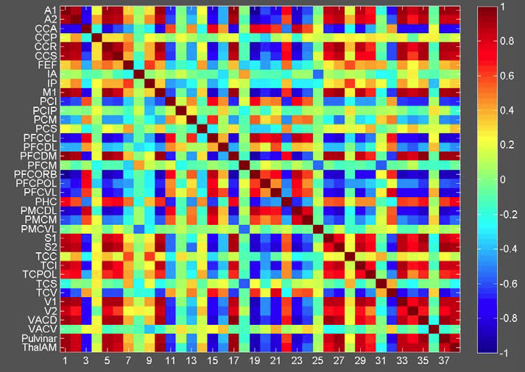
Really simple in principle (and let us assume, that the Matix is fully filled and not just a triangle): Still we need to discuss, how the metadata is persisted: x- and y-Axis labels. Color-Range. We could agree, that the color-range is just a question of visualizing (however in that case, the min- and max-values on the color-scale need to be dynamic from analyzing the given Data as well…

For now, we have a huge matrix, with checkboxes. We are still waiting for a nicer display solution from Michael, in order to continue work on it. No work was done, yet, on colors.
We have 66 points in the connectivity-matrix; this one displays 38. One proposal is to display only one hemisphere at a time (e.g. when the connectivity-matrix has mode that 40 nodes)

Time series

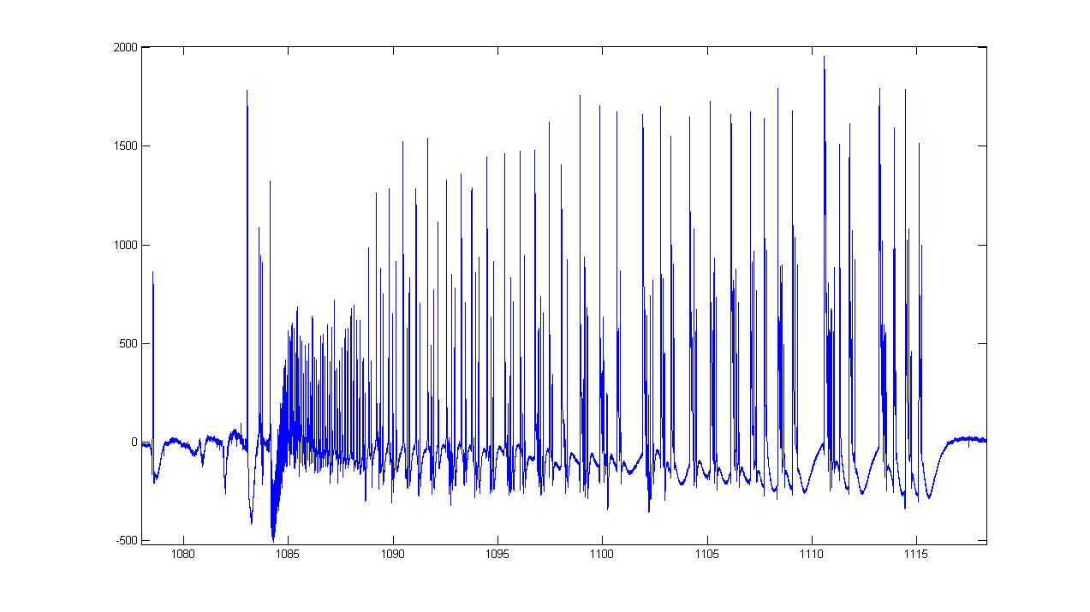
This on needs no real further discussion…

Histogram

Some examples….

Do we expect a matix (150 x 150 scalars) here? And just plot them in 3D?
Then we only have to discuss on transfer of axis-labels…
I do not understand to what 3D plot you refer.

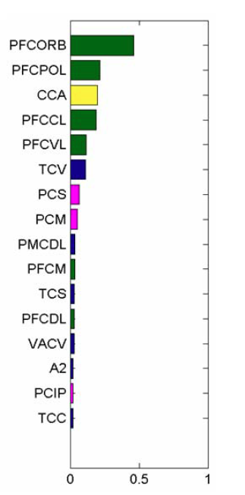
Basis here just a Vector, right? But here the coloring seems not to be in synch with the value for the given row. Additional metadata? Something to be set only in adjusting the graph and persisted additionally? (and again: Axis-labels…)

The histogram from above already has basic visualization support. We consider as input 3 vectors: one vector with labels, one vector of floatf, representing values, and one vector with colors.
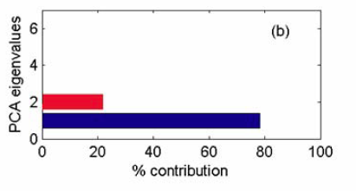
Nothing additional to the above…
This one seems like a result of some special data-analysis algorithm, with an overview over the brain network. From the visualization point of view, nothing too complex, but TVB Framework needs to acknowledge and fill the correct type for the result (Data Type).
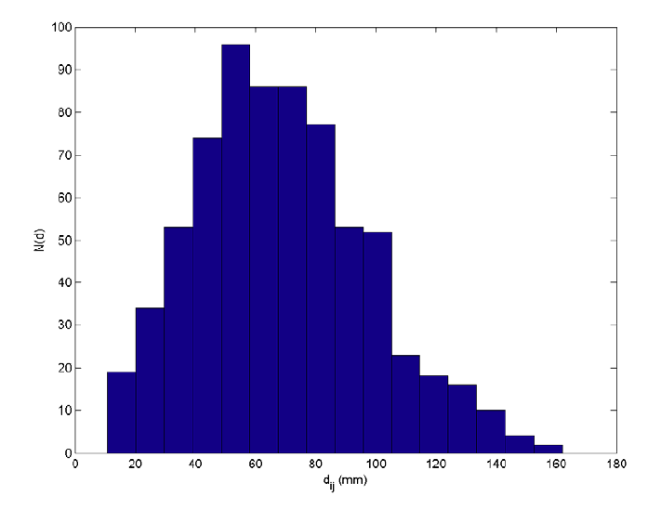
Quite simple (axis-labels, base-color)
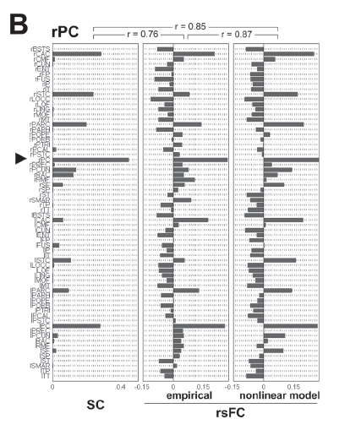
Similar to the above cases. However the grouping of multiple Histogram-Graphs and adjusting additional “decoration” to it, is not trivial. How important? Where in the time-line?
I see this like a comparison view of 3 different simulations, with different models or input parameters. Is this correct?

Space time plots (color coded)

Example with vertical axis coding physical space and horizontal axis time. The dotted white lines indicates parameter changes or specific time points (such as event of stimulation)

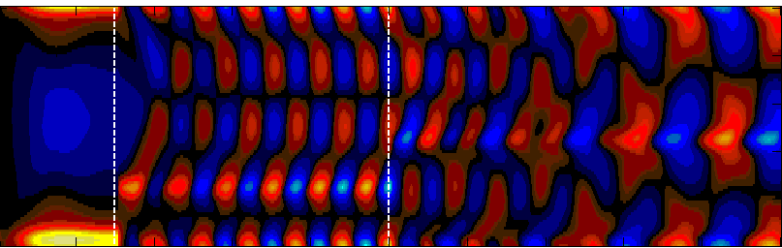
The basis ist again a matix, where each scalar is interpreted as a color-code (again: how to transport value-range to color-codes. Or leave it just to the visualizer?)
But here is also additional Metadata with the two-lines… How to deal with that?

Parameter spaces in 2D

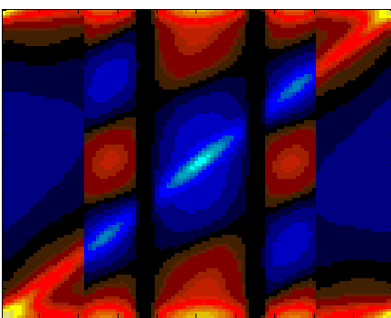
Same thing as above. Guess, that the two black vertical areas are in the data. Again: the labels and additional “decoration” with the arrows… (but here we have no classical labels on axises)

2D plots

here some examples of EEG and MEG data plotted in a plane, where the outermost sensors define the outer boundary. See also 3D plot for a 3D version. This plot should also run as a movie upon request to show temporal dynamics.

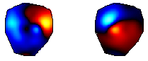
Here we have a “matix”, which is not “regular. Or can I assume, that there are enough points coded as color “white” (or left out) to make up for it?
Or should it be a projection of a 3-D Plot to a pane?
Below are various examples of visualization of connectivity patterns using 2D plots. 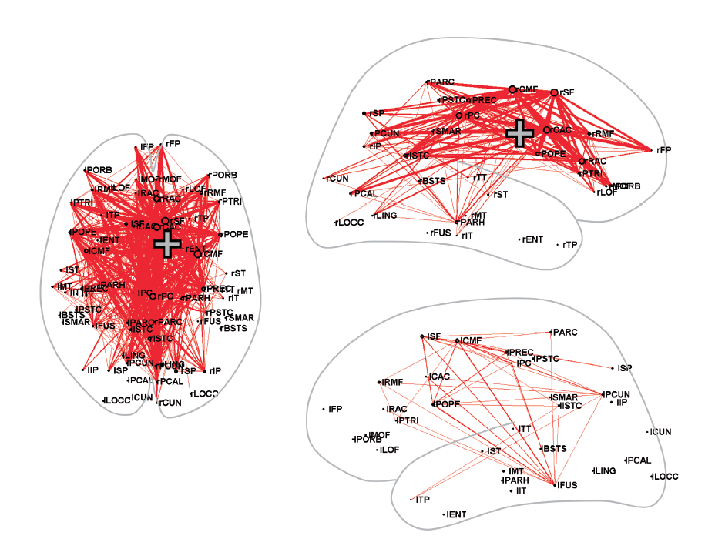
A bit difficult, to see this just as a matrix and produce it, right? With the context, that a given matrix is a connectivity-matrix, that would be a lot easier. We could prepare the 3 panes and map the connection on a value as the thickness of the connecting line of the two points, given the points are in the choosen template…

Example of multiple 2D plots within a configuration of rows and columns to visualize another dimension

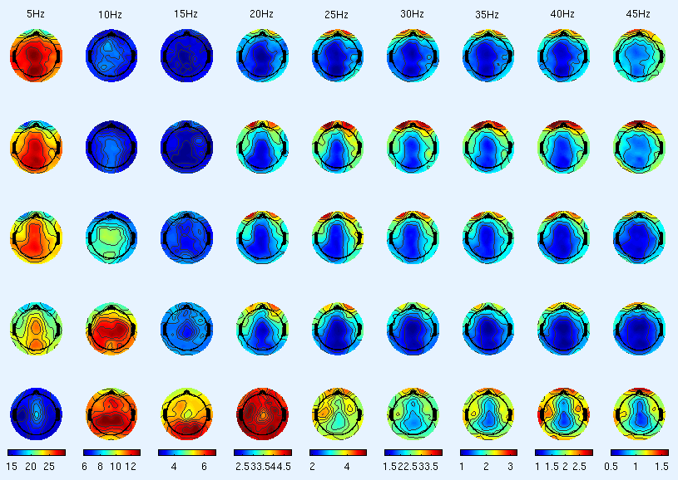

If each of the plots is given as a matix, we again have simple color-coding. But here we see, that it might be good, to transport the scale for the color-coding inside the data, right? In this case for the coloms. But that would give other questions, which would assume, that we have an additional dataformat here …

3D plots
surface data (EEG, MEG) in 3D shown together with its 2D projection.

Required functionality: zoom, rotate, display as a movie.

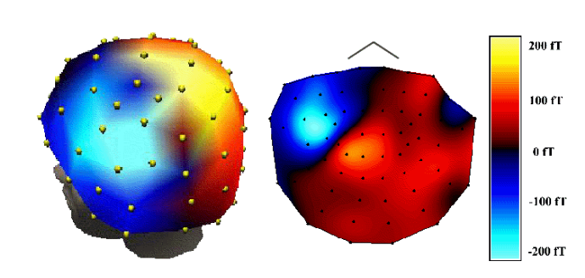

Can we assume that this is what we have? (ok, the interpolation is missing)

Parameter spaces in 3D. Here only surfaces separating parameter regions are shown. Those could also be coded in color. Required functionality: rotate, zoom.

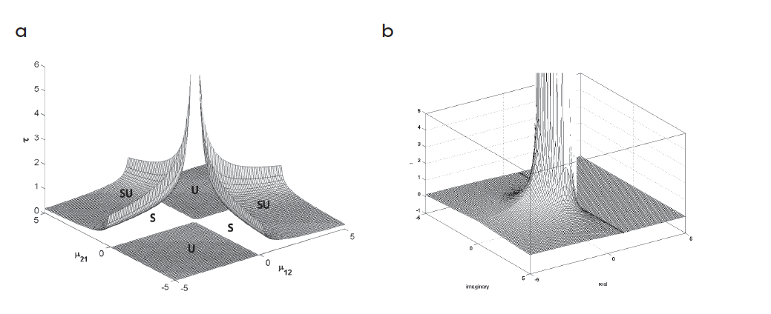
The color-coded ones of this we already had. And make that a grid-line should not be a big problem.
However: don’t we potentially have some math to draw and could better use something like this: http://matplotlib.sourceforge.net/examples/mplot3d/surface3d_demo.html

Connectivity data in 3D
Required functionality: zoom, rotate.

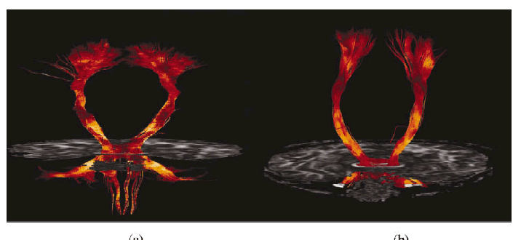
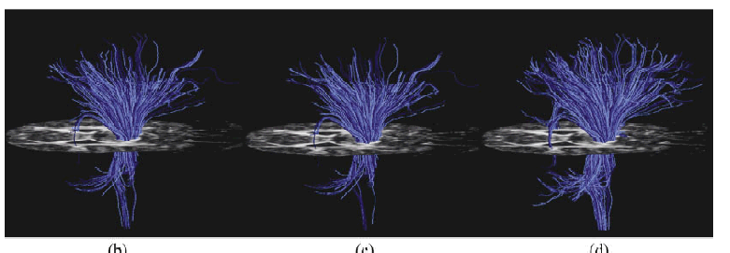

Ok, that is somewhat nasty. I think, we agreed, to not implement for November, but see afterwards, what we can get from Connectome, right?

Below are various examples of visualization of connectivity patterns using 3D plots. Sometimes the size of a node is used to scale a value (example 1), sometimes the thickness of a line (example 2).

Required functionality: zoom, rotate.

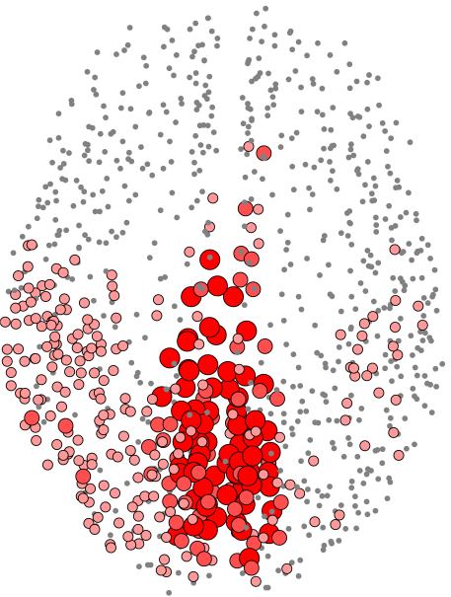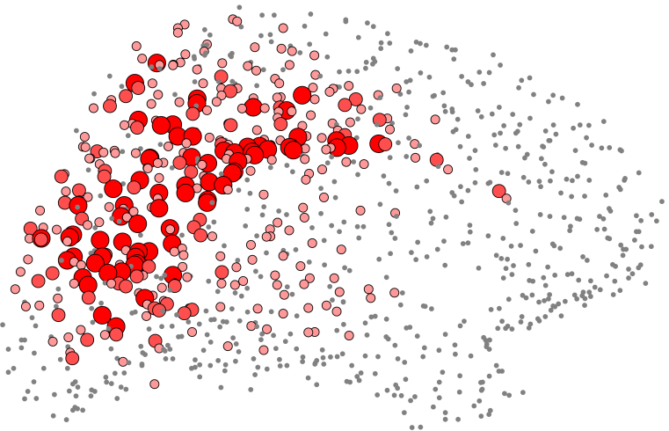
Understood in principle. However will be difficult without the context, that this is a connectivity and thus have additional information, which gives the 3D-Position of each point of the data-matix (which just holds the info of point-radius). Well, we have way more points here as in the connectivity-matixes we had…)

As zoom/rotate are required here, a WebGL visualizer should handle this.
From our point of view, is we get a list of 3D coordinates, and a vector of weight for each of the points, it is straight forward to implement it. As an exact analyzer/simulation monitor to produce these is not yet prepared, it would help us a lot if we could receive in advance the input data (in some txt files maybe)
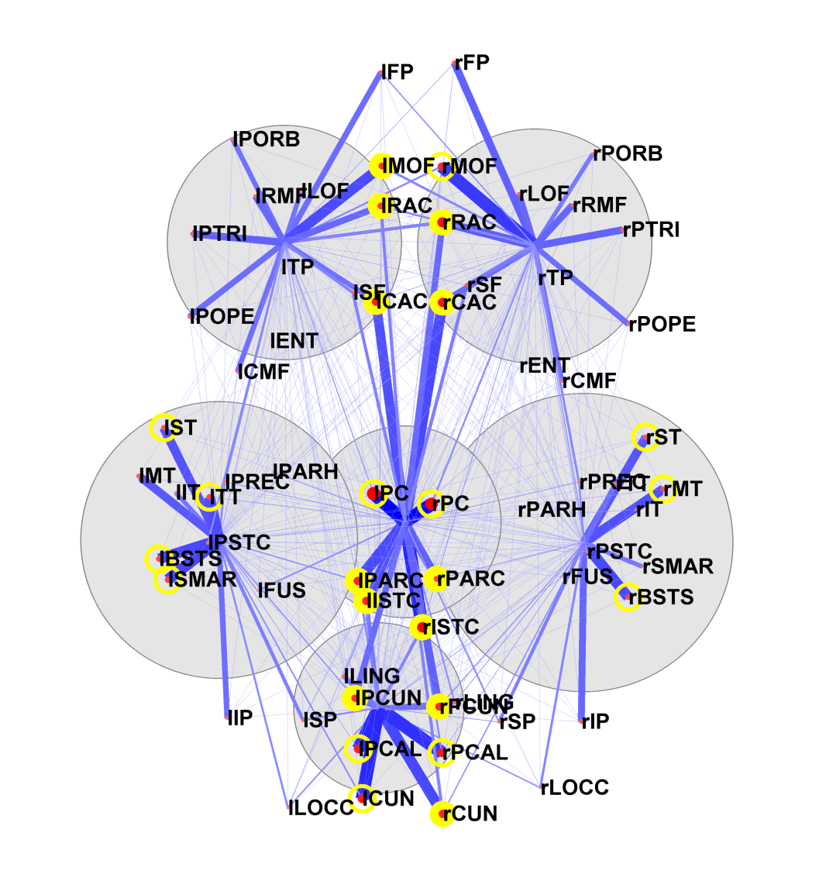
Similar as the connectivity-matrix some way above, we need to agree on the context-info (and I think, we have again the known version. What I cannot see, how do the blue, yellow and red circles emerge? So that needs more discussion
3-slice view

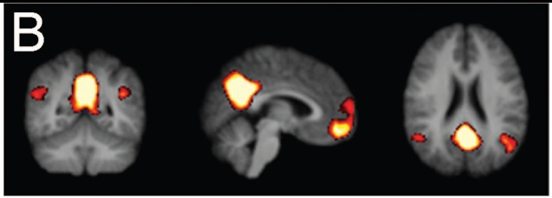
We have a bit of it right now. However not with the back-ground. And not with the additional highlighting… Who to transport that data?

xyz-scatter plots

in 2D in 3D

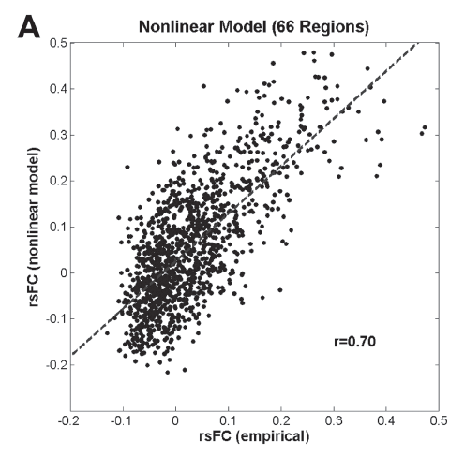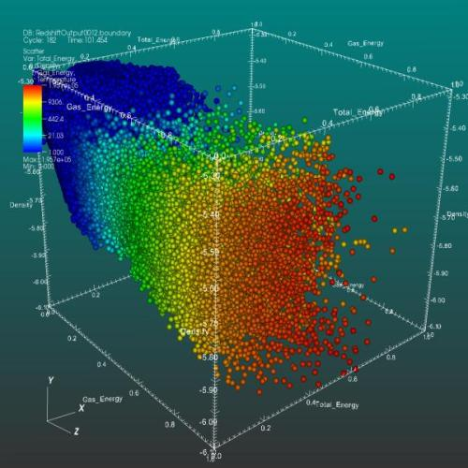

Should be doable with matplot http://matplotlib.sourceforge.net/examples/mplot3d/2dcollections3d_demo.html
Maybe some brush up… or if free 3d inspection and zooming is necessary, we could implement in WebGL …

Head-in-Head plots
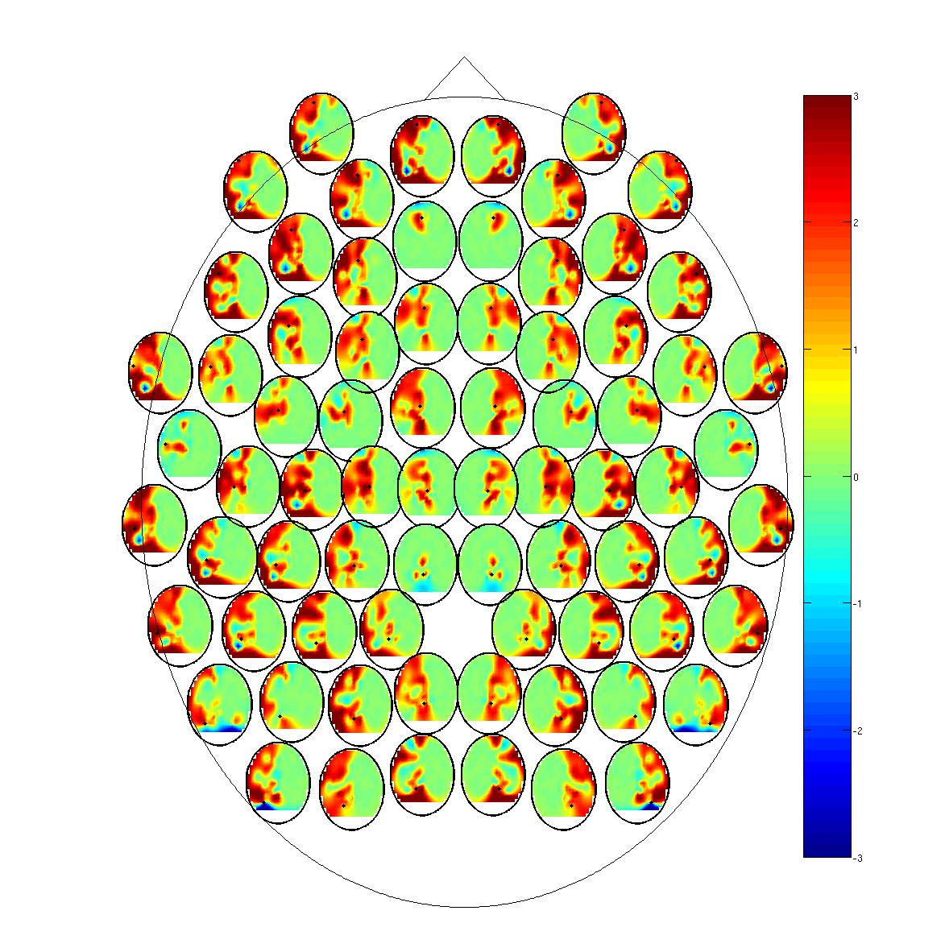
Pushed back for the moment, right?

