New design vs current design rules: 45 clashes to rule on
13 November 2026
This document lists 45 places where the new design mock-ups break a written design rule of the current site.
Each clash shows the current site on the left and the new design on the right, with a recommendation.
Mark each one override, adopt or combine, and either DESIGN.md or the mock-ups change to match.

Legend
Term | Meaning
Override | The new design wins. The rule is rewritten to match the mock-up.
Adopt | The current rule wins. The mock-up changes to match the rule.
Combine | Part of each. The entry states the exact blend.
Size S | A few components change.
Size M | One pattern changes across many pages.
Size L | Most public pages change.
Colour names | Forest is the dark green brand colour. Clay is the orange. Bone is the cream.

Recommendations by group
Group | Clashes | Override | Adopt | Combine
Colour | 6 | 1 | 0 | 5
Typography | 4 | 1 | 1 | 2
Surfaces, elevation and shape | 5 | 0 | 3 | 2
Layout and density | 4 | 1 | 1 | 2
Components | 6 | 0 | 3 | 3
Navigation and menus | 7 | 0 | 2 | 5
Iconography and imagery | 3 | 1 | 1 | 1
Motion | 3 | 0 | 2 | 1
Trust and brand rules | 5 | 0 | 4 | 1
Process rules | 2 | 0 | 1 | 1
Total | 45 | 4 | 18 | 23

Three things to know first
- Three clashes would fail automated checks the moment they are ported. Clashes 6 and 11 fail the colour guard in pnpm lint, which rejects loose colour values and tinted shadows. Clash 32 fails the footer spec, which pins the four shipped footer columns.
- Clash 1 decides most of the colour group. If Forest may be a page ground, clashes 3, 4, 28, 32 and 42 stop asking whether Forest is allowed. They only ask what sits on it.
- The "claimed" and "maintained" wording is settled, and DESIGN.md is current. No public page says "Claimed", and "Listing claimed by {vendor}" is not approved wording anywhere. Ruling 5 approves "Maintained by {Vendor} · updated {date}" for field captions only. The page-level chip keeps its two fixed labels. Entries 39 and 40 give the detail.

Index of all 45 clashes
No. | Clash | Size | Recommendation | Ruling
1 | Forest as the page ground | L | Override
2 | Tinted bands as the page ground | M | Combine
3 | Clay fills the main buttons | S | Combine
4 | Clay carries text and meaning | M | Combine
5 | Selected states fill solid | M | Combine
6 | Colour values outside the token file | M | Combine
7 | Display type on detail pages | S | Override
8 | Many large figures | M | Combine
9 | The type ramp | L | Combine
10 | Eyebrows and microheadings | M | Adopt
11 | Shadows instead of borders | L | Combine
12 | Large radii and pill shapes | L | Combine
13 | Gradients, noise and frosted glass | S | Adopt
14 | Cards inside cards | M | Adopt
15 | Side stripes | S | Adopt
16 | The detail page layout | L | Override
17 | Spacing off the 4-point scale | M | Adopt
18 | Uniform card grids | M | Combine
19 | Charts and meters on public pages | M | Combine
20 | Button anatomy | L | Combine
21 | Link styling | M | Adopt
22 | Too many chip styles | L | Combine
23 | Inputs | M | Adopt
24 | The integrations section | L | Combine
25 | A bare zero | S | Adopt
26 | The header's main links | M | Combine
27 | One mega-menu for four dropdowns | M | Combine
28 | Active-state markers | S | Combine
29 | Header search and sign-in | M | Combine
30 | The mobile menu | S | Adopt
31 | The breadcrumb separator | S | Adopt
32 | The footer | M | Combine
33 | Arrows used for navigation | S | Adopt
34 | Icons and logo tiles | M | Combine
35 | The hero diagram | M | Override
36 | Animation timing and decoration | M | Combine
37 | Hover and press movement | M | Adopt
38 | Smooth scrolling | S | Adopt
39 | A public "claimed" label | S | Adopt
40 | The maintenance chip and field captions | S | Adopt
41 | The agreement states | M | Adopt
42 | The wordmark | S | Adopt
43 | Public demand counts | M | Combine
44 | The anchor reference site | S | Adopt
45 | The same-behaviour rule | M | Combine

Colour

1. Forest as the page ground Size L Override
Current rule: Brand colours sit on neutral surfaces as accents. They are never the page background, and the live header is white.
Source: DESIGN.md §2, The Surfaces-Are-Neutral Rule. PRODUCT.md, Constraints.
New design: The header, the detail-page hero and the footer are full-width Forest bands. About a third of the first screen is dark green.
What is at stake: The rule keeps brand colour scarce and keeps the front door from reading as an internal tool. The dark band is what gives the new design its weight. No lint rule fires, because the light-only guard looks for dark-mode code, not a dark band.
Current site | New design
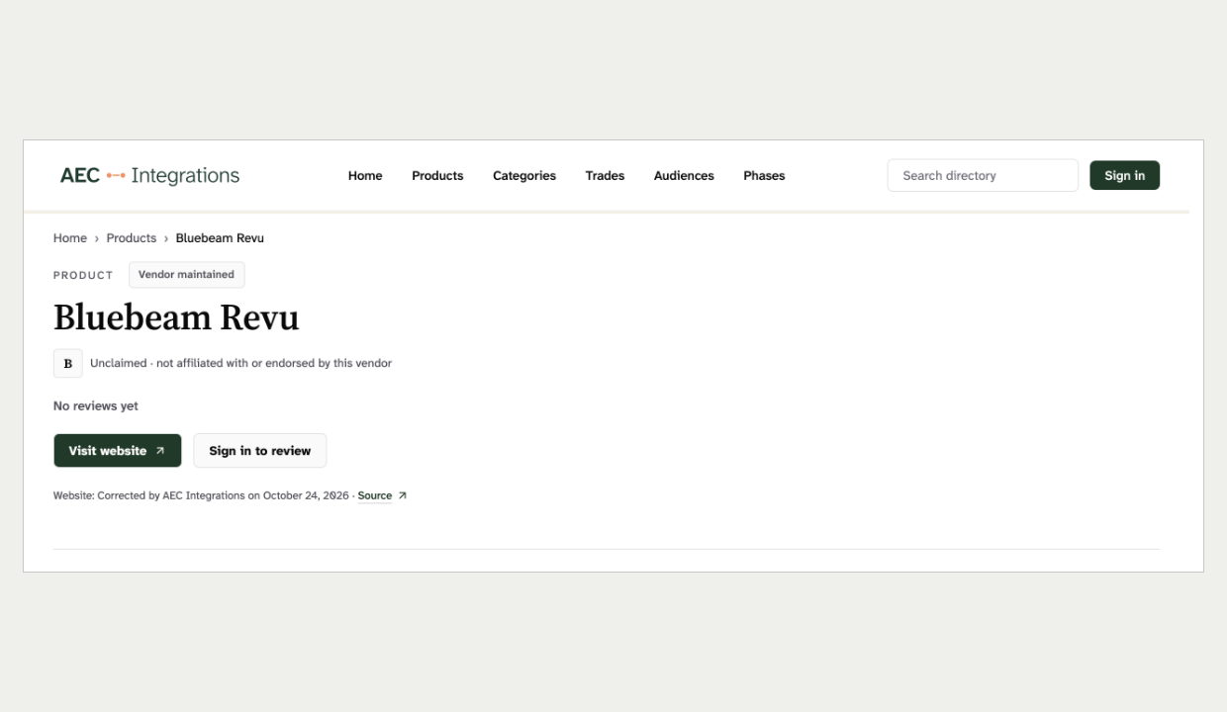 | 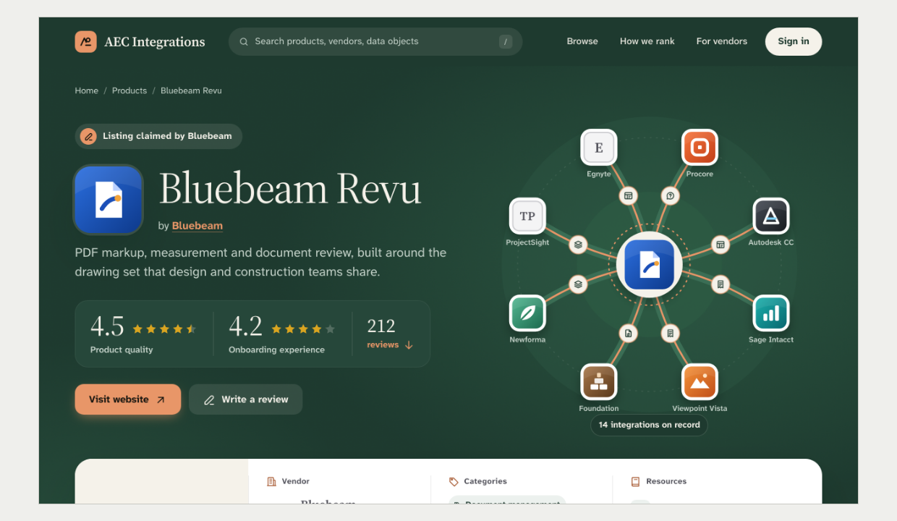
Header and product hero, Bluebeam Revu  Screenshot of the current site | Header and product hero, Bluebeam Revu  Mock-up 6
Recommendation: Override. Rewrite the rule so Forest may be the ground of three chrome bands: the header, the detail-page hero and the footer. The reading body stays white, so the site is still a light theme.
Ruling: x Override ☐ Adopt ☐ Combine Notes: ______________________________

2. Tinted bands as the page ground Size M Combine
Current rule: Bone is for hero and callout bands only and is never a page background. Forest soft, the pale green, is a wash for selected states.
Source: DESIGN.md §2, Bone and Forest soft. BRAND_GUIDELINES.md §4.
New design: Bone, pale green and a new deeper green band alternate down every page. White is a minority of the page.
What is at stake: When every band is tinted, no band reads as emphasis. A selected chip on a pale-green band also loses its signal. Not linted.
Current site | New design
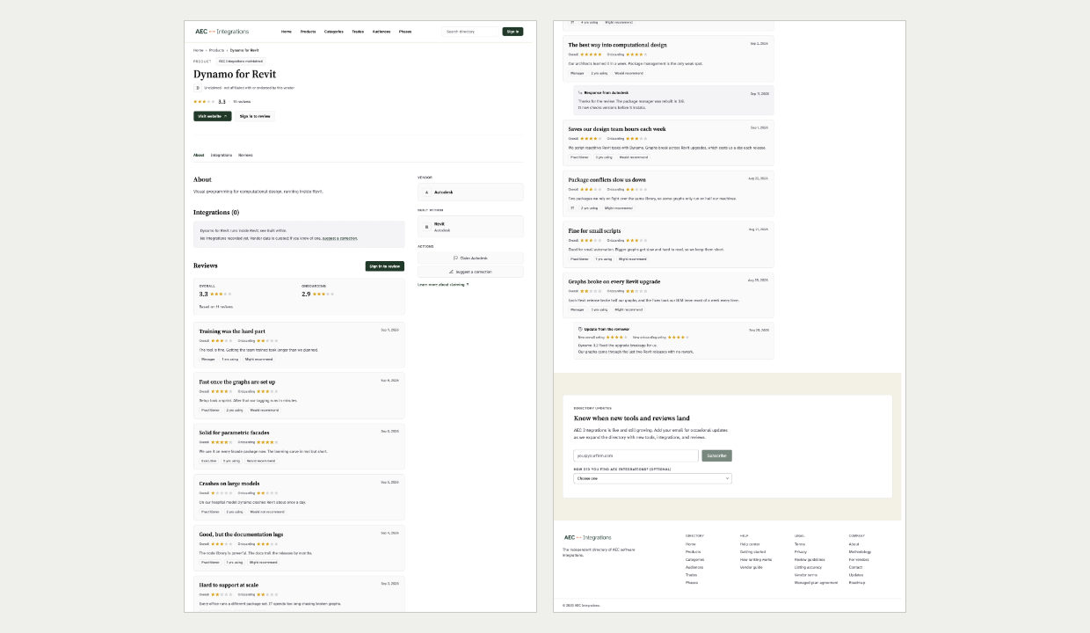 | 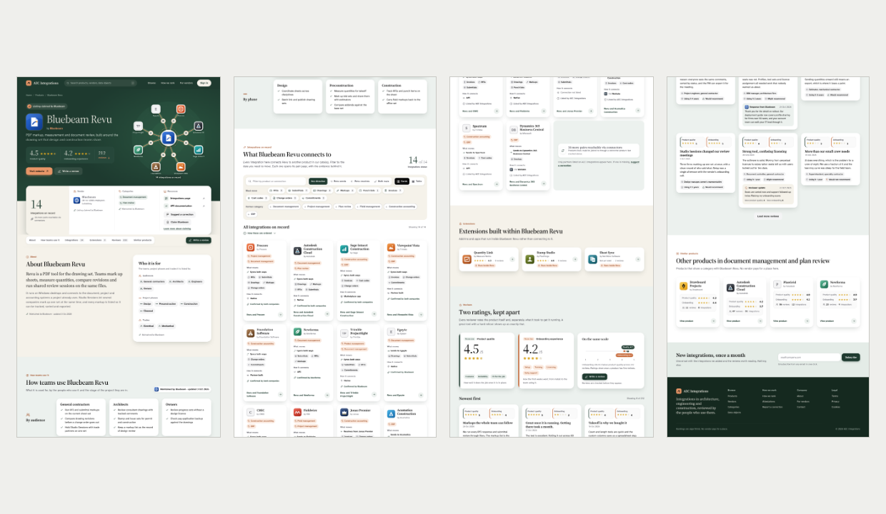
Whole product page, Dynamo for Revit, cut into strips  Screenshot of the current site | Whole product page, Bluebeam Revu, cut into strips  Mock-up 6
Recommendation: Combine. Keep white as the body ground and allow one Bone band per page for the key section. Drop the pale-green and deep-green bands so the pale green keeps meaning "selected".
Ruling: ☐ Override ☐ Adopt x Combine Notes: ______________________________

3. Clay fills the main buttons Size S Combine
Current rule: Every call to action is Forest. Clay never fills one.
Source: DESIGN.md §2, The Forest-Anchor Rule and The Clay-Restriction Rule. BRAND_GUIDELINES.md §5.
New design: "Visit website" and "It does exist" are filled Clay. The status dot, the logo seal and the menu trigger bar are Clay too.
What is at stake: One action colour tells the reader what to press. On a Forest band a Forest button vanishes, so the mock-up reached for Clay. Not linted, because the Clay limit is a review-only rule.
Current site | New design
 | 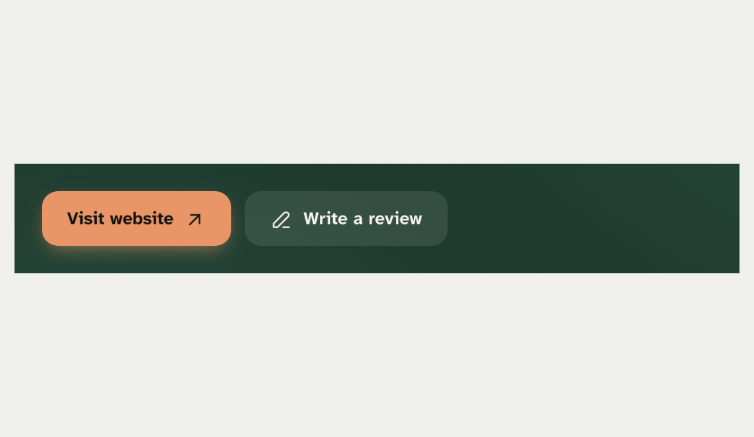
Product page buttons  Screenshot of the current site | Hero buttons on the Forest band  Mock-up 6
Recommendation: Combine. On a Forest band use the inverted primary that already ships in the "Getting Managed" panel: a white fill with Forest text, or a Bone fill. Clay stays a stroke and accent colour only.
Ruling: ☐ Override ☐ Adopt x Combine Notes: ______________________________

4. Clay carries text and meaning Size M Combine
Current rule: Clay never carries text or meaning. Anything orange that means something uses Clay deep, the darker orange. Clay stays under 5% of a screen.
Source: DESIGN.md §2, The Clay-Restriction Rule and the Clay row.
New design: The two product names in the pair statement are Clay. The vendor link, every kicker icon, the focus ring, the category chips and the onboarding series are Clay or Clay deep.
What is at stake: Spread across chips, icons and headings, Clay becomes a second brand colour. It also stops being the rare high-emphasis accent. Not linted.
Current site | New design
 | 
Pair statement set to the rules: ink heading, Forest link  Rendered from the current design rules | Pair statement with Clay product names  Mock-up 5
Recommendation: Combine. Keep Clay deep as the onboarding series colour, which the admin charts already use. Set highlighted names in Bone on Forest. Move chips, kicker icons and the focus ring back to neutral or Forest.
Ruling: ☐ Override ☐ Adopt x Combine Notes: ______________________________

5. Selected states fill solid Size M Combine
Current rule: Selected filters and active chips take the pale-green wash. The active route is Forest text with a 2px Forest underline.
Source: DESIGN.md §2, Forest soft. DESIGN.md §5, The row.
New design: Pressed segments, pressed filter chips, the current section link and chip hover all fill solid Forest. The view toggle fills near-black.
What is at stake: A quiet "selected" keeps the one primary action the loudest thing on the page. A solid-Forest pressed segment already ships twice: the vendor Views period toggle and the Cards toggle on the products page. The black toggle has no precedent. Not linted.
Current site | New design
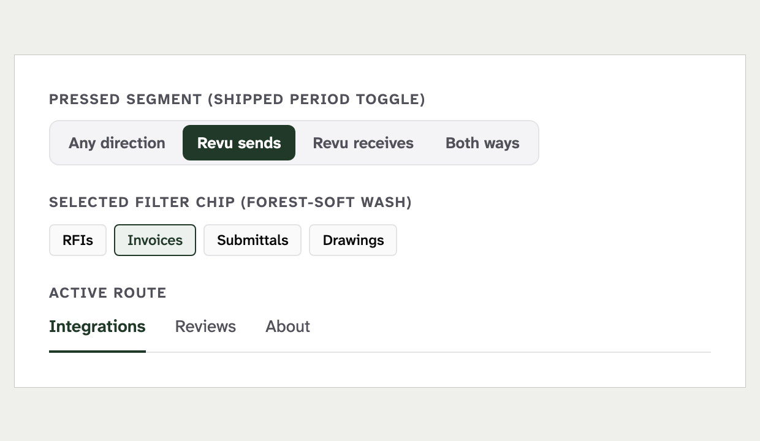 | 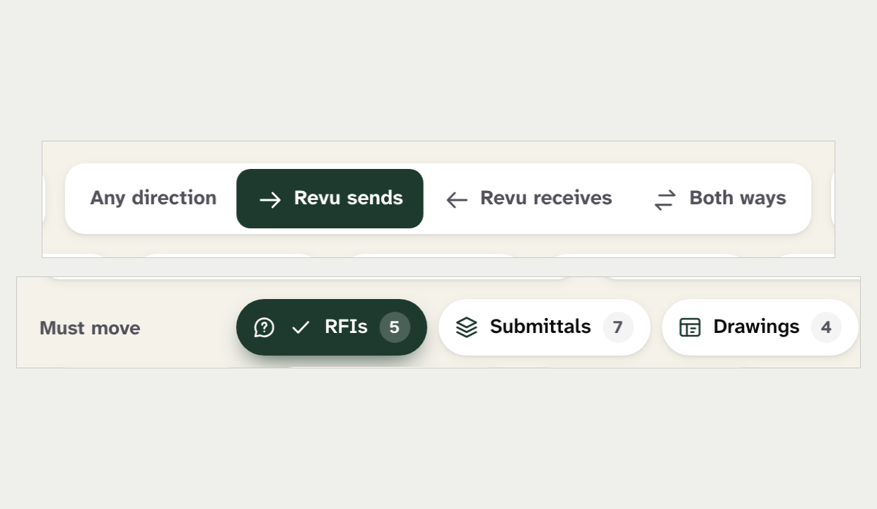
Pressed segment, selected chip and active route, set to the rules  Rendered from the current design rules | Direction segment and data-object chip, both pressed  Mock-up 6
Recommendation: Combine. Allow a solid Forest fill for pressed segmented controls and toggles, as the shipped toggles do. Keep the wash for selected filter chips, and make the view toggle Forest, never black.
Ruling: ☐ Override ☐ Adopt x Combine Notes: ______________________________

6. Colour values outside the token file Size M Combine
Current rule: No colour value may be written outside the token file. Tokens are OKLCH, and shadows use pure black only.
Source: ANGULAR_STYLE_GUIDE.md §20. DESIGN.md §6.
New design: Each page defines about 30 hex colours of its own. It mixes colours in the browser and tints shadows green.
What is at stake: One palette lets the contrast matrix verify every pair. The colour guard in pnpm lint rejects these values, so the markup cannot be ported as written.
Current site | New design
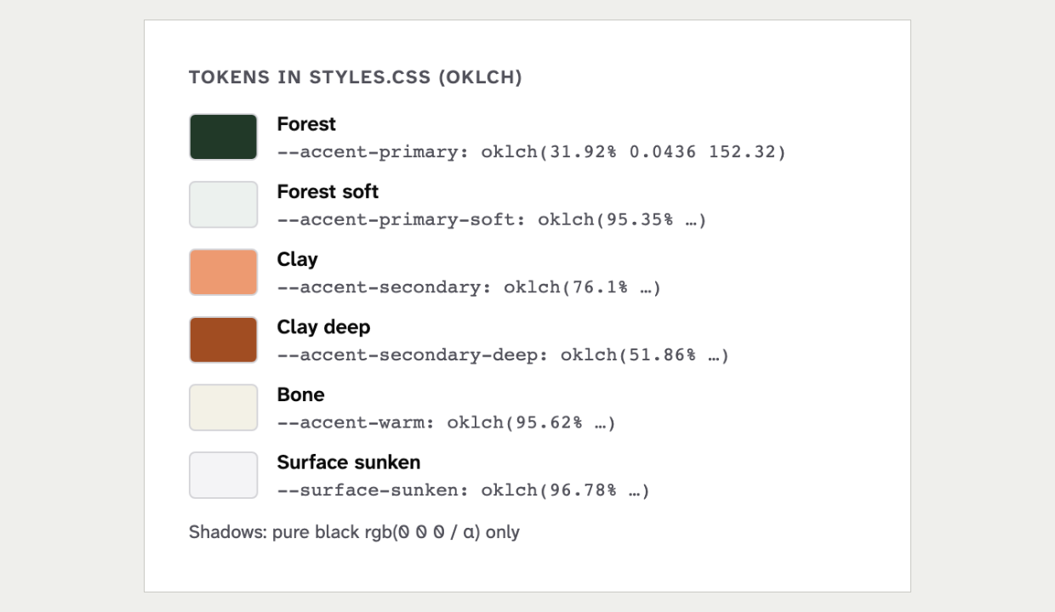 | 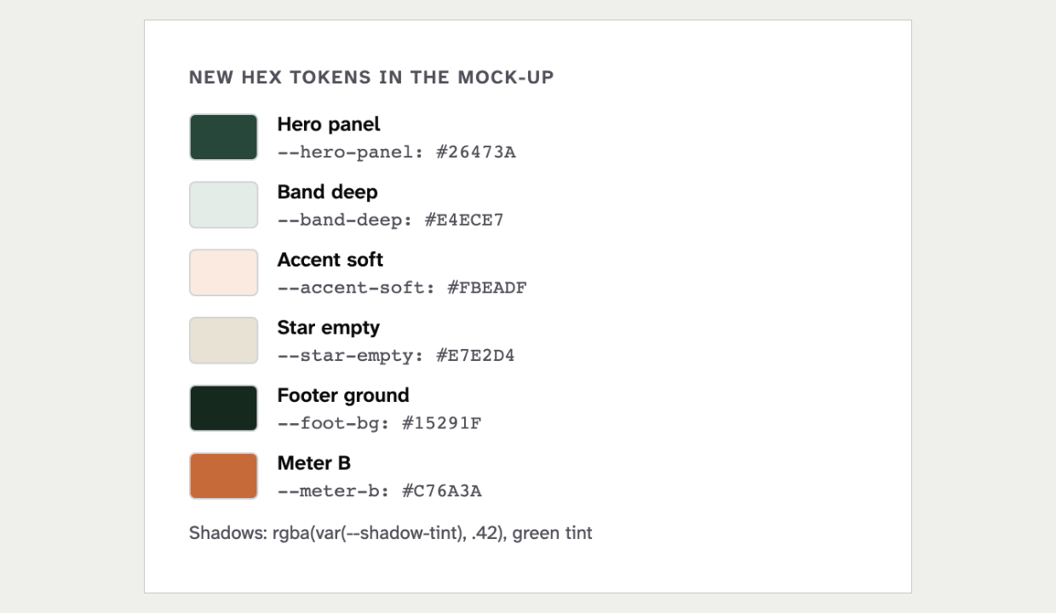
The brand tokens as they ship  Rendered from the current design rules | New colours the mock-up adds, read from its own stylesheet  Mock-up 6
Recommendation: Combine. Add the few genuinely new surfaces, the hero panel and the footer ground, as OKLCH tokens in the token file. Drop the rest, because the lint forces it anyway.
Ruling: ☐ Override ☐ Adopt x Combine Notes: ______________________________

Typography

7. Display type on detail pages Size S Override
Current rule: The Display size is for About, Home and vendor mastheads, once a page. Product pages use the Headline size for the page title.
Source: DESIGN.md §3, Hierarchy.
New design: The product name is set at up to 80px in a light serif weight. The pair statement is up to 58px.
What is at stake: The rule keeps the loudest type for brand pages. A detail page at Display size is the clearest single change in the new look. Not linted.
Current site | New design
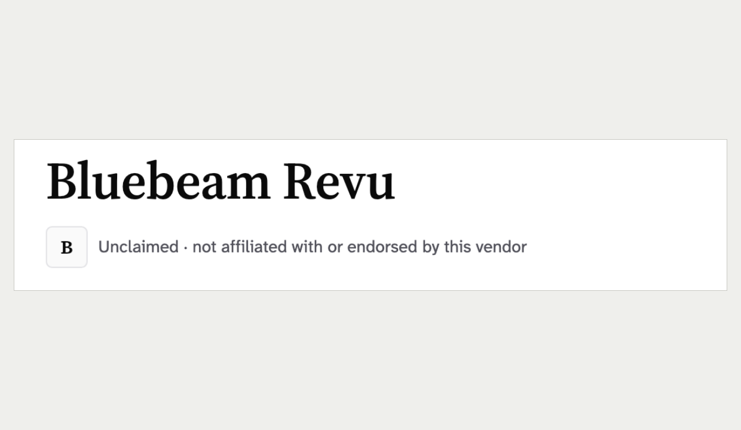 | 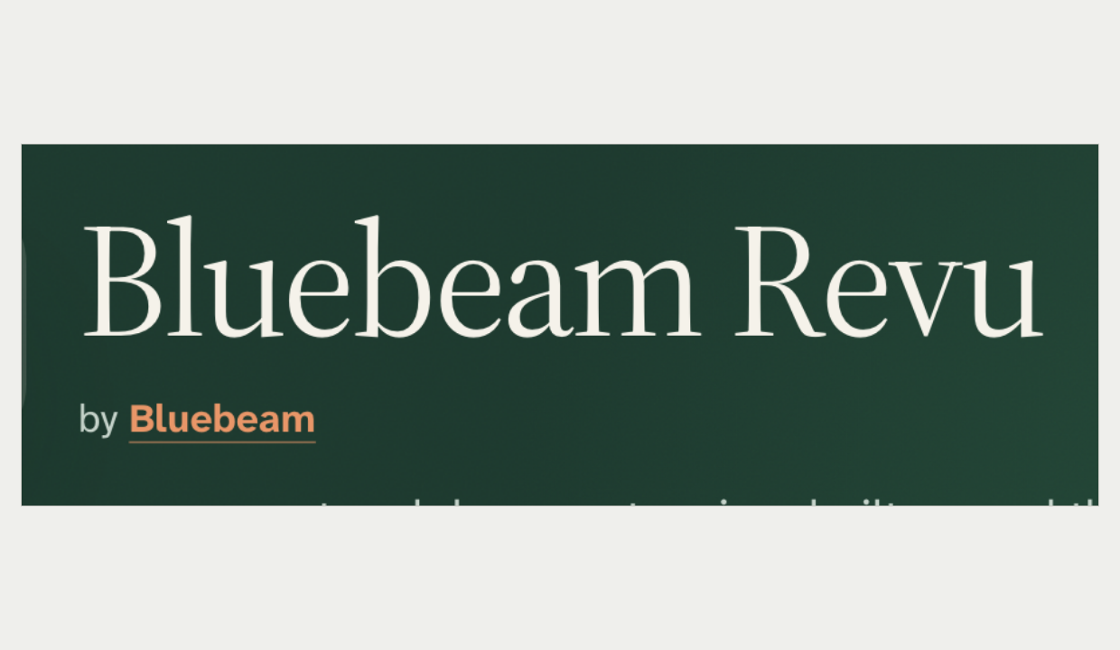
Product page title  Screenshot of the current site | Product page title on the Forest hero  Mock-up 6
Recommendation: Override. Extend Display to the title of product, vendor and pair detail pages, still once per page. This is the change that makes the new look, and it uses the brand serif.
Ruling: x Override ☐ Adopt ☐ Combine Notes: ______________________________

8. Many large figures Size M Combine
Current rule: No big-number dashboard look. A score is one Forest figure at headline scale, and the home page has the only figure row.
Source: DESIGN.md §6, Don't use the hero-metric template. DESIGN.md §5, Score Display.
New design: One product page carries four giant figures between 46px and 84px, in black ink. The pair and empty pages add more.
What is at stake: Four or five giant figures per page read as a SaaS metrics page. Numbers start to pose as proof. Not linted.
Current site | New design
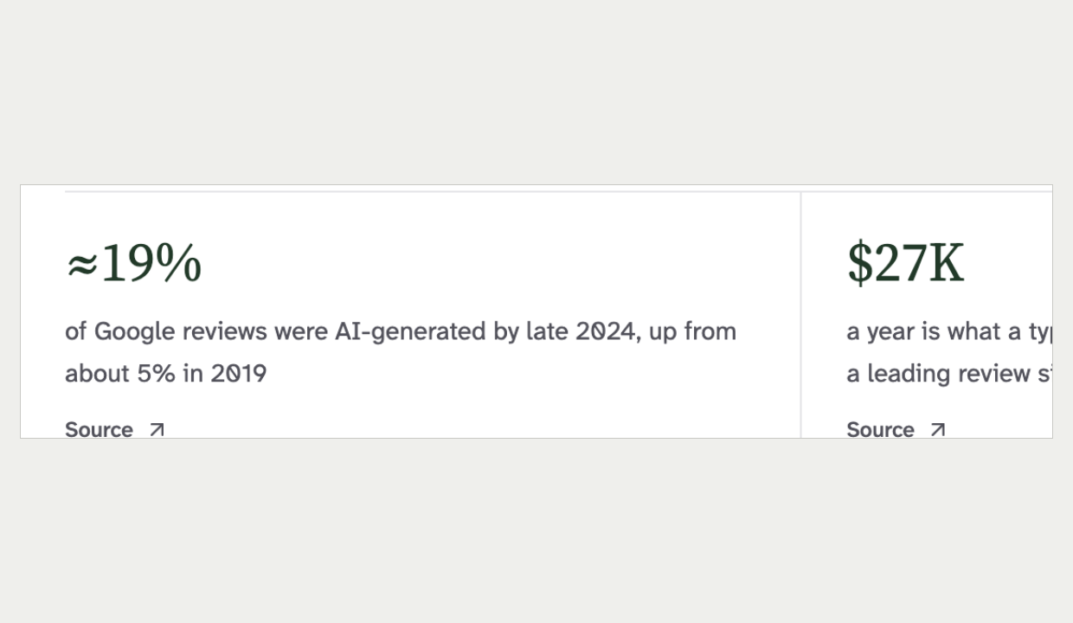 | 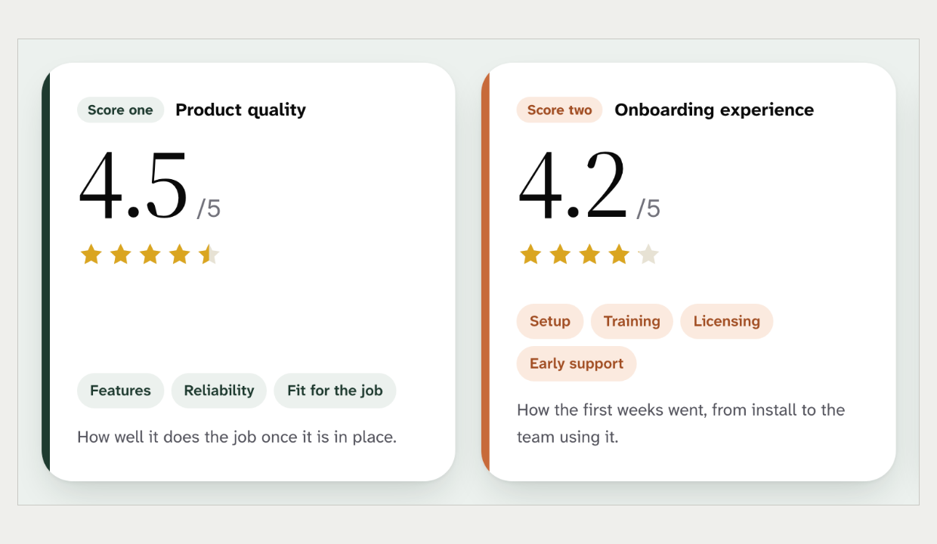
The home page figure row, the one place figures are allowed  Screenshot of the current site | Two 84px review scores in black ink  Mock-up 6
Recommendation: Combine. Keep one large figure per band, in Forest, at the Score Display size. Set the other numbers as inline text.
Ruling: ☐ Override ☐ Adopt x Combine Notes: ______________________________

9. The type ramp Size L Combine
Current rule: Text uses the named type roles. Section headings are 24px, labels are 13px semibold, and the serif never goes below 18px.
Source: DESIGN.md §3, Hierarchy and The Serif-Floor Rule.
New design: Section headings are up to 48px. About ten sizes sit between the roles, and buttons and chips are bold. Some serif text is 16px or 17px.
What is at stake: Named roles keep every page in one voice. The bigger headings and heavier labels are part of the new confidence. Not linted.
Current site | New design
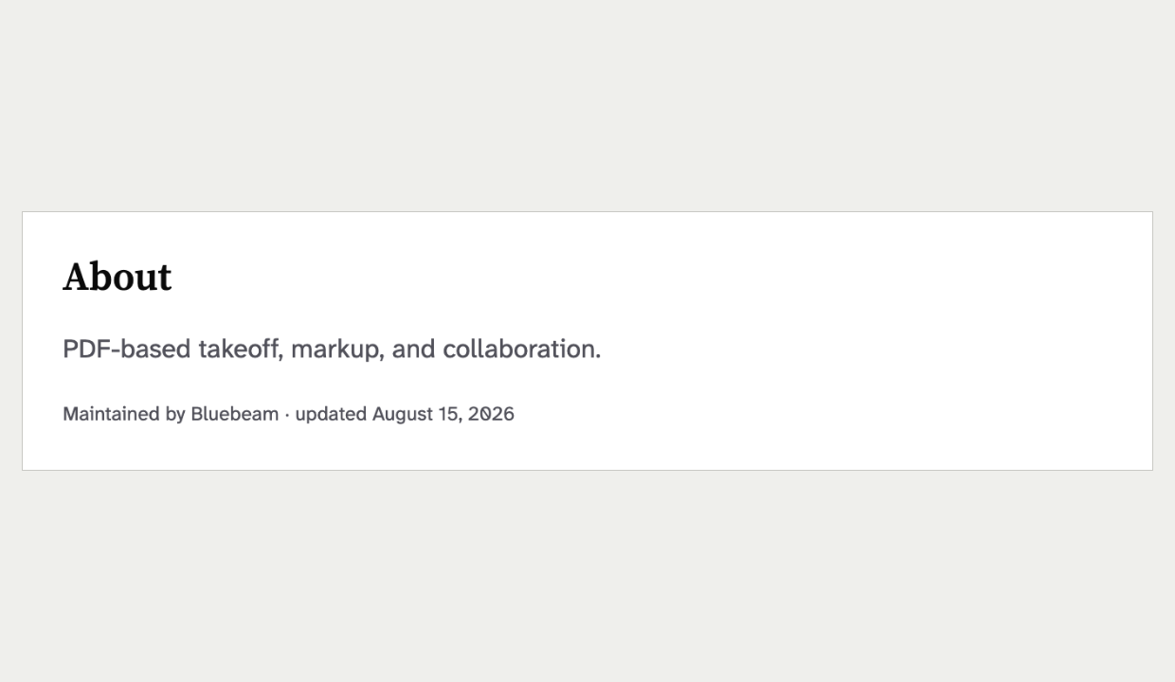 | 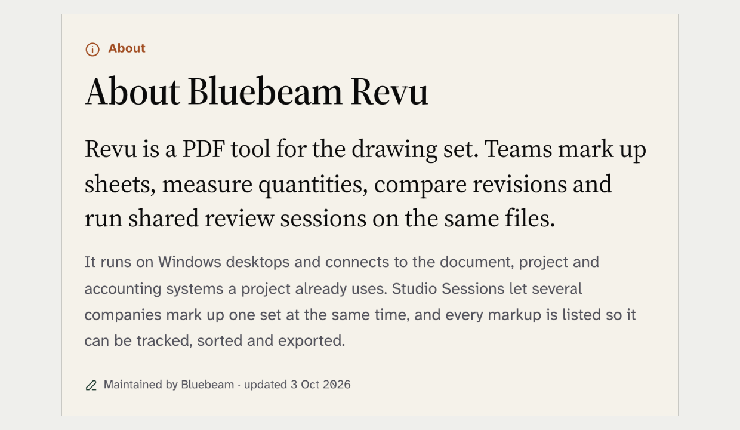
About section: heading, body and caption  Screenshot of the current site | About section with 48px heading and large lede  Mock-up 6
Recommendation: Combine. Add two roles to the rules: a larger section heading of about 36px and a lede of about 19px. Snap everything else to the existing roles, keep labels semibold and keep the serif floor.
Ruling: ☐ Override ☐ Adopt x Combine Notes: ______________________________

10. Eyebrows and microheadings Size M Adopt
Current rule: Eyebrows, kickers and sidebar headings use the overline style. It is small capitals, 12px, semibold and widely spaced.
Source: DESIGN.md §3, Overline and The Sentence-Case Rule.
New design: Kickers are sentence case, 14px, bold and Clay deep with an icon. The menu uses a second, smaller overline. That makes three microheading styles.
What is at stake: One overline style gives the page one print voice. It is also the only uppercase the site allows. Not linted.
Current site | New design
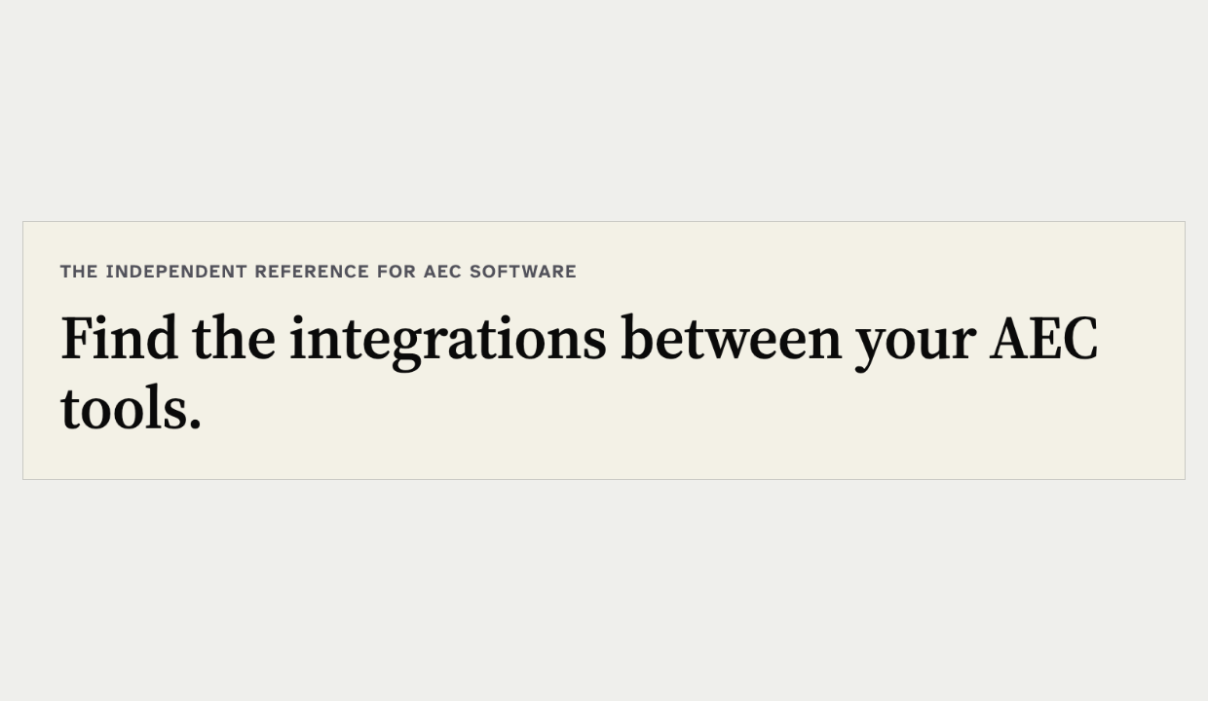 | 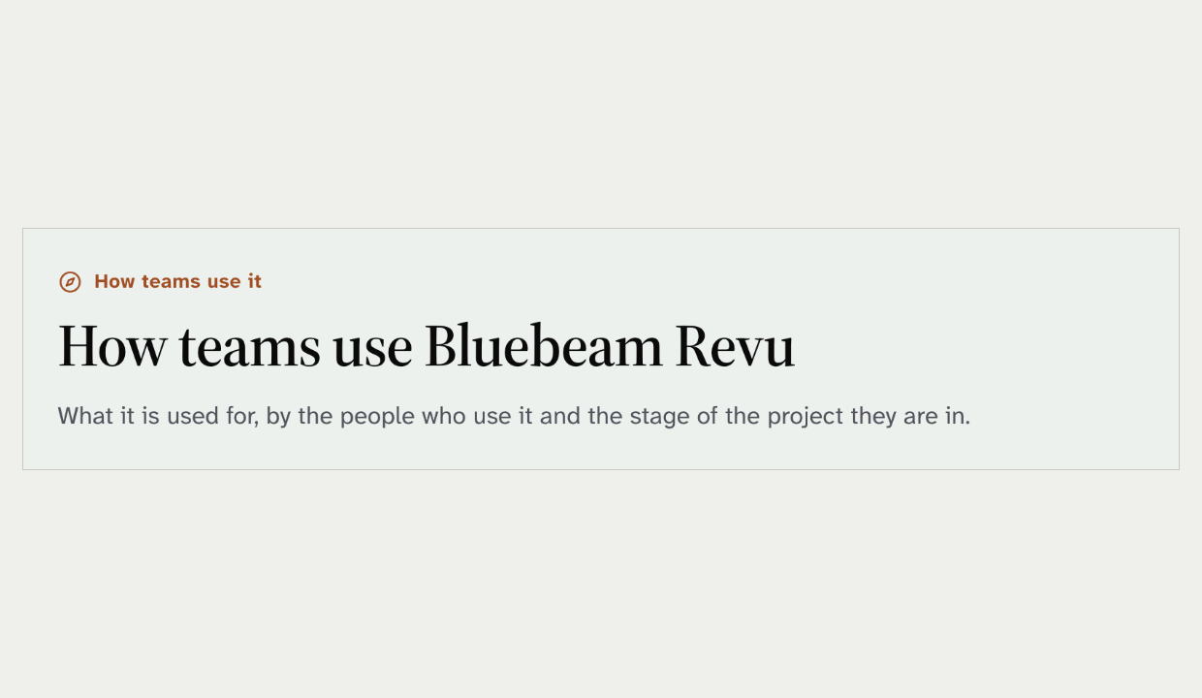
Home page overline above the title  Screenshot of the current site | Clay-deep kicker with icon above a section title  Mock-up 6
Recommendation: Adopt. Use the shipped overline style for every kicker and microheading, including the menu. Drop the Clay-deep kicker icons.
Ruling: ☐ Override x Adopt ☐ Combine Notes: ______________________________

Surfaces, elevation and shape

11. Shadows instead of borders Size L Combine
Current rule: Thin borders separate surfaces. Shadows are only for modals, dropdowns and focus rings, and they use pure black.
Source: DESIGN.md §4, The Borders-Not-Shadows Rule.
New design: Cards, panels, buttons, inputs and chips all float on green-tinted shadows. Almost nothing has a border.
What is at stake: A rounded card with a soft drop shadow is a known generic-AI look. The floating facts card is much of the mock-up's appeal. A tinted shadow fails the colour guard in pnpm lint.
Current site | New design
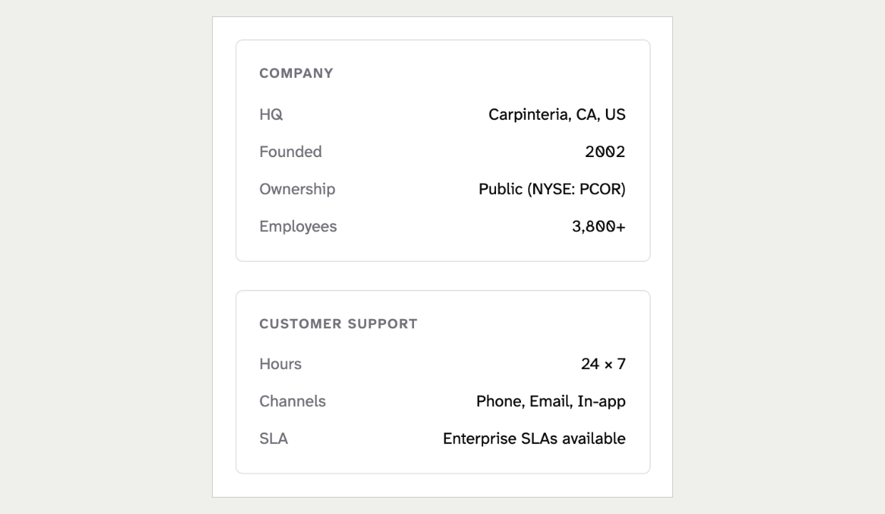 | 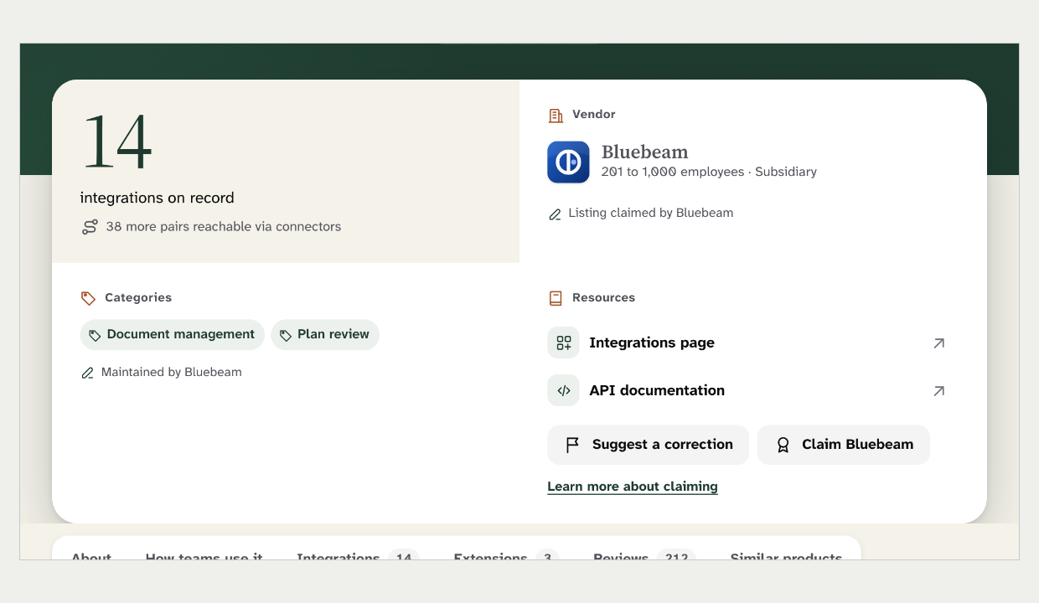
Company facts panels with hairline borders, vendor page preview  Screenshot of the current site | Facts card floating over the hero on a shadow  Mock-up 6
Recommendation: Combine. Add one card-elevation token in pure black for top-level floating surfaces: the facts card and entity cards. Keep borders, not shadows, on buttons, chips, inputs and tabs.
Ruling: ☐ Override ☐ Adopt x Combine Notes: ______________________________

12. Large radii and pill shapes Size L Combine
Current rule: Corner radii are 4, 8, 12 or 16px. Cards are 12px, chips are 4px, and a primary action is never a pill.
Source: DESIGN.md §4, Radius scale. DESIGN.md §5, Buttons.
New design: Cards have 22px to 26px corners and the menu panel 30px. "Sign in", the search link, every chip and the section-nav counts are pills.
What is at stake: Calm corners keep the print feel, and pill actions read as social-media UI. The soft large corners are central to the new look. Not linted.
Current site | New design
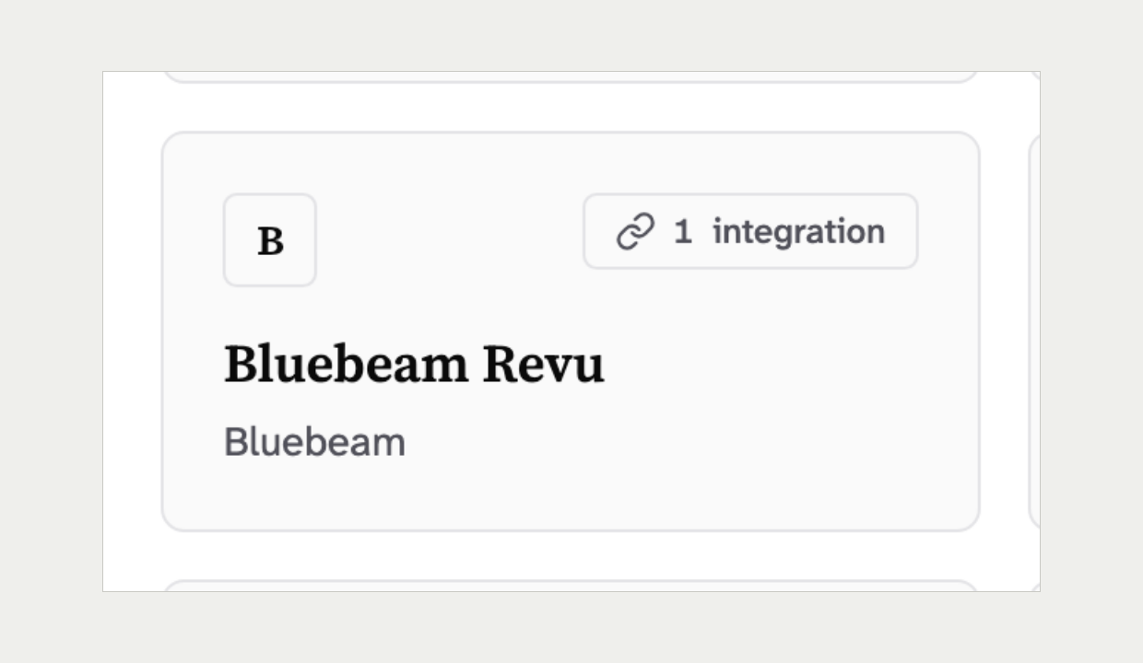 | 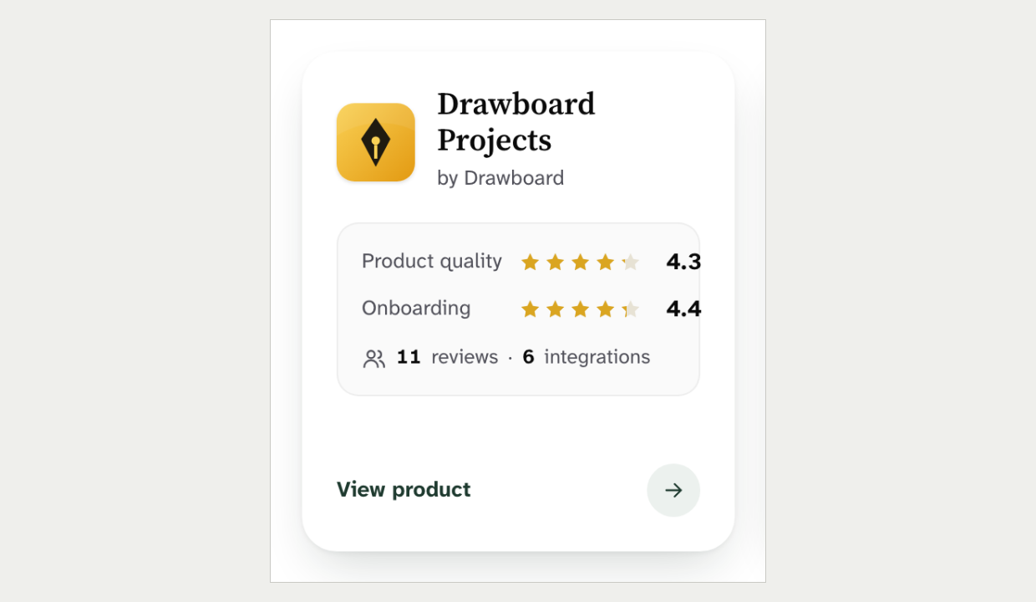
Product card with 12px corners and a 4px chip  Screenshot of the current site | Similar-product card with 24px corners and round controls  Mock-up 6
Recommendation: Combine. Add a 20px to 24px card radius and a 12px control radius to the scale. Let public chips be pills, but keep primary actions off the pill, so "Sign in" becomes a rounded rectangle.
Ruling: ☐ Override ☐ Adopt x Combine Notes: ______________________________

13. Gradients, noise and frosted glass Size S Adopt
Current rule: No gradient backgrounds for effect and no decorative frosted glass. A blurred sticky nav was removed once because text showed through.
Source: DESIGN.md §6. The section-nav component history.
New design: The hero has two radial glows and a noise texture. The empty-state card, the menu card and two meters use gradients, and the sticky section nav is blurred glass.
What is at stake: The rule keeps the site out of the AI-startup look. The noise and blur add nothing a solid Forest does not. Not linted.
Current site | New design
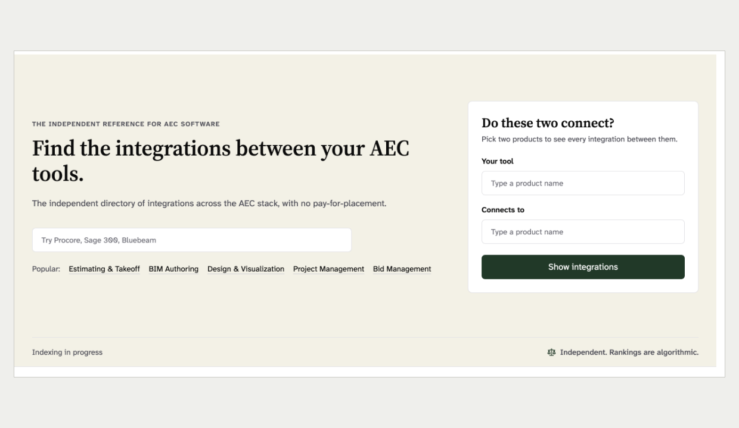 | 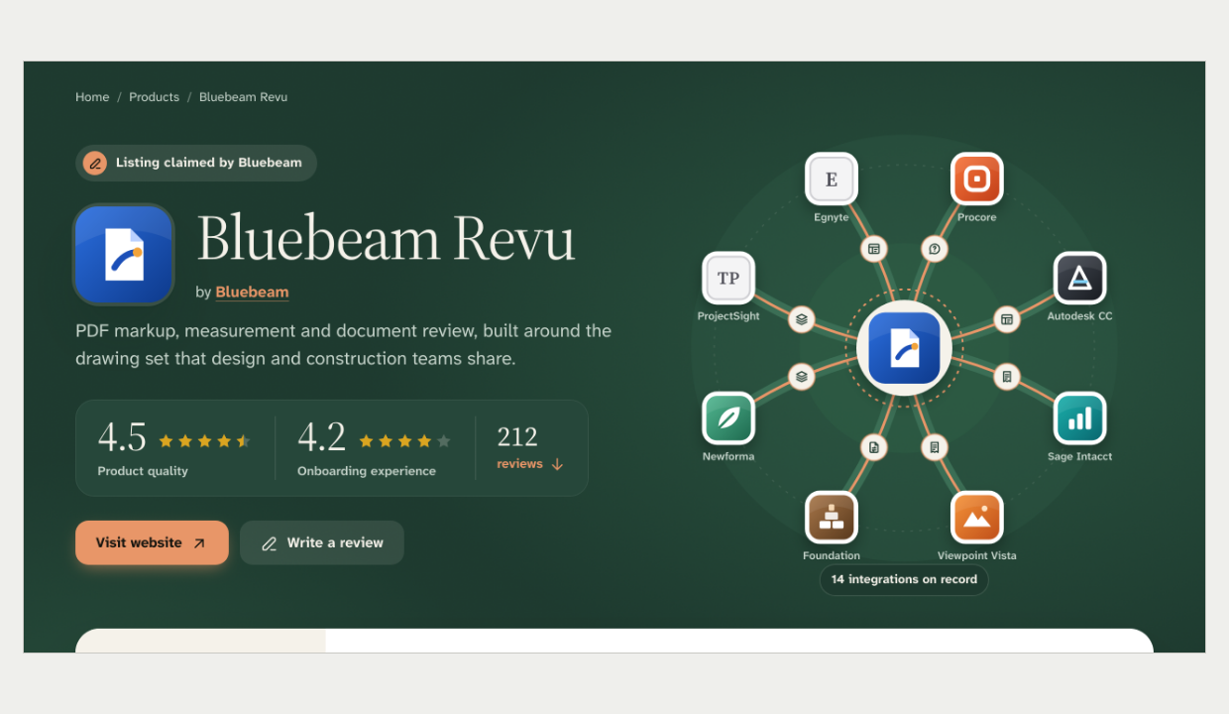
Home hero on a solid Bone band  Screenshot of the current site | Product hero with radial glows and a noise overlay  Mock-up 6
Recommendation: Adopt. Use solid Forest and solid surfaces, and a solid sticky bar. The section-nav history already decided this.
Ruling: ☐ Override ☐ Adopt ☐ Combine Notes: I really like the new design, convince me we need to change it.______________________________

14. Cards inside cards Size M Adopt
Current rule: Cards are never nested. A vendor reply sits below the review card on a grey ground with a full border, never inside it.
Source: DESIGN.md §6. DESIGN.md §5, Vendor replies.
New design: Each review card holds its own score tiles and a tinted reply panel. Product cards, the sidebar and the facts card hold more boxes inside.
What is at stake: Nested tinted boxes are the main source of visual noise in the mock-up. Flat structure reads faster. Not linted.
Current site | New design
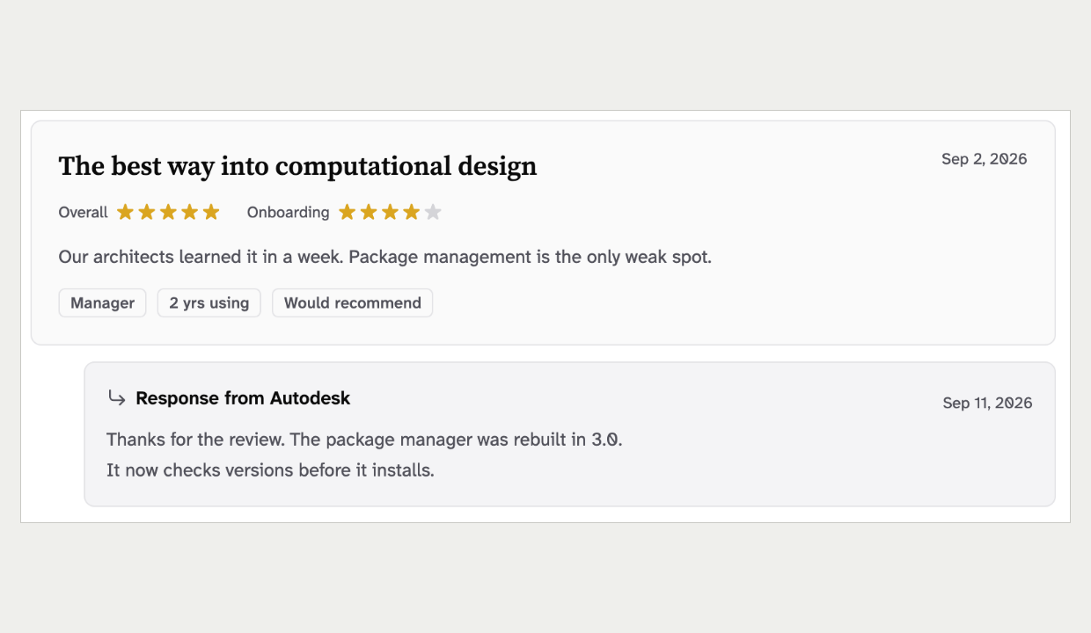 | 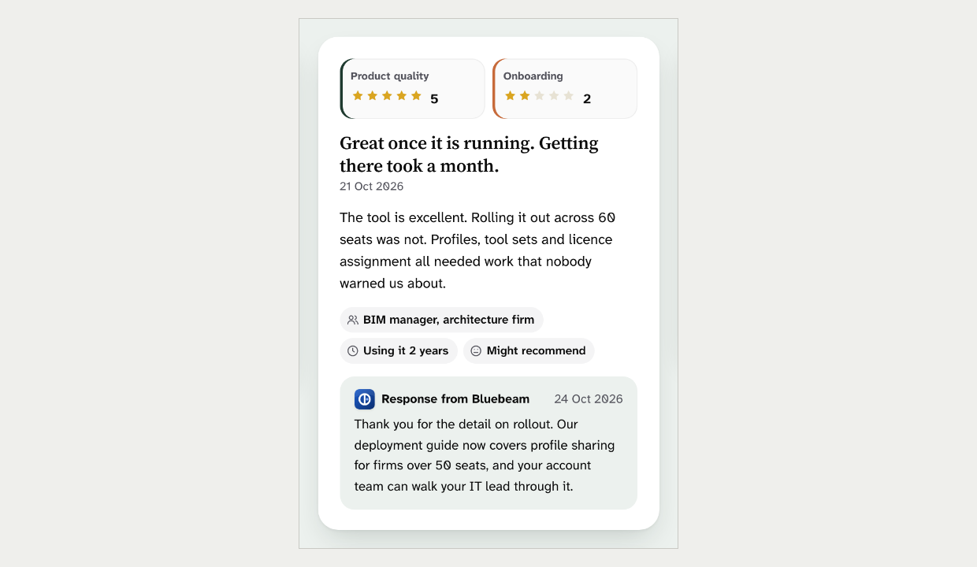
Review with the vendor response below it  Screenshot of the current site | Review card with score tiles and the reply inside  Mock-up 6
Recommendation: Adopt. Flatten with hairlines and spacing. Move the vendor reply below the review card, as it ships today.
Ruling: x Override ☐ Adopt ☐ Combine Notes: ______________________________

15. Side stripes Size S Adopt
Current rule: A coloured stripe thicker than 1px down the side of a card is banned.
Source: DESIGN.md §6, Side-stripe borders are banned.
New design: Each score card has a 7px stripe down its left edge. Other score rows use a 3px inset stripe.
What is at stake: Side stripes are a stock dashboard look. Here the stripe does real work, because it codes quality against onboarding. Not linted.
Current site | New design
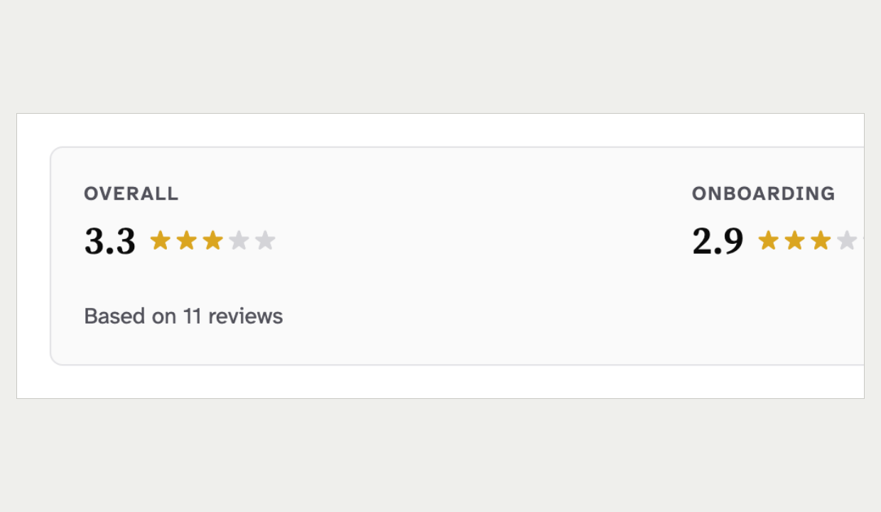 | 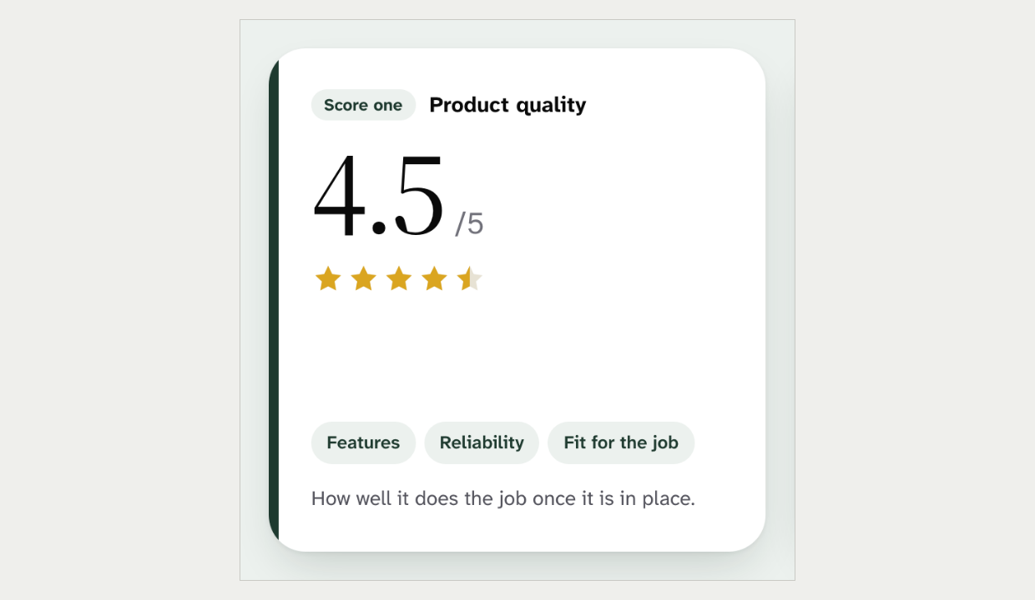
Review score summary with no stripe  Screenshot of the current site | Score card with a 7px Forest stripe  Mock-up 6
Recommendation: Adopt. Carry the two-score coding with the label colour or a small leading dot. The coding survives without the stripe.
Ruling: x Override ☐ Adopt ☐ Combine Notes: ______________________________

Layout and density

16. The detail page layout Size L Override
Current rule: Detail pages use the shared detail layout: a two-column body with a sticky sidebar. Tables in the body column are checked against a 608px width.
Source: DESIGN.md §5, DetailLayout.
New design: There is no sidebar. A dark hero is followed by a facts card that overlaps it, then full-width bands. Tables ask for up to 1240px.
What is at stake: The shared layout keeps vendor, product and pair pages built one way. Full-width bands are the core of the new design and remove the 608px limit. Pinned by the layout shell and per-page specs.
Current site | New design
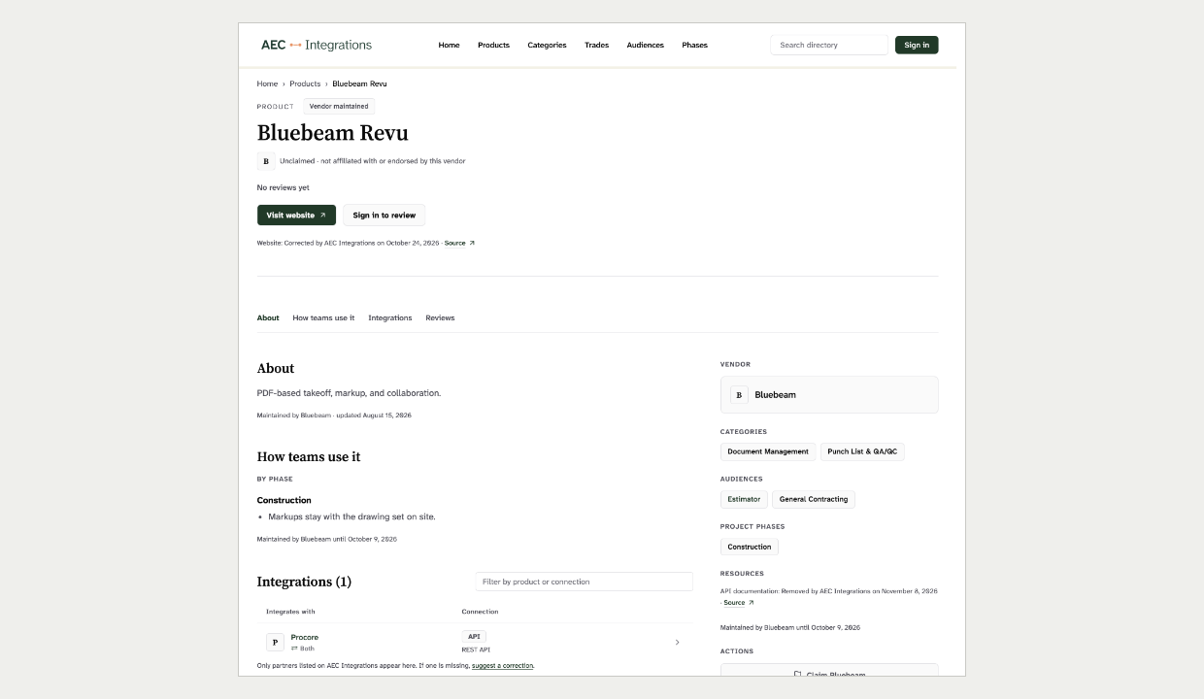 | 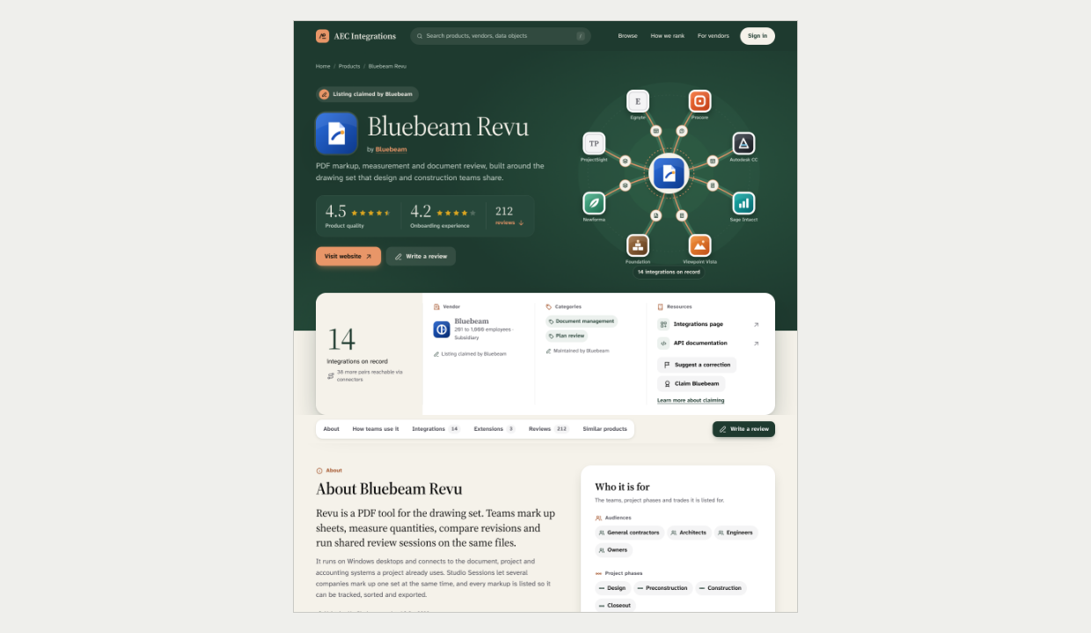
Product page, first screen and a half  Screenshot of the current site | Product page, first screen and a half  Mock-up 6
Recommendation: Override. Rewrite the detail layout as a band shell with a facts strip. Set a new table width check against the full 1216px column.
Ruling: x Override ☐ Adopt ☐ Combine Notes: ______________________________

17. Spacing off the 4-point scale Size M Adopt
Current rule: Spacing uses the 4-point scale. Page sections use the scale steps for their padding.
Source: DESIGN.md §6, Do vary spacing for visual rhythm.
New design: Bands, gaps and gutters use values between the scale steps.
What is at stake: The scale keeps rhythm the same across components built by different people. The values are close to the scale, so snapping them costs little and is not visible at a glance. Not linted.
Today | With the new design
Scale steps: 4, 8, 12, 16, 24, 32, 48, 64, 96 px  Section padding: 32 px, or 48 px from md  Gutter: From the container rules | Band padding: 104 px top, 96 px bottom  Gaps: 22, 26, 28, 30, 34, 38, 46 px  Gutter: 56 px
Recommendation: Adopt. Snap to the scale: 22 to 24, 26 and 28 to 24 or 32, and 104 to 96. The look survives.
Ruling: ☐ Override ☐ Adopt x Combine Notes: ____I do believe we have too many font sizes and varients, see what it looks like to limit them.

18. Uniform card grids Size M Combine
Current rule: No identical card grids. Product grids vary card sizes and lead with a wide card.
Source: DESIGN.md §6. PRODUCT.md, Anti-references.
New design: Integrations sit in four equal columns. Similar products, extensions, reviews and use cases are equal 3-up or 4-up grids.
What is at stake: Equal grids make the catalogue read like G2 or Capterra. Page 7 already breaks the rhythm with group headers. Not linted.
Current site | New design
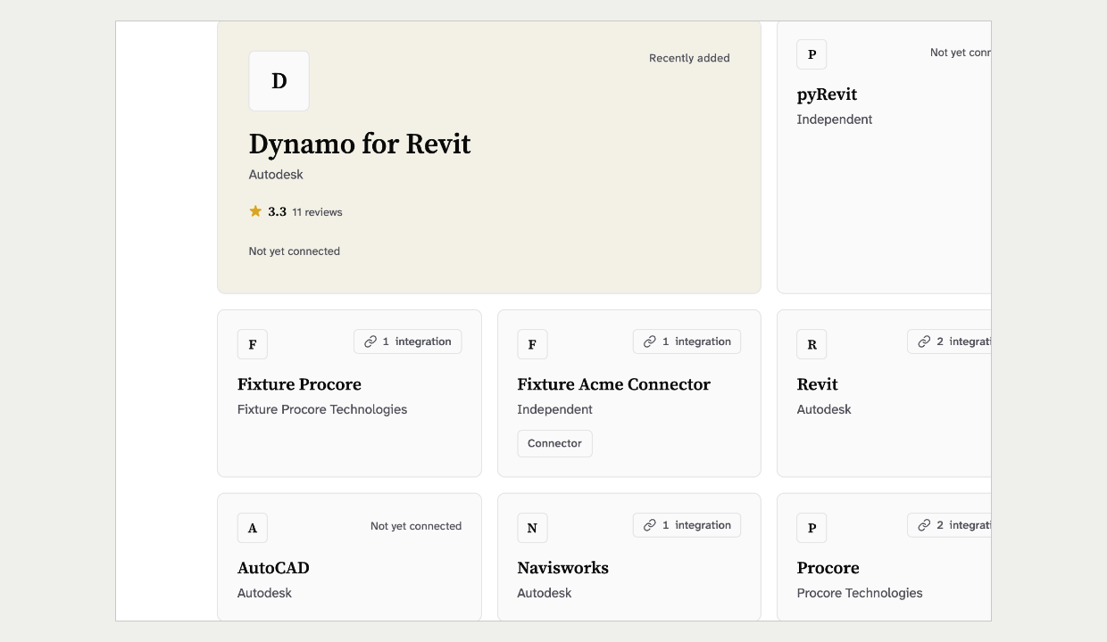 | 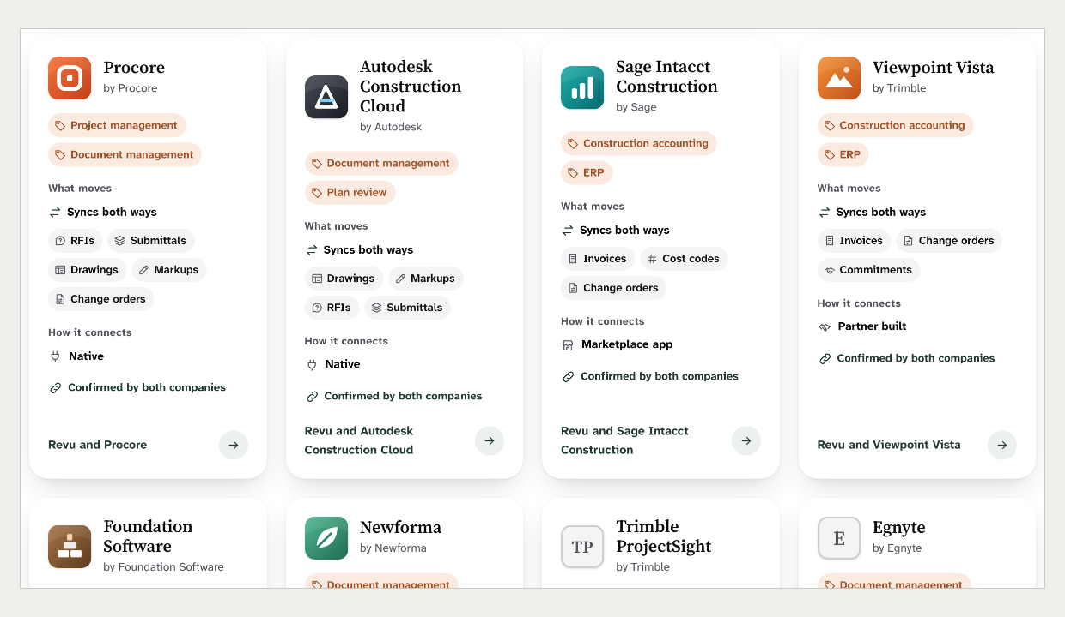
Products grid with a wide lead card  Screenshot of the current site | Integrations in four equal columns  Mock-up 6
Recommendation: Combine. Keep cards, but cap grids at three columns. Break each grid with a group header or a wider lead card, as page 7 does.
Ruling: ☐ Override ☐ Adopt x Combine Notes: ______________________________

19. Charts and meters on public pages Size M Combine
Current rule: Data charts are for the operator console only. A score may carry one plain range mark on an axis, with no fill and no gradient.
Source: DESIGN.md §5, Data visualization and Score Display.
New design: Product pages show a two-pin score scale with a gradient gap bar. Other pages add meters, evidence bars and category bars.
What is at stake: Public pages should show a number in text, never a decoration that looks like analysis. The bars do print their numbers beside them. Not linted.
Current site | New design
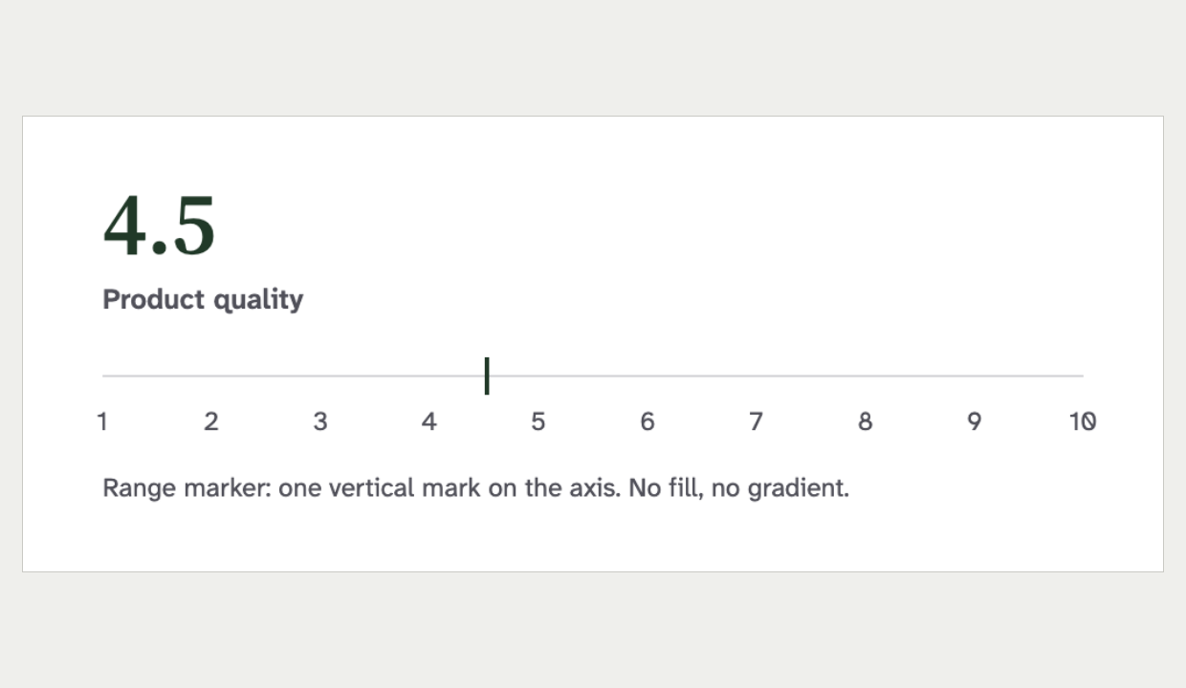 | 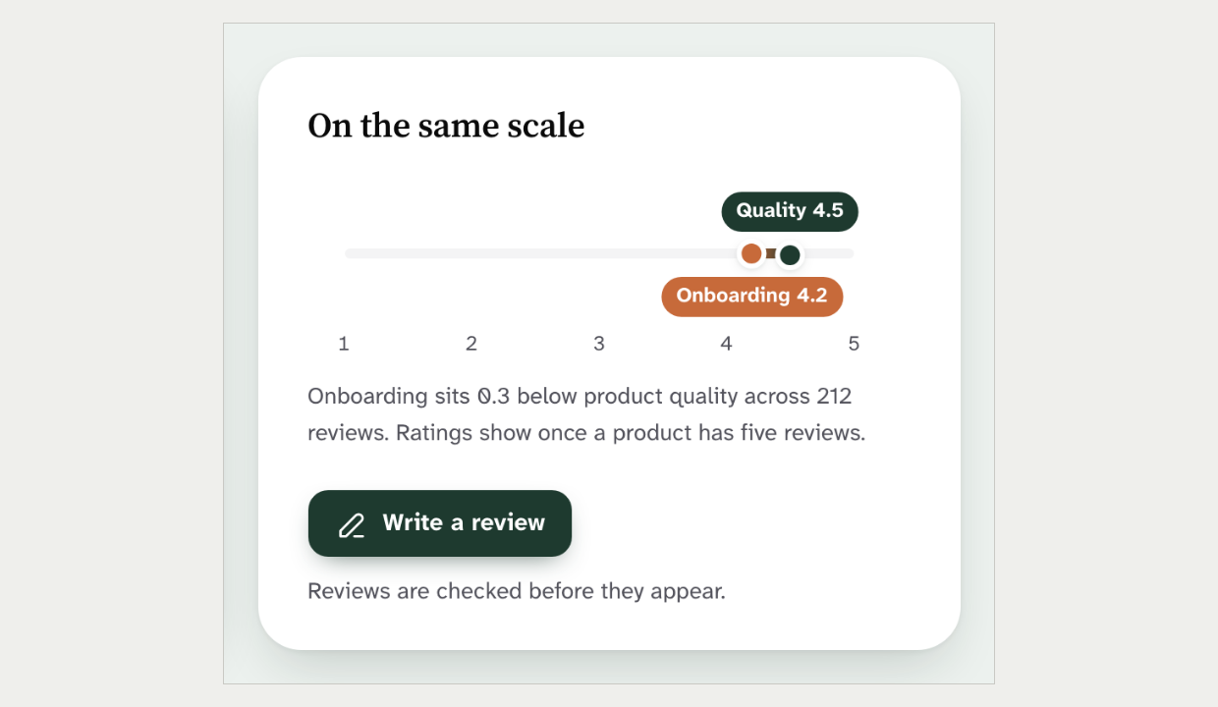
Score with a single range mark  Rendered from the current design rules | "On the same scale" with two pins and a gradient gap  Mock-up 6
Recommendation: Combine. Allow one public bar-meter pattern: single-hue Forest, no gradient, the number always printed. Rebuild the score scale to the range-mark rule.
Ruling: ☐ Override ☐ Adopt x Combine Notes: ______________________________

Components

20. Button anatomy Size L Combine
Current rule: Buttons use the label type at 13px semibold with 8px corners. The secondary button has a thin border, and nothing moves or casts a shadow on hover.
Source: DESIGN.md §5, Buttons.
New design: Buttons are 48px tall, bold, 15.5px, with 14px corners. Secondary buttons are borderless grey fills, and primaries cast shadows.
What is at stake: The rule keeps buttons calm and alike everywhere. The 44px to 48px height is a real gain in target size. Not linted.
Current site | New design
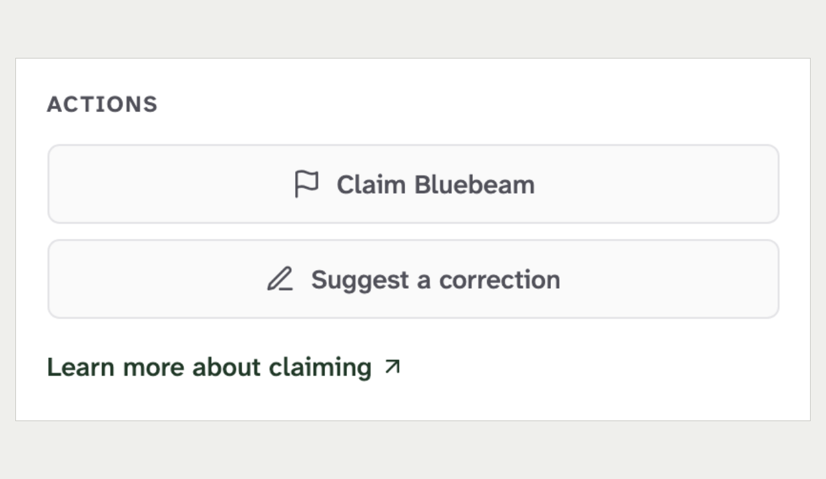 | 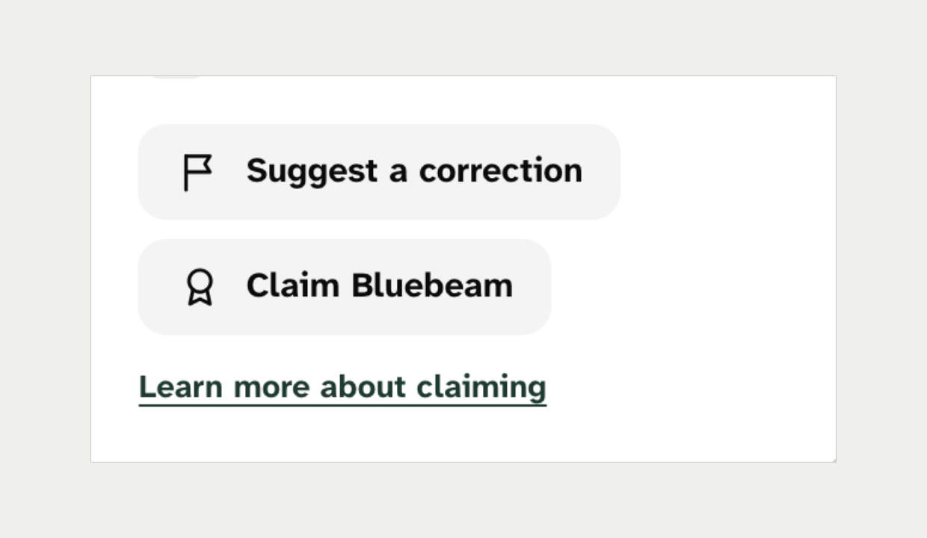
Sidebar action buttons  Screenshot of the current site | Facts-card action buttons  Mock-up 6
Recommendation: Combine. Take the 44px minimum height and a 12px radius. Keep the label weight, the bordered secondary and no shadow.
Ruling: ☐ Override ☐ Adopt x Combine Notes: _I like of like same size buttons _____________________________

21. Link styling Size M Adopt
Current rule: Accent colour is spent on the one primary action. Standalone links are small, grey and underlined, and links inside sentences are Forest and underlined.
Source: DESIGN.md §5, The Link Treatment Rule.
New design: Many links are bold Forest with no underline at rest. Product page 6 shows three filled primary buttons at once.
What is at stake: The rule keeps the reader's one task obvious and ties link style to its role. Not linted.
Current site | New design
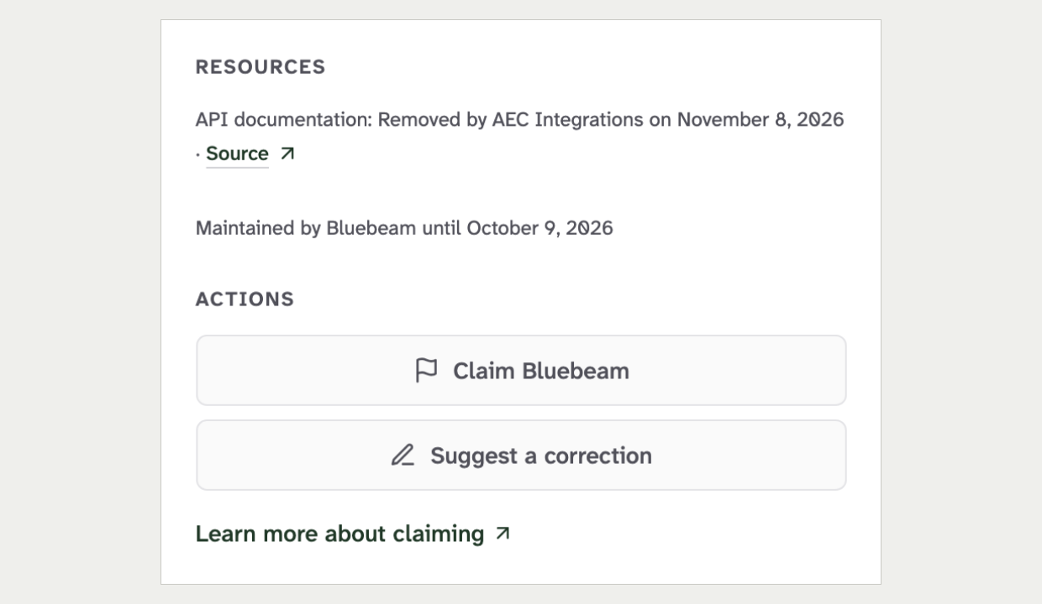 | 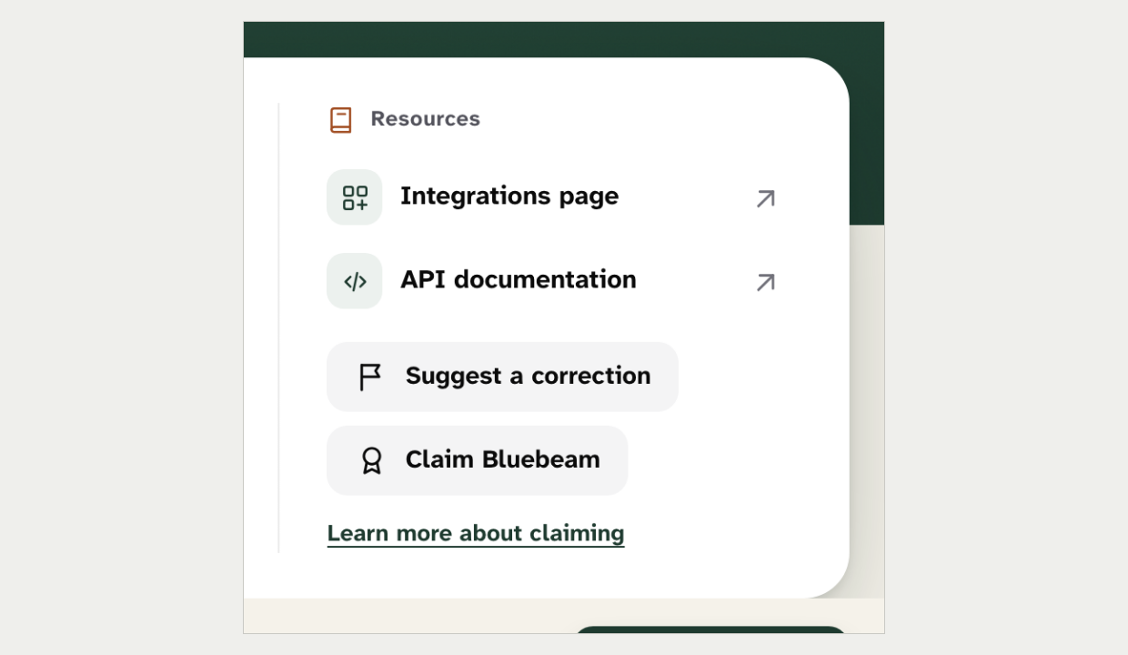
Sidebar resources and the claim link  Screenshot of the current site | Facts-card resources and the claim link  Mock-up 6
Recommendation: Adopt. Use the standalone-link style for "See all" links and the in-text style inside sentences. Keep one filled primary per view.
Ruling: ☐ Override x Adopt ☐ Combine Notes: ______________________________

22. Too many chip styles Size L Combine
Current rule: There is one chip spec, plus one denser in-row badge. The taxonomy chip is bordered, 4px corners, 13px medium.
Source: DESIGN.md §5, One chip spec and TaxonomyBadge.
New design: There are at least seven chip styles, mostly pills, mostly with icons, in weights from 600 to 700.
What is at stake: Mixed chip sizes broke rows twice before. Seven styles will break them again. Not linted.
Current site | New design
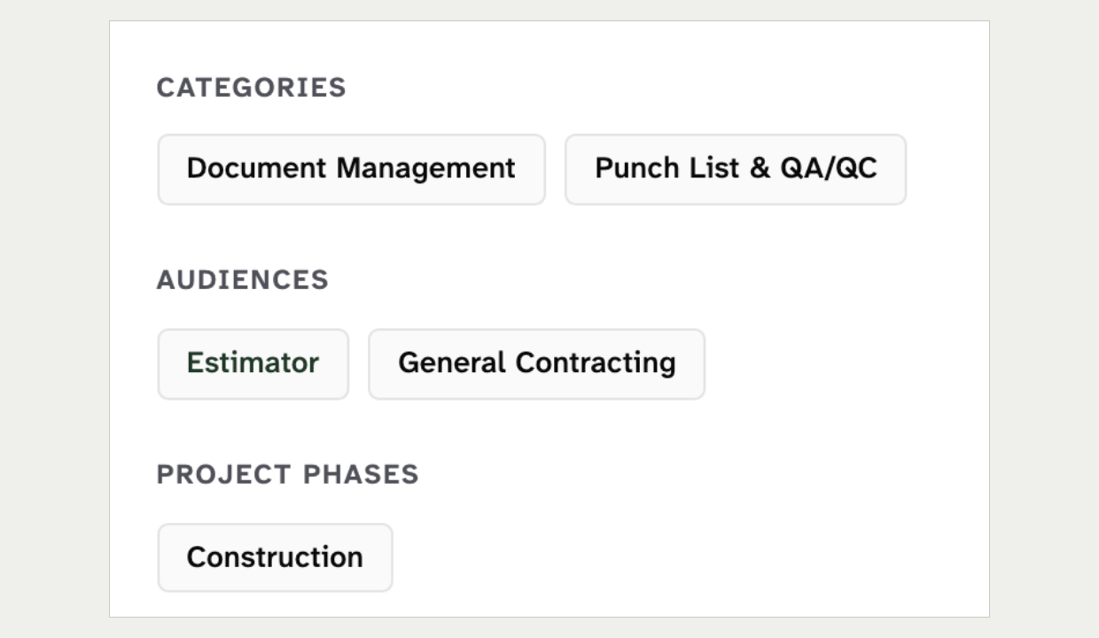 | 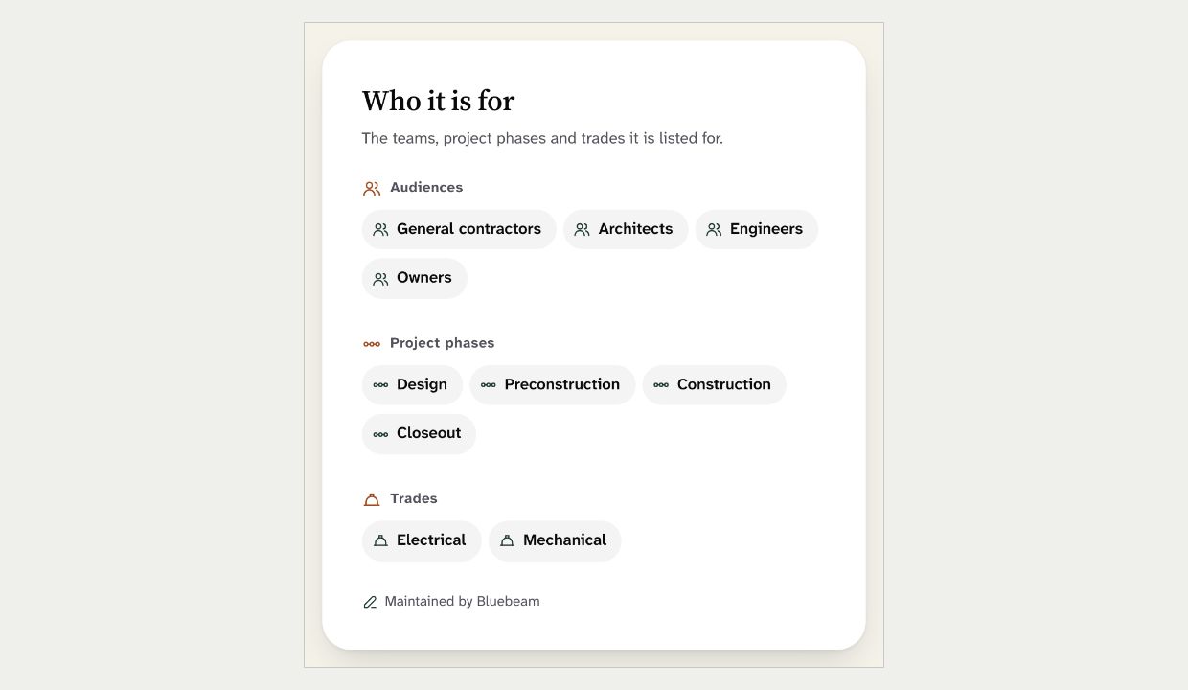
Sidebar taxonomy chips  Screenshot of the current site | "Who it is for" panel with icon pills  Mock-up 6
Recommendation: Combine. Define one public pill chip with an optional leading icon and one dense in-row variant. Rewrite the chip section around them and drop the Clay-tinted category chip.
Ruling: ☐ Override ☐ Adopt x Combine Notes: ______________________________

23. Inputs Size M Adopt
Current rule: Inputs have a 1px border in the input grey and a plain border colour change on focus, with no glow. Errors use the red status colour.
Source: DESIGN.md §5, Inputs.
New design: Inputs have no border, a shadow and 14px corners. Focus adds a wide tinted halo, and errors are Clay deep on a Clay tint.
What is at stake: A borderless input can fail the 3:1 boundary contrast that the input border exists to meet. Clay errors break the rule that warnings, not errors, use Clay deep. Not linted.
Current site | New design
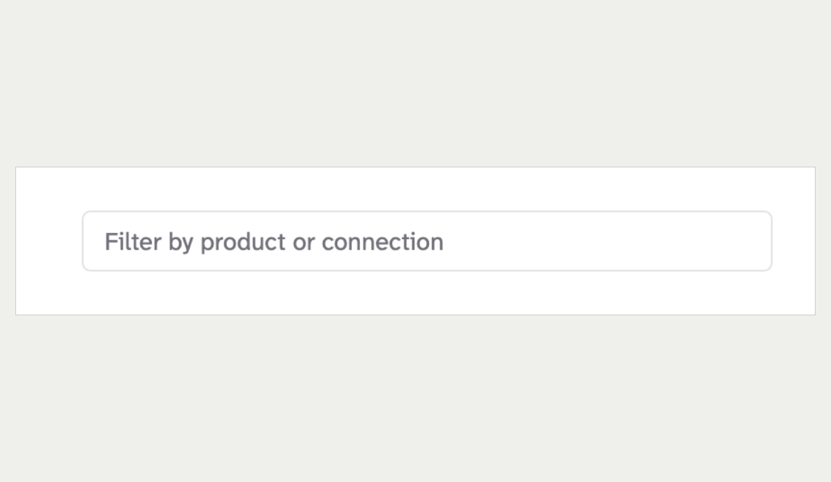 | 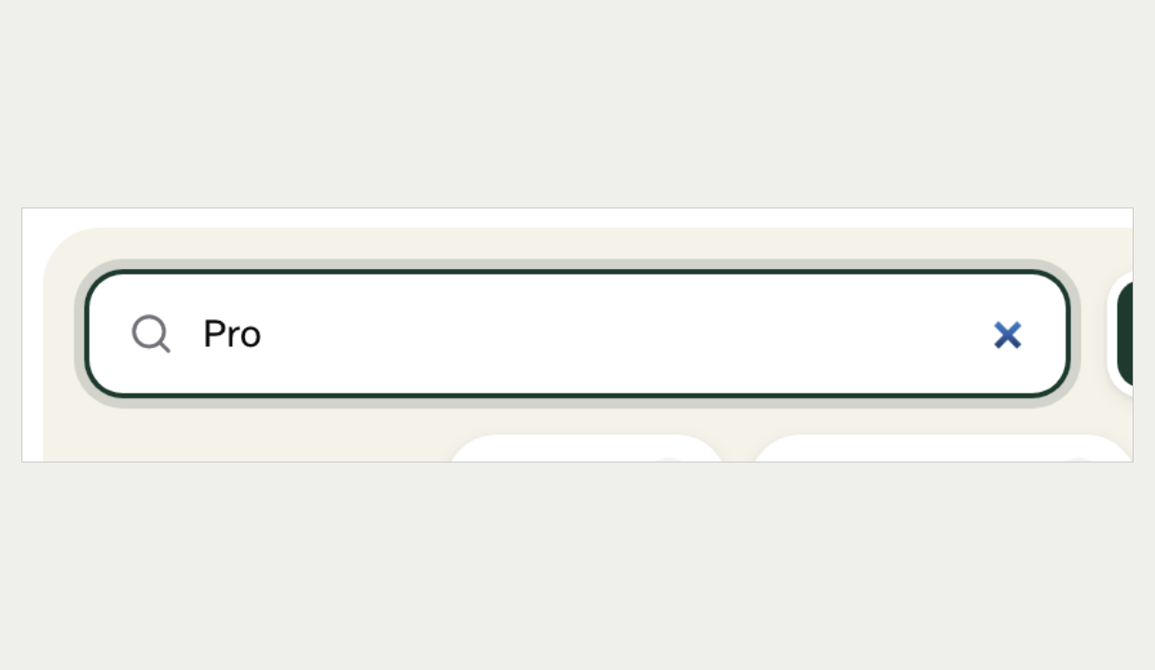
Integrations filter field, focused  Screenshot of the current site | Integrations filter field, focused  Mock-up 6
Recommendation: Adopt. Keep the shipped field control and the red error. Give it the new 12px radius from entry 12.
Ruling: x Override ☐ Adopt ☐ Combine Notes: ______________________________

24. The integrations section Size L Combine
Current rule: Integrations render as group cards, one per partner, with the filter in the heading row. Sort uses the shared sort select and the view toggle is the shared one.
Source: DESIGN.md §5, Integrations and Listing toolbar.
New design: A Bone "deck" holds search, a direction control, data-object and category chips and a view toggle. Page 7 adds grouping, a sticky jump rail, "Show 9 more" per group and a native select for sort.
What is at stake: The shipped pattern keeps both integration sections alike and keeps every row in the server HTML for crawlers. The deck is a real gain for a product with 58 integrations. A native sort select breaks the ruling of one sort control everywhere.
Current site | New design
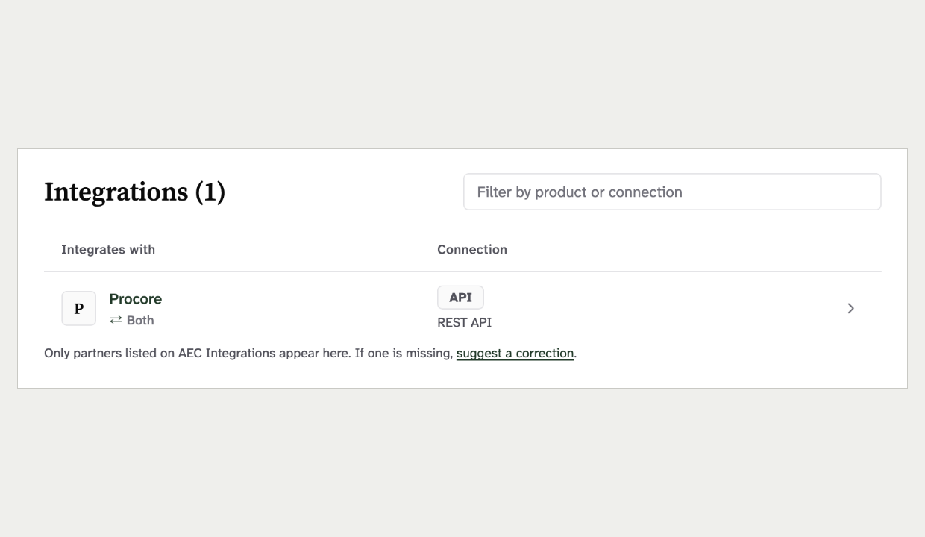 | 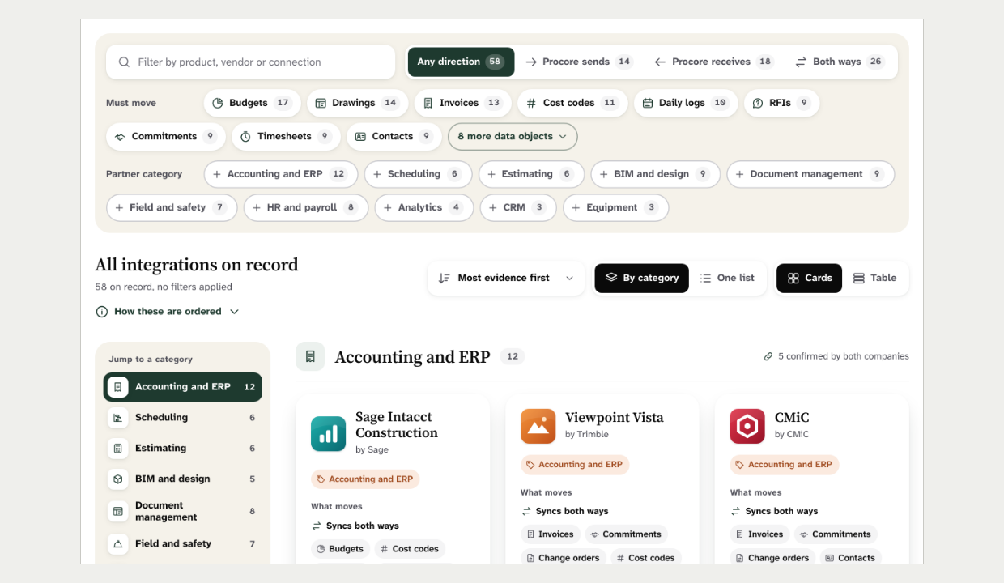
Integrations section, product page  Screenshot of the current site | Integrations deck, grouping and jump rail  Mock-up 7
Recommendation: Combine. Build the deck from shipped parts: the list filter, the view toggle and the shared sort select. Keep every row in the server HTML, and take the grouping and jump rail to Chris under entry 45.
Ruling: ☐ Override ☐ Adopt x Combine Notes: ______________________________

25. A bare zero Size S Adopt
Current rule: A zero count is never shown as a bare "0". The product card shows "Not yet connected" instead.
Source: DESIGN.md §5, IntegrationStat and the glance band.
New design: The empty product page prints an 80px "0" over "integrations on record". The section-nav count also reads "0".
What is at stake: A big zero reads like a verdict on the product. The card rule is pinned by the product-card spec, but this new figure is not.
Current site | New design
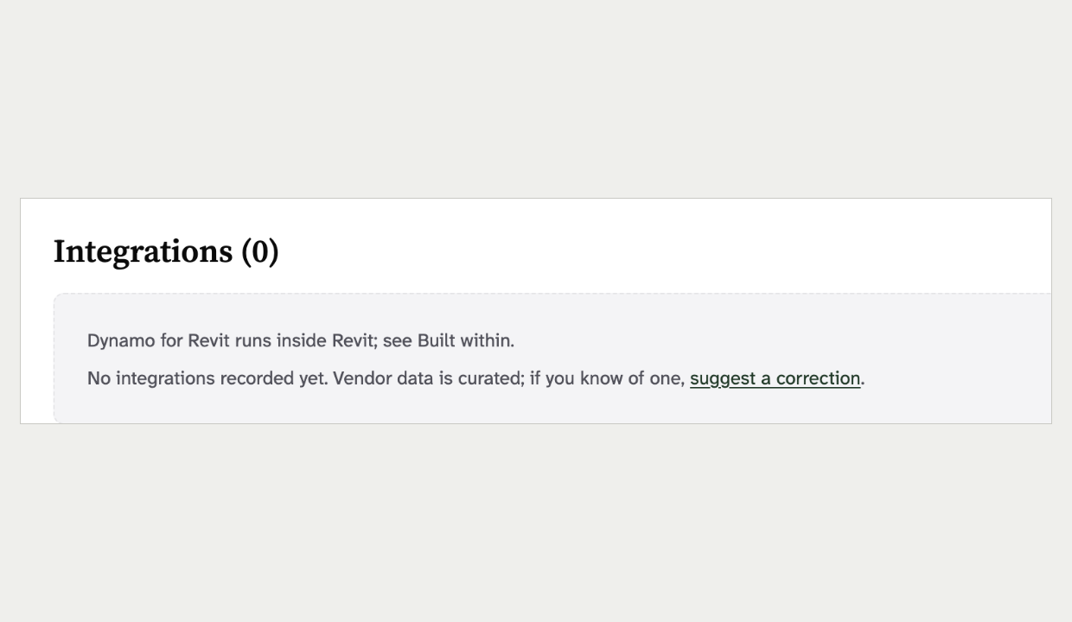 | 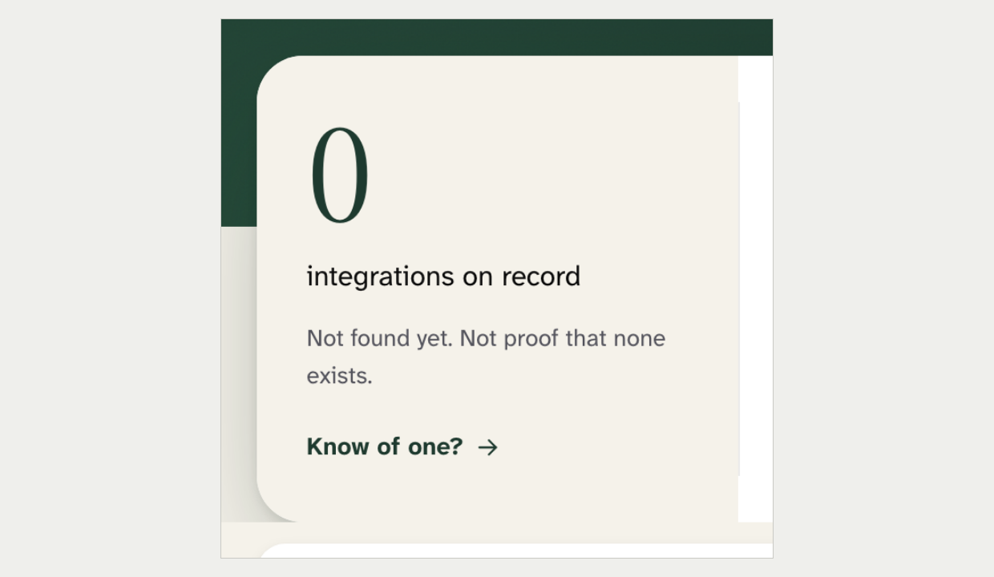
Integrations section with none on record  Screenshot of the current site | Facts card with an 80px zero  Mock-up 8
Recommendation: Adopt. Show a sentence such as "None on record yet" in place of the figure.
Ruling: x Override ☐ Adopt ☐ Combine Notes: __I like the new design____________________________

Navigation and menus

26. The header's main links Size M Combine
Current rule: The main row is Home, Products, Categories, Trades, Audiences and Phases. It is public-only and closed, and a new main link needs a re-measure at 1024px.
Source: DESIGN.md §5, The row and The Overflow Rule.
New design: The row is Browse, How we rank, For vendors and Sign in. Home and Products leave the row, and the four facets fold into Browse.
What is at stake: The rule protects the header width and keeps the taxonomy as the spine. The new row is narrower but promotes two footer-only pages. Pinned by the site-header and nav-menu specs.
Current site | New design
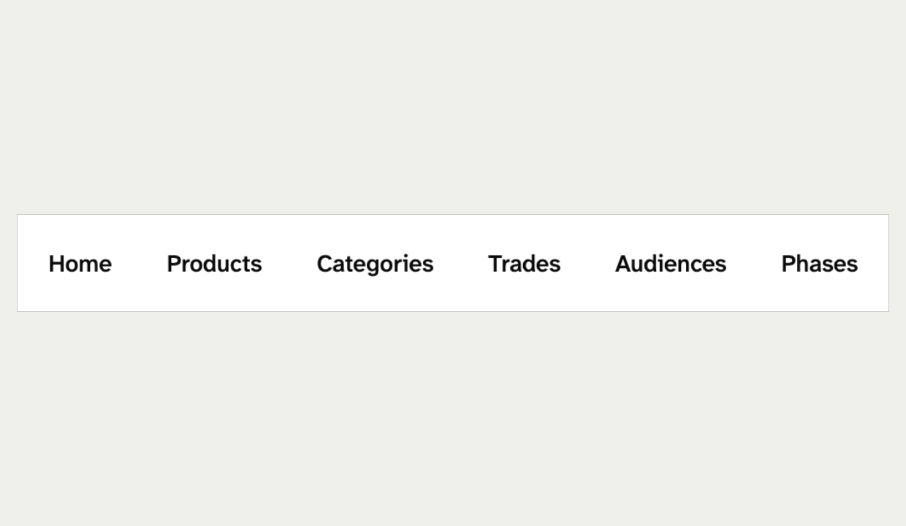 | 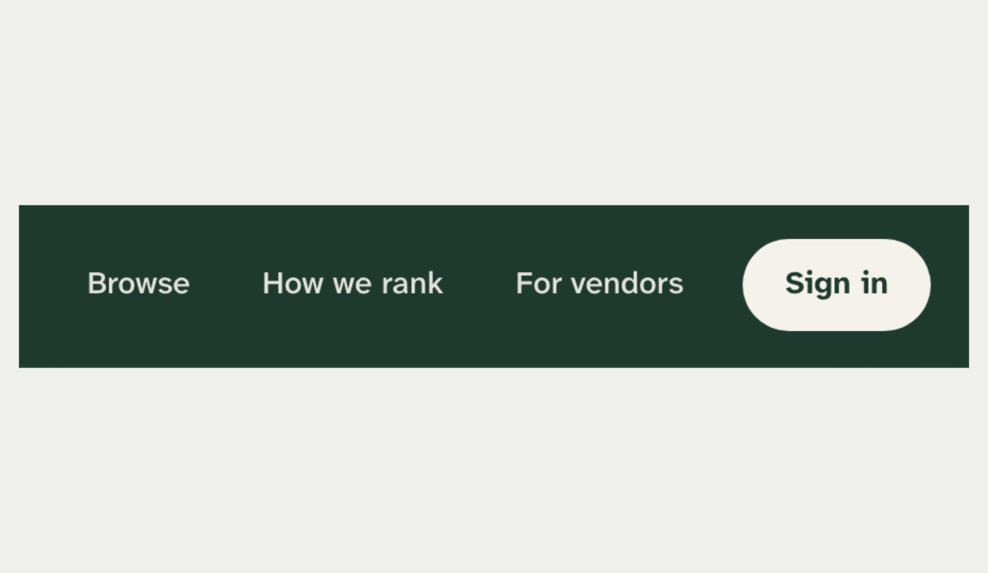
Header main links  Screenshot of the current site | Header main links on Forest  Mock-up 6
Recommendation: Combine. Accept Browse in place of the four facets. Treat "How we rank" and "For vendors" as new main links that need the 1024px re-measure and a ruling, and keep Products in the row.
Ruling: x Override ☐ Adopt ☐ Combine Notes: _Products is in browse (“All Products”) _____________________________

27. One mega-menu for four dropdowns Size M Combine
Current rule: All four header dropdowns behave the same on one shared base. Panels use the dropdown shadow and set type sizes and weights.
Source: DESIGN.md §5, header dropdowns.
New design: One full-width Browse panel has five columns with counts. Its own script adds open and close delays, a page dimmer and a wipe animation.
What is at stake: The mock-up honours keyboard and Escape behaviour, but it lives outside the shared base. The dimmer makes a menu act like a modal. Pinned by the flyout trigger and list specs.
Current site | New design
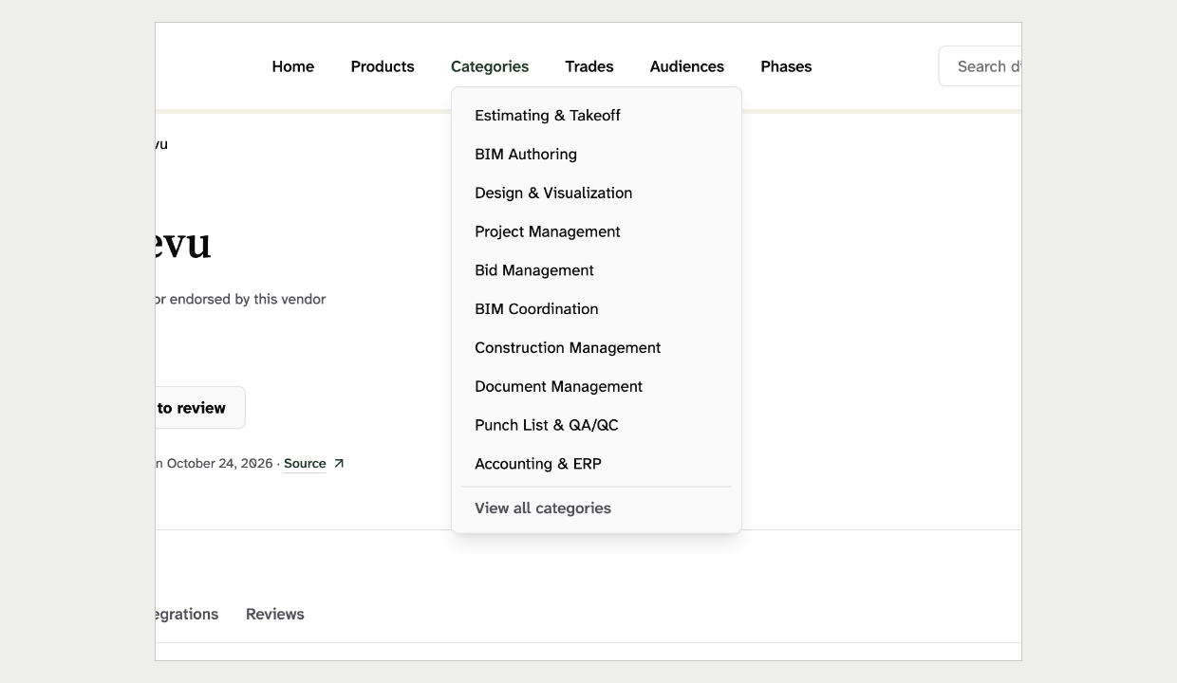 | 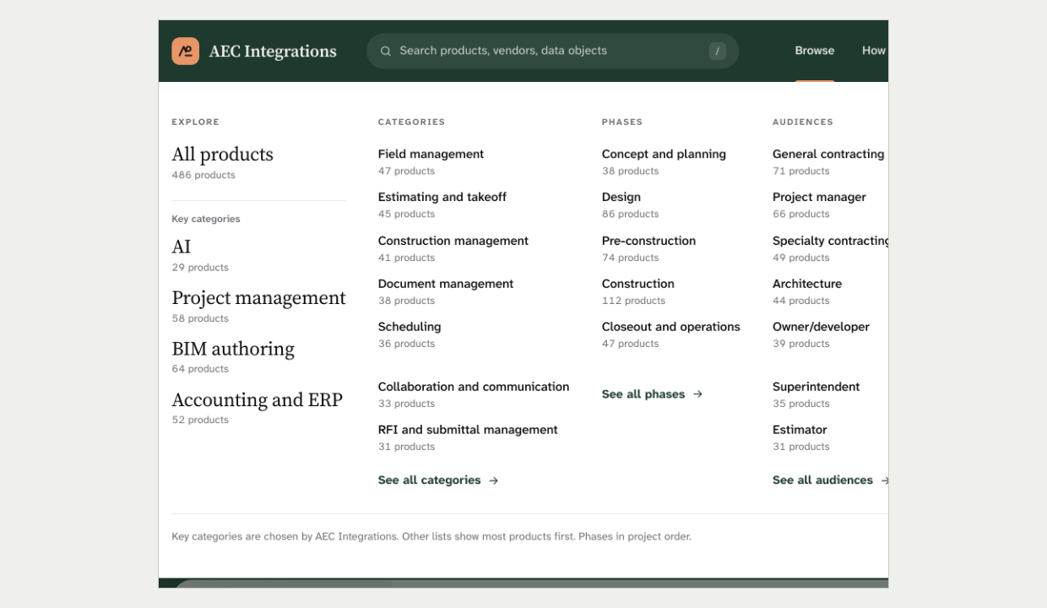
Categories dropdown open  Screenshot of the current site | Browse mega-menu open  Mock-up 6
Recommendation: Combine. Keep the one Browse panel and its columns, but build it on the shared dropdown base. Drop the dimmer, add any hover delay to the base so every dropdown gets it, and pin destinations at regular weight.
Ruling: x Override ☐ Adopt ☐ Combine Notes: ______________________________

28. Active-state markers Size S Combine
Current rule: The current route is Forest text with a 2px Forest underline. The section nav marks the current link Forest and bold over a hairline.
Source: DESIGN.md §5, The row. The section-nav component.
New design: A 3px Clay bar sits under "Browse". The sticky section nav and the jump rail mark the current item with a solid Forest pill.
What is at stake: One "you are here" marker works across router tabs, search tabs and the portal. Pinned by the section-nav spec for the attribute, not the colour.
Current site | New design
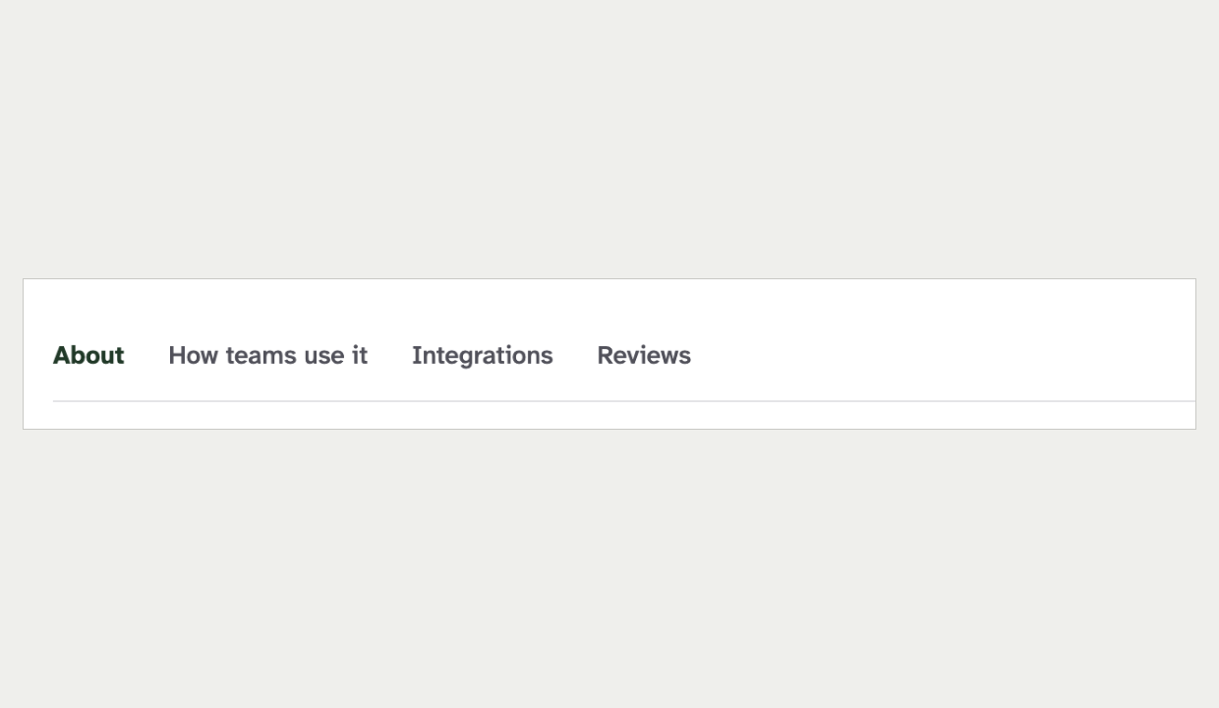 | 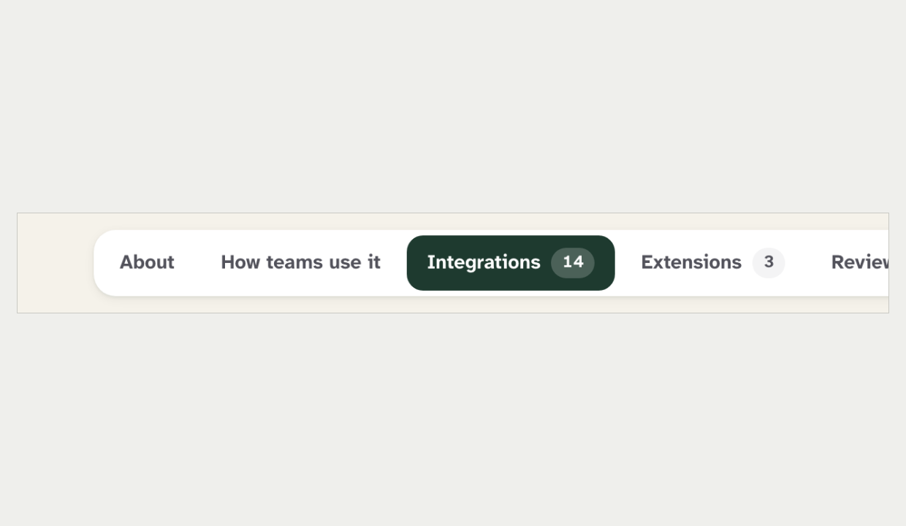
Section nav with "About" current  Screenshot of the current site | Sticky section nav with "Integrations" current  Mock-up 6
Recommendation: Combine. Use the 2px underline everywhere: Bone on the Forest header and Forest on light grounds. The section nav may keep its pill container but marks the current item with the underline.
Ruling: x Override ☐ Adopt ☐ Combine Notes: ______________________________

29. Header search and sign-in Size M Combine
Current rule: The header search field appears from the xl width and reads "Search directory". Sign in is a Forest button with 8px corners.
Source: DESIGN.md §5, header search.
New design: A wide pill link styled as a search field appears from 1040px. It reads "Search products, vendors, data objects" and shows a "/" shortcut.
What is at stake: The breakpoint was measured, and a link styled as a field is not a field. The "/" shortcut has no rule for focus handling yet. Pinned by the site-header and search-trigger specs.
Current site | New design
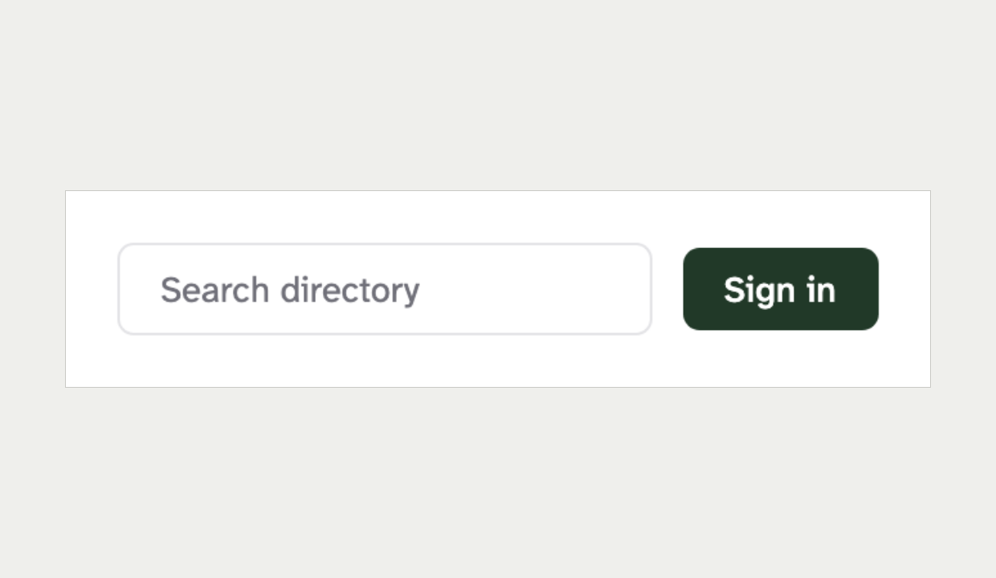 | 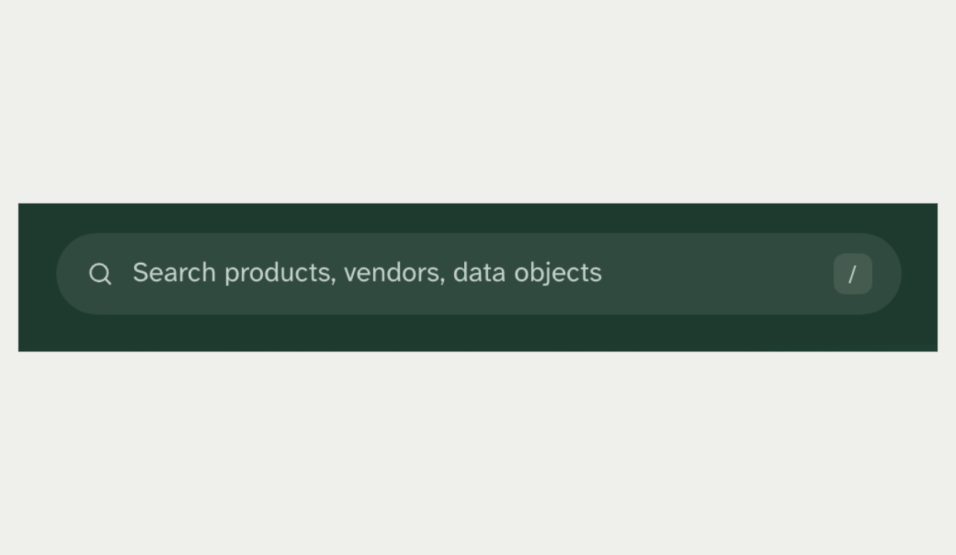
Header search field and Sign in  Screenshot of the current site | Header search link with shortcut key  Mock-up 6
Recommendation: Combine. Keep the real search field at xl and the icon trigger below it. Keep "Search directory" until search indexes data objects, and write a rule for the "/" shortcut before it ships.
Ruling: x Override ☐ Adopt ☐ Combine Notes: ______________________________

30. The mobile menu Size S Adopt
Current rule: On mobile the menu opens in an overlay with a focus trap. The rule also says the toggle is labelled, not a mystery icon.
Source: DESIGN.md §5, Mobile.
New design: The toggle is an icon with a screen-reader name. The panel is a plain absolute layer with a dimmer and no focus trap.
What is at stake: The overlay and focus trap protect keyboard and screen-reader users. The live toggle is also an icon with a screen-reader name only, so the real difference is the trap. Pinned by the nav-menu spec.
Current site | New design
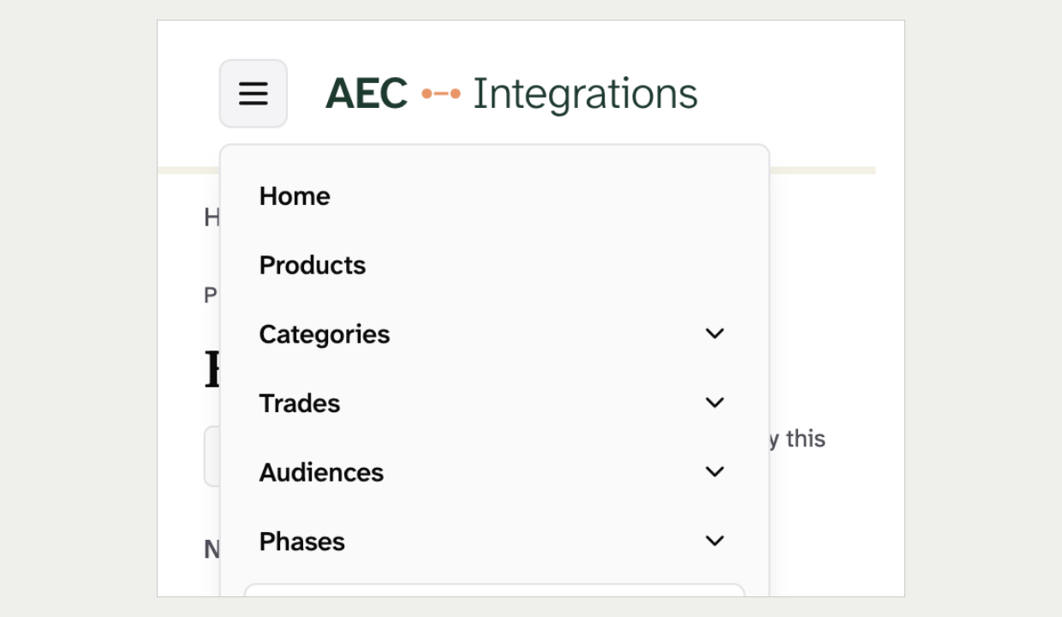 | 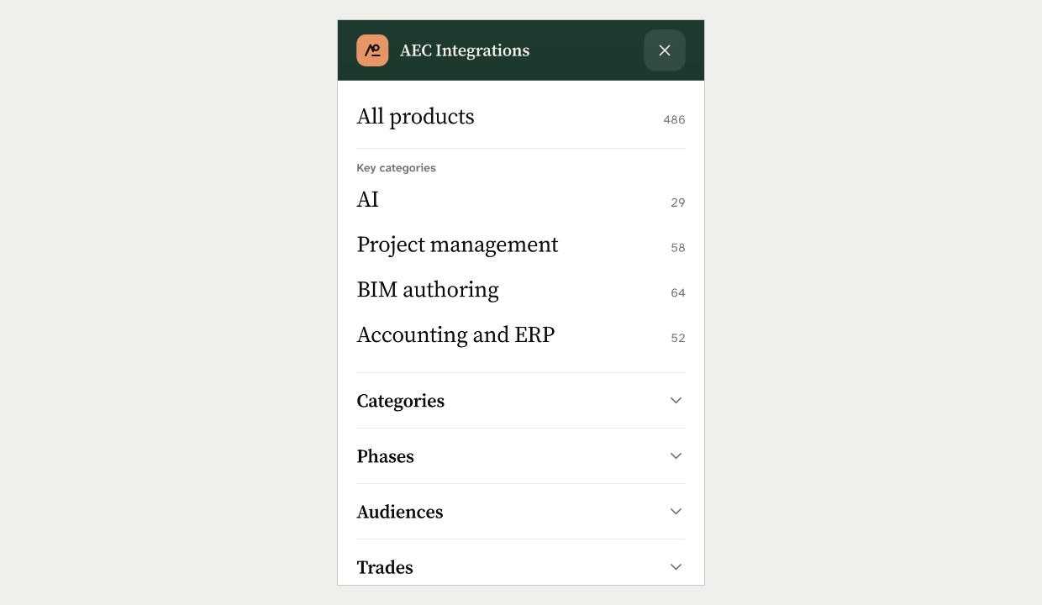
Mobile menu open, 390px wide  Screenshot of the current site | Mobile menu open, 390px wide  Mock-up 6
Recommendation: Adopt. Keep the overlay and focus trap, and restyle the panel rows to the new serif look. Decide separately whether the toggle gets a visible "Menu" word, because neither version has one.
Ruling: x Override ☐ Adopt ☐ Combine Notes: ______________________________

31. The breadcrumb separator Size S Adopt
Current rule: Public and console breadcrumbs use the same "›" separator, hidden from screen readers.
Source: DESIGN.md §5, Breadcrumb.
New design: The breadcrumb uses "/".
What is at stake: One breadcrumb grammar runs from public pages to the console. The docs top bar uses a slash, so one place changes either way. Not linted.
Current site | New design
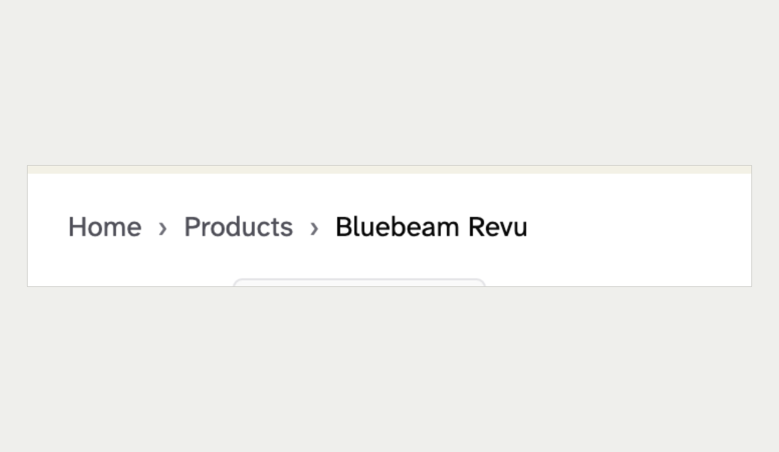 | 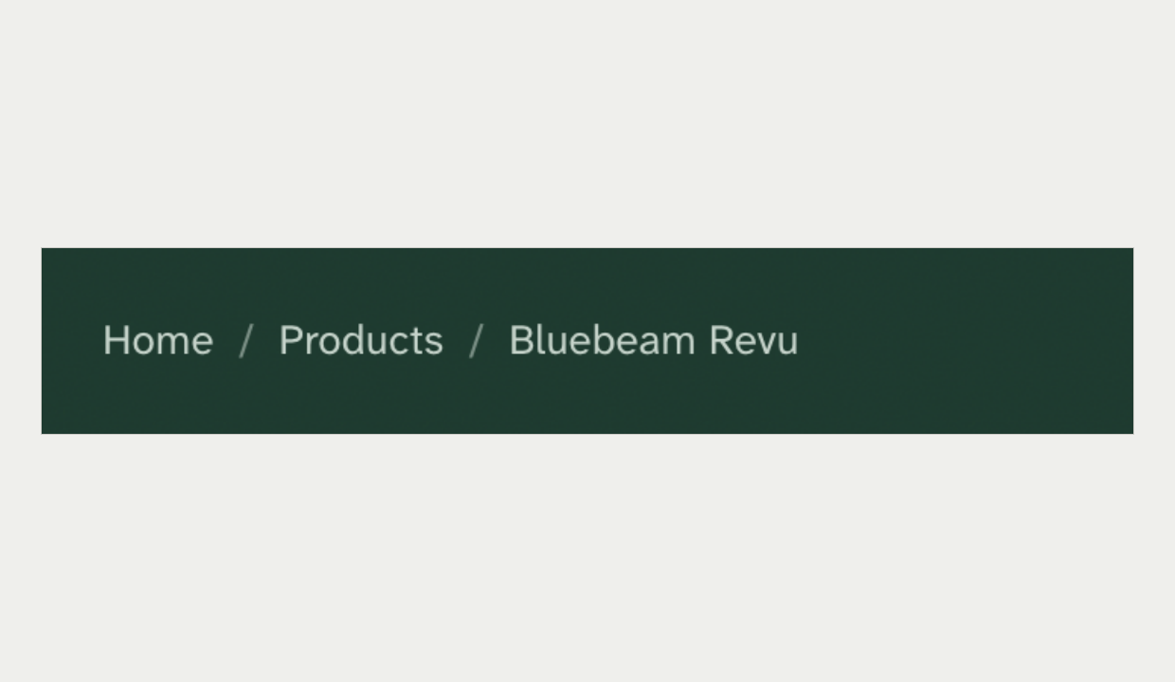
Breadcrumb  Screenshot of the current site | Breadcrumb on Forest  Mock-up 6
Recommendation: Adopt. Keep "›" on public and console pages.
Ruling: ☐ Override x Adopt ☐ Combine Notes: ______________________________

32. The footer Size M Combine
Current rule: The footer is white with four labelled columns: Directory, Help, Legal and Company. Column labels are overlines.
Source: DESIGN.md §5, Footer.
New design: A dark Forest footer has Browse, How we work, Company and Legal. It adds Vendors, Data objects, Attestations and Cookies, and drops the Help column.
What is at stake: The footer is the only server-rendered home of the taxonomy and of Methodology, Updates and Roadmap. The footer spec pins the columns, so these new columns fail a test today.
Current site | New design
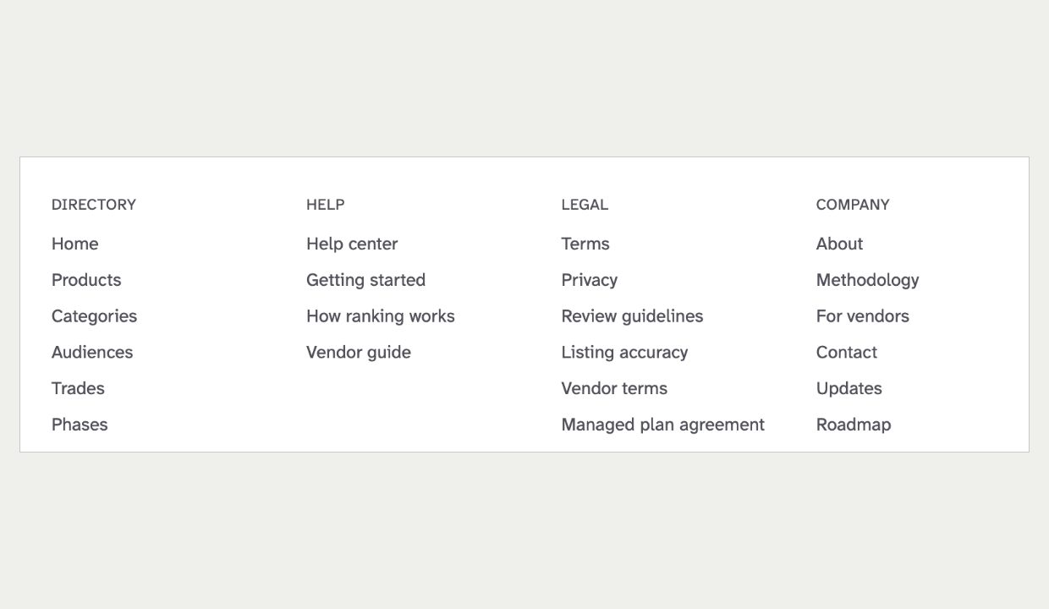 | 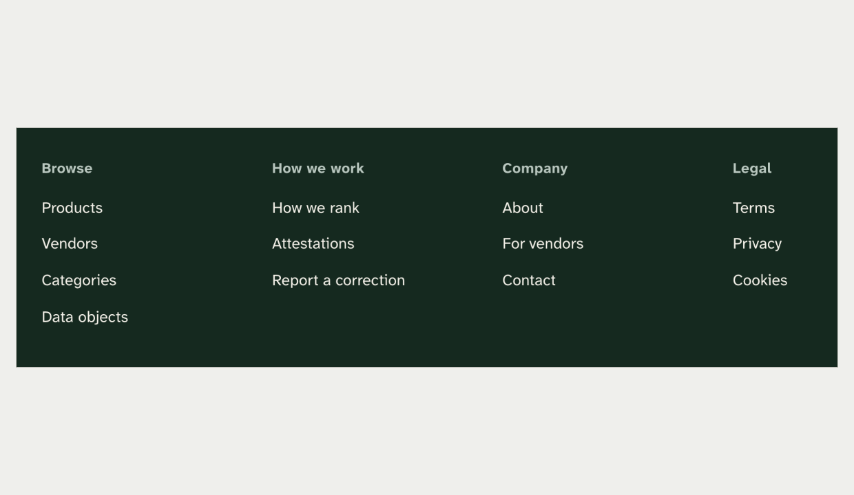
Footer columns  Screenshot of the current site | Footer columns on Forest  Mock-up 6
Recommendation: Combine. Accept the Forest ground under entry 1. Keep the four shipped columns and the overline labels.
Ruling: ☐ Override ☐ Adopt x Combine Notes: ______________________________

Iconography and imagery

33. Arrows used for navigation Size S Adopt
Current rule: An arrow glyph means data-flow direction and nothing else. A click affordance uses a chevron.
Source: DESIGN.md §5, The Arrow Rule.
New design: Buttons, menu links and every integration card use "→" to mean "go". The same cards also carry real direction arrows.
What is at stake: A navigation arrow next to a direction arrow misled readers on the pair page once. These cards repeat that collision. Not linted.
Current site | New design
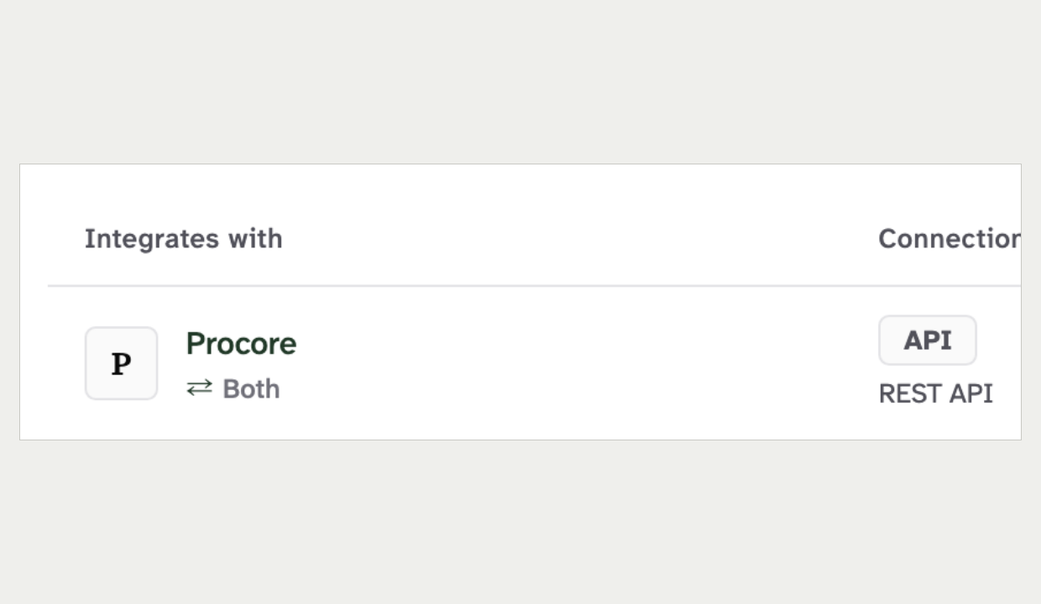 | 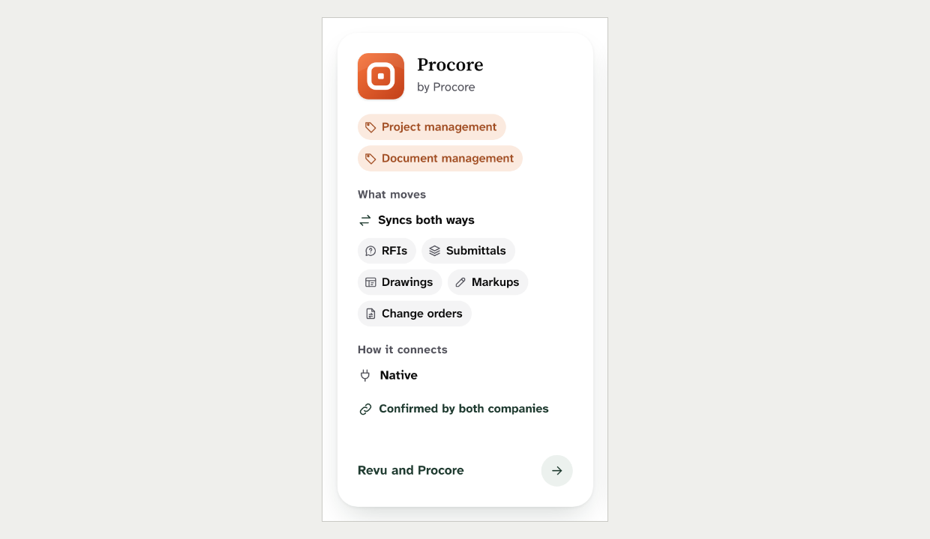
Integration row: direction arrows and a chevron to open  Screenshot of the current site | Integration card: direction arrows and a "go" arrow  Mock-up 6
Recommendation: Adopt. Use a chevron for every navigation affordance and keep arrows for direction only.
Ruling: x Override ☐ Adopt ☐ Combine Notes: ______________________________

34. Icons and logo tiles Size M Combine
Current rule: Icons come from Lucide only. A company mark is a rectangle tile, and hierarchy comes from scale and weight, not decoration.
Source: DESIGN.md §6. PRODUCT.md, Earned attention. BRAND_GUIDELINES.md §7.
New design: A hand-built icon set puts an icon on nearly every heading, chip, label and row. Logos are rounded squircles with a shadow, 104px in the hero.
What is at stake: Lucide keeps glyphs consistent with the app. An icon on every element stops icons meaning anything. Not linted.
Current site | New design
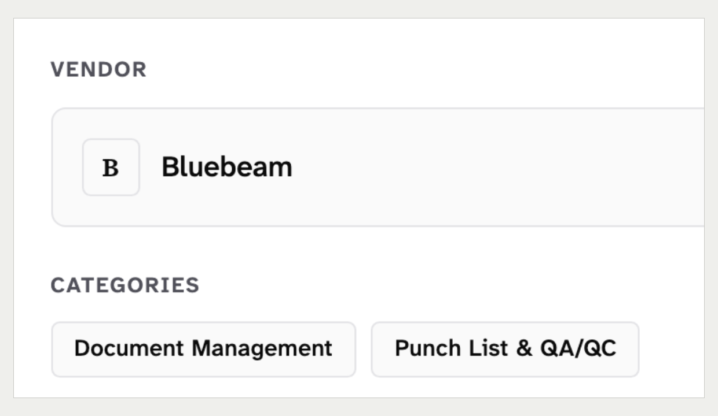 | 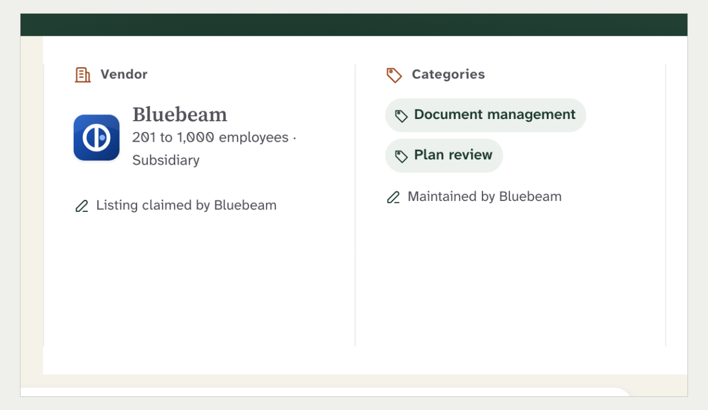
Sidebar vendor tile and category chips  Screenshot of the current site | Facts card vendor logo, icon headings and icon chips  Mock-up 6
Recommendation: Combine. Map every glyph to its Lucide match and keep icons on facet headings and data objects only. Allow a larger hero logo with a border, not a shadow.
Ruling: x Override ☐ Adopt ☐ Combine Notes: ______________________________

35. The hero diagram Size M Override
Current rule: No rule covers this today. The nearest guidance allows diagrams as imagery and bans separator glyphs between a pair.
Source: BRAND_GUIDELINES.md §7. DESIGN.md §5, The Arrow Rule.
New design: Product pages draw up to eight partner logos on spokes around the product, with data-object beads. The pair page joins two tiles with a ribbon, and the empty page shows dashed slots.
What is at stake: It is the most distinctive element of the new look, and it shows real data. It needs rules for what it may show, how it reads without JavaScript, and what it does at zero.
Current site | New design
Nothing like this exists today.  The nearest element is the pair page summary panel, which shows two product tiles side by side with no diagram. | 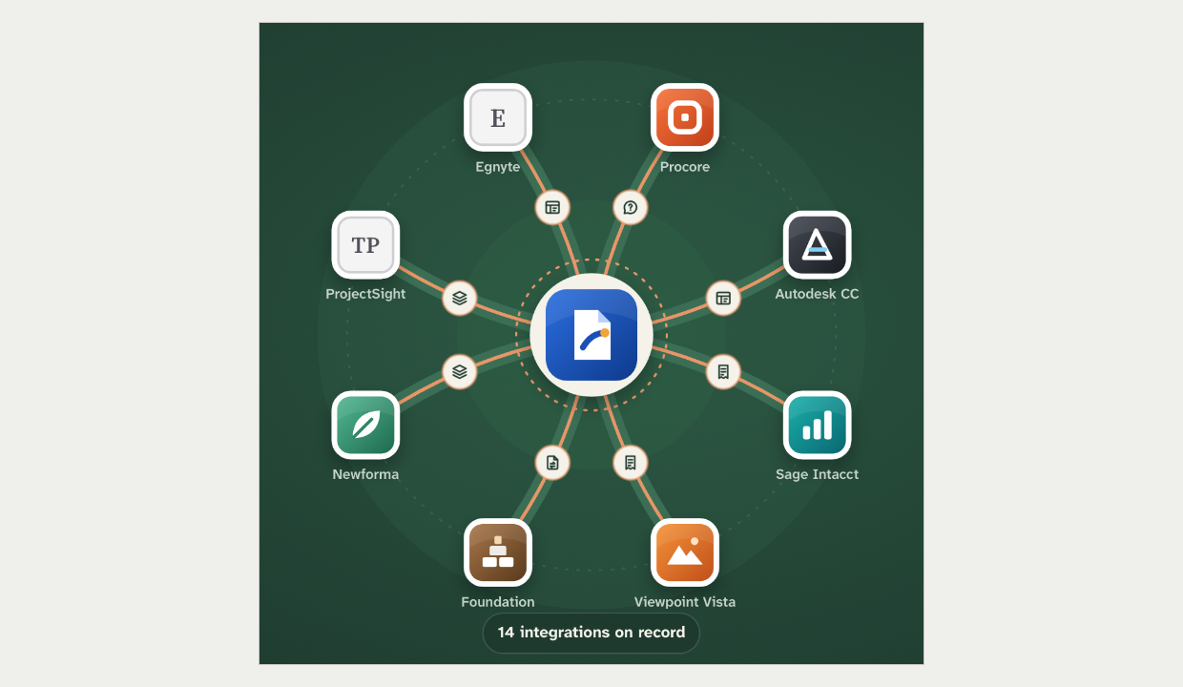
No image: no element of this kind exists on the current site. | Partner diagram in the product hero  Mock-up 6
Recommendation: Override. Write a "pair and product diagram" rule into the design rules. It shows real records only, renders static on the server, has a text equivalent and implies no ranking by position.
Ruling: x Override ☐ Adopt ☐ Combine Notes: ______________________________

Motion

36. Animation timing and decoration Size M Combine
Current rule: Motion uses three durations and has a purpose. Decorative animation is noise.
Source: DESIGN.md §6. PRODUCT.md. BRAND_GUIDELINES.md §7.
New design: The mock-ups use six more durations, entrance animations on cards, an endless breathing halo and a bouncing counter.
What is at stake: An endless loop on a reading page distracts. Entrance animation on server-rendered content replays on hydration. Reduced motion is honoured throughout, which is good. Not linted.
Today | With the new design
Hover: 120 ms  Default: 180 ms  Page transition: 280 ms  Decoration: None | Transitions: 200, 250, 300, 420, 450, 600 ms  Card entrance: Rise with a 30 to 45 ms stagger  Hero ring: Draws over 1.4 s  Halo: Endless 4.5 s loop
Recommendation: Combine. Move to the 120, 180 and 280 ms set and keep one entrance, for the hero diagram. Drop the endless loop, the per-card stagger and the bounce.
Ruling: ☐ Override ☐ Adopt x Combine Notes: ______________________________

37. Hover and press movement Size M Adopt
Current rule: Buttons do not move, scale or gain a shadow on hover. Cards change only their border colour on hover.
Source: DESIGN.md §5, Buttons and Cards.
New design: Cards lift 4px on hover. Buttons shrink slightly when pressed, and chips lift.
What is at stake: The rule keeps the page still under the pointer. Lift on hover is the main source of the "SaaS app" feel. Not linted.
Current site | New design
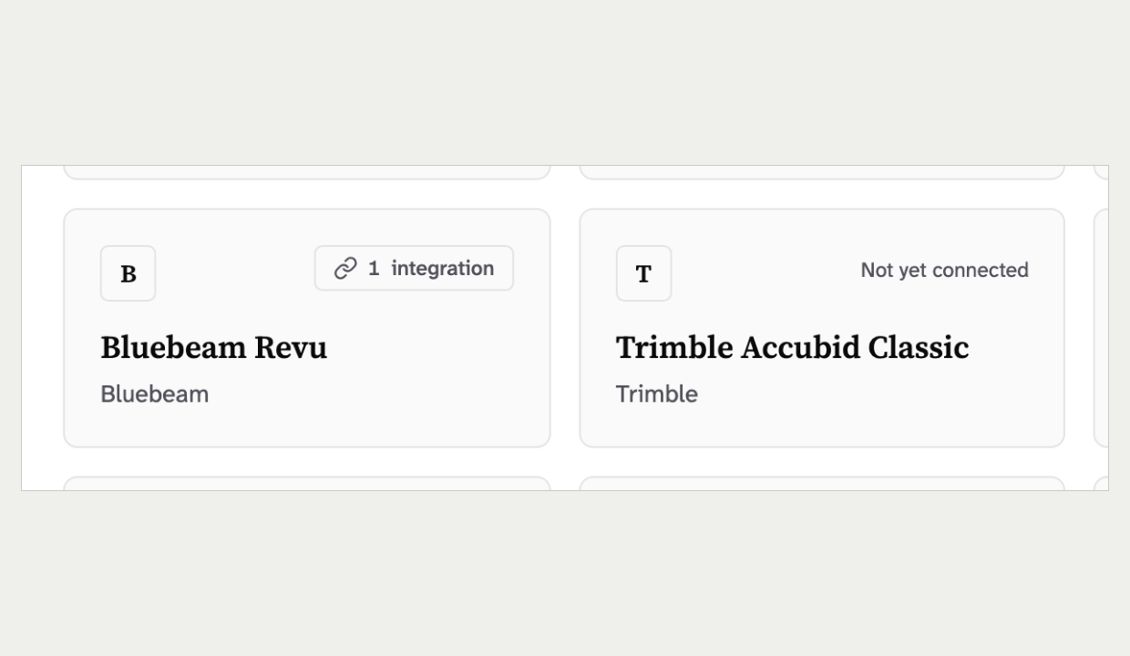 | 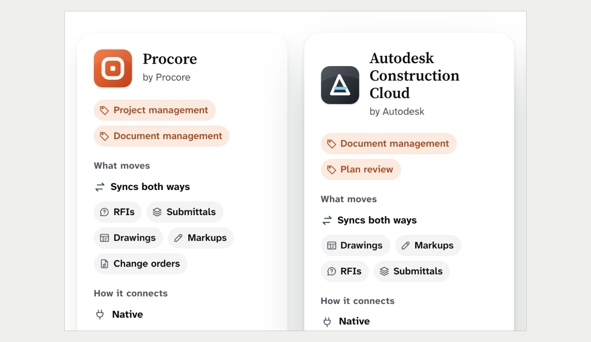
Product card under the pointer: border darkens  Screenshot of the current site | Integration card under the pointer: lifts 4px  Mock-up 6
Recommendation: Adopt. Use the darker border for card hover and a colour shift for buttons.
Ruling: x Override ☐ Adopt ☐ Combine Notes: ______________________________

38. Smooth scrolling Size S Adopt
Current rule: Router scroll restoration is already solved. Do not re-solve it.
Source: CLAUDE.md, Constraints. ANGULAR_STYLE_GUIDE.md.
New design: Every page turns on smooth scrolling for the whole document.
What is at stake: A global smooth scroll changes how Back and fragment links land. The scroll-restoration end-to-end tests guard that behaviour.
Today | With the new design
Scrolling: Instant, managed by the router setup  Back button: Returns to the saved position  Anchor links: Land under the sticky bar | Scrolling: Smooth for every jump  Back button: Animates, can land in the wrong place  Anchor links: Own scroll-margin rules
Recommendation: Adopt. Leave scroll behaviour to the existing router setup.
Ruling: x Override ☐ Adopt ☐ Combine Notes: __Make sure we know how to adopt the old way if needed. ____________________________

Trust and brand rules

39. A public "claimed" label Size S Adopt
Current rule: No public label says "Claimed". An unclaimed listing shows one muted line: "Unclaimed · not affiliated with or endorsed by this vendor".
Source: DESIGN.md §5, Unclaimed note. ADR 0051, claim end.
New design: Pages 6 and 7 show a hero pill reading "Listing claimed by Bluebeam". The facts card repeats it, and page 5 compares "Claimed by" against "Not claimed".
What is at stake: A "claimed" mark reads as endorsement and shows who engaged with us. The rule came out of the counsel review and ADR 0051. Pinned by the unclaimed-note spec.
What the site shows today: DESIGN.md is current here, and the legal review summary was wrong. No public page shows "Claimed" today, and the wording "Listing claimed by {vendor}" appears nowhere in the repo or the counsel record. The Vendor Terms do let us "say that the listing is claimed" and promise to remove a claimed label when a claim ends. So a claimed label would not break a legal page. It would reverse ADR 0051 and the design rule.
Current site | New design
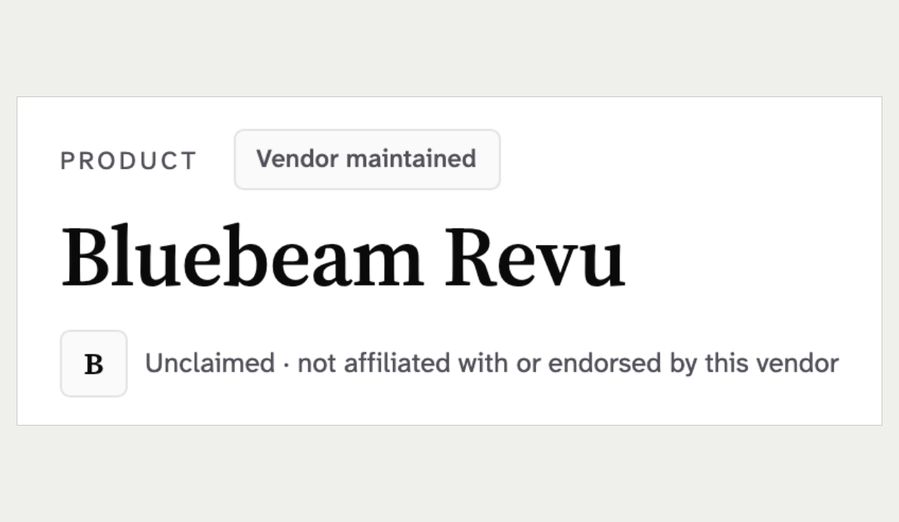 | 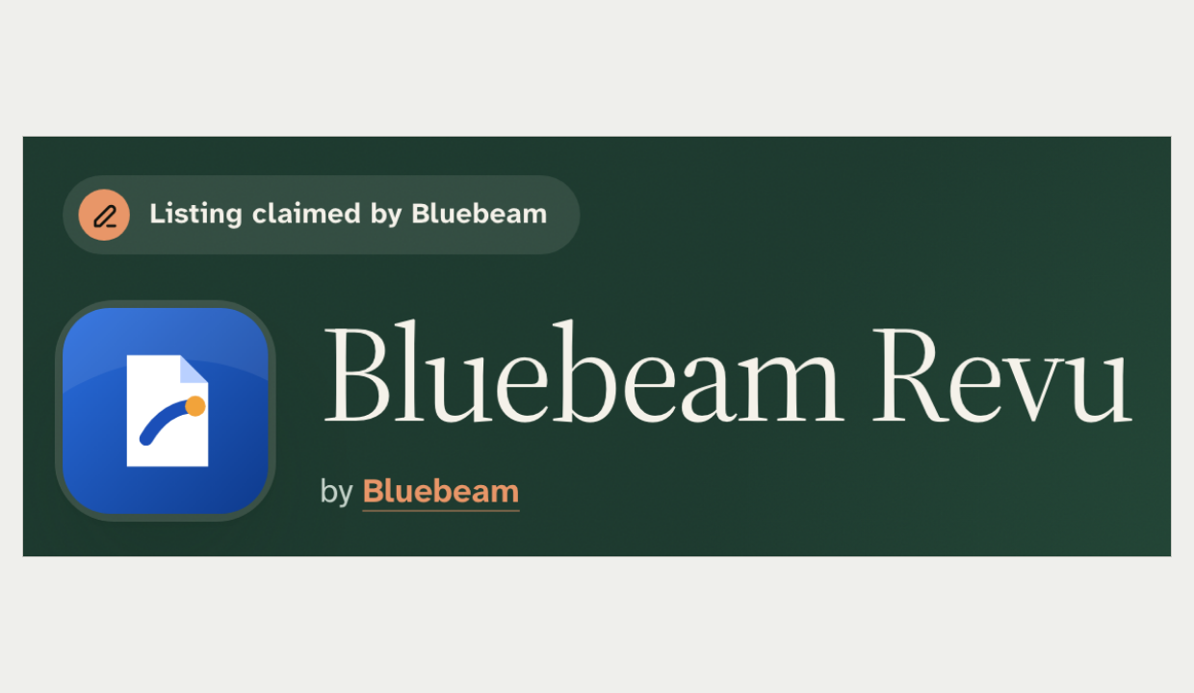
Product header: maintenance chip and unclaimed line  Screenshot of the current site | Product hero with "Listing claimed by Bluebeam"  Mock-up 6
Recommendation: Adopt. Remove the claimed label and keep the unclaimed note. Page 8 already renders the note correctly.
Ruling: ☐ Override x Adopt ☐ Combine Notes: ______________________________

40. The maintenance chip and field captions Size S Adopt
Current rule: The page-level maintenance chip has exactly two labels, "AEC Integrations maintained" and "Vendor maintained", with no company name and no icon. Field captions name the vendor in plain text with no icon.
Source: DESIGN.md §5, Maintenance marker and Field caption. STAGE_2_VENDOR_PORTAL_SPEC.md §4.5.8.
New design: Page 8 shows a hero pill reading "Maintained by AEC Integrations" with a Clay pencil. Pages 6 and 7 caption "Maintained by Bluebeam" with a pencil icon and no date.
What is at stake: The two fixed chip labels are a ruling of 2026-09-28. The caption wording is counsel ruling 5 of 2026-11-05. An icon turns either one into a status light. Pinned by the maintenance-marker and field-caption specs.
What the site shows today: Both sources are right because they govern two different components. Ruling 5 sets the field caption wording, "Maintained by {Vendor} · updated {date}", and the live caption renders exactly that. The page-level chip is outside ruling 5 and still shows only the two fixed labels, with the company name read to screen readers only.
Correction to the clash file: the mock-up's "Maintained by Bluebeam" caption wording is approved. Only its pencil icon and the missing date break the rule.
Current site | New design
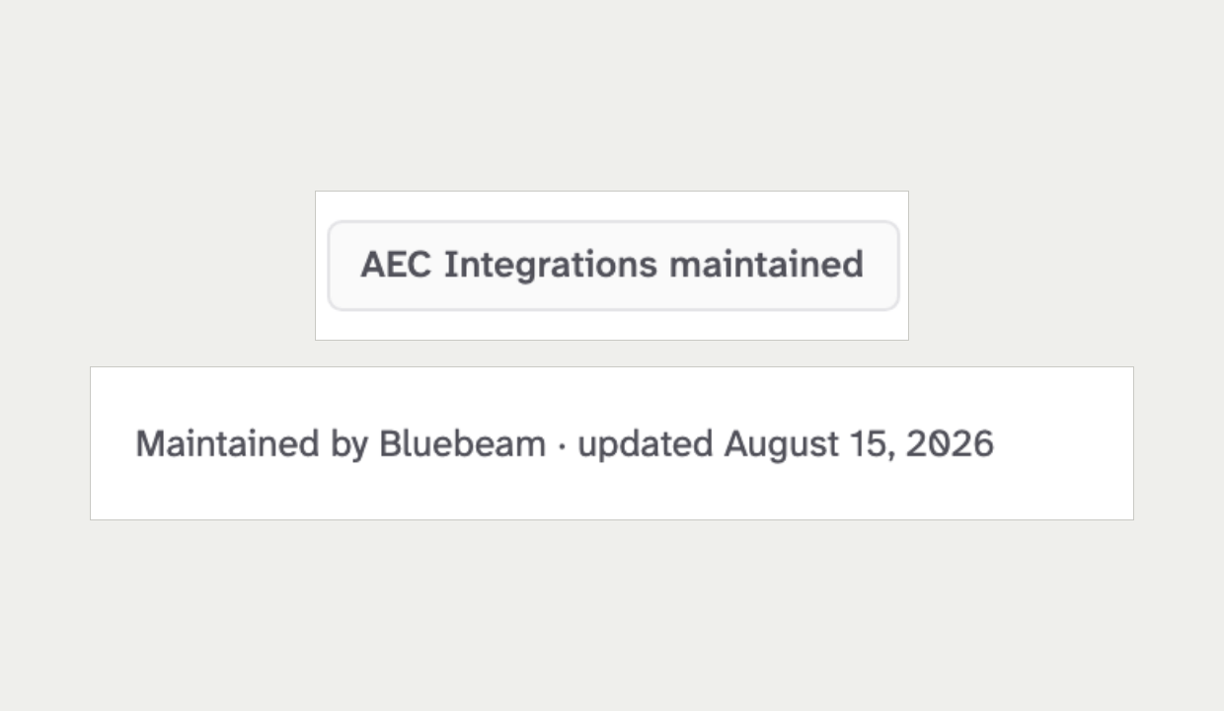 | 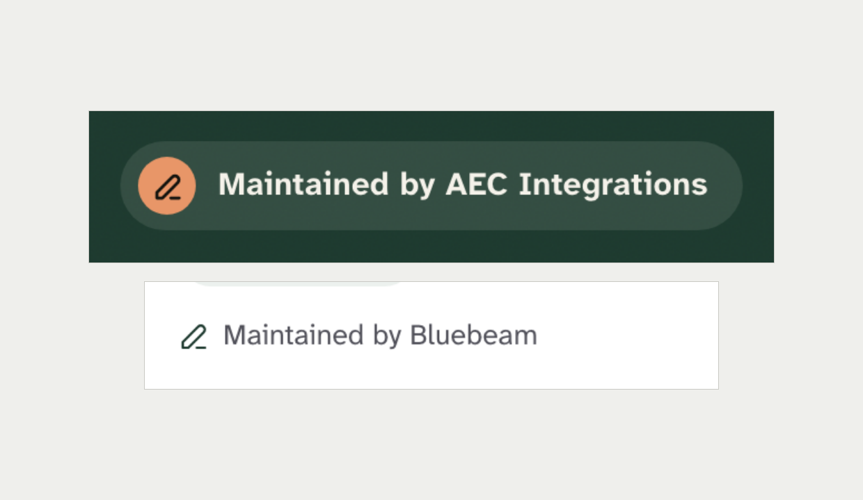
Maintenance chip, and a field caption naming the vendor  Screenshot of the current site | Hero pill with a pencil, and a caption with a pencil  Mock-ups 8 and 6
Recommendation: Adopt. Use the two fixed labels on the neutral chip. Keep captions as plain "Maintained by Bluebeam · updated {date}" text with no icon.
Ruling: ☐ Override x Adopt ☐ Combine Notes: ______________________________

41. The agreement states Size M Adopt
Current rule: The agreement badge has four states on a tonal ladder. A one-sided claim shares the neutral chip, and only "Confirmed by both companies" earns the green wash.
Source: DESIGN.md §5, Agreement badge.
New design: "Confirmed by both companies" and "Confirmed by Newforma" render in the same bold Forest text with the same link icon. None is a chip.
What is at stake: The ladder stops a one-sided claim looking like an agreed one. That is the core trust promise of the product. Pinned by the agreement-badge spec.
Current site | New design
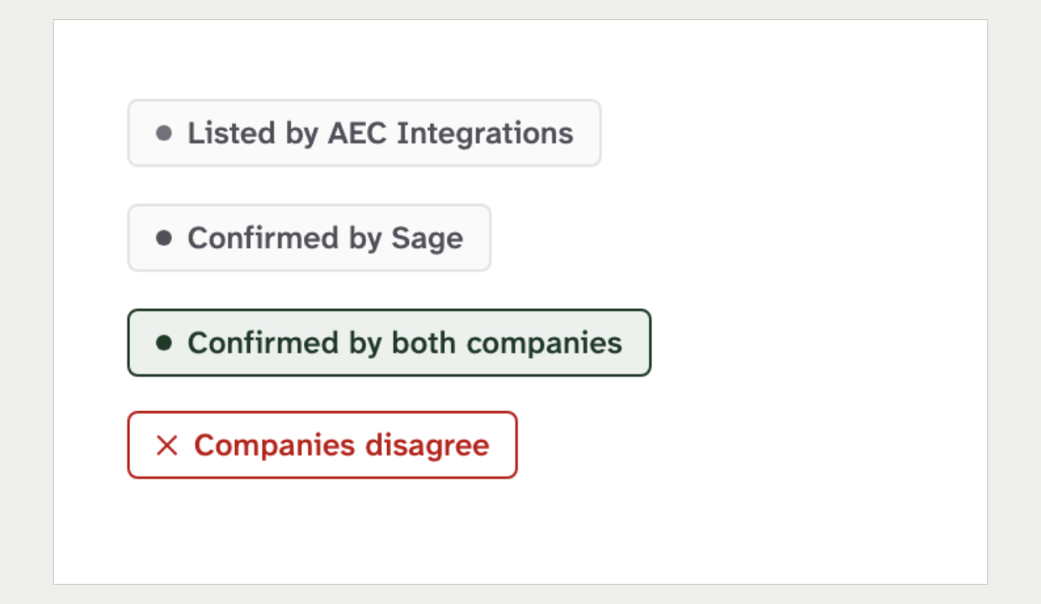 | 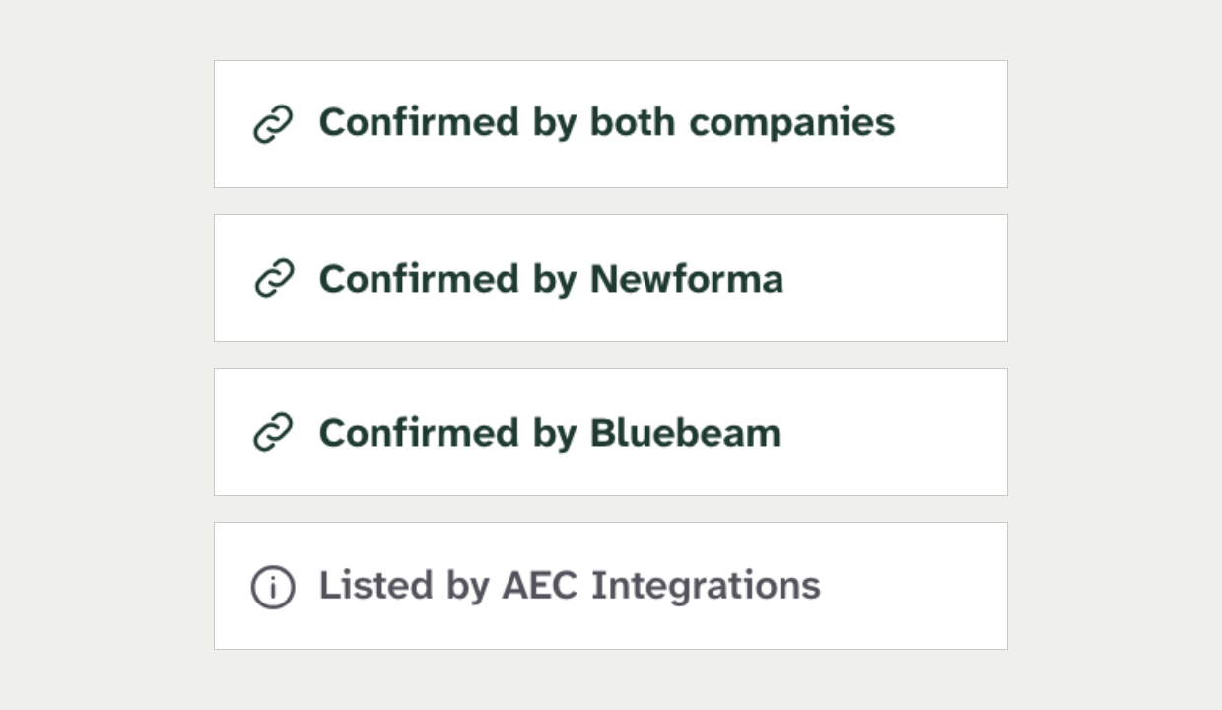
The four agreement states as specified  Rendered from the current design rules | Agreement lines on integration cards  Mock-up 6
Recommendation: Adopt. Render the shipped agreement badge on the cards. Aggregate counts may stay if they use the same state words.
Ruling: ☐ Override x Adopt ☐ Combine Notes: ______________________________

42. The wordmark Size S Adopt
Current rule: The header and footer use the outlined wordmark image with the connector mark. Logo changes go through the logo construction document.
Source: BRAND_GUIDELINES.md §8. branding/logo-construction.md.
New design: "AEC Integrations" is set in live serif text beside a new Clay seal glyph.
What is at stake: One mark matches the sign-in logo, social cards and email banner. A new mark is a rebrand. Not linted.
Current site | New design
 | 
Header wordmark  Screenshot of the current site | Header wordmark on Forest  Mock-up 6
Recommendation: Adopt. Use the shipped wordmark, in its Bone variant on the Forest header. The email banner already uses Bone type.
Ruling: ☐ Override x Adopt ☐ Combine Notes: ______________________________

43. Public demand counts Size M Combine
Current rule: No rule covers this today. The nearest are "Transparent by default" and the ban on any badge that signals promoted, sponsored or verified.
Source: PRODUCT.md, Principles. DESIGN.md §5, Badges.
New design: The pair page shows "Looked up 34 times in the last 90 days" and an "I need this too" counter. It also has a "Watch this pair" email field, and page 8 asks "Know of one?".
What is at stake: Most production page views are bot traffic, so a look-up count is only as honest as the bot filter. A public demand counter also invites gaming. The correction prompt is low risk.
Current site | New design
Nothing like this exists today.  The nearest element is the "suggest a correction" link under the integrations list. | 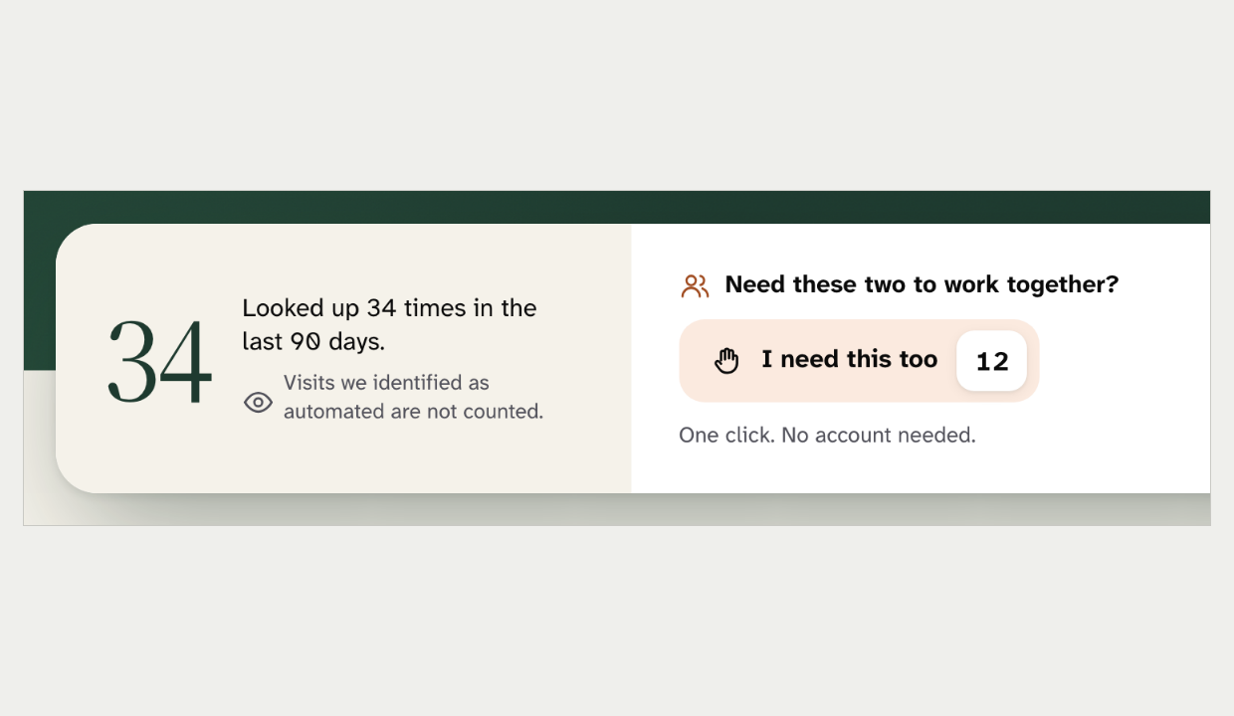
No image: no element of this kind exists on the current site. | Look-up count and "I need this too" counter  Mock-up 5
Recommendation: Combine. Ship "Know of one?" now. Write a rule before any public count ships. It covers the source, the bot filter and a floor, and the mock-up already hides counts below 10.
Ruling: ☐ Override ☐ Adopt x Combine Notes: ______________________________

Process rules

44. The anchor reference site Size S Adopt
Current rule: A surface that takes its theme from a reference site takes its components from the same site, and the anchor is recorded.
Source: DESIGN.md §2, The Anchor-Site Rule. CLAUDE.md, Design checklist step 2.
New design: No anchor is recorded for the mock-ups. The header, footer and detail pages depart from the current anchors.
What is at stake: The rule keeps the site reading as one publication, not a mashup. A precedent exists for an in-repo mock-up as the anchor. Not linted.
Today | With the new design
Site chrome anchor: Stripe  Catalogue anchor: Faire  Free plan surfaces: The in-repo mock-up | Anchor: None recorded  Chrome: Departs from Stripe  Catalogue: Departs from Faire
Recommendation: Adopt. Record these mock-ups as the anchor for the new look. Use Mobbin only for components the mock-ups do not cover.
Ruling: ☐ Override x Adopt ☐ Combine Notes: ______________________________

45. The same-behaviour rule Size M Combine
Current rule: A pattern behaves the same on every page. Anyone shipping a departure stops and tells Chris first.
Source: DESIGN.md §5, The Same-Behavior Rule.
New design: The integrations deck departs from four shared patterns, and none of the departures is recorded.
What is at stake: The rule exists because the search page shipped a different paginator and nobody raised it. If the new look goes site-wide, each departure becomes the pattern everywhere or a recorded exception. Not linted.
Today | With the new design
Filters: In the facet panel  Sort: Shared sort select in the toolbar  Paging: One shared paginator  Empty states: Plain, read alike | Filters: Chips in the integrations deck  Sort: Native select  Paging: "Show 9 more" per group and a "Load more" bar  Empty states: Illustrated Bone panel with a button
Recommendation: Combine. List each departure for Chris with the page that sets the current pattern. Where he keeps the new one, record it in the design rules and plan the change on the other pages.
Ruling: ☐ Override ☐ Adopt x Combine Notes: ______________________________

If every recommendation is accepted

What changes in DESIGN.md
- Allow Forest as the ground of the header, the detail-page hero and the footer. The reading body stays white.
- Allow one Bone band per page. Keep the pale green for selected states only.
- On Forest grounds, the primary button is the inverted white or Bone fill.
- Allow a solid Forest fill for pressed segmented controls and toggles.
- Add OKLCH tokens for the hero panel and the footer ground.
- Extend Display type to the title of product, vendor and pair pages, once per page.
- Add a section-heading role of about 36px and a lede role of about 19px.
- Add one pure-black card-elevation token for the facts card and entity cards.
- Add a 20px to 24px card radius and a 12px control radius. Allow public chips to be pills.
- Allow one public bar meter: single-hue Forest, no gradient, number printed.
- Raise the button minimum height to 44px with a 12px radius.
- Rewrite the chip section around one public pill chip and one dense in-row variant.
- Rewrite DetailLayout as a band shell with a facts strip and a 1216px table check.
- Rewrite the header row to Browse plus any main links Chris rules in, after the 1024px re-measure.
- Rebuild the four dropdowns as one Browse panel on the shared dropdown base.
- Use the 2px underline as the only active marker, in Bone on Forest.
- Add a "pair and product diagram" rule and a rule for any public demand count.
- Record the mock-ups as the anchor reference for the new look.
- Record each Same-Behavior departure Chris keeps.

What changes in the mock-ups
- Replace Clay buttons with the inverted primary, and Clay text with Bone or ink.
- Drop the pale-green and deep-green bands and keep one Bone band per page.
- Move every hex value into tokens and use pure-black shadows on top-level cards only.
- Give inputs their border back. Remove glows, noise, blur, side stripes and nested boxes.
- Snap type, spacing and durations to the scales, keep labels semibold and keep the serif floor.
- Use the overline for every kicker, and Lucide icons only where the rules allow.
- Show one Forest figure per band, and a sentence instead of a bare zero.
- Use chevrons for navigation, standalone and in-text link styles, and one filled primary per view.
- Keep the shipped footer columns, the "›" breadcrumb, the real search field and the shipped wordmark.
- Build the mobile menu and Browse panel on the shipped overlay and dropdown base, with no dimmer.
- Remove the claimed label and the hero maintenance pill. Use the chip labels and plain captions.
- Render the agreement badge on integration cards.
- Remove hover lift, press shrink, entrance stagger, the endless halo and global smooth scrolling.

