Database Backup And Deployment Process

1. login on server.
2. then run following command to list docker container :-

**sudo docker ps**

1. then find the marked one which postgres CONTAINER ID.
2. then run another command to get IP Address of that container.

**sudo docker inspect fed03960a849**

note :- fed03960a849 this is the container id.

1. 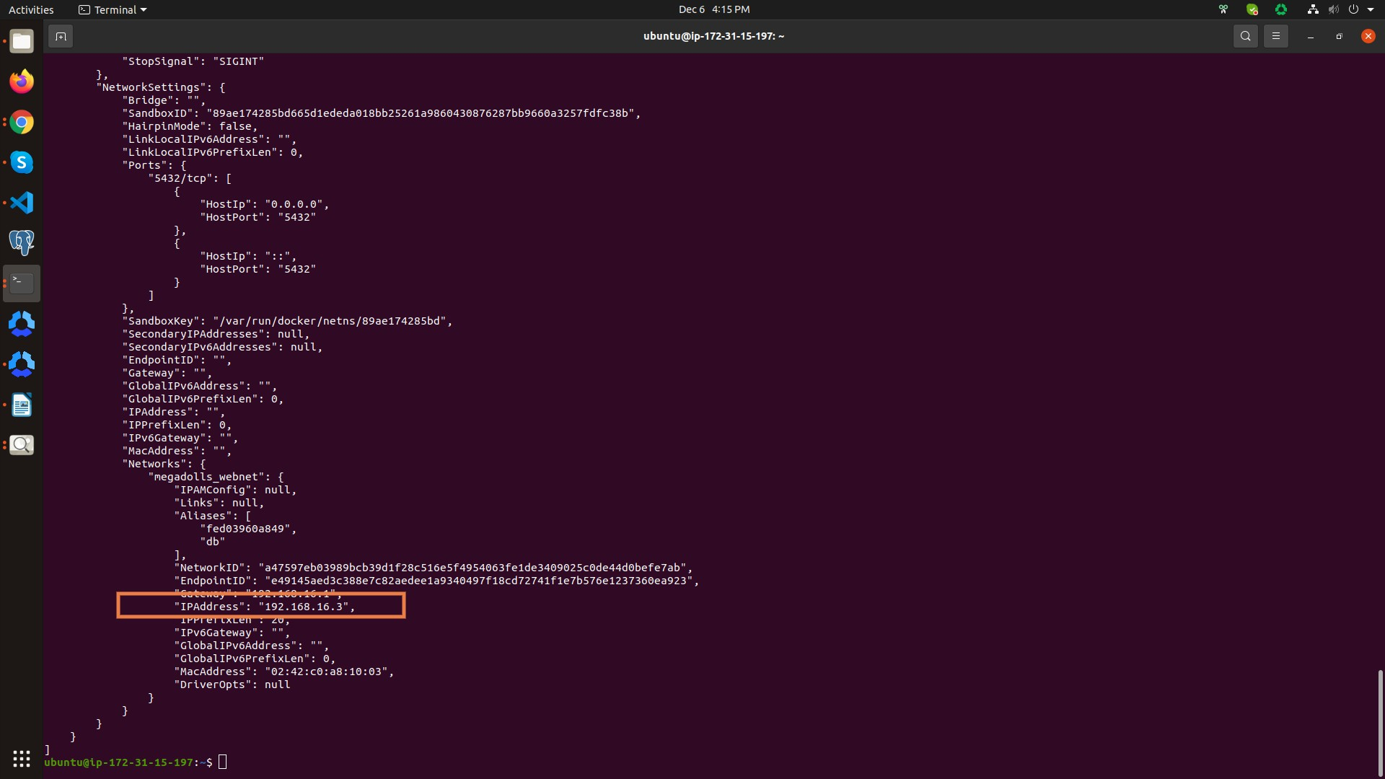you will get something like above image then find IPAddress: “192.168.16.3”.

Note :- Please Keep in mind that IPAddress changes everytime when docker container goes down.

1. Then run another command. this command will make database backup

**pg_*dump -h 192.168.16.3 -U postgres postgres > live_*server_24_nov_2022.sql**

-h = host

*192.168.16.3 this is the container’s IP*

*-U = username, which postgres*

*postgres is also our database name too*

*live_server_24_nov_2022.sql is file name in which we want to database backup*

1. *then run command :-* ***ls***
2. *this will list all files and there we can see our database backup file*
3. then go to our project folder by running following command :-

**cd megadolls_production/megadolls**

1. then run another command by this command we shut down docker container

Important Note :- please always take database backup before running this command

**sudo docker-compose down**

1. then take pull from master branch
2. then run following command this command make build for our project :-

**sudo docker-compose up –build -d**

1. after that restore database run following command :-

**psql -h *192.168.16.3* -U postgres -d postgres < *live_*server_24_nov_2022.sql**