COM 181 Systems Architecture
Coursework 2

Planning

Simple Program Flow Chart
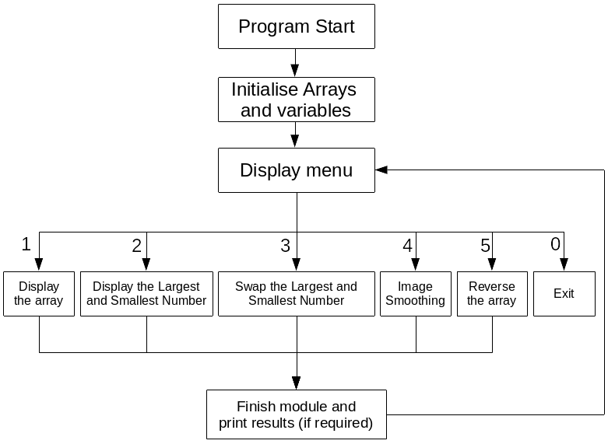

Program Functionality

The program should be able to:
- Allow the user to navigate the program via a menu
- Display the array in a user readable manner (numbers separated by a comma and a space, i.e. 1, 2, 3, 4, etc.)
- Display the largest and smallest number to the user in a way they understand
- Swap the largest and smallest number
- Run an ‘image smoothing’ function on the array
- Reverse the array
Functionality Design and Programming

0. Bootstrap
Flowchart
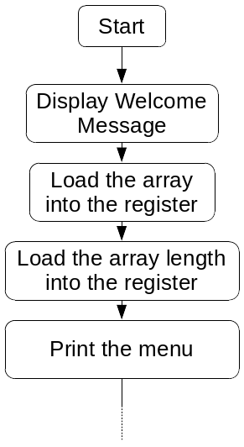
Code
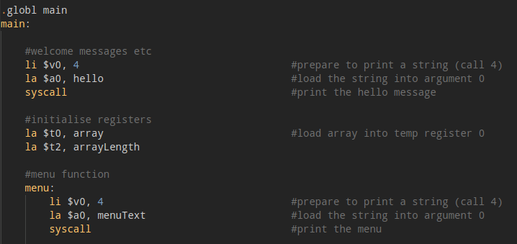
Here is the initialisation code. All this does is display the welcome message, and load the array and it’s meta data into the registers.

1. Allow the user to navigate the program via a menu
Flowchart

Code
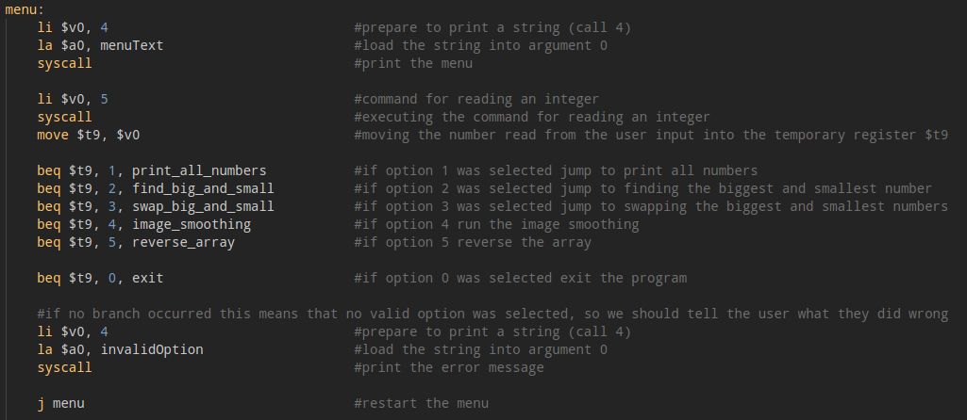
This is the code for the menu. First it prints the menu options, then reads in an integer. Then there are 5 BEQs that will redirect the program to different functions based on the input. If the input isn’t a option on the menu, and invalid option warning is printed and the program loops back to the start of the menu.

Output:
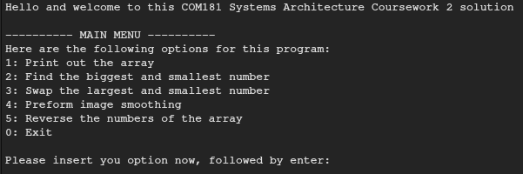
2. Display the array
Flowchart
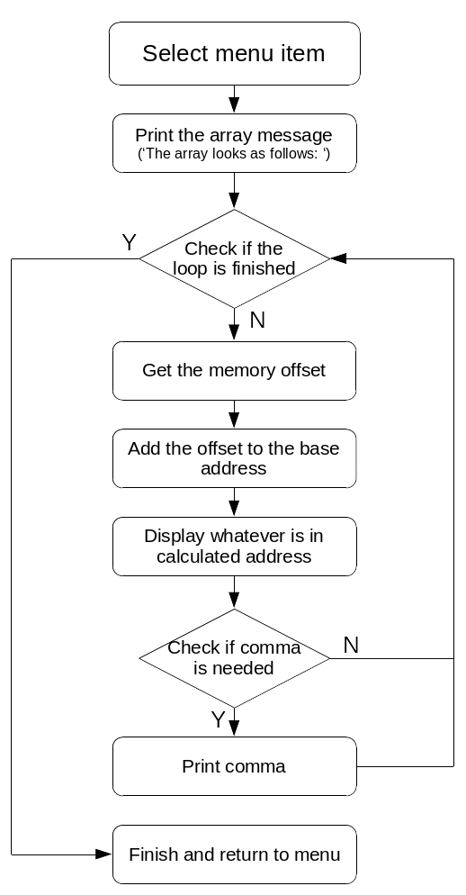

Code on the next page
Code
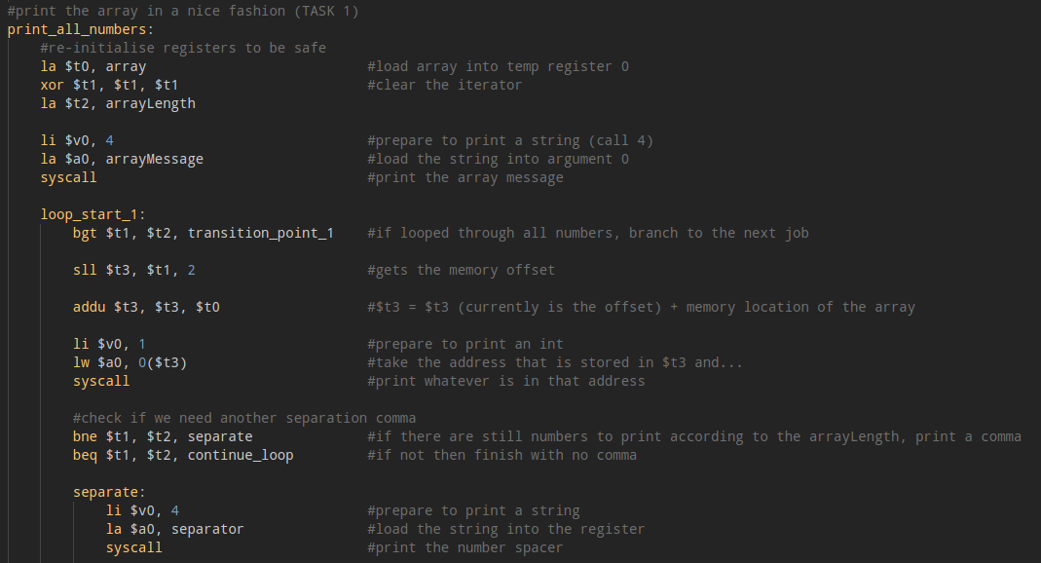
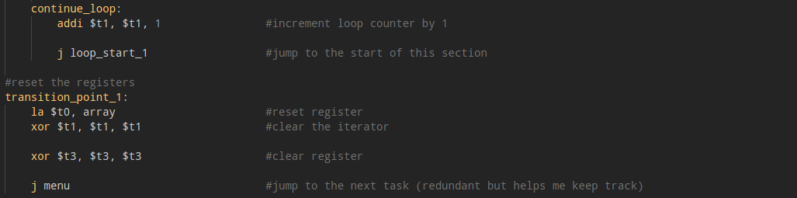
First the function checks if the current iterator count is the same as the array length. If it is, finish up the function. Otherwise, let the user know that the array is going to be printed by saying “The array looks as follows: “. The program then uses the current iteration count and multiplies it by 4 (to get the memory offset). Then this is added to the memory address of the array. These combined get the current element in the array of the number that is wanted (essentially n = array[i];). This is then printed. Then a check is run to see if a comma is needed. If the iterator is the same as the array length, don’t print a comma otherwise print one. Then continue the loop. Once finished, reset everything and return to the menu.

Output on next page
Output:
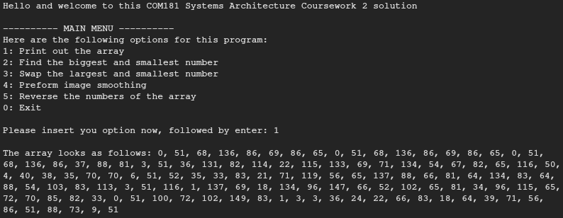

3. Find the largest and smallest number
Flowchart
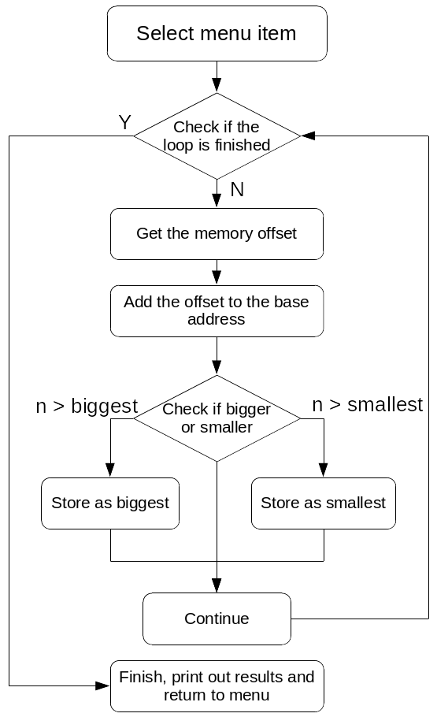

Code on next page
Code
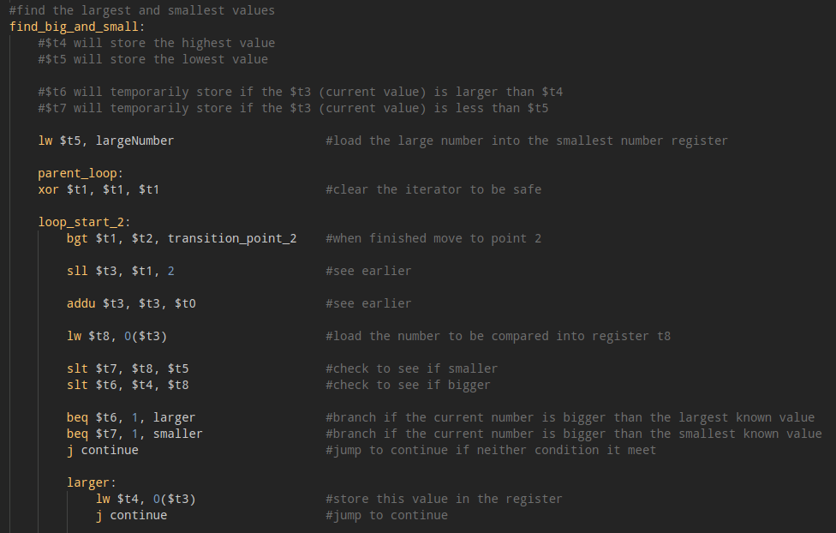
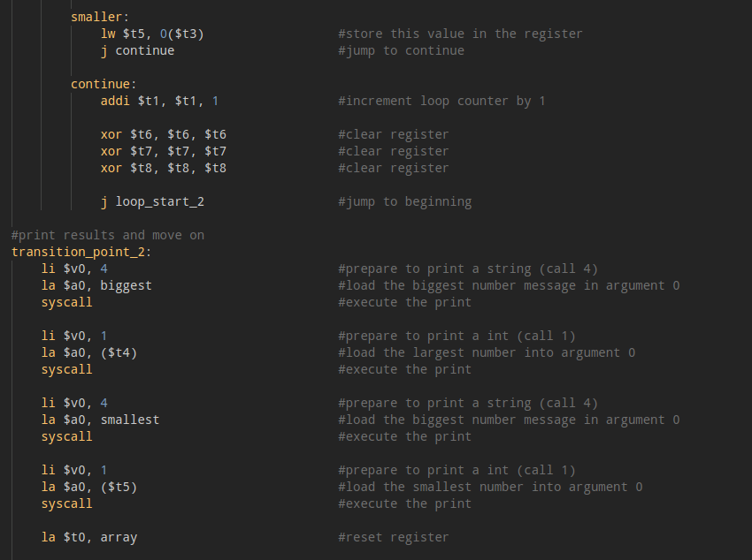
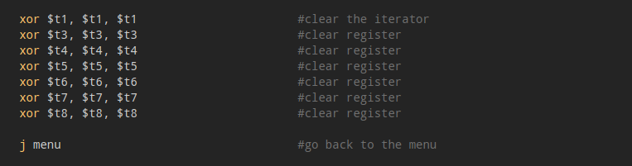
[See next page for explanation]
Before the module starts the main function, the register holding the smallest value is loaded with a very large number (to ensure that if the number is the smallest number is the first number it isn’t loaded into the largest register). The looping of this module is similar to the last one, so explanation of this can be skipped. When checking if the number is bigger or smaller: it is run through both a larger and smaller check. If it is bigger than the currently largest known number the register is set with a 1 flag, otherwise 0 and the same with the smaller number: if the current number is the smallest number the register is set to 1, otherwise 0. These flags are then checked with a BEQ which will cause the system to either store the current number in the register that stores the largest or smallest number or just continue without storing anything. Before the loop is finished, the registers storing the flag status and the current number are cleared to prevent any issues.

Once the module is finished, the largest and smallest values are printed, all the temporary registers are cleared and the program returns to the menu.

4. Swap the largest and smallest number
Code
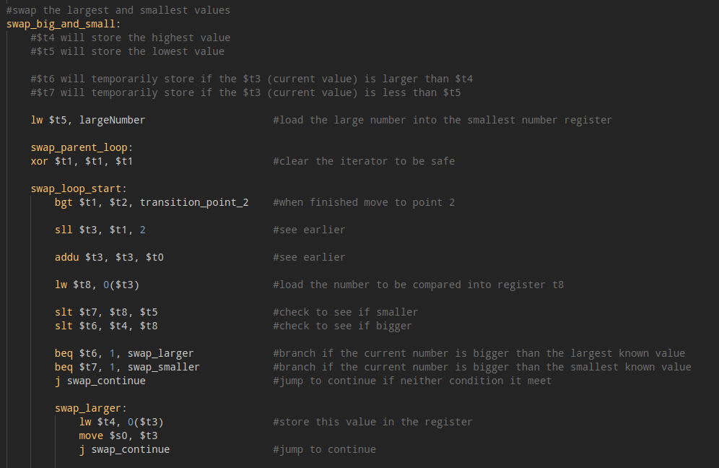
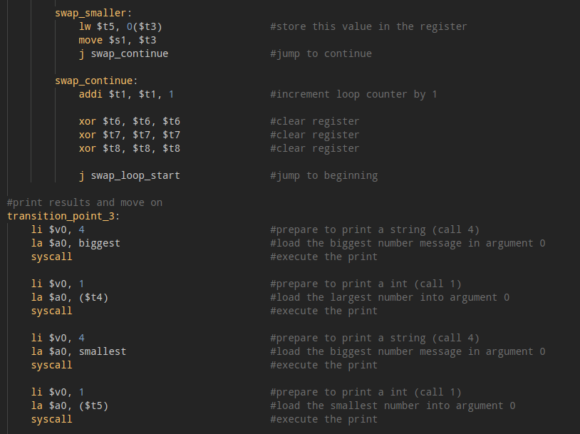
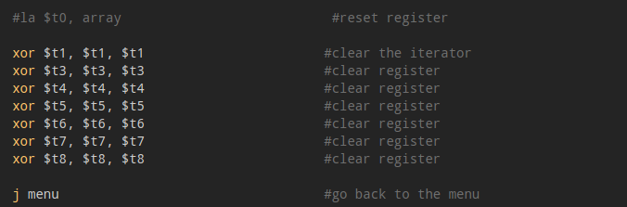

I based this off of the finding of the largest and smallest number, but I was unable to get this working, but the thought process was that if I stored the address off the largest and smallest and then swapped them I could get that to work. Unfortunately due to time constraints I couldn’t get this to work.
5. Image Smoothing
Code
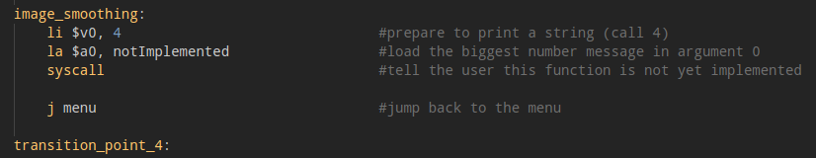
Due to time constraints I was unable to get anything presentable for this. I was experimenting with it and researching different methods but in the end I didn’t have anything remotely useable or presentable.

6. Reverse the array
Flowchart
Code on the next page
Code
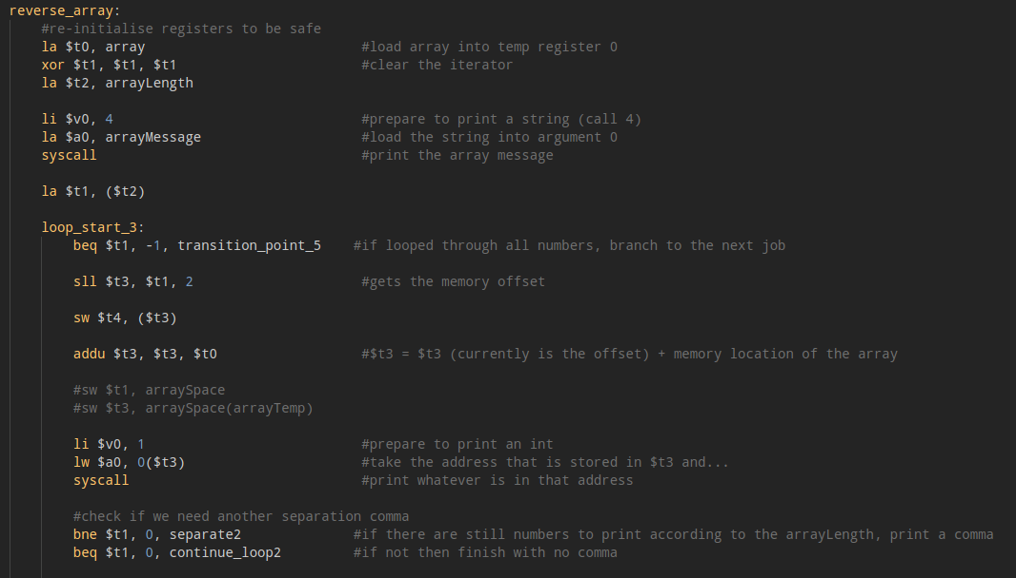
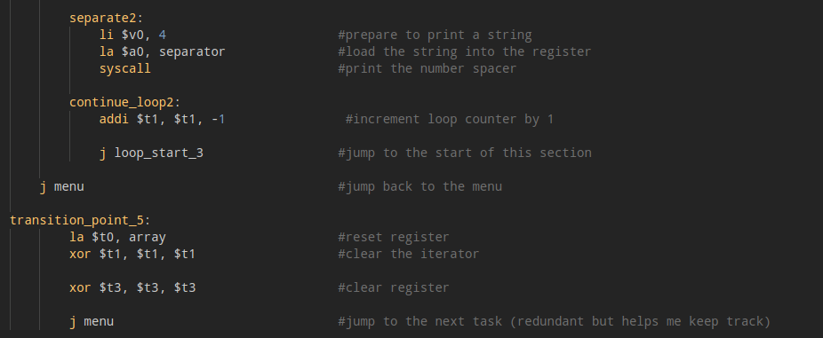
[See next page for explanation]

This works almost the same as displaying the array, but instead of starting at the start of the array the iterator is loaded with the array length and then counts down. While I was able to get the module to display the array I was unable to figure out how to properly store it back in memory.

Conclusion
The system is mostly functional, with 1 module not implemented, 2 modules with a broken implementation, and 3 requirements fully functional. I struggled most with the concept of memory and storing things back into registers or RAM. If I were to redo this project, I would focus more on understanding how SW works and how to commit results etc to memory.

