# Employee Database Project

By: Bob Palmer

Applied Database Management IS362DLS2A2016

Week 8 - Final Project

## Purpose

For this project, I have developed a database which contains employee information. Use of this database can be universally applied to time-clock, payroll, tax, and human resource applications. Included in this file is the data dictionary, the logical model, the "create" table, the physical model, an input form, an output report, an update/modify example, and three sample queries with results. Please see the included file “Palmer_EMP_DATA.accdb” to review actual implementation.

Each employee must have exactly one Pay_Type. Salaried employees do not clock in, and therefore, cannot have a variable Pay_Rate. Hourly employees, on the other hand, can hanve a variable Pay_Rate based on the position which they are working. This has practical application in many restaurant and retail settings, and also allows for the implementation of a shift differential for certain positions (such as overnight stocker or prep cook).

Bonuses are calculated based on a percentage of total sales, as long as the total sales exceed a defined minimum. This minimum can be defined based on any number of factors by an external application.

## Data Dictionary

Employee_ID: (AutoNumber) The internal identifier for an employee. Used across all tables which reference that employee.

First_Name: (Short_Text) Employee’s first name.

Middle_Name: (Short_Text) Employee’s middle name.

Last_Name: (Short_Text) Employee’s last name.

Street_Address: (Short_Text) Employee’s street address, including house number and street name.

City: (Short_Text) Employee’s city of residence.

State: (Short_Text) Employee’s state of residence, non-abbreviated with first letter capitalized.

Zip: (Short_Text) Employee’s Zip Code

SSN: (Short_Text) Employee’s Social Security Number

Pay_Type: (Number) How the employee is paid. Descriptions are found in the Pay_Type table field “PT_Name”.

PT_Name: (Short_Text) A text description of the numerical pay type.

Pay_Rate: (Currency) Dollar amount of an hourly employee’s hourly wage.

Job_Type: (Number) The employee’s job type. Descriptions are found in the Job_Type table field “Job_Description”

Job_Description: (Short_Text) A text description of the numerical job type.

Salary: (Currency) Dollar amount of a salaried employee’s annual salary.

Min_Weekly_Sales: (Currency) The minimum store sales required for a Salaried With Bonus employee to receive their bonus.

Percentage: (Number) The percentage of sales which the Salaried With Bonus employee receives as a bonus. Represented as a whole number.

## Logical Model

## C:\Users\Bob\AppData\Local\Microsoft\Windows\INetCache\Content.Word\EER.PNG

EER Diagram

Total Specialization Rule (Hoffer, et al, pp.121 fig. 3-6a)

Partial Specialization Rule (Hoffer, et al, pp.123 fig. 3-6b)

Disjoint Rule (Hoffer, et al, pp.124 fig. 3-7a)

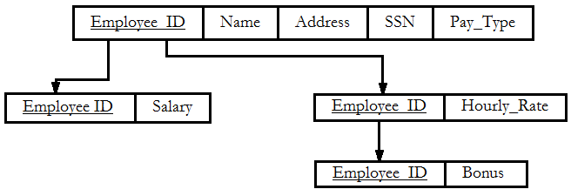

3rd Normal Form (Hoffer, et al., pp 186, fig 4-23 )

## “Create” Table

**CREATE TABLE** Pay_Type

(ID NUMBER(11,0) **NOT NULL**,

PT_Name VARCHAR(25),

**CONSTRAINT** Pay_Type _PK **PRIMARY KEY** (ID));

**CREATE TABLE** Employee_Base

(Employee_ID NUMBER(11,0) **NOT NULL**,

First_Name VARCHAR(25) **NOT NULL**,

Middle_Name VARCHAR(25),

Last_Name VARCHAR(25),

Street_Address VARCHAR(50),

City VARCHAR(25),

State VARCHAR(25),

Zip VARCHAR(10),

SSN VARCHAR(11),

Pay_Type NUMBER (11,0) **NOT NULL,**

**CONSTRAINT** Employee_Base_PK **PRIMARY KEY** (Employee_ID),

**CONSTRAINT** Employee_Base_FK **FOREIGN KEY** (Pay_Type) REFERENCES Pay_Type (ID));

**CREATE TABLE** Job_Type

(ID NUMBER(11,0) **NOT NULL**,

Job_Description VARCHAR(50),

**CONSTRAINT** Job_Type _PK **PRIMARY KEY** (ID));

**CREATE TABLE** Hourly_Rates

(ID NUMBER(11,0) **NOT NULL**,

Pay_Rate DECIMAL(6,2) **NOT NULL**,

Employee_ID NUMBER(11,0) **NOT NULL**,

Job_Type NUMBER (11,0) **NOT NULL,**

**CONSTRAINT** Pay_Type _PK **PRIMARY KEY** (ID),

**CONSTRAINT** Hourly_Rates_FK **FOREIGN KEY** (Employee_ID) REFERENCES Employee_Base (Employee_ID),

**CONSTRAINT** Hourly_Rates_FK **FOREIGN KEY** (Job_Type) REFERENCES Job_Type (ID));

**CREATE TABLE** Salaries

(ID NUMBER(11,0) **NOT NULL**,

Salary DECIMAL(11,2) **NOT NULL**,

Employee_ID NUMBER(11,0) **NOT NULL**,

Job_Type NUMBER (11,0) **NOT NULL,**

**CONSTRAINT** Salaries _PK **PRIMARY KEY** (ID),

**CONSTRAINT** Salaries _FK **FOREIGN KEY** (Employee_ID) REFERENCES Employee_Base (Employee_ID),

**CONSTRAINT** Salaries _FK **FOREIGN KEY** (Job_Type) REFERENCES Job_Type (ID));

**CREATE TABLE** Bonus

(ID NUMBER(11,0) **NOT NULL**,

Min_Weekly_Sales DECIMAL(11,2),

Employee_ID NUMBER(11,0) **NOT NULL**,

Percentage NUMBER (11,0) **NOT NULL,**

**CONSTRAINT** Bonus _PK **PRIMARY KEY** (ID),

**CONSTRAINT** Bonus _FK **FOREIGN KEY** (Employee_ID) REFERENCES Employee_Base (Employee_ID));

## Physical Model

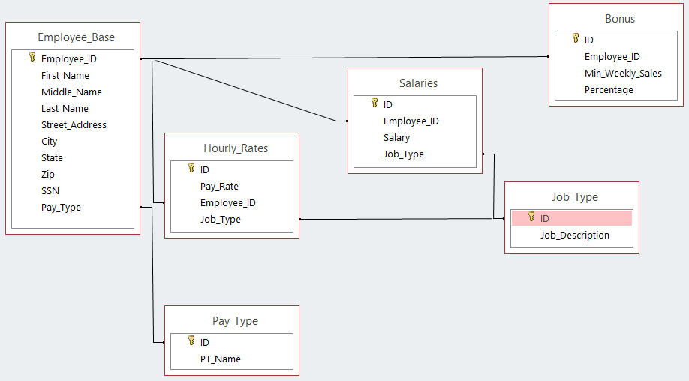

## Input Form and Output Report

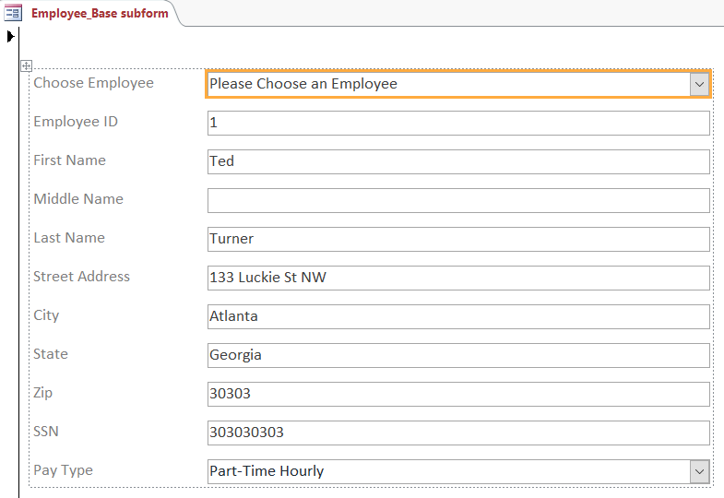

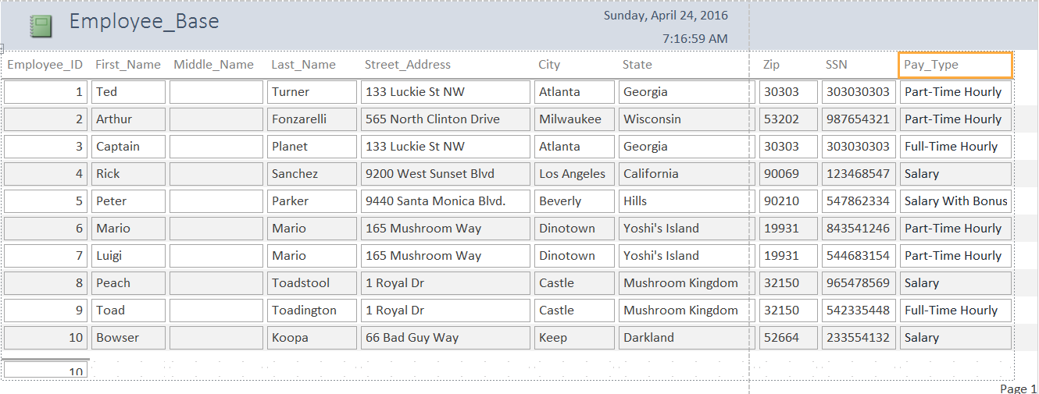

## Update/Modify Example

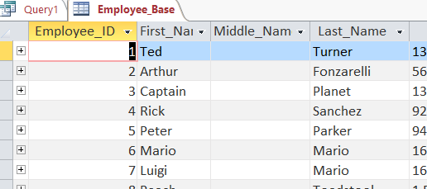

UPDATE Employee_Base SET First_Name="Miles", Last_Name="Morales" WHERE Employee_ID=5;

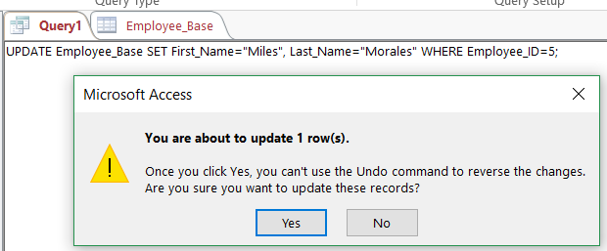

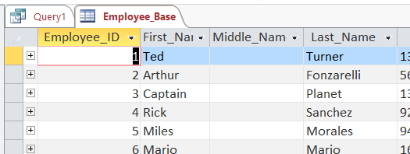

## Three Sample Queries w/ Results

### 1

SELECT * FROM Employee_Base WHERE Pay_Type = (SELECT ID FROM Pay_Type WHERE PT_Name = "Part-Time Hourly") ORDER BY Last_Name;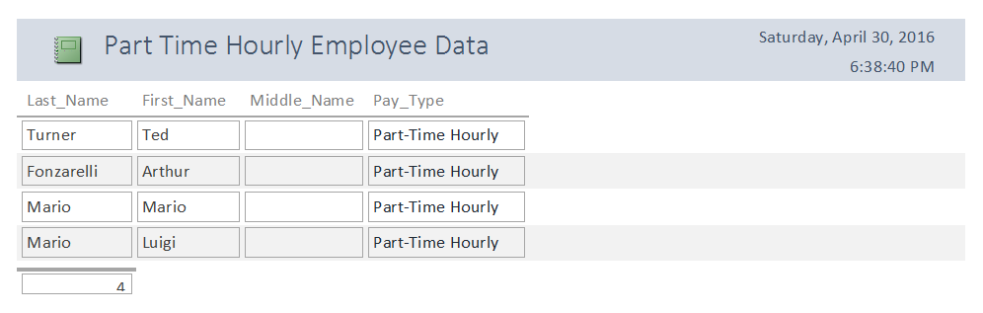

### 2

SELECT Employee_Base.Last_Name, Employee_Base.First_Name, Employee_Base.Middle_Name, Pay_Type.PT_Name, Salaries.Salary, Bonus.Percentage, Bonus.Min_Weekly_Sales

FROM ((Employee_Base INNER JOIN Salaries

ON Employee_Base.Employee_ID=Salaries.Employee_ID)

INNER JOIN Pay_Type

ON Employee_Base.Pay_Type=Pay_Type.ID)

LEFT JOIN Bonus

ON Employee_Base.Employee_ID=Bonus.Employee_ID;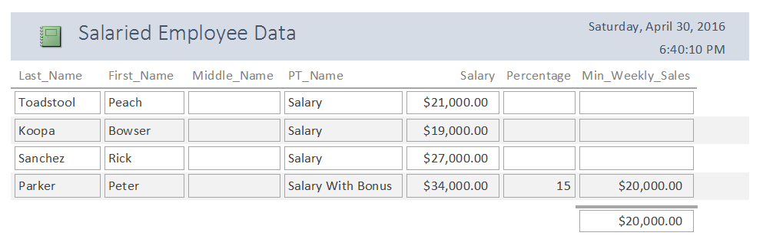(SQL INNER JOIN Keyword, 1999), (SQL COUNT() Function, 1999)

### 3

SELECT * FROM Employee_Base ORDER BY Employee_ID;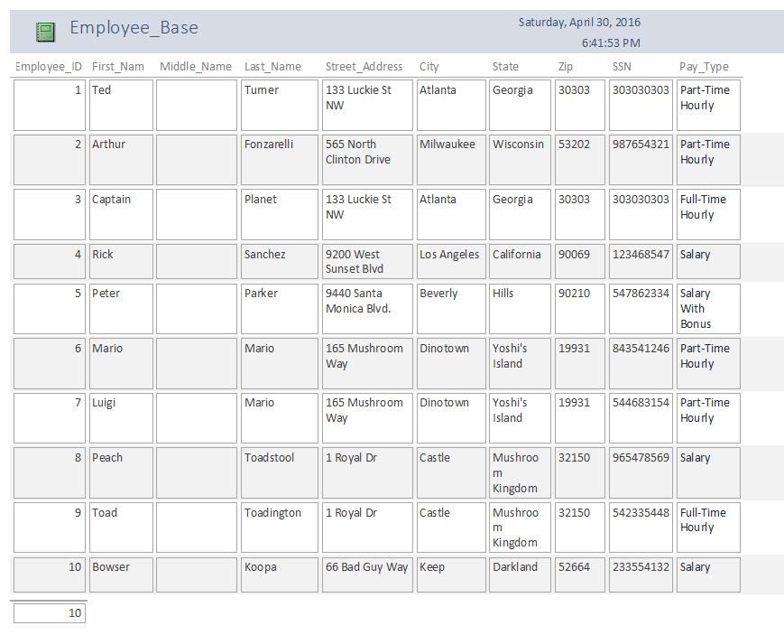

## Sources:

Hoffer, J. A., Ramesh, V., & Topi, H. (2016). Modern database management (12th ed.). Pearson.

SQL INNER JOIN Keyword. (1999). Retrieved April 7, 2016, from <http://www.w3schools.com/sql/sql_join_inner.asp>