Interim planning

Overview
The aim of this project is to create software that will be able to accurately and consistently identify the numberplate on any given car from the UK. This will involve investigating and researching how artificial intelligence systems, specifically neural networks, function and can be applied to a given project.

Purpose
The purpose of this project is to reduce waste caused by the constant printing of paper tickets, while also giving users one less thing to hold on to and worry about while they go about their other daily activities. Paper tickets are frequently lost, torn or have their magnetic strip wiped, rendering them useless. This at best delays the person, and at worst can cause them to need to pay a fine.

Composition
The software will be composed of two core parts, those being the network itself, and the front-end and database that the users interacts with. The network and the interface will both be written in C#, and the database will be using SQLite.

Methodology
When I am working on the project, I will be carrying out the works in small phases so I am not bogged down with a huge task that actually involves many smaller activities. Every two weeks I will take a few of these smaller subtasks and aim to complete them, akin to an Agile methodology of working.

Objectives
- A functioning, trained network that is able to recognise the font that is used on car number plate
- A sleek, easy to use interface for people to interact with to pay their costs
- A clean and elegant software solution that is intelligently designed and easy to maintain

Schedule of Activities

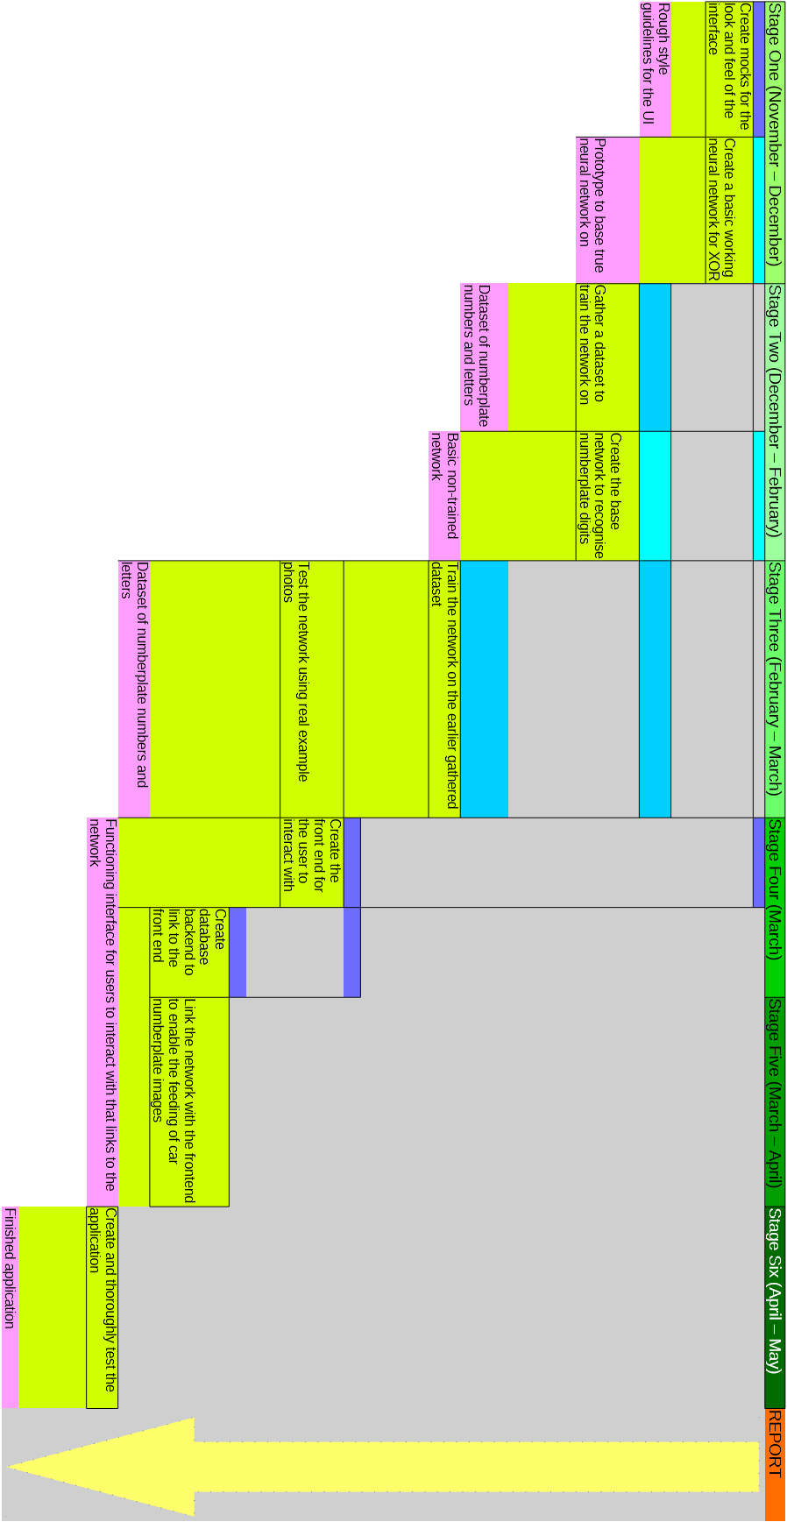

Risk Analysis

Risk: The XOR network is not able to learn with the given database.
Effect: No working prototype the base the real network on.
Control: Ensure the dataset is valid and correctly processed and passed to the XOR prototype network.

Risk: There is no valid dataset available for the real network.
Effect: The network is not able to learn or be trained.
Control: Check to ensure that the font is standard across all UK number plates, and able to be found easily online

Risk: The type of network the prototype is based on is not appropriate for the real network.
Effect: There will be less knowledge going into creating the real network.
Control: Do appropriate research about types of neural network and their applicability to the problem tackled in this project

Risk: The database integration is too slow for the average user to wait for patiently
Effect: A negative experience when trying to use the software
Control: Use a lightweight and simple database for the fastest response times

Risk: The tests find critical errors but are found too late in the project to resolve
Effect: The software is buggy, or does not work at all
Control: Keep testing each piece of the software throughout the project in small steps.

Investigative Report

This project has a heavy focus on artificial intelligence, and how it can be applied to the problem of detecting numbers and letters in a photograph. Therefore, there is focus on two main research areas. These are what exactly is a neural network, and how can they be applied to the project I am tackling, which is the recognition of numbers and digits on a number plate.
The first question is what exactly is a neural network. They are can be described as “an information-processing system[1]”, and an attempt at “modelling the information processing capabilities of a nervous system[2]”. In the same way that a neuron in the human brain does, a neural network receives and processes many signals at once, which combined with the powerful computing nature of computers leads to an incredibly useful tool that can be applied to many areas.
The study of neural networks spans across many fields, which demonstrates just how useful they can be, while their success both commercially and in areas of research “show promise for the future[3]”. Their wide range of applications is one of the motivating factors for my choosing of them for this project. Pattern recognition, the problem of recognising patterns in data, is well suited for a neural network that works with backpropagation. This is “simply a gradient descent method[4]” that is utilised to minimize the total error output of the network. These types of neural networks able to recognise patterns in data, such as the intensity and colour of a set of pixels passed in, and with enough training, can recognise similar patterns between varying sets of input data, or in my case, numbers and letters. By slowly changing weights within the network to reduce the error, a very accurate and consistent network can be created, which is critical in an application like this.

Bibliography

Raúl Rojas - Springer – (1996). Neural networks: a systematic introduction

This book serves as a comprehensive introduction to the topic of understanding the underlying theory behind neural networks. It begins from the ground up, starting with the biological motivation behind neural networks, before exploring more advanced topics such as recurrent networks and backpropagation.

Laurene V.Fausett - Prentice-Hall – (1994). Fundamentals of neural networks: architectures, algorithms, and applications

The author in this book explains and covers several types of neural network and how they can be applied to problems such as pattern classification and association. The focus on network architecture and application is immensely useful for researching how to approach my project, and it explains the concepts in a concise and straightforward manner.

Christopher M.Bishop - Clarendon - (1995). Neural networks for pattern recognition

This book has a heavy focus on the topic of pattern recognition. It fully explores the mathematical foundation of networks, and how to specifically apply them to solving problems in pattern recognition.

References

[1]: Laurene V.Fausett - Prentice-Hall – (1994). Fundamentals of neural networks: architectures, algorithms, and applications, p.3
[2]: Raúl Rojas - Springer – (1996). Neural networks: a systematic introduction, p.3
[3]: Laurene V.Fausett - Prentice-Hall – (1994). Fundamentals of neural networks: architectures, algorithms, and applications, p.7
[4]: Laurene V.Fausett - Prentice-Hall – (1994). Fundamentals of neural networks: architectures, algorithms, and applications, p.289

