Hierarchical Semantic Memory Architecture
A proposed memory and hardware co-design for long-horizon agentic AI
Core thesis
Long-horizon agents need memory that scales with accumulated understanding, not only with token history.
HSMA proposes a multi-level hierarchy that can demote raw KV into compressed neural state, semantic summaries, concept nodes, and a knowledge graph - while preserving pointers for selective reconstruction.
The opportunity is a new systems layer between inference, retrieval, and storage: semantic memory management for agentic AI.
Prepared for: Senior Technical Leadership
Prepared by: Oluwole Jaiyeoba
Document type: Internal concept proposal / architecture whitepaper
Version: 2.0
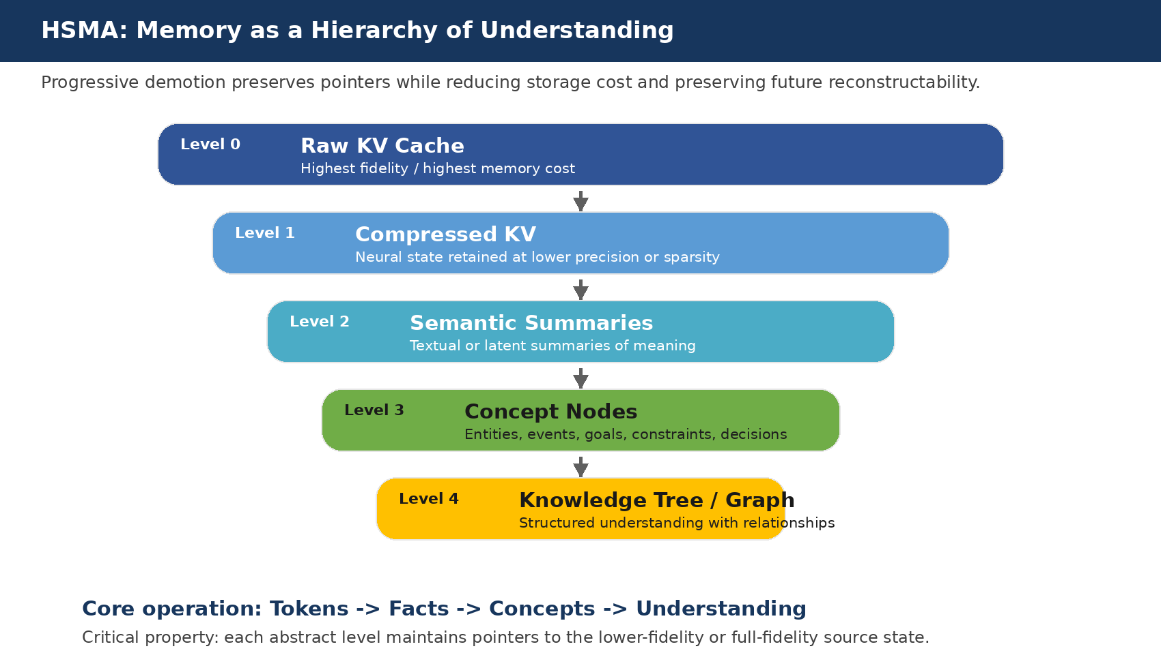
Figure 1. HSMA reframes LLM memory as progressive semantic abstraction with downward pointers.

1. Executive One-Page Summary
Large language models are moving from short-lived inference requests toward persistent agents that plan, use tools, collaborate, and accumulate state across long time horizons. In these workloads, memory pressure is no longer a secondary issue. It becomes a first-order systems bottleneck that affects cost, latency, accuracy, and deployability.
Proposal in one sentence
Build a Hierarchical Semantic Memory Architecture (HSMA) that continuously converts raw token/KV history into compressed KV, summaries, concepts, and knowledge graphs - while keeping pointers that allow the system to reconstruct only the context it needs.

Dimension | Executive summary
Problem | Current systems largely retain, compress, summarize, or retrieve history. They do not maintain a unified hierarchy from neural state to semantic understanding.
Architecture | HSMA: Raw KV -> Compressed KV -> Semantic Summaries -> Concept Nodes -> Knowledge Tree / Graph.
Novel contribution | A semantic demotion and selective reconstruction layer that links KV-cache management, RAG, summaries, and graph memory into one pointer-preserving hierarchy.
Hardware opportunity | Semantic Memory Controller, Knowledge Cache, Graph Accelerator, KV Demotion Engine, Reconstruction Engine, and longer-term Knowledge Processing Unit.
The strategic hypothesis is that future agentic systems will need a memory abstraction layer comparable in importance to virtual memory, cache hierarchy, and storage hierarchy in classical systems. The difference is that the movement policy is based not only on recency or address locality, but also on semantic utility, future relevance, and reconstructability.

2. Problem Statement: Agentic AI Changes the Memory Problem
Traditional inference workloads are bounded: a prompt arrives, tokens are generated, and the request ends. Agentic systems are different. They can run across sessions, use tools, write code, coordinate sub-agents, remember user preferences, and revisit decisions made thousands or millions of tokens earlier.
CURRENT SCALING PATTERN
More interaction -> more tokens -> more KV state -> more memory movement -> higher cost and latency.
The KV cache is especially important because it avoids recomputing prior key/value states during autoregressive generation, but its size grows with context length and batch size. Recent KV-cache research explicitly identifies the cache as a major inference memory bottleneck and proposes eviction, sparsity, and quantization techniques to reduce footprint [6, 8, 9, 10].
Reframing
The core question should shift from "How do we store more tokens?" to "How do we preserve useful understanding at the lowest necessary fidelity?"

3. Prior Art Landscape and Limitations
HSMA does not replace the existing research landscape. It attempts to connect several strong but currently separate lines of work into a single systems abstraction.
Approach | Primary unit | Representative work | Strength | Gap relative to HSMA
KV compression / eviction | Neural state | H2O, KIVI, SnapKV, PyramidKV | Reduces KV footprint and bandwidth | Does not create a semantic hierarchy or future reconstruction model
Long-context memory models | Hidden state / memory | Transformer-XL, Compressive Transformer | Extends temporal context | Mostly model-internal, not a full agent memory OS
RAG / RETRO | Text chunks | RAG, RETRO | Scalable retrieval from external memory | Usually flat retrieval; weak persistent relational structure
Agent memory | Notes / summaries | MemGPT, generative agents | Practical long-term memory management | Mostly text-level memory; limited KV integration
GraphRAG | Entities / graph | Microsoft GraphRAG | Structured retrieval and community summaries | Typically disconnected from neural cache and reconstruction path
The key observation is not that any one prior-art line is insufficient. The gap is that the system lacks a unified transition path from raw neural state to compressed state to semantic structures and back again when needed.

4. Proposed Architecture: Hierarchical Semantic Memory Architecture
HSMA introduces a multi-resolution memory hierarchy for long-horizon agentic systems. Each level stores the same underlying information at a different level of fidelity, cost, and reconstructability.

Figure 2. The HSMA hierarchy from raw neural state to structured understanding.
Level | Representation | Primary role | Storage / compute profile
0 | Raw KV cache | Maximum fidelity for active reasoning | High HBM footprint; fastest attention path
1 | Compressed KV | Retain neural state at lower cost | Quantized, pruned, clustered, or offloaded
2 | Semantic summaries | Compact textual or latent meaning | Cheap to store; may lose detail
3 | Concept nodes | Entities, events, decisions, goals, constraints | Structured metadata and references
4 | Knowledge tree / graph | Relationships and navigable understanding | Lowest cost; highest abstraction
Design principle
Higher levels do not merely summarize lower levels. They maintain typed pointers to source tokens, raw text, compressed KV, raw KV segments, timestamps, task state, and dependency relationships.

5. What Is Existing vs. What Is Novel
A credible architecture proposal should avoid claiming novelty for established ideas. HSMA builds on strong prior art, but the proposed contribution is the integration and systems co-design.
Category | Examples | Assessment
Existing prior art | KV compression, RAG, agent memory, graph retrieval, OS-inspired context management | Do not claim these as new. They are foundation technologies.
Incremental extensions | Better memory policies, graph-enhanced retrieval, compressed KV offload, summary hierarchies | Valuable but likely incremental unless integrated into a stronger architecture.
Proposed novel contribution | Semantic demotion + pointer-preserving hierarchy + selective reconstruction + hardware/runtime co-design | This is the investment-worthy system abstraction.
The strongest novelty claim is not "we compress KV" or "we build a graph." The stronger claim is: we manage neural, textual, and symbolic memory as a unified hierarchy and introduce runtime/hardware mechanisms for demotion, promotion, and selective reconstruction.

6. Architectural Walkthrough
Consider an agent that has discussed a product architecture, constraints, experiments, and unresolved decisions over many sessions. A flat transcript or vector store can retrieve matching chunks. HSMA instead maintains a navigable structure of the conversation and its reasoning state.
Step | Operation | Example
1. Observe | Process incoming tokens and produce raw KV | Conversation contains: "Paris is the capital of France."
2. Extract | Identify facts, entities, dependencies, and task relevance | Entity: France. Relation: capital_of(Paris, France).
3. Demote | Move cold state from raw KV into compressed KV or summaries | Old geographic fact no longer needs full HBM residency.
4. Link | Attach pointers from concept nodes to summaries, source text, and KV segments | Concept node France points to source span and compressed KV block.
5. Retrieve | When a question arrives, traverse concepts before loading detailed state | Question: "Which country did we discuss?" -> Geography -> Europe -> France.
6. Reconstruct | Rebuild only the relevant context branch | Load summary, source span, or replay tokens to regenerate KV as needed.
Important technical nuance
The architecture does not assume that semantic summaries can perfectly replace KV. It assumes multiple representations can coexist, and that fidelity should be allocated based on predicted future utility and reconstruction cost.

7. Proposed Hardware and Runtime Architecture
The near-term implementation should be software-first: a runtime, metadata store, KV compression layer, graph store, and reconstruction policy. The long-term hardware opportunity is to identify which semantic-memory operations become common enough, expensive enough, and structured enough to justify acceleration.
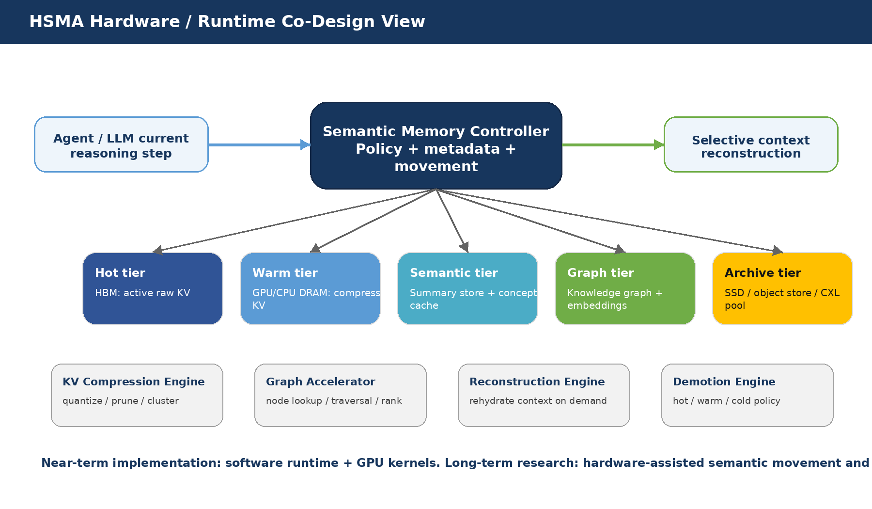
Figure 3. HSMA can start as runtime software and evolve toward hardware-assisted semantic memory movement.
Component | Near-term role | Long-term hardware path | Why it matters
Semantic Memory Controller | Runtime policy engine for promotion/demotion | Hardware-assisted metadata and movement engine | Coordinates memory by semantic utility, not only address locality
Knowledge Cache | GPU/host-resident active concepts and subgraphs | On-package or near-memory semantic cache | Keeps active reasoning structure close to compute
KV Demotion Engine | GPU kernels for quantization, pruning, clustering | Dedicated compression/decompression path | Reduces HBM pressure and KV bandwidth
Graph Accelerator | Software graph traversal and ranking | Specialized traversal/ranking primitives | Accelerates concept navigation for retrieval
Reconstruction Engine | Replay, retrieve, or rehydrate context on demand | Batched context rebuilding engine | Avoids full-history reload while restoring needed detail
Memory Fabric | HBM, DRAM, CXL/pool, SSD tiers | Semantic-aware placement and movement | Supports long-lived agents with multiple fidelity tiers
KPU | Research concept only | Knowledge Processing Unit | Could accelerate concept merge/split, summary updates, graph maintenance
This aligns with broader hardware trends: high-bandwidth GPU fabrics such as NVLink target low-latency GPU-to-GPU communication, while CXL provides a cache-coherent interconnect for processors, accelerators, and memory expansion. HSMA would add a semantic placement policy above these physical fabrics [11, 12].

8. Why This Could Become a New Systems Layer for Agentic AI
Classical systems introduced abstractions that made larger applications possible: virtual memory made address spaces larger than physical memory; cache hierarchies hid latency; databases separated logical queries from physical storage.
HSMA analogy
HSMA proposes a comparable abstraction for agentic AI: semantic memory management separates the agent's logical understanding from the physical representation of tokens, KV, summaries, and graph state.

Classical systems layer | Problem solved | HSMA analogue
Virtual memory | Programs exceed physical memory | Agents exceed fixed context windows
Cache hierarchy | Hide latency and exploit locality | Keep active reasoning state close to compute
Database indexing | Retrieve by structure rather than scan | Retrieve by concept graph rather than transcript scan
Storage hierarchy | Move cold data to cheaper media | Demote cold context to summaries/graph/archive
If agentic workloads become dominant, memory management may become as strategically important as model inference throughput. The architecture that controls what the agent remembers, forgets, abstracts, and reconstructs could become a foundational platform layer.

9. Research Roadmap
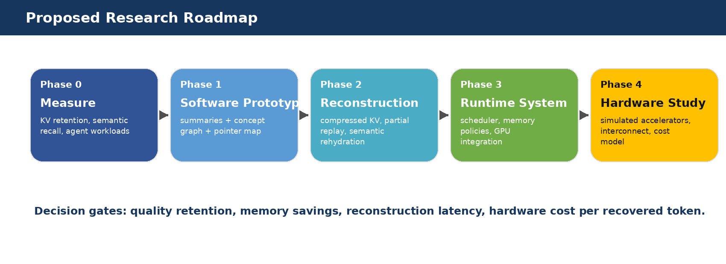
Figure 4. Suggested staged research roadmap with decision gates.
Phase | Goal | Key experiments | Exit criteria
0. Baseline measurement | Quantify problem size | Measure KV footprint, bandwidth, recall failures, and long-agent latency | Clear bottleneck model and workload suite
1. Software prototype | Build semantic hierarchy | Extract summaries, facts, concept nodes, pointer maps | Improved long-horizon recall with controlled overhead
2. Reconstruction | Prove recoverability | Compare raw retrieval, partial replay, compressed KV rehydration | Target quality within tolerance at lower memory
3. Runtime policies | Optimize movement | Promotion/demotion policies using attention, reuse, semantic centrality | Stable policies with predictable latency
4. Hardware study | Evaluate acceleration | Simulate compression, graph traversal, reconstruction, interconnect movement | Cost/performance case for hardware investment

10. Success Metrics
Metric | Target direction | Why leadership should care
Peak KV memory | Reduce at fixed quality | Lowers HBM requirements and cost per agent
HBM bandwidth per generated token | Reduce | Improves inference throughput and utilization
Long-horizon recall accuracy | Maintain or improve | Prevents agents from losing earlier decisions
Selective reconstruction latency | Bound tightly | Avoids stalls when old context becomes relevant
Task completion on agent benchmarks | Improve or hold | Proves memory savings do not break reasoning
Joules per completed task | Reduce | Captures system-level value beyond tokens/sec

11. Technical Risks and Open Questions
Risk | Why it is hard | Mitigation / test
Semantic fidelity | Summaries and concepts may omit details that matter later | Use downward pointers, confidence scores, and reconstruction tests
Future utility prediction | Low-attention information may become important later | Combine attention, reuse history, task state, and graph centrality
Reconstruction quality | Regenerated context may differ from original neural state | Compare replay, raw text retrieval, compressed KV, and hybrid methods
Graph drift | Long-lived graphs may become inconsistent or overgrown | Use versioning, decay, merge/split operations, and audit trails
Hardware justification | Semantic operations may be too irregular for silicon | Start with profiling and target only stable, high-frequency kernels
Security and privacy | Persistent memory can retain sensitive data | Add governance, deletion, provenance, and policy-aware demotion
Critical validation requirement
The proposal should not proceed to hardware investment until a software prototype demonstrates measurable memory savings without unacceptable degradation in long-horizon reasoning, recall, and tool-use performance.

12. Investment Rationale
HSMA is not a near-term replacement for KV compression, RAG, or GraphRAG. It is a system architecture that can incorporate them and expose a new control plane for long-lived agents. The investment case is strongest if three conditions hold:
- Agentic workloads become persistent enough that raw context retention is economically unattractive.
- Semantic recall and structured memory become quality differentiators, not optional features.
- A measurable subset of memory operations can be accelerated or co-designed with hardware and interconnects.
Under those conditions, HSMA offers a credible path toward platform differentiation: not just faster inference, but better memory architecture for agents that operate over long horizons.

13. Selected Prior Art and References
This proposal intentionally builds on existing work. The references below are included to help separate foundational prior art from the proposed HSMA contribution.
[1] Packer et al., "MemGPT: Towards LLMs as Operating Systems," arXiv:2310.08560, 2023.
[2] Rae et al., "Compressive Transformers for Long-Range Sequence Modelling," arXiv:1911.05507, 2019.
[3] Lewis et al., "Retrieval-Augmented Generation for Knowledge-Intensive NLP Tasks," arXiv:2005.11401, 2020.
[4] Borgeaud et al., "Improving language models by retrieving from trillions of tokens," arXiv:2112.04426, 2021.
[5] Microsoft Research, "Project GraphRAG: LLM-Derived Knowledge Graphs," project page, 2024-present.
[6] Zhang et al., "H2O: Heavy-Hitter Oracle for Efficient Generative Inference of Large Language Models," arXiv:2306.14048, 2023.
[7] Xiao et al., "Efficient Streaming Language Models with Attention Sinks," arXiv:2309.17453, 2023.
[8] Liu et al., "KIVI: A Tuning-Free Asymmetric 2bit Quantization for KV Cache," arXiv:2402.02750, 2024.
[9] Li et al., "SnapKV: LLM Knows What You are Looking for Before Generation," arXiv:2404.14469, 2024.
[10] Cai et al., "PyramidKV: Dynamic KV Cache Compression based on Pyramidal Information Funneling," arXiv:2406.02069, 2024.
[11] Compute Express Link Consortium, "About CXL," official overview, accessed 2026.
[12] NVIDIA, "NVLink and NVLink Switch," official overview, accessed 2026.
Bottom line
HSMA is a proposal for a new agentic AI memory layer: one that manages raw KV, compressed neural state, semantic summaries, concept nodes, and knowledge graphs as a single reconstructable hierarchy. The strategic opportunity is to make long-horizon agents scale with understanding, not merely with accumulated tokens.

