4-Way 7-Segment Display Instructions

Instructions on how to drive a 4-way 7 segment display using the raspberry pi and arduino board.

Equipment needed

- Piduino Arduino board
- 9 Resistors
- 4-way 7-segment display
- 16 wires
- Breadboard
- Raspberry Pi with necessary equipment, keyboard, mouse, etc...

Method

Put the display onto your breadboard first. This will give you a way of finding where all your wires and resistors should go. Next should come your resistors followed by your wires. Follow this circuit diagram in order to set up the circuit of the project:

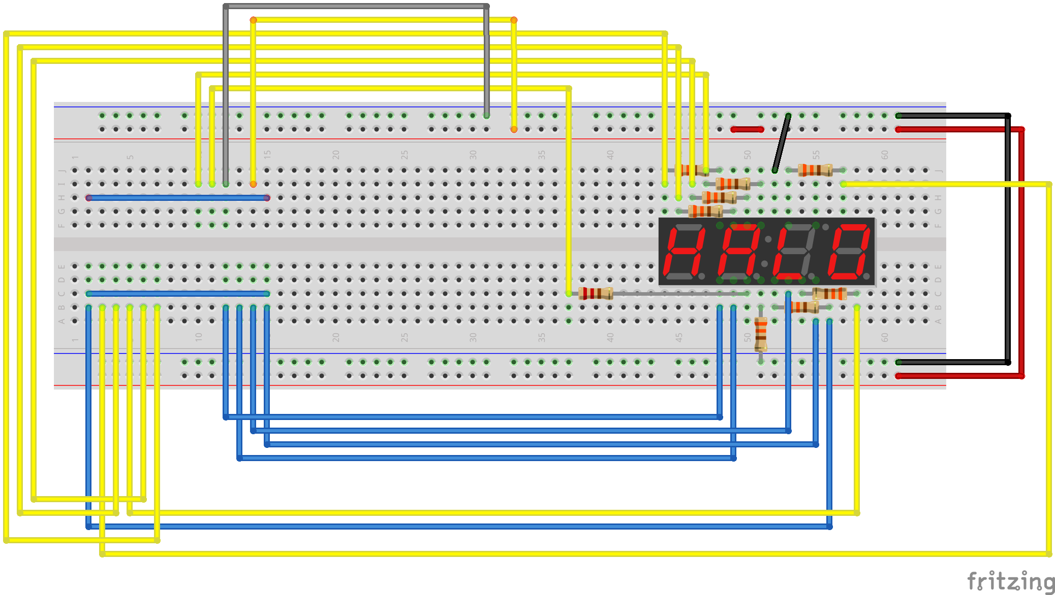
The two blue wires running straight across the left hand side of the board are a representation of the pins on the Piduino arduino board. The wires should run to the arduino board pins that match up to the circuit diagram pins. There are the same amount of pins on the diagram as on the board so this should not be a problem.

Next we need to download the code for this project to work. The code for the project can be found and downloaded at this web address, https://github.com/the3rdsun/Display. There is a button on the right hand side of the page that allows you to download all of the project code as a zip file.

In order for the project to run, you first need to upload the arduino C-code into the arduino flash memory as firmware, this is done by running the C-code from the arduino IDE. Next you need to run the python code named clock.py from the terminal using the command, 'sudo python clock.py'. This will cause the display to start working as a clock.

By Kyle Francis

