NeoPixels Instructions

Make pretty patterns using different coloured and different brightness LEDs, these can be sown into clothes!

Parts Required

- Adafruit 8-Neopixel strip
- Piduino Arduino board
- Raspberry Pi with necessary equipment, keyboard, mouse, etc...
- Three wires

Method

The circuit set up for this project is very simple, first you must solder three wires onto the Adafruit 8-Neopixel strip. The wire in the centre must be connected to the positive pin of the arduino board. Likewise, the pin on the right must be connected to the ground pin of the arduino board and the pin in the middle must be connected to one of the digital pins on the Piduino board. In out code we have used the pin D9 but you may change this if need be. Your circuit is now complete.

As with the other projects, the code, both the C-code and the python code for this project can be found and downloaded from github. The web address that this can found at is, https://github.com/the3rdsun/NeoPixels. Again, the button for downloading the zip file can be found on the right hand side of the web page.

In order for the project to work, you must first run the arduino C-code in order to change the firmware on the arduino board. Next you must run the python program from the LX Terminal using the 'sudo python led.py' command. It will ask you for the led that you want to change, you can either input 'all' to change all the LEDs or you can input a single number ranging from 0 to 7. The input for each of the red, green and blue values are percentages out of 100 and should be typed in as such. Now your project is set up and you can create pretty patterns with your NeoPixel LEDs.
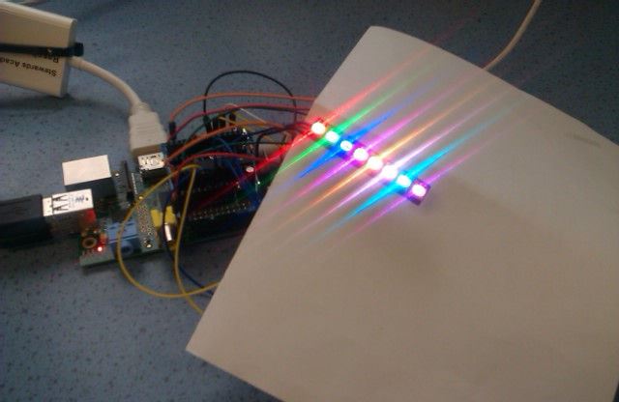

By Kyle Francis

