**CSS**

**Need to Know:**

* **Selectors, properties and their values**
* 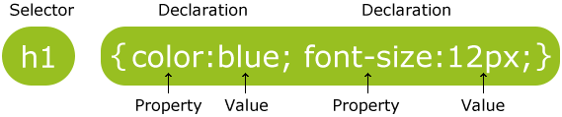
* **CSS**
* **CSS properties (**[**http://www.htmldog.com/reference/cssproperties/**](http://www.htmldog.com/reference/cssproperties/)**)**
* **<style> and the class attribute**
* **Style attribute**
* **Inline and internal styles**
* **The box model**

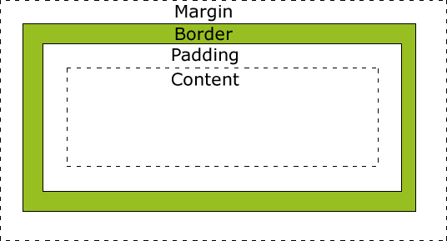

**Questions:**

1. **Compare and contrast the following methods for implementing CSS:**

<!DOCTYPE html>  
<html>  
  
<head>  
<style>  
  body {background- color:lightgrey}  
  h1   {color:blue}  
  p    {color:green}  
</style>  
</head>  
  
<body>  
  <h1>This is a heading</h1>  
  <p>This is a paragraph.</p>  
</body>  
  
</html>

<!DOCTYPE html>  
<html>  
  
<head>  
</head>  
  
<body style=”background-color:lightgrey;”>  
  <h1 style=”color:blue;”>This is a heading</h1>  
  <p style=”color:green;”>This is a paragraph.</p>  
</body>  
  
</html>

1. **In the above example of using internal style rules, list the selectors, properties and then values.**

**Selector-property-value**

**Body-background color-light grey**

**H1-color-blue**

**p-color-green**

1. **List one possible property value for each of the following properties:**
2. **Font** “Comic Sans”
3. **Text-align** “Right”
4. **Color “**Green”
5. **Background-image “**image.png”
6. **Padding** “20px”
7. **Width** “100%”
8. **Top** “12px”
9. **Cursor** “wait”
10. **Visit** [**http://www.htmldog.com/guides/css/beginner/applyingcss/**](http://www.htmldog.com/guides/css/beginner/applyingcss/) **and read through the tutorial on applying CSS. Make sure you understand what a selector is and its properties and values. Understand the different types of values that can be used to represent size, text and colour. Also make sure to review the concepts around the box model i.e. margin, border, padding etc.**

**Exercises:**

Using your knowledge of CSS update your class website. Make sure to stay consistent in regards to appearance across each page in your site i.e. same colours, fonts, sizes, positions etc..

Create a new page called **assignments**. Add a link from your home page to this page. Make sure to add a title and an image. You will be using this page to submit and link all projects that will be assigned to you in this class. Make sure to style this page similar to all the others.

**Extra:**

A nice simple tool to visualize your site pages and the links between them can be found online at (sign up for the free account):

<https://writemaps.com/wmaps/mapbuilder/97088>

Using this tool I was able to create the following site map which should represent what yours is to look like at this point. Create and rename any files and folders in your site that doesn’t match with this plan.

