**Intro to C# .NET and Other Terminology**

Notes:

* C# is a programming environment using a modified C/C++ programming language

Top Level Menu Bar

* Created by Microsoft
* Is an **IDE(integrated Development Environment)**

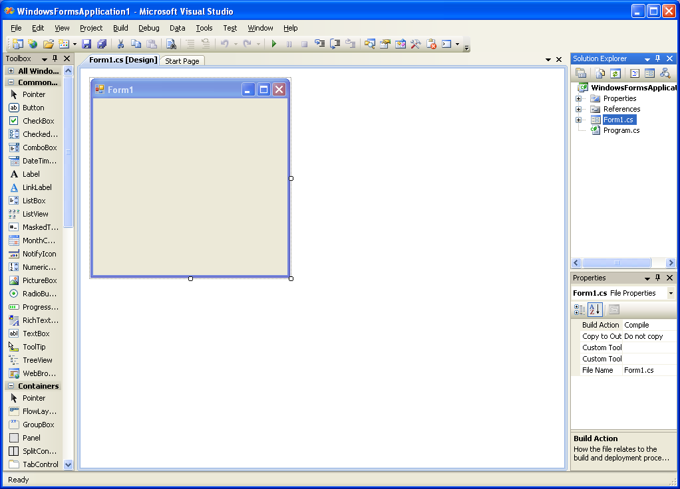

Properties

Window

Solution Explorer

Design Window

Form

Toolbox

Properties Window-used to change the properties of a component during design time

Solutions Explorer-contains a list of project files used in the project

* IDE🡪code, debug and design in the same program
* Every program written in C# generates several different folders and files
* Main files🡪.**cs and .sln**
* Project can be made into an executable file (.exe)
* 2 steps in C# programming🡪1**. design and 2. code**
* design🡪use the C# IDE and design the look of each window(form) in your app
* on the form draw the different components (buttons, labels etc) that are required
* next step🡪 write the code that will respond to events that happen to each component
* **events**🡪things that can happen to a specific component(control) i.e. a button gets clicked, a mouse moves over a label etc.)🡪C# is an EVENT driven, OBJECT ORIENTED programming language

**Exercises:**

1. Start C#. List 4 sub level menu items for the top level menu item File.

New Project

New Team Project

New File

Open Project

1. List the names of 5 different components found in the toolbox.

Pointer

HScrollBar

CheckBox

Label

1. Click on a control, then place your mouse over the form. Hold down the left mouse button and “draw” the control onto the form. What do the blue boxes around the edges of the control drawn onto the form indicate?

Show that you can change the size of the control.

1. Look at the Solutions Explorer window. How many forms are listed? What do you think the names of the project and form in the brackets represent? Click on the Project menu item, then Add Windows Form then the Add button. What happens in the Solutions Explorer?
2. Click on the *View* top level menu item, then on the sub level menu item *Code*. What happens?

Shows the code that corresponds to the designer

1. Select another control from the toolbox and draw it onto the form. What happens to the Properties window each time you select a new control on the form (try adding other controls and selecting them)?
2. There’s a small button with a small green arrow on the C# toolbar. Press it. What do you think happens when this button is pressed?

Runs the program.

1. Create a new project and name it **prjTheBeginning**. Design the form so that it has a textbox, a label, a radiobutton, a checkbox and a menubar. Save the project. Find the project folder. Compress it. Save it in your Unit 2 Lesson 1 folder. Upload it to your class website. Create a section in your unit 2 page titled “**My Work**”. Add a link here to your zipped project.

************************************************************************************Make sure that from now on you provide online access via links to all your work and that it is organized by lesson. Make sure all projects are compressed into zip files.

************************************************************************************

