Changing Properties During Run-Time

Changing Control Properties During Run-Time

- Run time occurs while the program is running/executed
- Up to this point we have seen how to change the properties of a control during design time→this was done via the properties window
- In order to change the properties of a control during run time we must write the code that will do this in the code window for the selected form
- The format for changing the property of a control in code is as follows: controlname.propertyname=value;
- For example lets assume that we have a button called btnMessage and a textbox called txtData on a form
- Now lets assume that we want the textbox to hold the text “I just changed the text property of this textbox” when the button was clicked
- To do this we must first create the event function for the button click event→why? Because we want this to happen when the button is clicked!!!!
- The button’s click event function looks like this when selected from the code window
- private void btnMessage_Click(object sender, EventArgs e)
{

}

Now we enter the necessary code inside this event procedure
private void btnMessage_Click(object sender, EventArgs e)
{
txtDate.Text=”This changes the text property of the txtData textbox”;
}

In this example we assigned a literal string to a property of a textbox that was expecting a string. A literal value is one we can literally see in our code. The following does the same thing but uses a referenced value:

txtDate.Text=btnMessage.Text;

We assign to a text property a string derived from another string property. However this time the value is referenced because you can’t literally see what has been assigned.

Remember that there are four types of property values:1. string 2. number, 3.Boolean and 4. Object.
- If you want to successfully write code in C# you need to learn as many different properties of as many different components as possible
- Lets look at some examples:
txtdata.Width=100;
txtdata.Visible=true;
txtdata.Top=0;
etc.
- Not only can you assign to a property a specific literal value that you determine , you can also assign to a property the property value of another control (the values must be of the same type OR they must be “convertible” to a useable value)
Examples
- txtdata.Text=cmdmessage.Text;
- txtdata.Top=cmdmessage.Top;
- cmdmessage.Width=txtdaa.Height;
- txtdata.Backcolor=lbltest.Forecolor;
- txtdata.Enabled=lbltest.Visible;
- the following examples would cause an error:
- txtdata.Backcolor=cmdmessage.Text;
- txtdata.Height=lbltest.Visible;
- Why?
- Because you cannot assign one property value type to a property requiring another.
- You can however assign values of one type to another if they can be converted into a useable form
- Here’s an example:
- picBall.Width=txtWidth.Text;
- This is not possible because the the picturebox width property is expecting a number. The text property is a string. HOWEVER, the textbox may contain a number that is a string and this can be converted to a useable number. SO the fix is as follows:
- picBall.Width=Convert.toInt16(txtWidth.Text);
- Convert is an object provided to you, the programmer, in VS.
- Objects, contain functions. In this case we are using Convert’s toInt16 function which takes value and attempts to convert it to an integer/number (int16 means a 16 bit integer-small for computers but big enough for our programs).
- Once converted, the value is assigned to the Width property as a valid number!
- This is called an explicit conversion as we had to force the code to do the conversion.
- There are times when these conversions will be done for you (called implicit conversions).
- You’ll know when an explicit conversion is needed because VS will give you an error message when it can’t assign values that are not of the proper type.

EXERCISES
Complete the following exercises. These will help you with a practical test that will be coming soon! Create all forms in one project. Add a button at the bottom left corner of each form and set up its click event. To go to another form when clicking the button use the following code (just replace the form name):

Form2 f=new Form2();//create a copy of form2 and assign it to variable f
f.show();//show form2

All the exercises come with a GUI that you need to replicate (soon you will design your own GUIs).

All exercises come with table listing the components you need, the events you need to set up and the properties you will need to change. Read the requirements of each program and use this info as a guide to writing the necessary code. DO NOT FORGET to continually document your code.

When all exercises are complete zip the executable and link it under your unit 2 “My Work” section as “CPDRT”.

- Recreate the following form:
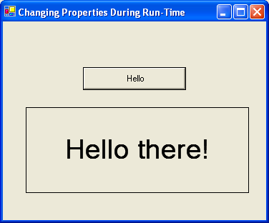
Write the necessary code so that when the user clicks the button the words “Hello there!” appear in the label.

Components | Events | Properties
Button | Click
Label |  | text

- Recreate the following form:
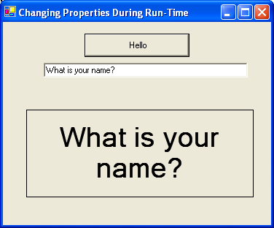
Write the necessary code so that when the used clicks the button the label will have the same text as the textbox.

Components | Events | Properties
Button | Click
Textbox |  | text
Label |  | text

- Recreate the following form:
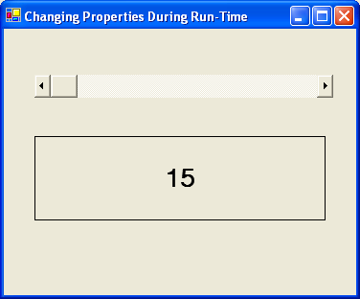
Write the necessary code so that when the user scrolls the horizontal scroll bar component the label displays the value property of the scroll bar.

Components | Events | Properties
HScrollBar | Scroll | Value
Label |  | text

- Recreate the following form:
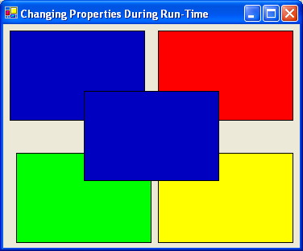

Write the necessary code so that when the used moves their cursor into any of the four outside labels, the center label changes to the same colour.
Components | Events | Properties
Label | mouseEnter | backcolor

5. Recreate the following form:
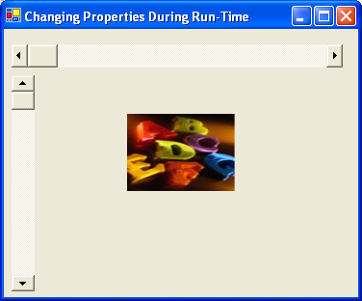
Write the necessary code so that when the horizontal trackbar is scrolled the width of the picturebox is equal to the value of the scrollbar. Apply the same principle to the vertical scrollbar and the height of the picture.
Components | Events | Properties
HScrollBar, VScrollBar | Scroll | value
Picturebox |  | Image, SizeMode

