Using Variables

Variables:
- Variables are reserved memory blocks that have been given a name
- Variables when created must also be designated to hold specific types of data
- A memory block expecting a string should not be given a number and vice versa(please note that are always ways around every rule (ex. Type conversions)!)
- In C# there are many different types of data that a variable can hold:
type | storage required | range | default value
C# byte | 1 byte | 0 to 255 | 0
C# int | 2 bytes | -32,768 to 32,767 | 0
C# long | 4 bytes | -2,147,483,648 to 2,147,483,647 | 0
C# single | 4 bytes | Negative values:  -3.402823E38 to -1.401298E-45  Positive values:  1.401298E-45 to 3.402823E38 | 0
C# double | 8 bytes | Negative values:  -1.79769313486232E308 to -4.94065645841247E-324  Positive values:  4.94065645841247E-324 to 1.79769313486232E308 | 0
C# String, variable length | 10 bytes + length of string | 0 to approximately 2 billion characters  (exact number believed to be 2,147,483,647) | ""  (zero-length string)
C# Boolean | 2 bytes | True or False | False

Declaring Variables
- Before a variable/memory block can be used it must first be reserved, assigned a name and a data type
- Use the following format to do this:
dataType variableName;
example: String userName;
- To declare more than one variable of the same type do the following:
- dataType variablename1, variablename2,variable3;
- Ex. int x,y,z;

Naming Variables:
“In C# variable names consist of letters, digits and the underscore character ( _ ) and must begin with a letter; they may optionally end with a special character which determines the type of the variable (see below). They cannot be any of the reserved words. These include the names of predefined methods, functions and statements examples: int, String, Double, button, textbox, function, class etc. A program may not run if a reserved word is used as a programmer defined name

Assignment Statements:
- Once a variable has been made you can assign data to it
- To do this use the assignment operator =
- Operators are symbols that act on one or more values
- For example:
- int number;
- number=5;
- String personsName;
- personsName=”Krnic”;
- bool tested;
- tested=true;

here’s a small example program:
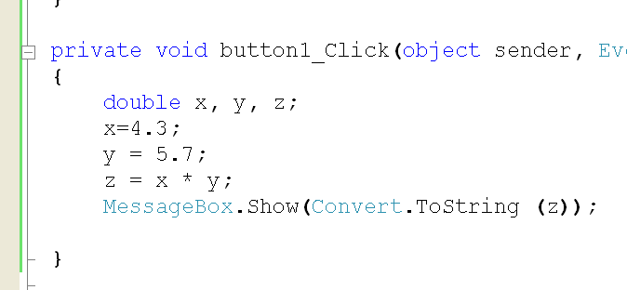

Common Errors:
- overflowàhappens when you try assign a number that is too large for the variable type
example:
byte x;
x=92834;àwrong!!!!(causes a run time error because byte variables can only hold 0 to 255, not 92834)

Using Variables: Questions and Exercises
- Create a new project titled “prjVariables”. In it add forms to create the following programs:
- Create the following form and write the code so that the user can determine the amount of money that they have in their “piggy bank”!
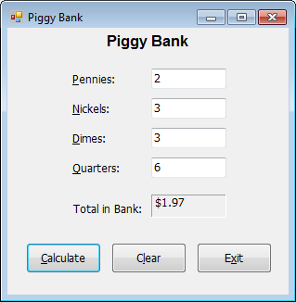
- Create the following program so that the user can calculate the total costs.
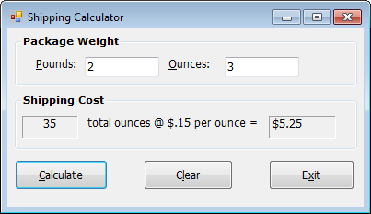
- Write and design a program that allows the user to input first and last names in two separate text boxes and then displays the last name, a comma, and then the first name in a label.
- Write and design a program that converts between temperatures in Fahrenheit and Celsius.

Applicable formulae:
F = 32 + (9/5)C
C = (5/9) (F-32)
Your program will have the following GUI:
A text box to enter the temperature
A button that will convert from Celsius to Fahrenheit
A button that will convert from Fahrenheit to Celsius
A label that will display the answer

HINTS: Start by designing the form. Name every component using proper naming protocols. Set up the appropriate events. Create the necessary variables. Write the code. Test and debug!

Add the zipped exe for this project to your unit 2 “My Work” section of your unit 2 class website.

Javascript Section:
- In js there are no data types to worry about in declaring variables
- Javascript can be written in a basic web page inside a script block
- The format for declaring variables in js is: var name;
- You assign variables either literal values or referenced values
- In js you can use the prompt function to get input from the user
- In js you can use the alert function similarly to the messagebox in C#
- The math operators in js are similar to those in C#
- Example code:

<script>

var amount=0;//always initialize new variables to a starting value

var taxRate=0;

var total=0;

amount=prompt(“How much does you coat cost?”);

taxRate=prompt(“What is the current tax rate as a percentage?”);

total=amount*(1+taxRate/100);

alert(“The coat will cost $“ + total +” with tax.”);

</script>

Exercises:
  - Create a web page. In one script block write a program that will ask the user for their current grades in math, english, science and French class. Calculate and display their average. Make sure all prompted input is clear, well written and specific. Make sure all output is properly formatted to appear understandable to the user. Add link to this page under Unit 2 in your web site.

