Modular Programming Practical Test

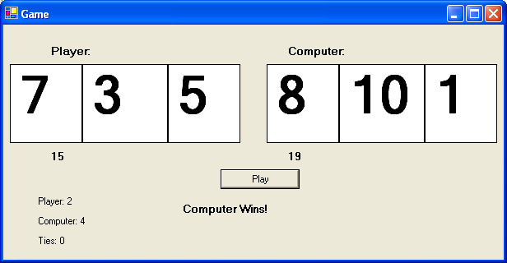

A game has been designed with all components named according to proper programming protocols. The game’s click event has also been coded. The required Random object has been created. Your job is to make the functions used in the play buttons click event. DO NOT add code to the click event. DO NOT delete code from the click event. DO NOT add other events. DO NOT make instance variables. Use the ones already provided. You may create local variables in your functions only. ONLY make the functions described below.

Game Objective: The game involves a set of 3 cards drawn for both the player and computer. Each card can range in value from 1 to 10. The player with the highest total wins.

Function Explanations and examples calls:

- dealCardsToPlayer()→a function that randomly creates three numbers from 1 to 10 and assigns their values to the first three card labels

- dealCardsToComputer()→a function that randomly creates three numbers from 1 to 10 and assigns their values to the next three card labels

- playerTotal(4,2,7)→a functions that has three parameters representing the three values of the players cards and returns the sum of those three values

- computerTotal(3,8,5) →a functions that has three parameters representing the three values of the computers cards and returns the sum of those three values.

- updatePlayerScore()→a function that adds one to the total number of wins the player currently has and displays the current total in a label.

- updateComputerScore()→a function that adds one to the total number of wins the computer currently has and displays the current total in a label.

- updateTies()→a function that adds one to the total number of ties between the computer and player and displays the current total in a label.

Marks

3 marks for each correct function
3x7=21 marks (Application)
10 marks for Code Formatting and Naming (Communication)

