Hang Man: Using String Functions

A classic game, Hang Man, would not be possible without the use of string functions. Your objective is to create your own version of this game.

A sample GUI for the program is provided (your GUI may be different). Your teacher may provide you with sample exemplar programs written by students in previous classes to give you more ideas.
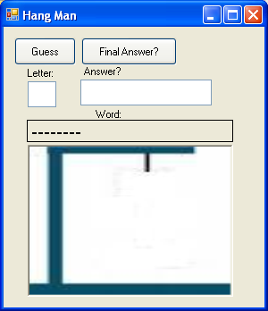

Additional requirements for this program are that you demonstrate your knowledge of custom and predefined functions, arrays and sorting.

You must create and use at least 4 custom functions. Two of these must use parameters and two should be without and at least on of them must return a value. You can, of course, make use of many more.

You will also need to implement arrays. These can be used to store and select random words.

Finally, sorting might be used to sort a list of high scores.

You are encouraged to come up with your own unique version of the game. Part of every project’s mark involves an evaluation of your proficieny in the field of programming, so the more complex the product the better your mark will be.

Additional Notes:
- When completed, zip your project and rename it as hangman.zip
- Create a web page on your class website under Unit 4 and add a link to the project
- Design the web page to promote your game
- Include screenshots and instructions
- Print your code and hand it in stapled to your rubric
- Make sure to highlight your use of your own function, string functions, arrays and sorting
- Highlight by using commented boxed asterisks
/*******************************************************************
******************Here we use the SUBSTRING function*************
*******************************************************************/

Name(s):[ ][ ][ ]
Marking Scheme: Hangman ICS3U

Category | Mark
GUI 10  Documentation 5  Naming 5  Webpage 10 |  | COMM
Functionality 20 |  | APP
Functions without Parameters 5  Functions with Parameters 5  Functions with Return values 5  String Functions 5  Arrays 5  Sorting 5 |  | KU
Complexity 20 |  | TI
Total / 100

