**„Programming Technology”**

**Assignment 1**

### Made by: Timur Ismailov Mamanovich

### Neptun code: FNHZ3W

***2019. December 4.***

Task 6

Choose a point on the plane, and fill a collection with several regular shapes (circle, regular triangle, square, regular hexagon). ***How many shapes contain the given point?***

Each shape can be represented by its center and side length (or radius), if we assume that one side of the polygons are parallel with x axis, and its nodes lies on or above this side. Load and create the shapes from a text file. The first line of the file contains the number of the shapes, and each following line contain a shape. The first character will identify the type of the shape, which is followed by the center coordinate and the side length or radius. Manage the shapes uniformly, so derive them from the same super class.

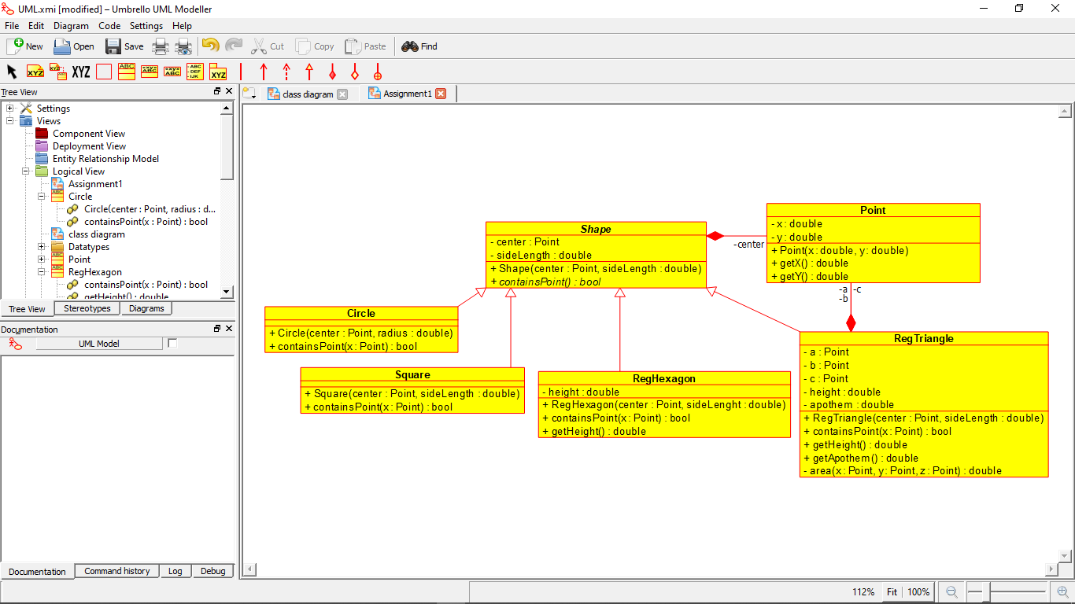Class Diagram

Test cases

1. test01.txt

Content:

4

s 0 0 5

t 0 0 5

c 0 0 5

h 0 0 5

Point: (0,0)

Expected: 4

Checking if correct objects are being built.

Checking if expected value equals answer for center point.

1. test02.txt

Content:

4

s 0 0 5

t 0 0 5

c 0 0 5

h 0 0 5

Point: (10,-10)

Expected: 0

Checking if correct objects are being built.

Checking if expected value equals answer for outside point.

1. test02.txt

Content:

10

s 3 0 5

t 4 4 18

C 2 8 4

c 4 1 7

s 1 4 2

t 9 2 9

h 12 15 51

c 24 42 4

S 5 4 5

s 8 8 3

Point: (1,4)

Expected: 4

Checking if expected value equals answer for multiple randomized objects.

1. test04.txt

Content:

(empty)

Point: (1,4)

Expected: 0

Checking output for empty file.

1. test05.txt

Content:

10

s 0 0 5 a

t 0 0 5

C 0 5

c 0 0 5

s 0 0

s 0 5

Point (1,4)

Expected: -1

Checking output for incomplete file.

Additionally, the validity of containsPoint(Point x) method was tested for each child class of Shape.