COM618 Data Science
Predicting Early Hospital Readmission
AE1 Assessment Report
Daniel Field

1. Introduction and Dataset Selection
Hospital readmission within 30 days of discharge is a costly outcomes in modern healthcare. The Hospital Readmissions Reduction Programme (HRRP) penalises US hospitals for excess 30-day readmissions[1]. Readmission risk is high for diabetic patients, as diabetes interacts with many other conditions and medications. Identifying patients at risk of early readmission before discharge is therefore benefitial.
The dataset selected is the “Diabetes 130-US Hospitals for Years 1999-2008 dataset, sourced from the UCI Machine Learning Repository” (https://archive.ics.uci.edu/dataset/296/diabetes+130-us+hospitals+for+years+1999-2008). It contains 101,766 patient records from 130 US hospitals. It has 50 features, such as demographics, and medication usages. The dataset has been used in several peer-reviewed studies (See references 12, 10, 3), allowing direct comparison of results against published baselines.
The target variable is binary: early readmission within 30 days is labelled 1, and all other outcomes are labelled 0. This follows the HRRP threshold and is the standard framing used in benchmark studies[2, 6]. The clinically meaningful boundary is 30 days, not the distinction between patients who are never readmitted and those who are eventually readmitted.
Before the dataset can be used, there are issues with the data that needs to be resolved. This is achived through “Data Cleaning”.

2. Data Cleaning
The dataset exhibits the three common quality problems in health informatics datasets: missing values, duplicate records, and inconsistent encoding.

2.1 Loading and Initial Inspection
The dataset encodes missing data as '?' rather than a standard null value. Loading with na_values=['?'] converts all ‘?’ placeholders to NaN at import:
Inspection of the data set shows multiple issues such as columns with high missing data, duplicate records, and formats, like age ranges, that cannot be used directly by a machine learning model. Figure 2 shows columns most impacted by missing data.
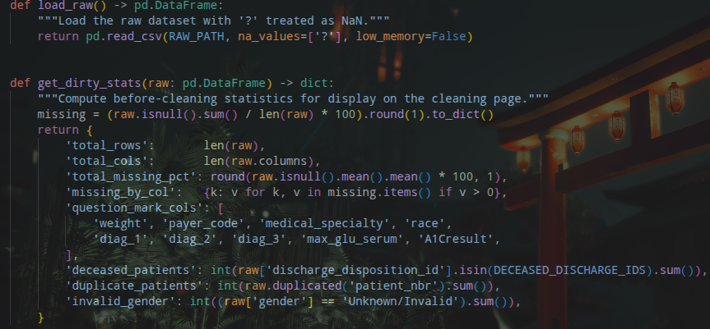Figure 1: Loading of Dataset
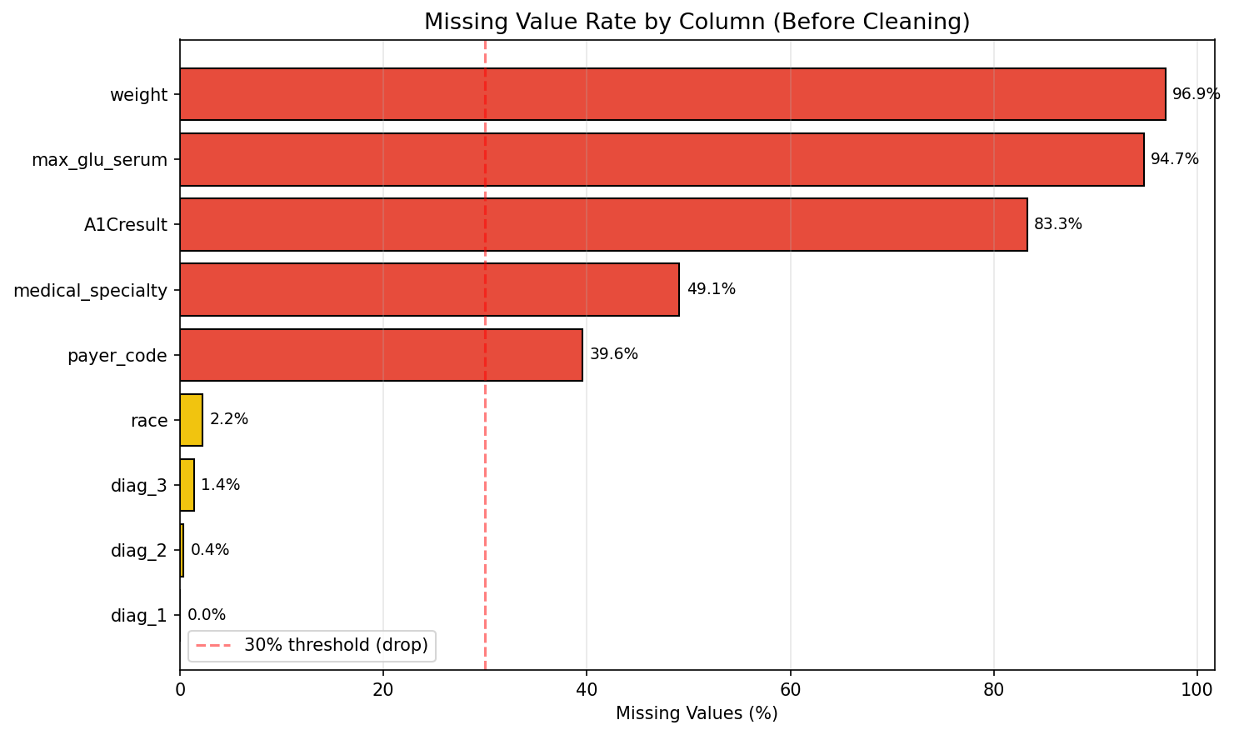Figure 2: Missing value rate by column before cleaning. Bars in red exceed the 30% drop threshold.

2.2 Removing Logically Invalid Records
Two categories of record are not suitable for analysing readmission, and are removed. First, 1,652 patients discharged as deceased (discharge_disposition_ids of 11, 19 and 20) cannot be readmitted. Second, the dataset contains multiple records per patient. Including the same patient would cause data leakage when training models, as patterns for that patient may be memorised by the model across different training/test sets. Only the first encounter per patient is kept, sorted by encounter_id:
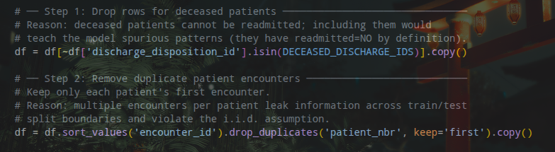Figure 3: Removal of Deceased and Duplicate Patients

2.3 Dropping High-Missingness Columns
The weight column (96.9% missing) cannot be meaningfully imputed. The medical_specialty column (49.1% missing) overlaps with ICD-9 diagnosis categories. The payer_code column (39.6% missing) records insurance type, which has no relevance to 30-day readmission.
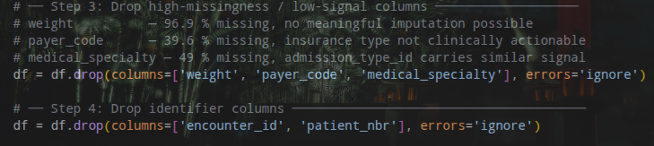Figure 4: Dropping of Missing and Irrelevant Columns

2.4 Encoding Categorical Features
Several columns require encoding to be suitable for later model training. The following are examples of encoding performed in this project:
- Age ranges are converted to numeric midpoints
- Gender is binary-encoded, and 3 unknown/invalid records are recoded to Female
  - The recoding to female is arbitrary, and since only three records are imputed, it has no impact.
- The 23 medication columns are ordinal-encoded 0–3
- The ICD-9 diagnosis columns cover over 700 unique codes
  - These are grouped into nine clinical categories rather than label-encoded to avoid implying a false ordering between unrelated disease groups
The stages of the Encoding process are shown below:
1. Each age range is mapped to its midpoint, so '[60-70)' becomes 65, giving the model a continuous numeric value.
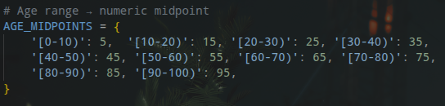Figure 5: Definition of Age Midpoints

Figure 6: Application of Age Midpoints

2. Gender is binary-encoded (1 = Male, 0 = Female). Race is encoded across six categories.
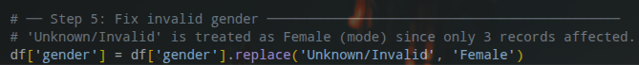Figure 7: Recoding of Unkown/Invalid Gender
3. For the two sparse lab-result columns (A1Cresult: 83.3% missing; max_glu_serum: 94.7% missing), a missing value is clinically meaningful. A patient whose HbA1c (blood-sugar levels over 2-3 months) was never tested during admission is likely less closely monitored than one with a recorded result. Encoding 'not tested' as a distinct category (0) preserves this rather than imputing a value. The full scale is None=0, Normal=1, slightly elevated=2, highly elevated=3.
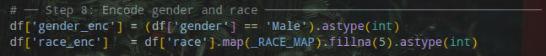Figure 8: Encoding of Gender and Race
Figure 9: Definition of Lab Result Maps

4. All 23 medication columns share the same scale. 0 = not prescribed, 1 = dose unchanged, 2 = increased, 3 = decreased. Missing values default to 0.
Figure 10: Fill Lab Results according to Map
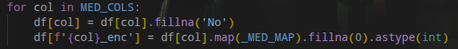Figure 11: Filling of Medication Columns

5. The below function maps each numeric ICD-9 code to one of nine categories using numeric ranges. All three diagnosis columns are processed the same way, then ordinal-encoded using DIAG_CAT_MAP.
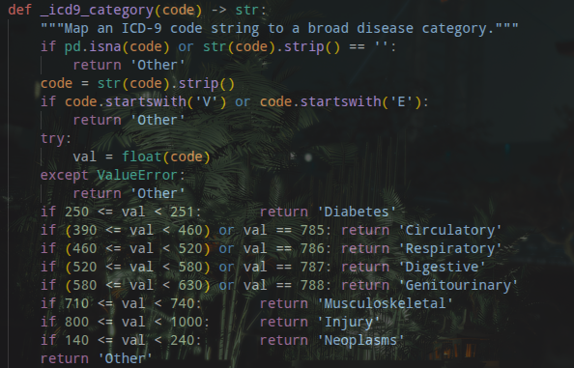Figure 12: ICD-9 Mapping Function Definition
The dataset state before and after cleaning is shown in Figure 14.
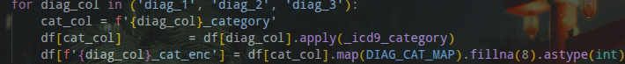Figure 13: Function Usage
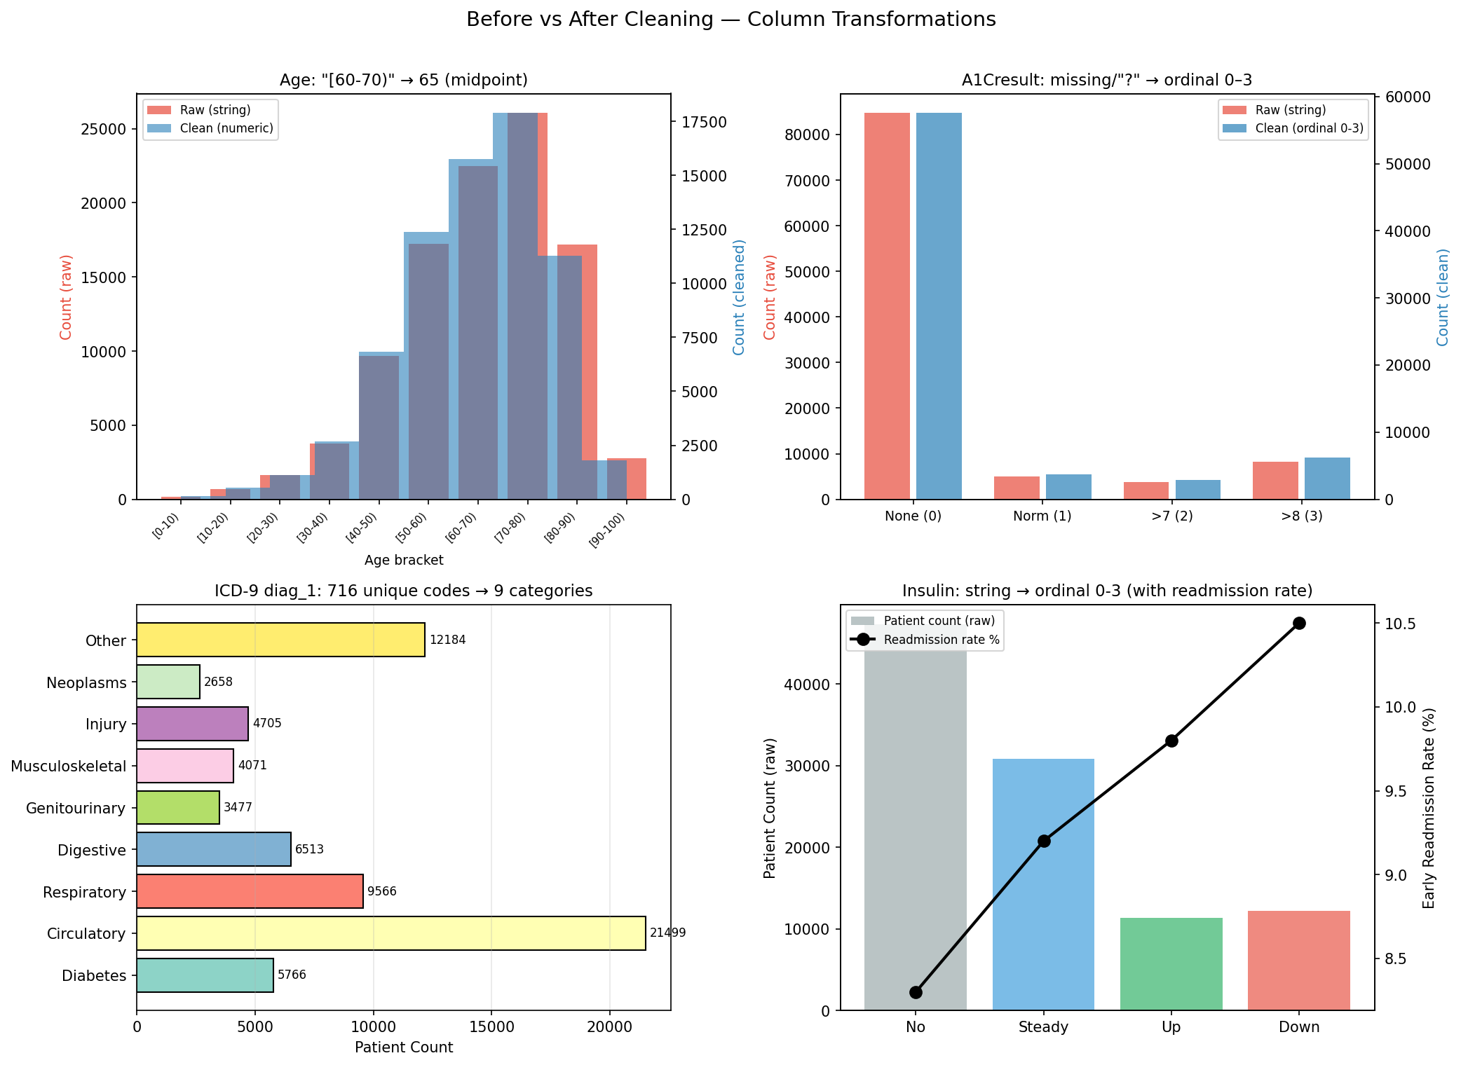Figure 14: Dataset Before and After
To ensure a sufficent number of records for machine learning, the total records of the dataset are recorded at each stage.
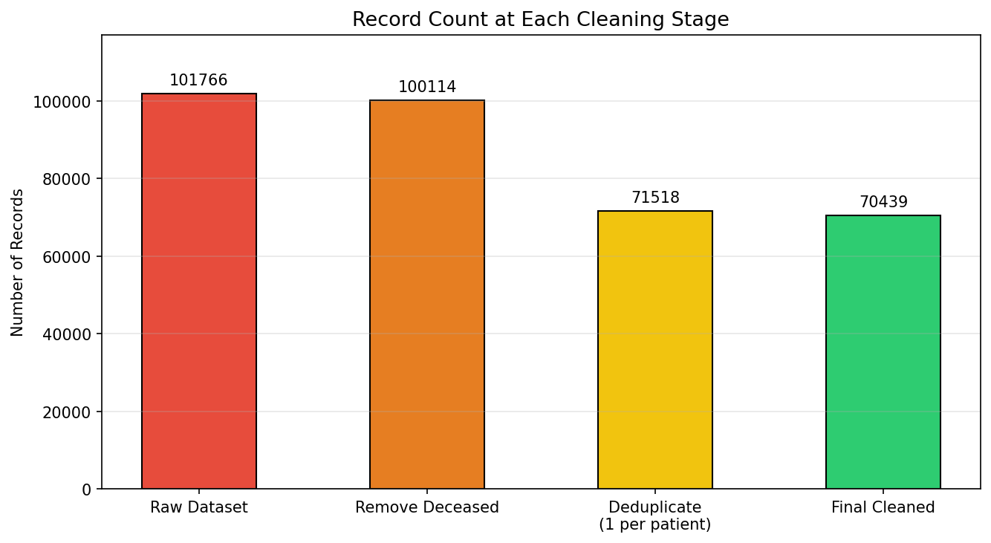
Figure 3: Record count at each cleaning stage. 101,766 raw records reduce to 70,439 unique patient encounters after removing deceased patients and deduplicating to one encounter per patient.

3. Exploratory Data Analysis
Exploratory Data Analysis (EDA) allows for the detection of naturally occuring patterns and anomalies in a dataset. It serves two purposes here in this project.
1. Identifying patterns that inform the clinical context
2. Identify features to guide feature engineering, further described in Section 4.

3.1 Class Imbalance
Only 8.9% of patient encounters result in early readmission. A classifier that simply predicts 'not early' for every patient achieves 91.1% accuracy while identifying no at-risk patients. This means accuracy alone is a misleading metric. Two decisions followed from this imbalance:
1. ROC-AUC was chosen as the primary evaluation metric because it measures a model's ability to differentiate between patients that will be readmiitted, and those who wont, regardless of the threshold for “high-risk” patients.
2. Balanced sample weights were applied during training to stop the model from optimising purely for the majority class.

3.2 Feature Correlation with Readmission
A correlation heatmap highlights relationships between numerical features to identify which features are most strongly associated with early readmission risk. The creation of the heatmap is shown below:
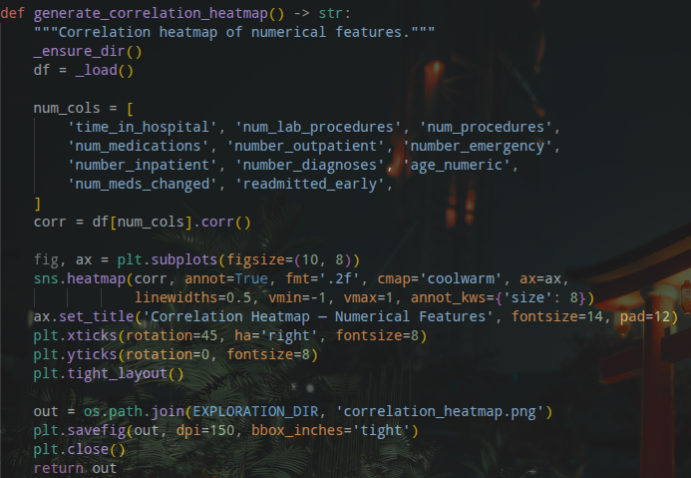Figure 15: Creation of Correlation Heatmap
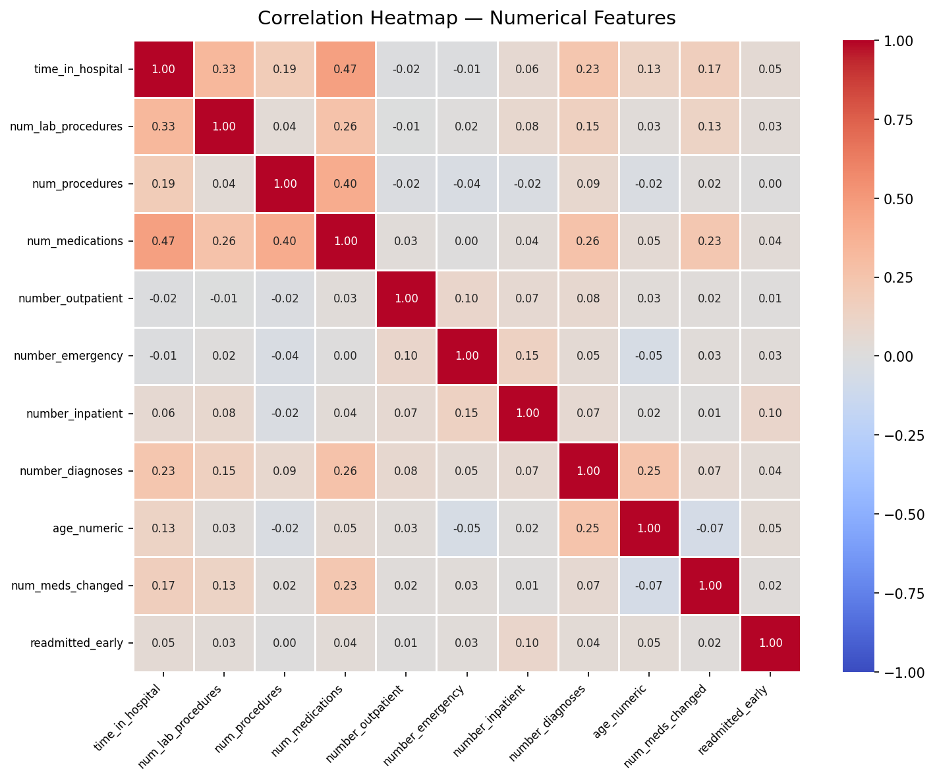Figure 16: Produced Correlation Heatmap
Prior inpatient admissions (number_inpatient) show the strongest individual correlation with early readmission. This is consistent with Jencks et al.[4], who found 19.6% of Medicare patients were rehospitalised within 30 days, with over half receiving no documented physician follow-up after discharge. Per-day averages were used so that longer hospital stays would not artificially inflate the number of procedures recorded for a patient.

3.3 Readmission by Clinical Subgroup
The project analyses early readmission rates across age groups to identify whether particular age groups are at risk of readmission within 30 days. Figure 17 shows that risk is highest in the 60-80 age range. This is expected, as diabetes management is typically highest at this range.
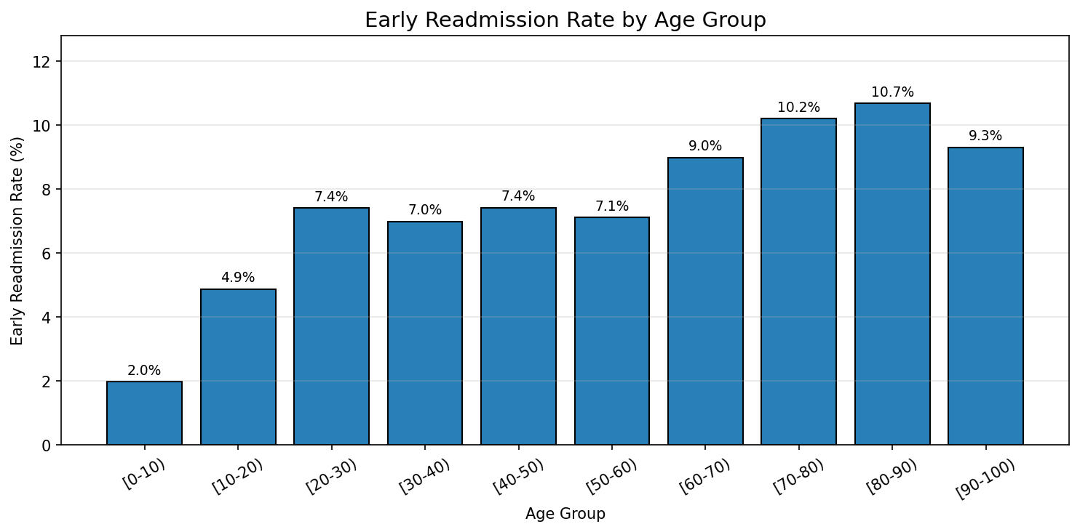Figure 17: Early Readmission Rate by Age Group
The early admission rate is also compared across diagnosis categories, defined during data cleaning (see Section 2.4). Figure 18 shows that Injury, Circulatory and Diabetes issues lead to highest rates.
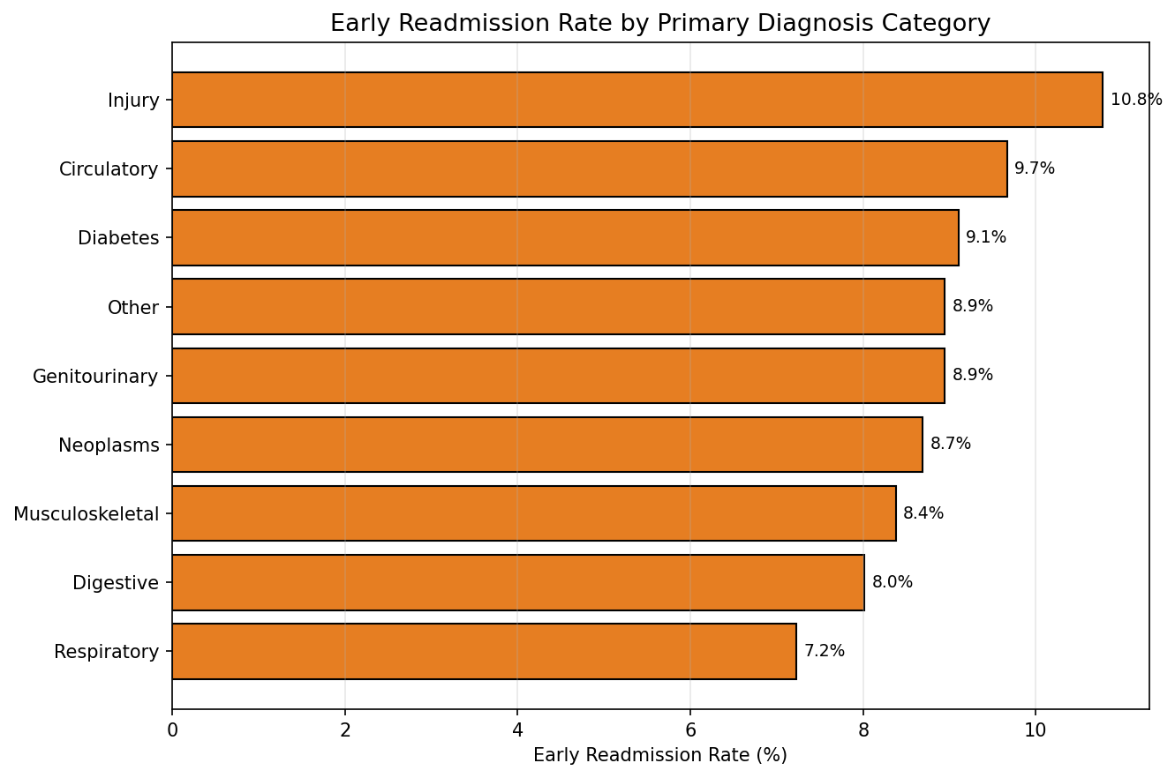Figure 18: Early Readmission Rate by Primary Diagnosis Category
Figure 19 focuses on diabetes and readmission rates, specifcally, how changes in Insulin Usage impacts it. Typically, a decreases in a patient’s insulin usage has the highest increase in their risk of readmission. At 9.8%, incresasing a patients insulin usage has a lesser impact on readmission risk than decreasing it, but still greater than keeping a steady usage. Patients that are not using insulin have lower readmission rates. This is likely because they do not suffer from diabetes, which has the third highest readmission rate (see Figure 18).
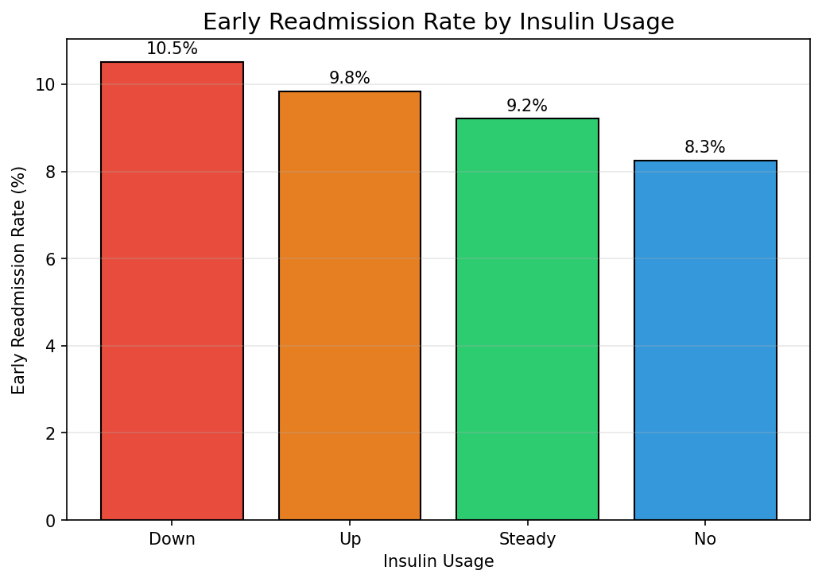Figure 19: Early Readmission Rate by Insulin Usage

After permorming EDA, relationships between existing features can be exploited to “Engineer” additional features from the dataset.
4. Feature Engineering

4.1 Capturing the Strongest EDA Signal
Section 3.2 identified number_inpatient as the strongest individual predictor of early readmission, consistent with Jencks et al. (2009)[4]. The new feature “has_prior_inpatient” combines all inpatient visits recorded into one flag: any prior hospitalisation versus none. This is more meaninful than the raw count, because the existence of prior admissions is more significant than the exact number. The three prior visits columns are aggregated into one feature. This reduces multicollinearity between the three columns, allowing for fewer training variables and faster training times for Machine Learning.

4.2 Removing a Confound: Care Intensity Ratios
EDA showed that time_in_hospital correlates weakly with readmission despite its clinical plausibility. The confound is that longer stays naturally increases procedures and medications, inflating raw counts.. Dividing by stay length + 1 produces per-day ratios that measure how actively a patient was managed relative to their stay.

4.3 Compound Risk: Interaction Features
Figure 20: Engineering of Care Itensity Ratios
28 new features were created to capture risks that single data points miss. For example, "premature_discharge_risk" flags patients with both a short stay and reduced insulin. This is shown below:
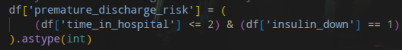Figure 21: Creation of premature_discharge_risk Feature

In total, 67 features were used in training, including:
- 28 Engineered features (risk combinations)
- 12 Clinical counts and lab results
- 10 Medication types
- 17 Demographic and diagnosis details

5.Machine Learning Models
Three models were trained and compared using an 80/20 stratified train/test split: 56,351 training records and 14,088 test records, preserving the 8.9% positive rate in both sets. Class imbalance was handled by applying balanced sample weights during training, implemented using scikit-learn [7].

5.1 Model Selection Rationale
Three models were chosen, shown in Table 1.
Model | ROC-AUC | Test Accuracy | CV ROC-AUC
Logistic Regression (LR) | 0.6388 | 72.5% | 0.628 ± 0.009
Random Forest (RF) | 0.6540 | 73.9% | 0.640 ± 0.007
Gradient Boosting (GB) (selected) | 0.6553 | 67.03% | 0.646 ± 0.007
Table 1: Models Selected
Gradient Boosting [3] builds trees sequentially, each correcting previous errors, progressively focusing on minority-class patients and non-linear interactions. Logistic Regression provides a linear baseline, but cannot capture these interactions. Random Forest achieves comparable discrimination to GB but lacks capabilities that concentrates training on difficult cases.

5.2 Model Training and Cross-Validation
Five-fold stratified cross-validation produced a stable ROC-AUC estimate with a standard deviation of 0.0070 across folds, confirming the result is not sensitive to any data partition chosen. Cross validation is shown below:
Figure 22: Cross Validation Example

6.Performance and Evaluation

6.1 Results
The performance of GB is shown below:
Metric | Value | Interpretation
Test Accuracy | 67.03% | Inflated by 91% majority class; not primary metric
ROC-AUC | 0.6553 | Within published range for this dataset (0.63-0.667)
CV ROC-AUC | 0.6461 ± 0.0070 | Stable across folds; confirms generalisation to unseen patients
Avg Precision | 0.1698 | Reflects 8.9% base rate; 1.9× improvement over random baseline (0.089)
F1 (Not Early) | 0.790 | High precision and recall on majority class
F1 (Early <30d) | 0.228 | Minority class; consistent with published results on this dataset
Train-Test Gap | 2.27% | Minimal overfitting; model generalises to unseen patients
Table 2: Model Performance Figures
The model correctly identifies 686 true early readmissions and 8,757 true non-readmissions. 573 early readmissions are missed (false negatives), a clinically significant consideration discussed in Section 6.4. See Figure 23
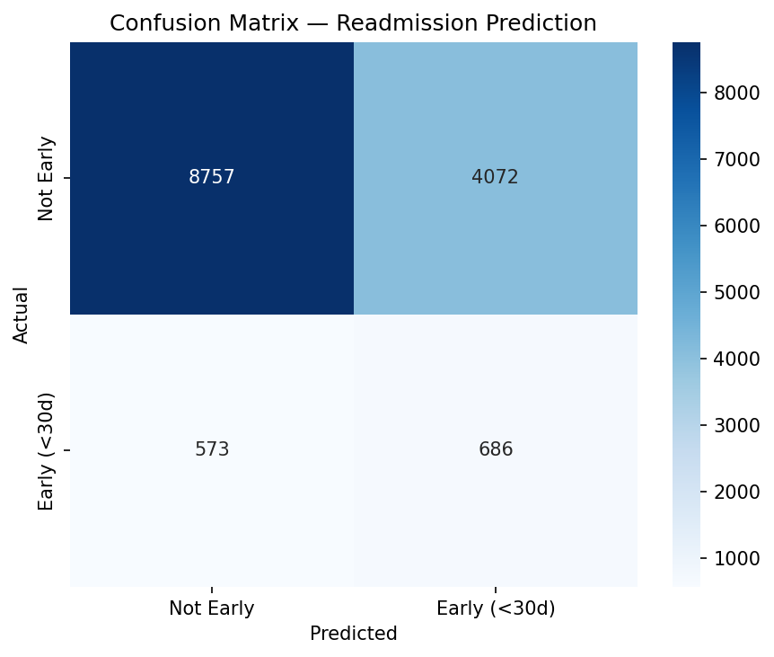Figure 23: Confusiion Matrix
Figure 24 shows the most important features. Discharge code and daily lab rate are the strongest predictors , consistent with Section 3.
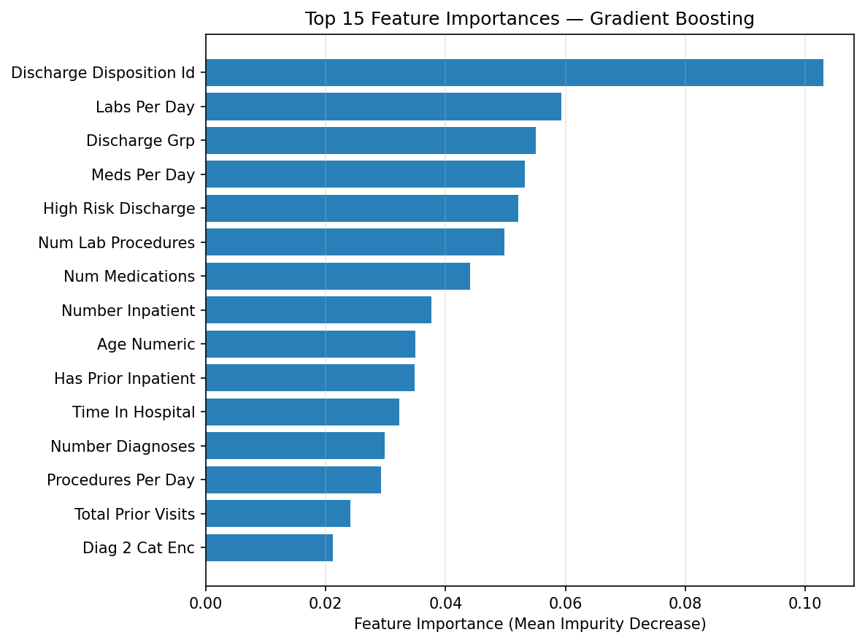Figure 24: Most Important Features

6.2 Comparison with Published Literature
Table 3 shows ROC-AUC scores from peer-reviewed studies that applied machine learning to the same dataset with the same binary 30-day readmission target, enabling direct comparison.
Study | Method | ROC-AUC | Notes
Strack et al. (2014) | Logistic Regression | approx. 0.630 | Original dataset paper; HbA1c impact focus
Shang et al. (2021) | Random Forest | 0.661 | Down-sampling; BMC Medical Informatics
Shang et al. (2021) | Tree Ensemble | 0.659 | Same study; down-sampling applied
Liu et al. (2024) | Gradient Boosting | 0.64 (95% CI: 0.64-0.65) | Journal of Medical AI; 9-model comparison
Liu et al. (2024) | Random Forest | 0.63 (95% CI: 0.63-0.64) | Same study
Emi-Johnson and Nkrumah (2025) | Gradient Boosting | 0.667 | Cureus; includes SHAP interpretation
Emi-Johnson and Nkrumah (2025) | Logistic Regression | 0.642 | Same study
This study | Logistic Regression | 0.6388 | Linear baseline; 67 features
This study | Random Forest | 0.6540 | Scikit-learn; balanced sample weights
This study | Gradient Boosting (selected) | 0.6553 | Best result; 67 features including 26 engineered
Table 3: Literature Comparison
The GB result of 0.6553 falls within the published range of 0.630–0.667, between Liu et al. [6] at 0.64 and Emi-Johnson and Nkrumah [2] at 0.667. Shang et al. [8] compared down-sampling with SMOTE oversampling and found down-sampling marginally superior.
LR achieved an AUC of 0.6388, below Liu et al. [6] at 0.64. This reflects the benefits from GB’s non-linear modelling capacity. Kansagara et al. [5] reviewed 30 studies of readmission risk models and found ROC-AUC from 0.55 to 0.83. Models using only administrative data consistently underperformed those using data with social factors, which are absent from this dataset. A result of 0.6553 is therefore consistent with the expected ceiling for administrative-data models.

6.3 Evaluation Metric Justification
ROC-AUC is the primary evaluation metric because it measures discriminative ability across all decision boundaries. It is robust to the class inbalance observed with this dataset. With an 8.9% positive rate, accuracy is misleading. A classifier that predicts 'not early' for every patient achieves 91.1% accuracy while flagging no at-risk patients. All four benchmark studies in Table 3 use ROC-AUC as their primary metric, making direct numerical comparison valid.
Average Precision (0.1698) complements ROC-AUC by measuring precision across recall thresholds under class imbalance. A random classifier would achieve an AP equal to the prevalence rate (0.089), so 0.1698 represents approximately 91% improvement over chance. The minority-class F1 of 0.228 is low, reflecting the imbalance in this dataset.

6.4 Clinical Implications and Limitations
In a clinical setting, false negatives are more costly than false positives. A missed high-risk patient may return as an unplanned emergency, while a falsely flagged patient receives additional follow-up at lower costs. The classification threshold can be lowered below the default 0.5 to improve recall at the cost of precision. Recall is preferred over precision, to reduce chances not readmitting at-risk patients.
Three limitations apply:
1. The dataset covers US hospitals from 1999–2008 and may not reflect current practice.
2. Administrative data lacks post-discharge and social information that explain a large number of preventable readmissions.
3. Keeping only one encounter per patient reduces the dataset from 101,766 to 70,439 records.

7. Conclusion
This project applied a full data science pipeline to the UCI Diabetes 130-US Hospitals dataset to predict early 30-day hospital readmission. Cleaning reduced 101,766 raw records to 70,439 unique patient encounters, addressing deceased patients, data leakage, high-missingness columns, and encoding inconsistencies. EDA identified prior inpatient history and discharge disposition as the strongest predictors, consistent with Jencks et al [7] and Shang et al [9].
Gradient Boosting achieved the best test ROC-AUC of 0.6553, within the published range of 0.630–0.667 [2, 6]. The 2.27% train-test gap confirms good generalisation. Kansagara et al. [5] found ROC-AUC from 0.55 to 0.83 across 30 readmission studies, placing this result within the expected range for administrative-data prediction.
Lower precision statistics were caused due to the class imbalance, with lower readmissions within 30 days. SMOTE was considered to reduce the imbalance, but was not used. This is because artificially increasing the minority class reduces the honesty of the dataset.

References
1. Centers for Medicare and Medicaid Services (2012) Hospital Readmissions Reduction Program (HRRP). Baltimore: CMS. Available at: https://www.cms.gov/medicare/payment/prospective-payment-systems/acute-inpatient-pps/hospital-readmissions-reduction-program-hrrp (Accessed: 30 April 2026).

2. Emi-Johnson, O. G. and Nkrumah, K. J. (2025) 'Predicting 30-Day Hospital Readmission in Patients With Diabetes Using Machine Learning on Electronic Health Record Data', Cureus, 17(4), e82437. doi: 10.7759/cureus.82437. Available at: https://pmc.ncbi.nlm.nih.gov/articles/PMC12085305/ (Accessed: 30 April 2026).

3. Friedman, J. H. (2001) 'Greedy function approximation: a gradient boosting machine', Annals of Statistics, 29(5), pp. 1189-1232. doi: 10.1214/aos/1013203451. Available at: https://projecteuclid.org/journals/annals-of-statistics/volume-29/issue-5/Greedy-function-approximation-A-gradient-boosting-machine/10.1214/aos/1013203451.full (Accessed: 30 April 2026).

4. Jencks, S. F., Williams, M. V. and Coleman, E. A. (2009) 'Rehospitalizations among patients in the Medicare fee-for-service program', New England Journal of Medicine, 360(14), pp. 1418-1428. doi: 10.1056/NEJMsa0803563. Available at: https://pubmed.ncbi.nlm.nih.gov/19339721/ (Accessed: 4 May 2026).

5. Kansagara, D., Englander, H., Salanitro, A., Kagen, D., Theobald, C., Freeman, M. and Kripalani, S. (2011) 'Risk prediction models for hospital readmission: a systematic review', JAMA, 306(15), pp. 1688-1698. doi: 10.1001/jama.2011.1515. Available at: https://pmc.ncbi.nlm.nih.gov/articles/PMC3603349/ (Accessed: 30 April 2026).

6. Liu, V. B., Sue, L. Y. and Wu, Y. (2024) 'Comparison of machine learning models for predicting 30-day readmission rates for patients with diabetes', Journal of Medical Artificial Intelligence, 7, 23. doi: 10.21037/jmai-24-70. Available at: https://jmai.amegroups.org/article/view/9179/html (Accessed: 30 April 2026).

7. Pedregosa, F., Varoquaux, G., Gramfort, A., Michel, V., Thirion, B., Grisel, O., Blondel, M., Prettenhofer, P., Weiss, R., Dubourg, V., Vanderplas, J., Passos, A., Cournapeau, D., Brucher, M., Perrot, M. and Duchesnay, E. (2011) 'Scikit-learn: Machine Learning in Python', Journal of Machine Learning Research, 12, pp. 2825-2830. Available at: https://jmlr.org/papers/v12/pedregosa11a.html (Accessed: 30 April 2026).

8. Shang, Y., Jiang, K., Wang, L. et al. (2021) 'The 30-days hospital readmission risk in diabetic patients: predictive modeling with machine learning classifiers', BMC Medical Informatics and Decision Making, 21(Suppl 2), p. 57. doi: 10.1186/s12911-021-01423-y. Available at: https://pmc.ncbi.nlm.nih.gov/articles/PMC8323261/ (Accessed: 30 April 2026).

