Payment Service

Requirements
Provide a design for part of a payments API. A list of payments might look like
http://mockbin.org/bin/41ca3269-d8c4-4063-9fd5-f306814ff03f
Design requirements:
- API should be RESTFUL
- API should be able to:
  - Fetch a payment resource
  - Create, update and delete a payment resource
  - List a collection of payment resources
  - Persist resource state (e.g. to a database)

REST API
The REST API follows the following scheme :
Method | Path | Description
GET | / | Main index
GET | /payments | List of payment objects
POST | /payments | Create new payment
GET | /payments/:id/:version | Get payment for given id and version.
PUT | /payments/:id/:version | Replace latest version of payment for given id, with the one sent in the body
PATCH | /payments/:id/:version | Update payment for given id and version, with the payment fragment sent in the body
DELETE | /payments/:id/:version

In the above paths, if :version = 0 then the operation is performed on the latest version.

The REST API returns a json data structure consisting of :
- An error-message and error-code (empty if no error has occurred)
- An array of payment objects (optional) (see example data file).
- An array of HAL-like links for the client to perform related functions on the returned payments.

Domain
The domain is payments.
A payment is defined as the credit of money to a beneficiary. This money is called the credit money.
Each payment is associated with a debit of money from a debtor. This money is called the debit money.
Money is a strictly positive amount of a specified currency. A payment of a zero amount of money is invalid.
Each debtor is defined in terms of an account from which the money is debited.
Each beneficiary is defined in terms of an account into which the money is credited.
The credit-money and debit-money can be in different currencies.
In a payment, if the credit money and the debit money have the same currency, the amount must also be the same for both.
An exchange rate can be multiplied with money to give money in a different currency. The exchange rate is specified in the foreign exchange (fx) contract.
In a payment, if the credit money and the debit money have a different currency, the amount can be different. The multiplication of the exchange rate with the credit money should equal the debit money.
A payment incurs one or more charges

Layers
Although the service is very simple, it is assumed that there is probably a rich set of business rules to enforce correctness of each payment. Also it is quite possible that we may need to support more complex types of payment in the future which might not follow the same form. Furthermore, when looking at the example dataset, it is clear that there is some duplicated structure i.e. beneficiary_party and debtor_party represent some kind of account, and in several places we have an (amount, currency) pair which hints at a money type. Hence, a domain model is probably a worthwhile investment.
We should also separate the data store logic from the domain and the persistence, as we may need to change the back-end data storage in the future.
Since our model is likely to have a different structure than the example dataset, we should separate the presentation logic from the business rules in the domain. This also allows us to generate different descriptions of the data for different types of needs in the future, whist keeping the validation logic and persistence logic decoupled from this.
A service layer will provide an API to perform the top-level operations on the resources. This service layer will be the main entry-point for a server layer which will actually implement communications to the client (e.g. the REST API). The service layer will be entirely independent of the communications, such that it should be easy to implement a different kind of server without changing the service layer.
So our layered stack looks like this.

Server

Service

Presentation

Domain Model
Store

Domain Model
The model is based on a lot of assumptions made by looking at the data. Further input needs to be gathered from the business to correct and enrich the domain model. We attempt to formalise some terminology here.
An outline of the model is shown below :
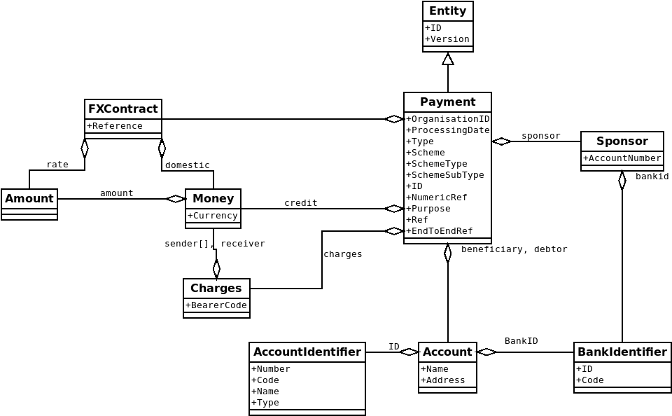

Organisation ID <Value>
An organisation-id is some opaque, non-empty, external string provided to the service. Hence in this model we don’t consider organisation-id to be an entity, it is simply a value.
This means we explicitly make the decision to allow any organisation-id to be used in transactions with the domain, without validation. If we did need to validate this field, we would need to some way to bring valid valid organisation-ids into domain, which adds complexity.

Payment <Entity>
A payment has a set of attributes, all of which are considered to be values :
- ID (required) – UUID - immutable
- Version (required) - incrementing integer, >=0
- An organisation-id (required)
- The credit-money which is required
- A processing-date which is required
- The beneficiary which is required
- The debtor which is required
- The charges information which is required
- The foreign-exchange contract which is not required
- The sponsor which is required
- Payment classification information :
  - A payment-type which is required
  - A payment-scheme which is required
  - A scheme-payment-type which is required
  - A scheme-payment-sub-type which is required
- External payment identities, references and descriptions :
  - A payment-id which is required
  - A numeric-reference which is required
  - A payment-purpose which is not required
  - A reference which is not required
  - An end-to-end reference which is not required

Debtor <Value>
A debtor is an account.
The (account_number, bank_id) cannot be the same for both the debtor and beneficiary)

Beneficiary <Value>
A beneficiary is an account
The (account_number, bank_id) cannot be the same for both the debtor and beneficiary)

Account <Value>
An account is a value consisting of :
- account-identifier (required)
- bank-identifier (required)
- name (required) – free-form text
- address (required) – free-form text

All of these field must be set to non-empty values.

Account Identifier <Value>
This is a value consisting of :
- an account-number
- an account-code (IBAN, BBAN)
- an account-name (required)
- an account-type (optional) integer
The account-number string is validated against the internal structure of the account-code where possible.

Bank Identifier <Value>
This is a value consisting of a bank-id and bank-id-code. The internal structure of the bank-id is validated where possible.

Amount <Value>
An amount is a value.
It is a number with a fixed number of decimal places.
An amount can be added to another amount, provided it gives a valid amount.
An amount can be subtracted from another amount, provided it gives a valid amount.
An amount be multiplied by another amount, provided it gives a valid amount.
An amount can be rounded to the nearest precision decimal places.

Currency <Value>
A currency is a value representing an international currency. e.g. GBP

Money <Value>
Money is an amount of a specified currency.
Money is quantified in terms of its smallest denomination e.g. in USD you cannot have fractions of 1 cent.
Money can be added to money of the same currency, provided it gives a valid amount of the same currency.
Money can be subtracted from money of the same currency, provided it gives a valid amount of the same currency.
Money can be multiplied by an amount, provided it gives a valid amount of the same currency.

Exchange Rate <Value>
An exchange rate is the amount of the domestic-currency required to purchase 1 amount of the foreign-currency.
An exchange rate with domestic-currency X can be applied to money of currency X, to yield money in the foreign-currency Y.

Foreign Exchange (FX) Contract <Value>
The FX Contract consists of :
- a contract reference (required) – free-form text
- an exchange-rate (required)
- domestic-money (required)
In a payment, the credit-money multiplied by the contract exchange-rate should equal the domestic-money.
In a payment the domestic-money of any fx-contract represents the debit-money.

Charges <Value>
Charges have a :
- bearer-code (required)
- an array of sender charges as money (required)
- receiver-charge as money (required)

Sponsor <Value>
A sponsor is a value consisting of :
- account-number (required) which is a string
- a bank-identifier (required)

We can add redirects for /payments:id to /payments:id/0 if necessarry.
Currently only GET /payments can return more than one payment object.
It is not clear what these charges are and two who they apply.
From the data it looks like this is a UUID, but since an organisation entity is outside the scope of the payments domain, we must assume a more general form to avoid coupling.
Making this a required field would make the payment unnecessarily confusing in the case of a payment in the same currency. A fake fx contract would need to be constructed between the same currencies and having an exchange rate of 1.
Assumed but could be dependent of payment type
This is “Credit” in the data, does it make sense for a payment to be a “debit”?
Its not clear if this is free-form text or an enum
Its not clear if this is free-form text or an enum
Assumed to be external to the model
Assumed to be external to the model
Assumed
It is assumed for simplicity that there is no other validation to be done on these fields
https://www.iban.com/glossary
It is not known what this integer means
http://www.sepaforcorporates.com/swift-for-corporates/list-ncc-national-clearing-codes/
https://www.iso.org/iso-4217-currency-codes.html
In fact we might not actually need this functionality
In fact we might not actually need this functionality
Presumed to be a single amount for each currency of the payment, but not sure.
The data suggests this is in the sender currency, but not sure if this is a restriction.
It is not clear if this should be just a string, or an account-identifier

