|  |  |  |  |
| --- | --- | --- | --- |
| Report Templates | | | |
| **STATE** | Chhattisgarh | **SECTION/REGION** | Bilaspur |
| **DATE OF APPLYING** | April 2020 | | |

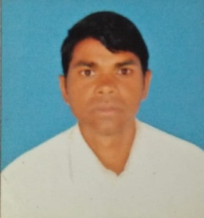

Name : Ajith Kindo

DateofBirth : 18-12-1982

Marital Status : Married

Mission Field (main village)

State : Dhodhra, Sarji, Chhattisgarh

Wife/husband name (if applicable) : Basanti Kindo

Children; Their names and ages : Stuti Kindo(14), Stor Kindo(12), Smayal

kindo (9)

ID : CGROH5

|  |  |  |  |
| --- | --- | --- | --- |
| Sl No | Name of the Village | Number of People Coming for Prayer | Number Baptized |
| 1 | Dhodhala | 15 | 12 |

I greet you all in the sweet name of our lord and Savior Jesus Christ. By God's grace we all are doing well. I thank God for the NCM for the prayer and valuable support for the ministry. May the Lord bless you abundantly for helping us for the ministry. The Lord is helping us to take care of my family and providing all our needs on time. There were times my family was going through physical struggles but God has given us good health. My children are doing well in their studies and they are also growing in the Lord. I thank God for the blessed family life he has granted us.

Right now I am ministering in a village called Dhodhala. Here people are very traditional but we are praying and sending the believers for the Gospelisation. Now days people are not having any freedom to come for the prayer because of the pressure from the BJP. In church everything is running well and the believers are growing in the Lord. Thus far the Lord has helped me in all my ministry I have not faced any persecution and opposition. I thank God for his love towards us.

Last month a brother named Ajit Ekka, who was very drunker. He has heard the Gospel in our meeting and gave life to Jesus. Now he has completely left the drinking habits. Once he was one of popular drunker in the village. As he has left many people are asking him about his changes. Please pray for him that he may stand with Gospel and testimony.

Please pray for the church growth and new people may come for the worship

Please pray for the healing of brother Kalyan and he has been paralyzed

Please pray for my family and God may give them good education

Please pray for my personal life and I may grow more in the Lord