**Richard Garnett Due to the cost type "project" , this £.3700 differs from DM1**

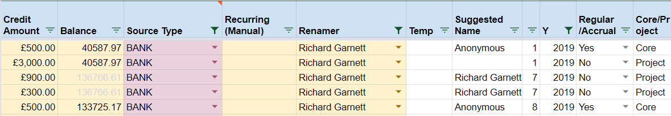

**Dave Fremel Due to the cost type " " , this £.960 differs from DM1**

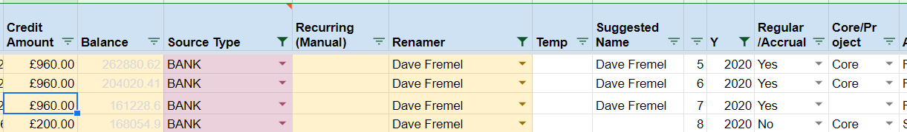

**Vicki Ibbett Comments - Due to the Source type "STEWARDSHIP" and Cost type “**N/A**” , this £.748 differs from DM2**

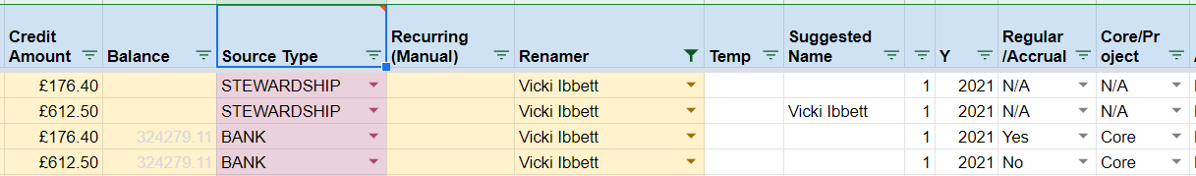

JM Warkentin **Due to the cost type "project" , this £.728 differs from DM1**

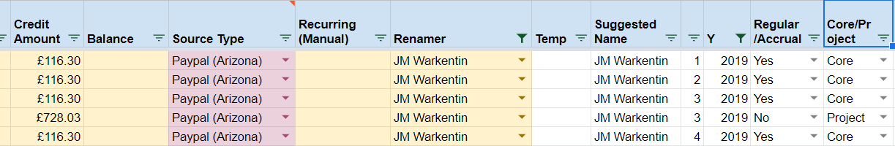

Peter Rainer Jones **Due to the cost type " " , this £.60 differs from DM1**

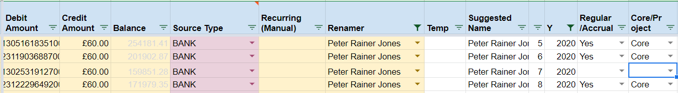

Nabil Raphael **Due to the cost type "N/A" , this £.360 differs from DM1**

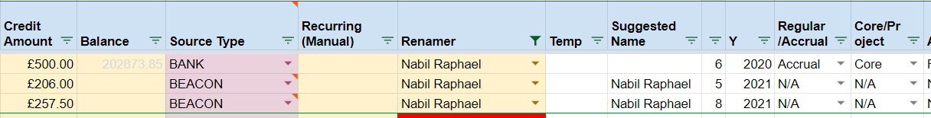

**David Leal Due to the cost type "N/A" , this £.360 differs from DM1**



**David Steinegger Due to the cost type "N/A" , this £.360 differs from DM1**

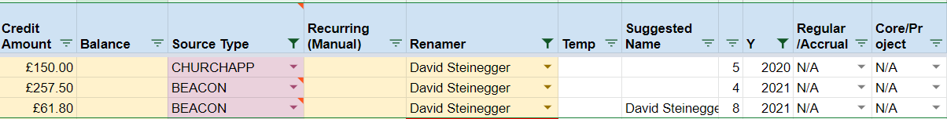

Robert Lyman **Due to the Source type "BEACON", this £.257.5 differs from DM1**

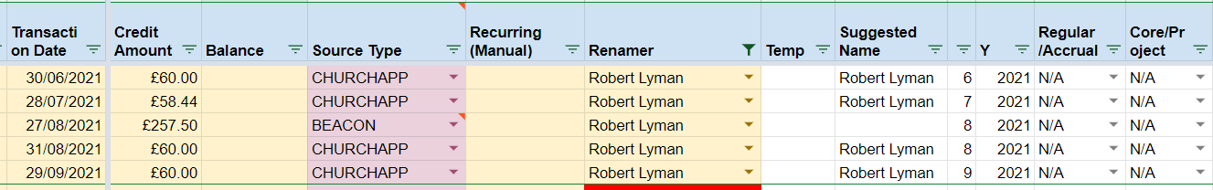

Victoria Savage **Due to the Source type "BEACON", this £.200 differs from DM1**

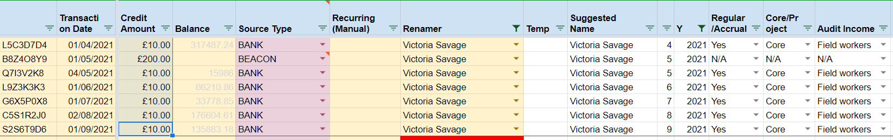

John & Renee Rinehart Due to the Source type "BEACON" , this £.206 differs from DM1

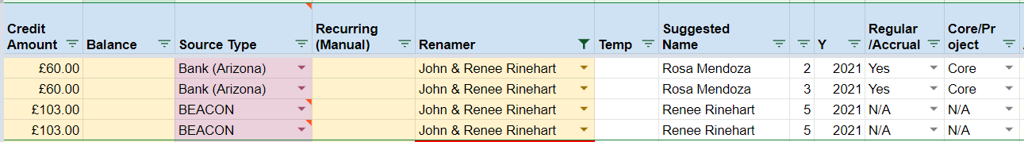

**Ian & Janet Hartley** Due to the Source type "STEWARDSHIP", this £.200 differs from DM2

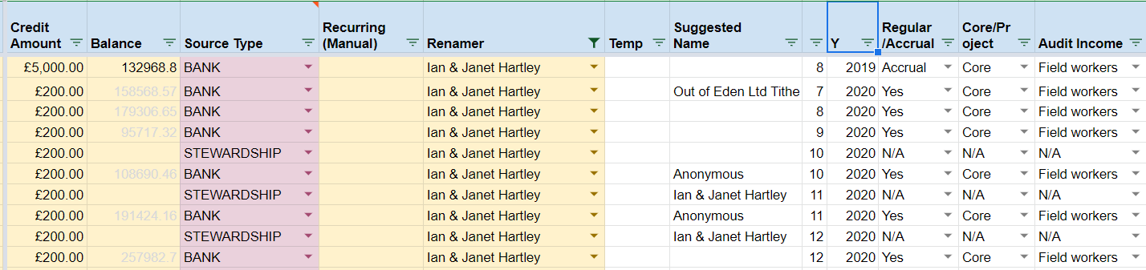

David Hutchinson Due to the cost type "N/A", this £.175 differs from DM1

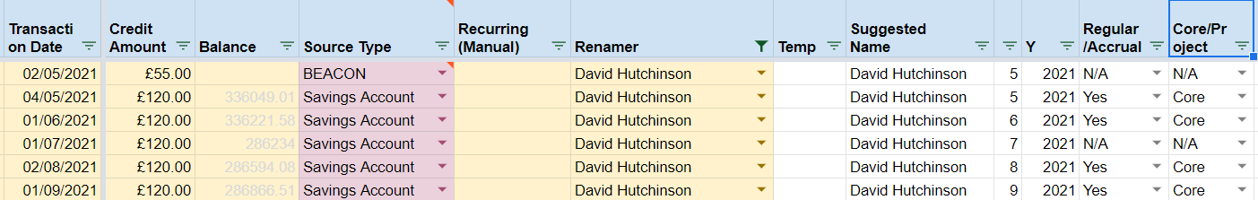

**David Pollard Due to the cost type "N/A" and Source type "BEACON", this £.134.92 differs from DM1**

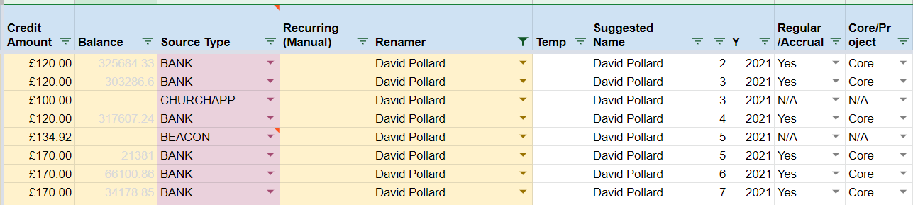

**David Smithard Due to the Source type "BEACON", this £.133.9 differs from DM1**

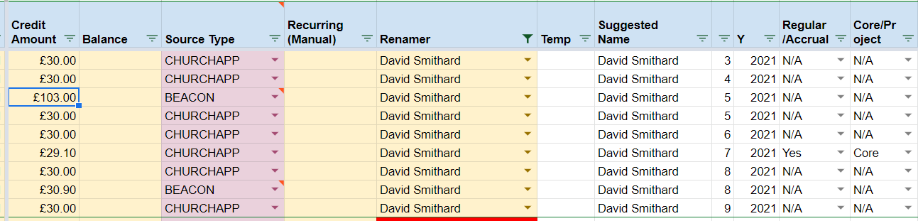

**Graham Cline Due to the Source type "STEWARDSHIP", this £.120 differs from DM2**

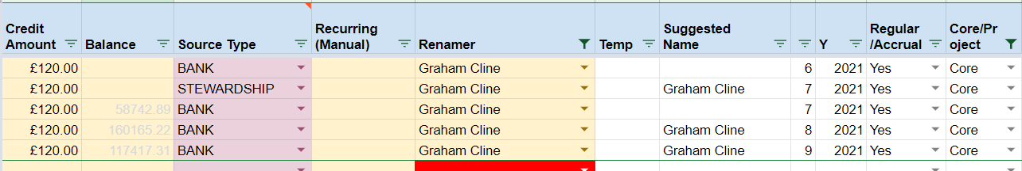

**Laura Bamford Due to the cost type "project", this £.109.01 differs from DM1**

