# INTRODUCTION

Recent advances in wireless communications are marked with the development of Fourth Generation (4G) technologies, including IEEE 802.16m [1] and 3GPP LTE-Advanced (Long Term Evolution) [2]. Both technologies focus on mobile subscribers with a limited power budget, where energy efficiency becomes critical due to relatively slow progress in battery technology. Consequently, power saving mechanisms are becoming increasingly important for next-generation wireless networks. Improving client operation period without recharging its battery, 3GPP LTE-Advanced defines a socalled Discontinuous Reception (DRX) mode, whereas IEEE 802.16m proposes Sleep Mode. In this paper, we compare the operation of the DRX mode against the sleep mode for realistic traffic patterns and conclude on their efficiency.

The sleep mode within the legacy version of the standard, IEEE 802.16e [3], has been thoroughly studied in [4] and [5]. The approach is based on an *M/GI/*1*/K* queueing model with vacations, where authors propose an optimization with respect to the packet loss probability. Another example of the legacy sleep mode performance evaluation is presented in [6], where an *M/G/*1 queueing model with variably-distributed vacations is considered. The work also introduces a set of optimization solutions depending on which system parameters are known.

Conventionally, the arrival process of new data packets into the system is assumed to be Poisson. As such, consideration of non-Poisson traffic is of separate research interest. In particular, [7] and [8] concentrate on DBMAP arrival flow and conduct performance analysis of packet delay and energy consumption for the sleep mode. The sleep mode within the novel IEEE 802.16m standard is addressed in [9] assuming constant sleep cycle duration. Some aspects of the sleep mode for VoIP traffic are studied in [10].

3GPP LTE power saving mechanisms have also been a subject of a number of research papers. In [11], it is argued that the DRX mode may reduce the mobile client energy consumption by 40-45% for video traffic and by 60% for VoIP traffic. However, the case of HTTP traffic is concluded to be the most promising, where the respective energy consumption may be decreased by up to 95%. We note that this parameter also depends on the traffic arrival rate [12]. The influence of the DRX parameters on client energy consumption and the mean packet delay is studied in [13]. However, existing research works are not addressing the explicit comparison between the sleep mode and the DRX mode. In what follows, we bridge in this gap by first introducing the power saving modes and then by conducting their comparative analysis.

## POWER SAVING MODES

### IEEE 802.16m Sleep Mode Operation

The core principle of IEEE 802.16m sleep mode algorithm is to consider mobile subscriber (MS) operation as a sequence of sleep cycles. A sleep cycle comprises two periods: an active period and a sleep period. During its active period, an MS listens to the channel activity, whereas it turns off its radio part during a sleep period in order to reduce its power consumption.

Figure 1 illustrates an example of the sleep mode operation. In the figure, each sleep cycle starts with a listening interval during which the base station (BS) notifies the MS about downlink data to be transmitted. In case of no data, the MS initiates a sleep period with the respective sleep cycle duration given by:

$C_{i} = min(2 · C_{i}-1,C_{max}),$ (1)

where *Ci* is the duration of the current sleep cycle; *Ci*−1 is the duration of the previous sleep cycle; *Cmax* is the maximum allowed duration of a sleep cycle.

When the BS has pending downlink data packets, their transmission starts immediately once the recipient MS enters the active state. The MS also resets its sleep cycle period to the initial value. Consequently, listening period increases, whereas sleep period decreases. Listening period may grow up until the end of the current sleep cycle. In the extreme case, this sleep cycle may have no sleep period at all.

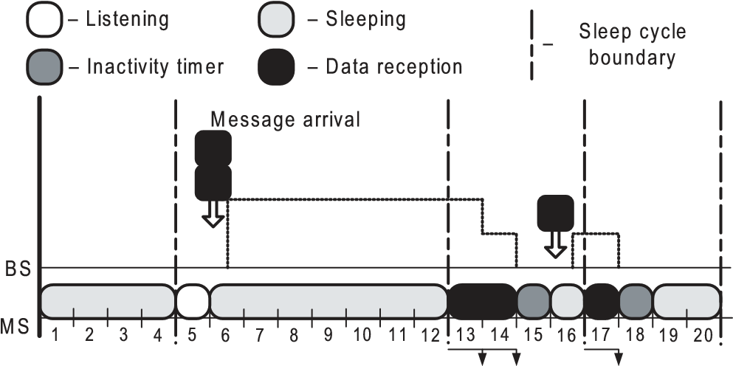

Fig. 1: The sleep mode operation

After each frame where it received some data, the MS continues listening to the channel activity. As such, the MS learns about whether the BS has more pending data packets to transmit. If there were no more downlink packet transmissions during the inactivity timer countdown, the MS enters the sleep state until the end of the current sleep cycle. Additionally, the BS may explicitly notify the recipient MS about its empty downlink buffer, when it transmits the last data packet. This advanced option, however, is not considered in what follows.

3GPP LTE-Advanced DRX Mode Operation

The DRX mode of 3GPP LTE-Advanced is based upon similar principles, as IEEE 802.16m sleep mode. In particular, an MS listens to the channel activity periodically to save some of its power. However, 3GPP LTE-Advanced defines an alternative mechanism to control the listening intervals. Figure 2 demonstrates an example of the DRX mode operation, as well as introduces several important parameters.

1

2345678910

11

1213

1415

1617181920

On Duration

Short DRX

Short DRX

Short DRX

Short DRX Cycle Timer

Long DRX Cycle

Fig. 2: The DRX mode operation

In the figure, the DRX mode differentiates between two types of cycles: a short DRX cycle and a long DRX cycle.

Similarly to the sleep mode, each cycle comprises a listening period (On Duration) and an inactivity period. Listening period may also be extended depending on the volume of the downlink data to be transmitted. After each frame where it received some data, the MS continues listening to the channel activity, as before. The listening period is controlled by the inactivity timer. The primary difference between the DRX mode and the sleep mode is the scheme to increase the sleep/inactivity duration. The DRX mode introduces an alternative parameter, named short DRX cycle timer. It determines the number of short DRX cycles, which should expire without any data transmission before the MS may switch to using its long DRX cycle. Upon any downlink packet reception, the MS resets its short DRX cycle timer and falls back to short DRX cycles.

# Summary of Power Saving Modes

Below we list the parameters related to each of the considered power saving modes.

Parameters of the power saving modes:

|  |  |  |
| --- | --- | --- |
| IEEE 802.16m | 3GPP LTE-A | Description |
| parameters | parameters |  |
| Listening | On | Active period during which |
| interval | duration | MS listens to the channel |
| Initial | Short | Duration of the first sleep |
| sleep cycle | DRX cycle | (DRX) cycle |
| Maximum | Long | Maximum allowed duration |
| sleep cycle | DRX cycle | of a sleep (DRX) cycle |
| Inactivity | Inactivity | Active period during which |
| timer | timer | MS continues to listen after data packet reception |
|  | Short DRX | Number of DRX short cycles |
| – | cycle timer | which pass before switching to the DRX long cycle |

# POWER SAVING ANALYSIS

In order to conclude on the efficiency of the power saving mechanisms, we exploit the so-called energy efficiency coefficient, which may be defined as in [14]:

$=\frac{E[T_{S}]}{E\left[T_{A}\right]+E[T_{S}]}$, (2)

where *E*[*TS*] is the mean time the MS spends in the sleep/inactive state; *E*[*TA*] is the mean time the MS spends in the active state. As such, the energy efficiency coefficient indicates the proportion of time an MS spends saving its power.

IEEE 802.16 and 3GPP LTE technologies are developed to support clients with diverse quality of service (QoS) requirements and restrictions on their arrival flows. QoS parameters may include packet delay and jitter, as well as minimum and maximum bandwidth. Clearly, power saving operation has a negative impact on packet delay and jitter. Consequently, both energy efficiency and delay-related metrics should be accounted for, when choosing the values of the power saving parameters. Importantly, various traffic types have different sensitivity to the above QoS parameters.

In this work, we focus on two polar scenarios corresponding to practical arrival flows. Firstly, we consider VoIP traffic, which typically has a tight restriction on the maximum packet delay. Of practical interest is the proportion of packets, which delay exceeds the indicated threshold. In this case, the optimization problem may be formulated as:

Maximize

*fη*

such that

Pr{D > dmax} ≤ x,

where *fη* is a function that describes the dependence of the energy efficiency coefficient on the power saving parameters (for the sake of brevity, we omit the list of such parameters in what follows); *D* is a packet delay value; *dmax* is the maximum tolerable delay.

Second practical scenario assumes the transmission of HTTP traffic. In this case, the mean packet delay itself may be subject to a restriction. Therefore, the optimization problem might be alternatively formulated as:

Maximize

*fη*

such that

fD ≤ dmean,

where *fD* is a function that describes the dependence of the mean packet delay on the power saving parameters; *dmean* is the mean packet delay restriction.

## WIRELESS SYSTEM MODEL

### Model Assumptions

Below we introduce a wireless system model in order to assess the performance of the power saving mechanisms. We note that our model is reasonably simple, but at the same time makes a powerful tool to optimize client energy efficiency for various traffic types. The assumptions of the model may be summarized as follows.

1. System topology comprises a BS and a single MS.

2. Only downlink channel (from BS to an MS) is considered.

3. During a frame, the MS may receive at most one data packet.

4. Data packets are served by the BS in the order of their arrival, without extra delays due to scheduling.

5. If a packet arrives at the BS during the frame *k*, it may be sent to the MS not earlier than in the following frame *k* + 1.

6. Data packet errors are not considered.

Here we discuss the limitations of the above system model. Assumption 1 is realistic due to the fact that an MS influences the other MSs in the system only via the packet scheduler at the BS. However, scheduling algorithms are not included into IEEE 802.16m and 3GPP LTE-Advanced standards, as well as left out of scope of this paper. As the result, we concentrate on the interactions between a single MS and the respective BS to abstract from possible inter-relations between the MSs in the system.

Additionally, we focus only on the downlink packet transmissions, as downlink data is known to dominate (up to 50:1) in the cellular deployment [15]. As the packet scheduler is not considered, the downlink packet transmissions are reasonably assumed to follow a FCFS discipline, where a packet takes one frame to be transmitted. Assumption 5 highlights the fact that due to the schedule management the immediate packet transmissions are not possible.

### Traffic Arrival Patterns

As we discussed above, this work compares HTTP and VoIP traffic. Both packet arrival flows belong to ON-OFF models [16], where each model has two states: an active (ON) state and a passive (OFF) state [17] (see Figure 3). If a model is currently in the ON state, it generates new data packets. Otherwise, in the OFF state there are no new arrivals.

ON

OFF

γ

1

γ

2

Fig. 3: Example of an ON-OFF model

There are two important differences between existing VoIP and HTTP traffic arrival models [18]. Firstly, packet interarrival times in the ON state are assumed to have different properties. In case of HTTP traffic, packet inter-arrival times are distributed exponentially with the parameter *λON* (as such, HTTP traffic model is also known as interrupted Poisson process, IPP [16]). In case of VoIP traffic, packet inter-arrival times are deterministic and all equal to 20 ms. Secondly, the two traffic arrival patterns demonstrate different steady-state behavior. Whereas ON and OFF dwell times have exponential distribution with parameters *γ*1 and *γ*2 for both models, the values of these parameters are different.

REFERENCES

1. *IEEE Std 802.16m-2011, Air Interface for Broadband Wireless Access Systems. Advanced Air Interface, May 2011*.
2. *LTE Release 10 & beyond (LTE-Advanced)*.
3. *IEEE Std 802.16-2004, Air Interface for Broadband Wireless Access Systems, October 2004*.
4. Y. Park and G. Hwang, “Performance modelling and analysis of the sleep-mode in IEEE 802.16e WMAN,” in *Proc. of the 65th IEEE Vehicular Technology Conference*, pp. 2801–2806, 2007.
5. Y. Park and G. Hwang, “An efficient power saving mechanism for delay-guaranteed services in IEEE 802.16e,” *IEICE Transactions on Communications*, vol. E92-B, pp. 277–287, 2009.
6. S. Alouf, E. Altman, and A. Azad, “Analysis of an M/G/1 queue with repeated inhomogeneous vacations with application to IEEE 802.16e power saving mechanism,” in *Proc. of the 5th International Conference on Quantitative Evaluation of Systems*, pp. 27–36, 2008.
7. K. de Turck, S. de Vuyst, D. Fiems, and S. Wittevrongel, “Performance analysis of the IEEE 802.16e sleep mode for correlated downlink traffic,” *Telecommunication Systems*, vol. 39, no. 2, pp. 145–156, 2008.
8. K. de Turck, S. Andreev, S. de Vuyst, D. Fiems, S. Wittevrongel, and H. Bruneel, “Performance of the IEEE 802.16e sleep mode mechanism in the presence of bidirectional traffic,” in *Proc. of the IEEE International Conference on Communications*, 2009.
9. K. de Turck, S. de Vuyst, D. Fiems, S. Wittevrongel, and H. Bruneel, “Performance of the sleep-mode mechanism of the new IEEE 802.16m proposal for correlated downlink traffic,” in *Proc. of the 3rd Euro-NF Conference on Network Control and Optimization*, pp. 152–165, 2009.
10. R. Kalle, M. Gupta, A. Bergman, E. Levy, S. Mohanty, M. Venkatachalam, and D. Das, “Advanced mechanisms for sleep mode optimization of VoIP traffic over IEEE 802.16m,” in *Proc. of the IEEE Global Telecommunications Conference*, 2010.
11. C. Bontu and E. Illidge, “DRX mechanism for power saving in LTE,” *IEEE Communications Magazine*, vol. 47, no. 6, pp. 48–55, 2009.
12. T. Kolding, J. Wigard, and L. Dalsgaard, “Balancing power saving and single user experience with discontinuous reception in LTE,” in *Proc. of the IEEE International Symposium on Wireless Communication Systems*, pp. 713–717, 2008.
13. L. Zhou, H. Xu, H. Tian, Y. Gao, L. Du, and L. Chen, “Performance analysis of power saving mechanism with adjustable DRX cycles in 3GPP LTE,” in *Proc. of the 68th IEEE Vehicular Technology Conference*, 2008.
14. *WiMAX Forum, K. Ramadas, and R. Jain, ”WiMAX System Evaluation Methodology,” version 2.1, July 2008*.
15. M. Flament, F. Gessler, F. Lagergren, O. Queseth, R. Stridh, M. Unbedaun, J. Wu, and J. Zander, “An approach to 4th generation wireless infrastructures: Scenarios and key research issues,” in *Proc. of the 49th IEEE Vehicular Technology Conference*, vol. 2, pp. 1742–1746, 1999.
16. A. Adas, “Traffic models in broadband networks,” *IEEE Communications Magazine*, vol. 35, no. 7, pp. 82–89, 1997.
17. *”Traffic Model for 802.16 TG3 MAC-PHY Simulations,” IEEE*

*802.16.3c-01/30r1, March 2001*.

1. *”Mean Traffic Bit Rate with ON-SID Modeling of VoIP Traffic,” IEEE C802.16m-07/123, July 2007*.