Choose File > New Project Under Categories, choose Java Web. Under Projects, choose Web Application. Click Next. Name the project "client" and make sure that you specify an appropriate server as your target server. (Refer to the "Getting Started" section for details.) Leave all other options at default and click next, leave all options as defuel and click next, check JavaServer Faces and under components check PrimeFaces then click finish.

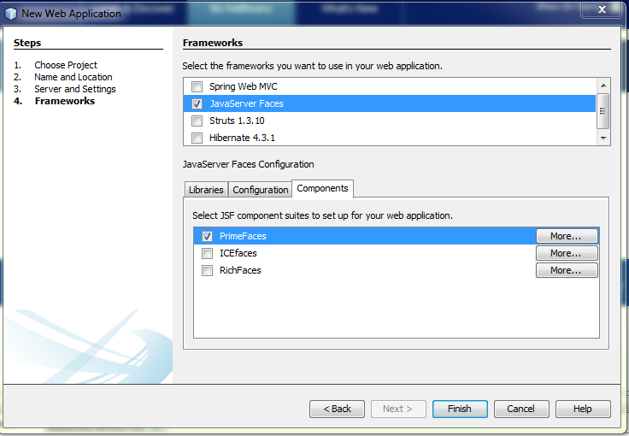

In the Projects window, right-click the client project node and choose New > Other and select Web Service Client in the Web Services category in the then choose the project that contains the web service and get the web service.

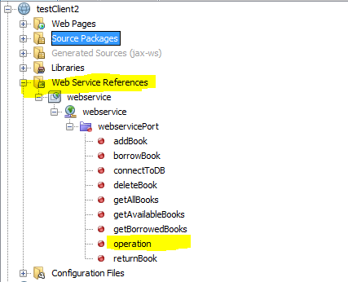

Under Web Service References you can find the webservice and all the operations invoked

To use the operation in the code drag the operation and drop it in the code, and a method calls the operation well be auto generated

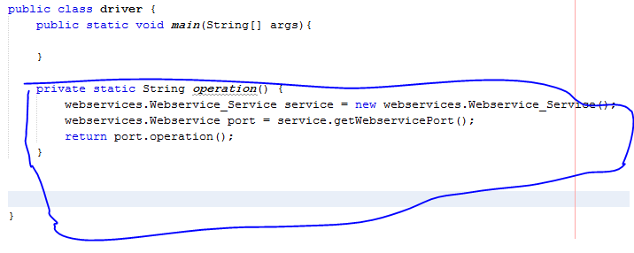

Then all you have to do is call the method to invoke the operation