Purchased on amazon, this product:
https://www.amazon.com/Diymore-Adjustable-Regulator-Converter-Constant/dp/B07Y7YB14L?th=1

Diymore 2pcs 20A 300W CC CV Step Down Module Adjustable DC 6-40V to 1.2-36V Voltage Regulator Buck Converter Constant Current Power Supply Module 20v to 12v Step Down

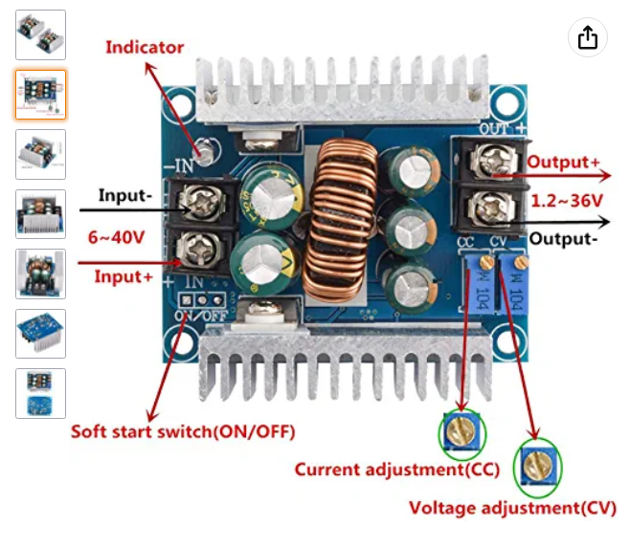
Key parameters:

- max of 20A, but we’ll be running much lower than that, so it won’t be strained
- input: DC 6 – 40 V
- output: 1.2 – 36 V
- the CC adjustable pot controls the maximum current: turn clockwise to increase the maximum value
- the CV adjustable pot controls the output voltage: turn clockwise to increase the output voltage.

Warning: accidentally touching the wrong part of the exposed voltage regulator could be dangerous to you and the regulator. Suggest using a plastic screwdriver for all adjustments

Warning: There are a lot of components and leads on the bottom side of the voltage regulator. Make sure the surface you’re working on is non-conductive, or that it has been mounted with standoffs to ensure spacing from the surface.

Tentative procedure to adjust output voltage:
- put on/off switch to off position (away from edge of board)
- attach voltmeter to outputs
- attach bench power supply at 20V to input
- put on off switch to on position (towards edge of board) using non-conductive screwdriver
- use CV pot to reach desired output voltage, as read on the voltmeter
(clockwise on pot = increase output voltage, changes quite slowly)
- vary the bench power supply output voltage and confirm constant regulator output voltage
( stay within 6-40V range for bench supply output.)
- label the regulator with the output voltage you have set

Tentative procedure to adjust maximum output current:
- put on/off switch to off position (away from edge of board)
- adjust pot CC all the way in counter-clockwise for minimal current
- connect a high current load, low resistance load to regulator output. (hair straightener,
curling iron, car headlight?) Maybe a short circuit with thick wire. Resistance under 5 Ohms
- attach an ammeter that can handle your desired max current in series with load. On
many multi-meters, you need to plug the leads in differently for high current.
- an alternate to ammeter in series: watch the current display on your bench supply
- connect bench power supply at 20V to input of regulator.
- adjust bench power supply max current to be a bit more than your desired max current
- put on off switch to on position (towards edge of board) using non-conductive screwdriver
- verify output current is low or 0
- gradually increase the allowed output current by turning the CC pot clockwise
- watch the output current, which should start to increase at some point
- when it gets to desired current, shut everything down
- label the voltage regulator with the maximum current you have set.

