THE AGING APPRENTICE
Manufacturing & Technology


Adding a BMP Logo to PCB Silkscreen
Fusion 360 Electronics — Step-by-Step Guide
v3Board Project • June 2026

Purpose | Add a company logo to the top silkscreen layer of a PCB design in Fusion 360 Electronics, ready for JLCPCB manufacturing.
Tools Required | Fusion 360 Electronics (PCB Editor), Claude AI (image prep), any image viewer
Layer | s1 SilkscreenTop (maps to layer 21 in the import ULP)
File Format | 1-bit monochrome BMP (black & white only)
Sizing | Specified during import — recommended minimum 200 MIL tall

Step 1 — Prepare the Logo File Using Claude AI
The import-bmp ULP in Fusion 360 Electronics requires a 1-bit (black and white) BMP file. The easiest way to prepare this is to ask Claude to process your original logo image. Claude will crop out any whitespace, threshold the image to pure black and white, and export a clean BMP ready for import.

What to Ask Claude
Upload your logo image to Claude and use a prompt like:

"I need this logo converted to a clean 1-bit black and white BMP for PCB silkscreen. Please crop tight to the logo content, remove any whitespace borders, and export as a monochrome BMP."

What Claude Will Produce
- A tightly cropped BMP with no wasted border space
- Pure 1-bit (2 colour) black and white — no greys
- Correct aspect ratio preserved
- Confirmation of the pixel dimensions and aspect ratio for sizing calculations

💡 Note: Claude uses a threshold of ~180/255 to separate logo content from the white background. If your logo has very light grey elements, ask Claude to adjust the threshold.

The cropped BMP file will be available to download from Claude. Save it somewhere accessible — you will need to browse to it during the ULP import step.

Step 2 — Open the ULP Importer in Fusion 360
With your PCB document open in Fusion 360 Electronics, navigate to the UTILITIES tab in the top toolbar. You will see a button labelled -ULP. Click it to open the ULP (User Language Program) dialog.

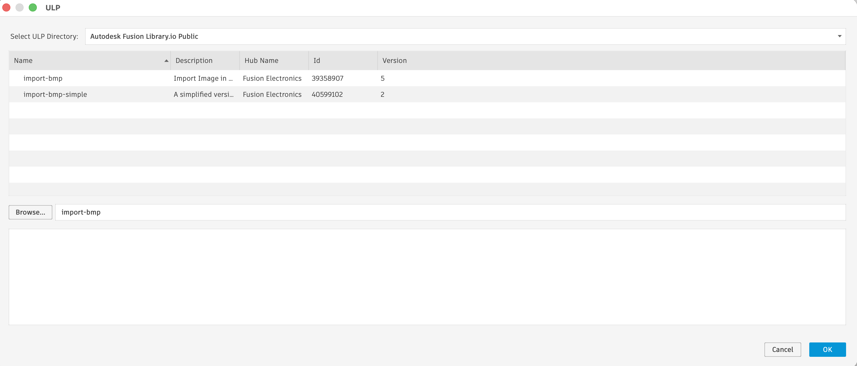
Figure 1 — The ULP dialog showing import-bmp and import-bmp-simple options

Choosing the Right ULP
Two BMP import options are available in the Autodesk Fusion Library.io Public directory:

import-bmp | Full version supporting up to 32 colours (not needed for monochrome logos).
import-bmp-simple ✓ USE THIS | Simplified version optimised for monochrome 1-bit images. Cleaner output for logos.

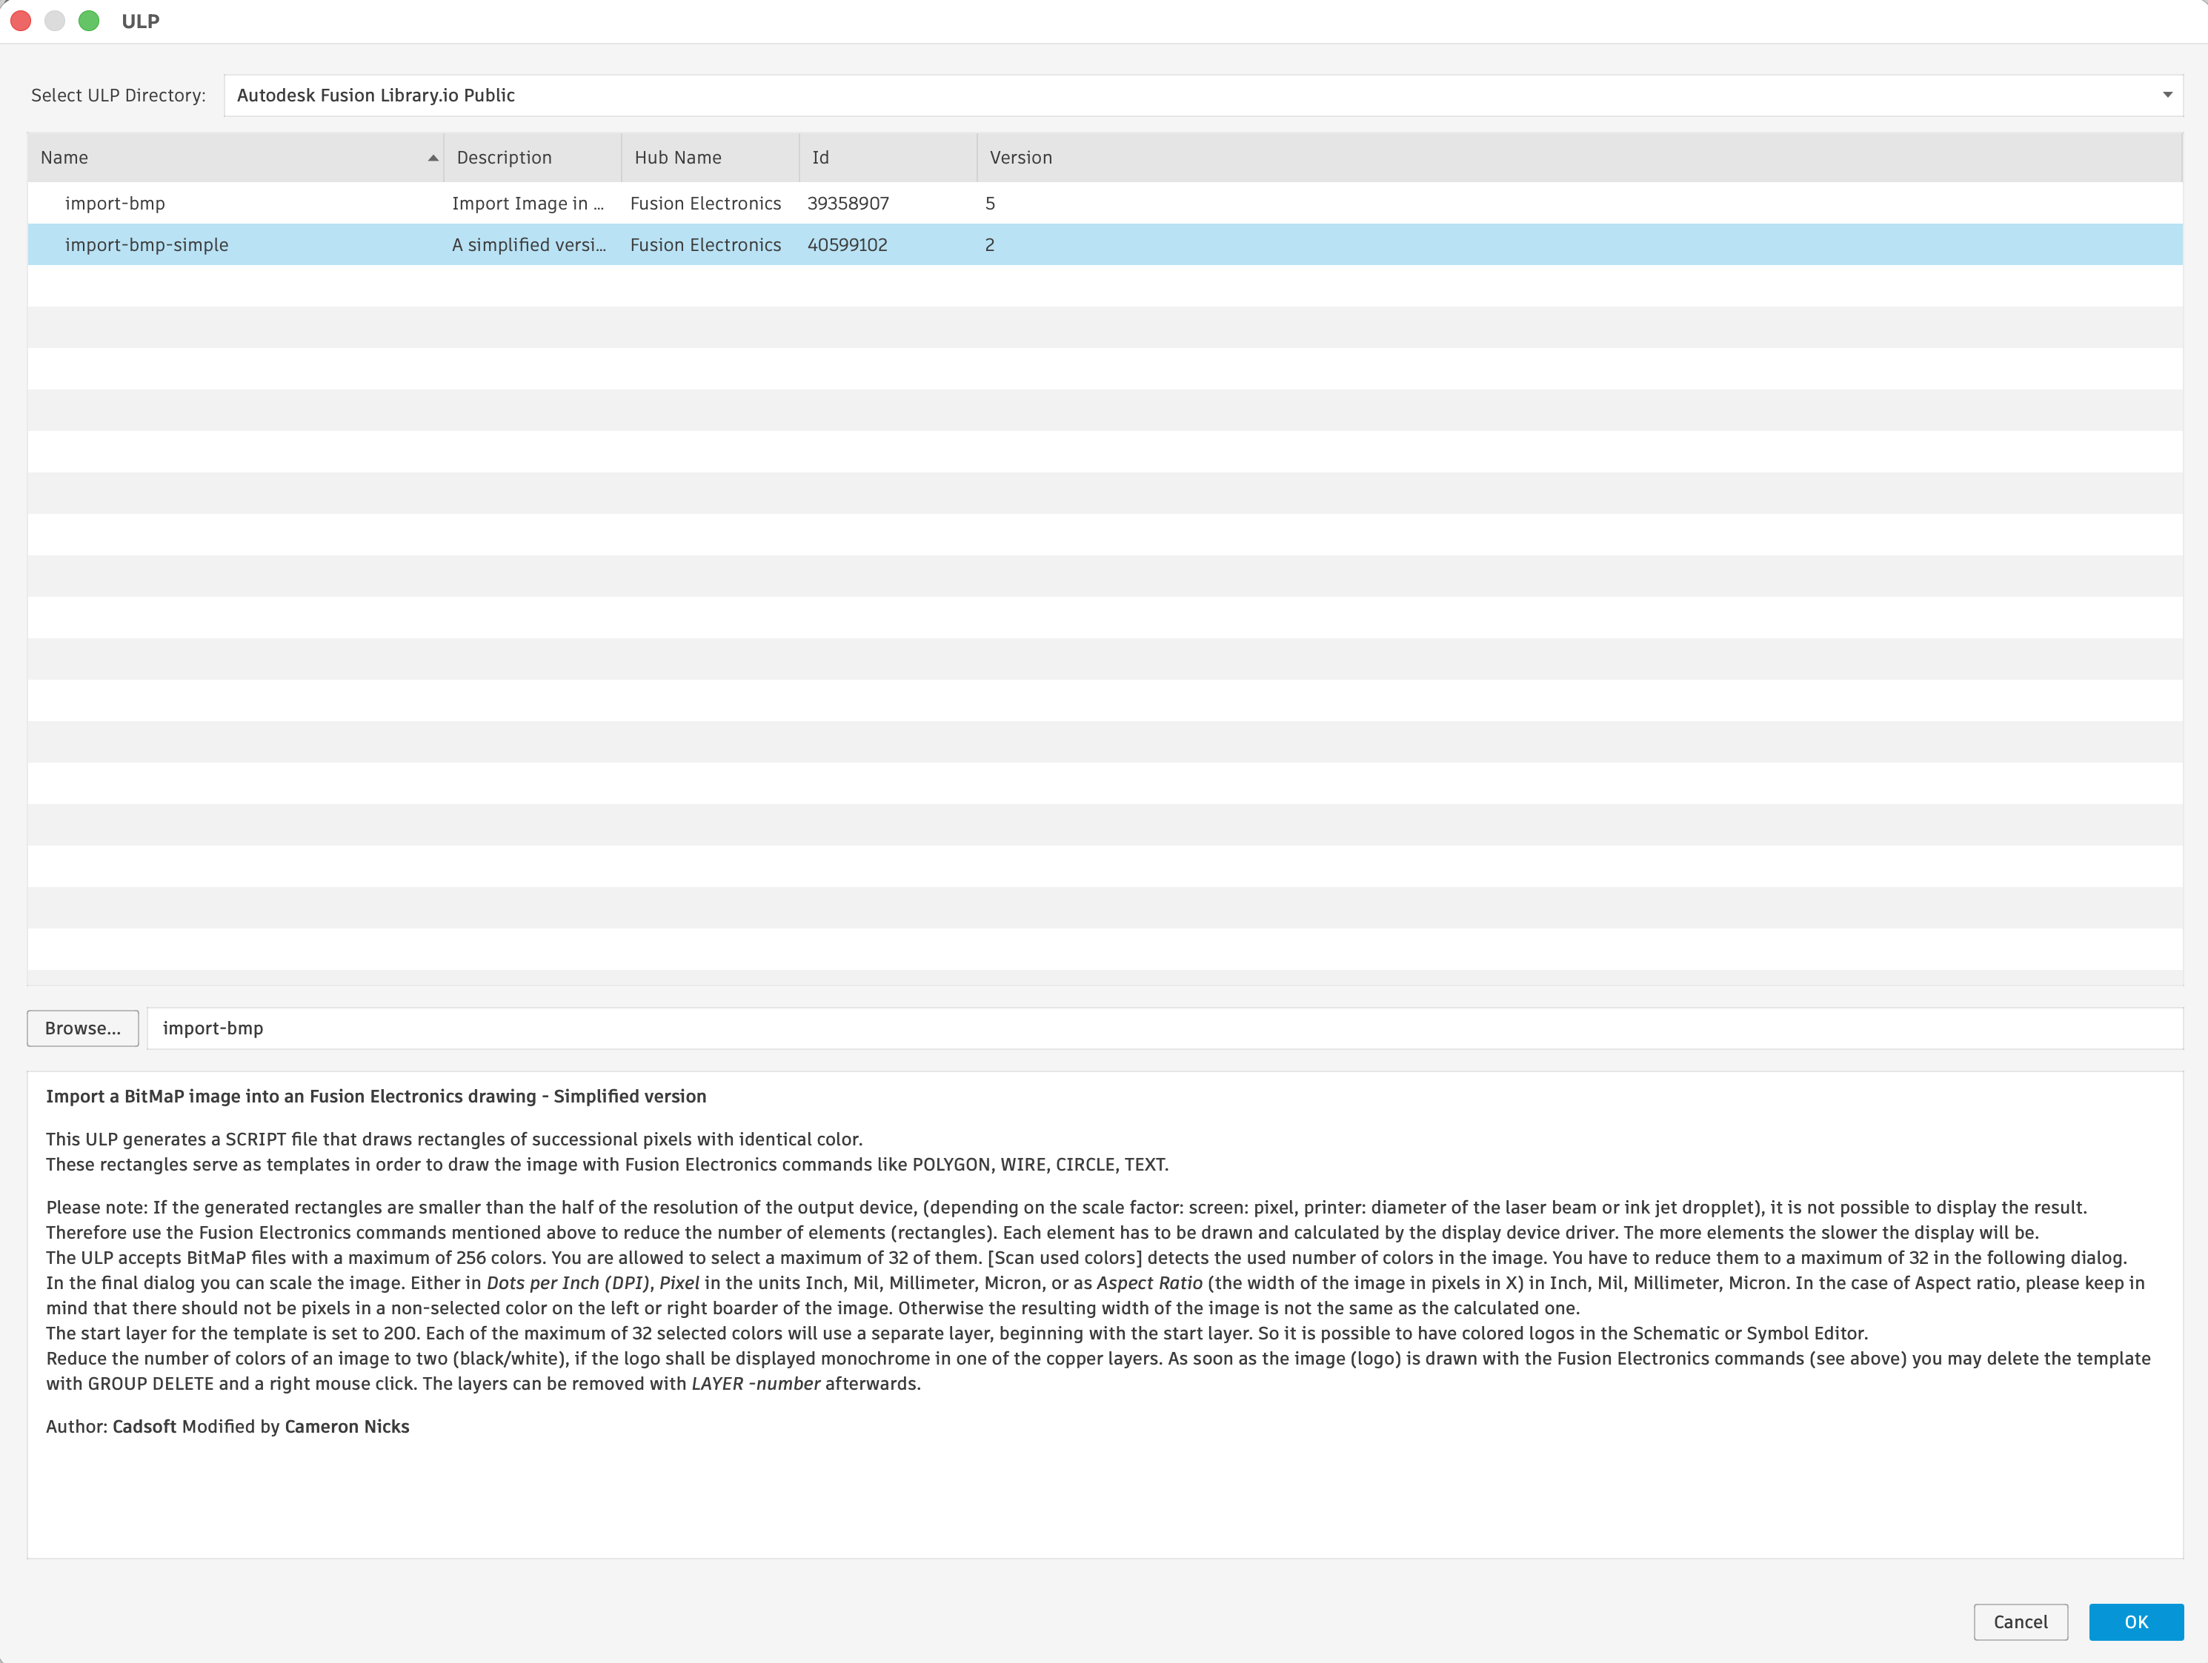
Figure 2 — Select import-bmp-simple and click OK

- Select import-bmp-simple from the list
- Click OK

Step 3 — Configure Import Settings
After clicking OK, a file browser opens. Navigate to your cropped 1-bit BMP file prepared in Step 1 and select it. The Import BMP dialog will then appear showing the file details and export settings.

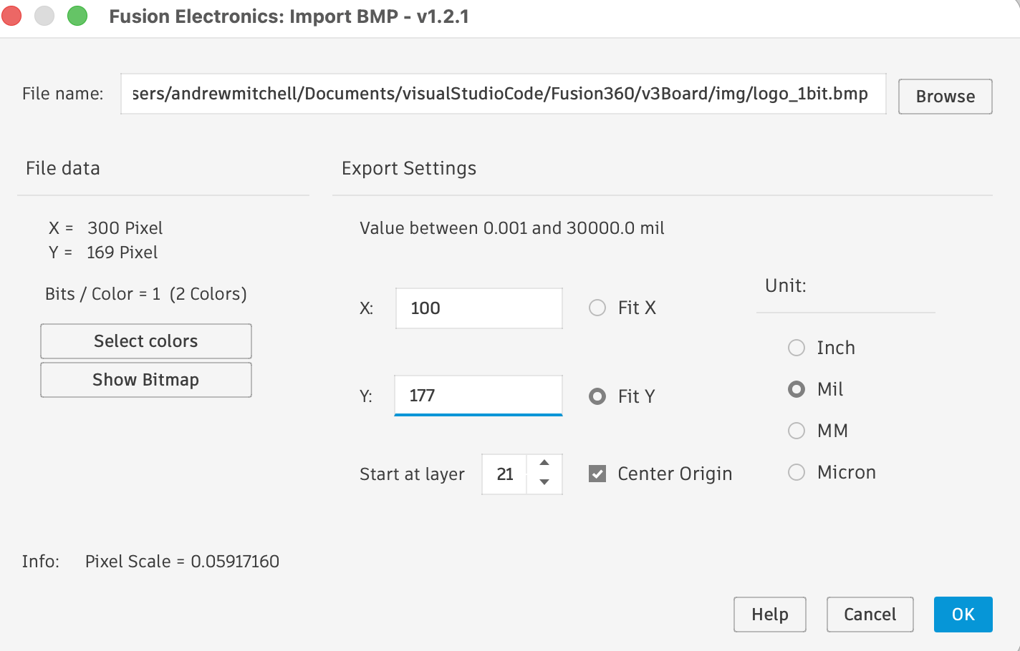
Figure 3 — The Import BMP settings dialog with correct values for a 250 MIL tall logo

Required Settings
Setting | Value | Notes
Unit | Mil | Always use Mil for PCB dimensions
X (height) | Your desired height in MIL | e.g. 250 for 250 MIL tall
Y (width) | X × aspect ratio | Ask Claude: "What is the Y value for 250 MIL tall?"
Fit Y | Selected (radio button) | Preserves proportions using Y as the width
Start at layer | 21 | IMPORTANT: Leave at 21 — Fusion maps this to s1 SilkscreenTop automatically
Center Origin | ✓ Checked | Makes placement easier — logo attaches at its centre

⚠️ Do NOT change Start at layer to 1. This places the logo on the copper layer (ct Top) instead of the silkscreen. Always leave it at 21.

Getting the Y Value from Claude
After Claude prepares your BMP, it will report the pixel dimensions and aspect ratio. You can ask:
"What Y value should I enter in the import dialog for a logo 250 MIL tall with a 1.814 aspect ratio?"
Claude will calculate: 250 × 1.814 = 453 MIL. Enter this as the Y value.

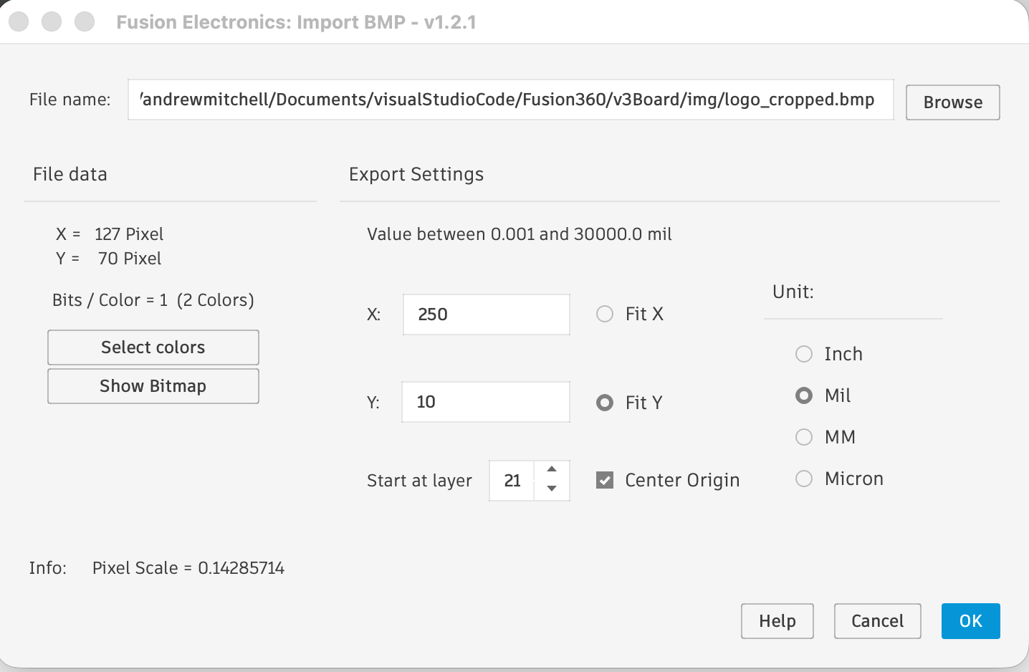
Figure 4 — Final settings: X=250, Y=453, Fit Y selected, layer 21, Center Origin checked

Step 4 — Accept and Run the Generated Script
After clicking OK in the import dialog, the ULP generates a script file and presents an "Accept Script?" dialog showing the commands it will execute. This is normal — the ULP converts your BMP into a series of rectangle drawing commands.

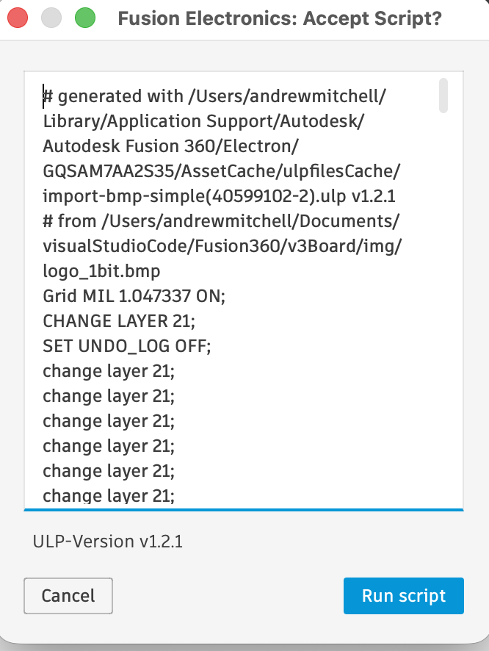
Figure 5 — The Accept Script dialog showing the generated drawing commands

The script will contain lines like:
- CHANGE LAYER 21; — sets the target layer
- SET UNDO_LOG OFF; — disables undo logging for performance (the import can create thousands of rectangles)
- Hundreds of rectangle coordinates representing each pixel block of the logo

- Review the script header to confirm it references your BMP file
- Click Run script to execute
- The cursor will change — you are now in placement mode

Step 5 — Place and Move the Logo onto the Board
After running the script, the logo will be attached to your cursor for placement. Click anywhere on or near the board to drop it. The logo frequently lands outside the board boundary — this is expected and easy to fix.

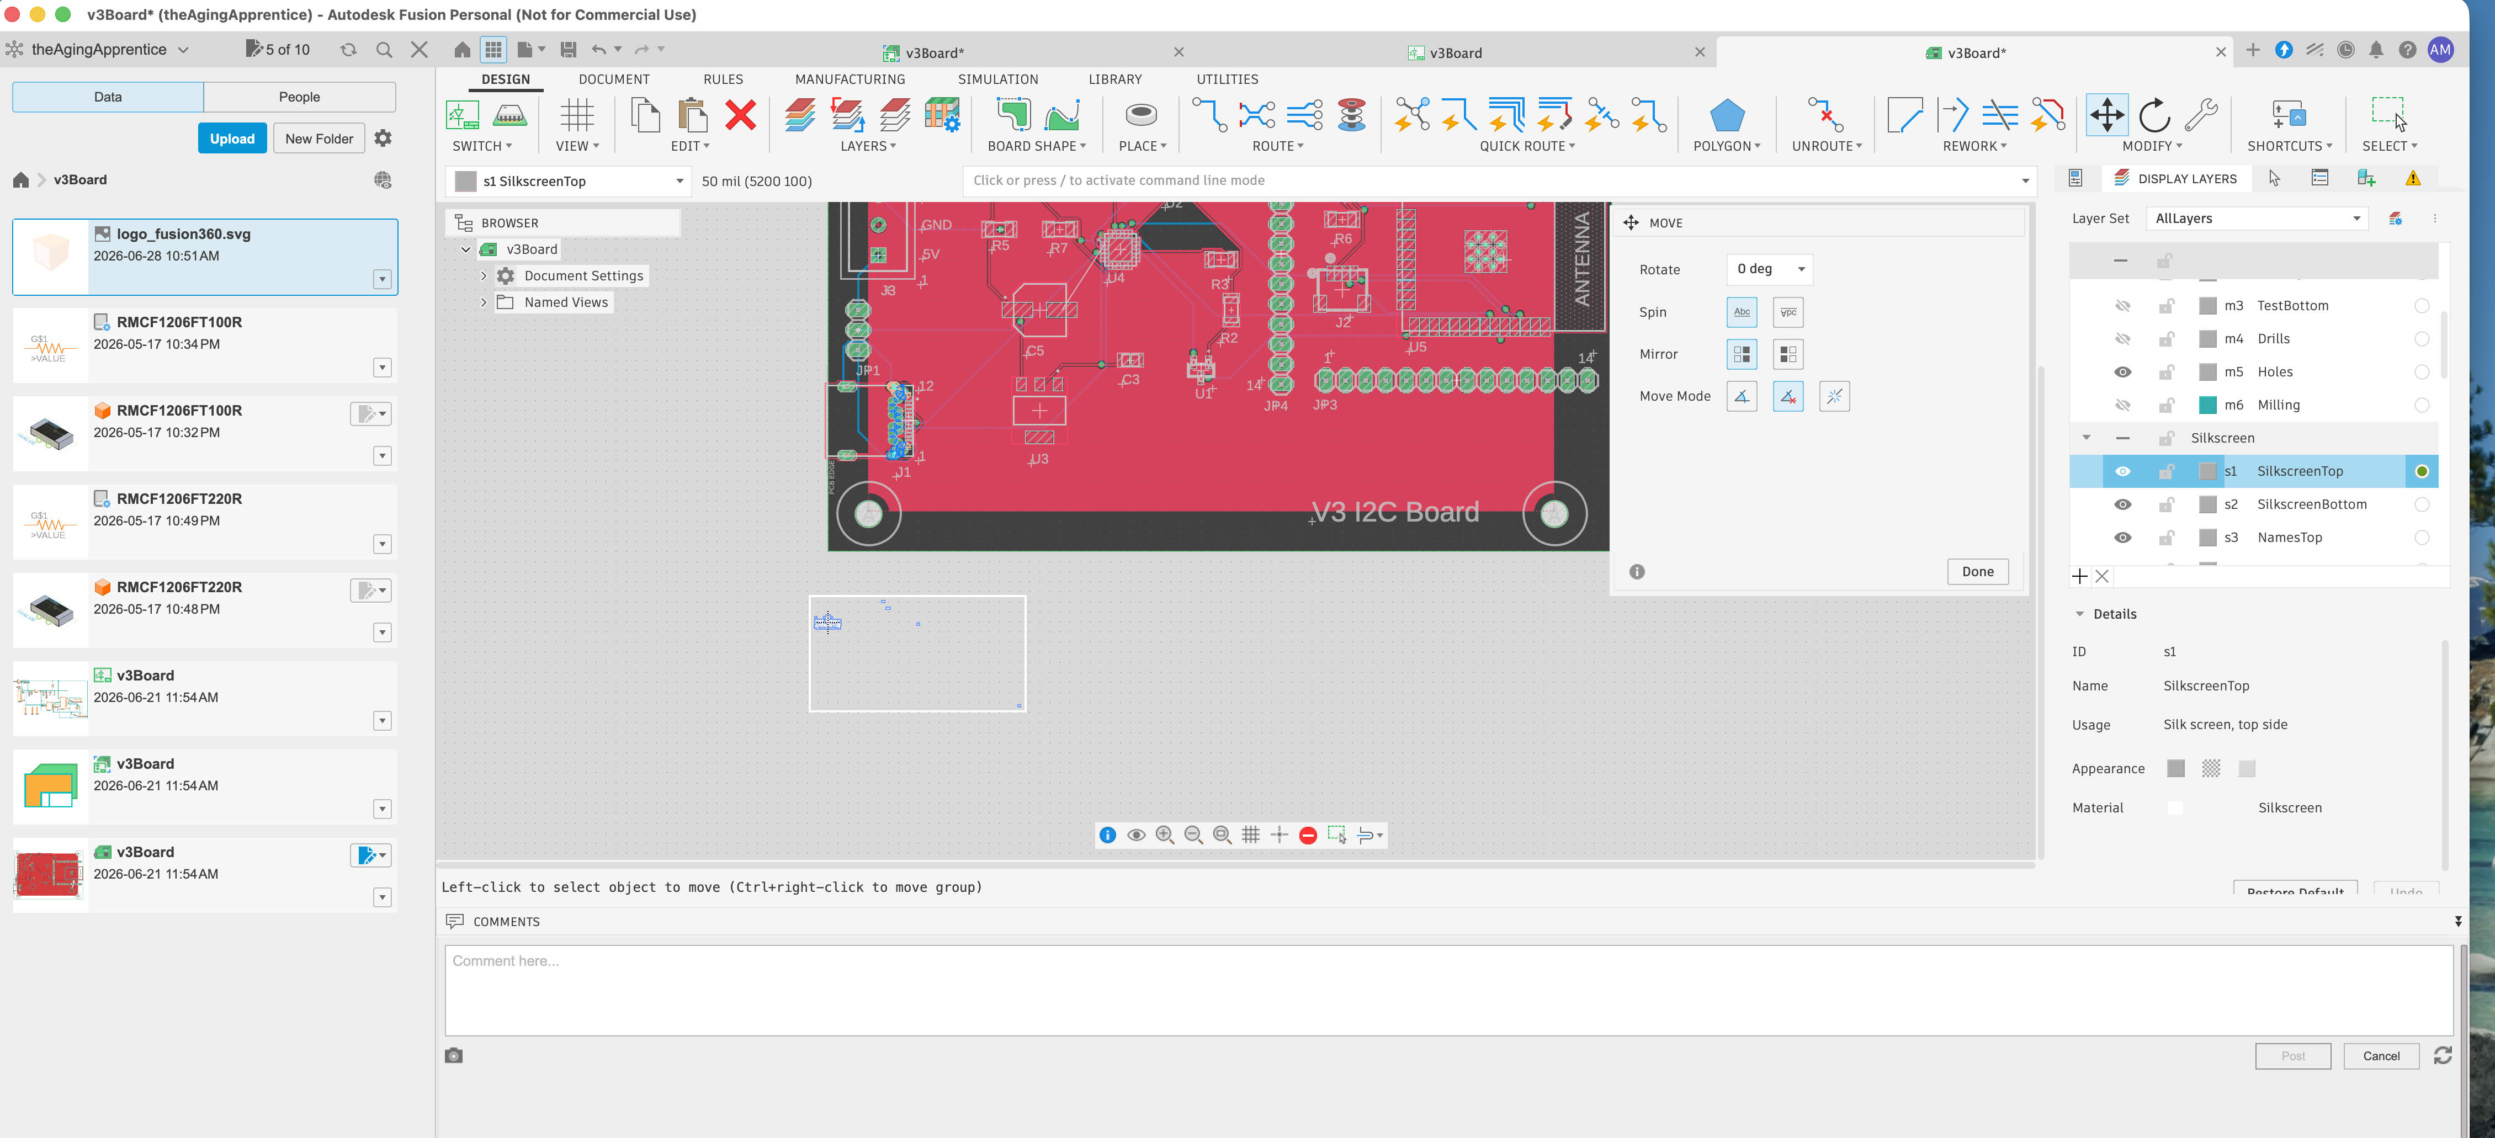
Figure 6 — The MOVE tool active with the logo placed outside the board boundary

Moving the Logo as a Group
The logo is made up of hundreds of individual rectangle elements. You must move them all together as a group. The status bar at the bottom of the screen gives you the key:

Ctrl + Right-click = select and move the entire group

Step-by-step to move the logo:
- Press M or go to EDIT > Move to activate the Move tool
- Hover your cursor over any part of the logo
- Hold Ctrl and Right-click on the logo
- All elements will attach to your cursor as a group
- Move your cursor to the desired position on the board
- Left-click to place

💡 Note: Good placement locations on the v3Board are the lower-left corner or lower-right corner — both have clear silkscreen space away from connectors and components.

Verifying the Layer
After placing, click on one rectangle of the logo and check the Details panel on the right side. You should see:
- ID: s1
- Name: SilkscreenTop
- Material: Silkscreen

⚠️ If the layer shows ct Top (copper) instead of SilkscreenTop, you will need to delete the logo and re-import with layer set to 21, not 1.

Step 6 — Verify in 3D View
Once the logo is placed on s1 SilkscreenTop and positioned on the board, switch to the 3D view to confirm it renders correctly as silkscreen ink on the board surface.

- Click the 3D PCB view button (cube icon) in the toolbar
- The logo should appear as white (or your silkscreen colour) on the board surface
- If the logo does not appear, check that s1 SilkscreenTop is visible (eye icon) in the Display Layers panel
- Save the document (Cmd+S)

JLCPCB Silkscreen Requirements
Before submitting to JLCPCB, ensure your logo meets these minimums:
Minimum line width | 0.153 mm (≈ 6 MIL)
Clearance from pads | ≥ 0.1 mm from any copper pad
Recommended logo size | 200 MIL tall or larger for readable detail
Colour | Single colour only — no gradients. Typically white ink on green/blue board.

Quick Reference — Complete Workflow

# | Step | Action
1 | Prepare BMP | Upload logo to Claude → request clean 1-bit cropped BMP → download file
2 | Get Y value | Ask Claude for the Y dimension: height × aspect ratio
3 | Open ULP | UTILITIES tab → -ULP button → select import-bmp-simple → OK
4 | Browse to BMP | Select your logo_cropped.bmp file
5 | Set dimensions | Unit: Mil | X: height | Y: width | Fit Y | Layer: 21 | Center Origin: ✓
6 | Accept script | Click Run script in the Accept Script dialog
7 | Place logo | Click near the board to drop the logo
8 | Move to board | Press M → Ctrl+Right-click on logo → drag to position → Left-click to place
9 | Verify layer | Click one element → Details panel should show s1 SilkscreenTop
10 | Check 3D view | Switch to 3D PCB view → confirm logo renders as silkscreen

Document prepared with assistance from Claude AI • The Aging Apprentice Manufacturing & Technology • June 2026

