SHAPER ORIGIN WORKSTATION
Vacuum Shelf Build Guide

Covers: MDF selection · VACUDOG vacuum workholding · Three shelf variations
Router table chamfering of 20mm dog holes · Freud 40-104 bit setup

Updated May 24, 2026



Table of Contents
1. The Three Shelf Variations 3
1.1 Standard Shelf — Plain Top 3
1.2 Vacudog Shelf — Single Centre Hole 4
1.3 MFT Shelf — Full Dog Hole Grid 6
2. Choosing the Right MDF 6
2.1 Why MDF Grade Matters for Vacuum Workholding 6
2.2 If Cabinet-Grade MDF Is Not Available 7
3. Chamfering the 20mm Dog Holes 7
3.1 Why Use a Router Table (Not the Shaper Origin) 7
3.2 The Freud 40-104 Chamfer Bit 7
3.3 How Bearing-Guided Depth Actually Works 8
3.4 Setting the Bit Height for a 4mm Chamfer 8
3.5 Chamfering Procedure 9
4. Quick Reference 9

0. Introduction
This document contains the instructions for creating your own Shaper Origin Workstation's large shelf. There are three variations that exist now that you can make without needing to do any designing. All three are based on the dimensions provided by Shaper hub and shown in Figure 1.

The SVG files for the pre-made variations of the shelf can be found online under theAgingApprentice “My Shaper Files” in the Folder called Shaper Workbench Larger Upgrade Kit Shelf variation. The SVG files you need to load into your Shaper Origin are in the Shaper Hub project in the “Shared By Me” Unlisted area. This project has out of date files in that need to be updated up before sharing the project file with the world.

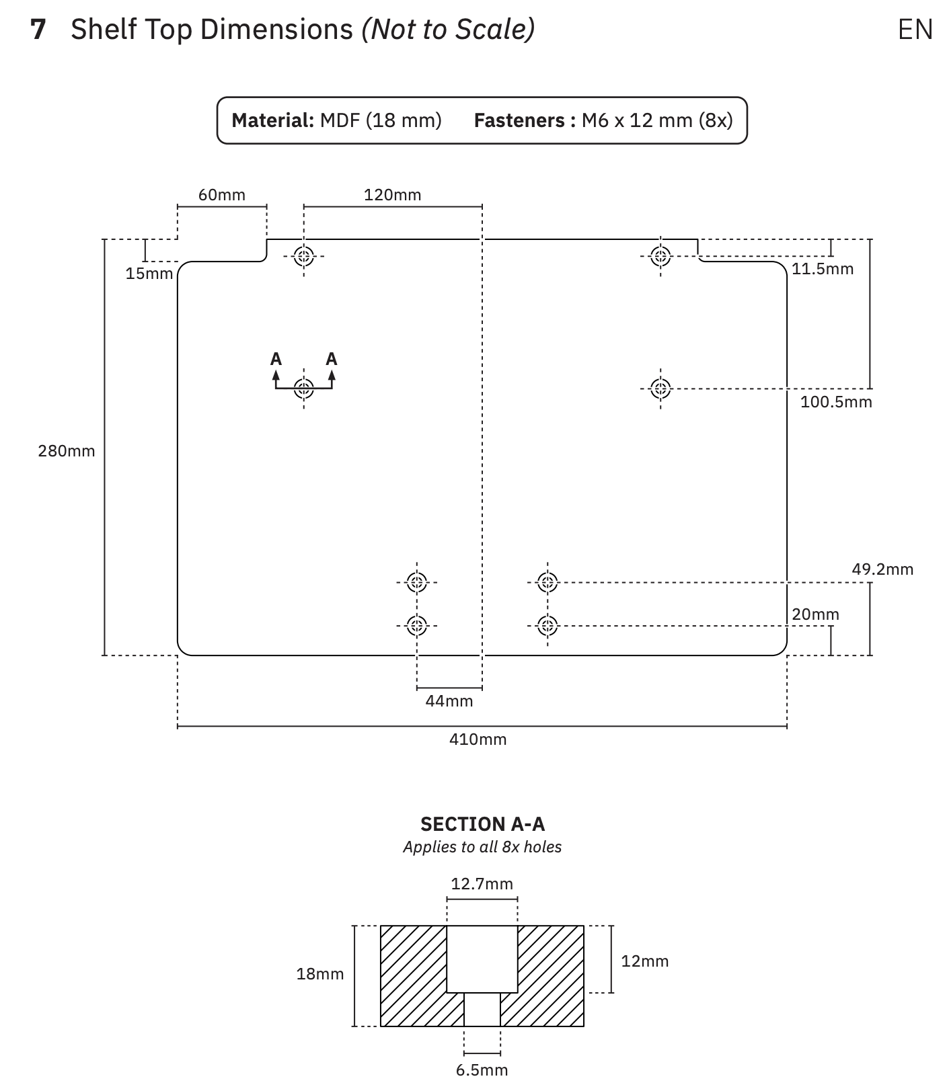
The basic dimensions for all Shaper Shelfs
Diagram provided by Shaper themselves showing the key dimensions of the workshelf.
Should show the full 410 × 280 mm top surface, support leg, and the Workstation frame for context.
Ideally taken from a 3/4 front angle so the support leg height adjustment is visible.
Figure 1: Standard Shaper shelf — the factory design, a plain 18mm MDF top used as a general spoilboard.

1.1 Standard Shelf — Plain Top
The standard shelf is the design produced by Shaper Tools as part of their Shelf Upgrade Kit (SKU:

1. The Three Shelf Variations
The Shaper Origin Workstation's large shelf can be built in three configurations depending on how you intend to hold work. All three are cut from 18mm MDF to the same 410 × 280 mm footprint and mount identically on the Workstation's clamping face.

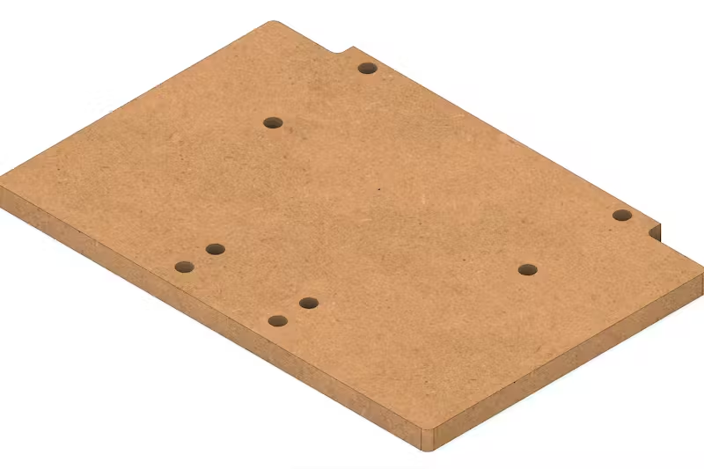
The Standard Shaper Shelf — plain flat top, no holes
Rendered image from Fusion360 showing the standard unperforated shelf mounted on the Workstation.
Figure 2: Standard Shaper shelf — the factory design, a plain 18mm MDF top used as a general spoilboard.

1.1 Standard Shelf — Plain Top
The standard shelf is the design produced by Shaper Tools as part of their Shelf Upgrade Kit (SKU: SU1-WSUK1). It is a plain, unperforated 18mm MDF top measuring 410 × 280 mm — more than three times the area of the small shelf included with the base Workstation.
The shelf slides onto the Workstation's clamping face and locks at height via a lever. An adjustable support leg keeps the surface coplanar with the Workstation under load, with height adjustment spanning 740 mm to 1,140 mm (29⅛" to 44⅞") to suit most bench heights.
This is the starting point from which the Vacudog and MFT variations are derived. It functions as a flat, rigid spoilboard — ideal for face routing, profiling, and any work where the material lies flat rather than standing vertically in the Workstation's clamping jaws.
The shelf is a consumable by design. Shaper publishes the cut SVG file so users can mill replacements from 18mm MDF with their Origin as the original surface becomes worn.

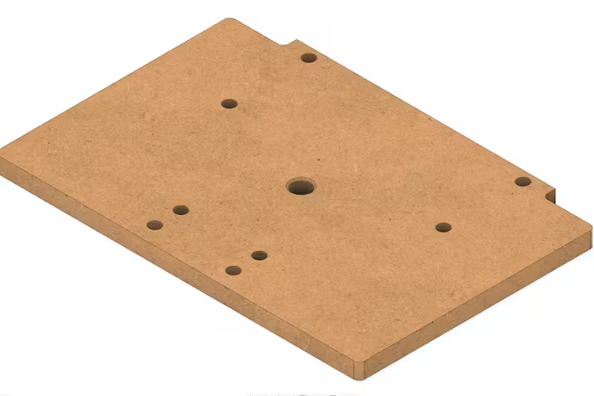
The Vacudog Shelf — single 20mm centre hole for vacuum workholding
Rendered image from Fusion360 showing the Vacudog shelf with the single central 20mm hole clearly visible.
Figure 3: Vacudog shelf — single chamfered 20mm centre hole accepts the VACUDOG stainless steel vacuum fitting.

1.2 Vacudog Shelf — Single Centre Hole
The Vacudog variation adds a single 20mm dog hole at the geometric centre of the shelf top. This hole accepts the VACUDOG stainless steel vacuum fitting, which connects to a shop vacuum to clamp workpieces directly to the shelf surface by suction — no clamps, no tape, no registration marks interfering with the cut path.
The hole is chamfered at 45° to a 4mm chamfer depth (see Section 3 for the full router table setup). This chamfer is required for the VACUDOG O-ring seal to seat correctly and form an airtight connection between the fitting and the MDF surface.
This variation is best suited to holding medium-to-large workpieces where you need unrestricted access to the full face and cannot afford clamp interference. A single vacuum point is sufficient for most face-routing operations when the workpiece is large enough to fully cover the vacuum port.

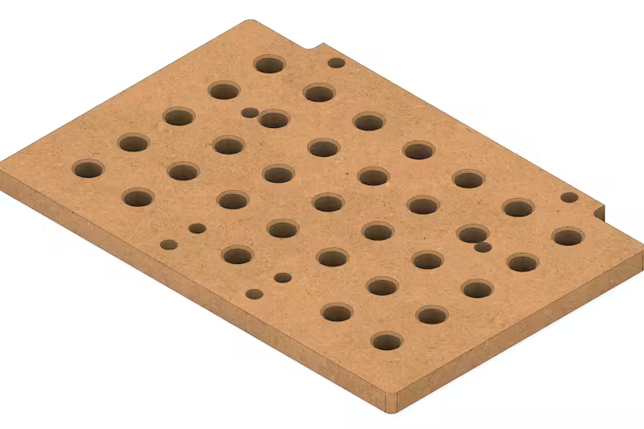
The MFT Shelf — 33-hole dog hole grid for full MFT-compatible clamping
Rendered image from Fusion360 showing the completed MFT shelf with all 33 dog holes drilled on the 96mm grid.
Figure 4: MFT shelf — 7 × 5 grid of 20mm dog holes (33 holes, 2 omitted at bolt positions) on a 96mm pitch, compatible with all standard MFT bench dogs and hold-downs.

1.3 MFT Shelf — Full Dog Hole Grid
The MFT variation drills a 7-column × 5-row grid of 20mm holes across the shelf surface on a 96mm pitch — the same spacing used by the Festool MFT and all MFT-compatible clamping systems. Two holes are omitted where they would conflict with the Workstation's mounting bolt positions, giving 33 holes in total.
This layout allows any MFT-compatible bench dog, toggle clamp, or VACUDOG vacuum fitting to be positioned anywhere across the shelf, giving maximum flexibility for holding odd-shaped or small workpieces that would be difficult to clamp conventionally. All 33 holes are chamfered at 45° using the same router table setup described in Section 3.
The MFT shelf is the most versatile of the three variations and is the recommended starting point if you plan to use the Workstation as a general-purpose fixture for face-routing operations.

2. Choosing the Right MDF

2.1 Why MDF Grade Matters for Vacuum Workholding
The material you choose for your worktop makes a significant difference in how well your VACUDOG system performs. Cabinet-grade or furniture-grade MDF is strongly recommended over standard construction-grade MDF.
Higher density MDF — typically 700–800 kg/m³ — has a tighter fibre structure that limits unwanted air flow through the worktop. This allows your vacuum pump to build the pressure differential needed for strong, reliable workholding. Low-density or builder-grade MDF is too porous: air bleeds through it too freely, and your pump will struggle to maintain adequate suction, especially as you cut more kerfs into the surface over time.

MDF Type | Typical Density / Performance
Cabinet-grade / furniture-grade MDF | 700–800 kg/m³ — recommended. Tight fibre structure limits air bleed-through; pump builds full pressure differential.
Standard / construction-grade MDF | 550–650 kg/m³ — marginal. Usable if sealed (see Section 2.2), but performance degrades faster as the surface is machined.
Low-density / underlayment MDF | < 550 kg/m³ — not recommended. Too porous; pump cannot maintain suction even when new.

⚠️ VACUDOG Spec: AirWeights (makers of VACUDOG-compatible systems) specifically recommend MDF with a density of at least 45 lb/ft³ (720 kg/m³). At lower densities the pump will not generate sufficient pressure differential due to excessive air flow through the board.

2.2 If Cabinet-Grade MDF Is Not Available
If you can only source standard or lower-grade MDF, you can seal the faces and edges with Minwax® Wipe-On Polyurethane, Clear Satin (946 mL/1 qt). This oil-based polyurethane penetrates into the MDF surface and, once cured, significantly reduces air permeability.
Application procedure:
- Lightly sand all faces and edges with 180-grit to open the surface fibres.
- Apply the first coat of Minwax Wipe-On Poly with a lint-free cloth, working it well into the edges — edge grain on MDF is highly porous and a common source of vacuum leaks.
- Allow to dry fully (approximately 2 hours at room temperature).
- Sand lightly with 320-grit between coats.
- Apply two to three coats total, including all four edges, the bottom face, and the top face.
- Allow to cure fully for 24 hours before drilling dog holes or cutting the profile.

💡 Note: Seal the MDF before cutting the shelf profile and holes. Machined edges and hole walls expose fresh unsealed fibre — apply a light brush coat of Wipe-On Poly to these newly exposed surfaces after cutting and allow to dry before use.

3. Chamfering the 20mm Dog Holes

3.1 Why Use a Router Table (Not the Shaper Origin)
The 20mm dog holes are drilled with a drill press or plunge router, not the Shaper Origin — they are simple circles that don't benefit from the Origin's precision positioning. The chamfer is then added at the router table for the same reason: it is a repetitive, identical operation on every hole, and a router table with a fence stop is faster, safer, and more consistent than hand-routing each hole individually with the Origin.
A router table also lets you set the chamfer depth precisely once and then run every hole in sequence without re-measuring, which is particularly important on the MFT shelf where all 33 holes must be identical.

3.2 The Freud 40-104 Chamfer Bit
The recommended bit for this operation is the Freud 40-104, a 45° chamfer bit with a top-mounted pilot bearing.

Specification | Value
Bit model | Freud 40-104
Angle | 45°
Overall length (H) | 2-3/16" (55.6 mm)
Carbide height (h) | 1/2" (12.7 mm)
Bearing position | Top of bit (highest point in router table position)
Bearing diameter | 1/2" (12.7 mm)
Shank | 1/2"

The bearing is the key feature: it sits at the very top of the bit. When the shelf is placed face-down over the spinning bit, the bearing rises up through the 20mm hole and contacts the top face of the MDF around the hole opening. The bearing registers against the face and acts as a self-limiting depth stop — which leads to an important point that is easy to get wrong.

3.3 How Bearing-Guided Depth Actually Works
With a top-bearing chamfer bit in a router table, it is tempting to assume that the bit height setting controls the chamfer depth. It does not — at least not in the way you might expect.
What actually controls the chamfer is how far the bearing sits below the board surface (or equivalently, how far above the router table surface the bearing sits). The relationship is:

📐 Key principle: Chamfer depth = distance the bearing sits above the router table surface. This is because the board's top face rests flat on the table, so the bearing height above the table equals exactly how far below the board surface the bearing will sit when the hole passes over it.

This means:
- If the bearing is flush with the table surface — no chamfer at all (bearing never contacts the board face).
- If the bearing is raised partway — a partial chamfer equal to that height.
- If the bearing is raised to its maximum — the largest chamfer the cutter geometry allows.

On a 45° bit, the chamfer height and width are always equal to each other (sin 45° = cos 45° = 0.707), and the chamfer size in both dimensions equals the bearing height above the table.

3.4 Setting the Bit Height for a 4mm Chamfer
For the VACUDOG and MFT shelf, a 4mm chamfer (4mm wide × 4mm deep at 45°) is the recommended size. It is large enough for the VACUDOG O-ring to seat reliably and for bench dog noses to engage cleanly, without being so large that it significantly weakens the hole edges.

✅ Setup instruction: Set the top of the router bit (the top of the nut above the bearing) to exactly 15mm above the router table surface. This accounts for the 11mm combined height of the bearing and retaining nut that sit above the cutting edge, plus the 4mm chamfer depth required. Measure with a digital caliper from the table surface to the very top of the bit. When your caliper reads 15mm, the bearing will be sitting exactly 4mm above the table — the correct cutting position.

Parameter | Value
Target chamfer size | 4mm × 4mm (at 45°)
Caliper reading (table to top of bit) | 15mm (= 4mm chamfer + 11mm bearing & nut height)
In imperial | ≈ 19/32" (0.591") to top of bit
Resulting hole diameter at top | 20mm + (2 × 4mm) = 28mm at the chamfer lip
Verify with | Digital caliper — measure table surface to top of bit (target: 15mm)

3.5 Chamfering Procedure
Once the bit is set, the operation is straightforward:
- Place the shelf face-down on the router table.
- Position the first 20mm hole directly over the bit. The bearing will pass up through the hole — it fits easily inside the 20mm hole (10mm radius vs 6.35mm bearing radius).
- Lower the shelf gently until the face rests flat on the table with the bearing inside the hole.
- Switch on the router and feed the shelf slowly in a clockwise direction (when viewed from above) around the hole — this is climb-cutting from below; keep a firm hold.
- One full revolution per hole. The bearing self-registers against the face, producing a consistent 4mm chamfer automatically.
- Move to the next hole and repeat.

⚠️ Safety note: Always keep firm downward pressure on the shelf while routing each hole. The bit is below the workpiece and there is a tendency for the cut to lift the board if feed rate is too fast. A slow, controlled revolution per hole is safer than a quick pass.

For the MFT shelf with 33 holes, work in a systematic row-by-row sequence. Total chamfering time once the bit is set is approximately 5–8 minutes.

4. Quick Reference
Item | Specification / Setting
Shelf dimensions | 410 × 280 × 18mm MDF
MDF grade target | Cabinet/furniture-grade, ≥ 720 kg/m³ (45 lb/ft³)
MDF sealant (if needed) | Minwax® Wipe-On Poly, Clear Satin — 2–3 coats including all edges
Dog hole diameter | 20mm
Chamfer bit | Freud 40-104, 45°, top bearing
Target chamfer size | 4mm wide × 4mm deep
Router table bearing height | 15mm to top of bit (4mm chamfer + 11mm bearing & nut)
Vacudog shelf holes | 1 hole — geometric centre
MFT shelf holes | 33 holes — 7 × 5 grid, 96mm pitch (2 omitted at bolt positions)
MFT grid pitch | 96mm column × 96mm row

5. Vacudog Setup
The Vacudog variation of the shelf requires additional hardware to work. As the name suggests, this shelf was designed and tested using the it uses the The Original Vacudog vacuum fitting adapter. This system does not come with a pump so it must be ordered separately. This Youtube video provides links to suggested pumps that are tested and known to work with this system. The pump we bought off Amazon is here. There are three things to hook up to the pump, the muffler, the pressure gauge, and an adapter for the hose that goes to the Vacudog unit. There are 4 quick connect adapters the come with the pump and one of them is the correct for the hose that comes with the Vacudog air clamp. Figure 5 shows where the three items are to be conne3cted. Use the Teflon tape that comes with the unit to ensure all connections are air tight.

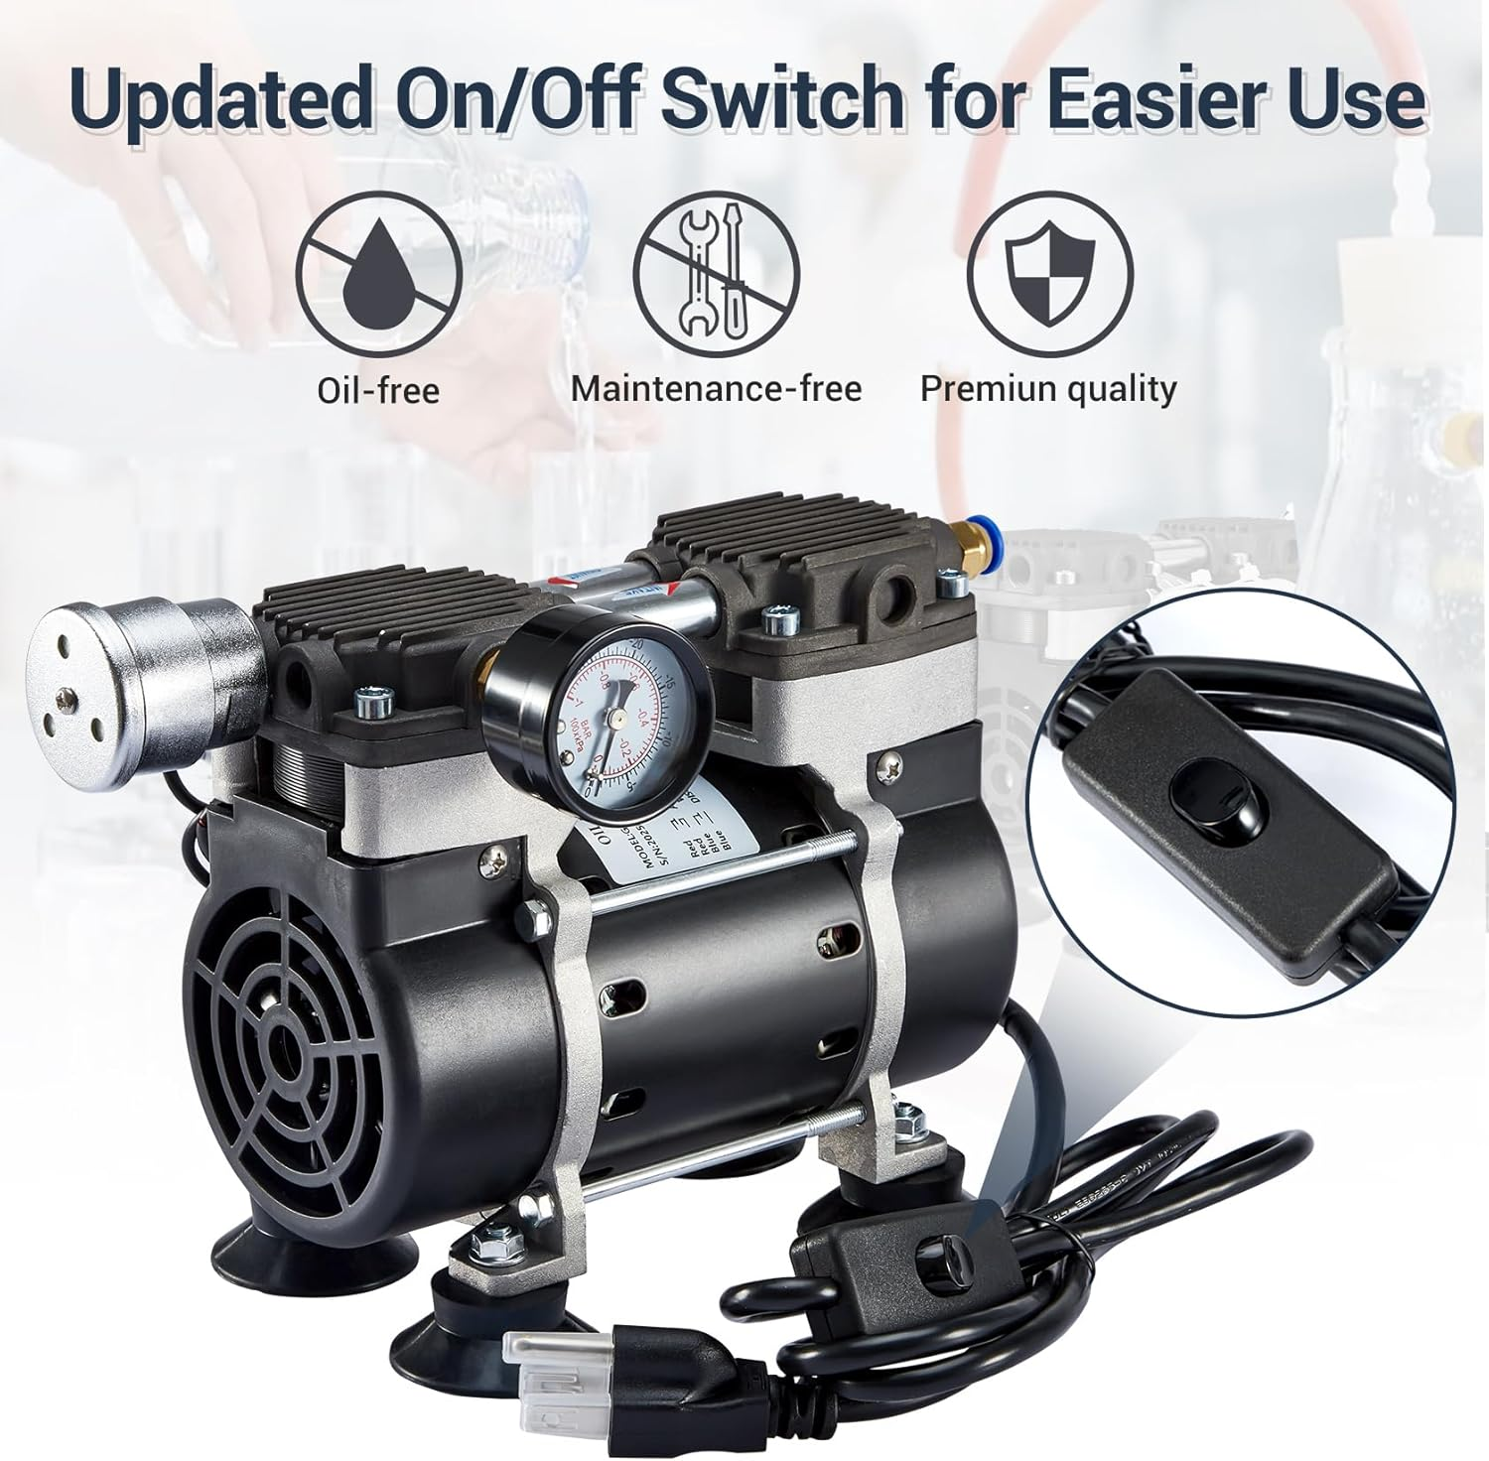
The pump we use with out Vacudog Shelf
Image from Amazon showing where the three accessories (muffler, pressure gauge, and quick connect, are to be connecteds.
Figure 5: One of the pumps recommended by “Got It Made” Youtube channel.

