PCB Design Notes
This document captures the things that I have learned that make the PCB creation process go smoother. I use the Fusion360 electronic design tool, which admittedly has its quirks but it is free and integrates into the CAD/CAM tooling that I use so it’s handy to have them all work together when making my designs.

Work environment setup
- Install Fusion360 (https://www.autodesk.com/ca-en/products/fusion-360/personal)
- Install SnapEDA plugin (https://apps.autodesk.com/FUSION/en/Detail/Index?id=5446990520022318629)

The basic workflow
Note that this workflow assumes that you have installed the SNAPEDA Fusion360 plugin. More details for each step can be added in time as well.

- Collect existing schematics that do what I want to do
- Create a new Github project for your design
- Clone the repo locally
- Go into Fusion360
- In an empty design, under the Utilities tab, click the SnapEDA button.
- Use the SnapEDA tool to search for the components that you need and add them to the SnapEDA fusion component library.
- In Fusion360 create a new design (File, New electronics design)
- Create schematic
- Select PCB copper layer colour
- Add mounting holes
- Go into 3D view and place the parts
- Add text to layer 21.
- Generate BOM
- Generate Gerber ZIP file
- Order PCBs from JLCPCB
- Order components from Digikey

Starting a new design
This ten minute video is a great reminder of the steps to take in creating a new design. https://www.youtube.com/watch?v=3D8WZ7Yq8CY. In short here is how to set about a new circuit design.

- Start Fusion360
- File, new electronics design
- New Schematic
- Click save and name your project
- Find the Frames library and select FRAME_A_L
- Use document/text tool to add text.
- Change added text to go to the Symbol layer (94)
- Start adding components
- Use Display Layers left side tab to turn off Values
- Use Place components left side tab to start placing components

Schematic Tips And Reminders
- Use name property on components
- Use value property on components
- Use name property of a net (wire) to connect things virtually. When asked say yes to add them too the net.
- Check your net lists for mistakes.
- Run the ERC tool in the validation tab of the schematic screen on your design when you think that you are done. Pay attention to “air wire” errors. Even if things look properly connect you may have an island that isolates one connections for a net that will cause your circuit not to work (like the ground plane for example).

Net Lists
It is handy to view your “netlists” to make sure that you have not duplicated or otherwise disconnect component that you intent to all be connected. To view your net lists:
- Go to the schematic screen in the Fusion360 electronic design mode
- Type EXPORT <enter> into the command field in the top tool bar.
- Select netlists from the dropdown menu that appears.
- Save the file to your disk
- View the file with VSCode.

Fusion360 Libraries
After you have done all the work to find part s on DigiKey that you can order that have Fusion360 libraries you can use a Snap Magic Fusion360 plugin to make library management far easier. I find manually creating libraries is tedious and error prone.

You get the SnapMagic plugin here:
https://support.snapmagic.com/en/articles/5015445-how-to-install-autodesk-fusion-360-plugin-on-mac
and follow the instructions to allow the installer to run.

Use it following these instructions:
NOTE – you open a normal design project to access the tool in Utilities. Once you have completed importing all the components for your new design, then go int a new or existing electronics design un the File menu and look for your parts in the SnapMagic library.
https://support.snapmagic.com/en/articles/6162348-how-to-add-parts-into-autodesk-fusion360-using-the-snapmagic-plugin

PCB design considerations
I use JLCPCB to make my boards and they provide the following guidelines I must adhere to in order to ensure that they can manufacture my designs.

2-Layer PCBs

Symbol | Description | Minimum (mm) | Comments
H | Via drill diameter | 0.15
P | Via copper diameter | 0.25
B | BGA pad diameter | 0.25
D | Drill to BGA pad spacing | 0.35 | Solder mask may expand over via if subceeded
S | Trace to trace spacing | 0.10
C | Trace to BGA pad spacing | 0.10 | BGA pad cut back if subceeded
G | Via copper to BGA pad spacing | 0.10 | BGA pad and via both cut back if subceeded
/ | Only one side with openings | Unavailable
/ | Double-sided openings | Unavailable
Advanced BGA Via Hole Epoxy/Copper Filling and Capping Capability

The application of epoxy filling and copper paste makes via-in-pad with filled vias the optimal choice for precise PCB routing. Additionally, JLCPCB has upgraded its equipment for multilayer boards, enabling the production of more precise BGA solder pads.

Capabilities Exceeded with Regular Vias

With minimum trace width (A) and clearance (B) both 0.09 mm, neighbouring pads need 0.27 mm edge-to-edge to allow a trace through the middle. 0.5 mm pitch BGA would have only 0.25 mm edge-to-edge so this layout is not manufacturable.

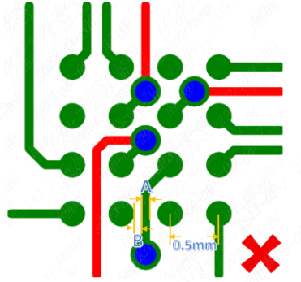

Via-in-Pad with Filled Vias

Optimization plan: Design BGA solder joints with a 0.25mm pitch, incorporating via-in-pad with filled vias in the middle (inner/outer diameter: 0.15/0.25mm). Utilize 0.09mm traces between two through-holes on the inner layers without BGA (as these independent vias do not require solder pads in the inner layers).

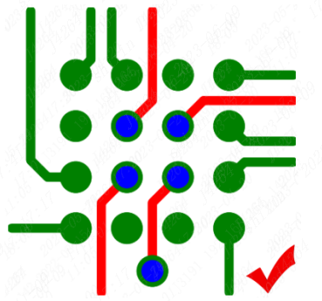

Reminder:
1. For Via-in-Pad with Filled Vias, do not fill them with ink in the middle. Instead, you can use epoxy or copper paste (copper paste has better thermal and electrical conductivity compared to resin). Afterward, ensure the BGA Via-in-Pad with Filled Vias are evenly plated.

2. For Via-in-Pad with Filled Vias process, try to achieve a minimum diameter of 0.2mm or larger for the plated through-hole (inner diameter), and design the solder pad (outer diameter) to be 0.35mm or larger.

3. For a few traces on multilayer boards, it is possible to achieve an ultra-thin width of 0.076mm (equivalent to 3 mil). Whenever possible, design wider traces to be around 0.09mm.

Please keep these considerations in mind for your PCB design.

