Ensuite bathroom maintenance

Refer to this document when the sinks start to drain slowly.

Basic set up
The sink plumbing in our ensuite bathroom was not properly set up and as such, the right hand sink uses the drain in the left hand sink for some of its venting. Figure 1 illustrates the issue.

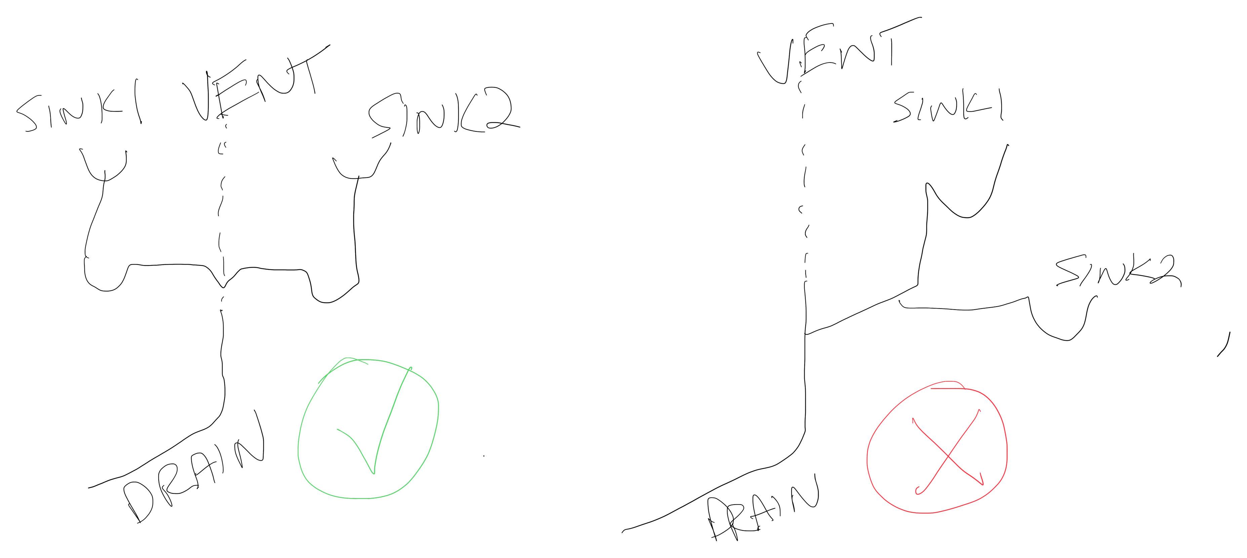Figure 1: Plumbing diagram
The plumbing illustrated on the left shows the correct way to connect two sinks, the drawing on the right show how it was actually installed. This means that once the sinks start to get clogged with hair etc. Then draining on the right sink will get markedly worse when the left sink is in use at the same time.
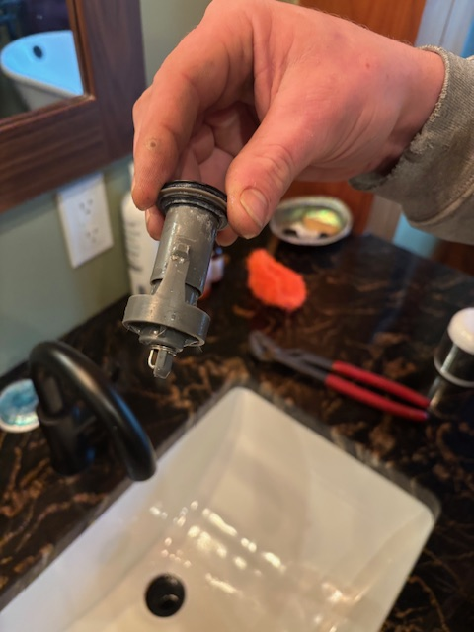Figure 2: Plunger Extracted

Fixing slow draining
In almost all cases, when the water draining starts to slow down simply pull the stopper out of the sink and clean up the gunk hanging off of it. Figure 2 shows a picture of the extracted plunger Most of the time if you slightly twist and pull on the plunger it will come out. If that does not work, unscrew the plunger counter clockwise and use pliers to slightly twist the insert while pulling it out.

Once the plunger is removed clear the gunk and re-insert the fully assembled plunger back into the drain and close/open the plug to properly seat the plunger.

If needed remove the P-Trap of the plumbing under the left hand sink and clean out the pipe between the p-trap and the drain hole in the sink. This procedure is almost always unnecessary. If doing all of the above does not work then a snake may be needed.

Plunger
If you need to use a plunger to try and clear a clog then be sure to stuff a rag into the overflow hole shown in figure 3.
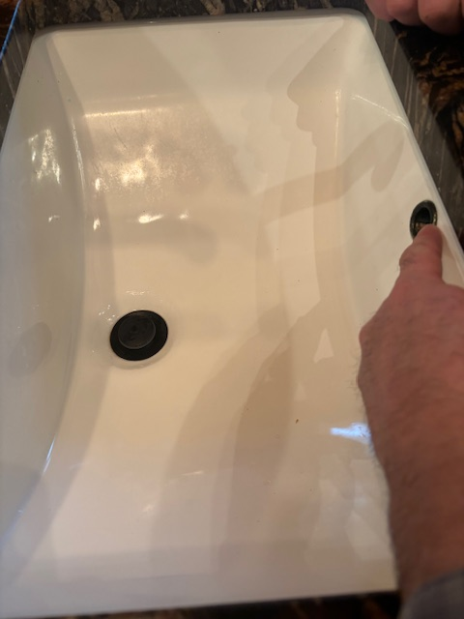Figure 3: Overflow drain

