Separating AC and DC Signals
Experiment Setup

Introduction
This experiment demonstrates how AC and DC can coexist on a single wire (as discussed in our previous conversation) and then be separated using a simple "bias tee" circuit.

The bias tee uses passive components: an inductor (which passes DC but blocks AC) for the DC path, and a capacitor (which passes AC but blocks DC) for the AC path. We'll keep everything low-power and safe: use a function generator to produce the mixed signal (e.g., a 1 kHz sine wave with 1 V peak-to-peak AC and a 5 V DC offset), at voltages well below anything hazardous (like a phone charger level). No high currents or mains power involved.

You'll build this on a breadboard for easy prototyping. The "wires" can be standard copper hookup/jumper wires from the breadboard kit (they're all copper inside). Connect your oscilloscope's two channels to observe: one to the mixed input wire, the other to toggle between the DC and AC outputs to verify separation.

Circuit Diagram
Here's a simple diagram of the bias tee circuit (adapted for your setup). The mixed AC+DC signal enters from the left (from your function generator). The DC output is extracted via the inductor path (wire 2), and the AC output via the capacitor path (wire 3). Grounds are common (connect all grounds together on the breadboard).

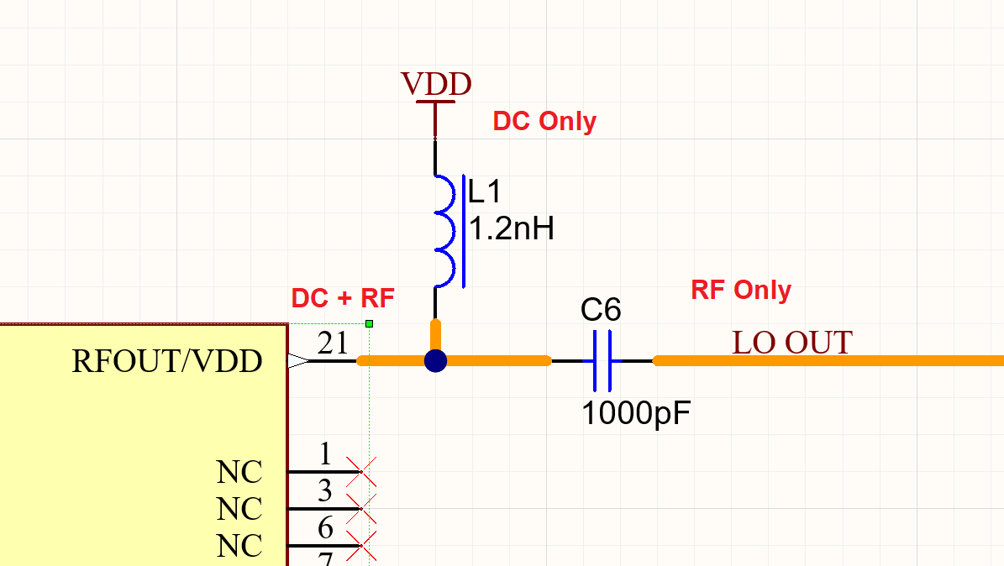Figure 1: Simple 2-input Bias Tee circuit

Step-by-Step Setup Instructions
- Generate the Mixed Signal (Wire 1):
  - Use the function generator to output a sine wave (e.g., frequency 1 kHz, amplitude 0.5 V for 1 Vpp AC) with a DC offset of +5 V.
  - Connect the function generator's output (BNC or terminal) to a jumper wire on the breadboard—this is your "first wire" carrying AC+DC.
  - Ground: Connect the function gen ground to a common ground rail on the breadboard.
- Build the Splitter on the Breadboard:
  - Junction Point: End of wire 1 connects to a breadboard row (call this the input junction).
  - DC Path (Wire 2): From the junction, connect a 10 mH inductor in series to another breadboard point—this is your DC output (wire 2). Optionally, add a 1 kΩ resistor from wire 2 to ground as a load (to simulate measurement without shorting).
  - AC Path (Wire 3): From the junction, connect a 1 µF capacitor in series to another breadboard point—this is your AC output (wire 3). Optionally, add a 1 kΩ resistor from wire 3 to ground as a load.
  - Common Ground: All outputs share the same ground as the input.
- Measurement with Your Scope:
  - Channel 1: Probe the mixed input (wire 1) vs. ground—should show a sine wave riding on +5 V DC.
  - Channel 2: Probe the DC output (wire 2) vs. ground—should show steady ~5 V DC with minimal ripple.
  - Then switch Channel 2 to the AC output (wire 3) vs. ground—should show the ~1 Vpp sine wave centered around 0 V (no DC offset).
  - Use your scope's 200 MHz bandwidth for clear waveforms; set timebase to capture a few cycles (e.g., 1 ms/div for 1 kHz).
- Tips for Success and Safety:
  - Start with low amplitudes (e.g., 1 V AC, 5 V DC) to avoid any component stress.
  - The inductor and capacitor values are chosen for ~1 kHz AC: The inductor's reactance blocks AC (XL ≈ 63 Ω at 1 kHz), while the capacitor blocks DC but passes AC (XC ≈ 159 Ω at 1 kHz). If separation isn't perfect, try adjusting frequency (higher freq improves separation) or values from your kits.
  - Total power is negligible (<10 mW), so no heat or shock risk. Always power off before rewiring.
  - If you see poor separation, add a shunt capacitor (e.g., 10 µF) across the DC output to ground for better AC filtering.

Shopping List
This shopping list assumes that you have a scope. Here's a minimal list of affordable parts. I selected beginner-friendly kits with assortments so you have extras for tweaks/experiments. All links are to Amazon Canada products with good reviews and fast shipping eligibility. Total estimated cost: ~$100-150 CAD, depending on options.

- Function Generator (for safe, low-power mixed AC+DC source): Seesii DDS Function Generator (1 Hz-500 kHz), supports sine waves, DC offset up to ±10 V, and various waveforms. Compact and USB-powered for safety.
  - Link: https://www.amazon.ca/Function-Generator-1HZ500KHZ-Frequency-Sawtooth/dp/B0BJ8XH8LX
- Breadboard Kit with Jumper Wires (for prototyping and copper wires): Organizer Breadboard Jumper Wires Kit (840 pieces, 14 lengths), includes a breadboard and preformed copper jumpers in various colors/lengths—perfect for your "wires."
  - Link: https://www.amazon.ca/Organizer-Preformed-Breadboard-Assorted-Prototyping/dp/B08HCGL6TC
- Capacitor Assortment Kit: Ceramic Capacitor Assortment Kit (1200 pcs, 24 values from 10 pF-10 µF), includes the 1 µF caps you'll need (and extras for filtering).
  - Link: https://www.amazon.ca/Ceramic-Capacitor-Assortment-Kit-Capacitors/dp/B07NRNQP4P
- Inductor Assortment Kit: Inductor Assortment Kit (145 pcs, 12 values from 10 µH-10 mH), includes 10 mH inductors for the DC path.
  - Link: https://www.amazon.ca/Inductor-Assortment-145Pcs-Inductors-Assorted/dp/B0C68MFZRC
- Resistor Assortment Kit (optional but recommended for loads/fine-tuning): 1280 Pieces 64 Values Resistor Kit (1 Ω-10 MΩ, 1/4 W), for adding loads to outputs (e.g., 1 kΩ).
  - Link: https://www.amazon.ca/Resistor-Assorted-Resistors-Assortment-Experiments/dp/B07L851T3V

If you need BNC-to-breadboard adapters for your scope/function gen (if they use BNC), add this: Search Amazon.ca for "BNC to alligator clips" (~$10). Once you get the parts, this should take 15-30 minutes to set up.

