Making Fusion 360 Libraries
Creating Hub libraries from SnapMagic libraries

Written by: The Aging Apprentice and Doug Elliott
Version: 1.0.0
Last Edited: 2026-01-25



Table of Contents
Revision History 3
Introduction 4
About this document 4
Terminology 4
Default Interface 5
Library Creation Interface 6
Process 1 – Importing Individual Private Libraries Into a Fusion Hub Project 7
Step 1: Make a new project to hold your libraries 7
Step 2: Start a new design 8
Step 3: Start a new library 9
Step 4: Import a local library file 10
Step 5: Open Library Manager 11
11
Step 6: Select Local Library 12
Step 7: Import the component 13
Step 7: Save to your Fusion Hub library 14
Step 8: Select the 3D model map 15
Step 9: Save the 3D model map to the Project Hub 16
Step 10: Select local STEP file 17
Step 11: Upload Step file to hub projects 18
Step 12: Insert Hub STEP file into the footprint mapping file 19
Step 13: Position the 3D image 20
Step 14: Save unsaved mapping changes 21
Step 15: Save library to hub 22
Step 16: Confirm Hub Assets 23
Step 17: Confirm Content Manager 24
Step 18: Confirm Component Properties 24
Next steps 25
Process 2 – Creating One Master Library 25
Step 1: Make a new empty library 25
Step 2: Import components from a Hub library 27

Revision History
Date | Author | Change
December 15, 2025 | The Aging Apprentice | Document created
January 4, 2026 | The Aging Apprentice | Corrected many typos and added figures.
January 8, 2026 | The Aging Apprentice | Added missing steps and added more figures, resized screen shots.
January 18, 2026 | Doug Elliott | Added instructions for adding hub component to a hub library in the section titled “Process 2 – Creating One Master Library"
January 18, 2026 | The Aging Apprentice | Added new screen shots and cleaned up the steps for process 1, importing individual private libraries into a Fusion Hub Project.
January 24, 2026 | Doug Elliott | Added Process 2 – Creating one mater library.
January 24, 2026 | The Aging Apprentice | Updated figures in process 1 and corrected missing steps.

Introduction
This document explains the workflow for creating electronics libraries in Fusion360 by first importing Eagle library files (.lbr) from sources such as SnapMagic or Ulralibrarian and creating a single Hub library to be used in your electronics design projects (.flbr) using a two step process. Step 1 involves importing the .lbr files into an individual hub library. Step 2 involves copying the component from the individual hub libraries to a single hub library that is mored easily included in projects and shared with others. This document assumes that you have already located appropriate .lbr and .STEP files and saved them to your local hard drive.

About this document
The process outlined in this document assume that you have already downloaded the appropriate library and associated STEP files from SnapMagic or other such web site. This document was written using this environment:

Fusion 2606.1.22 arm64 [Native]
Active Plan: Personal
macOS 26.2 (25C56) on Mac16,9

Note that the Fusion 2026 1.22 drop came out after the first few versions of this document were written. While it was checked on a Windows 11 machine some figures may differ from what you will see on Windows, or with later releases of Fusion360.

Terminology
An electronics library project is the project “directory” that appears at the top of the data panel of the Fusion360 UI right next to the home icon.
A component appears as a file inside the electronics project. It contains a symbol, a footprint and a 3D model and allows you to manage the mapping between all three items.
A 3D model is a STEP file that is mapped to a component file via the content manager in the electronics component UI.

Default Interface
When you first open Fusion360 you will see the screen shown in figure 1. Match the numbers in figure 1 with the numbered list beside it to understand the main screen layout and UI terminology used in this document.

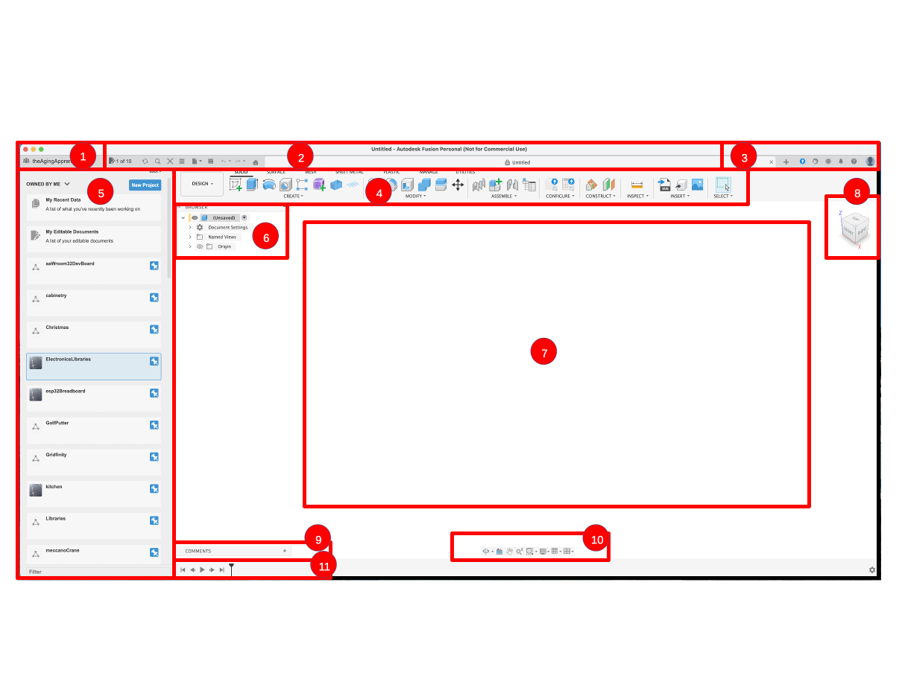Figure 1 - See numbered list to the right for the terms used to explain the standard UI panels and menus
- User Hub Login
- Application Bar
- Profile and Help
- Toolbar
- Data Panel
- ViewCube
- Canvas and Marking Menu
- Navigation Bar and Display Settings
- Timeline

Library Creation Interface
When you first open Fusion360 you will see the screen shown in figure 1. Match the numbers in figure 1 with the numbered list beside it to understand the main screen layout and UI terminology used in this document.

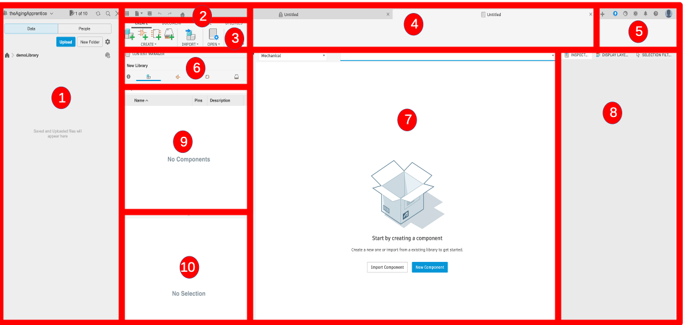Figure 2 - See numbered list to the right for the terms used to explain the library UI panels and menus
- Data Panel
- Application Bar
- Toolbar
- Document Tabs
- Fusion Application controls
- Content Manager
- Component Browser Panel
- Inspector Panel
- Component Browser Panel
- 3D Model Browser

Process 1 – Importing Individual Private Libraries Into a Fusion Hub Project

Step 1: Make a new project to hold your libraries
This step creates a new project into which to place libraries. This is a recommendation from the Autodesk Fusion team so we will take their advice. You only need to do this step once, and all subsequent library work and imports will go into this project.

If you have done this step previously then just navigate into this project folder in your Hub pane and open the library file before moving on to the next step, otherwise

- Navigate to the Home directory by clicking the home icon in the data panel.
- Click the New Project button as shown in Figure 1.
- Type in a project name, in this tutorial we will use the nae demoLibrary.
- Pin this project it so it appears at the top of the project list in the data panel.
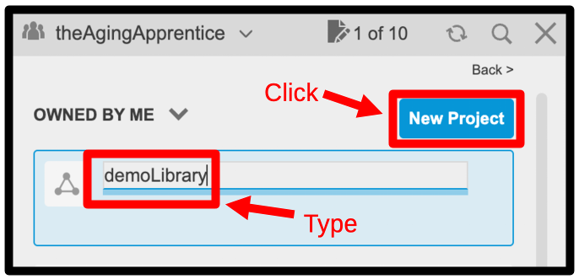Figure 3: Create New Project

Step 2: Start a new design
This step creates a new design document. We will not actually use this design document in the end but we need to open one in order to access the Electronics Library interface. The important artifacts that we are about to create will all be saved into the data panel and will be accessible to us even after this design document is closed.

Either select Design/Electronics/New Electronics Library menu options from the tool bar, or click the new tab (+ icon) button on the application bar as shown in figure 4. In either case a dialog box will appear asking you to specify the type of design you wish to make.

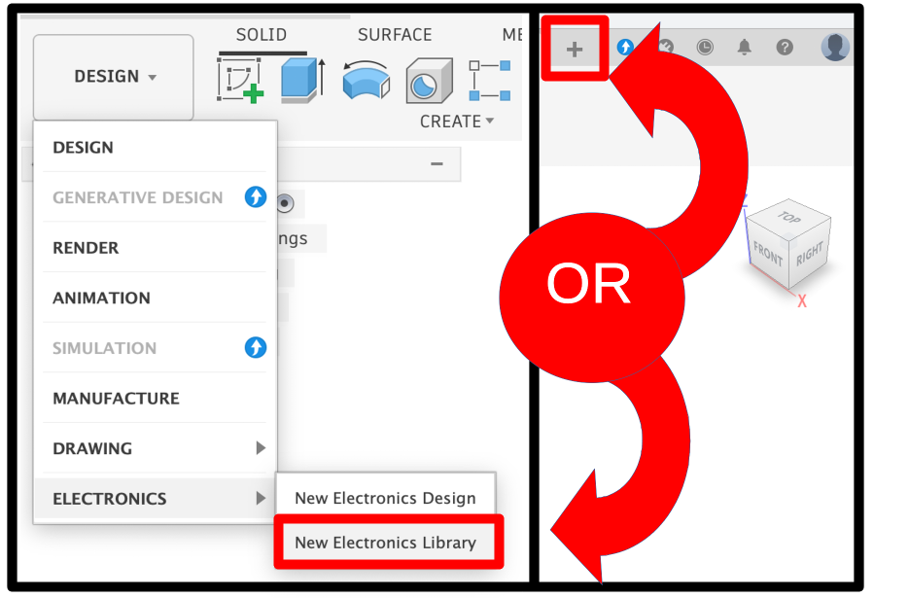Figure 4: Create new design

Step 3: Start a new library
Select the Electronics Library design option then click the Create New button as shown in figure 5.

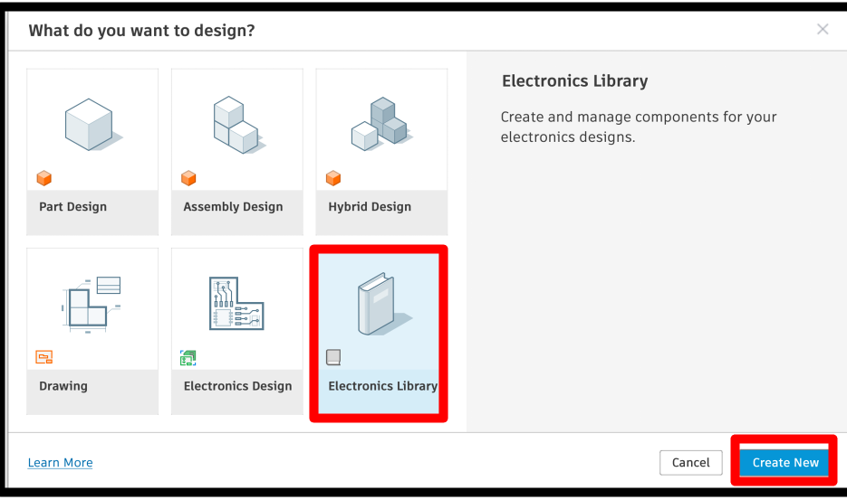Figure 5: Start new library design

Step 4: Import a local library file
This is step where there is an assumption that you have previously found and saved a SnapMagic or UltraLibrary .lbr file for your component to your local hard drive. If you have not done this step then do so now before proceeding.

Click the “Import Component” button in the centre of the “Canvas and Marking Menu” panel (see figure 6).
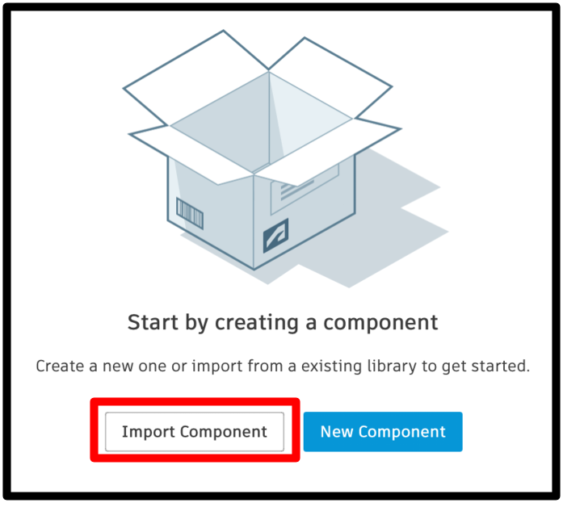Figure 6: Import external library

Step 5: Open Library Manager
Click the “Import from local file” button as shown in the zoomed in image in figure 7. This will present you with a typical file finder dialog box.
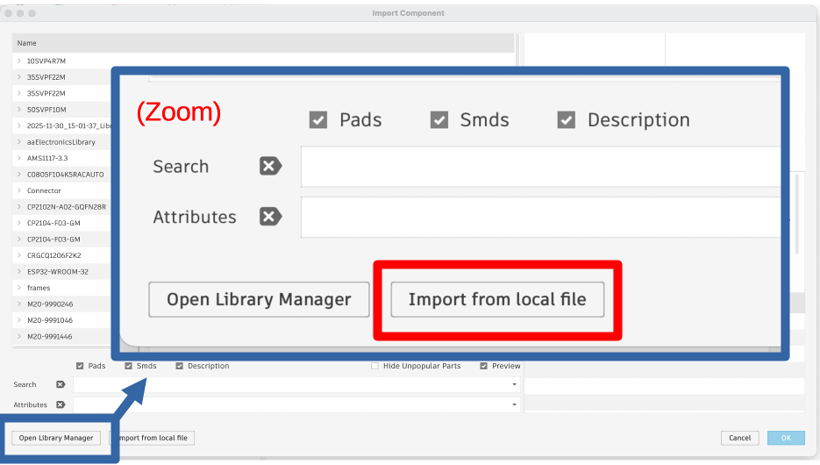Figure 7: Import local library

Step 6: Select Local Library
In the finder navigation dialog, locate the .lbr file that you wish to load from your local hard drive to your Fusion hub library area. Once you have located and selected the library file click the open button as shown in figure 8.

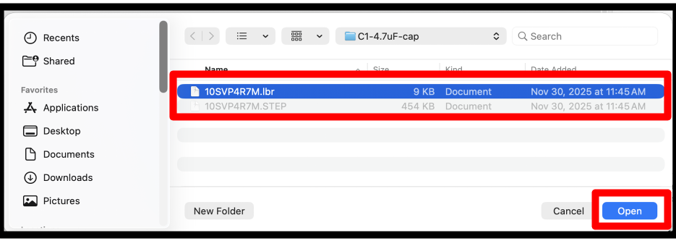Figure 8: Select local library

Step 7: Import the component

Click the “Import from local file” button as shown in the zoomed in image in figure 7. This will present you with a
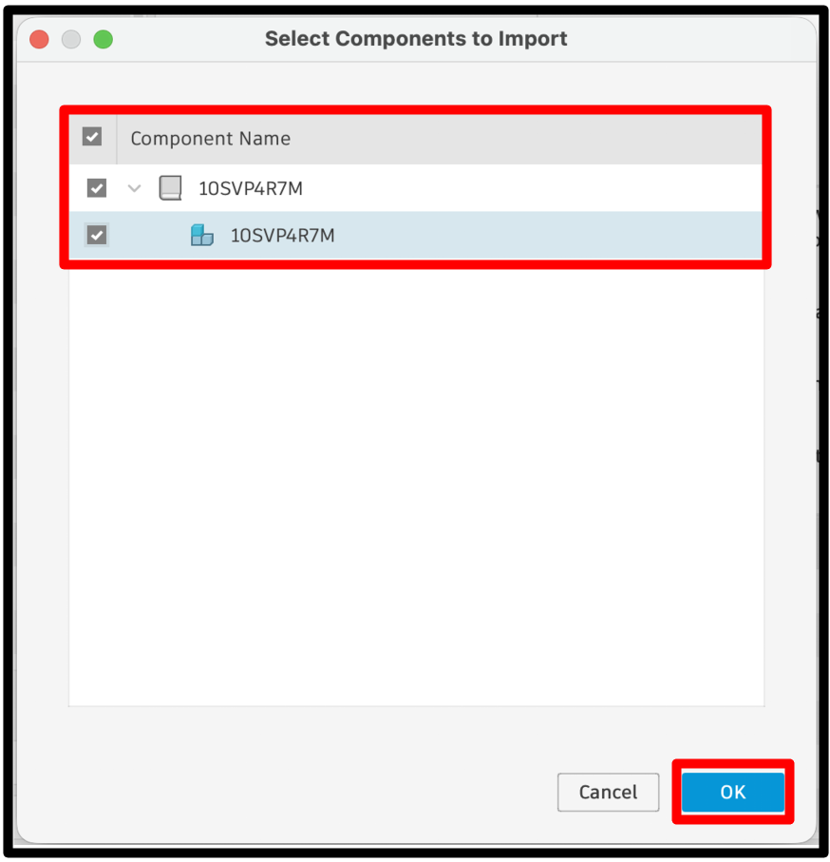

Step 7: Save to your Fusion Hub library
You have now converted a local eagle library into a fusion library and you need to save it to your project hub. You should see the component, containing a symbol and a footprint in the content manager window, as illustrated in figure 9. Click the save icon in the tool bar to save this single component to the hub library. You can use any name you like but I recommend using the same name as the component to make things easier in when you get to process 2 later.

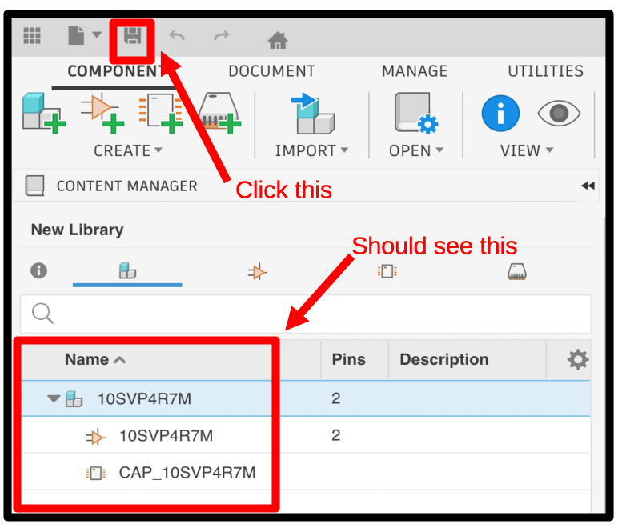Figure 9: Save to library to project hub

Step 8: Select the 3D model map
At this point the hub library that you have created does not include a 3D model for the single component that it contains. To add one start by expanding the component in the Content Manager pane, right clicking on the footprint, and then selecting the “Create New 3D Model” option from the drop down menu as shown in figure 10.
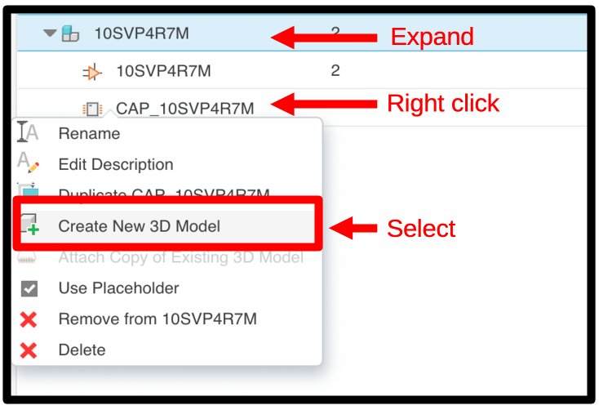Figure 10: Add a 3D model to the project Hub

Step 9: Save the 3D model map to the Project Hub
Next, save the 3D model mapping to the project hub by providing a name for the step file (3D model name), ensuring you are saving the file to the correct hub project, in the case of this tutorial our project is called demoLibrary, and then click the save button as shown in figure 11. You should now see the mapping file in the Hub pane and a footprint map in the component browser panel.

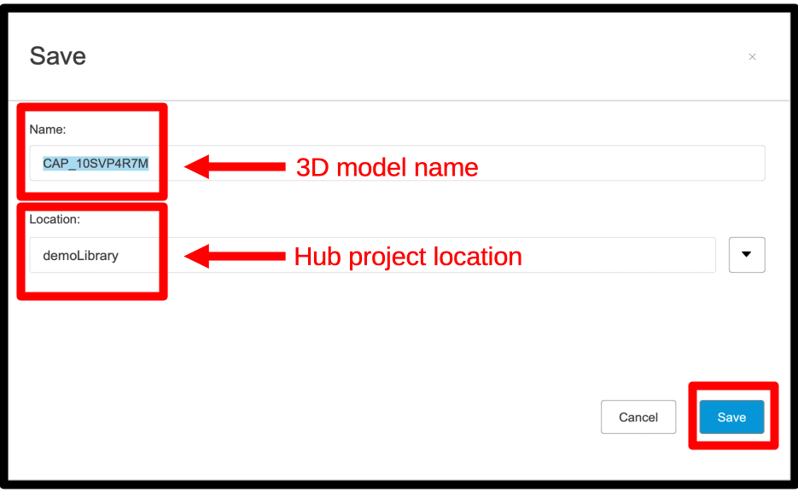Figure 11: Save 3D model to project hub

Step 10: Select local STEP file
This is another step where there is an assumption that you have previously found and saved SnapMagic or UltraLibrary STEP file for this component to your local hard drive. If you have not done this step then do so now before proceeding.

Click the upload button above the data panel as shown in figure 12, then click the Select Files button from the upload dialog box.

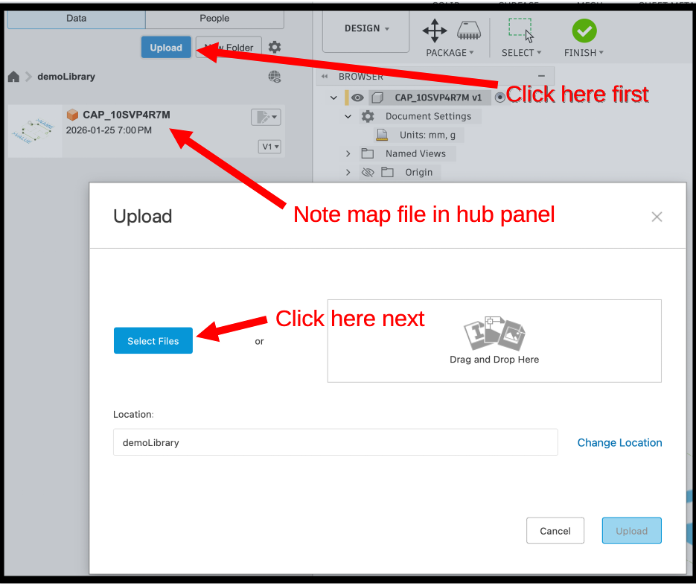Figure 12: Select 3D STEP file from local disk

Step 11: Upload Step file to hub projects

Click the upload button as shown in figure 13 to upload the local STEP file to the Project Hub. It will take a moment for the file to upload but you can watch it loading in the Data pane.
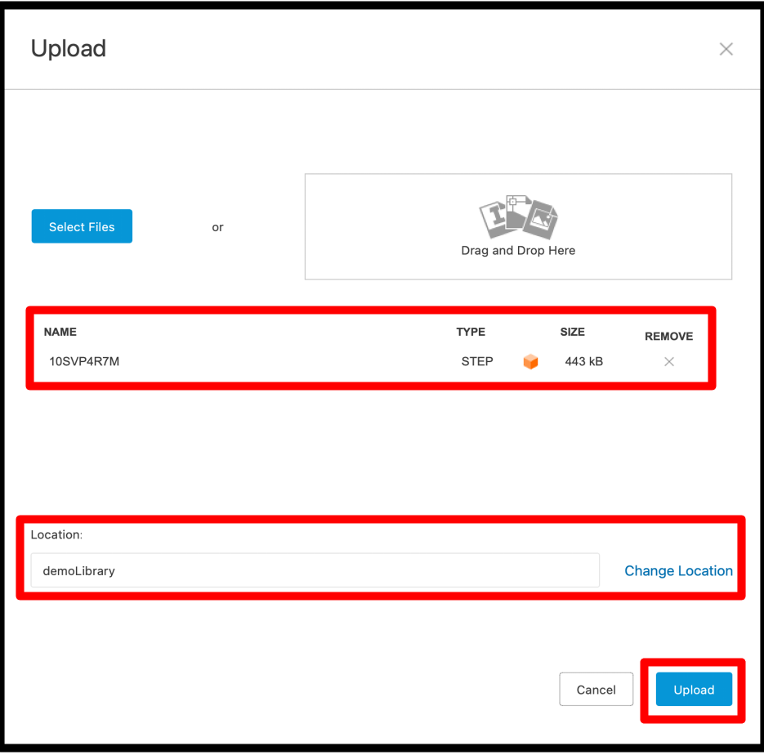Figure 13: Upload STEP file to Project Hub

Step 12: Insert Hub STEP file into the footprint mapping file
At this point you should see the STEP file and the footprint mapping file in the data panel (these are your hub assets) and the foot print of the component in the component browser panel. This is shown in figure 14 (note the image has been altered to better fit into the figure, in reality the foot print image is not overlayed with the data panel). Right-click on the hub STEP file and select the “Insert Into Current Design” option.

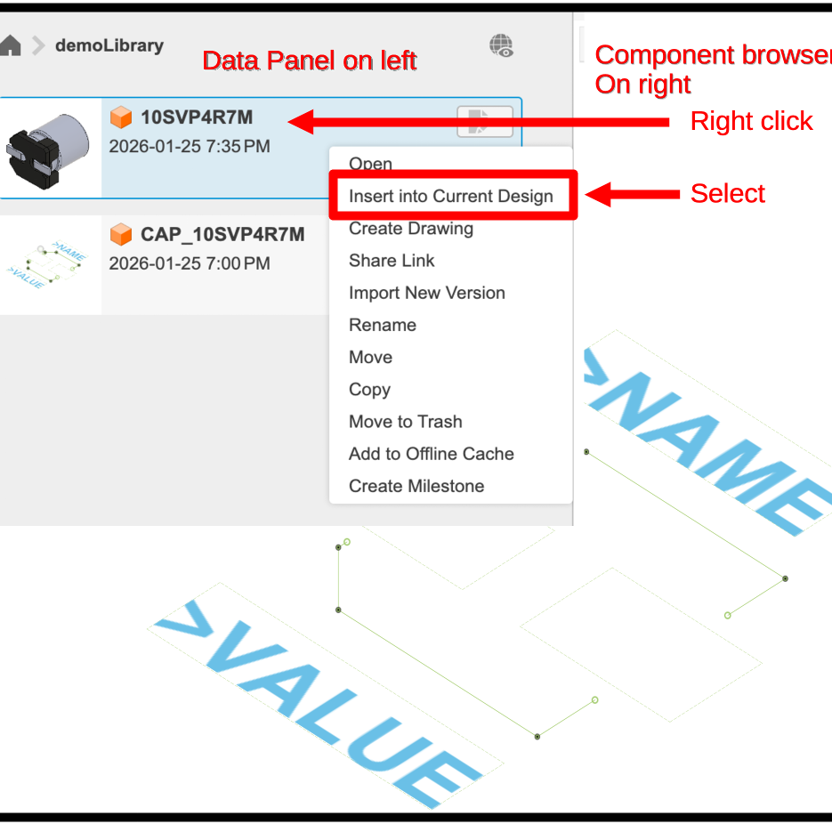Figure 14: Insert Hub STEP file

Step 13: Position the 3D image
Use the controls to orient the 3D image. When done, click the Finish button in the tool bar. This will cause a new dialog box to appear.
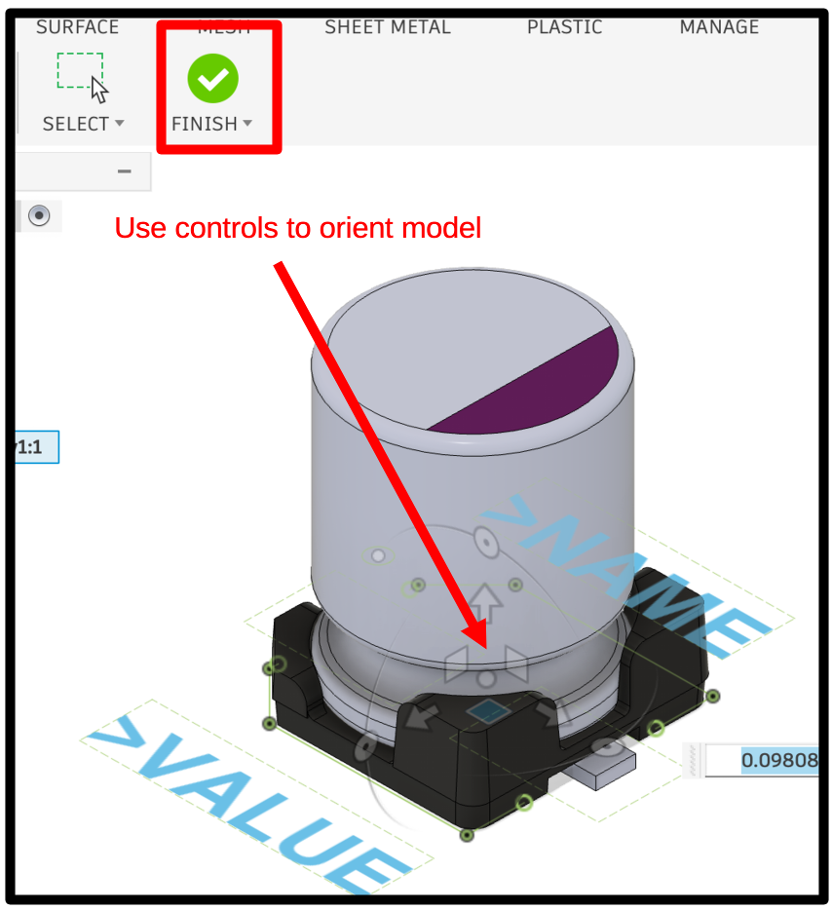Figure 15: Position 3D image

Step 14: Save unsaved mapping changes
When you clicked the finish button in the previous step, a dialog box automatically popped up asking you to save your changes. Click the Save button as shown in figure 16.

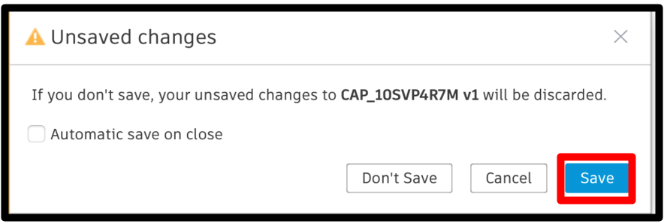Figure 16: Save 3D file to foot print mapping

You will then be presented with a second dialog box that allows you to add meta data for this change, including Version Description and Milestones. For our purposes you can ignore these options and simply click the OK button as shown in figure 17.

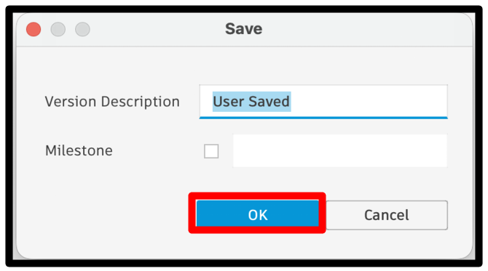Figure 17: Provide meta data if desired

Step 15: Save library to hub
The final step in this process is to save the new hub library to your hub project. Do this by clicking the save button in the tool bar as shown in figure 18. This will cause a save dialog box to pop up.

You can call the library anything you like but I suggest using the same name as the single component inside the library to make the second process coming up easier. Make sure that you save your new hub library to the project that you intend to use as your library. When you have the nae and location sorted click the save button.
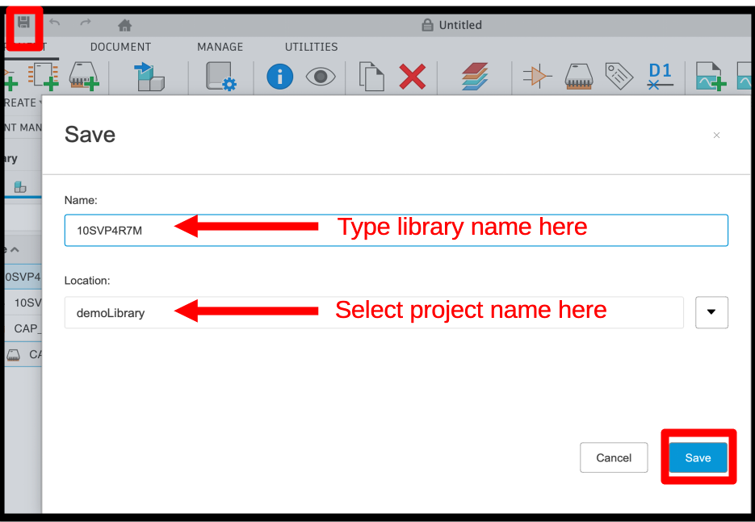Figure 18: Save Library to Hub

Step 16: Confirm Hub Assets
At this point you should see three files in your project hub, a library file, a STEP file, and a package file that maps the 3D model to the component footprint (see figure 19).
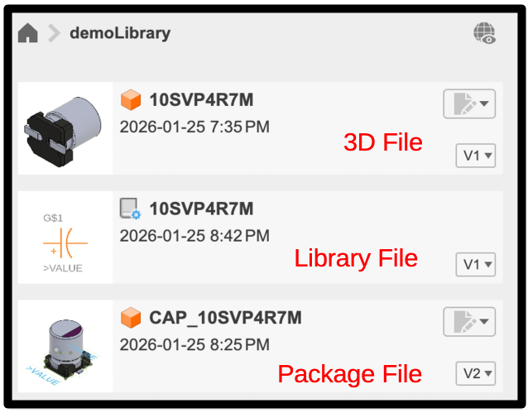Figure 19: Three hub files that make up one Hub Library

Step 17: Confirm Content Manager
You will also see that the Content Manager panel has a single component with a full asset tree including a component that contains a symbol and footprint, and that footprint in turn contains a package (which is the 3D model mapped to a footprint). This is illustrated in figure 20.
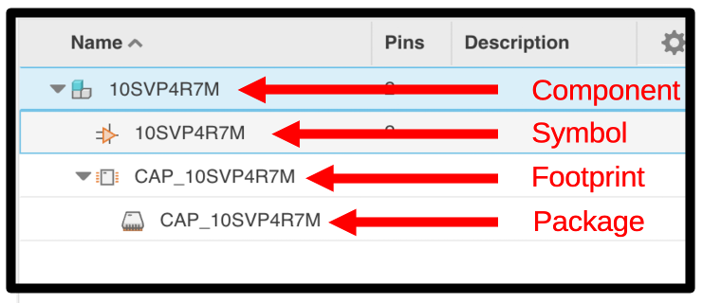Figure 20: Content Manager component tree

Step 18: Confirm Component Properties
Of note, there is a bug in Fusion as of the writing of this document where the 3D image is missing in the package browser window (see figure 21). This issue can easily be remedied by closing the library file and re-opening it.
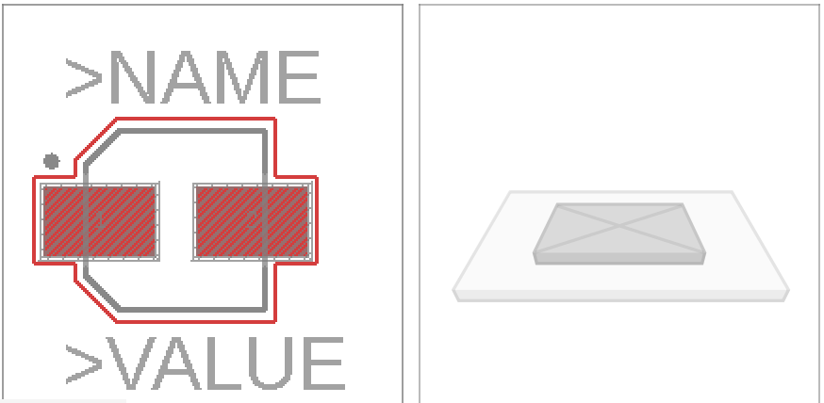Figure 21: Bug shown, 3D image missing in component properties

Next steps
Congratulations, you have now created a component file in your electronics library project that contains the lbr and STEP assets that you got from Snap Magic. This library is referred to as your hub library. Note that Fusion360 now considers the lbr file you downloaded to your hard drive to be the local library. You should ignore your local libraries and use the hub library exclusively in your designs.

You will likely repeat these steps to get all the components that you need for your next electronics design. Once you have all the individual Hub libraries created you may want to create one single master Hub library. The next section details the steps to do just that.

Process 2 – Creating One Master Library
Once you have components in the hub library, even if they are in their own individual libraries, you can import copies of just the completed components into a central library that is simpler to use in your projects.

Step 1: Make a new empty library
This step is only needed once per library. If you haven’t already done this,

- Get to a fresh Fusion360 page with no open tabs
- From the tool bar click the Change Workspace button (says Design on it – see below)
- Scroll down to the Electronics option
- Click on the New Electronics Library sub-option
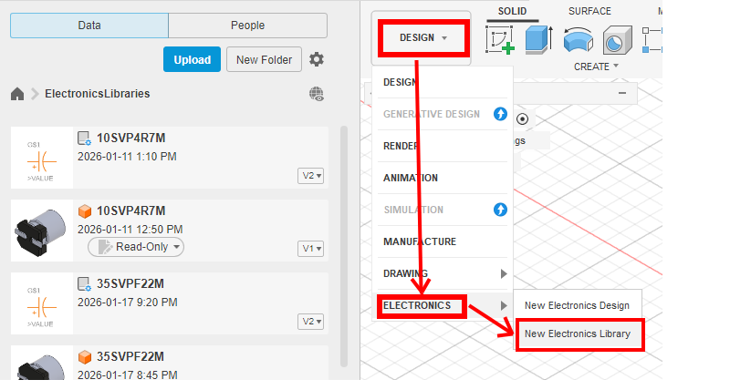Figure 22: New library
- Click the Save icon on the top Application Bar
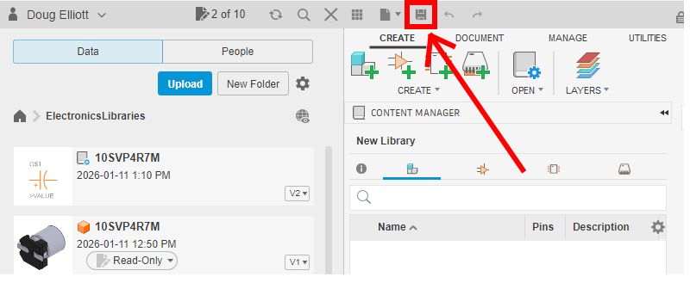
- Fill in the Name of your new central library (i.e. CentralLibForRobot in our example). The name should reflect the project it is being built for.
- Ensure you have selected the right project Location (i.e. ElectronicsLibraries project folder)
- Click the Save button
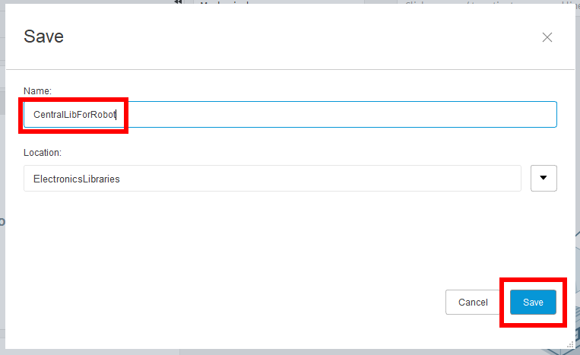
You should now see your new library (CentralLibForRobot in our example) under ElectronicsLibraries in the data panel. We will now add components to this empty library.

Step 2: Import components from a Hub library

If you have been creating components from external sources, you will likely have 3 files for each component:
- An unaligned 3D model, which has, next to its name, a visual image of the component before you aligned it with the footprint
- The aligned 3D model, which has an image of the aligned component and footprint.
- The completed component, which has a schematic symbol next to its name
These may or may not have the same filename, and it’s a good idea to track the filenames as you’re creating components. If you’re not sure which is which, double-click on the files. Only the completed component will show all three sub-components: the schematic, footprint and 3D model.
Repeat the following instructions for each of your components.
- If you haven’t already done it, open the central library by double-clicking on it in the data panel on the left.
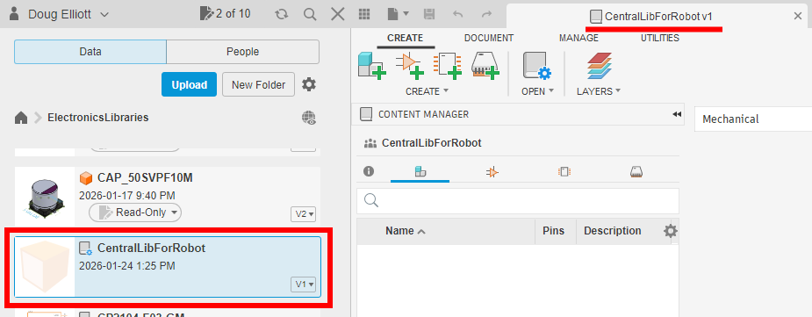
- At the top, click the Add a component symbol which has 3 blocks
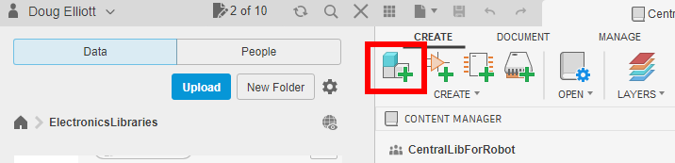
- In the “Add Component” pop up window, click the Import button
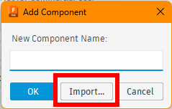

- In the Import Component pop up, double-click on the name of your component. This will display a second level name, which may or may not have the same name
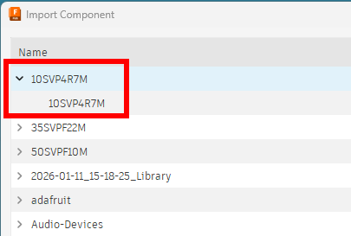
- Click on the second level name, and verify that the symbol, footprint and aligned 3D model appear in the top right corner of the pop up window
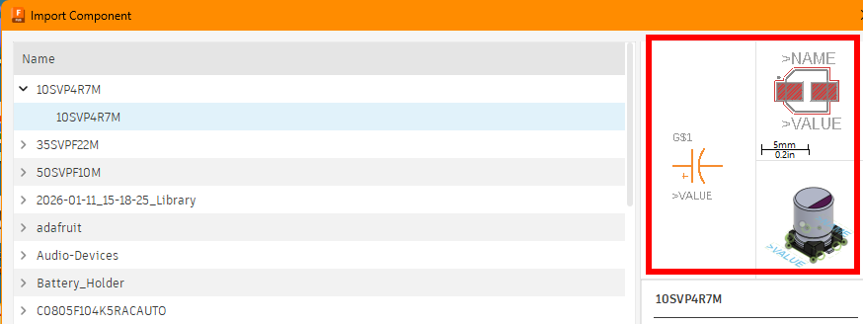
If not, either you selected the wrong component, or it wasn’t constructed properly.
- Double-click on the second level name to insert the component into the central library. The resulting display for the central library in the right panel should display the symbol, footprint, and aligned 3D model
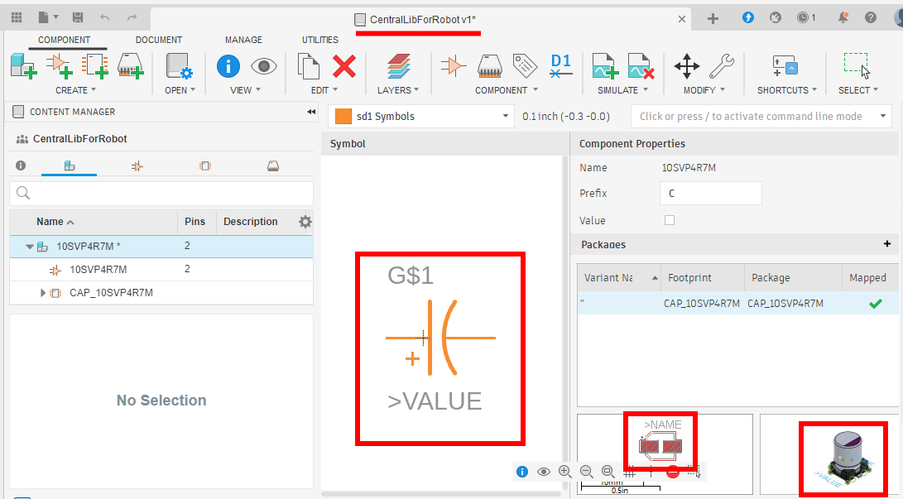
- Click the Save icon in the top menu, and then click OK (may vary for MAC users)
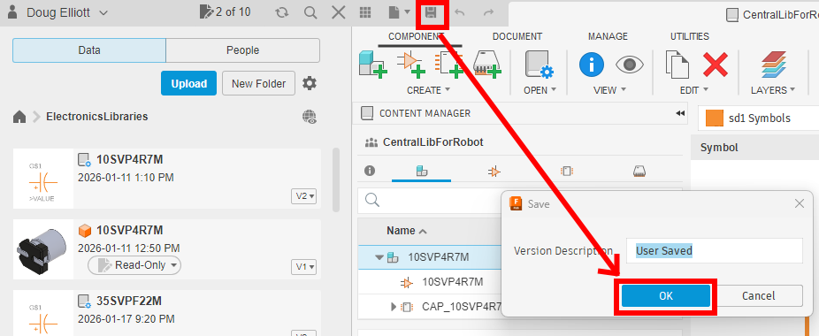
- This component has now been added to your central library. You can now repeat the process for your other components.
Table of Figures
Figure 1 - See numbered list to the right for the terms used to explain the standard UI panels and menus 4
Figure 2 - See numbered list to the right for the terms used to explain the library UI panels and menus 5
Figure 3: Create New Project 6
Figure 4: Create new design 7
Figure 5: Start new library design 8
Figure 6: Import external library 9
Figure 7: Import local library 10
Figure 8: Select local library 11
Figure 9: Save to library to project hub 13
Figure 10: Add a 3D model to the project Hub 14
Figure 11: Save 3D model to project hub 15
Figure 12: Select 3D STEP file from local disk 16
Figure 13: Upload STEP file to Project Hub 17
Figure 14: Insert Hub STEP file 18
Figure 15: Position 3D image 19
Figure 16: Save 3D file to foot print mapping 20
Figure 17: Provide meta data if desired 20
Figure 18: Save Library to Hub 21
Figure 19: Three hub files that make up one Hub Library 22
Figure 20: Content Manager component tree 23
Figure 21: Bug shown, 3D image missing in component properties 23
Figure 22: New library 24

