Adafruit Huzzah32 ESP32 Feather
Pin Mapping for Arduino

The Adafruit ESP32 Feather is a versatile development board featuring 40 digital IO pins. Of these, 16 pins support external interrupts, 16 pins can be used as analog input pins, and 17 pins support Pulse-Width Modulation (PWM). Below is the detailed pinout mapping for the Adafruit ESP32 Feather.

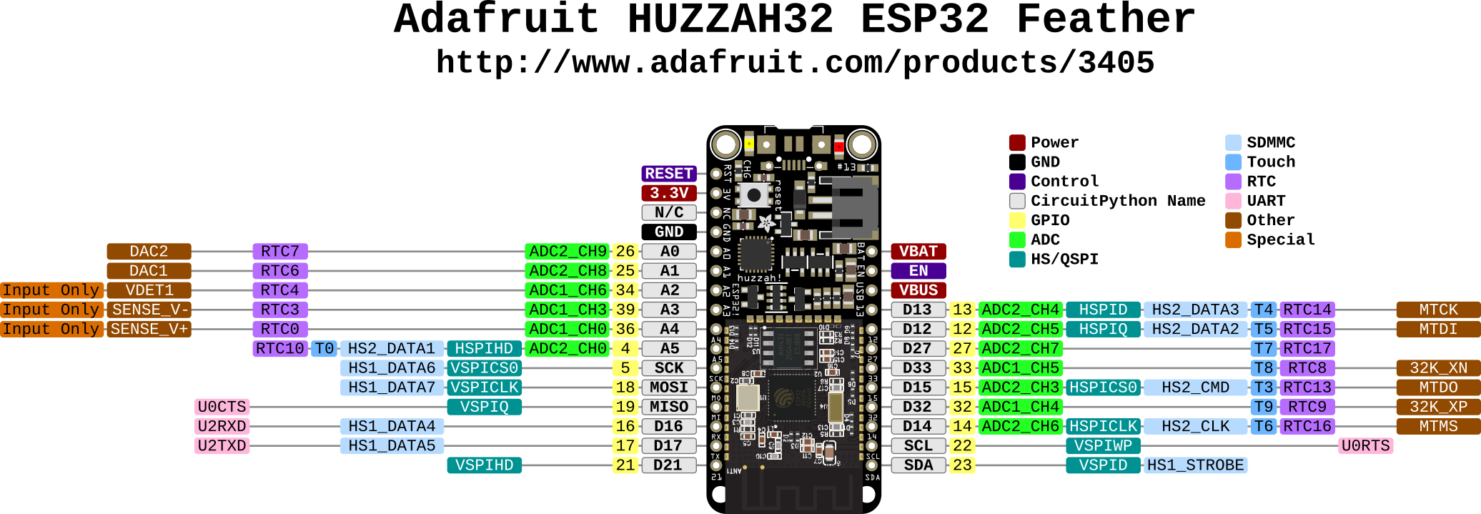

Pinout Table
Pin | Analog | Touch | PWM | Other
4 | A5 | T0 | PWM
5 |  |  | PWM | SCK
12 | A11 | T5 | PWM
13 | A12 | T4 | PWM | LED_BUILTIN
14 | A6 | T6 | PWM
15 | A8 | T3 | PWM
16 |  |  | PWM | RX
17 |  |  | PWM | TX
18 |  |  | PWM | MOSI
19 |  |  | PWM | MISO
22 |  |  | PWM | SCL
23 |  |  | PWM | SDA
25 | A1 |  | PWM | DAC1
26 | A0 |  | PWM | DAC2
27 | A10 | T7 | PWM
32 | A7 | T9 | PWM
33 | A9 | T8 | PWM | SS
34 | A2
35 | A13 |  |  | BATT_MONITOR
36 | A4
39 | A3

Pin Function Descriptions
- Analog: Pins that can be used as analog input pins.
- Touch: Pins that support touch input functionality.
- PWM: Pins that support Pulse-Width Modulation.
- Other: Additional functions such as:
  - RX / TX: Receive and Transmit pins for serial communication.
  - LED_BUILTIN: Pin connected to the built-in LED.
  - SCK, MOSI, MISO: SPI communication pins.
  - SCL, SDA: I2C communication pins.
  - DAC1, DAC2: Digital-to-Analog Converter pins.
  - SS: Slave Select pin for SPI.
  - BATT_MONITOR: Battery voltage monitoring pin.

