Meccano Crane V1.0 2025
Doug McGregor’s fun project
Documentation Version 1.0

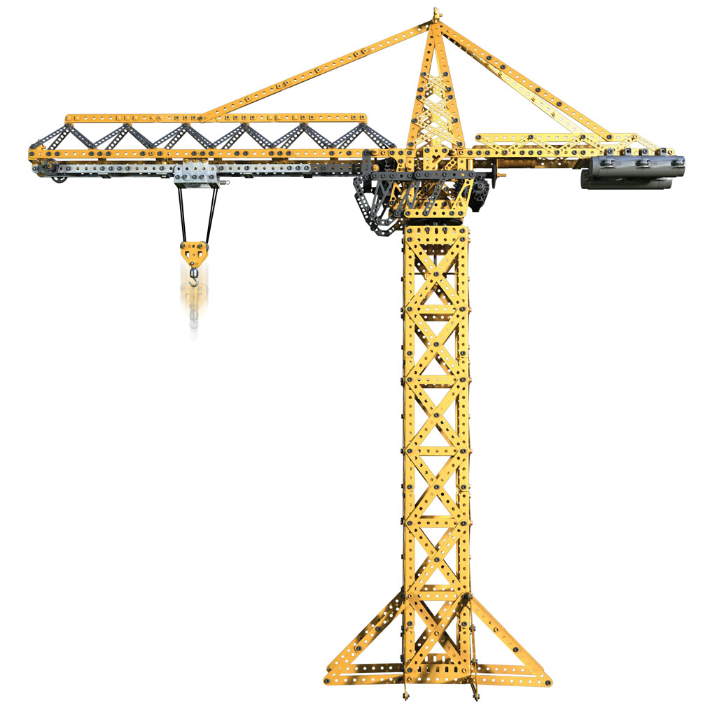



http://theagingapprentice.com

Contents
Introduction 3
Crane Chassis 3
Crane Drive System 3
Crane Control System 4
Base Station 4
Crane Remote Control 4
Developer Notes 5

Introduction
This document is a reference manual for the Meccano crane built by Doug McGregor. All the build details for this project are contained here, including the crane chassis, the drive system, the crane control system, and the operator remote control.

Crane Chassis
Put the details about the chassis here.

Crane Drive System
The crane’s 3DOF are driven by 3 Meccano universal motors. The first motor is the ER20 motor pictured in figure 1. Put details about the motors and gearing here.
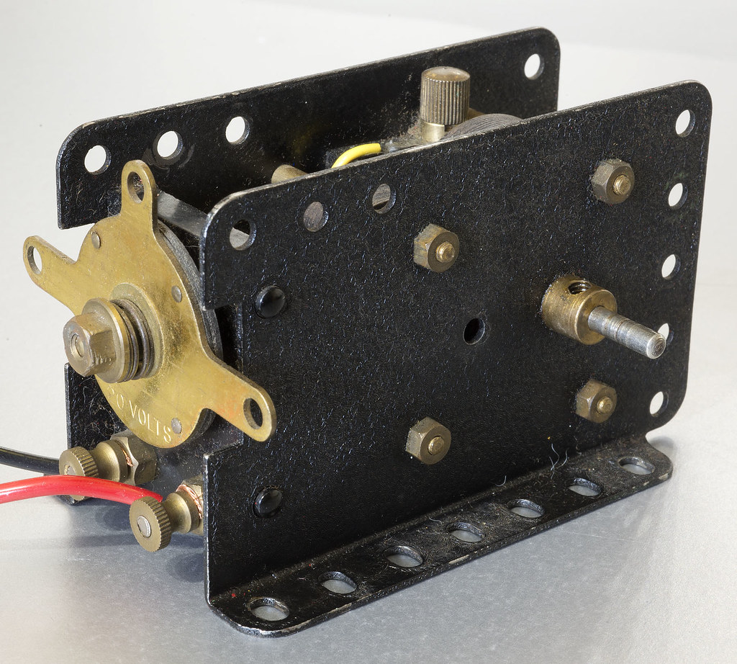

Crane Control System
The crane control system is made of two components, the base station and the remote control.

Base Station
Details about the base system.

Crane Remote Control
aaaa

Developer Notes
For now there is no custom board definition for the Arduino or PlatformIO IDEs for this board. Instead you can use the generic ESP32 board file. The Platformio.ini file can be set up as follows:

[env:esp32]
platform = espressif32
board = esp32dev ;featheresp32
framework = arduino
monitor_speed = 115200
upload_port = /dev/cu.usbserial-B00464MX
monitor_port = /dev/cu.usbserial-B00464MX
build_flags =
-D UART_SPEED=115200
-D MQTT_SERVER=\"192.168.2.21\"
-D MQTT_PORT=1883
-D MQTT_USER=\"\"
-D MQTT_PASSWORD=\"\"
-D LOG_TARGET=2 ; 0=No logging, 1=Serial only, 2=Serial & MQTT, 3=MQTT only
-D DEVICE_TYPE=\"GENERIC\"
-D KEEP_ALIVE=1000
-D BUILD_VERSION=\"1.0.0\"
lib_deps =
knolleary/PubSubClient@^2.8
arkhipenko/TaskScheduler@^3.8.5
bblanchon/ArduinoJson@^7.2.1

