Type or paste the title of the work here

**by**  
**[Firstname Lastname]**

[Previous degree, institution, YEAR]  
[Previous degree, institution, YEAR – if more than one list in descending order]

[Thesis/Project/Extended Essays] Submitted in Partial Fulfillment of the  
Requirements for the Degree of  
[Master of…/Doctor of…]

in the  
[School/Department of …]  
[Faculty of …]

© [Firstname Lastname] YEAR  
SIMON FRASER UNIVERSITY  
[Term YEAR]

Copyright in this work is held by the author. Please ensure that any reproduction   
or re-use is done in accordance with the relevant national copyright legislation.

Declaration of Committee

|  |  |  |
| --- | --- | --- |
| **Name:** | **[Firstname Lastname]** | |
| **Degree:** | **[Master of …/Doctor of …]** | |
| **Title:** | **Type or paste the title of the work here** | |
| **Committee:** | **Chair:** | **[Firstname Lastname]** [Academic Role, Academic Unit] |
|  | **[Firstname Lastname]** Supervisor [Academic Role, Academic Unit] | |
|  | **[Firstname Lastname]** Committee Member [Academic Role, Academic Unit] | |
|  | **[Firstname Lastname]** Committee Member [Academic Role, Academic Unit] | |
|  | **[Firstname Lastname]** Committee Member [Academic Role, Academic Unit] | |
|  | **[Firstname Lastname]** Committee Member [Academic Role, Academic Unit] | |
|  | **[Firstname Lastname]** Examiner [Academic Role, Academic Unit] | |
|  | **[Firstname Lastname]** External Examiner  [Academic or Professional Role, Academic Unit] [Institution] | |

Please review the Declaration of Committee page instructions on the library’s thesis website before completing this page:   
[**https://www.lib.sfu.ca/help/publish/thesis/format/declaration-committee**](https://www.lib.sfu.ca/help/publish/thesis/format/declaration-committee)

Remember to delete this note before submission.

Ethics Statement

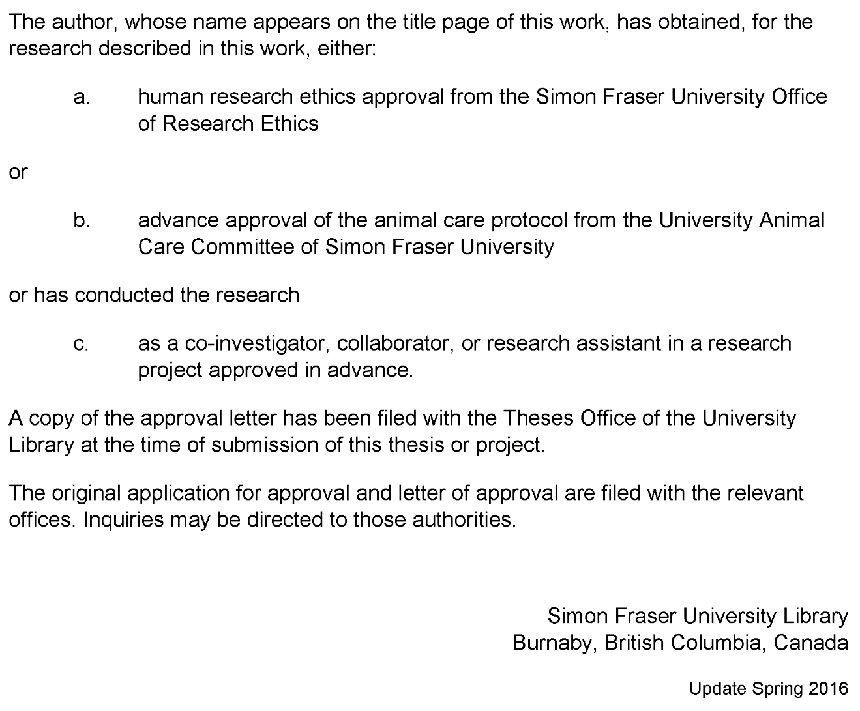

This page must appear as p. iii if your research required ethics approval. Remember to delete this note before submission.

If an ethics exemption was granted, this page must be removed.

If ethics approval was not required, this page must be removed.

Remember to update the Table of Contents after removing this page.

Abstract

Abstract paragraphs should be unindented: use the style **1_Para_FlushLeft.** Master’s abstracts are limited to 150 words; the limit is 350 words for doctoral abstracts. Abstract text must fit on a single page. Keywords may appear alone on a second page.

You may include up to six keywords or phrases. Keywords should be separated with semicolons.

**Keywords**: thesis template; Microsoft Word; keywords; 1” hanging indent; instructions

Dedication

This is an optional page. Use your choice of paragraph style for text on this page (**1_Para_FlushLeft** shown here).

To hide the heading at the top of this page, select the text and change the text colour to white.

Acknowledgements

This is an optional page. Use your choice of paragraph style for text on this page (**1_Para** shown here).

Table of Contents

Declaration of Committee ii

Ethics Statement iii

Abstract iv

Dedication v

Acknowledgements vi

Table of Contents vii

List of Tables viii

List of Figures ix

List of Acronyms x

Glossary xi

Preface/Executive Summary/Image xii

Chapter 1. Introduction 1

References 2

Appendix A. An Example of an Appendix 3

List of Tables

**No table of figures entries found.**

Use References>Insert Caption to create caption labels and numbers. Right-click on the text above and select Update Field to update this list. See the Thesis Template Instructions for information on creating tables, figures, and captions.

Remember to delete this note before submission.

If there are no tables in the document, remove this page.

List of Figures

**No table of figures entries found.**

Use References>Insert Caption to create caption labels and numbers. Right-click on the text above and select Update Field to update this list. See the Thesis Template Instructions for information on creating tables, figures, and captions.

Remember to delete this note before submission.

If there are no figures in the document, remove this page.

List of Acronyms

|  |  |
| --- | --- |
| SFU | Simon Fraser University |
| LAC | Library and Archives Canada |
|  | This is an optional page and can be removed if not used. |
|  | Use one table row for each item to allow sorting using Word’s table tools. |
|  | Apply the style **1_Para_NoSpace** to table rows as shown here. |
|  |  |
|  |  |

Glossary

|  |  |
| --- | --- |
| Thesis | An extended research paper that is part of the final exam process for a graduate degree. The document may also be classified as a project or collection of extended essays. |
| Glossary | An alphabetical list of key terms |
|  | This is an optional page and can be removed if not used. |
|  | Use one table row for each item to allow sorting using Word’s table tools. |
|  | Apply the style **1_Para_NoSpace** to table rows as shown here. |
|  |  |

Preface/Executive Summary/Image

This page can be used for a Preface, Executive Summary, or introductory image. This is an optional page and can be deleted if not used.

To hide the heading at the top of this page – e.g., if using an introductory image – select the text and change the text colour to white.

Do not delete the section break that follows this paragraph. If the section break is not visible, turn on non-printing characters using the Show/Hide icon (¶) on the Home ribbon.

# Introduction

References

Adams, Alice. (2002). Article Titles : A Qualitative and Quantitative Analysis. *Journal of Journal Studies, 23,* 189-672. doi:10.1015/0032-002X.56.7.893

Brown, Bob. (2010). *Books: Sustainable and Biodegradable Reading Technology.* New York, NY: Hydraulic Press. doi:10.1026/0022-005X.52.6.803

Carroll, Carol. (1999, July). Curating Curious Collections: An Interdisciplinary Perspective. *Predatory Publishing Quarterly, 16* (5)*,* 3-134.

Appendix A.  
  
An Example of an Appendix

Note: If you have figures or table in your appendices, do not include them in your List of Figures or List of Tables.

Number your figures and tables with the appendix letter e.g. Table A.1. (for the first table in Appendix A) or Figure B.2. (for the second figure in Appendix B).

Remember to delete this note before submission.