SC2002 Object-Oriented Design and Programming
Group Assignment Report · AY2026/27 Semester 1

Restaurant Rush
A turn-based restaurant management game for the command line, written in Java and built in three tagged stages.
Lab group | SCMA, Group 3
Members | CCDS LEE SHENG KAI  CCDS LEONG XUAN HAO  CCDS POLOYAPOY RON JOSHUA ABES (Apollo)  CCDS VICTORIA HAUGAA
Repository | https://github.com/theApolloAlien/restaurant-rush
Stage tags | stage-1, stage-2, stage-3
Build | Java 17 or newer, no external libraries. Run ./run.sh (or run.bat on Windows).

Contents
1 Overview
2 UML class diagram (final design, Stage 3)
3 UML sequence diagram
4 Design discussion
5 How the player's choices change the result
6 Development process and stage comparisons
7 Functional evidence
8 Rule interpretations
9 Reflection and contributions

1 Overview
In Restaurant Rush the player is the restaurant manager. Each turn they tell the Host, Waiter and Chef what to do, and the Cashier collects payment automatically. With one of each and only two tables, there is never enough staff time, so every turn comes down to the same question: who do we look after first?

Base setting
- 18 turns, 2 tables, no early ending
- Waiter, Chef and Cashier, one task each per turn (Stage 3 adds a Host)
- One arrival on turns 1, 4, 7, 10, 13 and 16
- Salad $9 (1 unit), Burger $15 (1), Pasta $18 (2)
- Win: at least 4 paid, $45 revenue and an average satisfaction of 60

Running it
./run.sh # build and play
./run.sh --script scripts/stage3-victory.txt
./run.sh --plain # no colour, ASCII only
./test.sh # 22 rule checks
git checkout stage-1 # then ./build.sh
After checking out a tag, run ./build.sh before ./run.sh, because the jar is not tracked by git. On Windows, run.bat and test.bat always recompile. Only a JDK is needed, with no build tool and no network access.

What happens in one turn
Step | What happens | Where the rule lives
0 | Start-of-turn display | Dashboard shows the turn, revenue, average, queue, tables, satisfaction, order status, available staff tasks and Happy Hour status
1 | Arrivals | Game.beginTurn asks ArrivalSchedule.arrivingOn(turn), then calls Restaurant.admit
2 | Manager choices | ConsoleUI reads one command per staff member; DirectedStaff.perform checks it (Host, then Waiter, then Chef)
3 | Kitchen and serving | Order.prepareUnit marks the order READY on its last unit; Order.serve only accepts a dish that was READY before this turn
4 | Eating and payment | Customer.finishEating, then Cashier.collectPayment (one per turn, oldest first)
5 | Waiting and abandonment | Customer.loseSatisfaction (rate depends on the customer type) and Restaurant.depart at 0
6 | Result after turn 18 | Objective.evaluate(Scoreboard) returns a GameResult

The three stages
Tag | Adds | Base-setting customers | Rule checks
stage-1 | Regular customers, menu, Waiter, Chef, Cashier, full turn sequence, both endings | 6 Regular | 12
stage-2 | VIPCustomer and CriticCustomer | Critic on turn 4, VIP on turn 7, 4 Regular | 16
stage-3 | Host, ComboMeal and Happy Hour | Same as Stage 2 | 22

2 UML class diagram (final design, Stage 3)
Drawn from the code at tag stage-3. Getters, toString(), most constructors and most private helpers are left out, and «record» components are shown as read-only properties. Editable version: docs/diagrams/class-diagram.drawio.
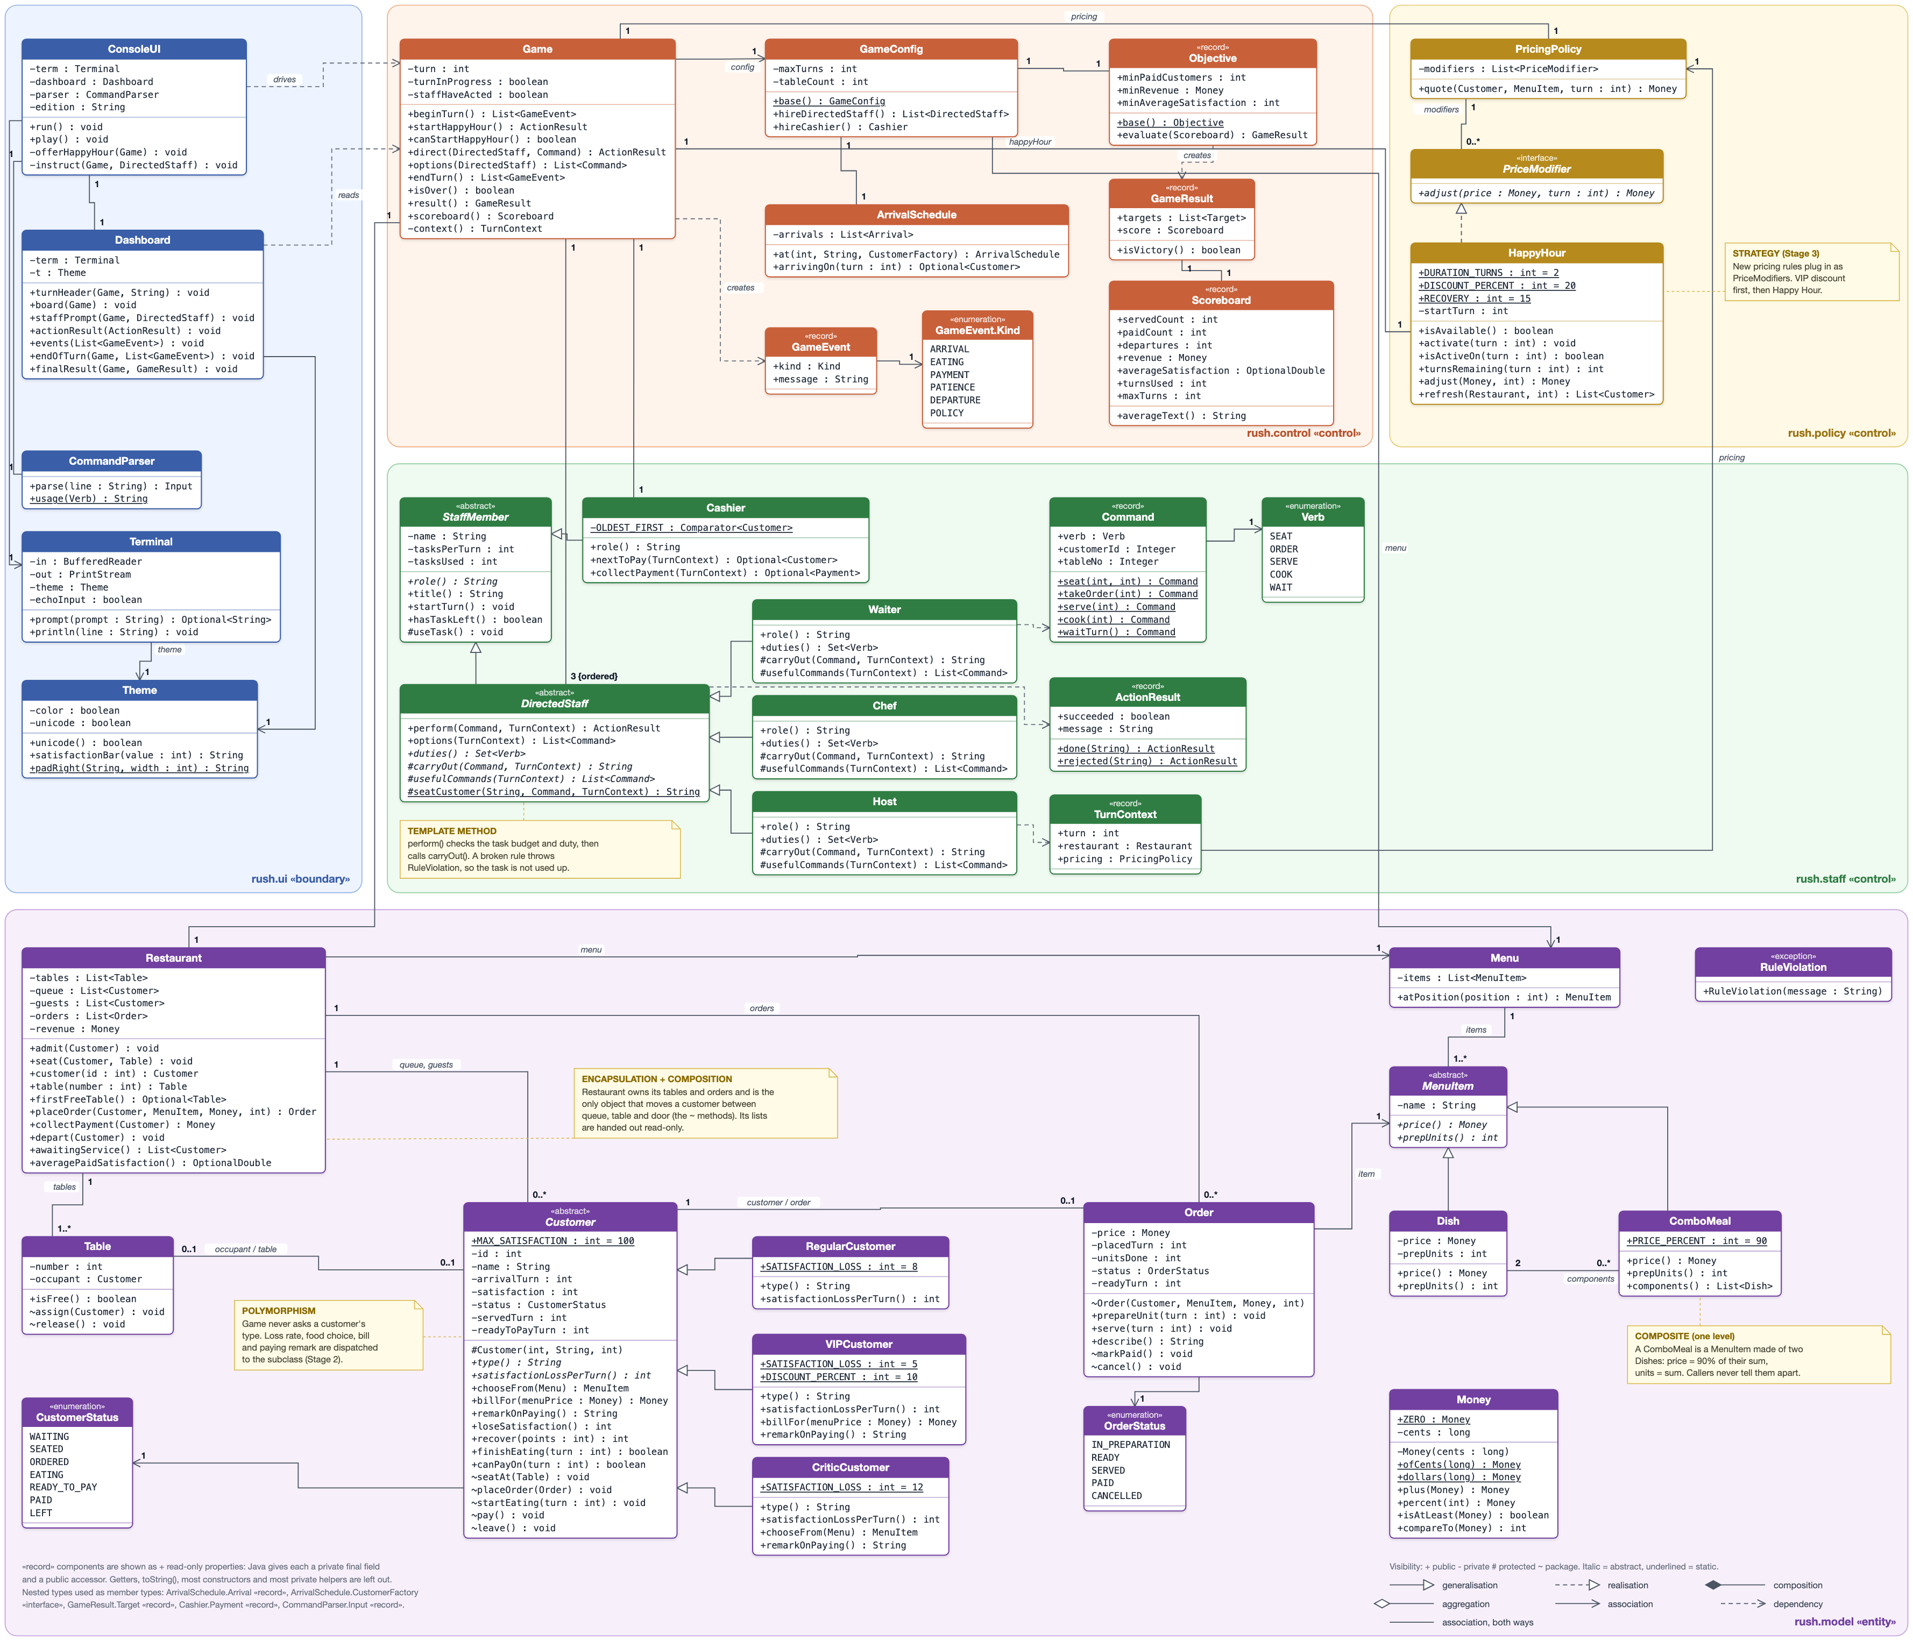

2.1 Reading the class diagram

Encapsulation
Money is immutable and stores integer cents, so prices add up exactly and each discount is rounded once. Restaurant is the only class that moves a customer between the queue, a table and the door: Customer.seatAt, placeOrder, startEating, pay and leave, and Table.assign and release, are package-private (~). The few public methods that change state (finishEating, loseSatisfaction, recover, Order.prepareUnit and serve) check the current status first. Every list is handed out read-only, and the UI only gives commands to Game.

Polymorphism
Customer owns the visit life cycle. The subclasses only override satisfactionLossPerTurn(), chooseFrom(Menu), billFor(Money) and remarkOnPaying(), plus the type() label, and Game, Waiter and Cashier never check a customer's type. In the same way, Dish and ComboMeal answer price() and prepUnits() differently, while Order and Chef treat them the same.

Composition and aggregation
Game owns its restaurant, staff, Happy Hour and pricing policy, which exist only for one game. Restaurant owns its two tables and its orders. Customers arrive from outside, so Restaurant only aggregates them. A ComboMeal aggregates two Dish objects that are also on the menu by themselves.

Inheritance
StaffMember holds the per-turn task budget. DirectedStaff adds the template method perform(), and Waiter, Chef and Host fill in duties() and carryOut(). The Cashier takes no instructions, so it extends StaffMember directly. HappyHour implements the PriceModifier interface.
The packages form layers, and dependencies only point one way: ui reads input and draws the screen, control runs the turn sequence, staff decides what each role may do, policy holds the pricing rules, and model holds the entities and their rules. The small records (Command, ActionResult, TurnContext, Objective, Scoreboard, GameResult, GameEvent) are immutable value objects.

3 UML sequence diagram
The scenario comes from the Stage 3 victory run (scripts/stage3-victory.txt). It follows VIP customer #3 Chloe from her arrival on turn 7 to her payment on turn 11, and then the result check after turn 18. It is drawn in six parts so that it stays readable when printed. The message numbers carry on from one part to the next, and the table below refers to them.
Required element | Where to find it
Customer arrival and order | Part 1, messages 1–7 (arrivingOn, «create», admit); part 2, 27–44 (chooseFrom, quote, placeOrder, «create» Order)
Waiter and Chef assignments | Host 18–26; Waiter 27–44 and 70–82; Chef 45–51 and 60–66. Every instruction goes through Game.direct and the template method perform, which calls carryOut
READY then SERVED | Part 3: prepareUnit(8) makes the order READY (64). Part 4: serve(9) (75) succeeds only if status == READY and readyTurn < turn, otherwise it is rejected and the task is not used (76–82)
Eating and payment | Part 5: finishEating(10) (84). On turn 10 the Cashier charges Ben, who has been ready longer (86–90). On turn 11: collectPayment, pay(), markPaid(), release() and the revenue update (92–106)
Result check | Part 6, 107–117: result(), Objective.evaluate, GameResult.isVictory(), then the Victory or Defeat screen
Stage 2 and 3 behaviour | VIP pricing (billFor, 10% off, 35–36); Happy Hour (activate, refresh, recover and adjust, 10–17, 37–38 and 56–58); the Host (18–26)
Guards and loops | loop over turns, waiting customers, price modifiers, guests and the Waiter's retries; opt [game.canStartHappyHour()]; alt for the manager's Happy Hour answer, a serve that succeeds or is rejected, and Victory or Defeat; opt for the Cashier
The manager choice that changes the outcome
On turn 7 the manager answers y to Happy Hour (message 9) before the Waiter takes Chloe's order. PricingPolicy.quote applies the VIP discount first and then Happy Hour (34–39), so her Pasta is locked at $18.00 × 0.9 × 0.8 = $12.96 instead of $16.20, and the waiting Critic recovers 15 points on turns 7 and 8. Over the whole run this costs $3.24 in revenue but raises the final average satisfaction from 75.6 to 82.6 (see Section 5).

Sequence diagram, part 1. Turn 7: arrival, Happy Hour and seating (messages 1–26)
Editable version: docs/diagrams/sequence-1-arrival-seating.drawio
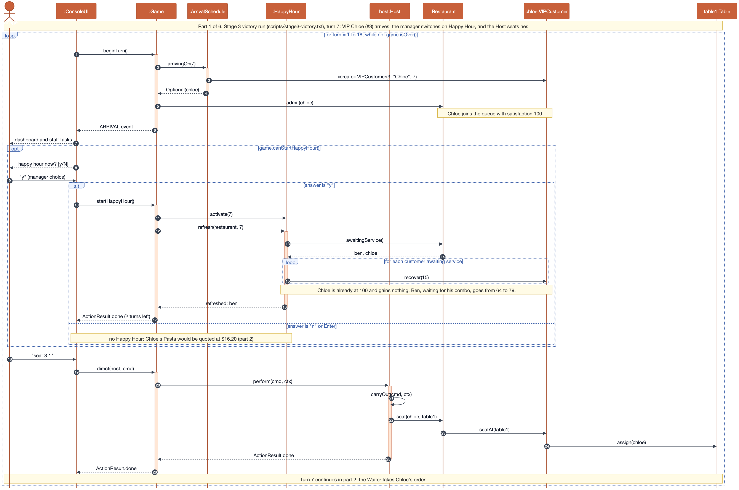

Sequence diagram, part 2. Turn 7: ordering, pricing and cooking (messages 27–54)
Editable version: docs/diagrams/sequence-2-order-pricing.drawio
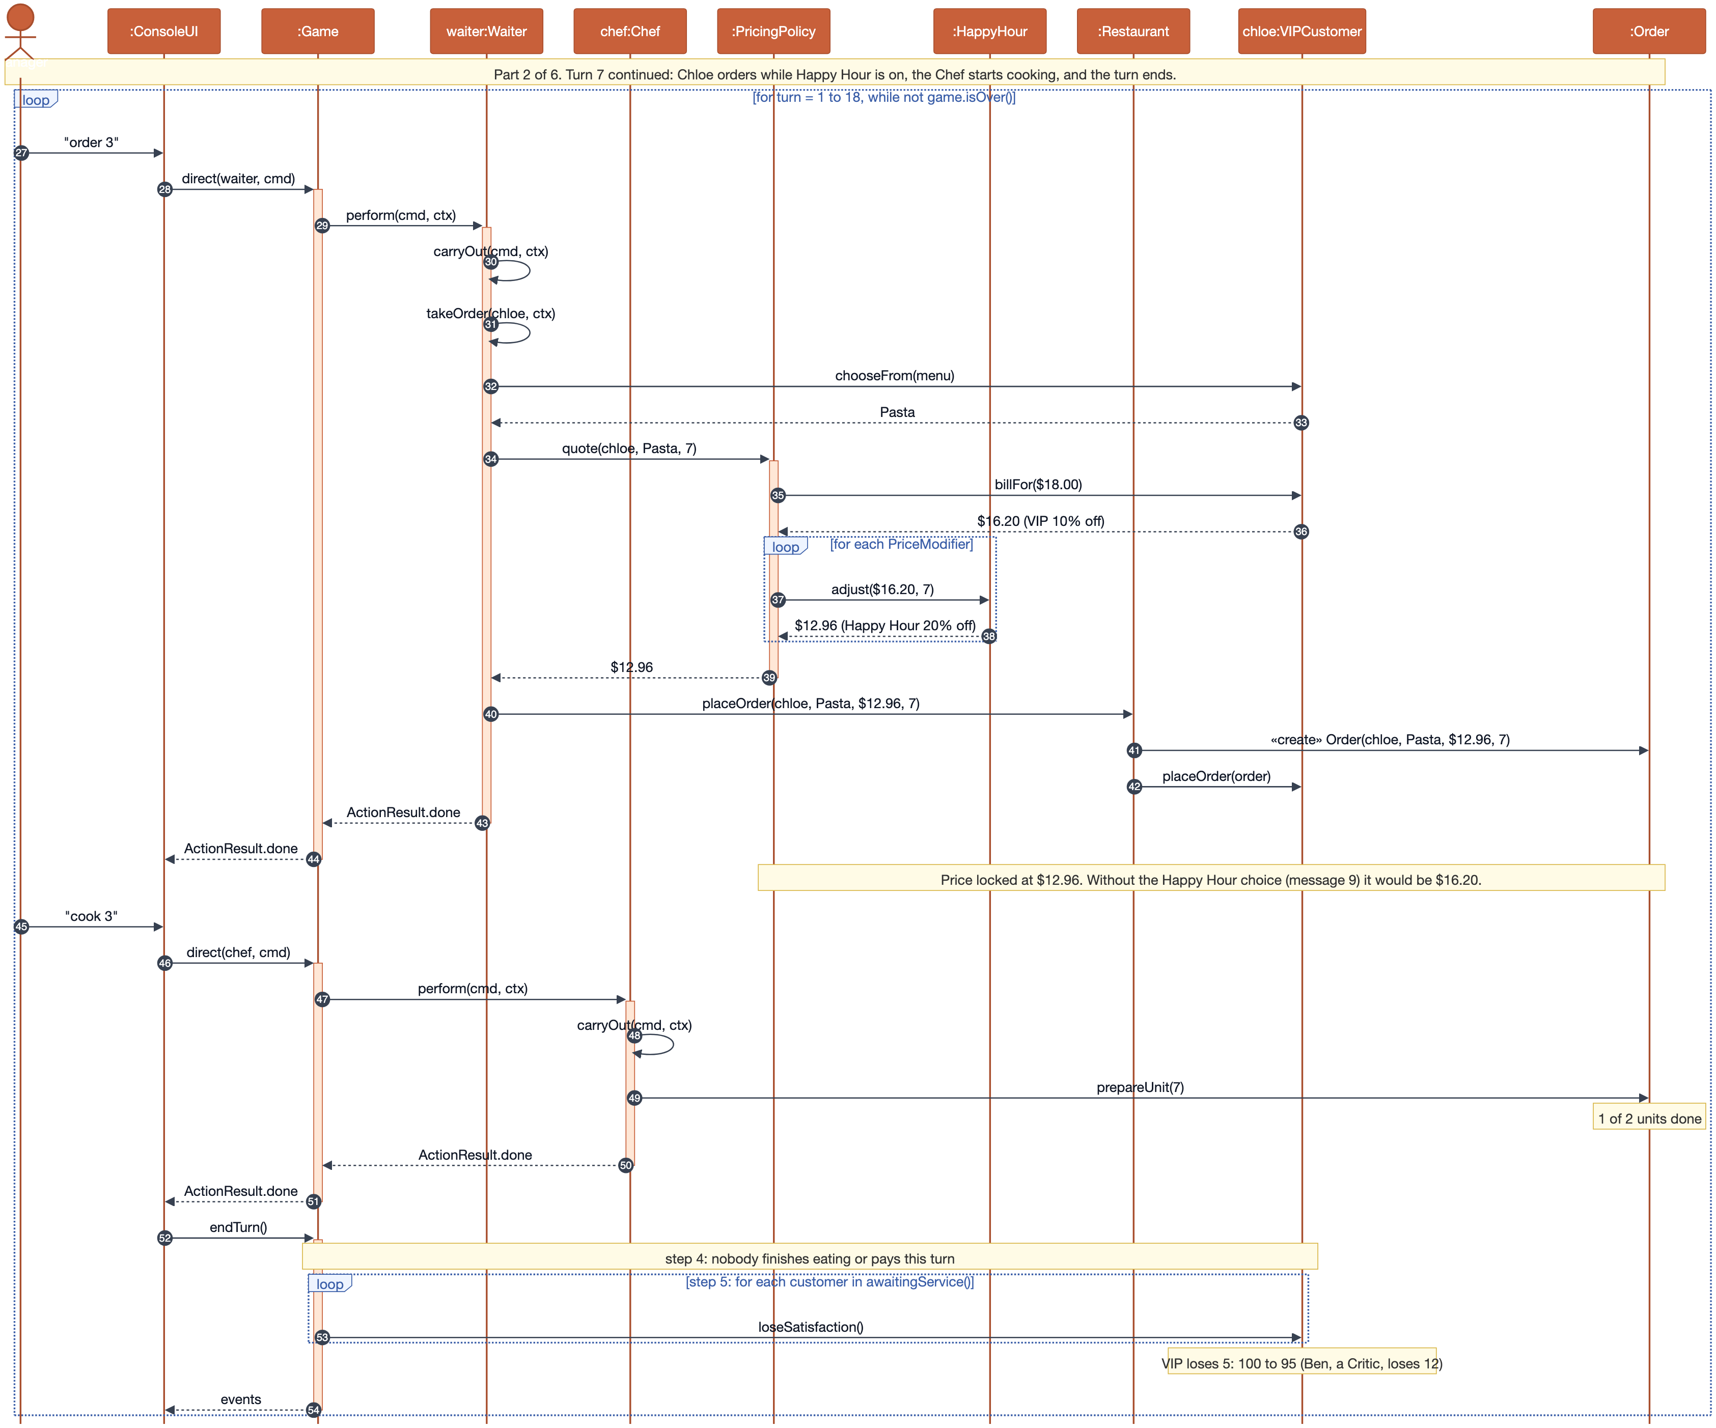

Sequence diagram, part 3. Turn 8: the order becomes READY (messages 55–69)
Editable version: docs/diagrams/sequence-3-ready.drawio
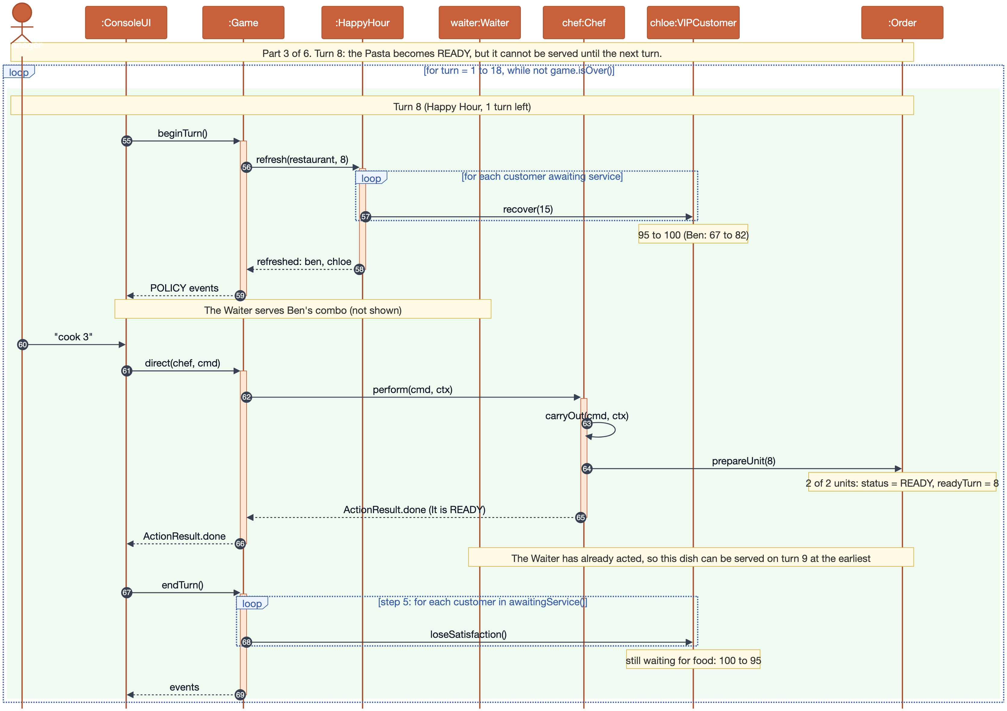

Sequence diagram, part 4. Turn 9: the order is SERVED (messages 70–82)
Editable version: docs/diagrams/sequence-4-served.drawio
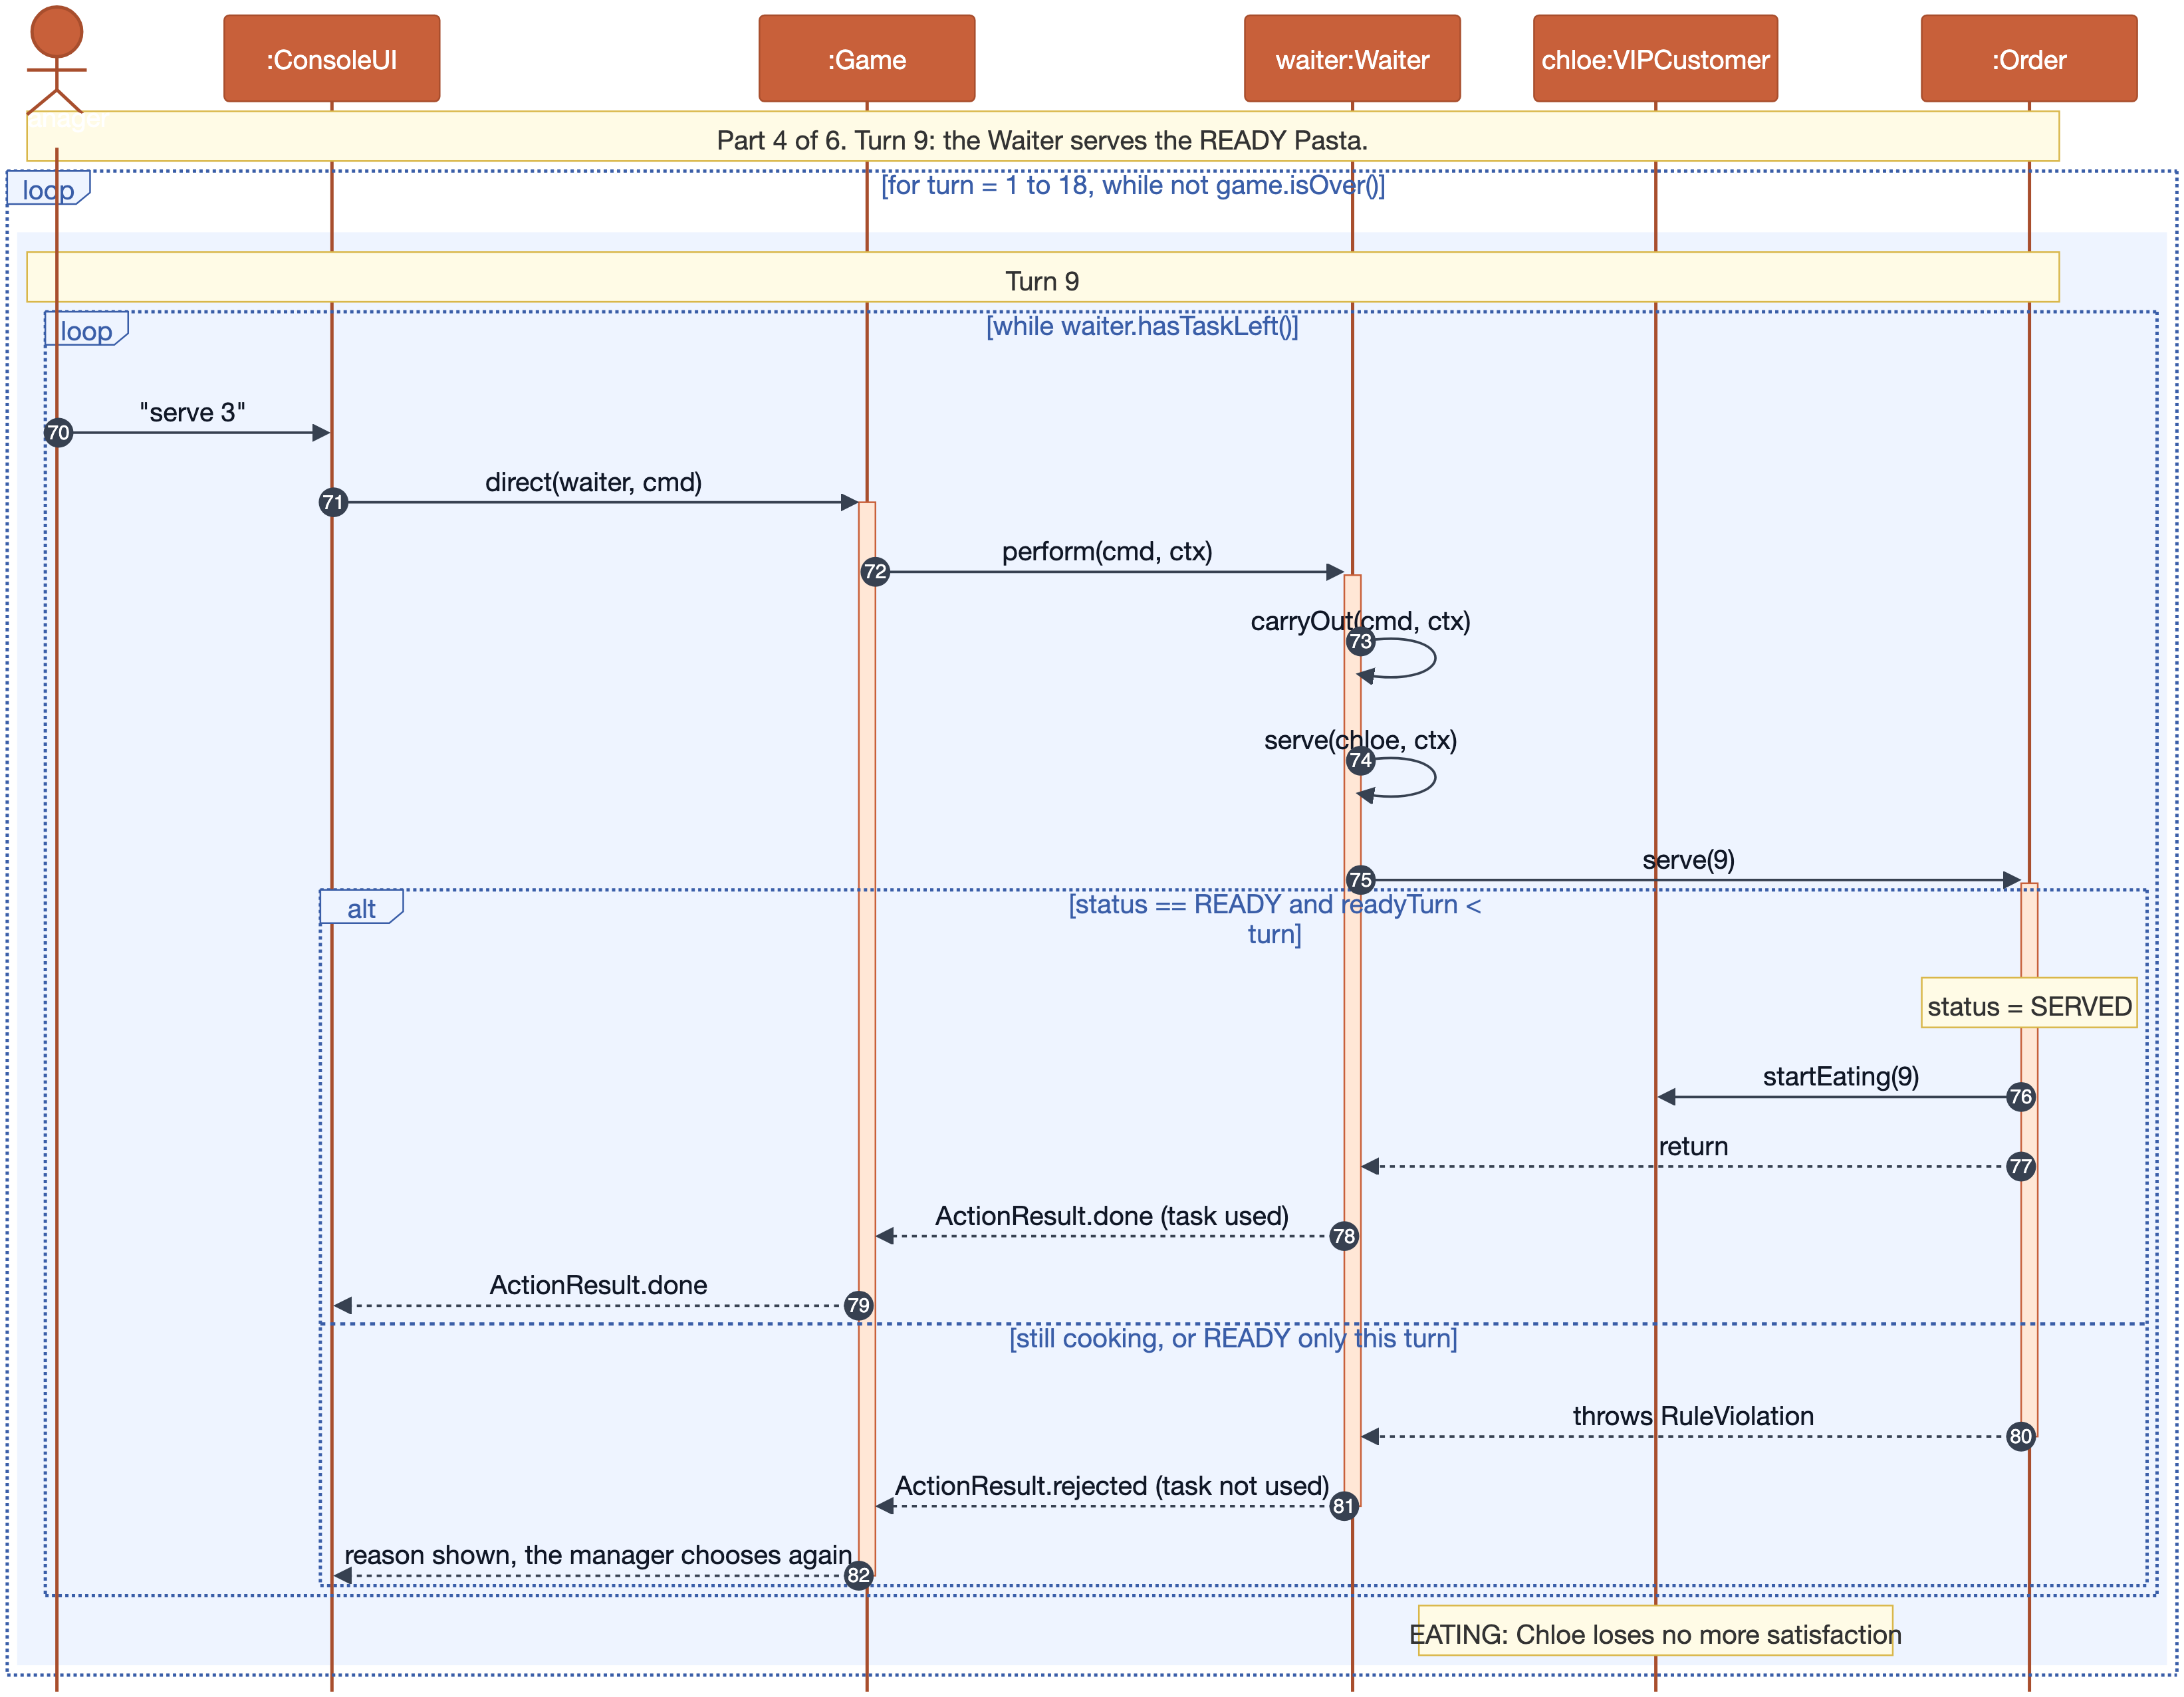

Sequence diagram, part 5. Turns 10 and 11: eating and payment (messages 83–106)
Editable version: docs/diagrams/sequence-5-eating-payment.drawio
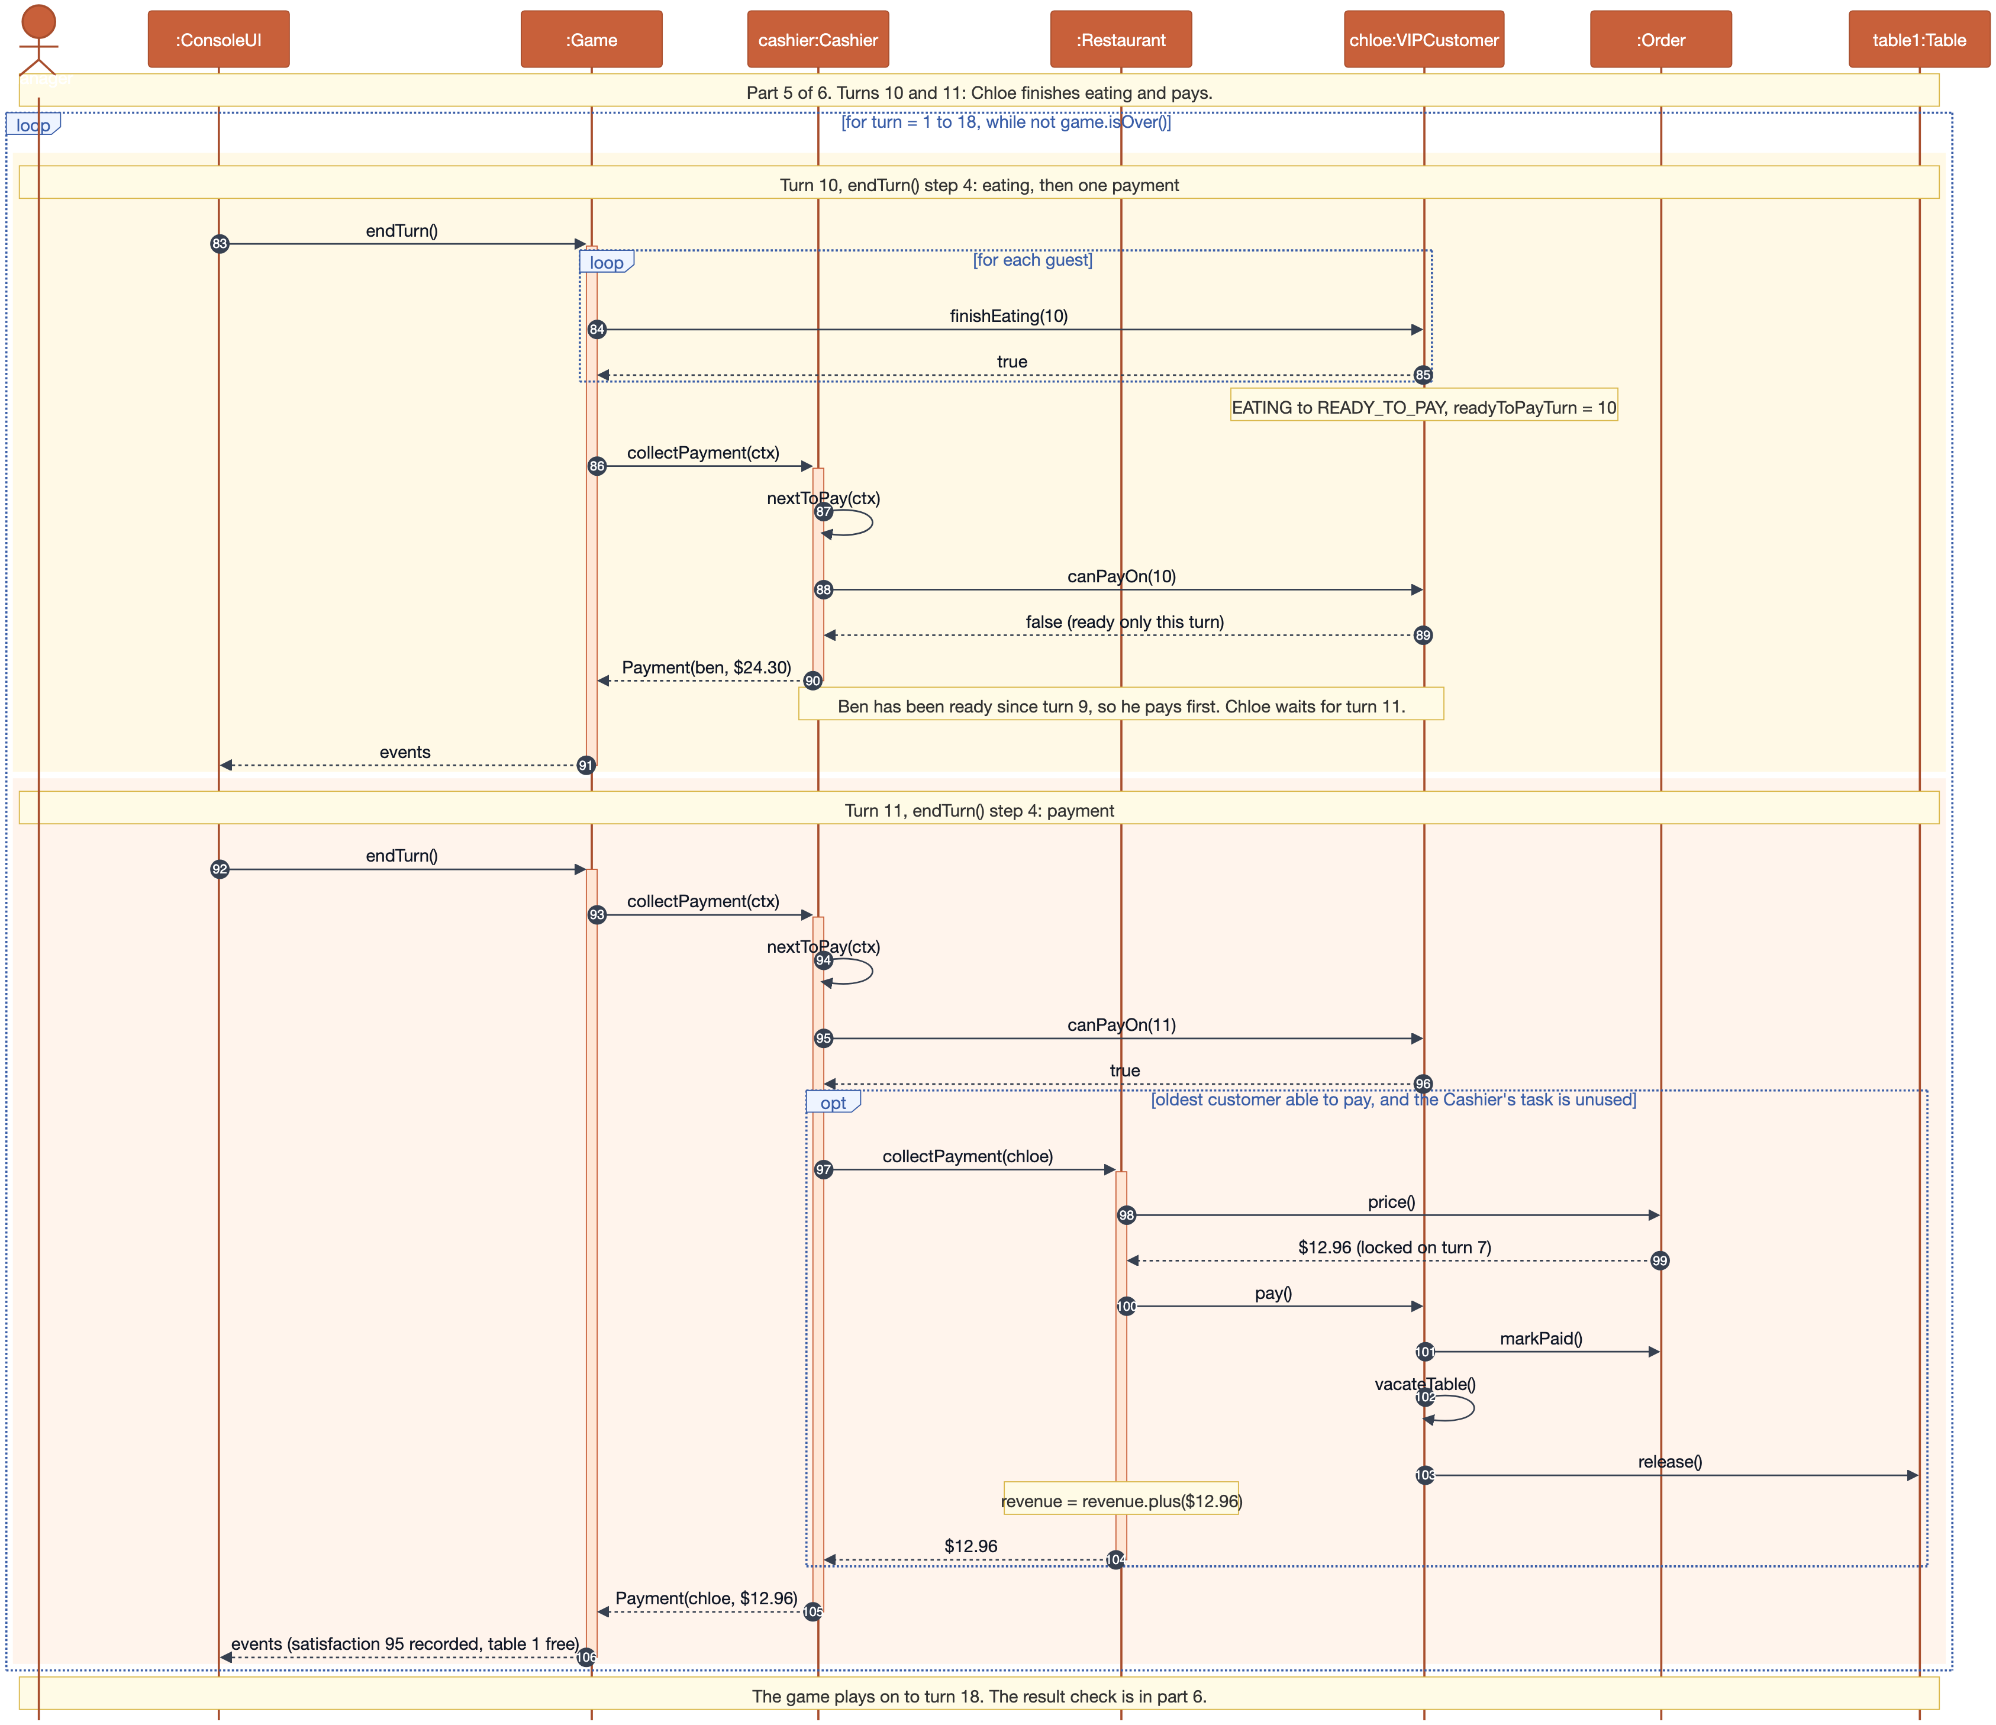

Sequence diagram, part 6. After turn 18: the result check (messages 107–117)
Editable version: docs/diagrams/sequence-6-result.drawio
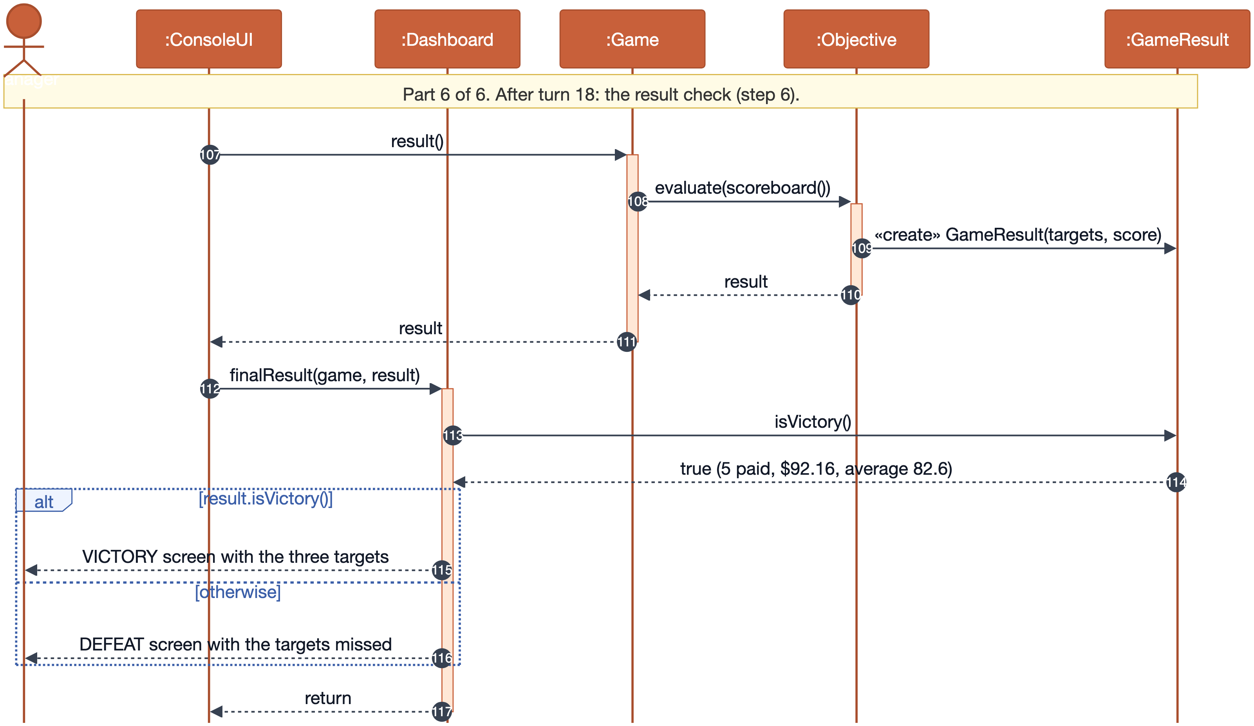

4 Design discussion

4.1 Key abstractions and their responsibilities
Abstraction | Layer | Responsibility
Game | control | Runs the six steps of a turn in order. The rules it triggers live in domain and staff objects.
GameConfig, ArrivalSchedule | control | The base setting: turns, tables, menu, who arrives when and which staff are hired. Each stage registers its additions here.
Objective, Scoreboard, GameResult | control | The targets, the end-of-turn figures, and the Victory or Defeat verdict.
StaffMember, DirectedStaff | staff | The per-turn task budget, and the template method that checks and carries out an instruction.
Waiter, Chef, Host | staff | What one role may do, and which commands are useful right now (shown as hints).
Cashier | staff | Takes one payment per turn from the customer who has been ready longest.
PricingPolicy, PriceModifier, HappyHour | policy | Locks the bill when an order is taken. Happy Hour's once-per-game life cycle, discount and recovery.
Restaurant | model | Keeps the queue, tables, guests, orders and revenue consistent with each other.
Customer and 3 subclasses | model | The visit life cycle and satisfaction (base class); patience, food choice and bill (subclasses).
Order | model | The locked price, cooking progress, the READY then SERVED rule, and cancellation.
MenuItem, Dish, ComboMeal, Menu | model | What can be ordered. A combo works out its price and units from its dishes.
Money, RuleViolation | model | Exact cent arithmetic, and a readable reason when a move breaks a rule.
ConsoleUI, Dashboard, CommandParser, Terminal, Theme | boundary | Prompts, drawing the state, checking the shape of a command, input/output, and colours with an ASCII fallback.

4.2 Design principles in the code
Single responsibility. Each rule lives in one place. "A dish finished this turn is served next turn at the earliest" is only checked in Order.serve. The Waiter just calls it, and the UI just prints the RuleViolation message. CommandParser only checks that seat 2 1 is well formed, never whether the move is legal, and Dashboard only reads the game.
Open/closed. Going from Stage 1 to Stage 2 added the VIP and Critic without touching Game, Customer, Restaurant, Order or any staff class (git diff stage-1 stage-2 -- src/rush/control/Game.java src/rush/staff is empty). In Stage 3 the Host is a new DirectedStaff registered in GameConfig, and the console's loop over game.directedStaff() picks it up unchanged (ConsoleUI changed only for the Happy Hour prompt and auto-wait, see Section 6). Combos needed no change to Order, Chef or Waiter.
Liskov substitution. The status transitions (seatAt, placeOrder, pay, leave) are written once in Customer and no subclass overrides them. The overrides keep the base contract: a loss rate of at least 0, an item from the given menu, and a bill no higher than the menu price. A rule check runs a VIP through exactly the same flow as a Regular. A ComboMeal can stand in for any MenuItem, and the Critic's choice and the Chef's unit counting work unchanged.
Interface segregation. The Cashier takes no instructions, so it is a StaffMember but not a DirectedStaff, and it does not have to implement duties() or carryOut(). ConsoleUI only uses the small DirectedStaff API, and PriceModifier has a single method.
Dependency inversion (partly). PricingPolicy depends on PriceModifier rather than HappyHour, and ArrivalSchedule depends on a CustomerFactory interface, so it never names a concrete customer class. However, Game still creates HappyHour and PricingPolicy itself. Passing them in through GameConfig would be the next step if more policies were added.

4.3 Patterns we used
Pattern | Where | Why
Template method | DirectedStaff.perform | The task-budget check, the duty check and "a rejected move costs nothing" are written once for every role.
Composite (one level) | MenuItem, Dish, ComboMeal | A combo is a menu item built from two Dish leaves, so its price and units are derived rather than copied. A combo cannot contain another combo.
Strategy | PricingPolicy with PriceModifier | Restaurant-wide pricing rules plug in after the customer's own discount, in a fixed order.
Command (simple) | Command record | Separates what the manager typed from who checks it, so a script is just a list of commands.
Factory references | ArrivalSchedule.at(4, "Ben", CriticCustomer::new) | Each stage registers its customers without the schedule knowing the customer classes.

4.4 Trade-offs
Decision | Benefit | Cost
Domain objects throw RuleViolation with a message for the player | One source of truth per rule, and the message shown is the rule itself. The UI never repeats a "can I?" check. | Exceptions on an expected path. Only DirectedStaff.perform and Game.startHappyHour catch them.
Customer abstract from Stage 1, MenuItem concrete until Stage 3 | Customer types were certain to come. Combos were the only reason for a second kind of menu item, so we waited until we needed it. | Stage 3 had to change MenuItem and its setup in GameConfig. The callers did not change.
Events are short English strings | Simple, and the UI styles them by GameEvent.Kind without parsing. | Tests have to compare text. A structured event per kind would be cleaner.
The dashboard colours customer types by name | Presentation stays out of the domain. | There is a small switch on type() in the UI, used only for colour. The rules have no type switch.
Staff with nothing useful to do wait automatically (Stage 3) | Fewer pointless prompts once there are three roles per turn. | A UI change between stages (documented in Section 6).

4.5 An alternative we considered: the State pattern for customers
A customer moves through WAITING → SEATED → ORDERED → EATING → READY_TO_PAY → PAID, or LEFT. We sketched one class per state, each implementing seat(), order(), serve() and endOfTurn() and rejecting moves it does not allow. That puts every transition in one place per state. We kept the enum because the life cycle is strictly linear, and the type behaviours (loss rate, bill, food choice) cut across every state. We would have had seven state classes and three customer types to keep in sync. An enum with guarded methods in one abstract class is shorter, easy to test, and keeps the polymorphism in the customer types, where the brief asks for it.
We also rejected a CustomerType enum with switches in the controller, because the brief asks for dispatch through the customer objects. We also rejected a Decorator chain for prices, because "VIP first, then Happy Hour" reads more clearly as an ordered list in PricingPolicy.

5 How the player's choices change the result
The base setting has no randomness, so any difference in the outcome comes from the manager. We replayed the real Game with fixed Waiter priorities, with and without the Chef cooking an order on the turn it is taken, and in Stage 3 with and without the Host and with different Happy Hour turns.

Stage 1
Waiter priority | Chef cooks same turn | Paid | Revenue | Avg sat. | Result
serve, order, seat | yes | 5 | $66.00 | 79.2 | Victory
serve, order, seat | no | 4 | $51.00 | 66.0 | Victory
seat, order, serve | no | 4 | $51.00 | 60.0 | Victory (just)
seat, serve, order | no | 3 | $42.00 | 60.0 | Defeat

Stage 2 (Critic and VIP)
Waiter priority | Chef cooks same turn | Paid | Revenue | Avg sat. | Result
serve, order, seat | yes | 5 | $67.20 | 76.0 | Victory
seat, order, serve | no | 4 | $52.20 | 62.5 | Victory
seat, serve, order | no | 3 | $43.20 | 59.3 | Defeat on all three targets

Stage 3 (Host, combos, Happy Hour)
Waiter priority | Chef same turn | Host used | Happy Hour | Paid | Revenue | Avg | Result
order, serve, seat | yes | yes | turn 7 | 5 | $92.16 | 82.6 | Victory
order, serve, seat | yes | yes | never | 5 | $95.40 | 75.6 | Victory
serve, order, seat | yes | yes | turn 7 | 4 | $67.86 | 84.3 | Victory
seat, serve, order | no | yes | turn 7 | 4 | $67.86 | 81.0 | Victory
seat, serve, order | no | no | turn 7 | 3 | $49.50 | 68.7 | Defeat
seat, serve, order | no | no | turn 14 | 3 | $49.50 | 57.0 | Defeat
Three things stand out:
- Serve before you seat. A served customer stops losing satisfaction and frees the table two turns later. Seating first only moves the waiting from the queue to a table.
- The Host changes the best priority. Once the Host does the seating, taking orders first beats serving first (5 paid against 4). Using the Host alone turns the weakest strategy from a defeat into a victory.
- Happy Hour is a trade-off. On turn 7 it costs $3.24 in revenue but lifts the average from 75.6 to 82.6. On turn 14 it helps nobody who can still pay before the game ends.

6 Development process and stage comparisons
Each stage is a tagged commit that runs on its own. We checked every tag from a clean git archive copy: it compiles, passes its own rule checks, and replays its own victory and defeat scripts.

Commit history
Commit | Date | Message | Tag
7727982 | 2026-10-08 | Stage 1: domain model (Money, menu, customers, orders, tables, restaurant)
a724465 | 2026-10-08 | Stage 1: staff roles and the six-step turn controller
3a27533 | 2026-10-08 | Stage 1: command-line interface with dashboard and command parser
ebdc913 | 2026-10-08 | Stage 1: rule checks, reproducible victory/defeat scripts and test notes | stage-1
a721c2d | 2026-10-08 | Stage 2: VIP and Critic customers dispatched through Customer subclasses | stage-2
13d6dc5 | 2026-10-08 | Stage 3: Host, ComboMeal (MenuItem becomes abstract), Happy Hour pricing policy | stage-3
The table runs up to the stage-3 tag. Later commits only add the report, diagrams and submission files: git diff stage-3 main -- src test scripts is empty. Compare on GitHub: stage-1...stage-2 and stage-2...stage-3. Locally: git diff stage-1 stage-2 --stat.

Stage 1 to Stage 2: customer behaviour (commit a721c2d)
File | Change | Reason
model/VIPCustomer.java | new | Loses 5 per turn; billFor gives 10% off.
model/CriticCustomer.java | new | Loses 12 per turn; overrides chooseFrom to order the most elaborate dish, and leaves a star review.
model/Money.java | +5 lines | percent(int), rounded half-up, first needed for the VIP discount.
control/GameConfig.java | small | Registration (two arrival lines and their imports): Ben (turn 4) becomes a Critic and Chloe (turn 7) a VIP. Still six arrivals.
ui/Dashboard.java | small | A colour per customer type and a legend in the help screen (presentation only).
Main.java, tests, scripts, docs | updated | Edition label, 4 new rule checks, Stage 2 scripts and notes.
Game, Customer, all staff, Restaurant, Order | unchanged | The new behaviour is dispatched through the new subclasses.

Stage 2 to Stage 3: new role and menu policy (commit 13d6dc5)
File | Change | Reason
staff/Host.java | new | A DirectedStaff whose only duty is SEAT. It reuses the shared seating helper.
model/Dish.java, model/ComboMeal.java | new | The concrete dish moved into Dish. ComboMeal takes 90% of the price and the sum of the units of its two dishes.
model/MenuItem.java | rewritten | Changed from concrete to abstract (price(), prepUnits()). Its public methods are the same, so Order, Chef, Waiter and the Critic did not change. Only the setup in GameConfig now builds Dishes.
policy/PriceModifier.java, policy/HappyHour.java | new | Once per game, two turns, 20% off orders taken, and 15 points of recovery at turn start for customers still waiting.
policy/PricingPolicy.java | changed | Applies a list of PriceModifiers after billFor, so the VIP discount comes first and Happy Hour second.
model/Customer.java | +14 lines | recover(points), capped at 100, only for customers still waiting for service.
control/Game.java | changed | Owns HappyHour. startHappyHour() only works before any staff member acts, and recovery happens in beginTurn().
control/GameConfig.java | small | Registration: the menu is built from Dishes plus two combos, and the Host is hired first.
control/GameEvent.java | 1 line | A POLICY event kind for Happy Hour recovery.
ui/ConsoleUI.java, ui/Dashboard.java | changed | The Happy Hour prompt and remaining-duration line, and auto-wait for staff with nothing useful to do.
Main.java, tests, scripts, docs | updated | Edition label, 6 new rule checks (22 in total), Stage 3 scripts and notes.
Waiter, Chef, Cashier, DirectedStaff, Restaurant, Order | unchanged | The Host and combos fit the existing abstractions.
Earlier behaviour still works. The Stage 3 rule checks still cover the Stage 1 worked example (Pasta from arrival to payment, satisfaction 92, 84, 76, paid $18.00 on turn 6), abandonment, the Cashier's order and the "READY, then SERVED next turn" rule, and they all pass.

7 Functional evidence
Every screen below is real output, captured by replaying the scripts at their own tag. Full plain-text transcripts are in docs/transcripts/.

7.1 Launch, dashboard and input handling (Stage 1, turn 1)
The start-of-turn display shows the turn, revenue against the target, paid count, average satisfaction (N/A before anyone pays), the queue, both tables, each customer's satisfaction, the kitchen and the tasks each staff member can do. Two bad inputs are explained and do not use up the Waiter's task.
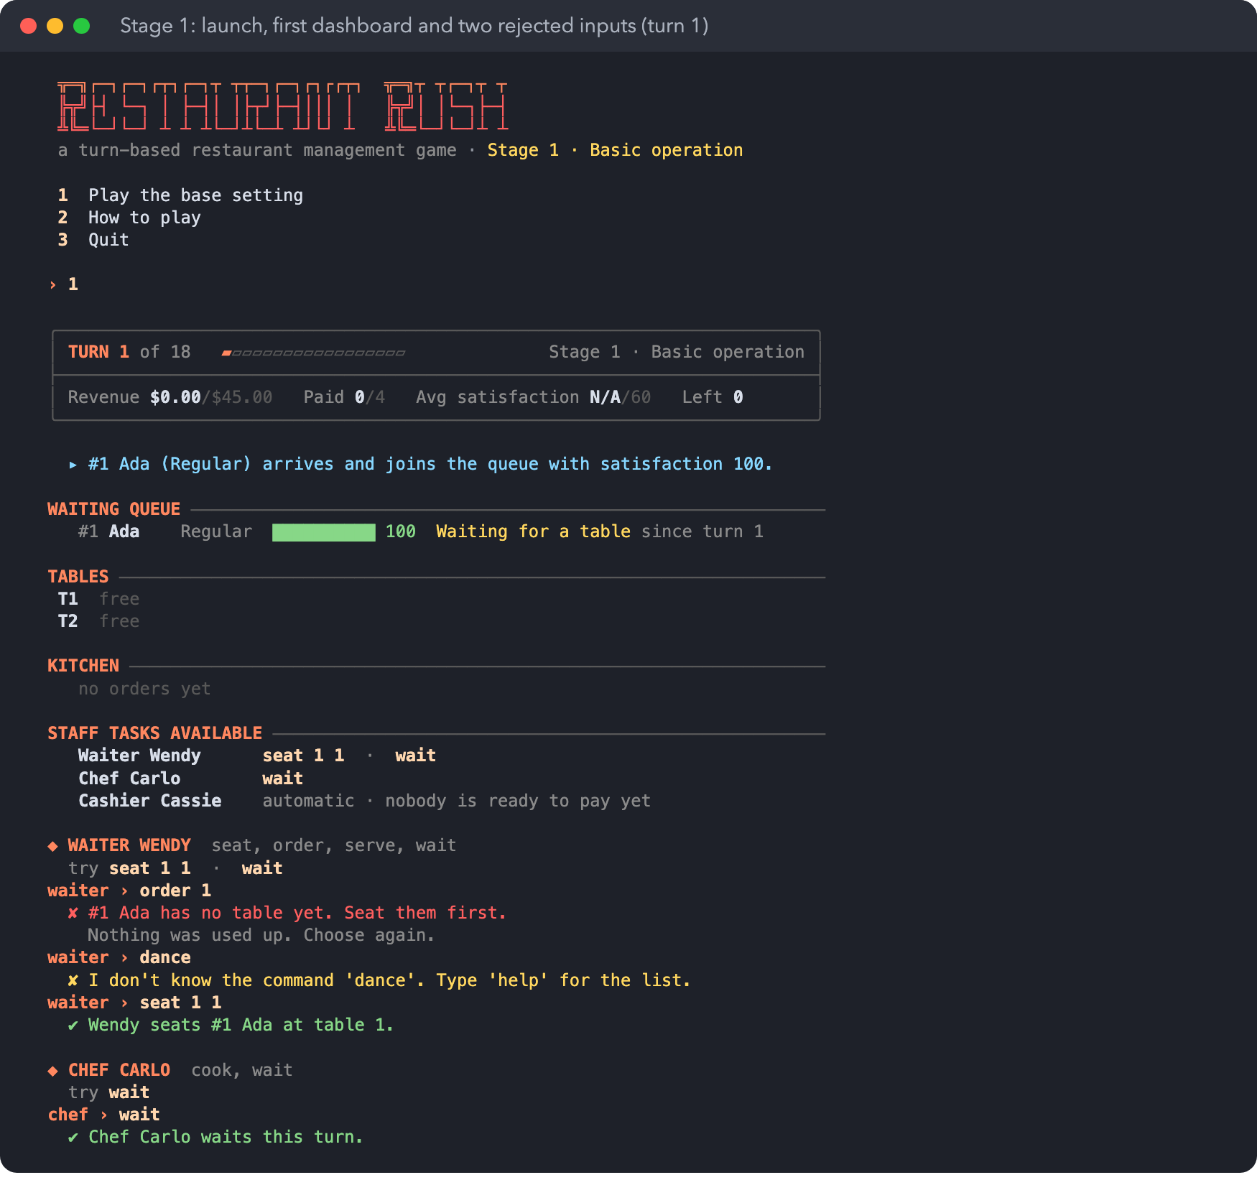

7.2 READY to SERVED, and a decision under pressure (Stage 1, turns 9 and 10)
On turn 9, serve 3 is rejected because the Pasta is only half cooked. The Chef then finishes it, but the Waiter has already acted. On turn 10, Dev arrives just as the Pasta is READY. There is only one Waiter, so the manager serves Chloe and leaves Dev in the queue for a turn.
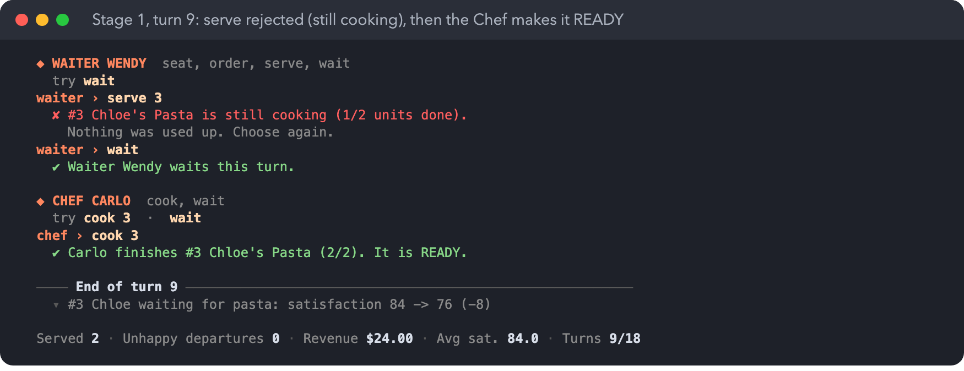
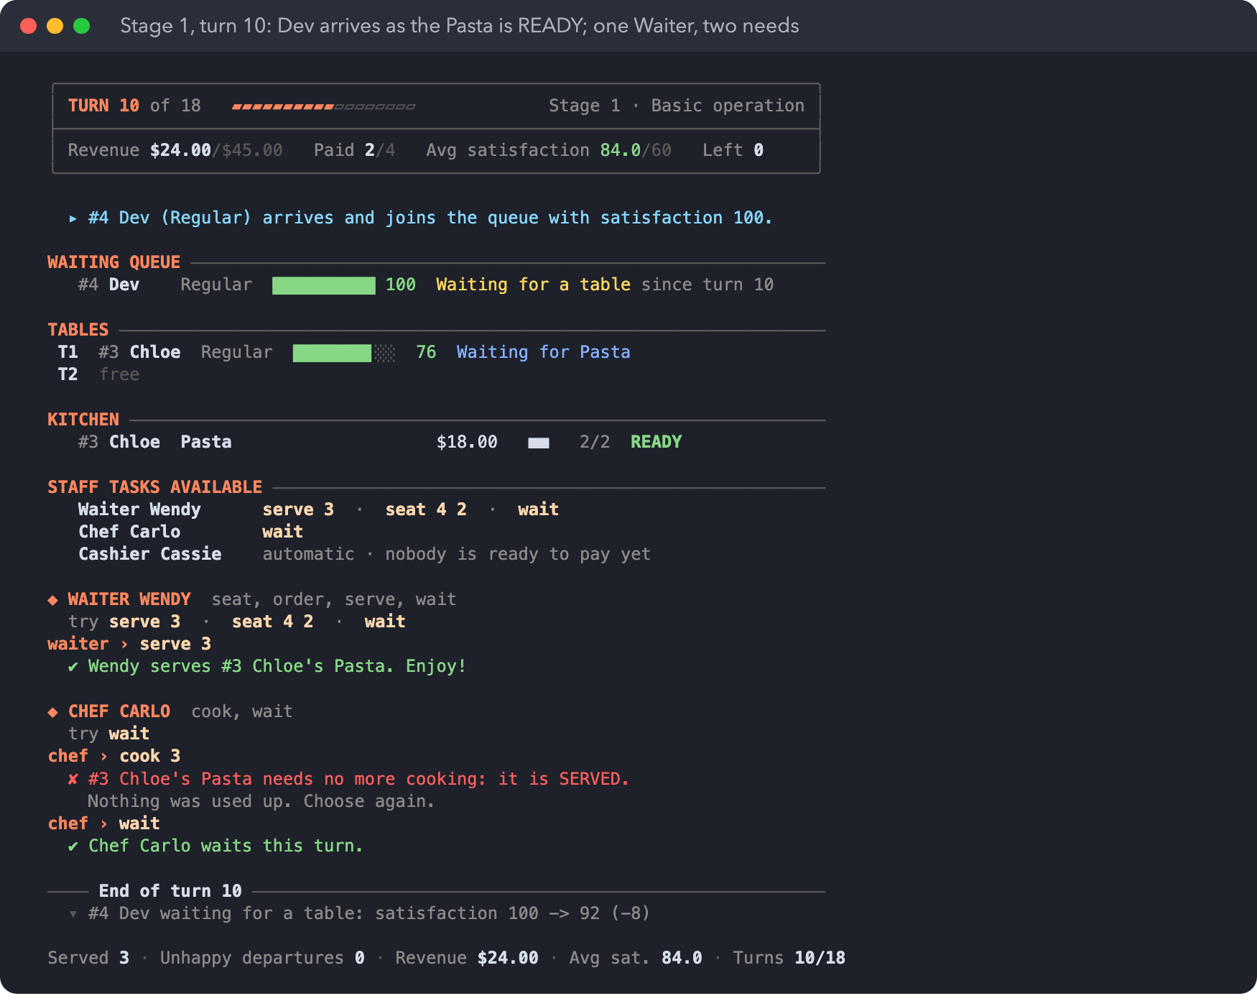

7.3 Payment, victory and defeat (Stage 1)
Chloe was served on turn 10, finished eating on turn 11 and pays on turn 12, which frees table 1.
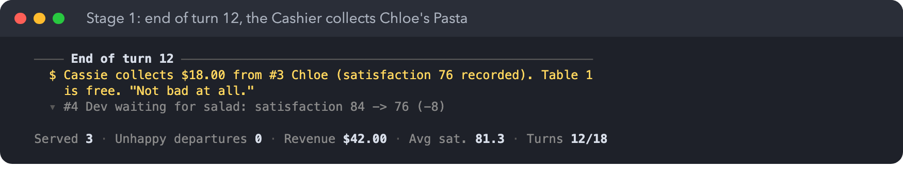
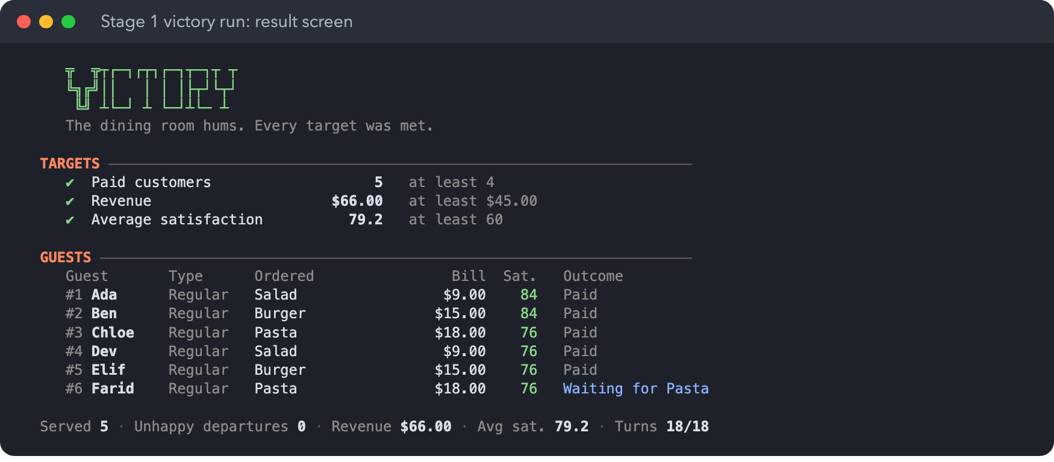
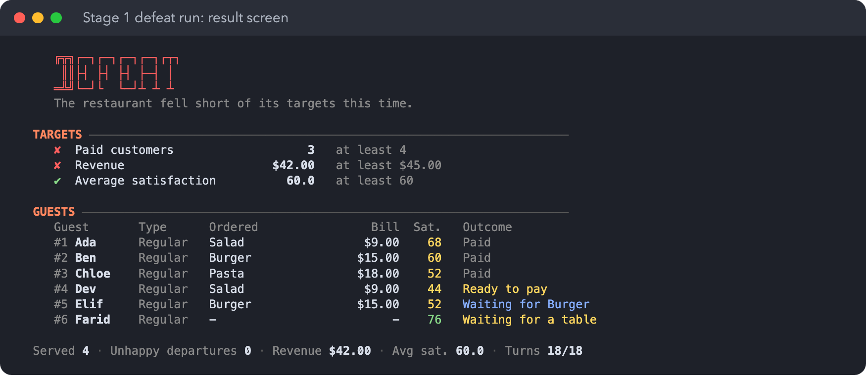
The victory script serves first, then takes orders, then seats, and the Chef cooks straight away: 5 paid, $66.00, average 79.2. The defeat script seats first and the Chef never cooks on the turn an order is taken: 3 paid, $42.00.

7.4 VIP and Critic behaviour (Stage 2)
The Critic (#2 Ben) orders Pasta even though the menu rotation would give guest #2 a Burger, and loses 12 points per turn while it cooks. On turn 7 the VIP arrives, and the manager serves the Critic first because the VIP only loses 5 per turn. On turn 9 the Critic pays and leaves a review. On turn 13 the VIP pays $16.20.
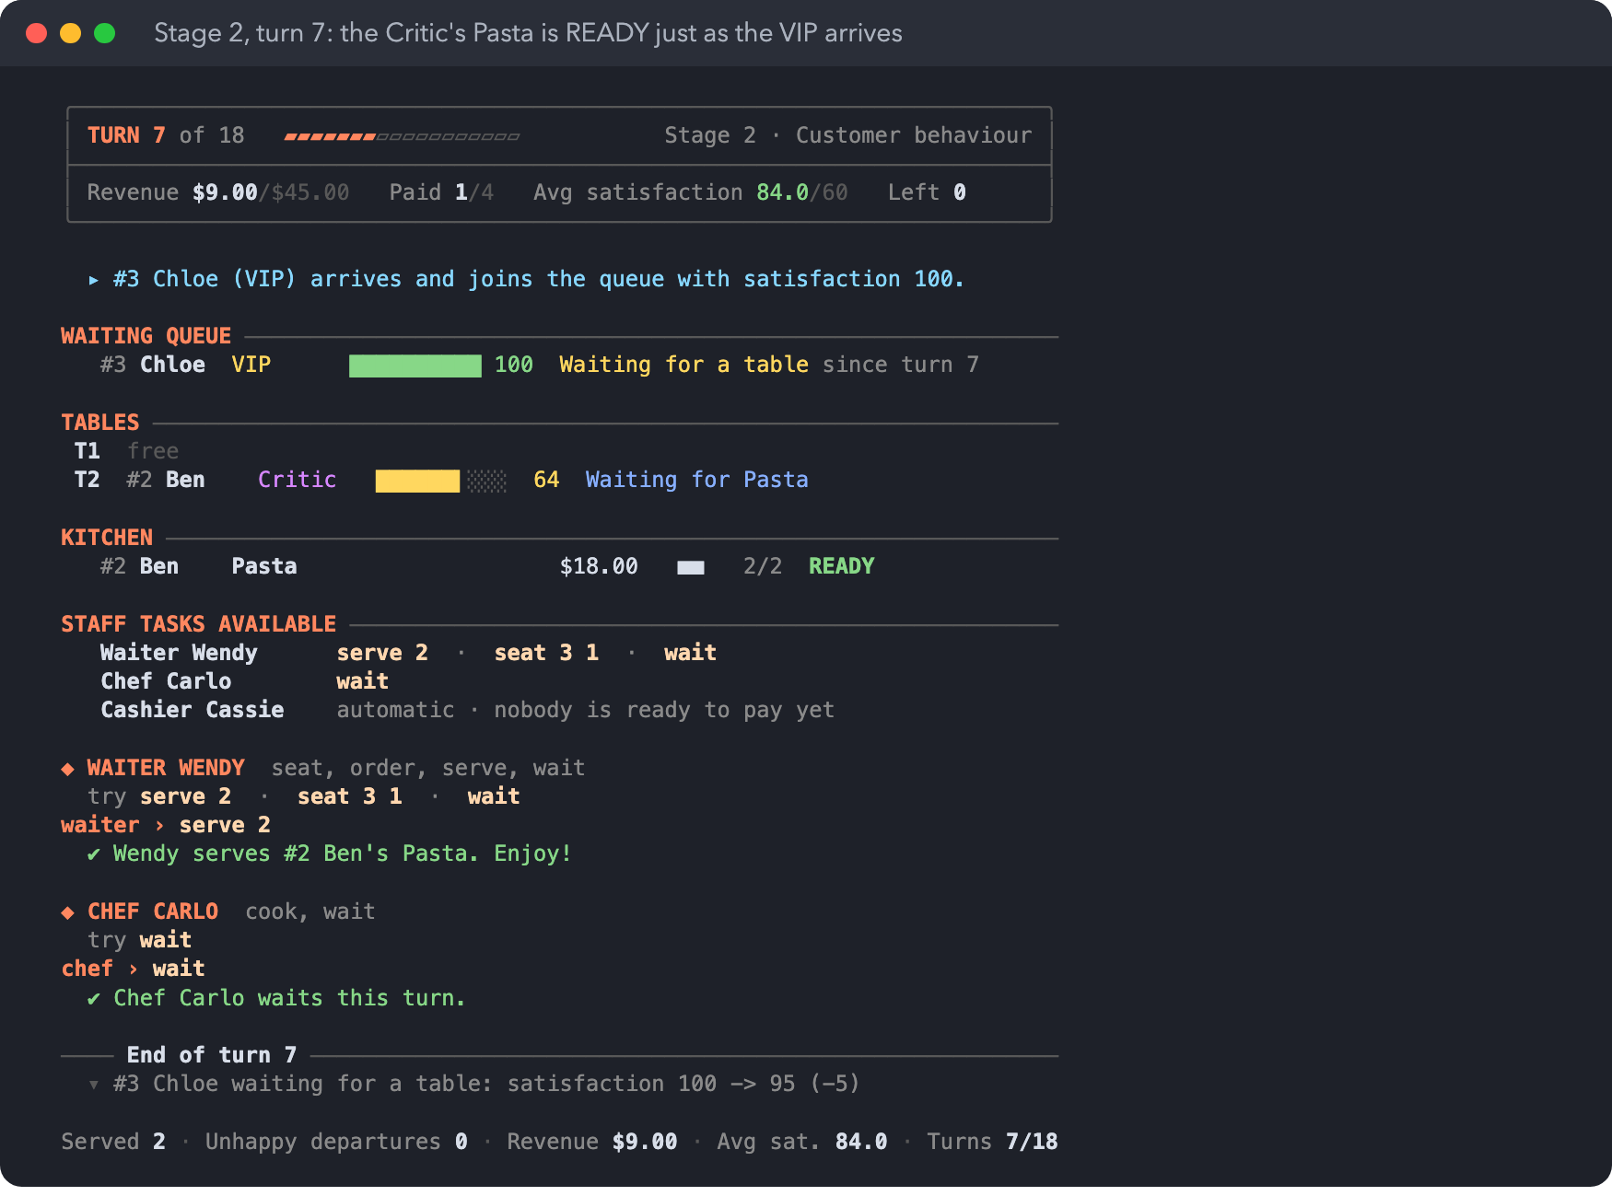
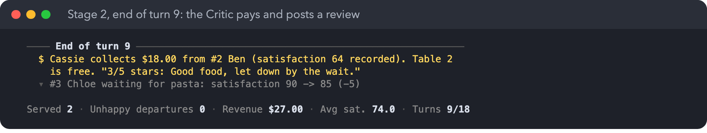

7.5 Stage 3 features: Host, combos and Happy Hour
On turn 7, Happy Hour is switched on before anyone acts. The Host seats the VIP, and the Waiter takes her order in the same turn ($18.00 × 0.9 × 0.8 = $12.96). The Critic is waiting for the 3-unit Salad + Pasta Combo ($24.30) and recovers 15 points. On turn 8 the header shows 1 turn left, and both waiting guests recover again.
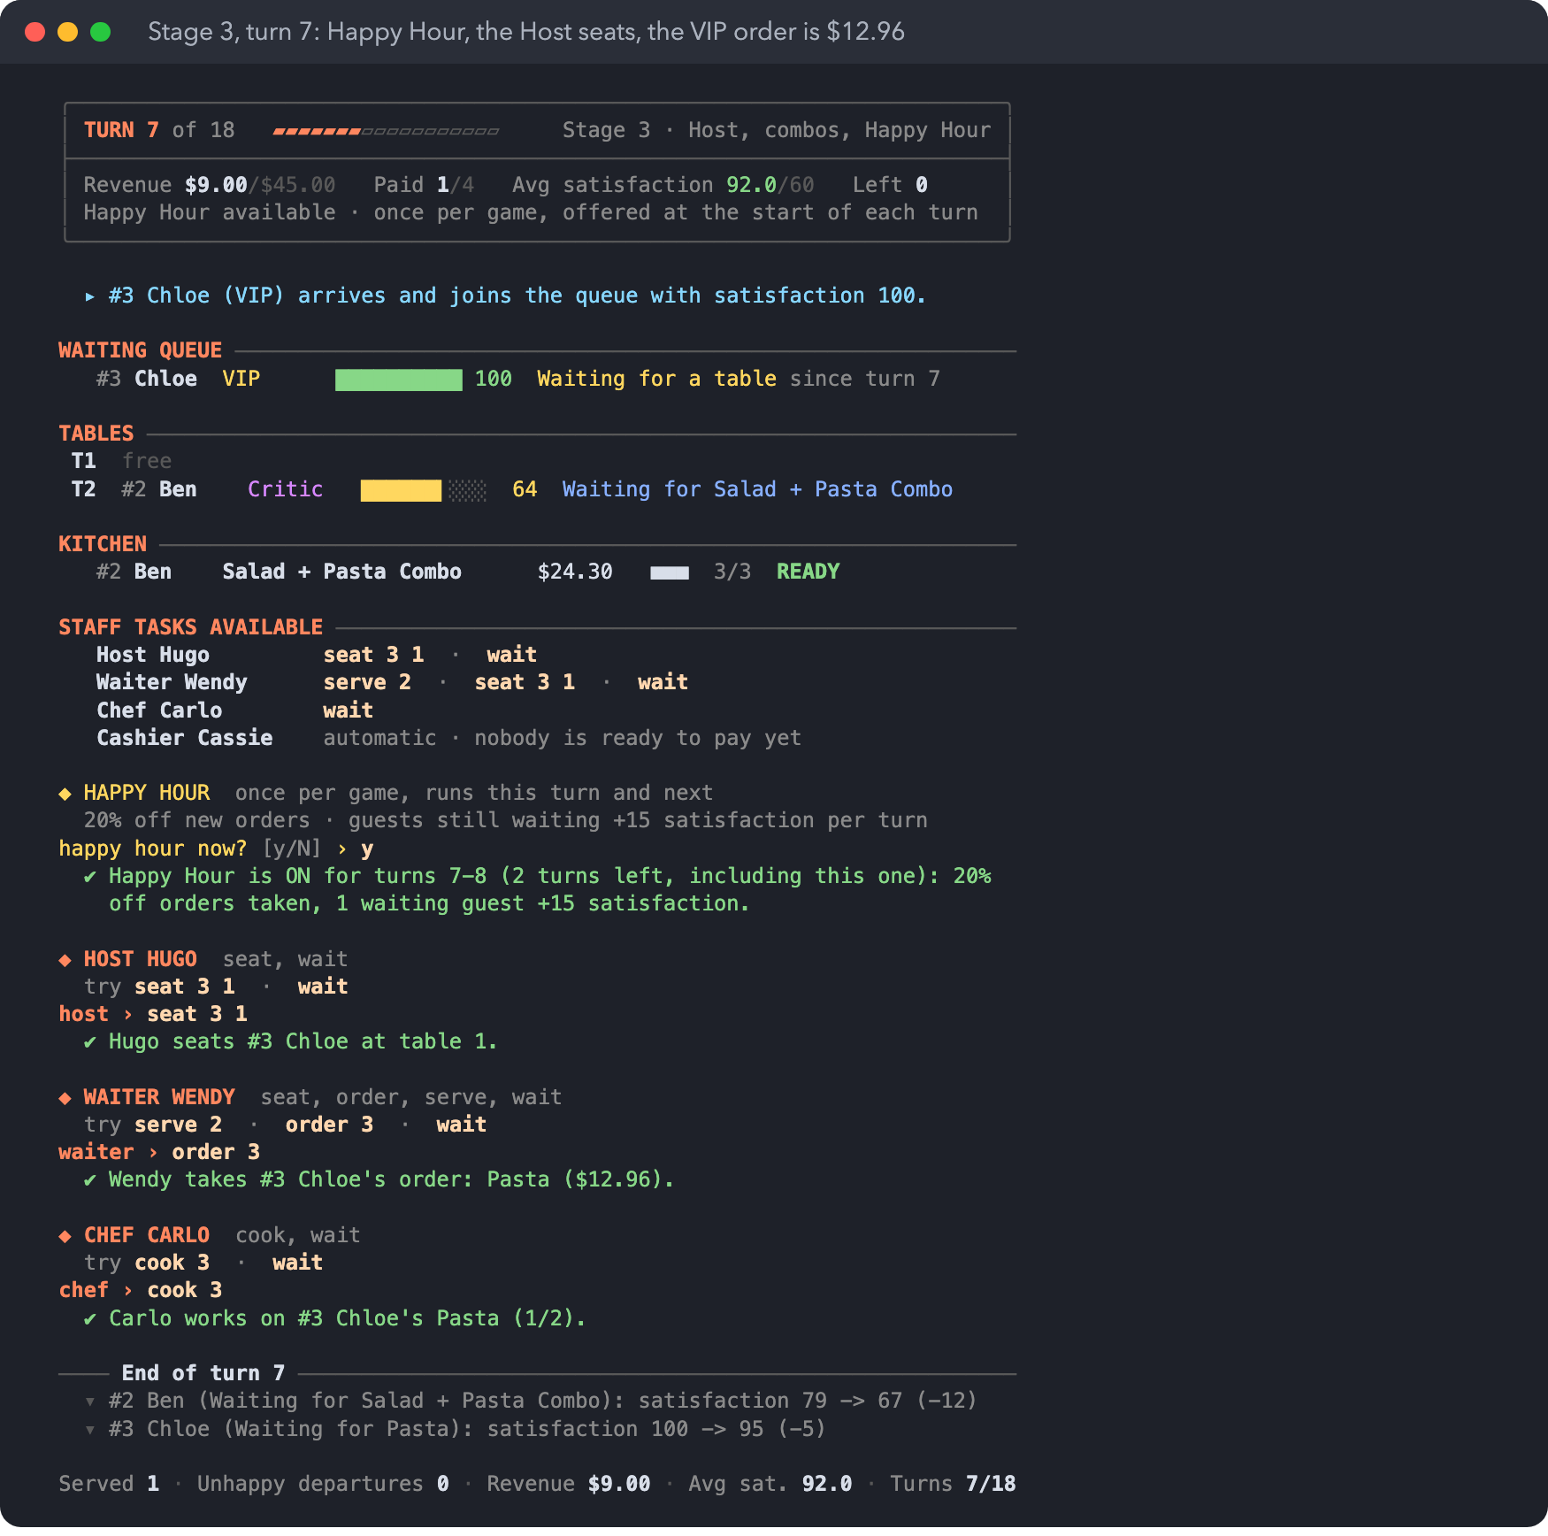
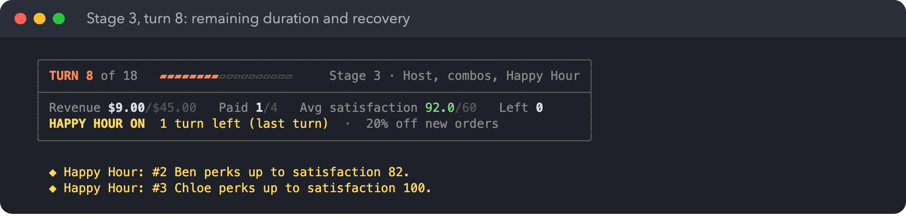

7.6 Victory and defeat (Stage 3)
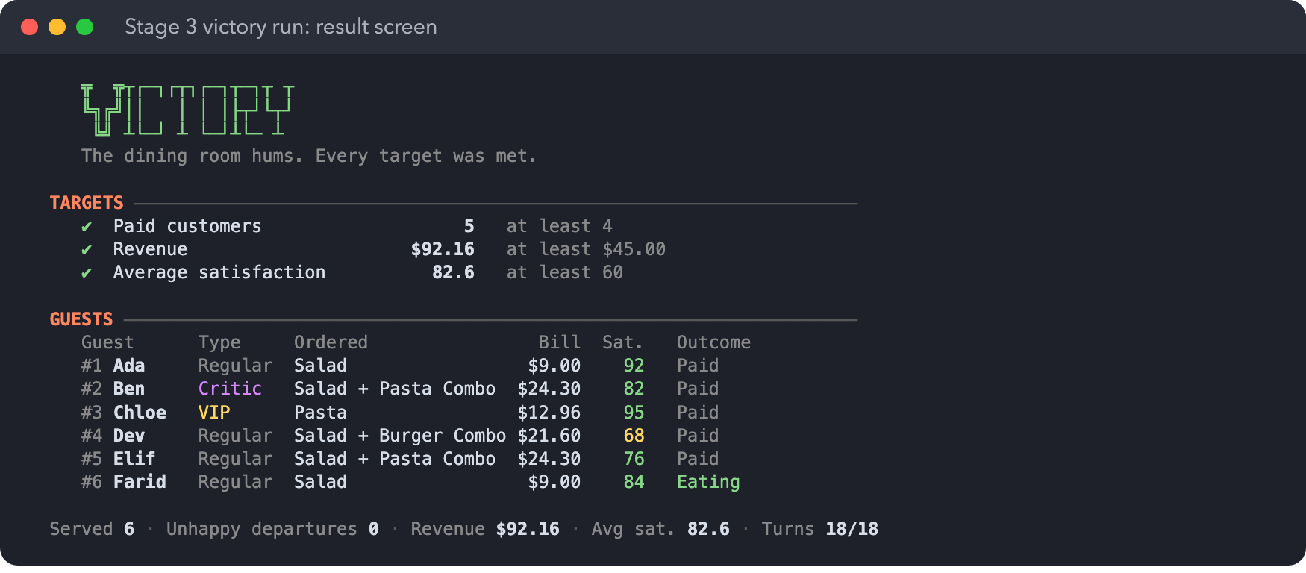
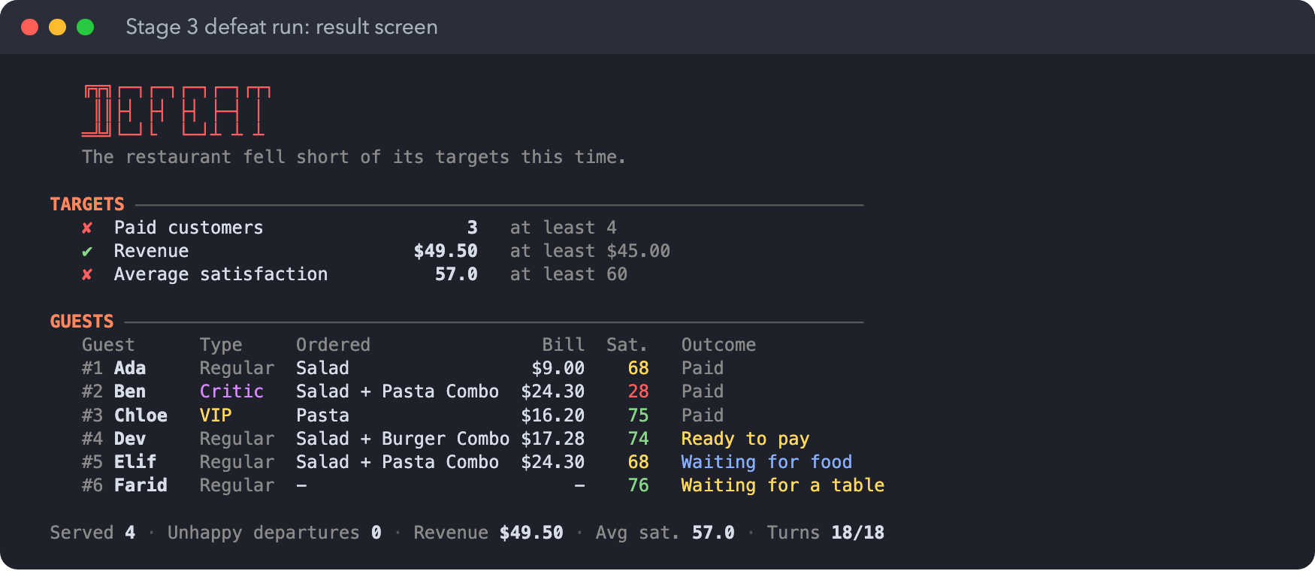
The defeat script ignores the Host and switches Happy Hour on at turn 14, too late to help anyone who can still pay: 3 paid, average 57.0.

7.7 Rule checks at each tag
./test.sh compiles src and test with plain javac, so no JUnit download is needed. It checks the rules against the real objects, including the brief's worked example and pricing examples, and replays the scripted runs through the real console.

stage-1
- PASS money is kept in cents and shown with two decimals
- PASS worked example 3.3: Pasta from arrival to payment
- PASS a dish finished this turn is served next turn at the earliest
- PASS an invalid choice explains why and does not use the task
- PASS the Waiter completes at most one task per turn
- PASS the Cashier takes one payment per turn, oldest first
- PASS a customer at 0 leaves, order cancelled, table freed, no revenue
- PASS served, eating and paying customers lose no satisfaction
- PASS customers choose their own food by rotating through the menu
- PASS the game always runs all 18 turns
- PASS scripted victory run ends in Victory
- PASS scripted defeat run ends in Defeat
12 passed, 0 failed

stage-2
- PASS money is kept in cents and shown with two decimals
- PASS worked example 3.3: Pasta from arrival to payment
- PASS a dish finished this turn is served next turn at the earliest
- PASS an invalid choice explains why and does not use the task
- PASS the Waiter completes at most one task per turn
- PASS the Cashier takes one payment per turn, oldest first
- PASS a customer at 0 leaves, order cancelled, table freed, no revenue
- PASS served, eating and paying customers lose no satisfaction
- PASS customers choose their own food by rotating through the menu
- PASS the game always runs all 18 turns
- PASS VIP: loses 5 per turn and gets 10% off
- PASS Critic: loses 12 per turn and orders the most elaborate dish
- PASS base setting has six arrivals including a VIP and a Critic
- PASS all customer types follow the same order and service flow
- PASS scripted victory run ends in Victory
- PASS scripted defeat run ends in Defeat
16 passed, 0 failed

stage-3
- PASS money is kept in cents and shown with two decimals
- PASS worked example 3.3: Pasta from arrival to payment
- PASS a dish finished this turn is served next turn at the earliest
- PASS an invalid choice explains why and does not use the task
- PASS the Waiter completes at most one task per turn
- PASS the Cashier takes one payment per turn, oldest first
- PASS a customer at 0 leaves, order cancelled, table freed, no revenue
- PASS served, eating and paying customers lose no satisfaction
- PASS customers choose their own food by rotating through the menu
- PASS the game always runs all 18 turns
- PASS VIP: loses 5 per turn and gets 10% off
- PASS Critic: loses 12 per turn and orders the most elaborate dish
- PASS base setting has six arrivals including a VIP and a Critic
- PASS all customer types follow the same order and service flow
- PASS combo: summed units, 90% of the combined price
- PASS Host seats one customer in addition to the Waiter
- PASS Happy Hour: once per game, this turn and the next
- PASS Happy Hour: 20% off after the VIP discount, locked when ordered
- PASS Happy Hour: waiting customers recover 15, capped at 100
- PASS Happy Hour only starts before any staff member acts
- PASS scripted victory run ends in Victory
- PASS scripted defeat run ends in Defeat
22 passed, 0 failed

8 Rule interpretations
Where the brief left a choice to us, this is what the game does.
Topic | What the game does
Food choice | A fixed rotation: guest #n orders item n on the menu, wrapping around. The choice is shown when the order is taken.
The Critic's behaviour | Always orders the item with the most preparation units, and the more expensive one on a tie (Pasta in Stage 2, the Salad + Pasta Combo in Stage 3). Leaves a 1 to 5 star review on paying, which does not affect the score.
Combo choice | Combos come after the dishes on the menu, so the rotation gives guests #4 and #5 the two combos.
Combos on the menu | Salad + Burger ($21.60, 2 units) and Salad + Pasta ($24.30, 3 units).
Display order | The scheduled arrival (step 1) happens before the dashboard is drawn, so the manager sees the new customer before choosing.
Host and Waiter order | Host, then Waiter, then Chef. The Waiter may take the order of a customer the Host seated this turn, just as the Chef may cook an order the Waiter took this turn.
Starting Happy Hour | Offered at the start of each turn until used, before any staff member acts. Recovery applies straight away on the first turn and at the start of the second.
"Waiting for a table or food" | WAITING, SEATED (not yet ordered) and ORDERED (including a READY dish not yet served). The same group loses satisfaction at the end of the turn.
Rounding | Half-up to the nearest cent after each percentage: a VIP Burger in Happy Hour goes $15.00, $13.50, $10.80.
Seating | seat 2 uses the first free table; seat 2 1 names the table.
Auto-wait (Stage 3) | A staff member whose only possible action is wait waits without a prompt.
Recorded satisfaction | A customer's satisfaction is frozen when they pay, so the average uses the values at payment.

9 Reflection and contributions

What worked
- Planning for all three stages from the start. Since every stage was published up front, Stage 1 already kept the customer life cycle separate from customer behaviour. Stage 2 then only touched the configuration, one helper in Money, and the display.
- Rules that explain themselves. Putting each rule in the object that owns the data (Order.serve, Table.assign, HappyHour.activate) gave us clear error messages for free and kept the UI free of rules.
- Scripts as tests. Saving runs as plain lists of commands made every victory and defeat reproducible for the marker, the video and the rule checks.

What we would do differently
- Pass PricingPolicy and its modifiers in through GameConfig instead of creating them in Game, so a new policy only needs registering.
- Use structured event objects instead of English strings, so tests can check events instead of text.
- Build the strategy replays from Section 5 into the test suite earlier. They showed that the Host changes the best Waiter priority, which we only noticed late.

Contributions
All four members contributed equally to the project. The table shows the area each member led and the parts of the video they present.
Member | Area led | Share | Video segments
CCDS POLOYAPOY RON JOSHUA ABES (Apollo) | Turn controller (Game, GameConfig, ArrivalSchedule), console UI and command parser | 25% | 1, 2
CCDS LEONG XUAN HAO | Domain model (Order, Restaurant, Table, Money), the kitchen-to-payment flow, VIP and Critic customers | 25% | 3, 4
CCDS VICTORIA HAUGAA | Stage 3 features (Host, ComboMeal, Happy Hour) and the scripted victory and defeat runs | 25% | 5, 6
CCDS LEE SHENG KAI | UML class and sequence diagrams, rule checks, stage comparisons in the README, and the report | 25% | 7

