A Minor Project-I Proposal on

**WHOLESALE-MART**

Submitted in partial fulfillment of the requirements for the degree of Bachelor of Engineering in Software Engineering at Pokhara University

***By***

**BISHAL SHRESTHA**

**SAUGAT POUDEL**

**SUCCESS CHHANTYAL**



**Department of Research and Development**

**GANDAKI COLLEGE OF ENGINEERING AND SCIENCE**

Lamachaur, Kaski, Nepal

**(May 2023)**

A Minor Project-I Proposal on

**WHOLESALE-MART**

Submitted in partial fulfillment of the requirements for the degree of Bachelor of Engineering in Software Engineering at Pokhara University

***By***

**BISHAL SHRESTHA**

**SAUGAT POUDEL**

**SUCCESS CHHANTYAL**

**Supervisor**

**Er. Rajendra Bahadur Thapa**



**Department of Research and Development**

**GANDAKI COLLEGE OF ENGINEERING AND SCIENCE**

Lamachaur, Kaski, Nepal

**(May 2023)**

# APPROVAL CERTIFICATE

This project entitled "**WHOLESALE-MART**" prepared and submitted by "**Bishal Shrestha**", "**Saugat Poudel**", "**Success Chhantyal**” under the supervision of "**Er. Rajendra Bahadur Thapa**" in partial fulfillment of the requirements for the Degree of Bachelor of Engineering in Software Engineering has been examined and is recommended for approval and acceptance.

**Date of Evaluation:** May 18, 2023

**……………………………………**

**Er. Rajendra Bahadur Thapa**

(Project Supervisor)

**…………………………………**

**Er. Rajendra Bahadur Thapa**

(Acting Coordinator)

**Research Management Committee**

**Gandaki College of Engineering and Science**

# ABSTRACT

WHOLESALE-MART is an innovative digital platform that revolutionizes the way dealers and retailers interact and conduct business. By leveraging advanced technology, this platform creates a seamless and efficient environment for the exchange of products and payments. With a focus on user convenience and security, WHOLESALE-MART offers a cutting-edge interface that enables real-time communication, order tracking, and payment processing. At its core, WHOLESALE-MART serves as a centralized hub where dealers and retailers can register and connect with each other effortlessly. By bringing together a diverse range of sellers and buyers, this platform streamlines the purchasing process for retailers. They can conveniently browse and select products from multiple dealers, all in one place. This eliminates the need for retailers to navigate numerous websites or physical stores, saving them valuable time and effort. For dealers, WHOLESALE-MART offers powerful inventory management tools, empowering them to effectively monitor and control their stock. By having a comprehensive overview of their inventory, dealers can make informed decisions about restocking and pricing. Additionally, the platform provides valuable insights into sales data, enabling dealers to optimize their offerings and maximize their profits.

**TABLE OF CONTENTS**

APPROVAL CERTIFICATE iii

ABSTRACT iv

Chapter 1 1

INTRODUCTION 1

1.1 BACKGROUND 1

1.2 PROBLEM STATEMENT 1

1.3 OBJECTIVES 2

1.4 IMPLICATIONS 2

Chapter 2 3

LITERATURE REVIEW 3

Chapter 3 6

TOOLS AND METHODOLOGIES 6

3.1 REQUIRED TOOLS 6

3.2 APPROACH USED 7

3.2.1 USE CASE DIAGRAM 7

3.2.2 USE CASE 8

3.2.3 ENTITY RELATIONSHIP DIAGRAM 8

3.2.4 SYSTEM SEQUENCE DIAGRAM 10

Chapter 4 11

EXPECTED RESULTS 11

Chapter 5 12

TIMELINE CHART 12

Bibliography 13

Appendices 14

**List of Tables**

Literature Review for Daraz 3

Literature Review of OkDam 4

Literature Review of Thokvikreta 5

Tools Required for WHOLESALE-MART 6

**List of Figures**

Figure 3.1Use Case Diagram for WHOLESALE-MART **7**

Figure 3.2 Entity Relationship Diagram for WHOLESALE-MART 9

Figure 3.3System Sequence Diagram for WHOLESALE-MART.……...…………..10

Figure 5.1 Timeline Chart for WHOLESALE-MART……………………………….12

Figure 6.1Wireframe ofWhole-saler List Page………………………………...……14

Figure 6.3 Wireframe of Product List Page ………………………………………......15

# Chapter 1

## INTRODUCTION

## BACKGROUND

“WHOLESALE-MART” is a great way which is a fully web-based application to simplify the business between dealers and retailers, and potentially reach a wider audience. With a web-based platform, retailers can easily browse and purchase products from multiple dealers in one place, while dealers can manage their inventory, track sales, and receive payments through the platform.

Currently, dealers and retailers rely on traditional methods of communication and transactions, such as phone calls, emails, and in-person visits. These methods can be time-consuming, error-prone, and inconvenient, leading to delays and inefficiencies in the supply chain. Additionally, these methods can be challenging for small businesses that lack the resources and infrastructure to manage complex supply chains.

The proposed web-based application will serve as a digital platform where dealers and retailers can register and connect with each other to facilitate the exchange of products and payments. The platform will provide a secure and user-friendly interface that allows for real-time communication and tracking of orders, deliveries, and payments.

## PROBLEM STATEMENT

In today's business landscape, it is true that technology has become an integral ­­part of running a ­­successful business. From managing inventory and sales to calculating taxes and conducting financial transactions, technology has streamlined and automated many aspects of business operations. However, it is important to note that technology alone cannot guarantee success in business. It is also necessary to have a solid understanding of the market, consumer behavior, and industry trends to make informed business decisions. Calculating annual selling estimations can be challenging. It is also important to keep detailed records of sales and transactions to ensure compliance with tax laws and regulation. When it comes to managing wholesale dealers and customers, it may be helpful to establish separate times or days for each group to visit the store. If the `WHOLESALE-MART` became a fully web-based application then it helps to minimize the transportation costs, also helps to manage salesperson costs. Additionally, implementing a system to prevent price leakage can help protect profits and maintain customer satisfaction. Ultimately, the success of a business depends on a combination of factors, including technology, market knowledge, and effective management strategies. By leveraging technology and staying informed about industry trends, businesses can stay competitive and thrive in today's marketplace.

## 1.3 OBJECTIVES

The aim and objectives of this project are:

1. To develop a web-application for managing wholesale business.
2. To calculate the annual selling estimation to pay government tax
3. To add, buy and order the product.

## 1.4 IMPLICATIONS

The proposed web-based application will serve as a digital platform where dealers and retailers can register and connect with each other to facilitate the exchange of products and payments. The proposed application offers several benefits, including:

**Improved Efficiency:** The platform will streamline the exchange of products and payments, reducing delays and errors in the supply chain.

**Cost Savings:** The platform will eliminate the need for intermediaries, such as brokers and middlemen, reducing costs and increasing profitability for both dealers and retailers.

**Increased Transparency:** The platform will provide real-time tracking and reporting of transactions, improving transparency and trust between dealers and retailers.

**Access to New Markets:** The platform will provide dealers and retailers with access to new markets and customers, expanding their reach and opportunities.

# Chapter 2

## LITERATURE REVIEW

Many web applications and mobile applications have already been developed in the market which provides a platform for product selling. Some of them are listed below:

**2.1.1. Daraz** (Daraz, 2023)**:** Daraz is the ultimate Nepali eCommerce website that offers a solution for all needs of the customers. It has a wide and assorted range of products including clothing, electronics, mobile phones, home and living, health and beauty and much more.

**Table 2.1.1. Literature Review for Daraz**

|  |  |  |
| --- | --- | --- |
| **Features** | **Daraz** | **WHOLESALE-MART** |
| Login/Register | ✔ | ✔ |
| Wholesale price | ✖ | ✔ |
| Online payment | ✔ | ✖ |
| Deals Customer | ✔ | ✖ |
| Voucher | ✔ | ✖ |

**2.1.2. OkDam** (OkDam, 2023)**:** OkDam is a definitive online shopping goal for Nepal offering totally bother free shopping background through secure and trusted portals. We offer you in popular and unique shopping experience with all your most loved brands and that's just the beginning. Customers never again need to hold up in traffic, expect rebate and invest hours searching for the products and services that they need.

**Table 2.1.2. Literature Review for OkDam**

|  |  |  |
| --- | --- | --- |
| **Features** | **OkDam** | **WHOLESALE-MART** |
| Login/Register | ✔ | ✔ |
| Wholesale price | ✔ | ✔ |
| Online payment | ✔ | ✖ |
| Wishlist | ✔ | ✖ |
| Review | ✔ | ✖ |

**2.1.3. Thokvikreta** (Thokvikreta, 2023)**:** Thokvikreta.com [(B2B)2C] facilitates buying and selling in Nepal with smooth logistic, working capital loans and Warehousing, enabling retailers and businesses to source products directly from manufacturers, brands, white labels, importers on a single platform by eliminating tradition wholesalers and distributors. Parallelly, we offer opportunity for end consumer to shop from the same platform.

**Table 2.1.3. Literature Review for Thokvikreta**

|  |  |  |
| --- | --- | --- |
| **Features** | **Thokvikreta** | **WHOLESALE-MART** |
| Login/Register | ✔ | ✔ |
| Wholesale price | ✔ | ✔ |
| Online payment | ✔ | ✖ |
| Deal B2C | ✔ | ✖ |
| Wishlist | ✔ | ✖ |

# Chapter 3

## TOOLS AND METHODOLOGIES

## 3.1 REQUIRED TOOLS

For the development of our project, we will be using the following tools:

**Table 3.1 Tools Required for WHOLESALE-MART**

|  |  |
| --- | --- |
| Tools | Description/Purpose |
| Xampp Application | Mainly of the Apache HTTP Server, Mysql database, and interpreters for scripts written in the PHP programming languages. |
| Php | It is used to manage dynamic content, databases, session etc…(backend) |
| Javascript (Jquery, ajax) | JavaScript library that simplifies creation and navigation of web applications |
| Html, CSS (bootstrap and Custom) | System for displaying material retrieved  how HTML elements are to be displayed on screen, or in other media |
| Mysql | To add, access, and process data stored in a database |
| Github | Code hosting platform for version control and collaboration |

## 3.2 APPROACH USED

We will be managing the basic CRUD operations of entities like managing product, managing order etc. The project will be developed by using suitable design patterns and solid principles.

### 3.2.1 USE CASE DIAGRAM

In the Unified Modeling Language (UML), a use case diagram can summarize the details of your system's users (also known as actors) and their interactions with the system. To build one, you'll use a set of specialized symbols and connectors. An effective use case diagram can help your team discuss and represent:

* Scenarios in which your system or application interacts with people, organizations, or external systems.
* Goals that your system or application helps those entities (known as actors) achieve.
* The scope of our system.

The high-level use case diagram of our project is:

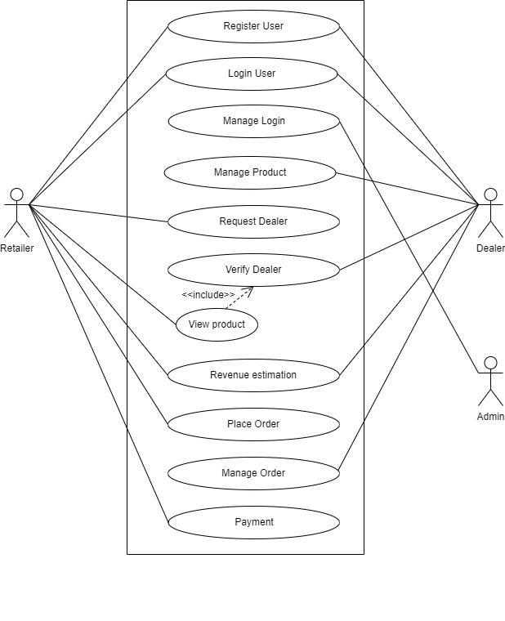

Figure 3. 1Use Case Diagram for WHOLESALE-MART

### 3.2.2 USE CASE

A use case is a software and system engineering term that describes how a user uses a system to accomplish a particular goal. A use case acts as a software modeling technique that defines the features to be implemented and the resolution of any errors that may be encountered.

Use cases define interactions between external actors and the system to attain particular goals. There are three basic elements that make up a use case:

**Actors**: Actors are the type of users that interact with the system.

**System**: Use cases capture functional requirements that specify the intended behavior of the system.

**Goals**: Use cases are typically initiated by a user to fulfill goals, describing the activities and variants involved in attaining the goal.

### 

### 3.2.3 ENTITY RELATIONSHIP DIAGRAM

An Entity Relationship (ER) diagram is a type of flowchart that illustrates how “entities” such as people, objects or concepts relate to each other within a system. ER Diagrams are most often used to design or debug relational databases in the fields of software engineering, business information systems, education and research.

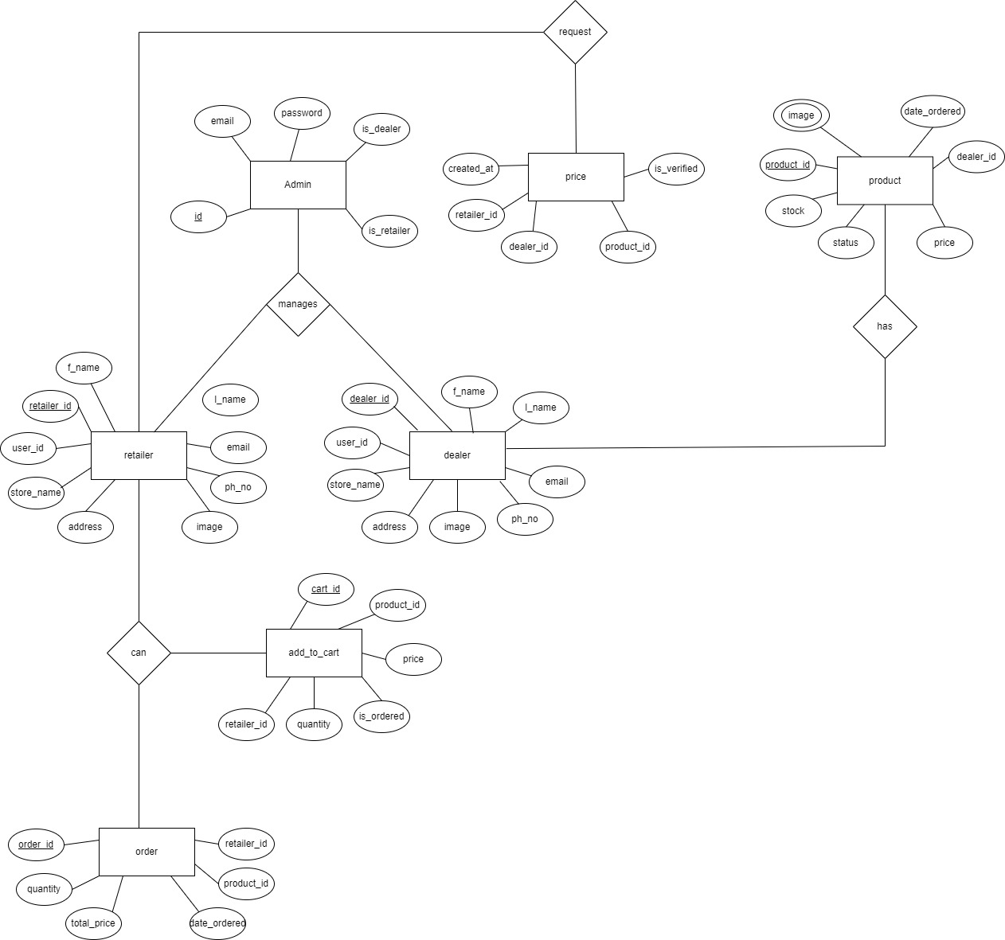

#### Figure 3. 2Entity-Relationship diagram of WHOLESALE-MART

### 3.2.4 SYSTEM SEQUENCE DIAGRAM

A sequence diagram is a type of interaction diagram because it describes how and in what order a group of objects works together. These diagrams are used by software developers and business professionals to understand requirements for a new system or to document an existing process. Sequence diagrams are sometimes known as event diagrams or event scenarios.

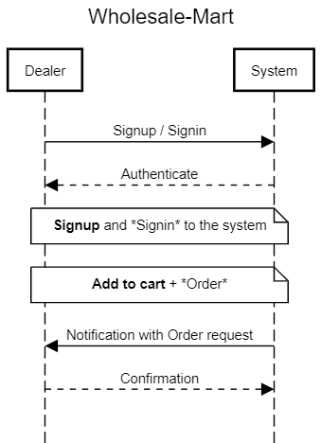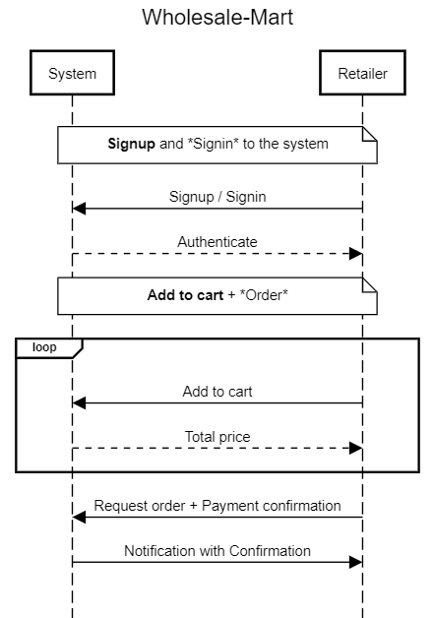

#### Figure 3. 3System Sequence Diagram for WHOLESALE-MART

# Chapter 4

## EXPECTED RESULTS

The outcomes are the changes or results that the organization expects to be achieved after the successful completion of the project. Results are divided into three types:

1. **Outputs:** This platform creates a user-friendly and efficient platform that enables dealers to showcase their products and connect with retailers seamlessly.
2. **Outcome:** This platform empowers dealers and retailers with a reliable and accessible online platform that fosters strong business relationships and drives sales growth.
3. **Impact:** There will be reduction in the cost and save time that is separated to visit the store and salesman expenditure.

# Chapter 5

## TIMELINE CHART

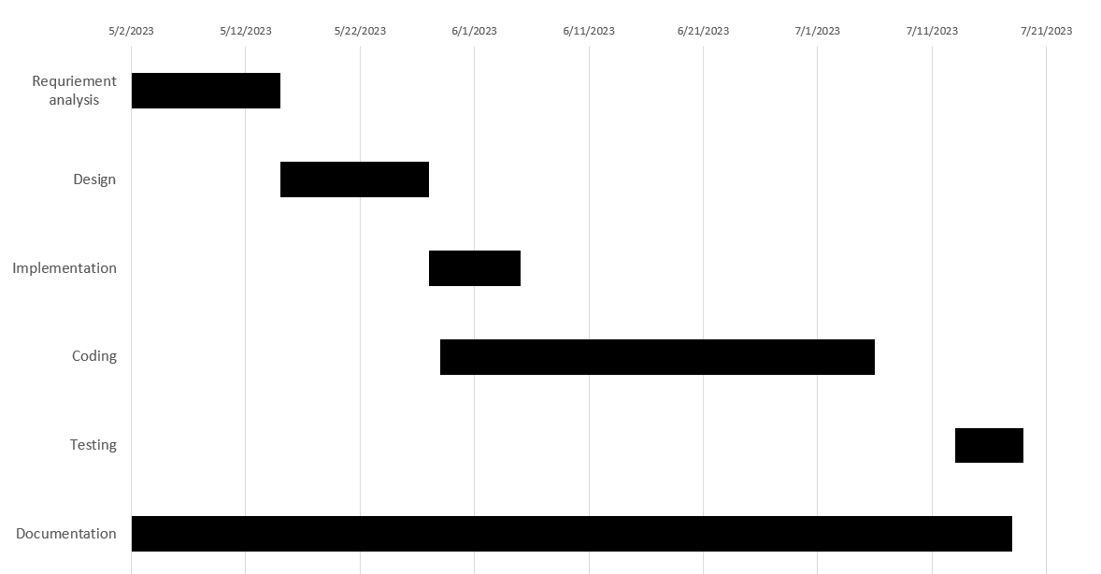

#### Figure 5. 1Timeline chart for WHOLESALE-MART

# Bibliography

Daraz. (2023). *Home Page*. Retrieved from Daraz: https://www.daraz.com.np/

DrawIO. (2023). *Home Page*. Retrieved from Draw IO: https://app.diagrams.net/

OkDam. (2023). *Home Page*. Retrieved from OkDam: https://www.okdam.com/

Sequencediagram. (2023). *Home Page*. Retrieved from Sequencediagram: https://sequencediagram.org/

Thokvikreta. (2023). *Home Page*. Retrieved from Thokvikreta: https://www.thokvikreta.com/

# Appendices

#### 

#### *Figure 6. 3* *Wire-frame of Whole-* *saler List Page*

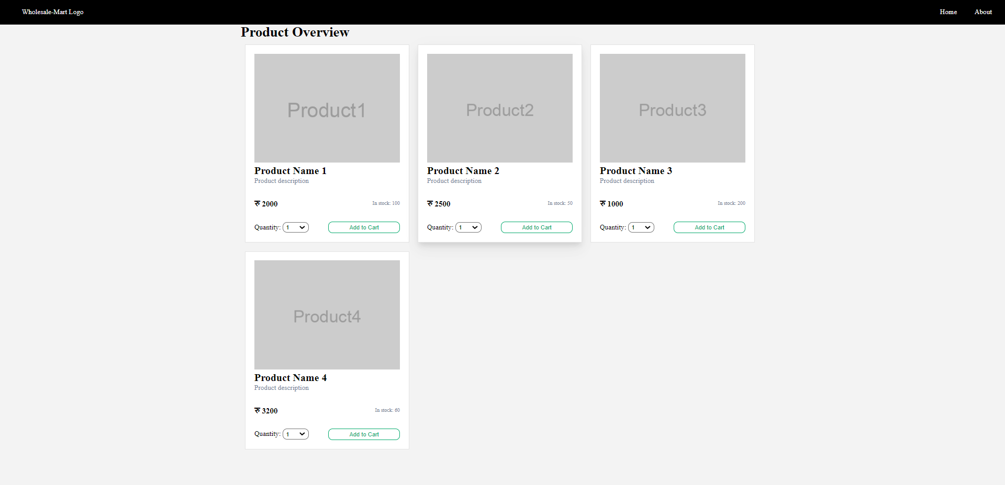

#### *Figure 6. 4* *Wireframe of Product List Page*