GRAPHIC ERA DEEMED TO BE UNIVERSITY
Clementown, Dehradun – 248002



A MINI-PROJECT REPORT
ON
“Hand Gesture Recognition”

Guided By: Submitted By:
Sarishma Dangi Srikant Soni
(Asst. Professor) 2015286

Department of Computer Science Engineering
Graphic Era
Session (2022-2023)

Acknowledgments

I would like to express my sincerest and heartfelt thanks to my supervisors, Mr Ankit Tomatr and Ms. Sarishma Dangi, for their unwavering teaching, support and encouragement in the making of this Project Report. Without their patience and dedication, I would just have thrown in the towel and called it a day, perhaps never to know the wonders of computer vision.

ABSTRACT

The project introduces an application using computer vision for Hand gesture recognition. A camera records a live video stream, from which a snapshot is taken with the help of interface. The system is trained for each type of count hand gestures (one, two, three, four, and five) at least once. After that a test gesture is given to it and the system tries to recognize it.

A research was carried out on a number of algorithms that could best differentiate a hand gesture. It was found that the diagonal sum algorithm gave the highest accuracy rate. In the preprocessing phase, a self-developed algorithm removes the background of each training gesture. After that the image is converted into a binary image and the sums of all diagonal elements of the picture are taken. This sum helps us in differentiating and classifying different hand gestures.

INTRODUCTION

Recent developments in computer software and related hardware technology have provided a value added service to the users. In everyday life, physical gestures are a powerful means of communication. They can economically convey a rich set of facts and feelings. For example, waving one's hand from side to side can mean anything from a "happy goodbye" to "caution". Use of the full potential of physical gesture is also something that most human computer dialogues lack

The task of hand gesture recognition is one the important and elemental problem in computer vision. With recent advances in information technology and media, automated human interactions systems are build which involve hand processing task like hand detection, hand recognition and hand tracking.

This prompted my interest so I planned to make a software system that could recognize human gestures through computer vision, which is a sub field of artificial intelligence. The purpose of my software through computer vision was to program a computer to "understand" a scene or features in an image.

A first step in any hand processing system is to detect and localize hand in an image. The hand detection task was however challenging because of variability in the pose, orientation, location and scale. Also different lighting conditions add further variability.

DIGITAL IMAGE PROCESSING

Image processing is reckoned as one of the most rapidly involving fields of the software industry with growing applications in all areas of work. It holds the possibility of developing the ultimate machines in future, which would be able to perform the visual function of living beings. As such, it forms the basis of all kinds of visual automation.

BIOMETRICS

Biometric systems are systems that recognize or verify human beings. Some of the most important biometric features are based physical features like hand, finger, face and eye. For instance finger print recognition utilizes of ridges and furrows on skin surface of the palm and fingertips. Hand gesture detection is related to the location of the presence of a hand in still image or in sequence of images i.e. moving images. Other biometric features are determined by human behavior like voice, signature and walk. The way humans generate sound for mouth, nasal cavities and lips is used for voice recognition. Signature recognition looks at the pattern, speed of the pen when writing ones signature.

HAND GESTURE DETECTION AND RECOGNITION

DETECTION
Hand detection is related to the location of the presence of a hand in a still image or sequence of images i.e. moving images. In case of moving sequences it can be followed by tracking of the hand in the scene but this is more relevant to the applications such as sign language. The underlying concept of hand detection is that human eyes can detect objects which machines cannot with that much accuracy as that of a human. From a machine point of view it is just like a man fumble around with his senses to find an object.

The factors, which make the hand detection task difficult to solve, are:

Variations in image plane and pose

The hands in the image vary due to rotation, translation and scaling of the camera pose or the hand itself. The rotation can be both in and out of the plane.

Skin Color and Other Structure Components

The appearance of a hand is largely affected by skin color, size and also the presence or absence of additional features like hairs on the hand further adds to this variability.

Lighting Condition and Background

As shown in Figure light source properties affect the appearance of the hand. Also the background, which defines the profile of the hand, is important and cannot be ignored.
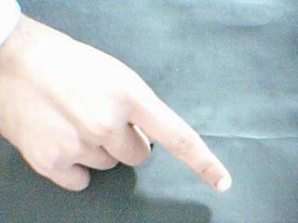

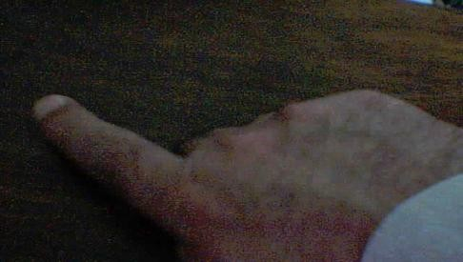

RECOGNITION
Hand detection and recognition have been significant subjects in the field of computer vision and image processing during the past 30 years. There have been considerable achievements in these fields and numerous approaches have been proposed. However, the typical procedure of a fully automated hand gesture recognition system can be illustrated in the Figure given below:
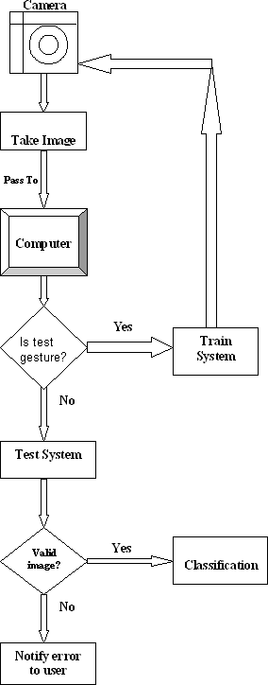

Hand Gesture Recognition Flow Chart

PROJECT CONSTRAINTS

I propose a vision-based approach to accomplish the task of hand gesture detection. As discussed above, the task of hand gesture recognition with any machine learning technique suffers from the variability problem. To reduce the variability in hand recognition task we assume the following assumptions:

    - Single colored camera mounted above a neutral colored desk.
    - User will interact by gesturing in the view of the camera.
    - Training is must.
    - Hand will not be rotated while image is capturing.

The real time gesture classification system depends on the hardware and software.

Hardware
    - Minimum 2.8 GHz processor Computer System or latest
    - Web cam (For real-time hand Detection)

Software
    - Windows 2000(Service Pack 4),XP, Vista, Windows 7,8,10,11,or Linux
    - Visual Studio Code
    - Python Libraries: OpenCV and Numpy

OpenCV

OpenCV is the huge open-source library for the computer vision, machine learning, and image processing and now it plays a major role in real-time operation which is very important in today’s systems. By using it, one can process images and videos to identify objects, faces, or even handwriting of a human. When it integrated with various libraries, such as NumPy, python is capable of processing the OpenCV array structure for analysis. To Identify image pattern and its various features we use vector space and perform mathematical operations on these features.

NumPy
NumPy, which stands for Numerical Python, is a library consisting of multidimensional array objects and a collection of routines for processing those arrays. Using NumPy, mathematical and logical operations on arrays can be performed.
NumPy is a Python package. It stands for ‘Numerical Python’. It is a library consisting of multidimensional array objects and a collection of routines for processing of array.

FUTURE WORK

The system could also be made smart to be trained for only one or two gestures rather than all and then made ready for testing. This will require only a few changes in the current interface code, which were not performed due to the shortage of time.
One time training constraint for real time system can be removed if the algorithm is made efficient to work with all skin types and light conditions which seems impossible by now altogether. Framing with COG (Centre of gravity) to control orientation factor could make this system more perfect for real application.

The system‟s speed for preprocessing could be improved if the code is developed in VC/VC.Net

Conclusion:

The results also showed that the gesture recognition application was quite robust for static images. However, the video version was enormously affected by the amount of illumination, such that it was necessary to check and adjust the HSV values for skin colour when starting the program to get the proper output.

Sometimes the adjustment was difficult to do because of the lighting conditions and the amount of objects in the background. The application was very susceptible to noise on the video stream. Slight hand movements could affect gesture recognition. Nevertheless, if the hand is steady enough for long enough, the program outputs the correct command.

It was also observed that while the program was executing there were memory leaks. Attempts to remedy the problem were made by using the OpenCV functions to release memory. Despite this, the leaks continued. Perhaps the leaks were due to the implementation of OpenCV functions for the sequences behind the scenes.

For integrating the program with the robot in the future, it would be necessarily to consider other output such as speed or velocity as part of the navigational control commands. Based on the results, a computer vision application could detect and recognize simple hand gestures for robot navigation using simple heuristic rules. While the use of moment invariants was not considered suitable because the same gestures could be used pointing in opposite directions, other learning algorithms like AdaBoost could be explored to make the program more robust and less affected by extraneous objects and noise.

Bibliography

J.Jenkinwinston (96207106036), M.Maria Gnanam (96207106056), R.Ramasamy (96207106306), Anna University of Technology, Tirunelveli: Hand Gesture Recognitionsystem Using Haar Wavelet.

Machine Learning (Technical Strategy for AI Engineers in the Era of Deep Learning) by “Andrew NG”

