PRODUCT SALES PORTFOLIO & MARKETING KIT
AttendEase Pro
Low-Budget, High-Quality Multi-Store Attendance Management System Powered by Office Wi-Fi

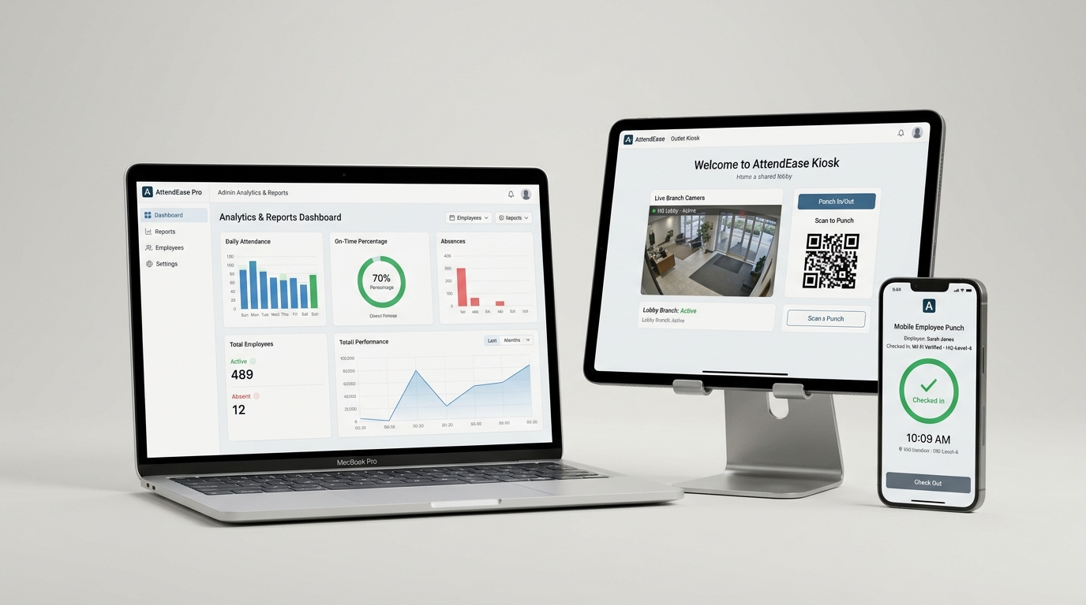
Figure 1: AttendEase Pro Complete Multi-Device Suite (Admin Analytics, Branch Kiosk & Employee Mobile Punch)

1. Executive Summary & Core Value Proposition
The High Cost of Old Attendance Machines: Traditional biometric fingerprint and RFID card machines cost $250 to $800+ per branch. They demand complex wall mounting, power cabling, and dedicated network lines. In day-to-day operations, sensors fail frequently due to dusty or damp fingers, replacement parts are expensive, and syncing multiple branches requires cumbersome software. Alternatively, generic GPS mobile attendance apps are notorious for being bypassed using fake GPS spoofing apps or punched from adjacent coffee shops.
The AttendEase Pro Innovation: AttendEase Pro transforms your office's existing Wi-Fi router into an impenetrable digital timeclock with zero extra hardware. By enforcing office gateway IP/subnet validation combined with single-device cryptographic hardware tokens, employees must physically be connected to the branch Wi-Fi to check in. The system runs on cost-efficient shared web hosting, drastically slashing capital expenditure and ongoing maintenance.
Value Pillar | What It Delivers | Business Impact
💸 90% Cost Reduction | No biometric scanners, RFID cards, or wiring to purchase. Runs on standard cPanel/PHP hosting. | Saves thousands of dollars on hardware purchases and annual maintenance contracts.
🔒 Zero 'Buddy Punching' | Validates office Wi-Fi IP and binds each employee's profile to a single browser cryptographic device token. | Guarantees 100% genuine physical presence; colleagues cannot punch in for each other.
🏢 Multi-Branch Ready | Centralized web portal with outlet quotas, store branding, and real-time attendance streams. | Enables CEOs and HR directors to oversee 1 to 50+ stores or offices from a single screen.
⏱️ Automated Shift Math | Tracks day shifts and overnight cross-midnight shifts, auto-calculating exact late penalties and overtime. | Cuts monthly HR payroll preparation time from days down to a 1-click Excel export.


Figure 2: Seamless Employee Mobile Punch — One-Touch Attendance Verified by Office Wi-Fi

2. Head-to-Head Competitive Comparison
Comparison Factor | Biometric Scanners | Generic GPS Apps | AttendEase Pro (Office Wi-Fi)
Hardware Cost | $300 – $1,200 / location | $0 | $0 (Zero Hardware Required)
Installation Time | 2-4 days (cabling & drilling) | Instant | 5 Minutes (Add Wi-Fi IP in Admin)
Anti-Fraud Security | High (but sensor wears out) | Low (easily mocked via fake GPS) | Very High (Wi-Fi IP + Device Binding)
Multi-Store Sync | Requires complex static IP setup | Cloud-based | Real-time Native Cloud Architecture
Sanitary / Touchless | Unsanitary physical contact | Touchless (own phone) | 100% Touchless & Hygienic
Ongoing Maintenance | High (replacement parts & sensors) | Expensive per-user fees ($5/user) | Ultra-Low (Standard cPanel hosting)

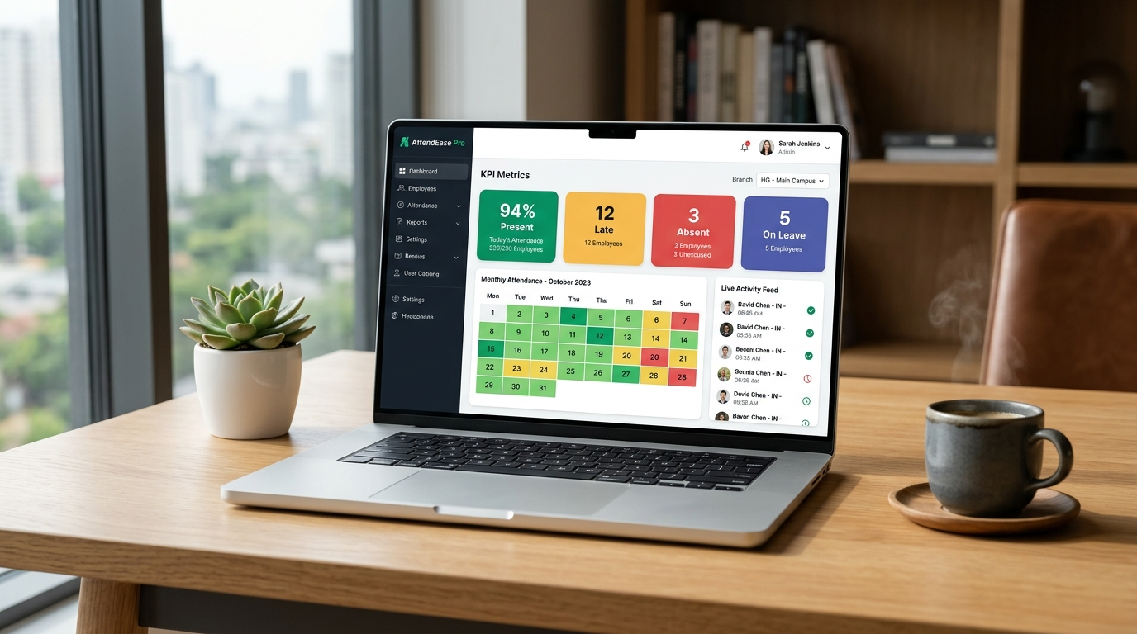
Figure 3: High-Performance Administrator Dashboard — Live Branch Switcher, Real-Time Logs & Monthly Reports

3. Plug-and-Play Website & Sales Outreach Copy
Website Hero Tagline & Pitch:
"Stop Wasting Money on Fragile Biometric Hardware. Turn Your Existing Office Wi-Fi into an Enterprise-Grade Timeclock."
Accurate, tamper-proof employee attendance verified by your office router. No biometric scanners, zero buddy punching, and instant 1-click Excel payroll reports.
WhatsApp & Direct Outreach Script:
"Hi [Business Owner Name]! Still dealing with fingerprint machines breaking down, messy cabling, or employees punching in for their friends? We developed AttendEase Pro — an attendance system that uses your office's existing Wi-Fi router. Employees tap once from their smartphones when they arrive at work. Zero biometric hardware to buy, impossible to fake from outside, and ready for multi-store management. Would you be open to a 2-minute live demo this week?"

4. Product Feature Checklist for Client Proposals
- Wi-Fi IP & Subnet Gateway Enforcement: Attendance calls validate against designated branch office router IP addresses.
- Cryptographic Single-Device Token Binding: Binds each employee's profile to a single smartphone/PC browser to prevent buddy punching.
- Multi-Store Tenant Isolation: Allows owners to configure unlimited branch outlets with individual work shifts and Wi-Fi networks.
- Cross-Midnight & Overnight Shift Engine: Fully supports late-night shifts with automated checkout closures and early-leave calculations.
- Overtime & Late Arrival Tracking: Calculates human-readable precision metrics (+2h 15m OT, -30m late) automatically.
- Automated Excel (.xlsx) & PDF Reports: Pre-formatted monthly summaries filtered by outlet, department, or individual staff members.
- Low-Cost Shared Hosting Compatibility: Engineered with clean Laravel/React architecture running effortlessly on standard cPanel/DirectAdmin.

