1; Email alert notification optimization for messages between manufacturers and wholesalers.
- On each message it will send email.

2; Email alert notification optimization on Shipex email if someone registering Shipex platform
- Done

3; Data to analyse and see how many people who clicked on Shipex website
- Pages for stat:
home, help, privacy, terms, package, subscriptions, profile, settings,
login (manufacturer & wholesaler), register (manufacturer & wholesaler),

4; landing page URLs for ads like Google, naver or any search engine
- You mean to show google Adds In Manufacturer & Wholesaler Login Pages?
In where it will show in the screen below, let me know please.
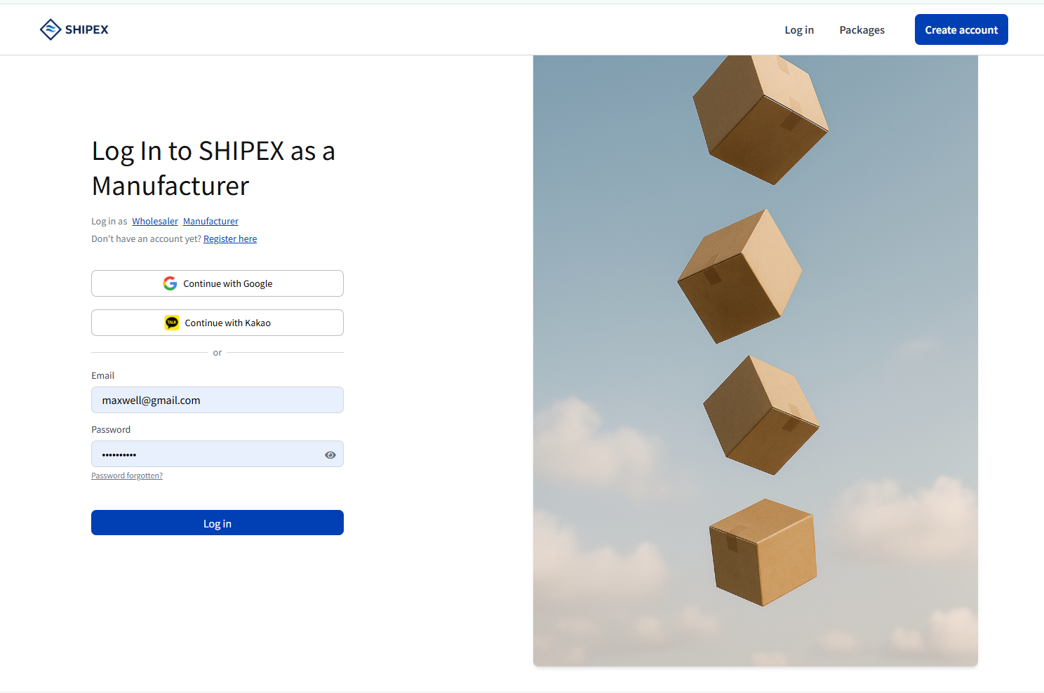

5; another payment for TOSS and one that can host credit card and master card payments
- You mean here will be two gateways, PayPal + TOSS.

