The E-prescription. I have spoken to the API vendor. This what they said about how to integrate.
Please read this document: https://docs.google.com/document/d/101q98xHHgWrPTyKBgu-9LBgJlSctCLnl9_j-hQ2wwtw/edit?tab=t.0

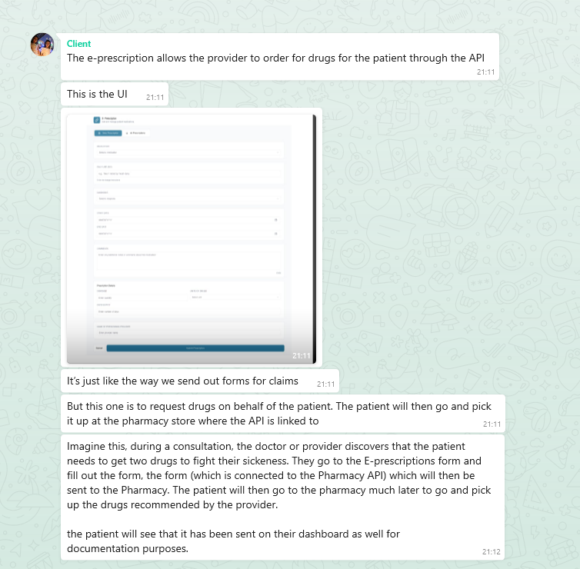

So, a little update, due to the complication of the pricing, we might need to do a simpler pricing system to make things straight forward and easy to implement. We now have just one pricing as well as Medicare. The pricing is $149 monthly ($1499 yearly). I have done the design and you can see it attached.

Figma file for all. the edits here: https://www.figma.com/design/cfKadFc0PqkRUuInCRmKTX/SugarPros?node-id=76-4639&t=GLsPbt6p3QNBC4kt-0
To Access your DxScript UAT Environment
DxScript Auth REST API: https://authtest.sigmapoc.com/api/token
DxScript Web Application SSO URL: https://test2.sigmapoc.com/SSOLogin.asp?token=<token>
HL7 SOAP service URL: https://test2.sigmapoc.com/services/HL7SOAP.svc
DxScript Web Application *Stand Alone* URL: https://test2.sigmapoc.com/

