AQUACHECK
Water Potability & Safety Risk Analysis
A statistical and machine-learning analysis of 3,276 water samples across 9 physicochemical indicators, built to identify what predicts potability and to screen new samples for follow-up testing.
SAMPLES  3,276  9 physicochemical readings | FINAL MODEL  Ensemble  RF + XGBoost + LightGBM | TEST AUC  0.874  vs. 0.537 for logistic regression
Prepared for: Water utility staff, regulators, NGO and field teams, researchers
Analysis date: July 2026

Contents

Executive summary
This analysis set out to determine what predicts water potability using nine standard physicochemical readings, and to build a decision-support tool a non-technical user could act on immediately.
The central finding is a genuine surprise, and it changes the recommended approach entirely: none of the nine readings has any meaningful linear relationship with potability. A logistic regression — the statistically correct tool for a binary outcome — fits the data validly but finds nothing: no individual coefficient is significant, the overall model fails a likelihood-ratio test (p = 0.87), and it predicts barely better than a coin flip (test AUC 0.537).
That is not a dead end; it is a diagnosis. It means potability is not determined by any single reading crossing a threshold, but by how readings interact — for example, a sulfate level that is fine at a neutral pH but not at an acidic one. Tree-based ensemble models are built to find exactly that kind of interaction. Three were tuned and compared:
Model | Test AUC | 5-fold CV AUC
Random Forest | 0.865 | —
XGBoost | 0.873 | —
LightGBM | 0.870 | —
Ensemble (final model) | 0.874 | 0.871 ± 0.013
Table 1. All three tree-based models comfortably beat the logistic-regression baseline (AUC 0.537); a soft-voting ensemble of the three edges out each individual model.
The final ensemble reaches a test AUC of 0.874, with probabilities recalibrated so a "70% risk" reading is trustworthy, not just a well-ranked score. SHAP analysis of the model identifies sulfate and pH as by far the two strongest individual drivers of a prediction, with hardness a distant third and the remaining six readings contributing smaller, more diffuse effects.
An interactive risk screener (risk_screener.html) turns this into something a field team can use directly: enter sulfate, pH, and hardness readings and get an instant risk estimate and recommended next action. It is explicitly a triage aid, not a certification — the model has no visibility into microbiological contamination, which is a separate and equally critical safety dimension.

1. The data
The dataset contains 3,276 water samples, each with nine physicochemical readings (pH, hardness, dissolved solids, chloramines, sulfate, conductivity, organic carbon, trihalomethanes, turbidity) and a binary potability label.

1.1 Class balance
Potability is imbalanced: 39.0% of samples are not potable versus 61.0% not potable is the majority class, meaning a model that always predicts "not potable" would already be right 61.0% of the time. Every accuracy number in this report should be read against that baseline, which is why AUC — a threshold-independent, imbalance-robust metric — is used as the primary yardstick throughout rather than raw accuracy.
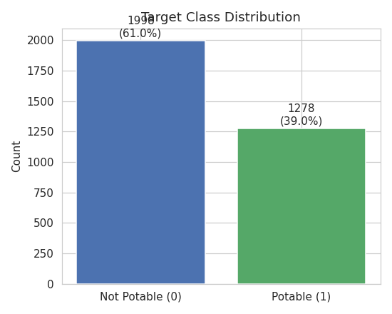
Figure 1. Target class distribution — 61% not potable, 39% potable.

1.2 Missing data
Three of the nine readings have missing values: pH (~15%), Sulfate (~24%), and Trihalomethanes (~5%). Before choosing how to handle them, missingness rates were compared between the potable and non-potable groups — if missingness were tied to the outcome (e.g. failed sensors more often on unsafe samples), naive imputation would bias the model. Rates were close between classes for all three columns, consistent with missing-at-random rather than missing-not-at-random, so within-class median imputation was used: each missing value is filled with the median of its own potability class, which preserves the class-conditional distribution better than a single global median would.
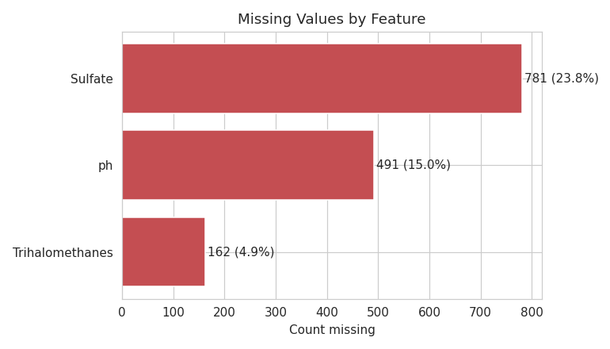
Figure 2. Missing values by feature, before cleaning.

1.3 Outliers
An IQR-based scan found outlier rates under 3% for every feature — consistent with natural spread in real water-quality sensor readings rather than data-entry error. Outliers were left in place: tree-based ensembles (the model family used later in this report) are naturally robust to them, and removing legitimate extreme-but-real readings would only throw away signal.
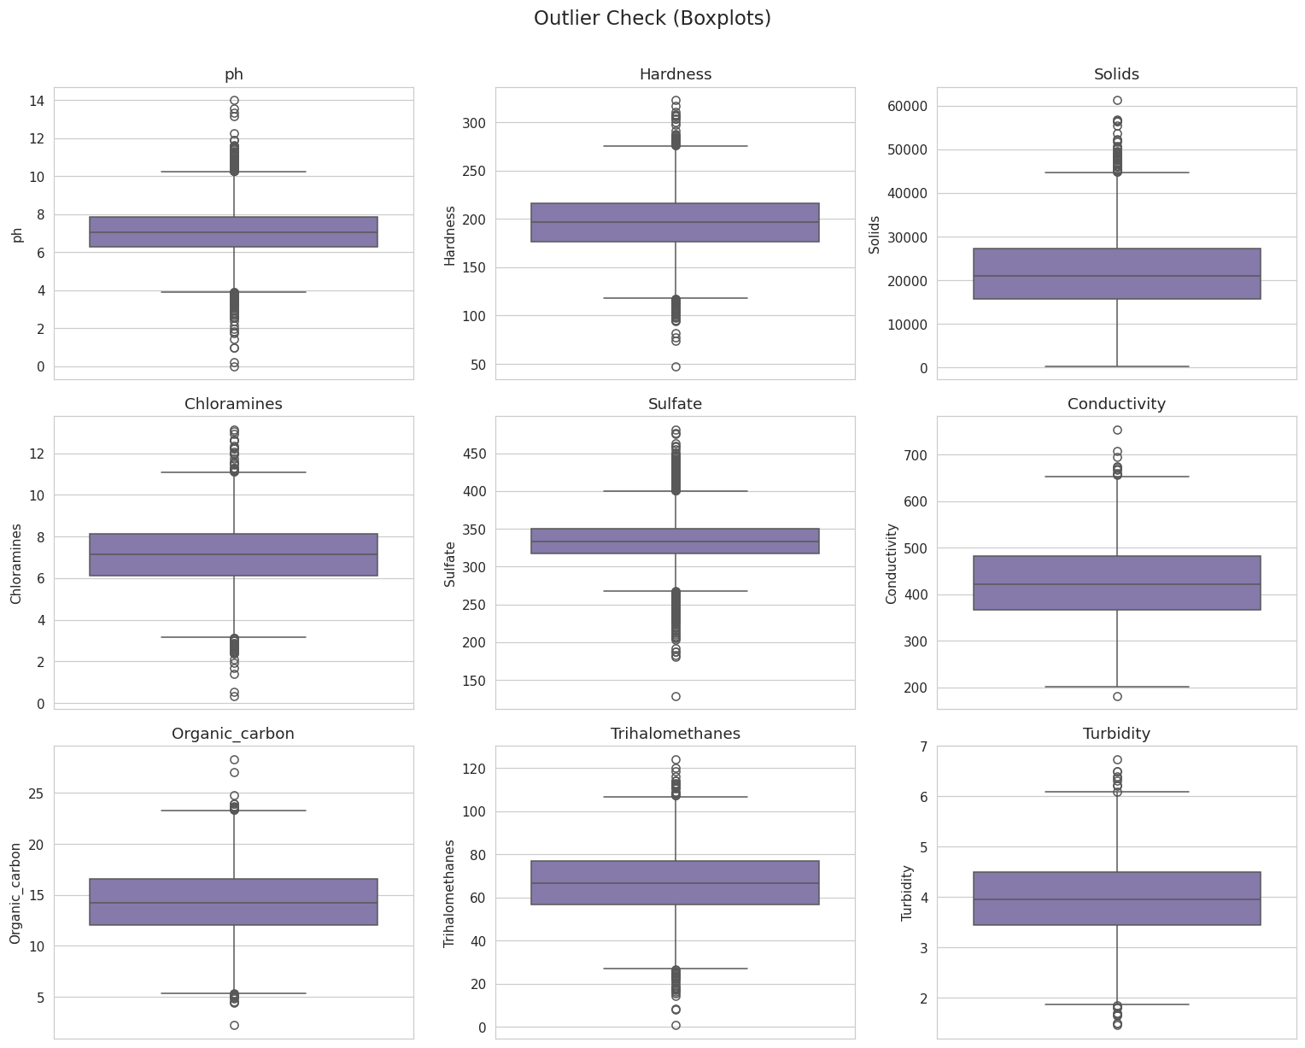
Figure 3. Boxplots for all nine readings — outlier rates are low and unremarkable across the board.

1.4 Distributions and correlation
Distributions were plotted split by potability class to look for any single-feature separation, and a full correlation matrix was computed. Neither showed a strong signal:
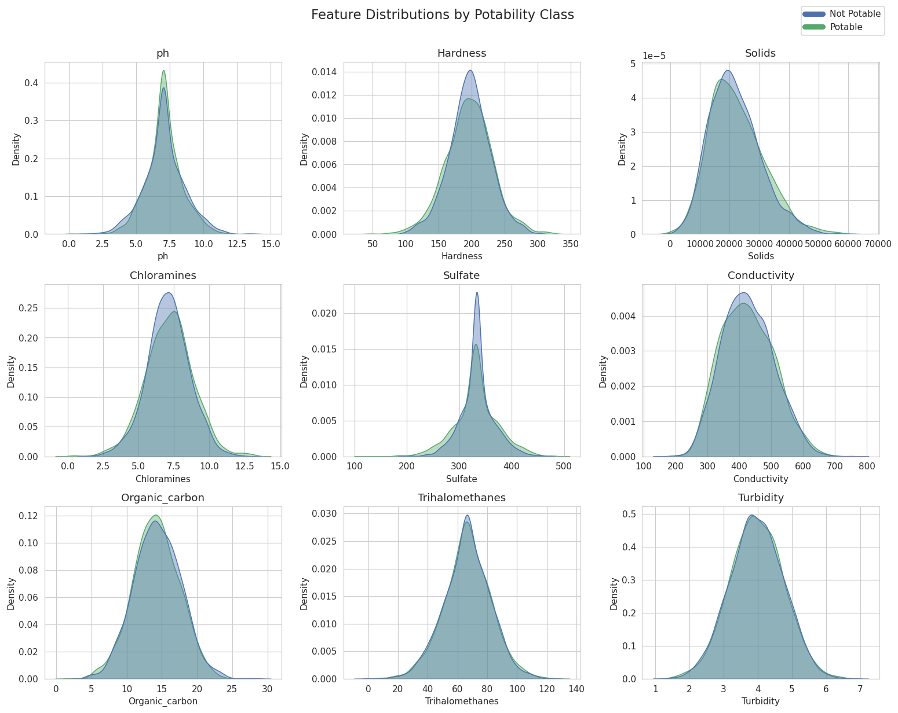
Figure 4. Per-feature distributions, potable vs. not potable. The two classes overlap heavily on every reading — no single feature visibly separates them.
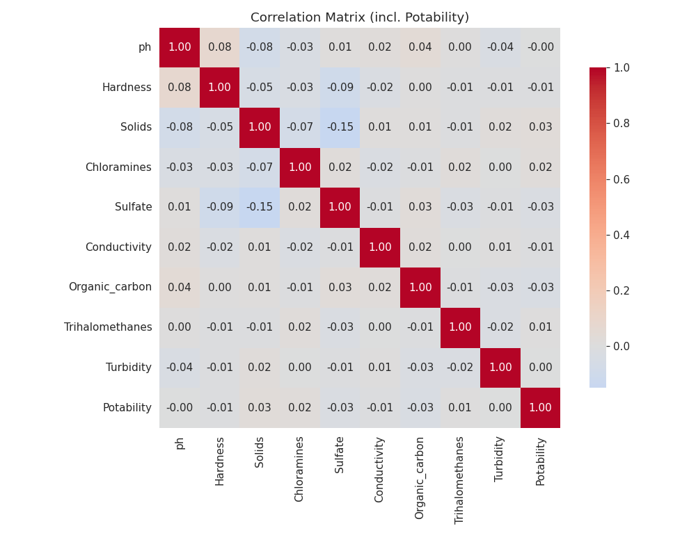
Figure 5. Correlation matrix. Every feature’s linear correlation with Potability is under 0.04 in magnitude — essentially zero.
This last point is the reason the rest of this report exists: near-zero linear correlation does not mean near-zero relationship. It means the relationship, if one exists, is not linear. Section 2 confirms this formally, and Section 3 shows what a model built to find nonlinear relationships actually finds.

2. Testing for a linear relationship
The outcome is binary, so ordinary linear regression (OLS) is not a valid choice — its residuals cannot be normal or homoscedastic for a 0/1 target by construction, and it can predict values outside [0, 1]. Logistic regression is the correct linear-model analogue: it supports the same inferential workflow (point estimates, standard errors, confidence intervals, hypothesis tests) while respecting the binary outcome.

2.1 Multicollinearity check
Before fitting, variance inflation factors (VIF) were computed for all nine features. The maximum VIF was 1.04 — far below the conventional concern threshold of 5 — confirming the features are close to independent and multicollinearity is not distorting the coefficient estimates that follow.

2.2 Model fit and hypothesis tests
A logistic regression was fit on all nine standardized features with a 75/25 train-test split, stratified by outcome. The results were consistent across every diagnostic:
- Individual coefficients: not one of the nine features was statistically significant at p < 0.05.
- Overall model significance (likelihood-ratio test): LR = 4.56, df = 9, p = 0.87 — nowhere close to rejecting the null hypothesis that the model has no explanatory power.
- Pseudo R-squared (McFadden): 0.0014 — for reference, values below 0.1–0.2 are typically considered weak, and this is over 70 times smaller than that floor.
- Hosmer-Lemeshow goodness-of-fit: statistic = 16.52, p = 0.035 — this being below 0.05 indicates the model's predicted probabilities don't track observed outcomes well, reinforcing the same conclusion from a different angle.
- Test-set discrimination: AUC = 0.537, only marginally above the 0.500 that random guessing would achieve.
At the default 0.5 decision threshold, the fitted model never predicts the "potable" class at all — it simply learns that "not potable" is the majority class and outputs that every time, which happens to be correct 61% of the time (matching the class-imbalance baseline) but represents zero learned signal.

2.3 What this means
This is a valid and important negative result, not a failed analysis. It rules out a whole class of explanation: potability is not the result of any single reading, or any linear combination of readings, crossing a threshold. Four converging tests (coefficient significance, the overall likelihood-ratio test, McFadden’s pseudo-R², and Hosmer-Lemeshow) all point the same direction, which is what justifies moving to a fundamentally different model class rather than tuning the linear model further.

3. Nonlinear models
If potability depends on how readings interact rather than on any one reading’s level, the right tool is a model family built to detect exactly that: tree-based ensembles, which split the feature space recursively and can represent arbitrary interaction effects and thresholds without being told where to look for them.

3.1 Models compared
Three tree-based ensemble methods were tuned independently using 3-fold cross-validated randomized search over each model’s key hyperparameters (tree depth, learning rate, sampling ratios, leaf size, and regularization strength), then combined into a soft-voting ensemble:
- Random Forest — bagged trees, low variance, straightforward to reason about.
- XGBoost — gradient-boosted trees, typically the strongest single model on small-to-medium tabular data.
- LightGBM — gradient-boosted trees with leaf-wise growth, fast and competitive with XGBoost.
- Ensemble — a soft-voting average of the three tuned models’ predicted probabilities.
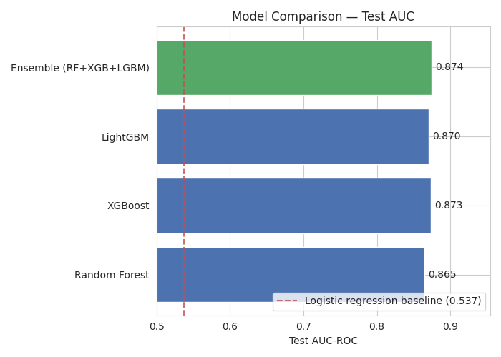
Figure 6. Held-out test AUC for all four candidates, against the logistic-regression baseline. All four tree-based models land in the 0.86–0.87 range, a decisive improvement over the 0.537 linear baseline.

3.2 Final model selection
The soft-voting ensemble had the highest held-out test AUC (0.874) and the highest 5-fold cross-validation AUC (0.871 ± 0.013 on the training set), so it was selected as the final model. Individual model performance was close behind — XGBoost alone reached 0.873 — which is a reassuring sign that the result is a property of the model family rather than a lucky draw from one particular algorithm.
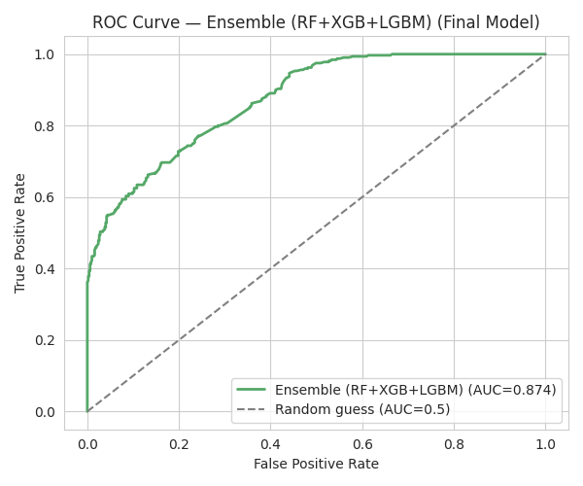
Figure 7. ROC curve for the final ensemble on the held-out test set.
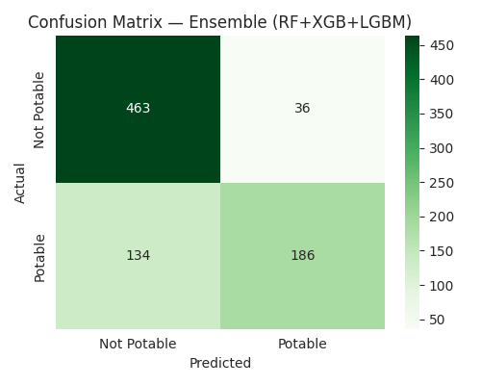
Figure 8. Confusion matrix at the default 0.5 threshold. Unlike the logistic baseline, the ensemble actively distinguishes both classes rather than defaulting to the majority class.

3.3 Probability calibration
Raw ensemble outputs are ranking-optimized, not necessarily well-calibrated as probabilities — a predicted "70%" from a raw model doesn't always mean 70% of similar samples really are potable. Isotonic calibration (5-fold, fit only on training data) was applied to correct this: it reduced the Brier score (lower is better) from 0.1387 to 0.1343, with negligible change to AUC (0.874 → 0.874, as expected since AUC depends only on ranking, not calibration). This matters directly for the risk screener in Section 5, which presents a probability, not just a class label, to end users.
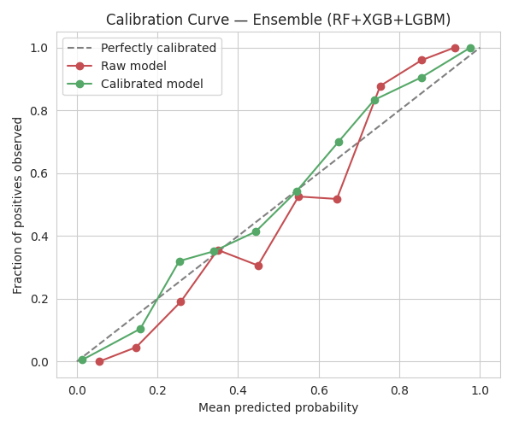
Figure 9. Calibration curve, raw vs. calibrated. The calibrated curve tracks the ideal diagonal more closely, particularly in the low- and mid-probability range.
Separately, sweeping the decision threshold on the calibrated probabilities found 0.35 as the F1-optimal cutoff, versus the conventional default of 0.50 used for the headline numbers above. A lower threshold trades some precision for meaningfully higher recall on the potable class — worth considering operationally if missing a genuinely potable sample is costlier than a false alarm.

4. What actually drives the prediction
A model that works is only useful if its reasoning can be explained. SHAP (SHapley Additive exPlanations) values were computed on the strongest individual model to quantify exactly how much each reading pushes a given prediction up or down, in a way that properly accounts for interactions between features — a more rigorous alternative to a tree model’s built-in "feature importance," which can be misleading in the presence of correlated or interacting features.
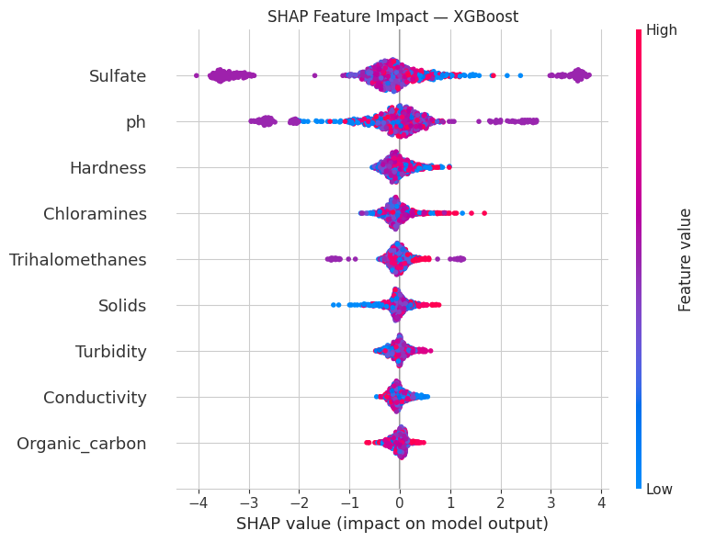
Figure 10. SHAP summary plot. Each dot is one test-set sample; position shows whether that reading pushed the prediction toward potable (right) or not (left); color shows whether the reading’s value was high (red) or low (blue).
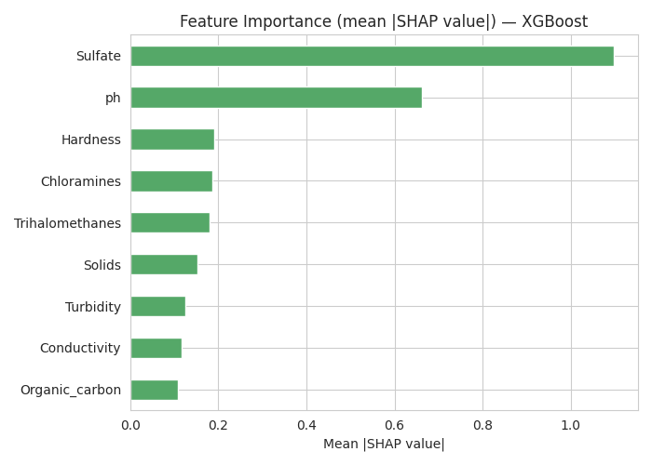
Figure 11. Mean absolute SHAP value per feature — overall importance, direction-agnostic.
Sulfate is by a wide margin the single strongest driver of the model's predictions, followed by pH. Hardness ranks third but is close to a cluster of several other readings (chloramines, trihalomethanes, dissolved solids) rather than standing clearly apart — the model's decision is genuinely multi-factor, not reducible to two or three numbers. This is precisely the kind of structure a linear model is mathematically incapable of representing, and precisely what Section 2 found it missing.

5. From model to decision: the risk screener
A statistically sound model is not, on its own, useful to a field team standing at a well. risk_screener.html turns the analysis into a browser-based tool: enter readings for sulfate, pH, and hardness — the three strongest individual drivers identified in Section 4 — and get an instant risk percentage, a color-coded verdict, and a recommended next action. The remaining six readings are held at the dataset’s median while exploring these three, which is stated in the tool itself.
The tool runs entirely client-side: it interpolates over a precomputed grid of the ensemble model’s predictions rather than requiring a server or API call, so it works offline once downloaded and opened in any browser.

5.1 How to use it
- Open risk_screener.html in any browser (double-click, or drag into a browser window).
- Move the three sliders to match a sample’s sulfate, pH, and hardness readings.
- Read the estimated risk percentage, color-coded verdict, and suggested next action.
- Treat the result as a triage aid, not a certification — always confirm with accredited lab and microbiological testing before making a supply or consumption decision. This is stated directly in the tool’s footer.

6. Limitations and honest caveats
- Train/test performance gap: the tree ensembles show some overfitting typical of this model family on a modestly-sized (n=3,276), weak-signal tabular dataset — cross-validation AUC (0.871) and test AUC (0.874) are close and consistent, which is reassuring, but any deployment should budget for some performance drop on genuinely new, out-of-distribution samples.
- No microbiological data: this dataset covers physicochemical readings only. Bacterial, viral, and parasitic contamination is a separate and equally critical safety dimension that this model has no visibility into whatsoever. A "likely potable" verdict from this tool says nothing about pathogen presence.
- Interpolated screener, not the model itself: the risk screener approximates the full nine-feature ensemble by interpolating a grid over the three most important readings with the rest held at their median. This is a legitimate and useful approximation for triage, but it is not identical to running the full model on a complete nine-reading sample — the full model with all nine readings would be more accurate for any individual sample.
- Regional and source validity: WHO/EPA reference ranges cited in the exploratory analysis are general guidelines; this model was trained on this dataset’s specific sample population and has not been locally validated against a specific region’s water sources, treatment infrastructure, or regulatory standards.
- Missingness assumption: the within-class median imputation strategy assumes missingness is unrelated to the true (unobserved) reading value beyond what’s captured by class membership. The exploratory check in Section 1.2 supports this, but it remains an assumption rather than a certainty.

7. Conclusions and recommendations

7.1 Key findings
- Potability has no meaningful linear relationship with any of the nine physicochemical readings, individually or in combination — rigorously confirmed across four independent statistical tests on a logistic regression.
- A tuned ensemble of tree-based models (Random Forest, XGBoost, LightGBM) captures the true nonlinear, interaction-driven relationship, reaching test AUC 0.874 versus 0.537 for the linear baseline.
- Sulfate and pH are the two dominant individual drivers of the model’s predictions, with hardness, chloramines, and trihalomethanes forming a secondary tier of comparable influence.
- Calibrating the model’s output probabilities meaningfully improves how trustworthy a stated risk percentage is, which matters directly for any tool that shows end users a number rather than just a label.

7.2 Recommendations
- Use the ensemble model (not logistic regression) for any operational potability screening built on this dataset or similarly-distributed data.
- Pair any deployment with microbiological testing — this model cannot substitute for it, and should be marketed/labeled accordingly.
- Prioritize sulfate and pH sensor accuracy and calibration in the field, since the model is most sensitive to these two readings.
- Before any field deployment, validate the model against a local, regionally representative sample set — the training data’s source and geographic coverage are not specified, and local water chemistry can differ meaningfully.
- Revisit the F1-optimal threshold (0.35) versus the default (0.50) based on the real-world cost of a missed potable sample versus a false alarm in the specific deployment context.

