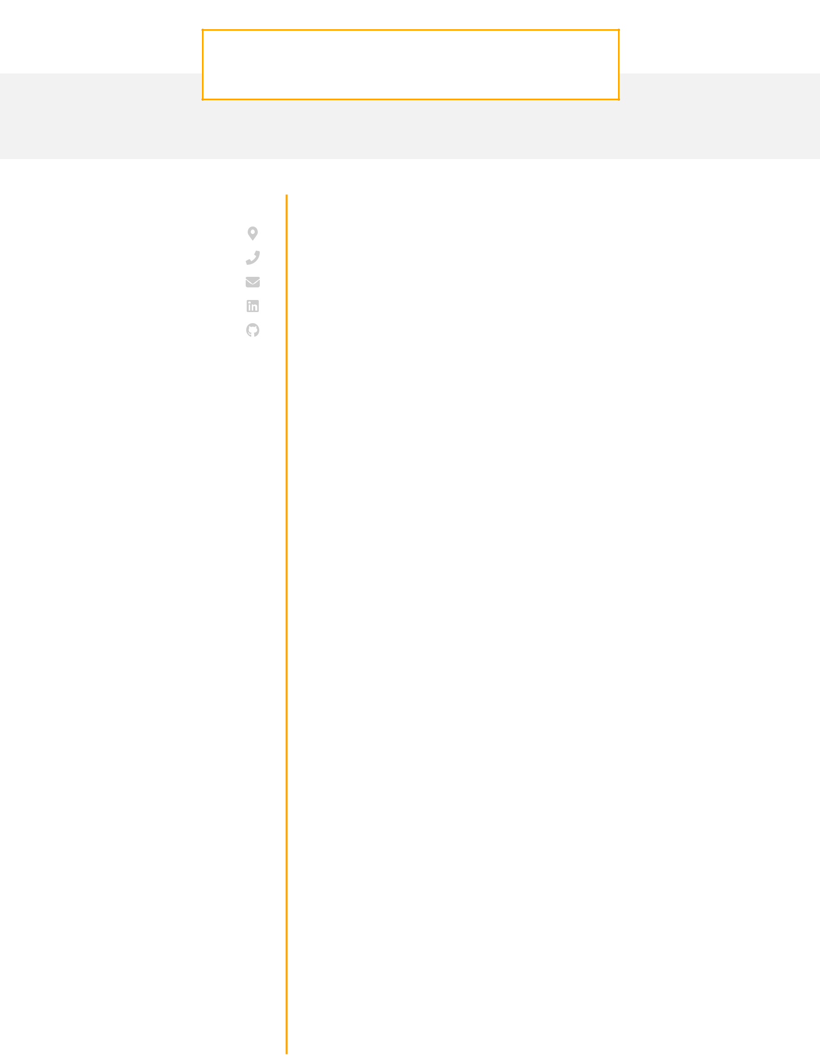
JOHN GONALEZ

Python Developer

CONTACT

Pittsburgh, PA

- 456-7890 john1652@gmail.com LinkedIn Github

EDUCATION

M.S.

Computer Science

University of Chicago
Chicago, IL / 2014 - 2016

B.S.

Computer Science

University of Pittsburgh
Pittsburgh, PA / 2010 - 2014

SKILLS

HTML/ CSS

SQL (PostgreSQL, Oracle)

JavaScript (Angular)

Python (Django)

REST APIs (GraphQL)

AWS (Redshift, S3)

Git

CAREER OBJECTIVE

Experienced Python developer with extensive Django experience looking to continue to develop my skill set on the back-end at a company driven to addressing the climate crisis.

WORK EXPERIENCE

Python Developer
DoorDash / September 2018 - current / Chicago IL
· | Worked on building new Angular components for the customer-
 | facing web app which improved the time on page for the
· | average user by 2 minutes
· | Worked within an agile team and helped prioritize and scope
 | feature requests to ensure that the biggest impact features were
· | worked on first
· | Built extensive test coverage for all new features which reduced
 | the number of customer complaints by 7%

Python Developer
Knewton / April 2016 - September 2018 / Pittsburgh PA
· Worked alongside another developer to implement RESTful APIs in Django that enabled our internal analytics team to increase reporting speed by 24%

· Using Selenium built out a unit testing infrastructure for a client web application that reduced the number of bugs reported by the client by 11% month over month

PROJECTS

Cryptocurrency Price Tracker
Creator

- Incorporated API calls to several applications and stored data eﬃciently in in our PostgreSQL backend

- Utilized D3.js to allow users to dynamically visualize price movements over time periods of their choosing

