For optimal resolution, recommend clicking here to view in browser

Issue 9 | March 2021




TOPLINE NEWS

News from Around the Company: RDV Response Team shares:


- Preliminary results of RECOVERY trial evaluating tocilizumab in hospitalized COVID-19 patients with hypoxia and systemic inflammation
- Next steps in response to results from the tocilizumab + RDV Phase 3 REMDACTA trial

Insights: What we've learned so far from four recent advisory panels and one Sentinel panel, and outputs from Global Connectivity Week 2021. FEATURED: Conference insights from CROI 2021


Research: Assessment of two recent RDV RWD studies from Italy and one RDV RWD study from Spain; additional updates from the COMMIT RFP program


COVID-19 Landscape:


- Phase 3 favipiravir study in Kuwait fails to meet primary endpoint
- FDA grants EUA's for bamlanivimab+etesevimab and Johnson & Johnson's COVID-19 vaccine
- Pfizer/BioNTech provide new stability data for their COVID-19 vaccine
- Pfizer-BioNTech COVID-19 vaccine found to reduce SARS-CoV-2 virus transmission after 1 dose
- Merck to support Johnson & Johnson with manufacturing and supply of COVID-19 vaccine
- Monoclonal antibody VIR-7831 demonstrates 85% reduction in hospitalization or death, and maintains activity against UK, South African, and Brazilian variants

Resources:


- New COVID-19 Treatment Guidelines slide deck
- New Disease Course and Treatment Timing slide deck
- Updated Investigational Therapeutics for COVID-19 slide deck
- Updated RDV Medical Affairs FAQ

NEWS FROM AROUND THE COMPANY
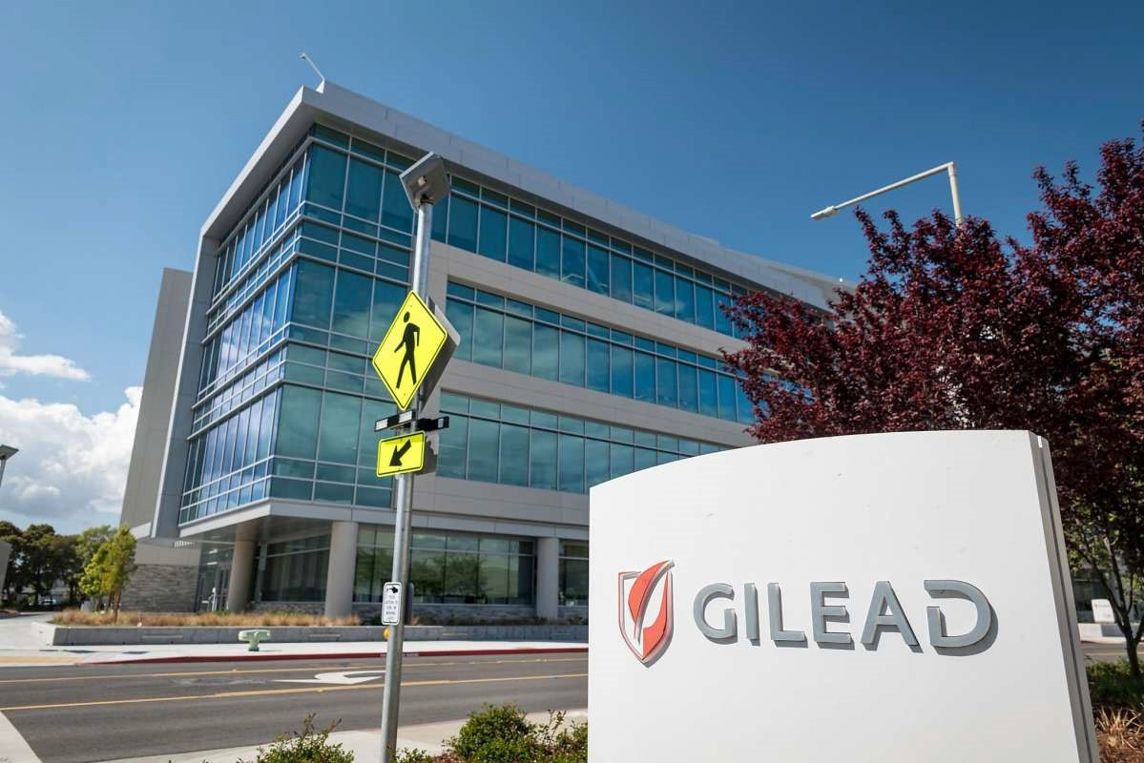

RDV Response Team: Response to the RECOVERY Trial (Tocilizumab)
On February 11, preliminary data was released as a preprint from the Randomized Evaluation of COVID-19 Therapy (RECOVERY) study conducted by Oxford University, demonstrating that tocilizumab, a humanized anti-interleukin (IL)-6 receptor antagonist approved globally for the treatment of certain rheumatologic disorders and cytokine release syndrome, reduced mortality by 15% and reduced the need for a ventilator and time spent in hospital in severe COVID-19 patients.
In response, the RDV Response Team provided a communication with an overview of the study design and results, and concluded that no action is needed at this time from the country level.

Study Design
- Randomized, controlled, open-label study evaluating safety and efficacy of tocilizumab in hospitalized COVID-19 patients with evidence of hypoxia and systemic inflammation
- 2022 patients randomized to tocilizumab IV + SoC vs. 2094 patients on SoC. As part of SoC, patients could be on dexamethasone and the anti-viral, VKY

Results
- Primary outcome:
  - 596 (29%) of the patients in the tocilizumab group died within 28 days compared with 694 (33%) patients in the SoC arm (rate ratio 0.86; [95% confidence interval [CI] 0.77 to 0.96]; p=0.007)
- Secondary outcome:
  - Tocilizumab increased the probability of discharge alive within 28 days from 47% to 54% (rate ratio 1·23, [95% CI 1.12 to 1.34], p<0.0001). These benefits were seen in all patient subgroups, including those requiring oxygen via a simple face mask through to those requiring mechanical ventilators in an intensive care unit
  - Among patients not on invasive mechanical ventilation at enrollment, tocilizumab significantly reduced the chance of progressing to invasive mechanical ventilation or death from 38% to 33% (risk ratio 0.85, [95% CI 0.78 to 0.93], p=0.0005)

RDV Response Team: Response to the REMDACTA Trial (Tocilizumab + RDV)
On March 11, Roche announced that the Phase 3 REMDACTA trial of tocilizumab + RDV vs. placebo + RDV did not meet its primary endpoint of time to improved hospital discharge at Day 28 for patients with severe COVID-19 pneumonia.
In light of this press release, the RDV Response Team communicated the following next steps and actions:
- Reactive company statement was sent to local Pubic Affairs leads by Arran Attridge (Global Public Affairs)
- Reactive Medical Affairs REMDACTA FAQ [link] was sent to local MA leads by Lauren Dau (Global Medical Affairs)
- Questions on the findings related to tocilizumab are to be referred to Roche

INSIGHTS


Digital Advisory Panel 2021 (February)

An online longitudinal digital global advisory panel, which initially ran from July to December 2020, resumed in February 2021 featuring a panel of 11 experts representing Italy, UK, Spain, Germany, Argentina, US, and Japan. In the first round for 2021, the following topics were covered:

FEBRUARY 3:


Maximum Symptom Duration Before Starting RDV: For a majority of participants, use of RDV was limited to patients who had symptom onset within 7-10 days. Generally, limitations are more strongly enforced in European countries, with more therapeutic liberty found in the US, and no restrictions found in Japan.
Delay Between Hospital Admission and Start of RDV Treatment: Answers varied by country/region, with RDV
treatment generally being initiated within the same day as hospital admission. In cases where there were delays, reported causes included consultations between ID physician and pulmonologist (US), clinical management being performed at home (Italy, Japan), and SARS-CoV-2 PCR tests (Japan).
Full report with additional topics >>

Austria COVID-19 Advisory Board (February 11)

A virtual MAAP led by the Austria Medical Affairs team was held on February 11, featuring a panel of 6 advisors. The objectives of this MAAP were to gain insights on the positioning of RDV in the treatment of COVID-19 patients in Austria, to gain insights into the clinical effectiveness and usage of RDV, to learn about the barriers to using RDV, and to determine the need for medical education and preferred methods of communication.
Below is a snapshot of the insights from the panel:

Feedback on the Positioning of RDV: Participants recommended that RDV be started early in disease. Generally, treatment initiation should take place until Day 10 after symptom onset, although this isn't a clear cutoff; RDV treatment may be started within Days 12 or 13, but not after Day 14. Additionally, advisors agreed that oxygen saturation and symptom duration are key factors in selecting RDV for treatment.


Current Situation and COVID-19 Management: The current situation in all hospitals is stable and well under control, although SARS-CoV-2 mutations are of concern and will likely cause a third wave in Austria. All advisors agreed that SARS- CoV-2 is not likely to disappear anytime soon, and will be something we will have to live with (as we do now with the influenza virus).


Full report with additional topics >>

Korea COVID-19 Advisory Board (December 16)
A virtual MAAP led by the Korea Medical Affairs team was held on December 16, featuring a panel of 5 ID specialists. The objectives of this MAAP were to identify the
current standard of care in Korea, obtain insights on the relevance of RDV treatment in clinical practice based on available clinical trials and real-world studies of RDV, and understand the optimal clinical usage and RDV's future role in COVID-19 treatment.
Below is a snapshot of the insights from the panel:

Brief Review of RDV Clinical Data: For COVID-19 patients with hypoxia, RDV ± steroid treatment was standard of care in Korea. Additionally, advisors agreed that early use of RDV was beneficial to moderate patients, although there was a lack of consensus on the definition of severities in clinical practice.


Ongoing RDV Monotherapy and Combination Studies: Two advisors stated that outpatient treatment of COVID-19 would not be feasible in Korea, given the limited resources in hospitals designed for COVID-19 care. There are currently no effective treatment options available for critically ill patients, and thus different combination therapies should be evaluated continuously to meet the unmet need for effective treatment in these patients.


Full report with additional topics >>

US COVID-19 Sentinel Panel #6 (January 25 - February 4)
A US Sentinel panel led by the US Medical Affairs team was launched in July, targeting up to 40 US healthcare providers who are actively engaged in the management of patients with COVID-19. Each panel consists of virtual KOL pulse engagements, with 30-minute surveys done every 2 weeks over the span of 3 months.
The primary objective of the Sentinel panel is to gain insights on COVID-19 treatment to better understand and react to a rapidly changing environment. This information will be used to enhance and adapt Medical Affairs educational programs for healthcare providers.
The sixth panel was completed in January and February, and featured 19 panelists representing infectious diseases, critical care/emergency medicine, pulmonology, and gastroenterology/hepatology. The majority of respondents currently practice at an academic institution.
Below is a snapshot of the insights from the panel:



Eligibility for RDV Treatment: Based on survey responses, RDV is prescribed across the spectrum of COVID-19 disease, most often being given to patients on low-flow oxygen followed by those requiring high-flow oxygen. 37% of respondents reported that RDV is also prescribed in IMV and ECMO patients. 95% reported that they have enough RDV to treat all of their COVID-19 patients, even with recent increased demand. And RDV use has remained stable over the past 3 months, and has generally not been impacted by other COVID-19 therapeutic agents.


COVID-19 Vaccinations: Among patients, those aged 65+ and those with co-morbidities are currently being targeted for vaccination. Among these at-risk individuals, there is a variable but improving uptake of vaccination. 74% of respondents were not concerned with safety of the available vaccines, but are generally more concerned with efficacy against emergent variants.

Full report with additional topics >>

US COVID-19 MS MAAP (January - February)
In January and February, the US MS COVID-19 team conducted a series of four MS MAAPs engaging 30 clinical pharmacists from across the United States whose backgrounds ranged from infectious diseases to Director of Pharmacy. The team gathered opinions on the RDV clinical trial data (ACTT-1 and the SIMPLE studies) and gained an understanding of how their institutions develop protocols and clinical pathways.
Key findings included:

Clinical trials and experience are the primary drivers in the development of institutional protocols, rather than guidelines. Clinical pharmacists play a critical role in the development of their respective institutional guidelines

A major concern is how cumbersome it is to prepare RDV; pharmacists requested data on alternative methods of preparation which are less time-intensive (e.g., tubing prepared IV solution; use of NS instead of SWFI for reconstitution; developing ADD-Vantage bags)


Cost increase is a concern because RDV is impacting pharmacy budgets (pharmacy works within an annual budget and even though the drug is reimbursed to the hospital, pharmacy does not receive the drug portion back). Despite showing Cost-Effectiveness Analysis (CEA) data, pharmacists stated that information on budget impact would be more relevant to them


Full report with additional topics >>

Conference Insights


US - CROI 2021 (Overview)
CROI 2021 was held on March 6-10 as a virtual event, and featured a number of abstracts from Gilead Sciences, Inc. spanning the company's HIV and COVID-19 research efforts. In attendance were representatives from the Global Medical Affairs (Mark Thrun, Frida Abramov, Lauren Dau, Aprille Espinueva) and the US Medical Affairs teams (Celine Der-Torossian, Alexandra Lachmann, Bryan Polsonetti). Each day included 4.5 hours of live (real-time) interactive and engaging sessions in a variety of formats. Also available were symposia and Science Spotlights (3- to 5-minute prerecorded oral presentations), both available on-demand.
Selected abstracts on COVID-19 treatment research are as follows:

Poster 1295: Remdesivir Versus Standard of Care for Severe Coronavirus Disease 2019 Infection (Olender)
These are the final results from the comparative study of patients on RDV on the SIMPLE Severe Study 5773 vs. a real-world retrospective non-RDV cohort from Study 5807. The co-primary endpoints were clinical recovery on Day 14 based on a 7-point ordinal scale and Day 28 all-cause mortality

Key Findings:
- RDV was associated with significantly higher rates of clinical recovery at Day 14 (65% vs. 56%, p = 0.0017) and lower Day 28 all-cause mortality (12% vs. 16%, p = 0.026) compared to SoC
- In a multivariate analysis adjusting for factors influencing 28-day survival, RDV was associated with a 35% reduction in odds of death
Full slide deck >>

Poster 2287: Acute Kidney Injury in Patients with Moderate COVID-19 Treated with RDV versus SoC (Ogbuagu)
This was a subanalysis of the SIMPLE Moderate study evaluating whether there was any association with RDV and acute kidney injury (AKI).

Key Findings:
- AKI was observed less frequently in participants receiving RDV vs. SoC (7% vs. 10%; p = 0.03)
- Age-adjusted relative risk estimates also showed no significant association of RDV with risk of AKI relative to SoC (RR 0.67, p = 0.079)
- There was no difference in risk of renal AE's with RDV vs. SoC
Full slide deck >> Full poster >>

Poster 2618: Treatment and Outcomes of COVID-19 in the US: Are They Different According to Race? (Mozaffari)
This was a retrospective cohort study of adult patients with a discharge diagnosis of COVID-19 (ICD-10-CM: U07.1) admitted between May and November 2020 using the chargemaster inpatient data from the Premier Healthcare Database. 190,529 patients were included in this analysis from 823 hospitals; 64% were White, 19% were Black, and 13% were from other races.

Key Findings:
- Use of RDV increased approximately 10-fold from May to November; a similar increase was observed with dexamethasone
- Overall, in-hospital mortality rate decreased by 35% for the overall cohort
- No major differences in treatment utilization and mortality were observed by race
- Initiation of RDV on Day 1 or 2 of hospitalization increased over 2-fold from May to November. There was no difference by race
Full slide deck >>

Poster 2696: Safety and Efficacy of Remdesivir in a Pediatric COVID-19 Population - CARAVAN (Munoz)
CARAVAN (Clinical Administration of RDV After COVID-19 DiAgnosis in ChildreN) is an ongoing single-arm, open-label study evaluating RDV in pediatric patients hospitalized with COVID-19. The data presented at CROI was as of December 18, 2020. This preliminary assessment included 27 pediatric participants aged 28 days to <18 years old, hospitalized with COVID-19 who were treated with RDV for up to 10 days.

Key Findings:
- In total, ~70% showed clinical improvement on the 7-point ordinal scale at Day 10, and at the last follow-up point, 82% of patients were discharged
- Most participants had at least 1 adverse event (AE), 41% had Grade ≥3 AE; however, only 3 (11%) were treatment-related
- Two (7%) discontinued study drug due to an AE, both associated with elevation of liver enzymes
- Two patients died due to severity of illness, unrelated to study treatment
- Overall, AE's and lab abnormalities observed were consistent with patients' complex medical history and COVID-19 infection course
Full slide deck >> Full poster >>
Additionally, the CROI post-conference training is scheduled for March 31, 2021, with the post- conference deck to be available shortly thereafter.

US - CROI 2021 (Key Competitor Abstracts)

Reduction in Infectious SARS-CoV-2 in a Treatment Study of COVID-19 with Molnupiravir


These were preliminary findings on a secondary objective from a Phase 2a, randomized, double-blind, placebo-controlled trial to evaluate the safety, tolerability, and efficacy of molnupiravir to eliminate infectious SARS-CoV-2 RNA detection in persons with COVID-19. The primary efficacy objective was reduction in time to viral negativity measured by RT-PCR analysis of nasopharyngeal swabs. The secondary objective was reduction in time to negativity of infectious virus isolation in nasopharyngeal swabs.

Key Findings:
- At Day 5, there was a significant reduction in positive viral culture in molnupiravir-treated participants vs. placebo (0% vs. 24%, p = 0.001)
- By dose group, a statistically significant difference vs. placebo was demonstrated for the 800 mg group at Day 5 (0% vs. 30%, p = 0.022), while the 200 mg and 400 mg arms were non-significant
- Of the 202 treated participants, 4 experienced a serious adverse event (0 drug- related), and 7 discontinued study drug (3 due to an AE)

The Takeaway:
In a Phase 2a clinical study, a significant reduction in positive viral culture was observed in molnupiravir-treated patients at Day 5. The investigators did not report out yet the primary objective or on any clinical outcomes.

Bamlanivimab + Etesevimab for the Treatment of COVID-19 in High-Risk Ambulatory Patients
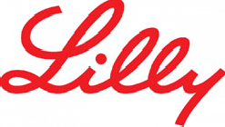

New Phase 3 data was presented from BLAZE-1, a randomized, double-blind, placebo-controlled trial to evaluate the efficacy and safety of bamlanivimab and etesevimab in mild to moderate COVID-19 am bulatory patients with risk factors (cancer, chron ic kidney d is ease, CPOD, down syndrome, heart conditions, immunocompromised, obesity, pregnancy, sickle cell disease, smoking, type 2 diabetes mellitus). Participants received a single IV infusion consisting of a combination of 2800 mg bamlanivimab + 2800 mg etesevimab, or placebo. The primary endpoint was hospitalization or death through Day 29.

Key Findings:
- Compared to placebo, bamlanivimab + etesevimab significantly reduced COVID- 19 related hospitalizations or any-cause deaths by Day 29 (2.1% vs. 7.0%, p = 0.0004), representing a 70% risk reduction
- There were no deaths in the bamlanivimab + etesevimab arm, compared to 10 deaths in the placebo arm
- A significant reduction in viral load was observed in the bamlanivimab + etesevimab arm compared to placebo as soon as Day 3 (p<0.001). This effect was maintained through Days 5, 7, and 11
- The benefit of bamlanivimab + etesevimab on symptom resolution was clear within 4 days of treatment

The Takeaway:
The newly reported Phase 3 findings confirm and replicate the Phase 2 results, with a 70% reduction in risk of hospitalization, decreased viral load, and improved sustained symptom resolution. These results provide additional efficacy and safety data that support the use of dose recently granted by the US FDA and a positive scientific opinion by the EMA's CHMP.

Bamlanivimab Prevents COVID-19 Morbidity and Mortality in Nursing Home Setting
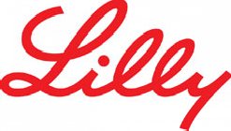

New data was presented from BLAZE-2, a Phase 3, randomized, double-blind, placebo-controlled, single-dose study evaluating bamlanivimab for the rapid prophylaxis of COVID-19 in a nursing home setting.

Key Findings:
- 80% reduction in risk of symptomatic COVID-19 among nursing home residents (OR 0.20, p<0.001)
- 72% reduction in risk of symptomatic COVID-19 among high-risk participants (OR 0.28, p<0.001)
- 76% reduction in risk of SARS-CoV-2 detection by RT-PCR among nursing home residents (OR 0.24, p<0.001)
- Among those who did test positive for SARS-CoV-2, viral load was significantly lower in the bamlanivimab group vs. placebo even after the first positive test.
There was a significant reduction in viral load 1 week later in the bamlanivimab group
- No deaths in bamlanivimab group compared to 4 deaths in the placebo arm

The Takeaway:
So far in BLAZE-2, bamlanivimab has been shown to prevent both SARS-CoV-2 infection and symptomatic COVID-19 in nursing home residents. This represents an important patient population, given that in the US, long-term care facilities account for 5% of COVID-19 cases but 37% of deaths.

Global Connectivity Week 2021 - COVID-19 Recap
Global Connectivity Week 2021 was held on February 22-25 as a virtual event, providing an opportunity to connect global and local teams and ensure that global strategy considers relevant and consistent local needs. This year, the objectives for GCW concerning VKY and COVID-19 were to review changes to key issues, assumptions, and insights for each strategic pillar; identify likely inpatient competitors' approach to COVID-19; and develop a list of Priority Business Limiting issues for inpatient IV VKY for the next 6 months.
Over three days of plenary and breakout sessions, participants (45 in attendance for COVID-19) reviewed insights and feedback on each strategy pillar, engaged in a Competitor Strategy Workshop, and defined competitors-specific issues for Gilead to align on Priority Business Limiting issues.
Below are some of the key topics of discussion during GCW:

- The VKY Patient / Positioning: Where to use VKY remains a question being shaped by many stakeholders, with many varied perceptions and answers
- VKY Combinations: Clarity on where and how to use VKY in combination is a critical question
- Awareness of VKY Data: Still low awareness of actual data/cost/antiviral data, across a very diverse treating audience
- "Modest Effect" Perception of Efficacy: VKY efficacy and value not yet broadly established, in particular mortality
- Protocols Vary and Restrict VKY Within Label: Decision-making almost always by protocol, and protocol limitations are a significant barrier
- Access and Cost-Effectiveness: Ability to demonstrate cost-effectiveness is increasingly needed and difficult
Post-GCW, the ILT co-leads will make revisions to the ISP based on outputs from GCW and will share changes with their teams. An Executive Feedback Session is scheduled for the end of March to align on pivotal business issues and strategic options facing the ILT, discuss strategic decisions and rationale, and receive feedback on preliminary Global Strategic Pillars. The rollout of the ISP is currently slated for end of May.

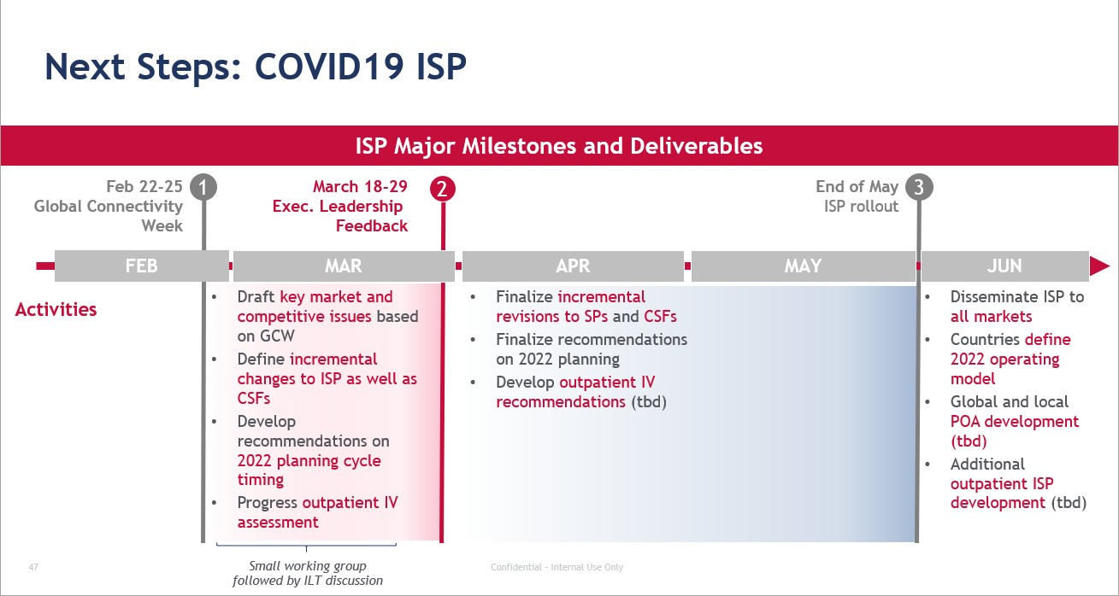

READ MORE

RESEARCH AND PUBLICATIONS


RDV Real World Data Studies

Remdesivir Use in Patients Requiring Mechanical Ventilation due to COVID-19
Published in the November 2020 edition of Open Forum Infectious Diseases, the open- access journal of the Infectious Diseases Society of America (IDSA) and HIV Medicine
Association (hivma). This was a retrospective, single-center study evaluating RDV in 113 patients from Italy requiring mechanical ventilation, between March 1 and March 31, 2020.

Key Findings:
- Using multivariable analysis, RDV was significantly associated with hospital discharge (HR, 2.25; 95% CI, 1.27-3.97; P=0.005) and with a nonsignificantly lower mortality (HR, 0.73; 95% CI, 0.26-2.1; P=0.56)
- RDV was independently associated with extubation (HR, 2.1; 95% CI,
1.19-3.73; P=0.011), which was considered a competing risk to death in the ICU in an additional survival model

The Takeaway:
In this cohort of mechanically ventilated patients, RDV was not associated with a significant reduction in mortality, but it was consistently associated with shorter duration of mechanical ventilation and higher probability of hospital discharge, independent of other risk factors.
More information can be found on Slide 15 of the RDV - Real-World Data slide deck.

READ MORE

Effectiveness of Remdesivir in Patients with COVID-19 Under Mechanical Ventilation in an Italian ICU
Published in the November 2020 edition of the Journal of Antimicrobial Chemotherapy, this was a retrospective, single-center study of RDV in 25 mechanically ventilated patients from Italy between February 29 and March 20, 2020.

Key Findings:
- Kaplan-Meier curves showed significantly lower mortality among patients treated with RDV compared to those who did not receive RDV (56% vs. 92%, P<0.001)
- Cox regression analysis showed that RDV treatment was the only factor associated with better survival (OR 3.506; 95% CI 1.768-6.954; P<0.001)

The Takeaway:
Compared to the non-RDV group, a significantly lower mortality and better survival rate were observed among mechanically ventilated patients treated with RDV.
More information can be found on Slides 16 of the RDV - Real-World Data slide deck.

READ MORE

Real-Life Use of Remdesivir in Hospitalized Patients with COVID-19
Published on March 6, 2020 in Revista Española de Quimioterapia (official journal of the Spanish Society of Chemotherapy), this was a single-center observational cohort study of patients admitted for ≥48 hours with confirmed COVID-19 who received RDV between July 1 and September 30, 2020. This study was conducted at Hospital Clinic in Barcelona (Spain).

Key Findings:
- Among the 123 patients who received RDV, RDV was associated with the following:
  - 4.1% mortality rate through 30 days (5/123) overall; 8.3% mortality rate through 30 days among patients who required ICU admission (2/24)
  - 19.5% required ICU admission
  - 7.3% required mechanical ventilation
- The 30-day mortality among patients receiving RDV and tocilizumab concomitantly was 5.3%
- No adverse events requiring RDV discontinuation were reported

The Takeaway:
In a real-life cohort of patients with COVID-19, including those with cancer or hematologic disease, RDV was associated with a low mortality rate and a favorable safety profile.

READ MORE



COMMIT™ COVID-19 RFP Program Updates
The COMMIT™ (COvid-19 unMet MedIcal needs and associated research exTension) COVID-19 RFP program was launched on June 22 by Gilead Medical Affairs in a global effort to further address the unmet medical need in COVID-19. Through this program, Gilead will support individual projects, of up to $250,000 USD, that expand data on clinical course and outcome in vulnerable populations, evaluate long-term sequelae, or assess real world safety and effectiveness of RDV used alone or in with other agents.
On March 9, 2021, a training call was held to present the ISR/Collab/LSS process. During this training, the following data generation topics were reviewed as part of the expanded scope for MAST submissions:
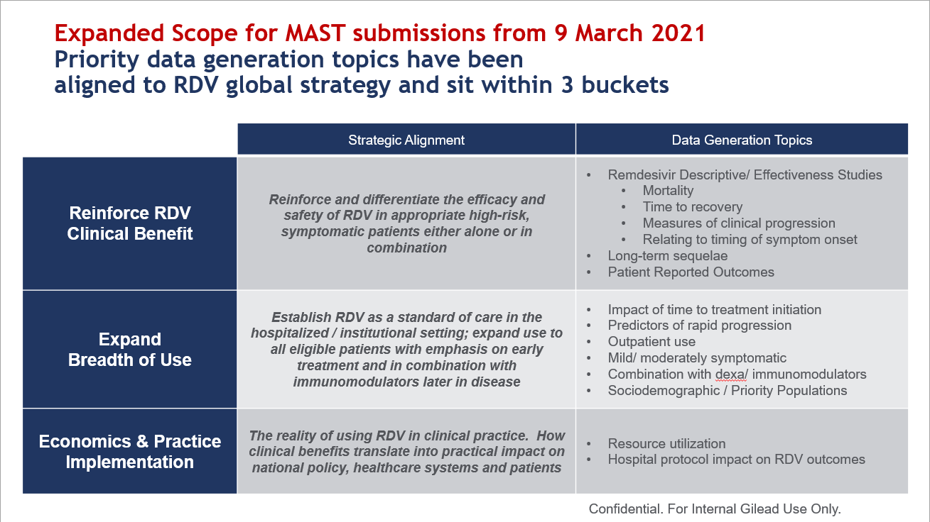

COVID-19 LANDSCAPE
Vaccines:
Pfizer and BioNTech announced new stability data for the Pfizer- BioNTech COVID-19 Vaccine, supporting its storage at temperatures more commonly found in pharmaceutical freezers and refrigerators (-25° C to -15°C). Currently, the EUA label states that the vaccine must be
stored at ultra-cold temperatures (-80°C to -60°C). Story >>
New data from the University of Cambridge suggests that a single dose
of the Pfizer-BioNTech COVID-19 Vaccine can reduce by 75% the

number of asymptomatic SARS-CoV-2 infections. Story >>
The US FDA issued an EUA for the Janssen (J&J) COVID-19 Vaccine to be distributed in the US for individuals aged 18 years and older. This is the third vaccine to receive authorization in the US for the prevention of
COVID-19. Story >>
Merck announced that it has entered into a partnership with Johnson & Johnson to support the manufacturing and supply of the Janssen COVID-
19 Vaccine. Story >>

Therapeutics:
Dr. Reddy's Laboratories announced the termination of its Phase 3 favipiravir study conducted in Kuwait, citing an interim analysis revealing that its primary endpoint was not met. Story >>

The US FDA issued an EUA for Eli Lilly's combination antibody treatment, bamlanivimab and etesevimab, for the treatment of mild to moderate COVID-19 in adults and pediatric patients at high risk of progressing to severe COVID-19. Like Eli Lilly's previous EUA for bamlanivimab monotherapy, this decision was based on the results of the BLAZE-1 trial. Story >>

An Independent Data Monitoring Committee recommended that the Phase 3 COMET-ICE trial be stopped, given that the monoclonal antibody VIR-7831 demonstrated an 85% reduction in hospitalization or death vs. placebo in COVID-19 patients at high risk of hospitalization. Story >>

GSK and Vir Biotechnology additionally announced results of a study demonstrating that VIR-7831 maintains activity against the UK, South African, and Brazilian variants. Story >>

KEY RESOURCES

Upcoming Events This Month

Medical Affairs Events


March 6-10: Congress - CROI 2021


Ongoing: Online Advisory Panel - 6 Month Global Digital Panel

COVID-19 SharePoint Resources
The MA COVID-19 SharePoint site was launched in March 2020 as a global collaborative space to support the launch of RDV. We encourage you to bookmark this resource to stay informed of the latest developments, including key publications, slide deck additions/updates, and Global Response Documents.
MA COVID-19 SharePoint site >>












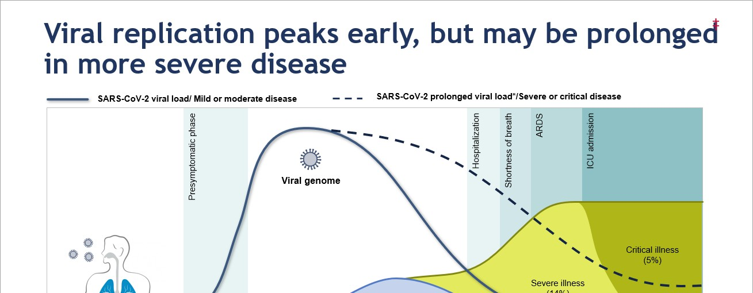

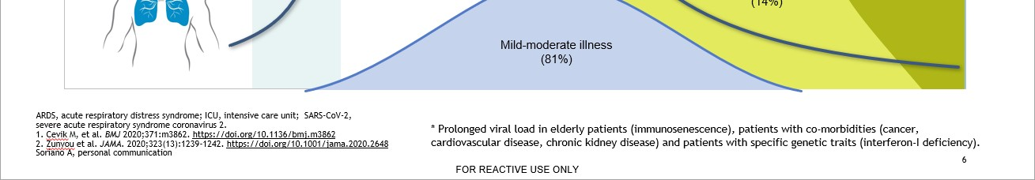

Slide Deck - NEW

COVID-19 Treatment Guidelines (February 9)
Overview of Global COVID-19 Treatment Guidelines (WHO, NIH, IDSA, MHLW, S2K), and a summary of key guideline recommendations for RDV
Slide Deck on Egnyte >>

Slide Deck - NEW

Disease Course and Treatment Timing (March 8)
Overview of the disease course, antiviral therapy, combination therapies, and immunomodulator therapy
Slide Deck on Egnyte >>

Slide Deck - UPDATE

Investigational Therapeutics for COVID-19 (February 26)
Updated with new data and regulatory guidance for a number of investigational agents, including bamlanivimab+etesevimab; casirivimab+imdevimab; molnupiravir; favipiravir, tocilizumab; and COVID-19 vaccines from Moderna, Pfizer/BioNTech, Oxford/AstraZeneca, Johnson & Johnson, and Novavax
Slide Deck on Egnyte >>

FAQ - UPDATE

RDV Medical Affairs FAQ (March 5)
Contains updates on clinical study data and incorporation of specific FAQs (e.g., SARS-CoV-2 variants, SOLIDARITY, DisCoVeRy)
FAQ on Egnyte >>

Global COVID-19 Team
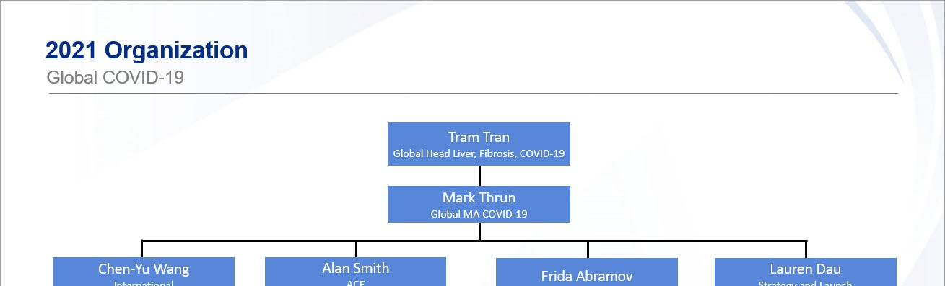
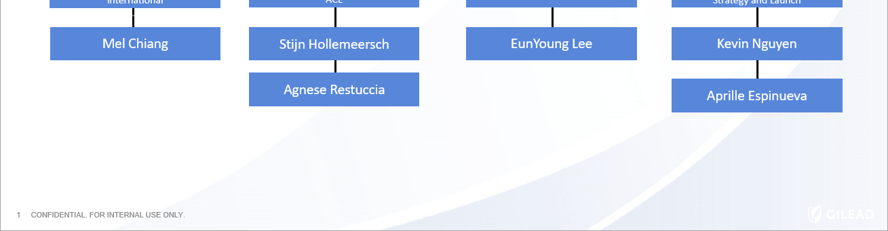

EDITORIAL TEAM

Kevin Nguyen


Senior Manager Global MA COVID-19

Mark Thrun


Executive Director Global MA COVID-19

Lauren Dau
Senior Director Global MA COVID-19


Tram Tran


Vice President
Global Head Liver, Fibrosis, COVID-19

We value your feedback.

If you have any comments, questions, or content requests, please send an email to the editor: kevin.nguyen22@gilead.com

Gilead Sciences, Inc.
333 Lakeside Drive, Foster City CA 94404 United States

You received this email as part of the #Medical Affairs - All distribution list.
Unsubscribe

