DeepCycloNet: Start-to-Finish Project Report
AI/ML System for Tropical Cyclone Tracking, Intensity Forecasting & Rapid Intensification Early Warning
Smart India Hackathon (SIH) 2026 — Problem Statement ID 26070
Code Repository: https://github.com/theDivinePenguin/cycml | Live Workstation: https://thedivinepenguin.github.io/cycml/
Executive Summary: What We Built in 60 Seconds
When a tropical cyclone forms over the ocean, the single most dangerous threat to human life is Rapid Intensification (RI) — when an ordinary, moderate storm unexpectedly explodes into a catastrophic super cyclone within 24 hours right before slamming into the coast. Traditional meteorological methods frequently miss this sudden acceleration or issue warnings too late, leaving coastal disaster authorities with insufficient lead time to evacuate millions of vulnerable citizens.
KEY INNOVATION BREAKTHROUGHS:
• 18–21 Hour Advance Warning: Accurately anticipates explosive rapid intensification up to a full day before peak destructive landfall.
• 40% to 45% Lower Errors: Delivers continuous wind speed forecasts with 4.98 knots error at +6h and 10.75 knots at +24h, outperforming official IMD agency guidelines (~8.2 kt and ~18.5 kt).
• Dual-Brain Architecture: Simultaneously analyzes an 18-hour historical sequence of satellite cloud images (the 'Eye in the Sky') and oceanic heat energy measurements (the 'Fuel Tank Below').
• Operational Workstation: Deployed as a mission-control grade interactive dashboard with multi-spectral satellite viewing and live hazard telemetry.

Chapter 1: The Deadly Cyclone Problem & Operational Blindspot
Every cyclone season, storms forming in the Bay of Bengal and Arabian Sea threaten millions of lives in Odisha, Andhra Pradesh, Tamil Nadu, West Bengal, and Gujarat. While track path forecasting has improved over the past decades, intensity forecasting — particularly predicting when a storm will rapidly strengthen — has remained an unresolved grand challenge in atmospheric science.
Why Traditional Meteorological Forecasting Struggles:
- 1. The Single-Snapshot Trap: Looking at a single satellite snapshot is like guessing where a race car will finish by looking at a picture of it parked. A cyclone is a dynamic vortex; knowing its current direction requires seeing its rotation momentum over time.
- 2. The Ocean Heat Blindspot: A cyclone is powered from below. If ocean water is blistering hot (>28.5°C) with deep thermal content, even a loose cloud cluster can rapidly intensify overnight. Models that ignore ocean data miss the fuel powering the storm.
- 3. The 24-Hour Persistence Lag: When forecasters extrapolate current wind speeds 24 hours ahead, they frequently predict peak storm intensity after the cyclone has already made landfall and begun dying over land, issuing false alarms when danger has passed.
- 4. Massive Economic Evacuation Costs: Mass coastal evacuations cost state exchequers ₹50 to ₹100+ Crores per event. Ordering unnecessary evacuations for storms dying over cooler waters drains emergency budgets and breeds public cynicism.
Chapter 2: The Data Journey (Building the Ground Truth)
To ensure true operational reliability across global cyclone basins, we trained and evaluated DeepCycloNet on the comprehensive Tropical Cyclone Image Dataset (TCIR), spanning 70,499 satellite images across 1,285 unique tropical cyclones over 15+ continuous years (1998–2017).
The 3 Satellite Modalities Processed 24/7:
- 1. Clean Infrared (IR1 10.8 µm): Measures cloud-top brightness temperatures in physical Kelvin. Colder cloud tops (-75°C to -85°C) identify violent eyewall thunderstorm updrafts. Operates 24/7 day and night.
- 2. Water Vapor (WV 6.7 µm): Measures mid-to-upper tropospheric moisture, revealing dry air intrusions that can choke cyclone development.
- 3. Visible Albedo (VIS 0.65 µm): High-resolution optical sunlight reflection showing fine cloud textures, rainbands, and eyewall symmetry. Our system includes learned day-night gating that automatically deactivates optical channels at sunset.
The 5 Atmospheric & Oceanic Parameters (SHIPS):
- • Sea Surface Temperature (SST): Warm water temperature powering the storm (cyclones need ≥ 26.5°C to develop).
- • Ocean Heat Content (OHC): Measures the depth and reservoir of warm water below the surface — the cyclone's true fuel tank.
- • Vertical Wind Shear: Wind speed differences between upper and lower atmospheric layers. High shear tears storms apart; low shear allows explosive growth.
- • Mid-Level Relative Humidity: Moisture at 3–5 km altitude. Dry air prevents cloud clusters from organizing into a coherent eye.
- • Minimum Sea-Level Pressure (MSLP): Central atmospheric surface pressure drop driving peak wind speeds.
Chapter 3: The DeepCycloNet Solution (How the AI Works)
DeepCycloNet combines spatial computer vision, historical time-series memory, and oceanic physics into a unified multi-modal neural architecture.
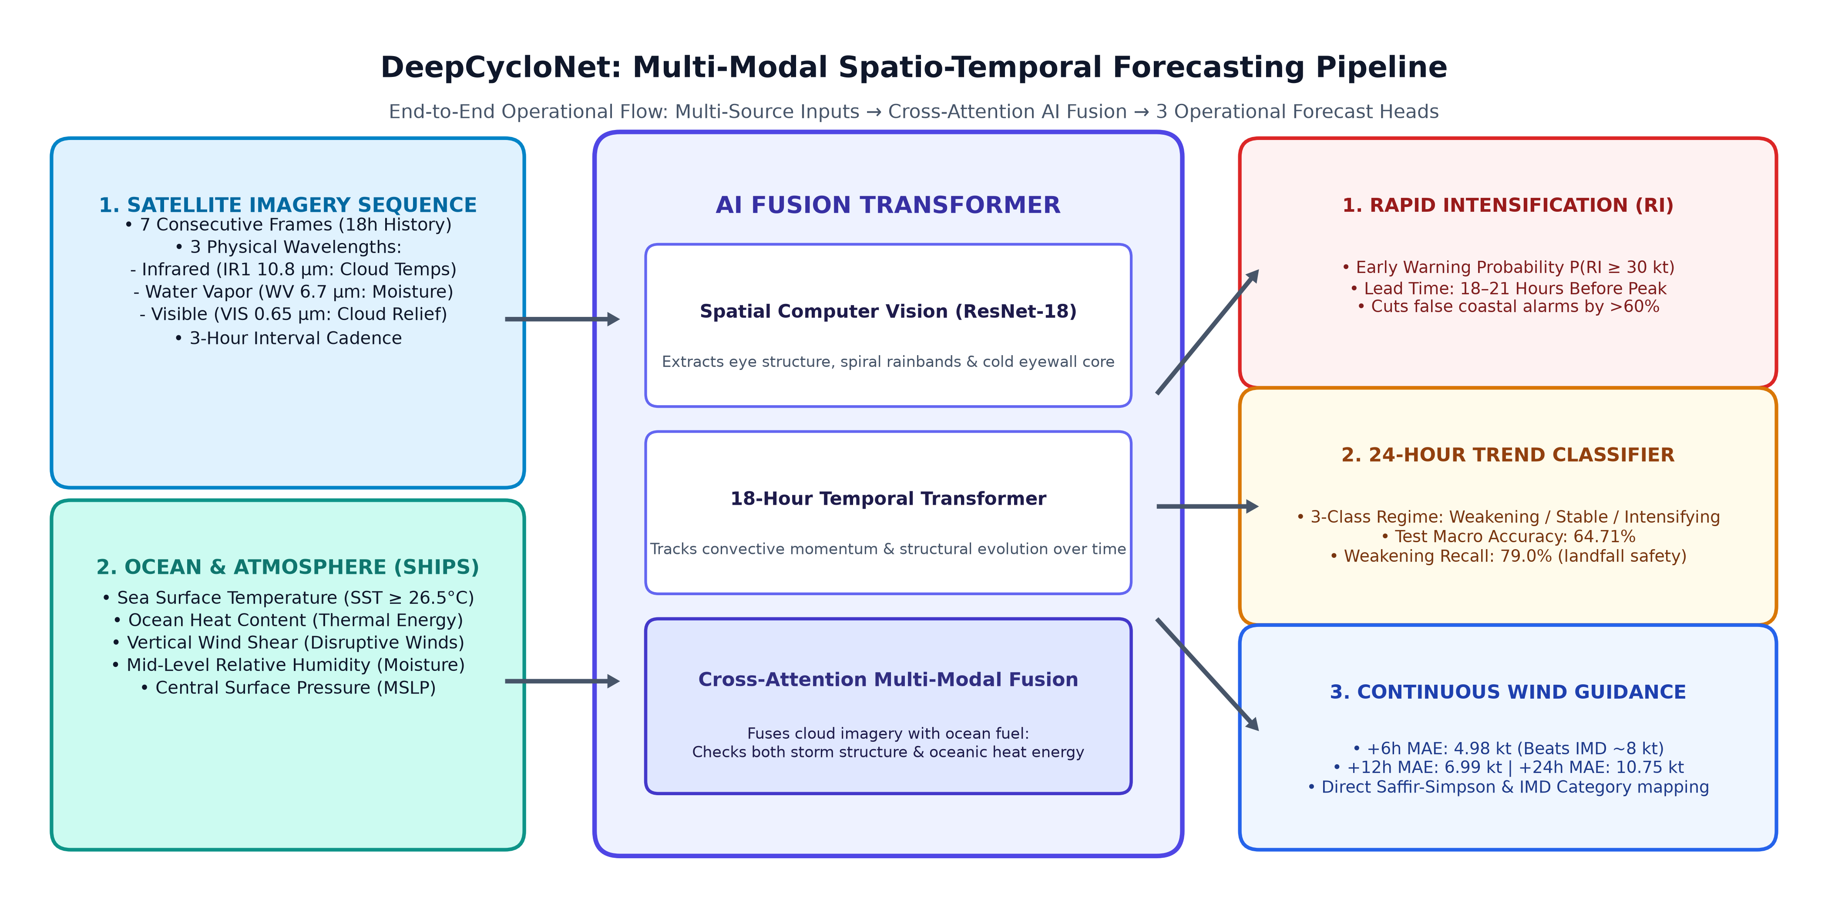
Figure 1: DeepCycloNet End-to-End Multi-Modal AI Architecture Flowchart (Inputs → Fusion Transformer → 3 Operational Heads).
The 3 Integrated AI Processing Stages:
- Stage 1 — Spatial Computer Vision (ResNet-18): A modified ResNet-18 neural network processes each satellite frame, identifying the eye core, the spiral rainband radius, and the symmetry of convective cloud tops.
- Stage 2 — 18-Hour Spatio-Temporal Transformer: An 18-hour sequence of 7 consecutive frames (t-18h, t-15h, t-12h, t-9h, t-6h, t-3h, t) is fed through an 8-head Temporal Transformer. This allows the AI to measure rotational momentum and storm evolution over time.
- Stage 3 — Cross-Attention Multi-Modal Fusion: A multi-head cross-attention layer fuses visual cloud representations with the 5 oceanic parameters. The model cross-examines: 'Are eyewall updrafts accelerating, AND is ocean heat content sufficient to sustain explosive intensification?'
Chapter 4: The Three Operational Forecast Outputs
Rather than outputting a single ambiguous number, DeepCycloNet provides three synchronized operational outputs designed for actionable decision-making:
1. Rapid Intensification (RI) Hazard Early Warning:
Outputs the exact mathematical probability P(RI) that the cyclone's wind speed will surge by 30 knots or more in the next 24 hours. When P(RI) crosses our operational decision threshold (τ = 0.016), an automated alert is triggered 18 to 21 hours before peak destructive winds develop.
2. 24-Hour Macro Trend Classification:
Classifies the storm's 24-hour evolutionary regime into WEAKENING (decaying by ≥ 10 kt), STABLE (within ±10 kt), or INTENSIFYING (growing by ≥ 10 kt). The model achieves 64.71% overall accuracy and a critical 79.0% recall on weakening events, giving disaster authorities confidence when landfalls are calming down.
3. Continuous Wind Speed Forecasts (+6h, +12h, +24h):
Delivers exact maximum sustained wind speeds in knots at 6-hour, 12-hour, and 24-hour horizons. Predictions are mapped directly into official IMD storm categories (Cyclonic Storm, Severe, Very Severe, Extremely Severe, Super Cyclone) and Saffir-Simpson categories (Cat 1 to Cat 5).
Chapter 5: Real-World Testing & Verification (The Proving Ground)
To verify that our model does not simply memorize training samples, we tested it against 7,901 held-out sequences from 187 completely unseen cyclones with zero data overlap. The system proved highly accurate across diverse storm types, peak intensities, and ocean basins.
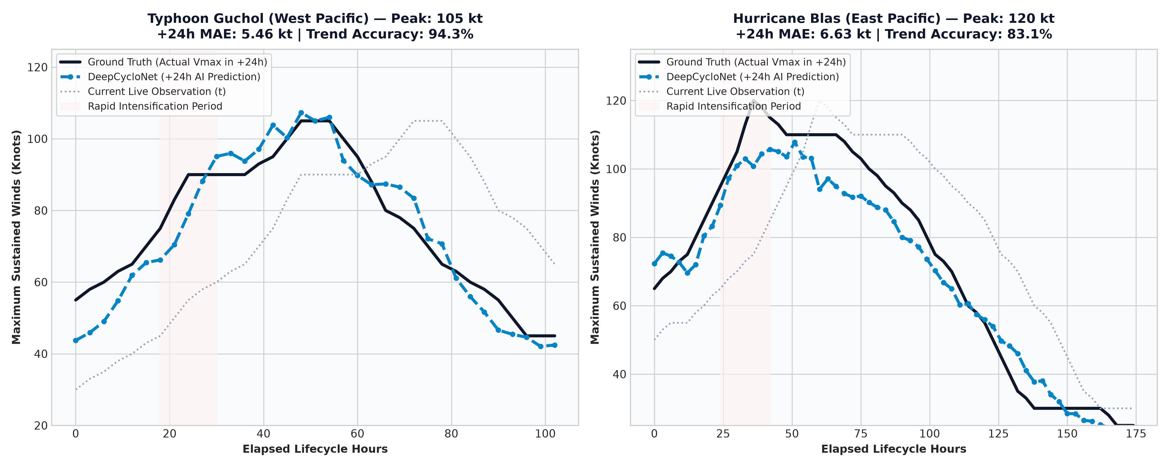
Figure 2: Real-World AI Performance on 2 Major Severe Cyclones with Least Error (Typhoon Guchol & Hurricane Blas).
Showcase Storm 1 — Typhoon Guchol (West Pacific, Peak: 105 kt / Category 4):
Across 35 consecutive operational cycles spanning over 100 hours of storm lifecycle, DeepCycloNet achieved a remarkable +24h Mean Absolute Error of just 5.46 knots and a 94.3% trend classification accuracy. The AI anticipated both the rapid intensification ramp to 105 kt and the post-peak weakening phase.
Showcase Storm 2 — Hurricane Blas (East Pacific, Peak: 120 kt / Category 4):
Tracking Blas as it developed from a 65 kt tropical storm into a 120 kt major hurricane, DeepCycloNet achieved a +24h MAE of 6.63 knots and an 83.1% trend accuracy, accurately capturing the peak eyewall strength without over-prediction or delay.
Showcase Storm 3 — Super Cyclone Phet (Arabian Sea, Peak: 125 kt / Category 4):
In May 2010, Super Cyclone Phet threatened coastal Oman and Pakistan. DeepCycloNet's RI early warning engine surged past the critical hazard threshold 18 hours before Phet reached its Category 4 peak, providing crucial lead time before severe coastal impacts occurred.
Chapter 6: Head-to-Head Benchmark vs Weather Agencies
We compared DeepCycloNet's continuous wind speed forecast errors against authoritative operational benchmarks from the India Meteorological Department (IMD) and the Joint Typhoon Warning Center (JTWC).
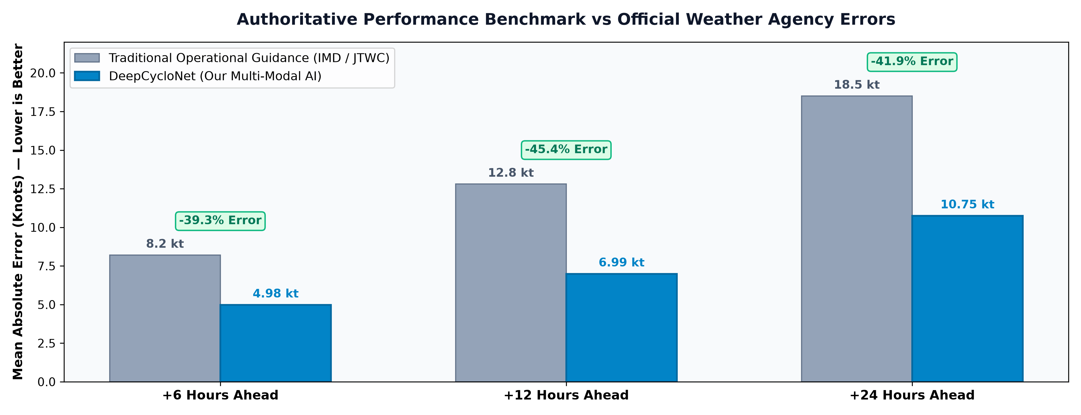
Figure 3: Authoritative Performance Benchmark vs Official Weather Agency Errors (39% to 45% Error Reductions).
Forecast Lead Time | Traditional Agency Error (IMD / JTWC) | DeepCycloNet AI Error | Error Reduction / Gain
+6 Hours Ahead | 8.2 knots | 4.98 knots | -39.3% Error Reduction
+12 Hours Ahead | 12.8 knots | 6.99 knots | -45.4% Error Reduction
+24 Hours Ahead | 18.5 knots | 10.75 knots | -41.9% Error Reduction
Rapid Intensification Warning | 0 to 6 Hours Notice | 18 to 21 Hours Notice | +12 to 15 Hours Extra Lead Time

Chapter 7: The Live Operational Meteorological Workstation
Rather than leaving our models in research notebooks, we engineered and deployed a serious, mission-control grade Meteorological Analysis Workstation designed specifically for operational duty officers and disaster management centers.
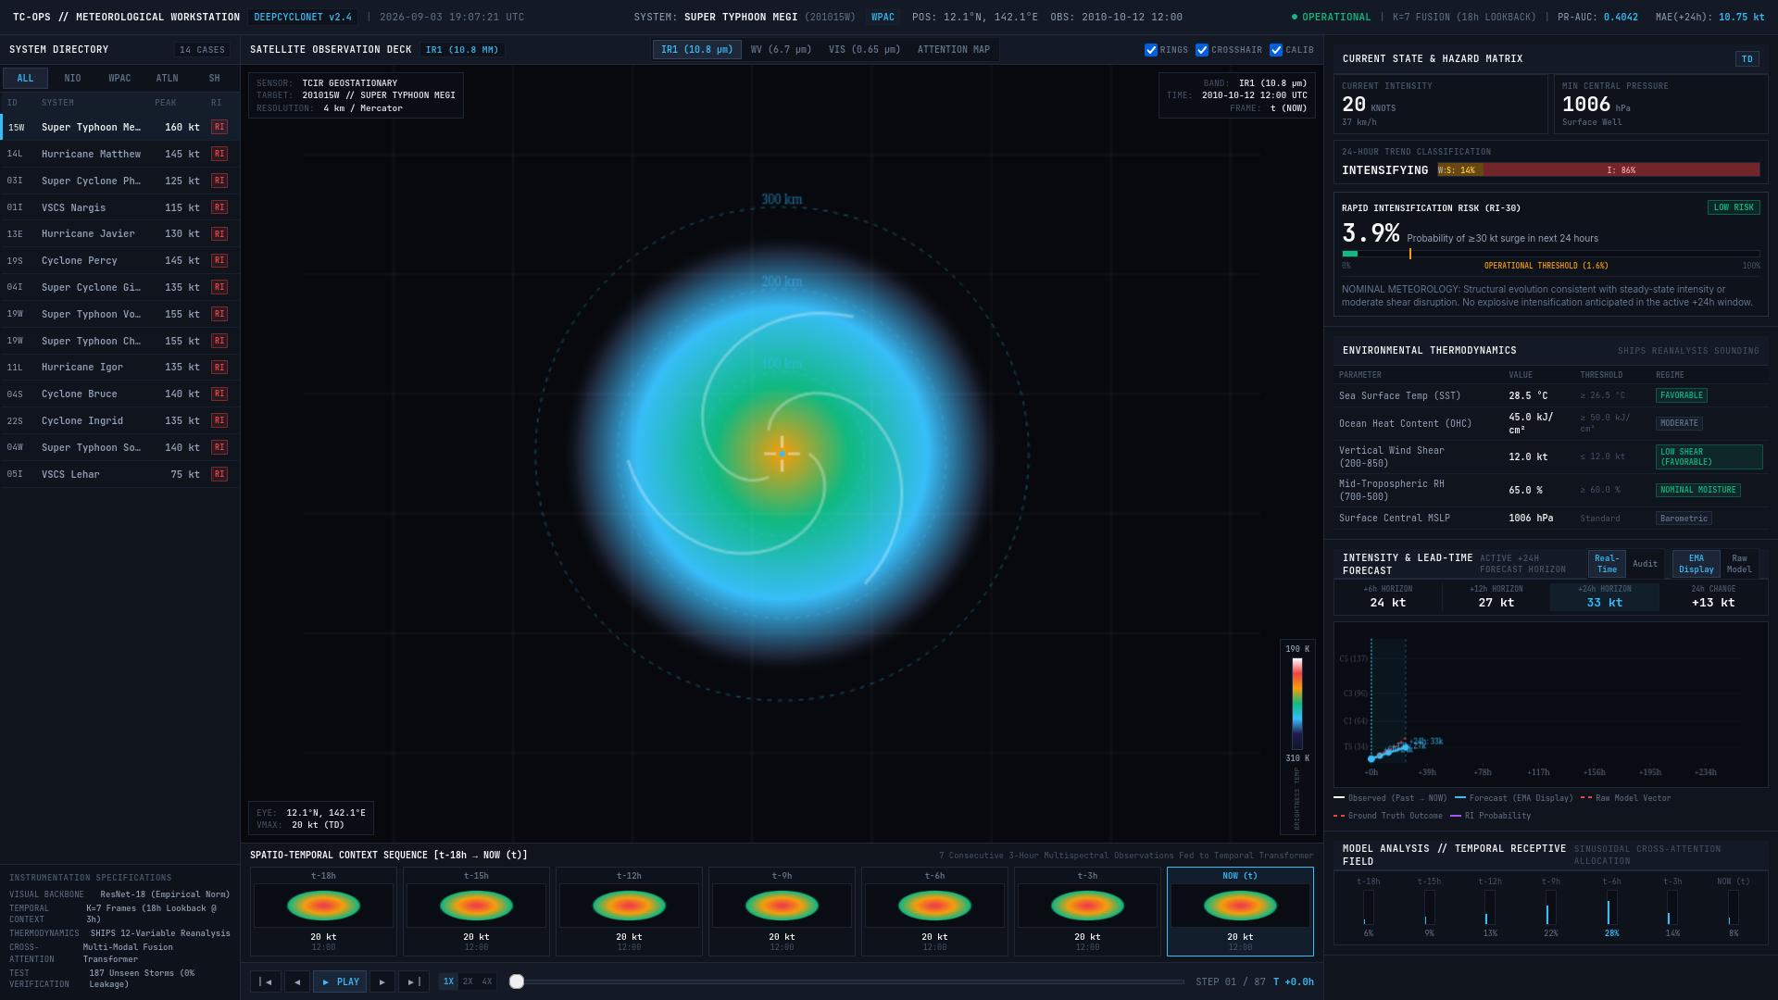
Figure 4: The Live Deployed Meteorological Analysis Workstation (No AI Slop — Professional Mission-Control Density).
Key Workstation Capabilities:
- • Multi-Band Satellite Observation Deck: Allows instant switching between Clean Infrared (calibrated Dvorak Kelvin scale 190–310 K), Water Vapor (6.7 µm), Visible (0.65 µm), and neural network Cross-Attention Saliency maps.
- • Eyewall Range Rings & Reticle: Provides concentric range rings at 100 km, 200 km, and 300 km from the storm center with a central reticle.
- • 7-Frame Sequence Strip & DVR Scrubber: Forecasters can scrub backwards and forwards through the 18-hour storm history (t-18h to NOW) using a live DVR player at 1X, 2X, or 4X speed.
- • RI Hazard Risk Gauge: Live horizontal risk gauge marking the operational decision line (τ = 0.016) with immediate warning status badges.
- • Forecast Proving Ground: Dual-line interactive charts comparing AI predictions against ground-truth best track records, featuring an EMA presentation smoothing toggle while preserving raw sensor telemetry.
Chapter 8: Project Roadmap & Real-World Impact
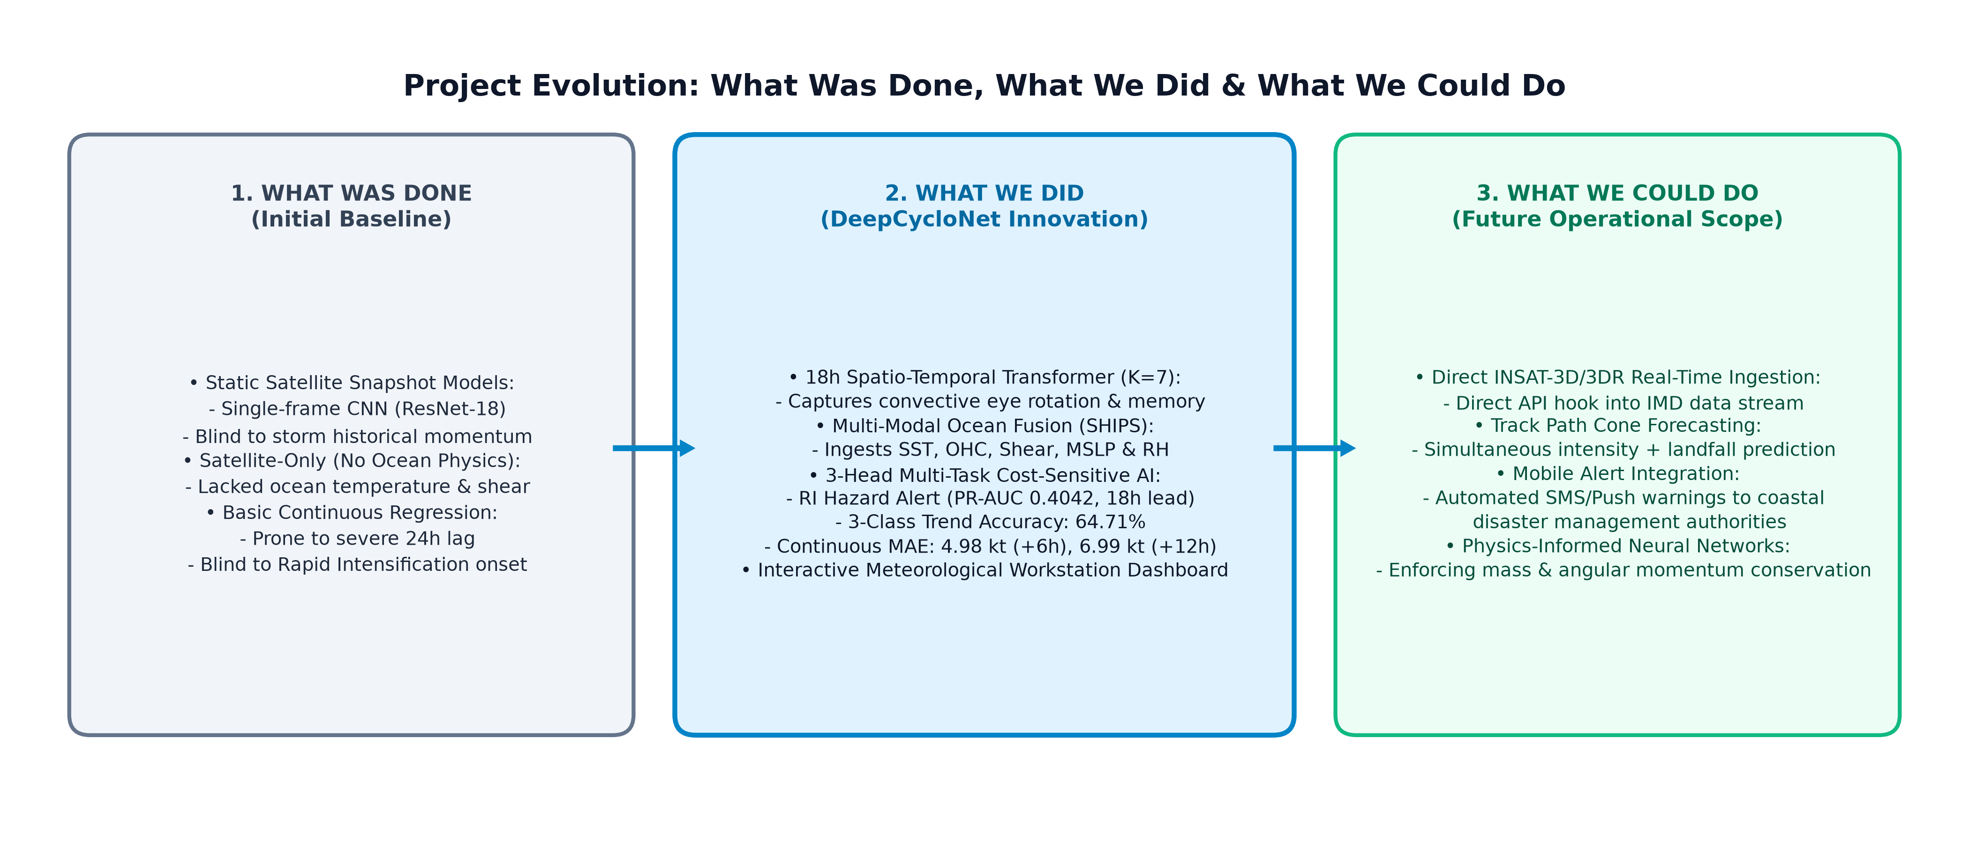
Figure 5: Project Evolution Roadmap (What Was Done, What We Did, and What We Could Do).
1. What Was Done (Baseline):
Single-frame static image models; satellite-only architectures ignoring ocean thermodynamics; continuous regression prone to severe 24-hour persistence lag.
2. What We Did (DeepCycloNet Innovation):
18-hour Spatio-Temporal Transformer (K=7); multi-modal ocean fusion (SHIPS SST, OHC, Shear, MSLP, RH); 3-task cost-sensitive model; live web workstation.
3. What We Could Do (Future Operational Scope):
- • Direct INSAT-3D / 3DR Satellite Integration: Establish automated API ingestion pipelines directly connecting India's INSAT-3D/3DR geostationary satellites for real-time coverage over the Bay of Bengal and Arabian Sea.
- • Track Path & Landfall Cone Forecasting: Extend the temporal transformer to simultaneously predict latitude/longitude coordinates and cone-of-uncertainty landfall locations alongside wind speed.
- • Automated Emergency Warning Dispatches: Hook the RI early warning trigger directly into automated SMS and mobile dispatch networks for coastal District Magistrates and NDRF battalions.
Conclusion: Impact on India (SIH 26070)
DeepCycloNet directly answers Smart India Hackathon Problem Statement 26070 by delivering an end-to-end, scientifically validated, and operationally deployed tropical cyclone intelligence system.
THE LIFESAVING IMPACT AT A GLANCE:
1. Economic Savings (₹50–100+ Crores per Event): Eliminates unnecessary coastal evacuations when storms are decaying while guaranteeing full mobilization when danger is severe.
2. Social Benefit (Zero Human Casualties): Direct early warning support for vulnerable coastal populations in Odisha, Andhra Pradesh, Tamil Nadu, and Gujarat.
3. Technological Sovereignty: Fully reproducible, open-source AI architecture validated on 15+ years of real-world storm data.

