Car Crash Fix-Amount Predictor (CCDP)
Photo → identify vehicle → detect & localize damage → itemized repair-cost estimate (USD / INR)
Capstone Project Report · Release v1.0.0

1. Problem Statement
Motor-insurance claims and second-hand car valuation both hinge on a slow, subjective task: looking at a photo of a damaged vehicle and estimating the repair cost. Manual appraisal is inconsistent between assessors and does not scale. The goal of this project is an end-to-end computer-vision system that takes a single photograph of a car and returns an auditable, itemized repair-cost estimate. This decomposes into four learnable sub-problems: (1) identify the vehicle make/model so the right price tier is used (a luxury bumper costs far more than an economy one); (2) detect and classify the damage; (3) localize it to a specific body panel and severity; and (4) convert that into a defensible monetary figure. The system must also handle real-world inputs — no car, an undamaged car, or multiple cars in one frame.

2. Dataset Description
Three permissively-licensed public datasets are used, each training a distinct model. No single dataset covers the full task, so they are composed.
Dataset | Size | Labels / Features | Role & source
Stanford-Cars | 16,185 imgs | 196 make/model/year classes + GT bounding boxes | Trains the identifier. Krause et al., 2013.
CarDD | ~4,000 imgs | 6 damage classes, COCO polygon masks (dent, scratch, crack, glass-shatter, lamp-broken, tire-flat) | Trains damage segmentation. Wang et al., 2023.
carparts-seg | 3,833 imgs | 23 raw part classes → 15 canonical panels, polygon masks | Trains parts segmentation. Roboflow Universe (CC0), via Ultralytics.
Preprocessing. Stanford images are cropped to their ground-truth car bounding box, resized to 224×224, and ImageNet-normalized. CarDD COCO polygons are converted to YOLO-segmentation text labels (normalized polygon vertices) and split 80/10/10. carparts-seg ships pre-split. Augmentation for the identifier: RandAugment(2, 9), random-resized-crop, horizontal flip, plus MixUp (α=0.2) and CutMix (α=1.0) applied to 80% of batches.

3. Methodology
The cost estimator was built as a deliberate four-variant progression (A→B→C→D); each variant adds one capability the previous one lacked, which makes the design rationale explicit and measurable.
- Variant A — ResNet-50 multilabel classifier: answers “what damage types are present?” but has no location, size, or instance count — cost is a coarse tier guess.
- Variant B — YOLOv8 detector + XGBoost: adds bounding-box localization and box-area features for a regressed cost (R² ≈ 0.74 on CarDD).
- Variant C — YOLOv8-seg + XGBoost: replaces boxes with pixel masks (true damaged area). Mask features on ground-truth polygons reach R² 0.94, but on real predicted masks only 0.71 — the segmenter’s noise is eaten by the regressor.
- Variant D — segmentation ∩ parts → catalog (shipped): drops the regressor entirely. It intersects damage masks with part masks per-pixel (“crack on the front bumper”), derives severity from the damage-to-car area ratio, and prices each (part × severity) line item from a three-tier catalog. Output is auditable line items, not one opaque number.
Rationale. Transfer learning (ImageNet → ResNet-50; COCO → YOLOv8n-seg) is chosen because the datasets are small (thousands of images). The identifier feeds a make-based price tier, so make-level accuracy — not exact trim — is what actually drives cost. A Mask R-CNN gate extends the pipeline to multi-car photos by cropping each vehicle and running the per-car pipeline independently.

4. Experimental Details

4.1 Architecture (primary network: ResNet-50 identifier)
The identifier is the main trainable network: a torchvision ResNet-50 (ImageNet-V2 pretrained) with a custom classification head. PyTorch is used throughout; the layer table below is the torchinfo.summary() equivalent of model.summary().
Block (depth-1) | Output shape | Params
Conv1 + BN + ReLU + MaxPool | [64, 56, 56] | 9,536
layer1 (3 bottlenecks) | [256, 56, 56] | 215,808
layer2 (4 bottlenecks) | [512, 28, 28] | 1,219,584
layer3 (6 bottlenecks) — unfrozen | [1024, 14, 14] | 7,098,368
layer4 (3 bottlenecks) — unfrozen | [2048, 7, 7] | 14,964,736
AdaptiveAvgPool + custom head | [196] | 1,149,636
Total | — | 24,657,668
Head: Dropout(0.2) → Linear(2048→512) → ReLU → Dropout(0.3) → Linear(512→196). Trainable params: 1.15M in Stage 1 (head only), 23.21M in Stage 2 (layer3/4 + head). The damage and parts models are YOLOv8n-seg networks (CSP backbone + PAN-FPN neck + segmentation head; ~3.26M params, 11.5 GFLOPs each).

4.2 Evaluation metrics, loss & dataset split
Aspect | Specification
Loss function | Identifier: CrossEntropyLoss with label-smoothing 0.1. YOLO-seg: box + mask + classification + DFL composite loss.
Metrics | Identifier: top-1 accuracy, macro-F1, make-level accuracy, cross-entropy. Seg: box & mask mAP@50 / mAP@50-95. Cost: MAE / MAPE / R².
Split — Stanford | 8,144 labelled imgs → 90% train / 10% val, stratified per class (seed 42). Official test labels were never released, so the 10% held-out (788 imgs) is the test set.
Split — CarDD / carparts | 80 / 10 / 10 train/val/test (CarDD); 3,156 / 401 / 276 (carparts-seg).

4.3 Implementation details & callbacks
Hyperparameter | Value
Optimizer | AdamW, weight decay 1e-4
Learning rate | Stage 1: 1e-3 (head only) → Stage 2: 1e-4 (upper backbone)
Batch size / epochs | 32 / 25 total = 3 (Stage 1) + 22 (Stage 2)
Callbacks | ReduceLROnPlateau(patience=2, factor=0.5) on val loss; best.pt saved on val-accuracy improvement; per-epoch resumable checkpoint (model + optimizer + scheduler + RNG)
Image size | 224×224 (identifier); 640×640 (YOLO-seg, 80 epochs, batch 16, patience 20)

4.4 Other methods
Two-stage fine-tuning (freeze backbone → unfreeze layer3/4) stabilizes warm-up before adapting features; MixUp + CutMix + label smoothing regularize the long-tailed 196-class problem; ground-truth-bbox cropping removes background clutter the identifier would otherwise overfit. For costing, the parts∩damage intersection replaces a black-box regressor with transparent catalog line items.

5. Results and Discussion

5.1 Results (held-out test set)
Model / Metric | Value | Note
Identifier — top-1 accuracy | 0.7703 | 788 held-out imgs; ~151× the 1/196 chance baseline
Identifier — make-level accuracy | 0.8541 | 49 makes — what the cost tier actually consumes
Identifier — macro-F1 | 0.7594 | balanced across the long tail
Identifier — cross-entropy loss | 1.158 | on held-out split
Damage seg — box / mask mAP@50 | 0.712 / 0.711 | CarDD test, YOLOv8n-seg, nc=6
Parts seg — box / mask mAP@50 | 0.704 / 0.714 | carparts-seg test, nc=23
Variant C cost — R² (GT / pred masks) | 0.94 / 0.71 | quantifies segmenter noise

5.2 Visualizations
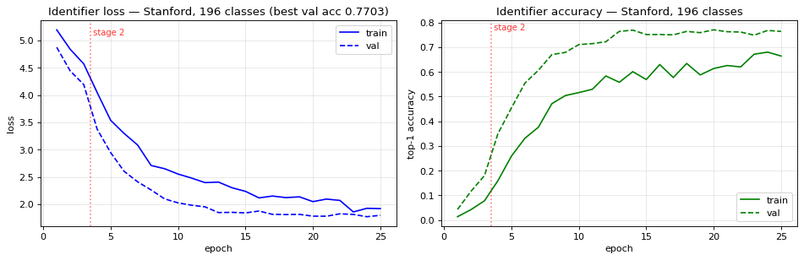
Figure 1. Identifier training/validation loss and top-1 accuracy over 25 epochs. The red marker is the Stage 1→Stage 2 boundary; unfreezing layer3/4 at epoch 4 drives the sharp accuracy jump.
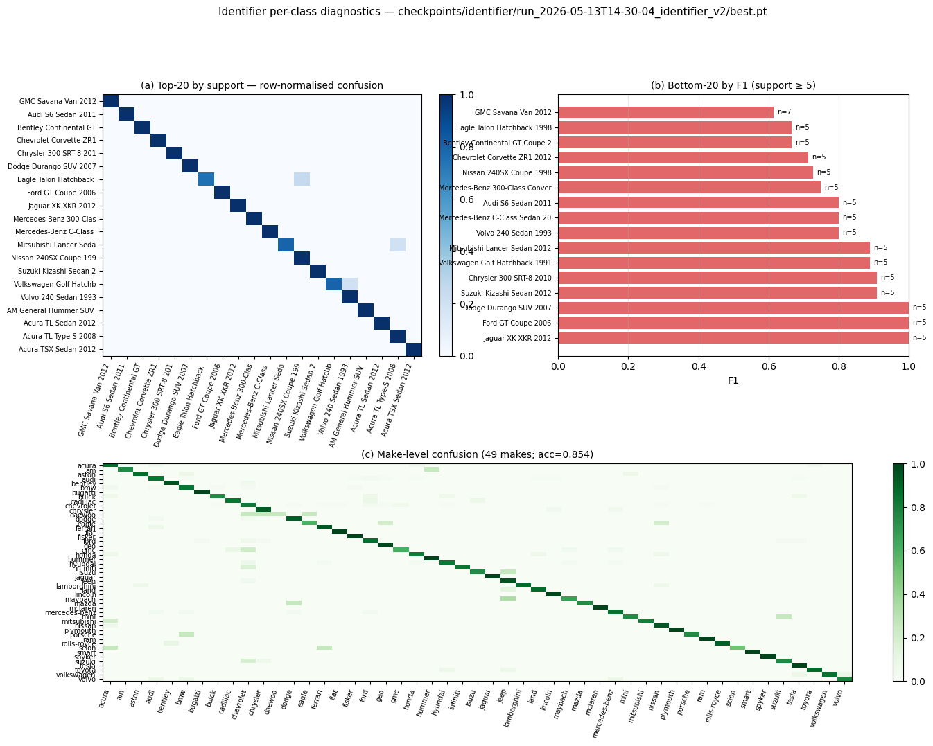
Figure 2. Identifier diagnostics: (a) top-20-by-support confusion, (b) 20 weakest classes by F1, (c) make-level confusion (acc 0.854). Most errors confuse trims of the same make — harmless for cost tiering.

5.3 Analysis
- What worked: two-stage transfer learning reached 0.77 top-1 on a 196-way fine-grained task from only ~7.3k training images. Make-level accuracy (0.854) comfortably supports the cost tier, which is the metric that matters downstream.
- What worked: Variant D's parts∩damage intersection produces auditable, per-panel line items and is robust to imperfect masks (a mask only needs to fire in the right region, not be pixel-perfect).
- What underperformed: Variant C's mask→regressor path scored R² 0.71 on predicted masks versus 0.94 on ground truth — the segmenter's noise, not the feature choice, is the bottleneck. This motivated dropping the regressor in Variant D. Separately, an explored VMMRdb 1,163-class identifier extension regressed to 0.33 (preprocessing mismatch: full-frame vs GT-crop) and was not shipped.
- Confusion structure: errors cluster within a make (year/trim), visible as near-diagonal blocks in Figure 2(a); the make-level heatmap 2(c) is far cleaner.

5.4 Improvements
- Retrain the cost regressor on a hand-labelled holdout: the current n=20 end-to-end cost holdout uses draft labels and is indicative only — a properly labelled set would let MAE/MAPE be reported with confidence.
- Upgrade the seg backbone (YOLOv8n → s/m) and add test-time augmentation to lift mask mAP, directly improving part attribution.
- Add an explicit “undamaged / out-of-distribution” head to reduce false-positive damage on clean cars, and fine-tune the identifier on in-region (e.g. Indian-market) makes for deployment.

