Excel
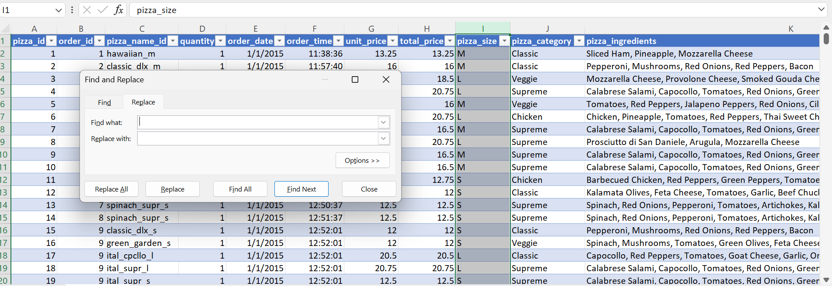
Data cleaning---
Select table - pizza_size press ctrl+H
Result – find what – L
Replace with – large ….press-(replace all) ----- Large
So same as that—M Replace with Medium
-----S Replace with Regular
----xlarge – Replace with X-large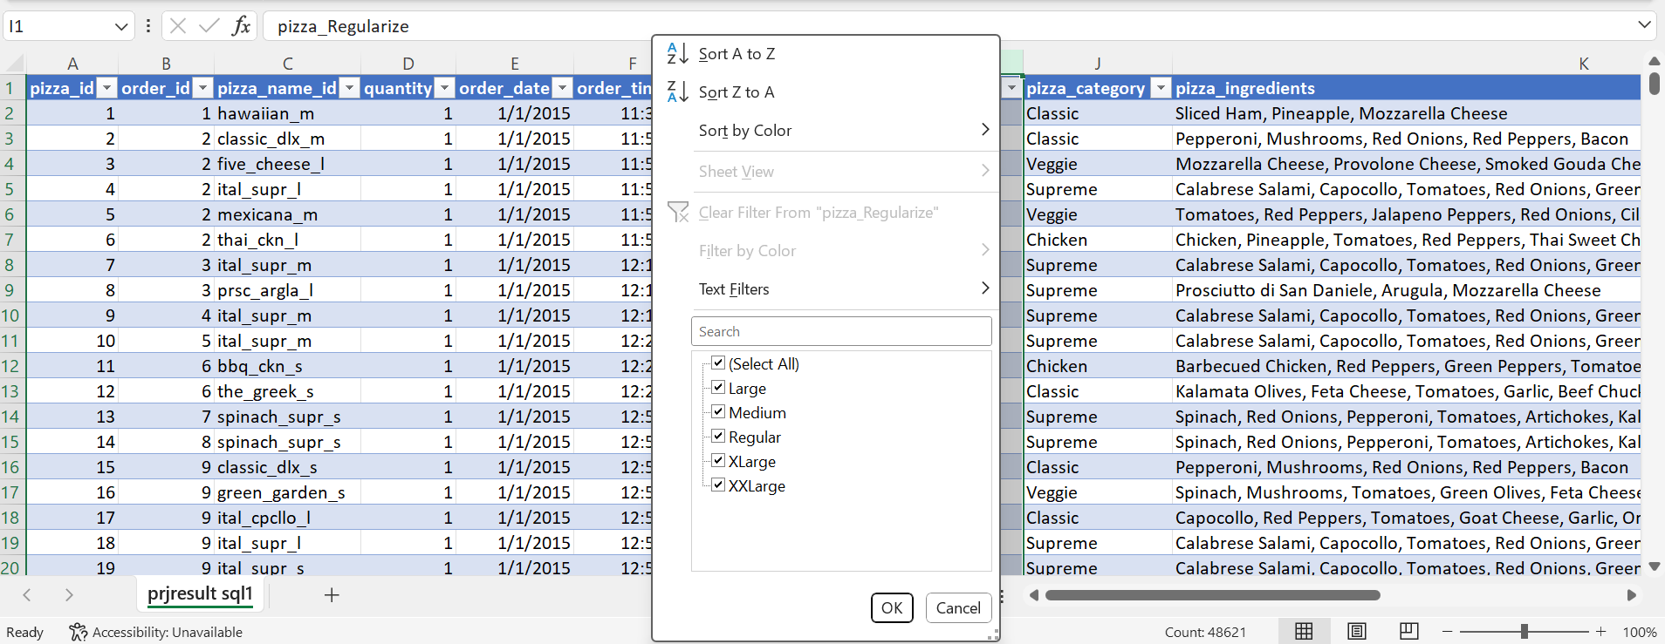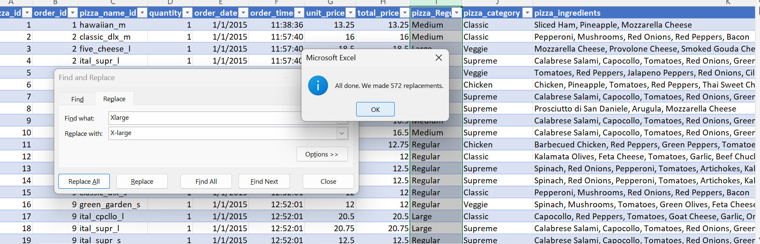
2.Data processing
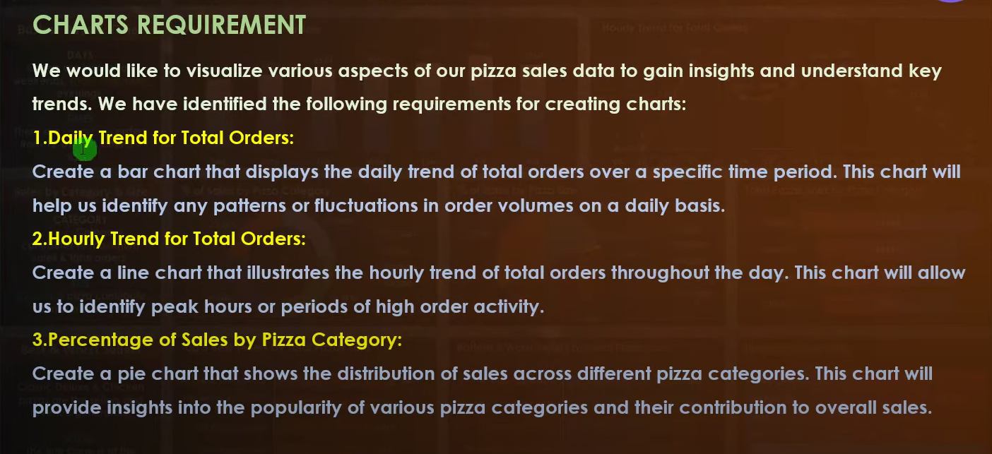
1.To find out daily trend
Select order_time
add a column between order_time and order_date
use the formul--=TEXT([@[order_date]],"dddd")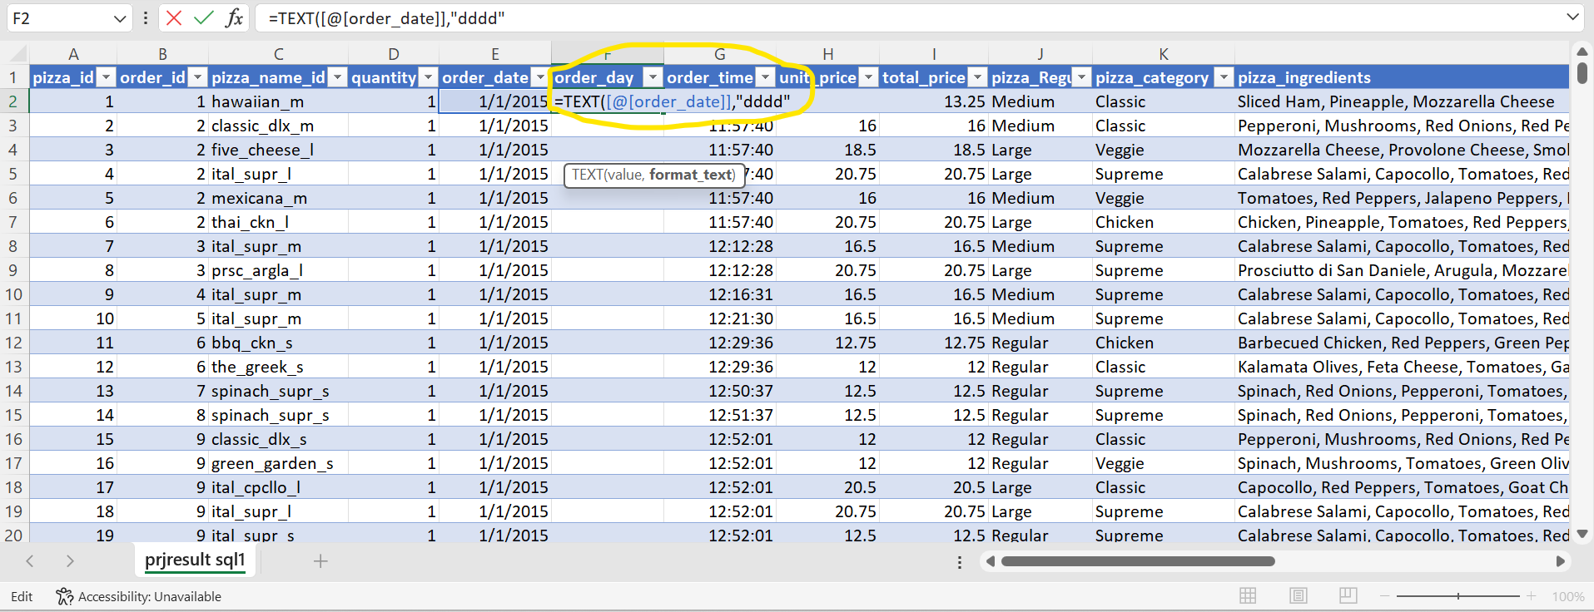

Data analysis 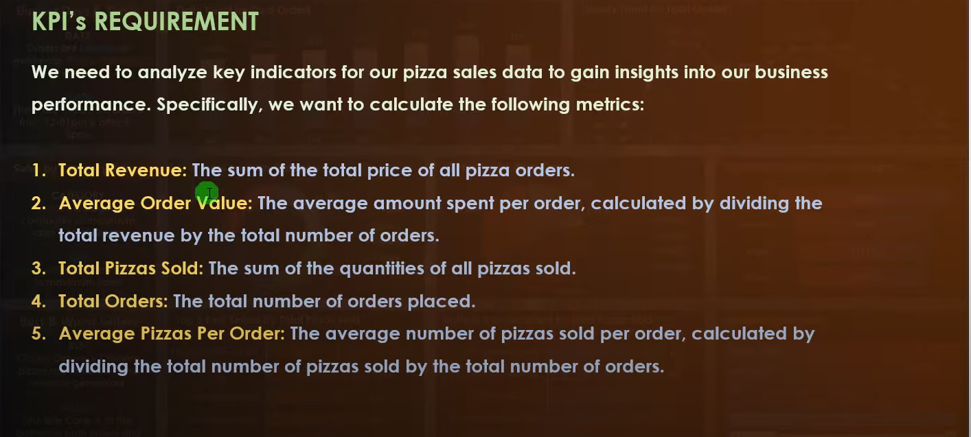

Remove duplicatae values into column -- =COUNTIF(B:B,[@[order_id]])
Use Case:
- Duplicate detection
- Frequency analysis
- Grouping by count

Devided by 1 --- so that -- =1/COUNTIF(B:B,[@[order_id]])
Use Case:
- Normalized weight calculation
- Unique record contribution
- Aggregation without duplication bias
Avarge order value ---- deviding revenue by total number
=GETPIVOTDATA("Sum of total_price",$A$3)/GETPIVOTDATA("Sum of total_orders",$A$3)

3.Total of order
Quantity push into values
4. Avg_Pizza_per_order
---total number of pizza devided by total number of orders
=GETPIVOTDATA("Sum of quantity",$A$3)/GETPIVOTDATA("Sum of total_orders",$A$3)

