**Assignment to create a prototype match-3 feature**

Building a match-3 feature in a slot game, a slot game comprises different streams of works

1. Game concept
2. Art/Animations/sounds
3. Math
4. Engineering

We expect you to be an expert in engineering and for rest of the competencies you can take dummy assets from web or we can support you to get them to build a prototype game

**Game concept:**

Take a moment to see following slot game and focus at match-3 feature that starts at 4:12 (4 minutes and 12 seconds) timeline

<https://www.youtube.com/watch?v=8t_Pfa4gkJA>

You are expected to build a feature based on this game

Task Description:

* create an interface that look like this

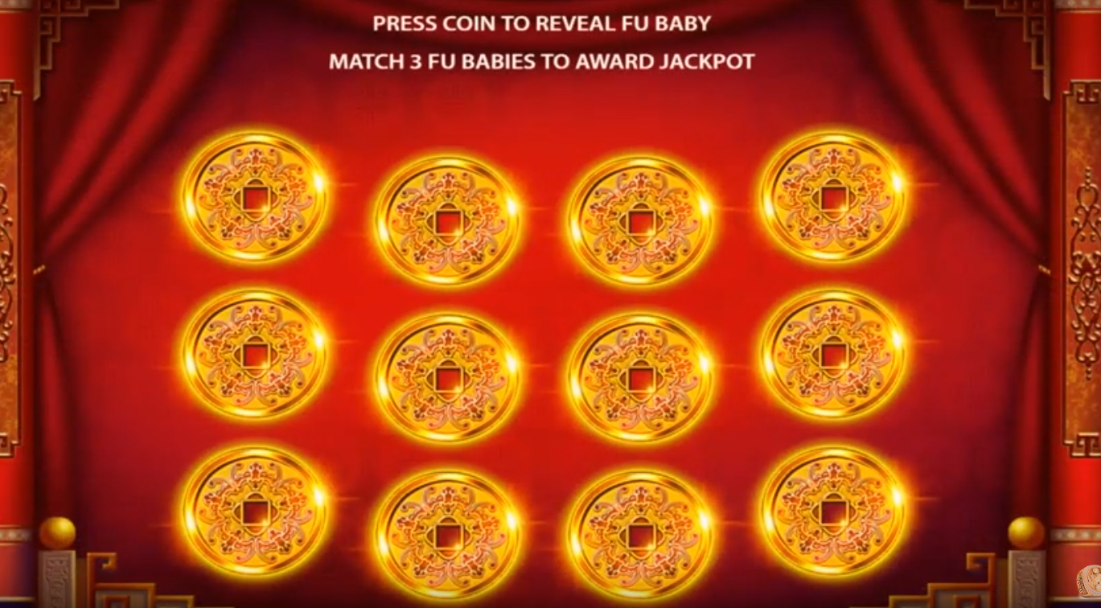

* Description about game play:
  + When user touches any of these 12 icons it reveals one of 4 different type of awards
  + Each icon reveals an award called jackpot
  + Award for these jackpots are 100K, 200K, 500K and 1 m (k for thousand and m for million)
  + Name of these jackpots are Mini, Minor, Major and Grand
* Description about reveal feature:
  + On receiving player touch, your code should randomly reveal one of these awards (Mini, Minor, major, Grand)
  + Each Award has following weightage to be picked
    - Mini has 50% chance
    - Minor have 25% chance
    - Major has 20% chance
    - Grand has 5 % chance
  + When an award is revealed, your code should check if there are 3 similar awards revealed out of all revealed awards or not
  + If total 3 similar awards have been revealed then conclude feature by presenting a banner as follows, see at 4:29 timelines of video

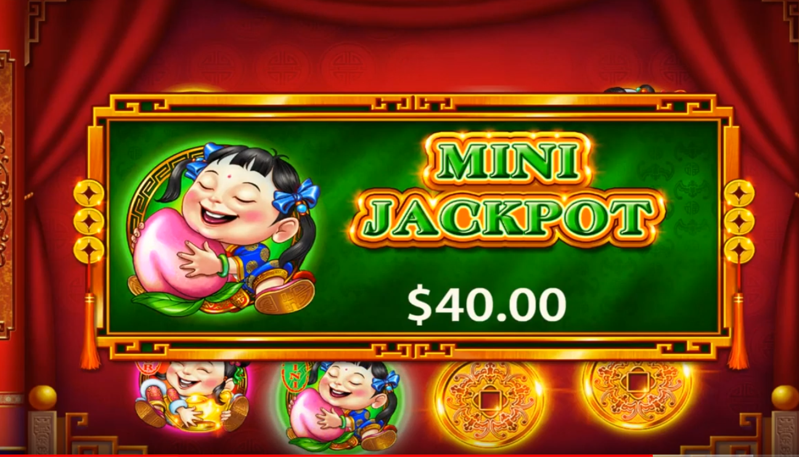

* + If not, player will continue selecting un-revealed icons
* Add Resume/Recover functionality.
  + Player should be able to start again from where he left when the application is exited/closed. All the game data should be recovered correctly.
* Display game statistics which captures following details:
  + Total number of Games played.
  + Number of times Mini , Minor , Major and Grand jackpot was hit and their respective amount in total.
  + Total Game win amount.

**Note: Implementation should not use PlayerPrefs** .

**Art/Animations/sounds:** you can choose any art you want from your previously created portfolio or use anything from web and same for sounds

**Engineering:**

please use unity 3D engine to build this prototype game and use C# programming language as used with unity to build game play.

All engineering work /script should be written in C# that can be integrated and executed with unity 3D engine

Please share, source code, apk file that can run on android device and a video to evaluate, feel free to reach out to discuss any thing that may be unclear .