Warwickshire & West Mercia Police



Drug Drive / FIT Submissions Guide.

V1.0

23rd November 2015

Contents

Introduction 3
Creating a New Submission 4
Tab 1 – Time / Location 5
Tab 2 – Tests Performed 8
Tab 3 – Person / Arrest 12
Tab 4 - HCP (health care professional) 16
Tab 5 - Blood/Urine 17
Tab 6 - Disposal 18
Tab 7 - Additional details 19
My submissions / Finalising partly completed submissions 21

Introduction
Drug Drive / FIT Submissions are available via the Force Desktop -> Start -> All Programs -> Sessions -> Drug-FIT Test
The Drug Drive / FIT submission homepage will show the user you are logged in as
Standard users will have 3 buttons available. Create New Submission, My Submissions and User Guide. Admin users will have an extra button Administrators.
These buttons are reflected in the Nav bar as links at the top of the screen.

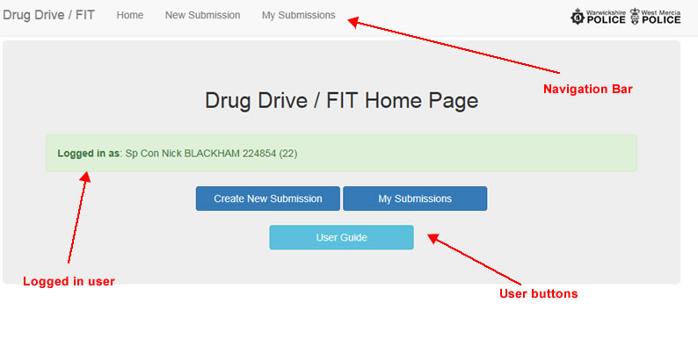

Creating a New Submission

To create a new submission click the `New Submission` Nav bar link or the `Create New Submission` button on the home screen.

A submission has 7 tabs, depending on the nature or your submission all or just some of the tabs will be enabled.

You cannot move on to the next tab until you have completed mandatory data in he current tab. Mandatory fields are marked with an asterisk * and are in yellow.

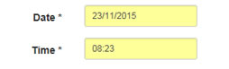

When the tab is completed the green 'Next Tab' button will be available.

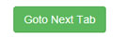

Your submission is saved every time you press the Next Tab button. You can go back to previous tabs when they are completed by clicking the tab title. As your submission is saved every time you click the Goto Next Tab button you can stop entering a submission and complete it at a later time, see the `My submissions / Finalising partly completed submissions` section.

Tab 1 – Time / Location

When opening this tab two fields must be completed. These are the date and time that the drug swipe / fit took place.

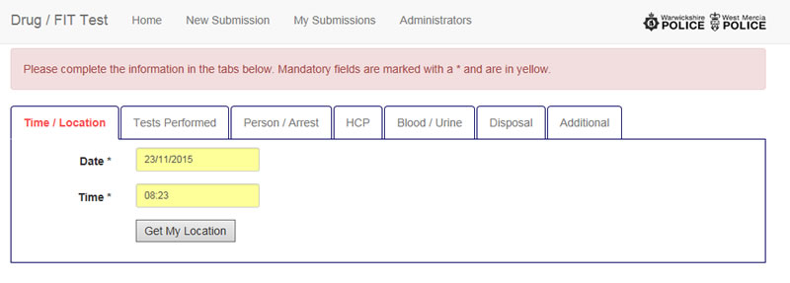
Clicking the 'Get my Location' button will send a request to get your location from ARLS at that date/time.

If your location is available then Force / LPA / Beat Code will automatically be populated for you.

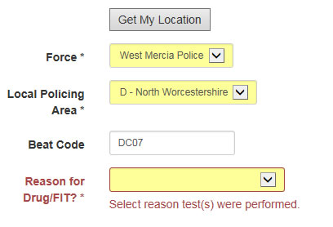
If your location cannot be found then you will need to complete Force / LPA fields manually, beat code is optional.

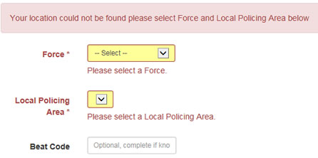

You will also need to complete the reason for the test.
Once all mandatory fields are complete the green 'Next Tab' button will appear. Clicking it will save your submission and move you to the next tab.

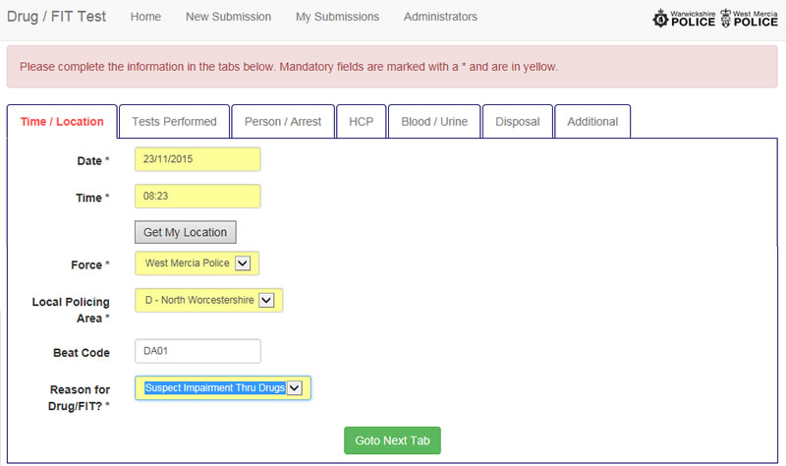

Tab 2 – Tests Performed

The first question on this tab is the location of the test. Roadside, Station or Hospital

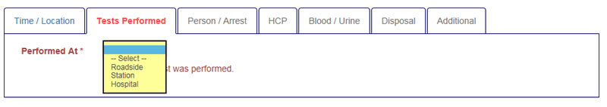

If you select roadside then 3 further sections are available.
FIT test Y/N. If Y is selected then the result of the fit test and time of test required.
Breath test Y/N. Y/N is required but any other details are optional
Drug Test Y/N. If Y then the result of the test and batch no are mandatory. If the test is positive then the drugs detected are mandatory.

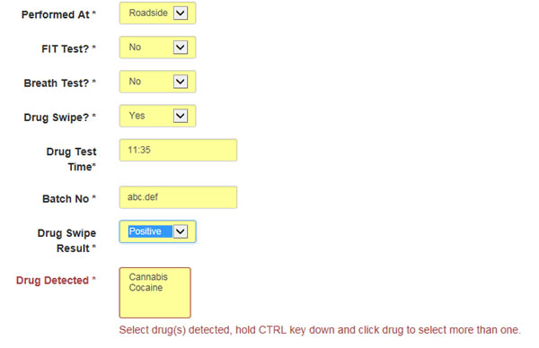
If you select station then 2 further sections are available
Breath test Y/N. Y/N is mandatory but other details are optional
Drug Test Y/N. If Y then the result of the test and batch no are mandatory. If the test is positive then the drugs detected are mandatory.

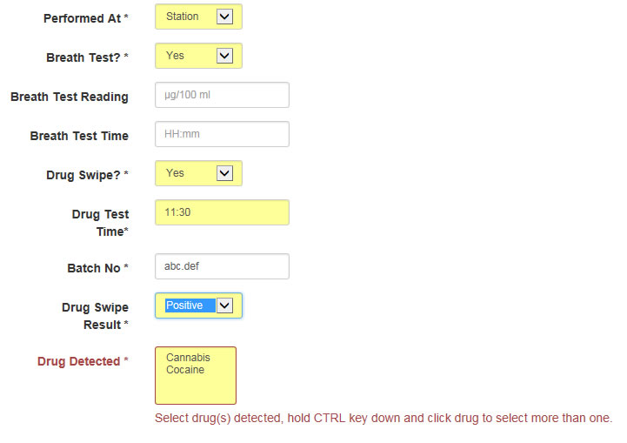

If you select Hospital 1 further section is available
Drug Test Y/N. If Y then the result of the test and batch no are mandatory. If the test is positive then the drugs detected are mandatory.

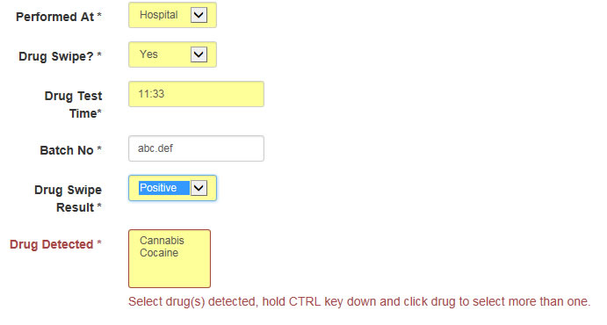

Once all mandatory fields are complete the green 'Next Tab' button will appear. Clicking it will save your submission and move you to the next tab.

Tab 3 – Person / Arrest

The first question on this tab is arrested Y/N

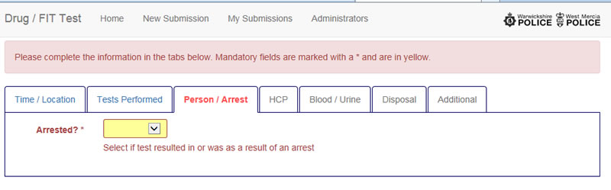

If Y Arrested is selected then a list of custodies from the last seven days is displayed. 10 custodies are displayed per page. To move between pages use the previous/next or page number buttons below the custody table. You can filter the list by typing in the filter box at the top of the custody list table. Eg custody no, person arrest surname etc..

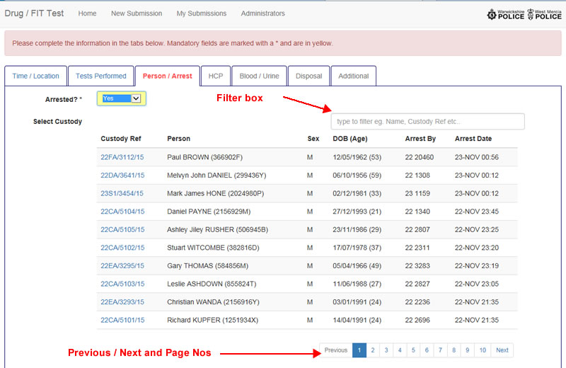

To select the correct custody click its reference number.
This will then populate the person’s age / sex and ethnicity details from the custody. If any of these are not available you will need to complete them manually.

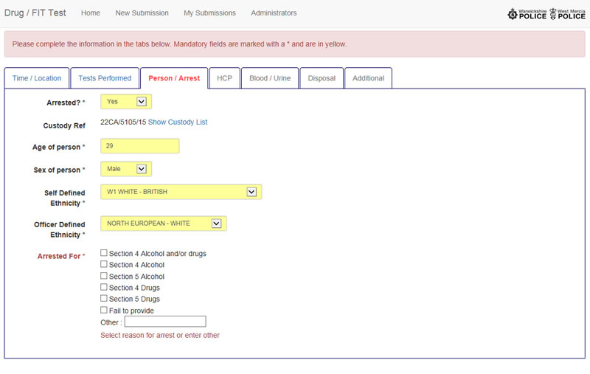
You will then need to complete the Arrested For field before you can move onto the next tab.
If N Not Arrested is selected then age / sex / ethnicity details must be completed manually.

If the drug swipe was positive and no arrest was made then you will need to complete the reason for no arrest box.

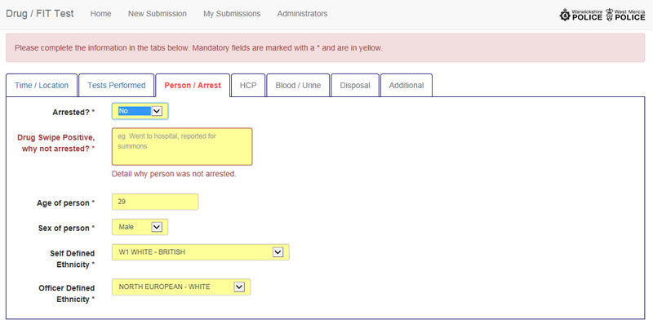

Once all mandatory fields are complete the green 'Next Tab' button will appear. Clicking it will save your submission and move you to the next tab.

Tab 4 - HCP (health care professional)

Tab only required if Arrested in tab 3 is Y
Only mandatory field is Referred to Health Care Professional Y/N field all other fields are optional.

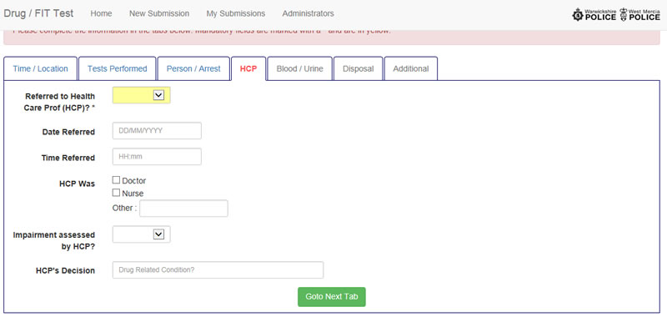

Once all mandatory fields are complete the green 'Next Tab' button will appear. Clicking it will save your submission and move you to the next tab.

Tab 5 - Blood/Urine

Tab Only required if Arrested in tab 3 is Y
All fields on this tab are optional

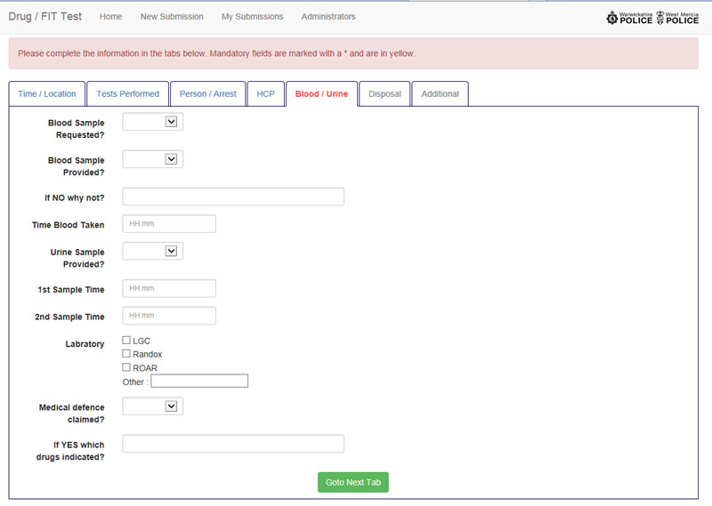

Tab 6 - Disposal
Tab only required if Arrested in tab 3 is Y

It is mandatory that you select a method of disposal.

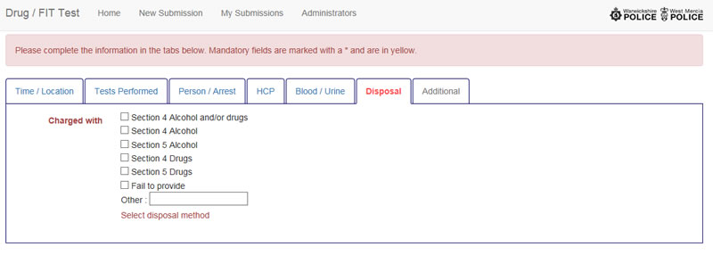

Once all mandatory fields are complete the green 'Next Tab' button will appear. Clicking it will save your submission and move you to the next tab

Tab 7 - Additional details

This is the final tab and has a text box that any other useful information can be put in.

If your submission is valid a green box will be displayed above the tabs to denote this and a button below the text box `Submit Drug\FIT Test` will be displayed.

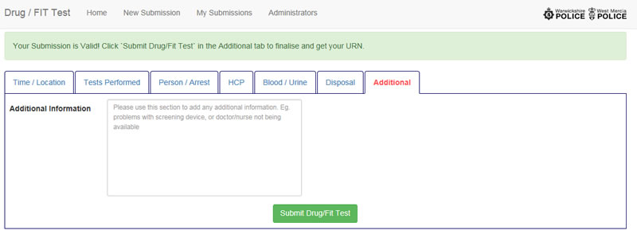

Clicking the button will save your submission and display your URN.

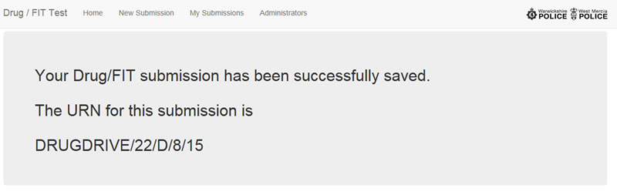

Your submission is now complete.

My submissions / Finalising partly completed submissions

The my submission screen displays a list of the submissions that you have completed (these will have a URN displayed next to them) and ones you have started but not finalised (these will have no URN but will have a pencil I and trash can icon next to them).

The table displays records in blocks of 10, you can scroll through by clicking the previous/next or page number buttons below the table. The filter box above the table allows you to type text to search entries eg. Urn, person arrested name etc...

To view a completed submission click the URN and a PDF document of the submission will be displayed.

To complete a submission you have started click the pencil icon next to it, the submission will load in the data that you had previously entered and open in the first tab, you can then move through as per creating a new submission.

If you have a submission you have started but no longer want it you can click the trash can icon to delete it from your list.

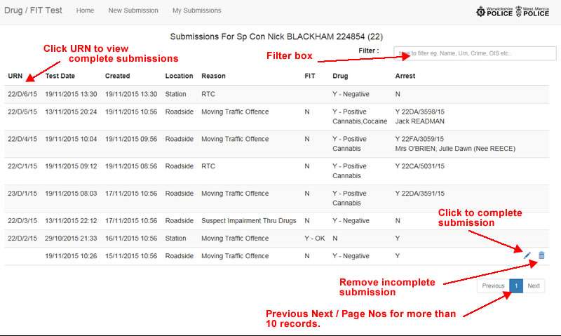

If you choose to delete an incomplete submission then you will be asked to confirm you want to do this.

